Supplementary images and figures
Table 1 hiPSC lines utilized in this study
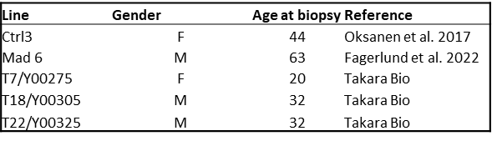
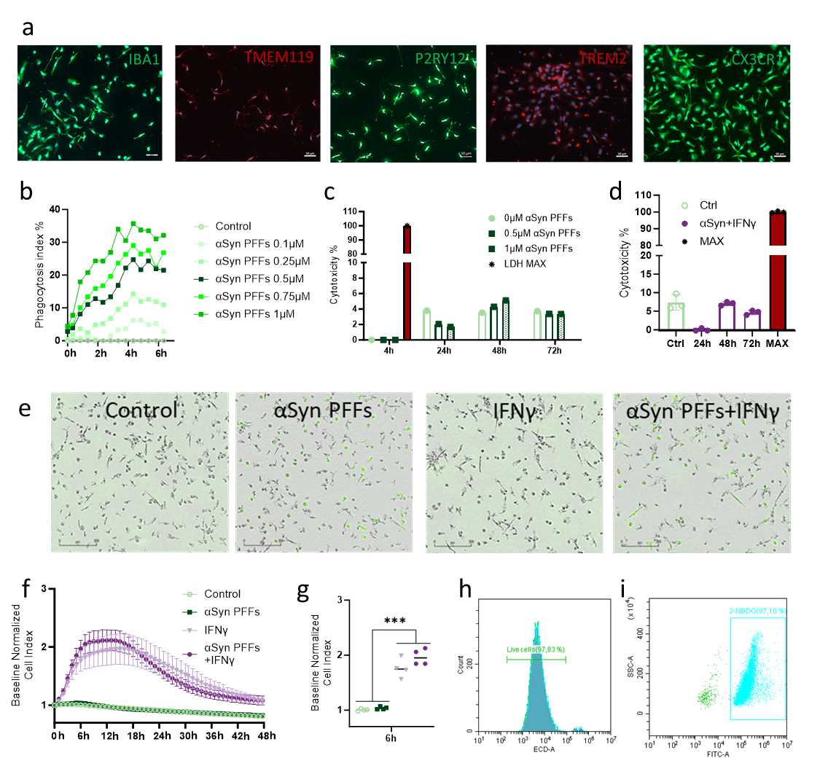
Figure S 1 (a) Representative ICC images of microglial markers IBA1 (green), TMEM119 (red), P2RY12 (green), TREM2 (red), and CX3CL1 (green). Scale bar 50µm. (b) Phagocytosis of ATTO 465-labeled αSyn PFFs with different concentrations. (c) LDH release measurement used as indicator for cytotoxicity. 0.5µM and 1µM concentrations tested over time. (d) LDH release used to detect cytotoxicity of 0.5µM αSyn PFFs + IFNγ 20ng/ml. (e) IncuCyte images from 6h timepoint in phagocytosis. Green fluorescence from ATTO 465-labeled αSyn PFFs. Scale bar 200nm. (f) xCELLigence measurement to assess the cellular impedance. All stimulants given at timepoint 0h. (g) Statistically significant changes in the microglial cellular impedance detected at 6h timepoint with xCELLigence. (h) Propidium Iodide (ECD-fluorescence) was used to detect the live cells. (i) The 2-NBDG positive cells (FITC-fluorescence) were gated using SSC-A and FITC-A. All graphs error bar indicating SD. One-way-ANOVA was used to determine statistical differences. Tukey’s multiple comparisons was used. p<0.05=* p<0.01=**, p<0.001=***

