Supplementary file for the full uncropped Western Blots
The samples are labeled as follow:
Controls = 1, 2, 3
αSyn PFFs = 4, 5, 6
IFNγ = 7, 8, 9
αSyn PFFs+IFNγ = 10, 11, 12
αSyn control sample with only fibrils=PFF
Multiple stainings were done on the same blot with different antibodies in different hosts (e.g., anti-rabbit, anti-mouse) without stripping the membrane between the stainings. The order of the images indicates the order in which they were stained.

Figure 2C: Total αSyn and βactin
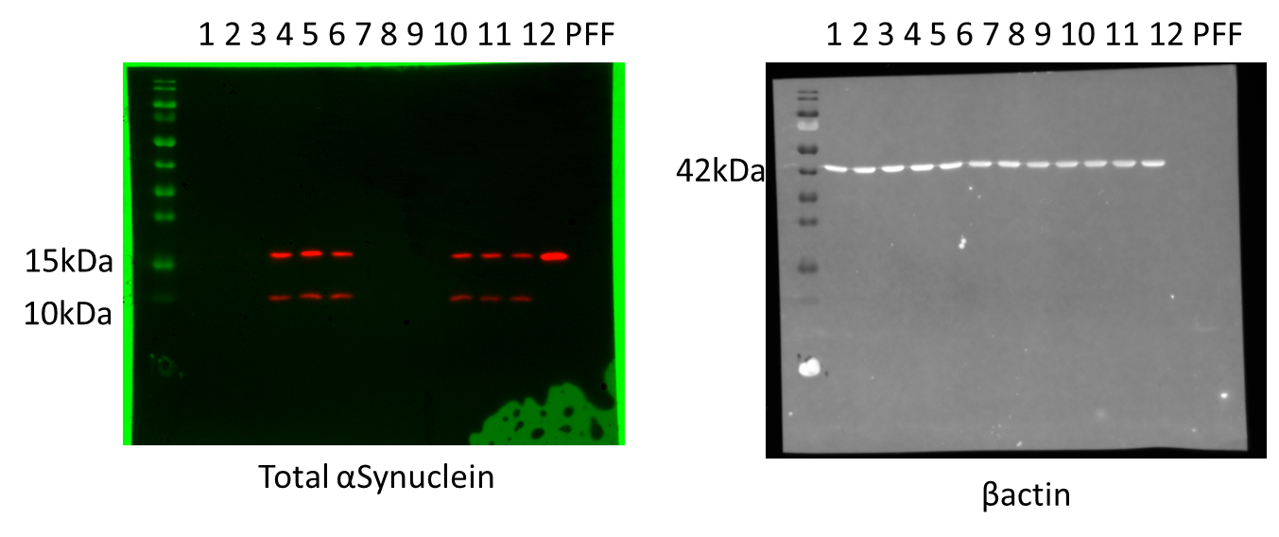
Figure 2F: βactin and TREM2
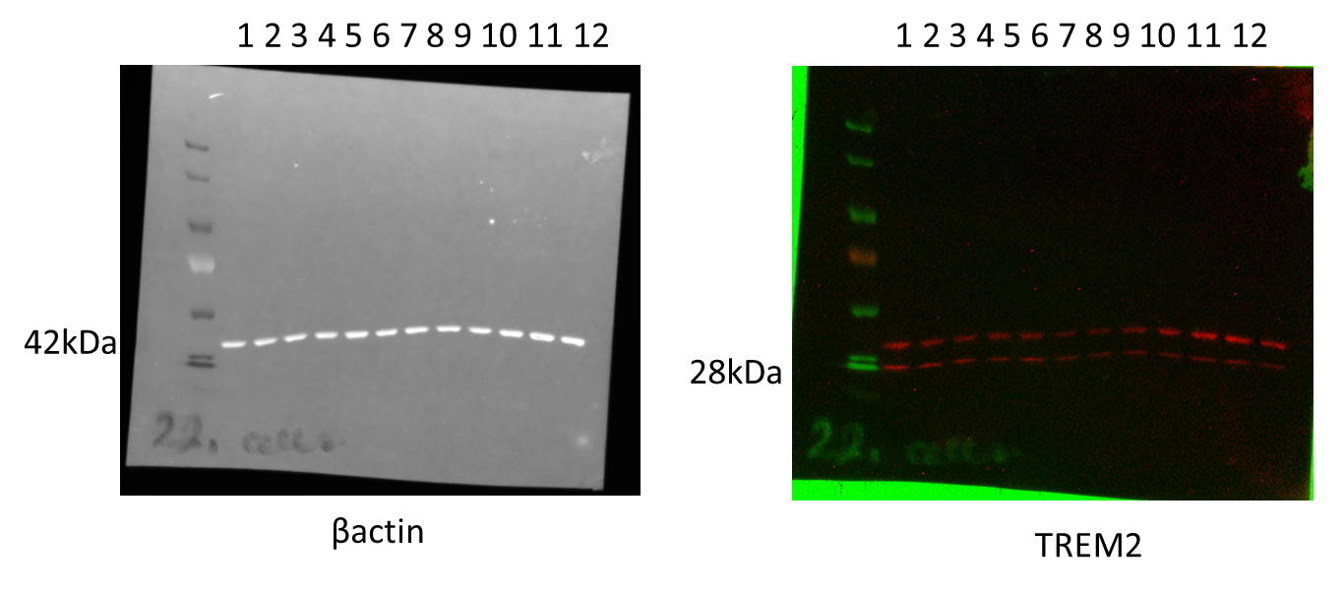

Figure 2G: TLR4 and βactin
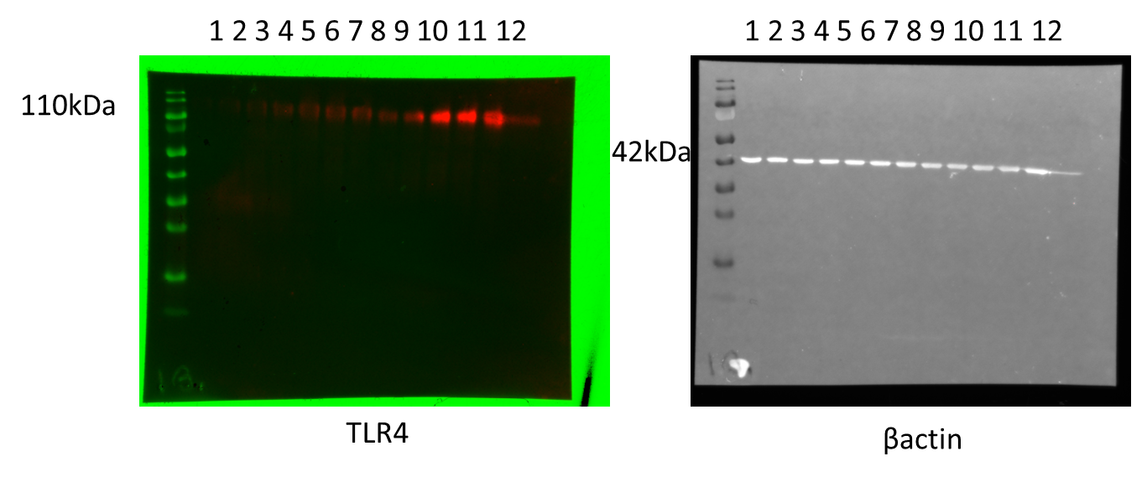
Figure 3B: p62, βactin, and Beclin1
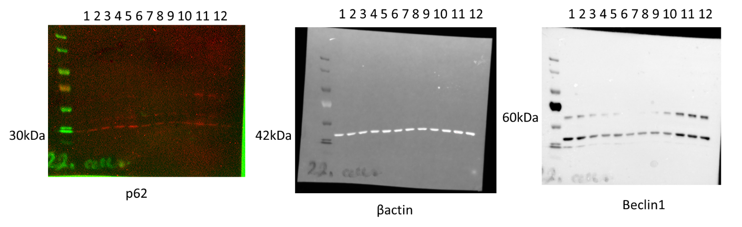
Figure 3D: Total αSyn insoluble fraction
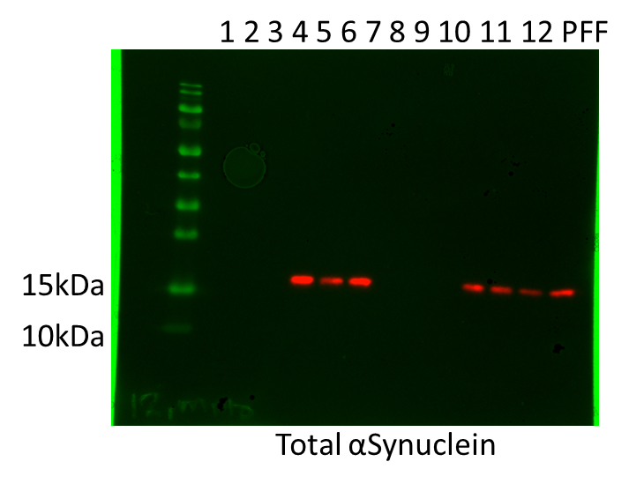

Figure 3F: LAMP1 and βactin
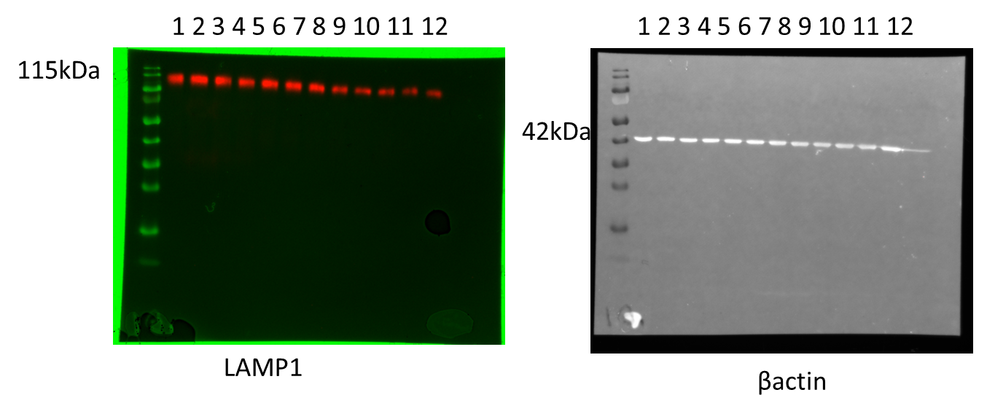
Figure 3G: LAMP2 and βactin (NOTE: sample 1 pipetted twice due to small leakage into ladder well)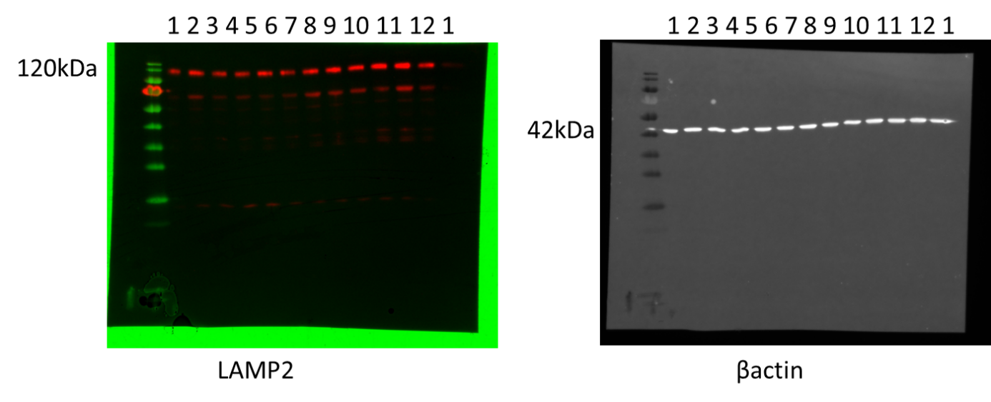
Figure 4B: Cytochrome C, TOM20, and βactin
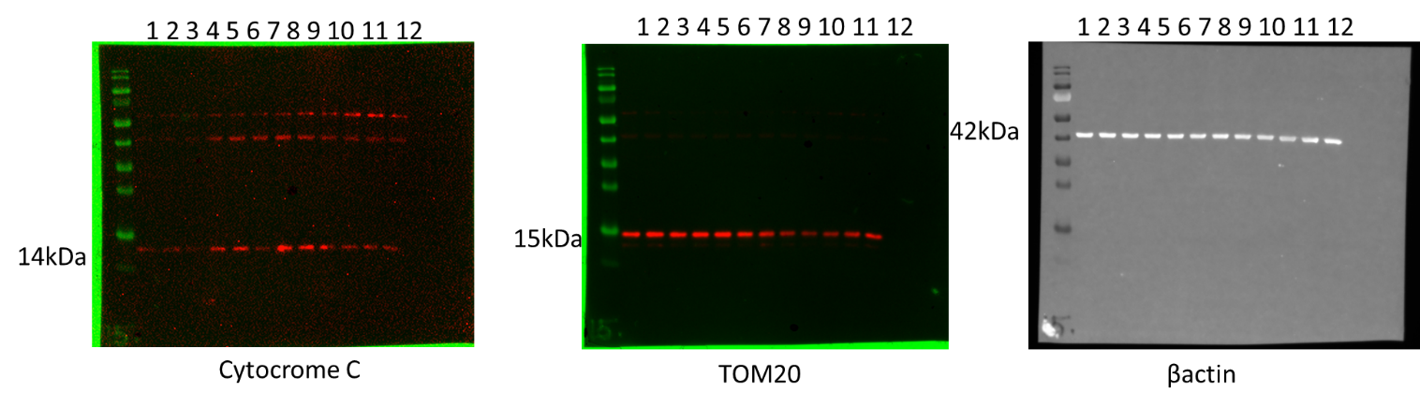

Figure 4C: iNOS and βactin
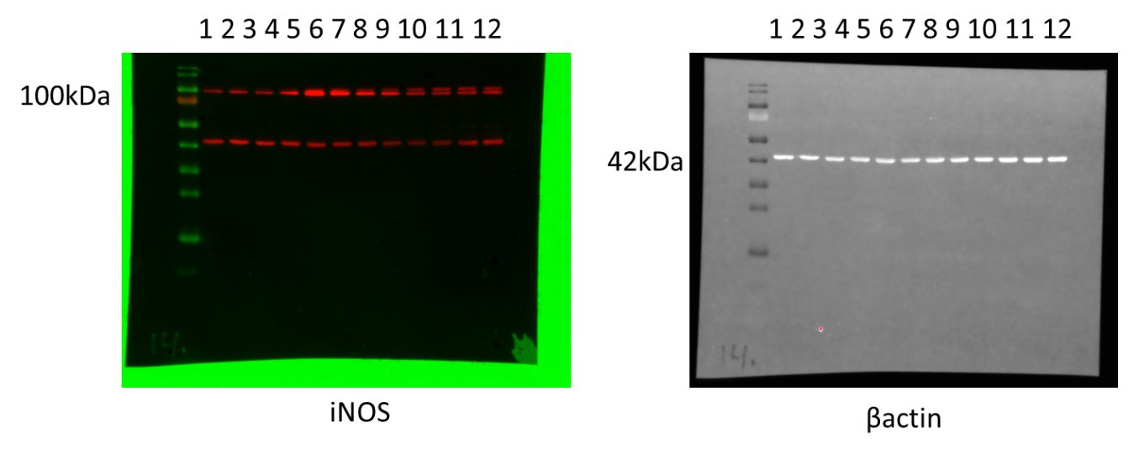
Figure 4D: βactin and SOD2
