Supplemental Information

- Phylogenetic analysis of hemagglutinins
Supplemental Table 1. Phylogenetic analysis of hemagglutinins used in this study. Sequences were obtained from GISAID and aligned with the MUSCLE algorithm in MEGA. Pairwise distances were computed as the number of amino acid differences.
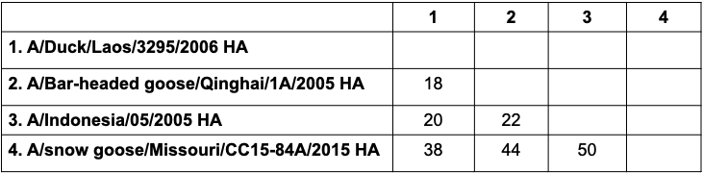

- Comparison of ELISA results
Supplemental Figure 1. Correlation matrix of ELISA binding results. Spearman’s rank correlation coefficients (r) were calculated in GraphPad Prism 10.0.3. Correlation coefficients range from -1 to 1, where 1 indicates positively correlated data and -1 indicates negatively correlated data. An r of 0 indicates the ELISA values do not vary together.
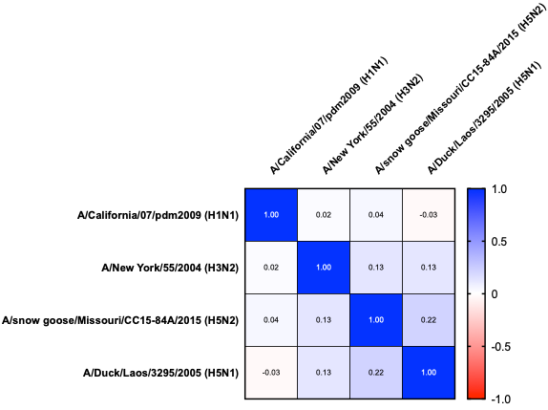
- Neutralisation assay optimisation
Supplemental Figure 2. Creation of seropositive cut-offs for pseudotyped neutralisation assays. NT50 is the 50% neutralising titre, which is represented here as the dilution factor of the serum necessary to reach 50% inhibition of pseudovirus growth. We took the highest Scottish blood donor pseudoneutralisation NT50 value (1:1000) to create a cut-off, as these individuals were considered extremely unlikely to have been exposed to a real H5N1 virus as in Thompson et al¹. a 14 samples were considered seropositive to A/Bar-headed goose/Qinghai/1A/2005(H5N1). b 3 samples were considered seropositive to A/Indonesia/05/2005(H5N1).

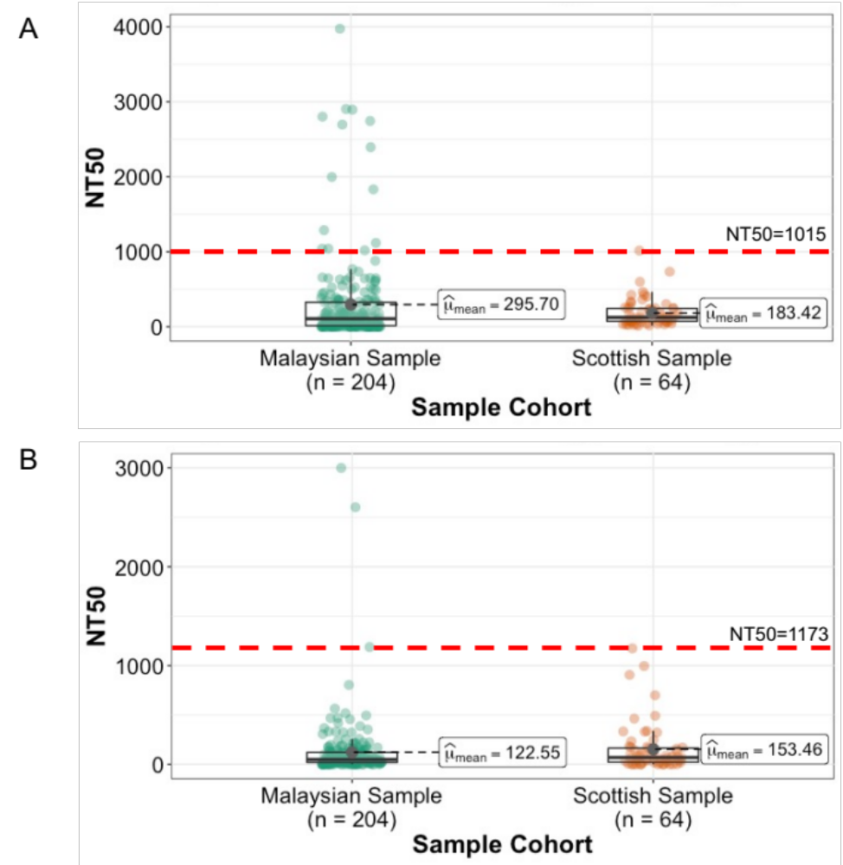
- Confirmation of bead-antigen conjugation

Supplemental Figure 3 Confirmation of bead conjugation by flow cytometry. Side scatter versus forward scatter plots were used to draw gate 1 to exclude debris and doublets. The count versus PE histogram was used to observe PE fluorescence in the different conditions. Data was analysed with FlowJo™ 10.8.2. H1 CA coated beads indicates A/California/07/2009(H1N1) HA, H1 NY denotes A/New York/18/2009(H1N1) HA, and H3 represents A/Wisconsin/67/2005(H3N2) HA.

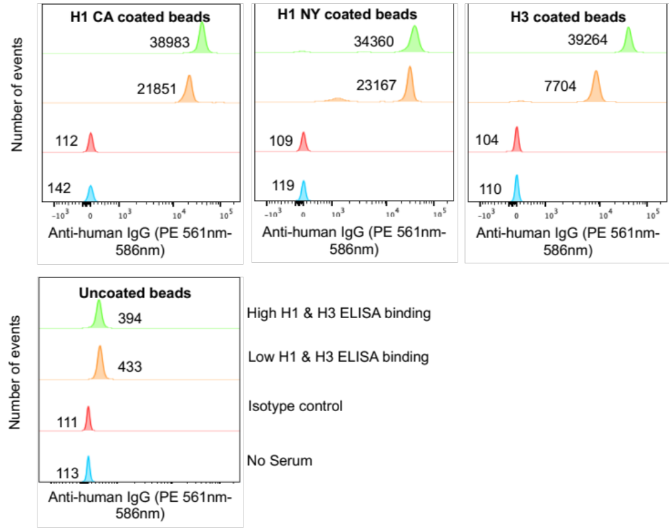

- ELISA control cohorts and plate controls

Supplemental Figure 4. Binding to A/Duck/Laos/3295/2005(H5N1) HA by ELISA including control cohorts and plate controls. Plates were coated with 0.125µg/mL of A/Duck/Laos/3295/2006(H5N1) HA in 50µL 1X PBS. All samples shown were tested in duplicate at a 1:50 dilution. Rural Malaysia indicates our cohort of interest for this study. The Urban Malaysia cohort indicates samples collected from blood donors in Kota Kinabalu, Malaysian Borneo. Scottish indicates samples from the Scottish blood donor cohort. PHP post H5 vaccination refers to pooled human plasma from an H5 vaccination trial, obtained from BEI Resources. One H5 PHP pool was considered medium titre, and the other pool was low titre according to the suppliers, hence the two distinct points. These individuals were immunized intramuscularly with two doses of an inactivated monovalent subvirion investigational influenza using A/Indonesia/05/2005(H5N1). The Oxford and UMS plate controls are polyclonal goat antiserum raised against our ELISA antigen. a Shows age-matched cohorts, where the ages range from 18-65. b Shows the full rural and urban Malaysia cohorts, ages ranging from 0-104 with all controls.
A
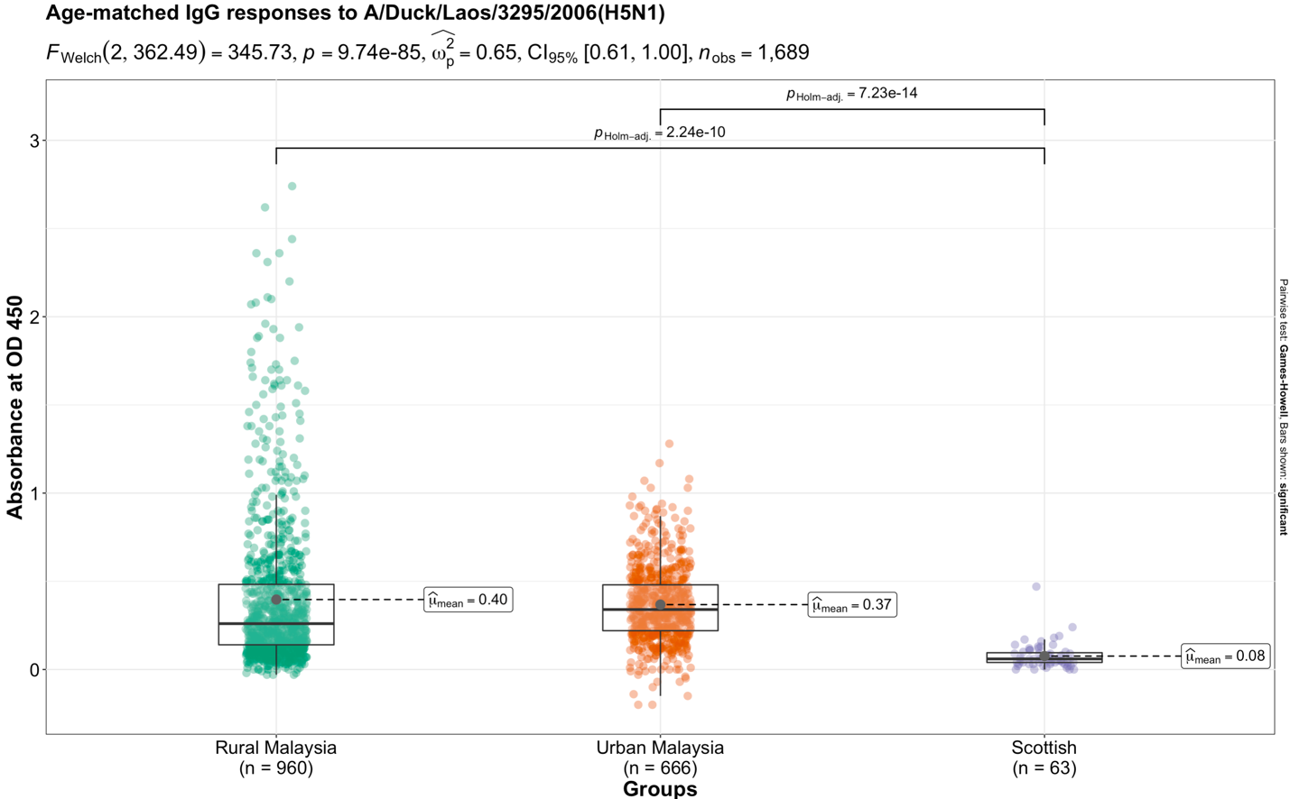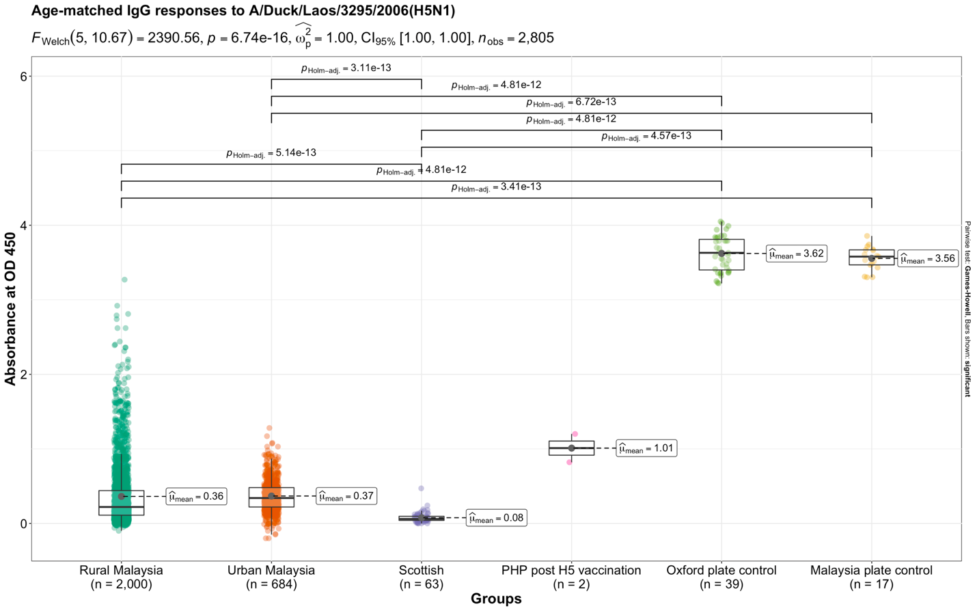
B

Environmental risk factors | Odds of H5N1 binding > 2 AU
Predictors | Adjusted odds ratios | 95% CI | p-value
(Intercept) | 0.00 | 0.00 – 0.00 | <0.001
Normalized differential vegetation index | 1.66 | 1.10 – 2.57 | 0.018
Elevation (meters above sea level) | 0.00 | 0.00 – 0.00 | <0.001
Distance from the sea (m) | 894.78 | 56.09 – 16572.80 | <0.001
Mean diurnal range, 1970 - 2000 (°C) | 0.00 | 0.00 – 0.00 | <0.001
Minimum temperature of coldest month, 1970 - 2000 (°C) | 0.00 | 0.00 – 0.00 | <0.001
Precipitation of the wettest month. 1970 - 2000 (mm) | 0.40 | 0.15 – 0.88 | 0.040
Precipitation seasonality, 1970 - 2000 (coefficient of variation) | 5.38 | 0.83 – 38.44 | 0.084
Distance from irrigated farmland (m) | 0.61 | 0.38 – 0.92 | 0.027
- Geostatistical analysis of H5 binding and wild distributions
Hierarchical models of environmental risk factors were integrated into a Bayesian framework with the Matérn covariance function used as a spatial effect as in Fornace et al². and Klim et al³. The deviance information criterion (DIC) was used as a method to compare our models. A smaller DIC is indicative of improved model fit. The DIC for the model of wild bird distribution with a spatial effect and fixed effects (the environmental risk factors) was 1098.52, versus 5104.99 for the model with only a spatial effect, and 1526.31 for the null model. In the models predicting the probability of high H5 binding, the model with a spatial and fixed effect was also the best fit as the DIC was 378.30 (388.69 = spatial effect only, 8762.31= null model).

Supplemental Table 2. Multivariate environmental risk factor analysis of H5N1 binding distribution. Adjusted odds ratios for fixed effects which impact the odds of H5 binding being greater than 2 AU. The model with lowest AIC is shown (336.12). The log likelihood was -159.0579. MASS::stepAIC was used to determine the model with the lowest AIC using a stepwise parsimonious approach (both forward and backward selection)⁴. Data was mean centred and scaled prior to analysis. Odds ratios were calculated and plotted using the sjPlot⁵ package in RStudio^{6,7}.
Supplemental Table 3. Multivariate environmental risk factor analysis of wild bird distribution. Adjusted odds ratios for fixed effects which impact the odds of a wild bird sighting. The model with lowest AIC is shown (316.2). The log likelihood was -150.1009. MASS::stepAIC was used to determine the model with the lowest AIC using a stepwise parsimonious approach (both forward and backward selection)⁴. Data was mean centred and scaled prior to analysis. Odds ratios were calculated and plotted using the sjPlot⁵ package in RStudio^{6,7}.

Environmental risk factors | Odds of wild bird sightings
Predictors | Adjusted odds ratios | 95% CI | p-value
(Intercept) | 0.00 | 0.00 – 0.00 | <0.001
Euclidean distance from roads | 0.00 | 0.00 – 0.00 | <0.001
Elevation (meters above sea level) | 0.00 | 0.00 – 0.08 | 0.001
Distance from the sea (m) | 9.16 | 2.43 – 33.43 | 0.001
Maximum temperature of warmest month, 1970 - 2000 (°C) | 0.00 | 0.00 – 0.05 | <0.001
Precipitation of the wettest month, 1970 - 2000 (mm) | 0.16 | 0.09 – 0.29 | <0.001
Distance from bush forest (secondary) (m) | 1.51 | 0.93 – 2.44 | 0.094
Distance from old forest (primary) (m) | 1.35 | 1.07 – 1.69 | 0.010

Supplemental Table 4. Multivariate environmental risk factor analysis of poultry distribution. Adjusted odds ratios for fixed effects which impact the odds poultry ownership. The model with lowest AIC is shown (68102). The log likelihood was --34034.95. MASS::stepAIC was used to determine the model with the lowest AIC using a stepwise parsimonious approach (both forward and backward selection)⁴. Data was mean centred and scaled prior to analysis. Odds ratios were calculated and plotted using the sjPlot⁵ package in RStudio^{6,7}.

Environmental risk factors | Odds of wild poultry ownership
Predictors | Adjusted odds ratios | 95% CI | p-value
(Intercept) | 0.59 | 0.58 – 0.59 | <0.001
Euclidean distance from roads | 0.98 | 0.98 – 0.98 | <0.001
Population density (per km²) | 0.99 | 0.99 – 1.00 | 0.008
Elevation (meters above sea level) | 1.10 | 1.06 – 1.14 | <0.001
Aspect (degrees) | 0.99 | 0.99 – 1.00 | 0.011
Distance from the sea (m) | 0.78 | 0.75 – 0.81 | <0.001
Average temperature, 1970 - 2000 (°C) | 3.49 | 2.54 – 4.79 | <0.001
Mean diurnal range, 1970 - 2000 (°C) | 1.10 | 1.04 – 1.17 | 0.002
Maximum temperature of warmest month, 1970 - 2000 (°C) | 0.82 | 0.73 – 0.92 | 0.001
Minimum temperature of coldest month, 1970 - 2000 (°C) | 0.31 | 0.25 – 0.39 | <0.001
Precipitation of the wettest month, 1970 - 2000 (mm) | 1.03 | 1.03 – 1.04 | <0.001
Distance from bush forest (secondary) (m) | 0.96 | 0.95 – 0.97 | <0.001
Distance from mangroves (m) | 0.95 | 0.93 – 0.97 | <0.001
Distance from oil palm plantation (m) | 1.01 | 1.00 – 1.01 | 0.045
Distance from irrigated farmland (m) | 0.99 | 0.99 – 1.00 | 0.028
Distance from old forest (primary) (m) | 1.03 | 1.02 – 1.03 | <0.001

Supplemental Table 5. Models of wild shorebird distribution and H5 binding with null, separate, and joint spatial effects.

Model |  | DIC | Marginal likelihood | Spatial range (km)
M1 | No spatial or environmental effect (H5) | 8762.31 | -4381.26
M2 | Spatial effect only (H5) | 388.69 | -201.07 | 47.2769
M3 | Spatial and environmental effect (H5) | 378.30 | -200.56 | 28.7355
M4 | No spatial or environmental effect (wild birds) | 1526.31 | -763.15
M5 | Spatial effect only (wild birds) | 5104.99 | -184.94 | 94.7576
M6 | Spatial and environmental effect (wild birds) | 1098.52 | -173.29 | 87.1406
M7 | Combined model of wild birds and H5, separate spatial effect | 1454.16 | -368.85 | 1.0517
M8 | Combined model of wild birds and H5, shared spatial effect | 1410.58 | -374.13 | 0.879029  Scaling parameter:  1.058

Supplemental Table 6. Covariates in model of H5 binding with shorebird distribution and shared spatial effects.
Probability of H5 binding | Mean | SD | 95% BCI
Normalized differential vegetation index | 0.627 | 0.236 | 0.164, 1.089
Elevation (meters above sea level) | -2.317 | 1.989 | -6.214, 1.581
Distance from the sea (m) | 1.069 | 2.137 | -3.119, 5.257
Mean diurnal range, 1970 - 2000 (°C) | -0.353 | 2.127 | -4.522, 3.816
Minimum temperature of coldest month, 1970 - 2000 (°C) | -3.570 | 2.261 | -8.001, 0.862
Precipitation of the wettest month. 1970 - 2000 (mm) | -0.707 | 0.851 | -2.375, 0.961
Precipitation seasonality, 1970 - 2000 (coefficient of variation) | 1.356 | 1.852 | -2.274, 4.987
Distance from irrigated farmland (m) | -1.293 | 0.940 | -3.134, 0.549
Probability of shorebird sightings
Euclidean distance from roads | -6.364 | 1.939 | -10.164, -2.565
Elevation (meters above sea level) | -2.959 | 2.132 | -7.138, 1.220
Distance from the sea (m) | 0.612 | 2.716 | -4.710, 5.935
Maximum temperature of warmest month, 1970 - 2000 (°C) | 0.754 | 2.055 | -3.275, 4.782
Precipitation of the wettest month, 1970 - 2000 (mm) | 0.882 | 1.845 | -2.734, 4.498
Distance from bush forest (secondary) (m) | 1.458 | 0.550 | 0.381, 2.536
Distance from old forest (primary) (m) | 0.985 | 1.194 | -1.356, 3.326

Supplemental Figure 5. Distribution of poultry ownership per village. Figure generated in QGIS 3.30.2⁸.
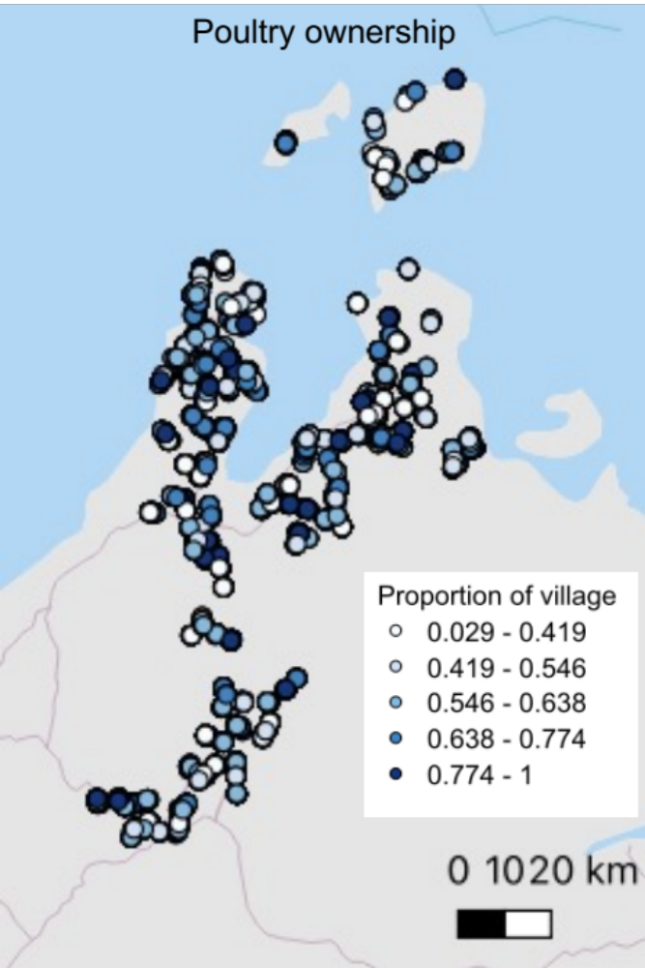

- Viral proteins, antibodies, & antiserum

Supplemental Table 7. Viral proteins for ELISAs and bead-based assays.
Protein | Strain | Catalog number; lot number(s) | Contributor | Purification method & tag
H5 HA from H5N1 | A/Duck/Laos/3295/2006 | NR-13509; 61942042 | St. Jude Children's Research Hospital (CEIRS) | “Purified by conventional chromatographic methods”
H5 HA from H5N2 | A/snow goose/Missouri/CC15-84A/2015 | NR-50651; 70003601 | St. Jude Children's Research Hospital (CEIRS) | “Purified by conventional chromatographic methods”
H3 HA from H3N2 | A/New York/55/2004 | NR-19241; 59311910 | BEI Resources | “Purified under conditions that preserve its biological activity and tertiary structure”
H3 HA from H3N2 | A/Wisconsin/67/2005 | NR-49237;  70052281 | BEI Resources | Nickel affinity chromatography & C-terminal histidine tag
H1 HA from H1N1 pdm09 | A/California/07/2009 | NR-51668;  70026141 | St. Jude Children's Research Hospital | Ion exchange and affinity chromatography
H1 HA from H1N1 pdm09 | A/New York/18/2009 | NR-51159; 70019462 | BEI Resources | Affinity chromatography & C-terminal histidine tag
H1 HA from H1N1 pdm09 | A/California/04/2009 | NR-15749;  70041927 | BEI Resources | Nickel affinity chromatography & C-terminal histidine tag

Supplemental Table 8. Antibodies and antiserum for ELISAs. PBMCs stands for peripheral blood mononuclear cells.
Reagent | Details | Catalog number; lot number | Provider | Contributor | Production information
Polyclonal goat antiserum H5 HA | A/Duck/Laos/3295/2006 (H5N1) | NR-18931; 59137401 | BEI Resources | St. Jude Children's Research Hospital (CEIRS) | Immunization of a goat with baculovirus-expressed HA
Polyclonal goat antiserum H5 HA | A/snow goose/MO/CC15-84A/2015 (H5N1) | NR-50875;  70008201 | BEI Resources | St. Jude Children's Research Hospital (CEIRS) | Immunization of a goat with bromelain-released HA
Polyclonal goat antiserum H5 HA | A/Bar Headed Goose/ Qinghai/1A/05 (H5N1) | NR-14818; 58720709 | BEI Resources | St. Jude Children's Research Hospital (CEIRS) | Immunization of a goat with baculovirus-expressed HA
Low titre human antisera H5N1 | A/Indonesia/05/2005 (H5N1) | NR-33667; 60864514 | BEI Resources | NIAID/NIH | Pooled polyclonal antisera from humans immunized intramuscularly with two doses of an inactivated monovalent subvirion investigational influenza vaccine: A/Indonesia/05/2005 PR8-IBCDC-RG2.
Medium titre human antisera H5N1 | A/Indonesia/05/2005 (H5N1) | NR-33668; 60898956 | BEI Resources | NIAID/NIH
Polyclonal goat antiserum H1 HA | A/California/04/2009 (H1N1) (antiserum, goat) | NR-15696; 58895528 | BEI Resources | St. Jude Children's Research Hospital (CEIRS) | Immunization of a goat with baculovirus-expressed HA
High titre human convalescent sera H1N1 | 2009 H1N1 (strain not provided) | NR-18964;  59164848 | BEI Resources | NIAID/NIH | Convalescent serum collected post infection. High and low indicate relative antibody titres according to the provider.
Low titre human convalescent sera H1N1 | 2009 H1N1 (strain not provided) | NR-18965; 59163837 | BEI Resources | NIAID/NIH
Polyclonal goat antiserum H3 HA | A/Hong Kong/2286/2017 (H3N2) | NR-51700; 70027287 | BEI Resources | NIAID/NIH | Immunization of a goat with bromelain-released HA
Secondary antibody, anti-goat | Donkey anti-Goat IgG (H+L) Cross-Adsorbed Secondary Antibody, HRP | A16005; 70-18-04-2419 & 77-56-060528 | Thermo Fisher Scientific | Invitrogen
Secondary antibody, anti-human IgG | Anti-Human IgG (Fc specific) −Peroxidase antibody produced in goat | A0170-1ML; 0000129825 | Merck Life Science UK Limited | Sigma-Aldrich

- Pseudovirus titration results

Supplemental Figure 6 Pseudotyped influenza titration results. Titration data collected for two the pseudoviruses used in this study A/Bar-headed goose/Qinghai/1A/05 (H5N1) HA and A/Indonesia/05/2005. N=10 preparations of pseudovirus were titrated in duplicate and pooled for use in neutralisation assays. The minimum relative light units (RLU) accepted for use in this assay was 1*10⁵. Data was analysed and graphed in GraphPad Prism 10.0.3.
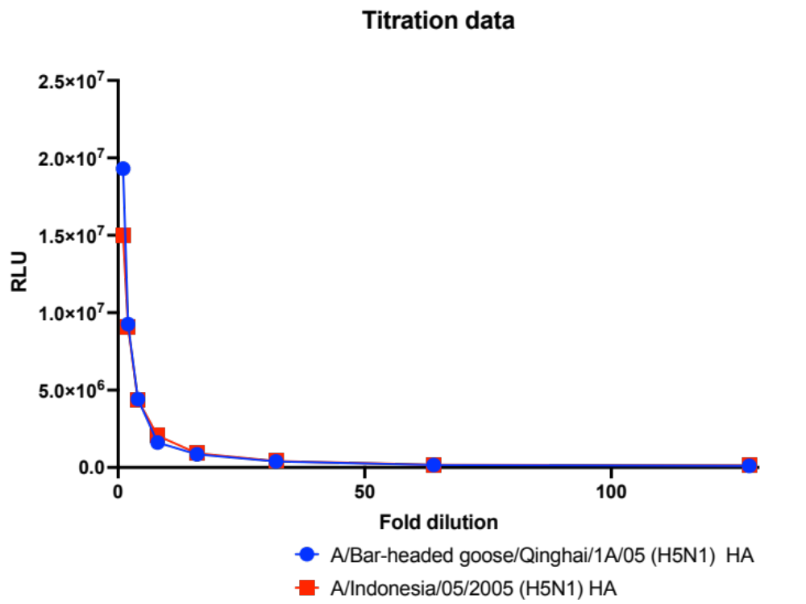

- Cross-reactivity depletion assay optimisation

Supplemental Table 9. Buffers required for cross-reactivity depletion assay.
Buffer name | Components (supplier, product code)
Block buffer | - 500mL 1X PBS  - 0.1% Bovine serum albumin (Sigma-Aldrich, B6917-100MG)  - 0.02% Tween® 20  - 0.05 % Sodium Azide (Sigma-Aldrich, 71289-50G)
Wash buffer | - 500mL 1X PBS  - 0.1% Bovine serum albumin  - 0.02 % Tween® 20
Storage buffer | - 500mL 1X PBS  - 0.05% sodium azide
Assay buffer | - 500mL 1X PBS  - 0.1% Bovine serum albumin

Supplemental Figure 7 Optimisation of bead-based cross reactivity depletion assay. a. Effect of successive bead passages on pseudotyped neutralisation. The original NT50 of medium titre human convalescent H1N1 sera (BEI Resources) was 2662 against A/Indonesia/05/2005(H5N1) HA. After five passages of fresh beads diluted to 300 beads/uL (cocktail mixture) NT50 dropped to 349.8, which was statistically significant p<0.0001 by a sum-of-squares F Test in GraphPad. After 10 passages, the reduction in NT50 was not statistically significant (NT50=251.2, p=0.1205). Against A/Bar-headed goose/Qinghai/1A/05 (H5N1) HA, the NT50 for this sample was 1421, after five passages this was 540.7 (p=0.0003), and after 10 passages this was 535.5 (p=0.9749). This suggests that five passages was the optimal choice to preserve beads, virus, and plasma. b. Effect of non-coated beads on pseudotyped neutralisation. The NT50 of low titre human antisera H5N1 (BEI Resources) was 3862 against A/Bar-headed goose/Qinghai/1A/05 (H5N1) HA, after five passages of beads which were not coated with any HA, the NT50 did not change statistically significantly (NT50=4257, p=0.8490). However, when treated with seasonal HA beads, the NT50 of this plasma sample experienced a statistically significant reduction (NT50=1441, p=0.0016).
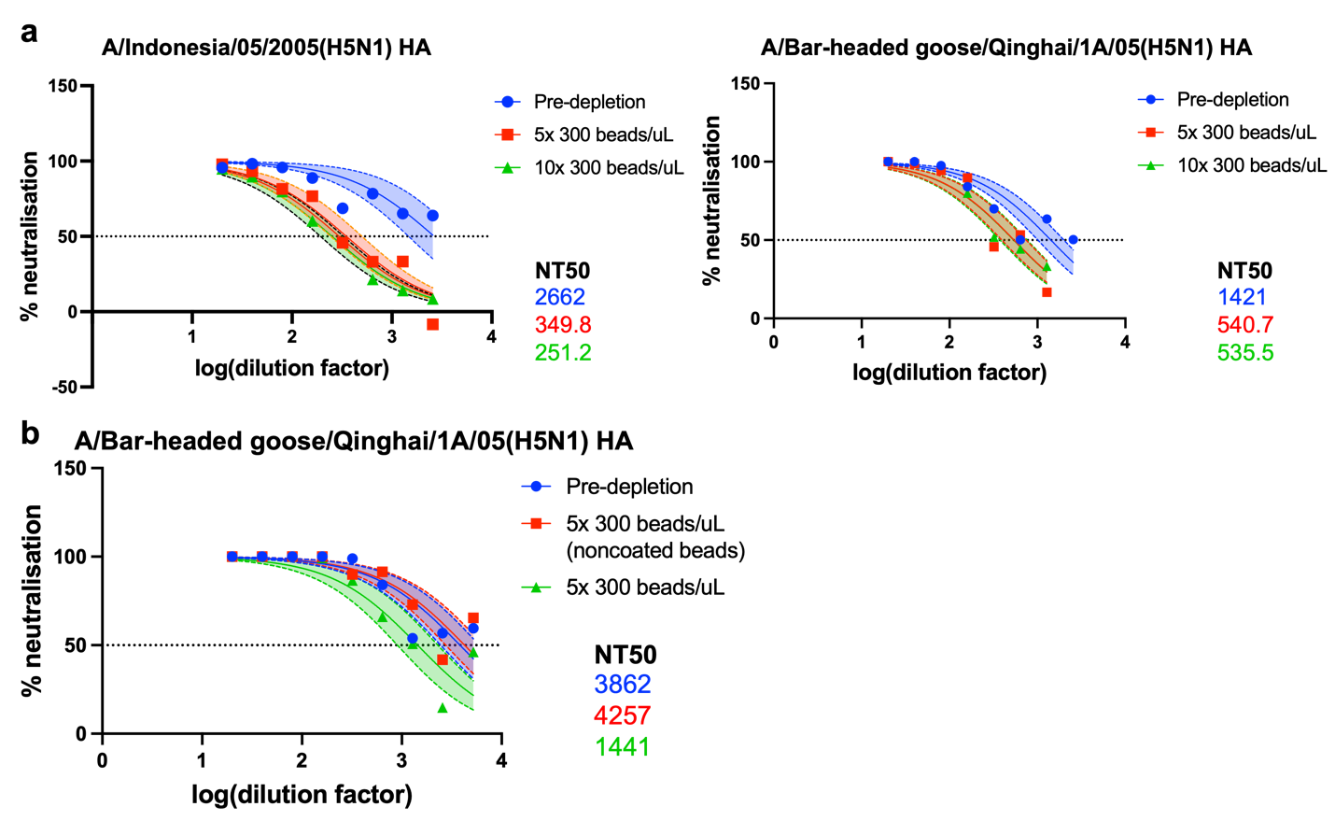

Supplementary references
1 Thompson, C. P. et al. Detection of neutralising antibodies to SARS-CoV-2 to determine population exposure in Scottish blood donors between March and May 2020. Eurosurveillance 25, doi:10.2807/1560-7917.es.2020.25.42.2000685 (2020).
2 Fornace, K. M. et al. Environmental risk factors and exposure to the zoonotic malaria parasite Plasmodium knowlesi across northern Sabah, Malaysia: a population-based cross-sectional survey. The Lancet Planetary Health 3, e179-e186, doi:10.1016/s2542-5196(19)30045-2 (2019).
3 Klim, H. et al. Quantifying human-animal contact rates in Malaysian Borneo: Influence of agricultural landscapes on contact with potential zoonotic disease reservoirs. Frontiers in Epidemiology 2, doi:10.3389/fepid.2022.1057047 (2023).
4 Venables, W. & Ripley, B. Modern Applied Statistics with S. 4th edn, (Springer, 2002).
5 sjPlot: Data Visualization for Statistics in Social Science v. 2.8.15 (2023).
6 R Core Team. R: A language and environment for statistical computing. , <https://www.R-project.org/.> (2020).
7 RStudio: Integrated Development for R. (RStudio, PBC, Boston, MA, 2020).
8 QGIS Geographic Information System v. 3.30.2 (Open Source Geospatial Foundation, 2009).

