Supplementary Information

Human Adipose-Derived Stem Cells Genetically Programmed to Induce Necroptosis for Cancer Immunotherapy

Soyeon bak^{a,b,†}, Kyoung Sub Kim^{a,b, †}, Kun Na^{a,b,*}

ªDepartment of Biomedical-Chemical Engineering, The Catholic University of Korea, 43 Jibong-ro, Wonmi-gu, Bucheon-si, Gyeonggi-do, 14662, Republic of Korea
^{b}Department of Biotechnology, The Catholic University of Korea, 43 Jibong-ro, Wonmi-gu, Bucheon-si, Gyeonggi-do, 14662, Republic of Korea
†These authors contributed equally

*Correspondence to Prof Kun Na,
Department of Biomedical-Chemical Engineering, The Catholic University of Korea, Bucheon-si, Gyeonggi-do, Republic of Korea;
E-mail: kna6997@catholic.ac.kr

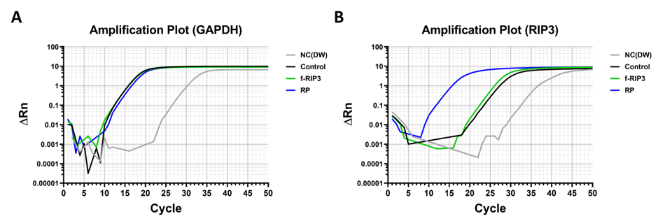
Figure S1 Amplification plot of RT-PCR. (A) GAPDH and (B) RIP3 primer in RT-PCR.

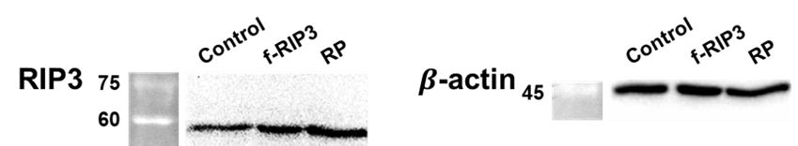
Figure S2 Western blot analysis after treated RP in ADSCs. Samples were run at equal protein concentrations.

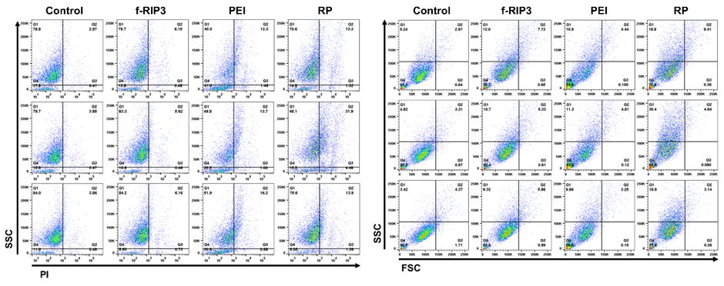
Figure S3 PI staining analysis of ADSCs treated with SF medium, f-RIP3, PEI and RP for 4 h and cultured for 4 days.

