Supplementary data
Figure S1: [a, b, c] Absorbance spectra for the synthesized CDs samples from alginate. [d] photographic images of the synthesized samples.
[a] | 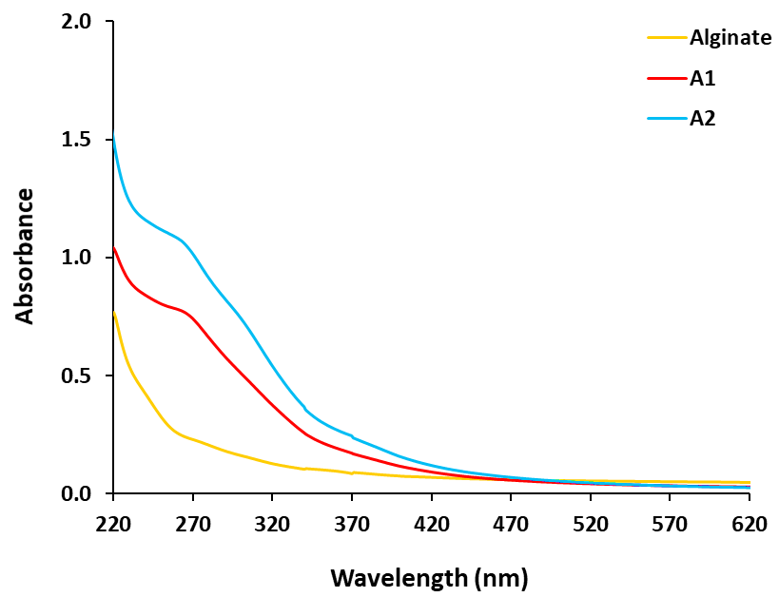
[b] | 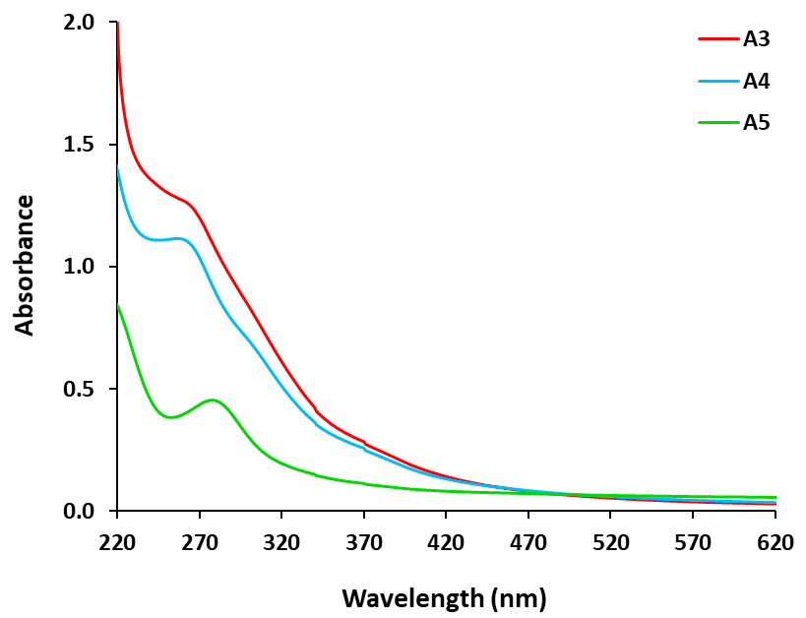
[c] | 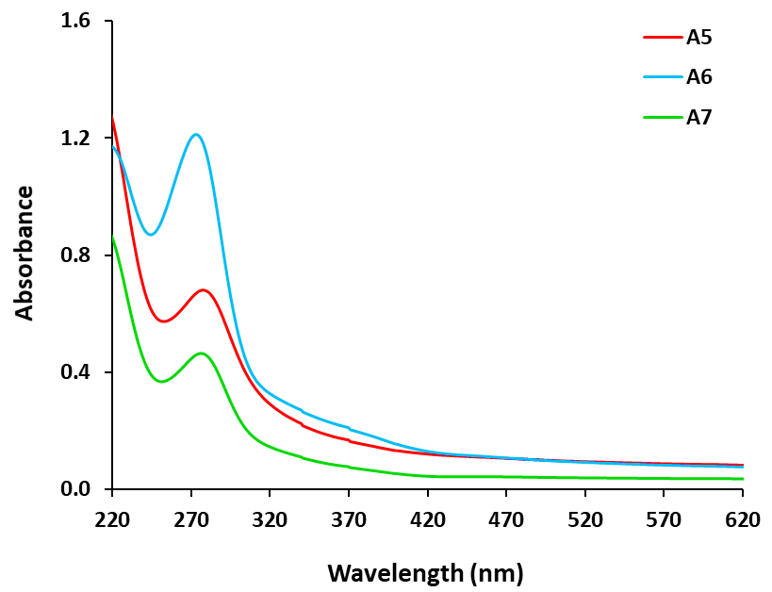
[d] | 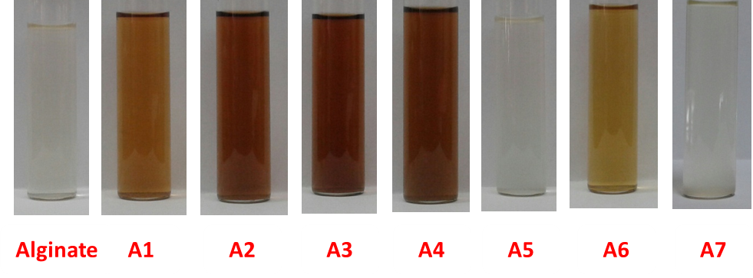

Figure S2: Fluorescence properties for the synthesized CDs samples from alginate; [a, b] emission spectra (excitation wavelength = 380 nm) and [c] photographic images under UV-lamp (365 nm).
[a] | 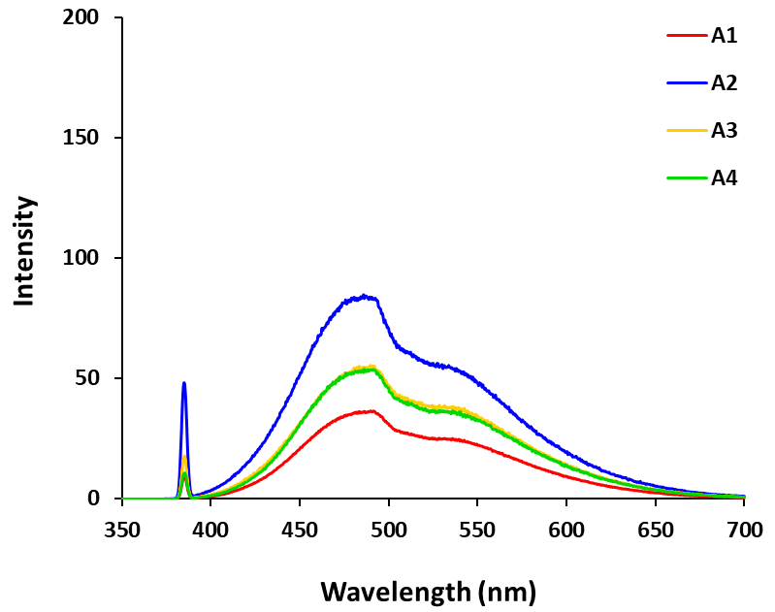
[b] | 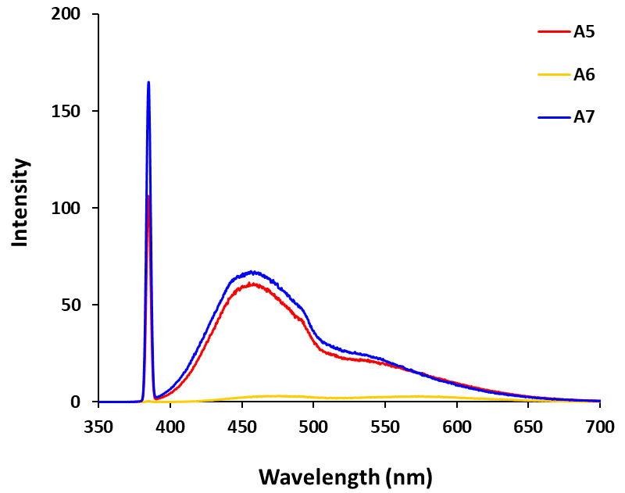
[c] | 