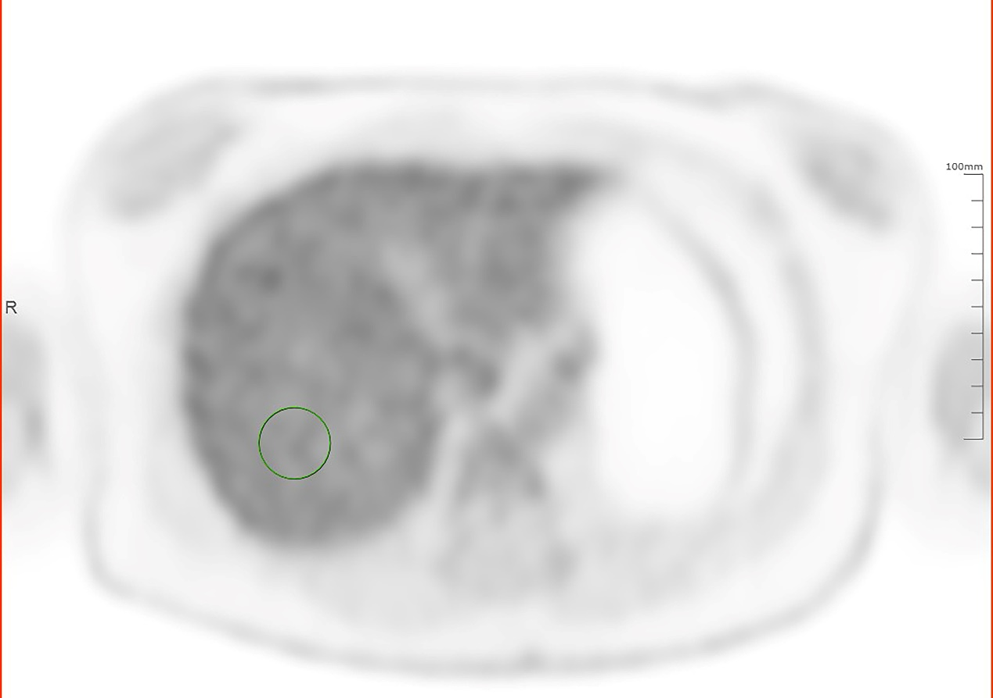
SI. Fig. 1 Axial slice with ROI. An axial slice of one of the patient scans showing the ROI used to derive the SNR in the liver (green contour).

