Electronic Supplementary Material
Fig.1 Mass spectrometry of compound 2 (A), [¹⁹F]3 (B) and [¹⁹F]4 (C); ¹H NMR of compound 2 (D) and [¹⁹F]3 (E).
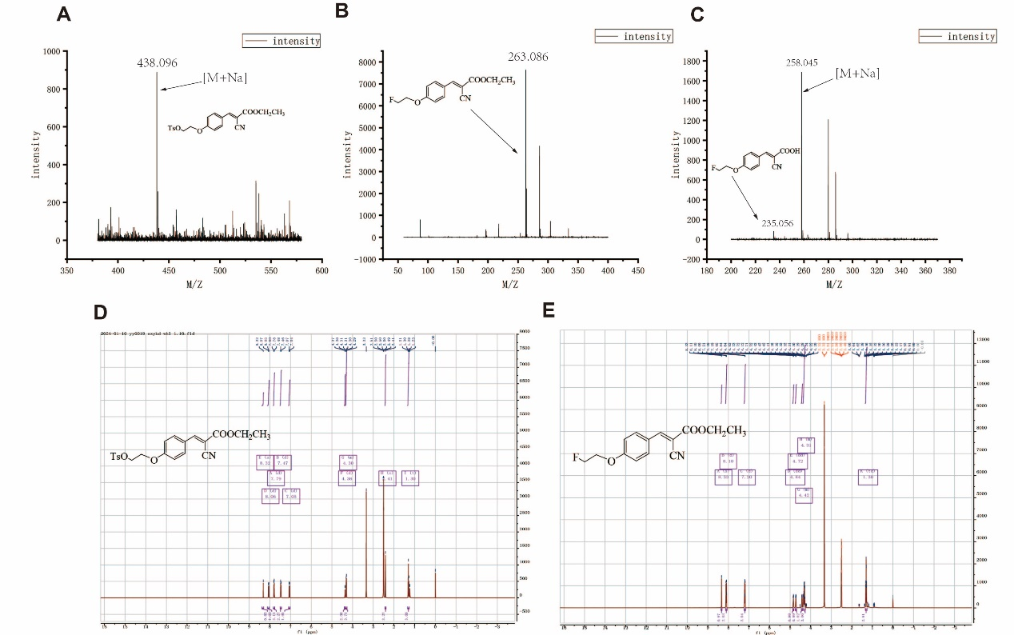
Fig.2 (A) The radio-HPLC chromatogram of [¹⁸F]4, the mixture solution of [¹⁸F]4 and [¹⁸F]3 after being reacted at 100°C for 10 min and at 110°C for 15 min; (B) the radio-TLC chromatogram of [¹⁸F]4. 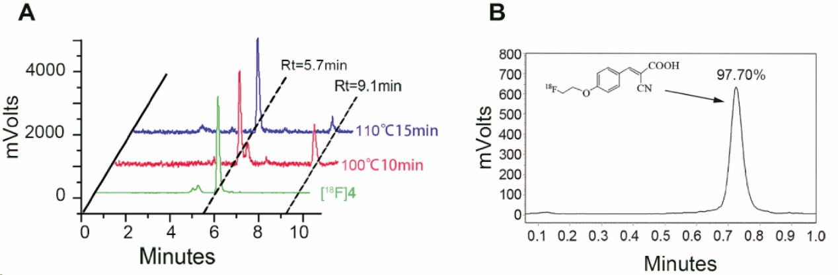
Fig.3 (A) The radio-HPLC chromatograms of [¹⁸F]4 after incubations of 60 min and 120 min in PBS and FBS, and the radio-HPLC chromatogram of urine from SD rats after intravenous injection of [¹⁸F]4 for 60 min; (B) the radio-TLC chromatogram of blood from SD rats after intravenous injection of [¹⁸F]4 for 60 min.
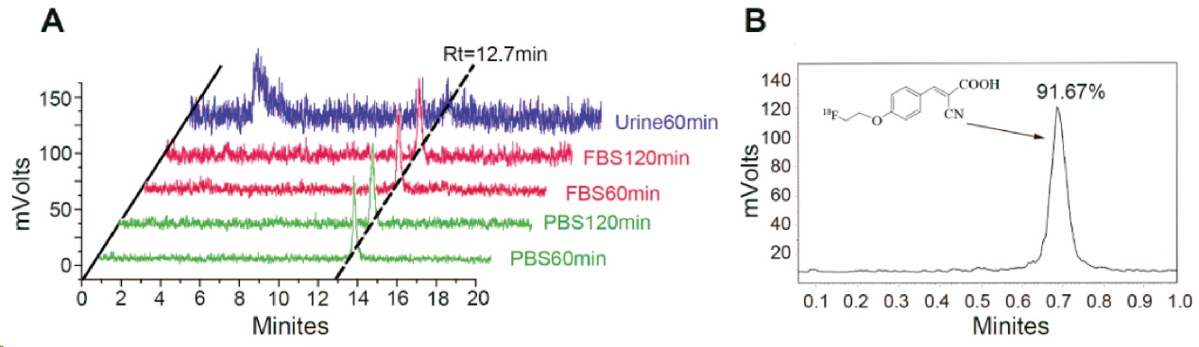
Journal: Molecular Imaging and Biology
Names of the authors: Dongmei Shi^{a, #}, Ling Liu^{a, #}, Kaixin Qinª, Yuzhou Zhengª, Wenhao Huª, Jiarui Youª, Ping Wu^{a, b, c}, Xinzhong Hao^{a, b, c}, Haiyan Liu^{a, b, c}, Gao Jie^{d}, Jianguo Li^{d}, Zhifang Wu^{a, b, c,} *, Sijin Li^{a, b, c,} *, Hongliang Wang^{a, b, c,} *
Affiliation(s) and address (es) of the author(s):
ª Department of Nuclear Medicine, First Hospital of Shanxi Medical University, Taiyuan, Shanxi, 030001, People’s Republic of China.
^{b} Shanxi Key Laboratory of Molecular Imaging, Shanxi Medical University, Taiyuan, Shanxi, 030001, People’s Republic of China.
^{c} Collaborative Innovation Center for Molecular Imaging of Precision Medicine Shanxi Medical University, Taiyuan, Shanxi, 030001, People’s Republic of China.
^{d} National Atomic Energy Agency nuclear technology (Nonclinical evaluation of radiopharmaceuticals) research and Development Center, China Institute for Radiation Protection, Taiyuan, Shanxi, 030006, People’s Republic of China.
Corresponding authors:
Dr. Hongliang Wang Tel: +86-351-4639275, Fax: +86-351-4639276, E-mail:hongliang0812@163.com
Prof. Zhifang Wu Tel: +86-351-4639275, Fax: +86-351-4639276, E-mail:wuzhifang01@163.com
Prof. Sijin Li Tel: +86-351-4639275, Fax: +86-351-4639276, E-mail:lisjnm123@163.com

