Figure S1. Climate diagram for Awash Fentale District (a) and climate diagram for Amibara District (b) (Source: Shiferaw 2020a).
Figure S1. Elbow method for determining optimal number of plant community types or clusters in non- invaded and P. juliflora invaded areas.
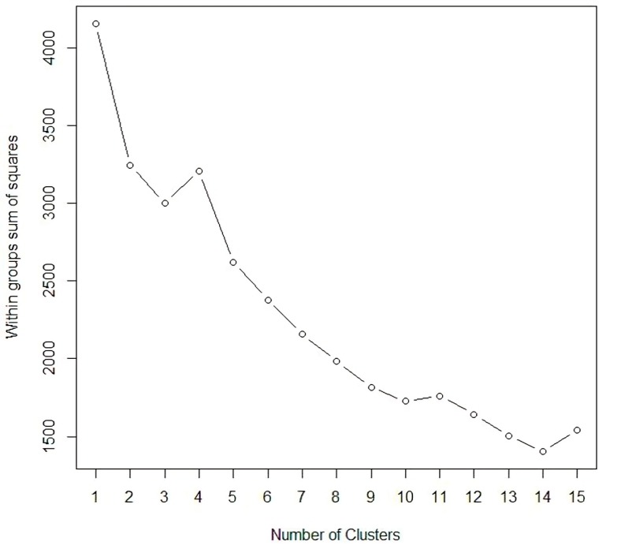
Figure S2. Elbow method for determining optimal number of plant community types or clusters in non- invaded and P. juliflora invaded areas.
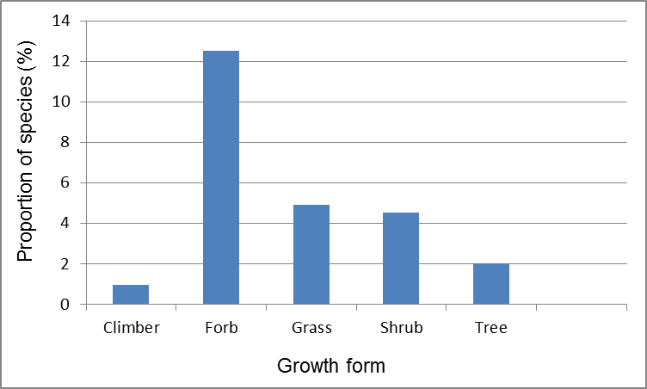
Figure S3. The proportion of growth forms in Amibara and Awash Fentale districts of P. juliflora invaded and non-invaded areas.

