Supporting Information

Effects of ceramic waste powder addition on overflow sewage treatment and its mechanism of nitrogen removal
Zian Zhou ª, Xinyuan Zheng ^{b}, Yinghao Hua ^{b}, Meixin Guo ª, Xiaoting Sun ª, Yan Huang ª, Liming Dong ^{a,}*, Suping Yu ª

ª Beijing Technology and Business University, Key Laboratory of Cleaner Production and Integrated Resource Utilization of China National Light Industry, Beijing 100048, China
^{b} WonderFlow Environmental Science & Technology (Beijing) Co, Beijing 100000, China
*Corresponding author: Liming Dong
Email: donglm@btbu.edu.cn

Fig. S1 XRD of ceramic
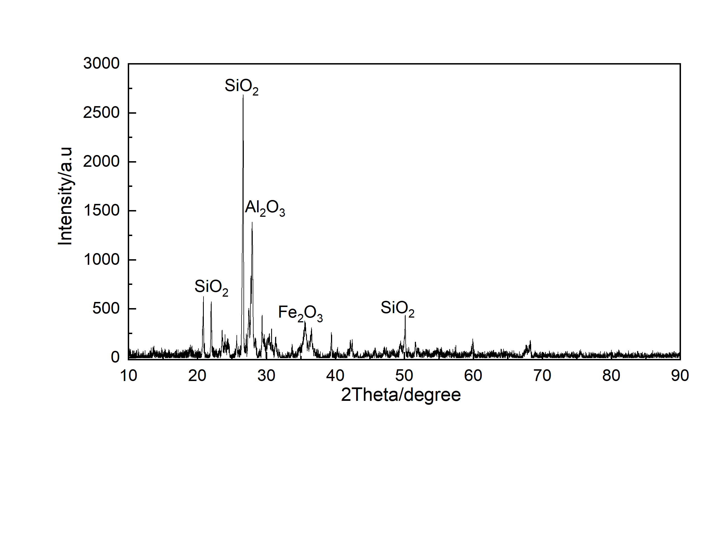

Fig. S2 Colour and SV₅ for 3 groups of sludge, from left to right, CAS, HPB(＜75μm），HPB(75-150μm）.
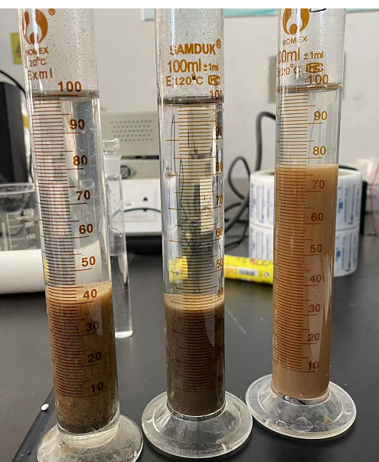

Fig. S3 Microscopic results of sludge in 3 reactors after long-term
CAS
HPB(＜75μm)
HPB(75-150μm)

