SUPPLEMENTARY MATERIALS
Mass spectrometry-based metabolomics study of nicotine exposure in THP-1 monocytes
Silvio Uhlig^{1,2}, Bergitte Pearl Olderbø¹, Jan Tore Samuelsen¹, Solveig Uvsløkk¹, Lada Ivanova², Camille Vanderstraeten³, Lene Aiko Grutle¹, Oscar Daniel Rangel-Huerta²
¹ Nordic Institute of Dental Materials, Sognsveien 70A, 0855 Oslo, Norway
² Toxinology Research Group, Norwegian Veterinary Institute, P.O. Box 64, 1431 Ås, Norway
³ Department of Bioanalysis, Faculty of Pharmaceutical Sciences, Ghent University, Ottergemsesteenweg 460, 9000 Gent, Belgium

 | Page
Fig. S1: Chemical class assignment of THP-1 metabolites from ClassyFire | S3
Fig. S2: PCA scores plot for the whole dataset including blanks and quality control samples | S4
Fig. S3: Example of a nicotine molecular network from Compound Discoverer software | S5
Fig. S4: Extracted ion LC-HRMS chromatograms of nicotine-related compounds in THP-1 cell extract following cation-exchange SPE | S6
Fig. S5: Mirror plots from Compound Discoverer software showing HRMS/MS spectra of methylthioadenosine, L-glutamate and cytosine | S7
Fig. S6: HRMS/MS spectra from data-dependent analysis of uric acid | S8
Fig. S7: Box and whisker plot for cytosine; all data | S9
Fig. S8: Box and whisker plot for uric acid; all data | S10
Fig. S9: Box and whisker plot for methylthioadenosine; all data | S11
Fig. S10: Box and whisker plot for L-glutamate; all data | S12
Table S1a–S1e: List of reference metabolites that were included in an in-house library | S13–S17
Table S2: Complete list of differential metabolites in THP-1 cell extracts (1 h exposure) for which no reference standards were available | S18
Table S3: Complete list of differential metabolites in THP-1 medium extracts (1 h exposure) for which no reference standards were available | S19
Table S4: Complete list of differential metabolites in THP-1 medium extracts (4 h exposure) for which no reference standards were available | S20
Table S5a–S5b: P-values from paired t-tests of amino acid levels, selected amino acid ratios, and sums of amino acids | S21–S22
Table S6a–S6b: Explanations for the diagnostic relevance of changes in amino acid levels, amino acid and polyamine ratios, and sums of amino acids and polyamines | S23–S24
Table of Contents

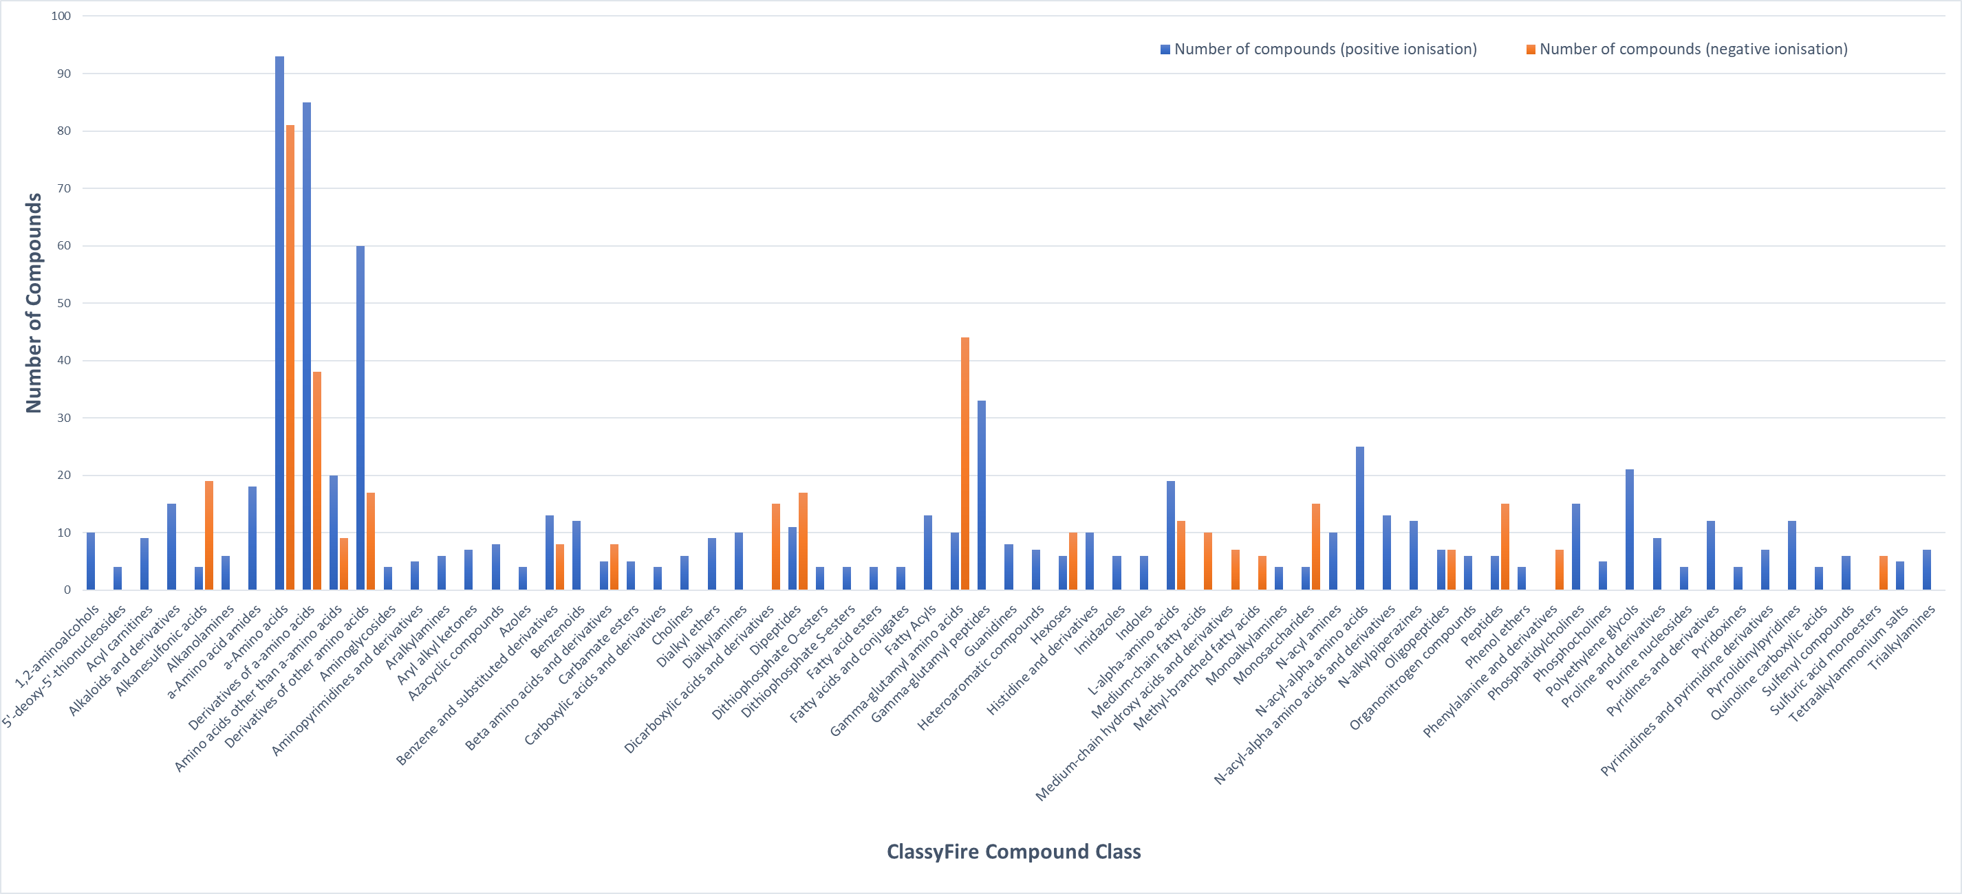
Figure S1. Automated chemical class assignment of the 532 compounds that were present in at least 80% of the samples in one group using ClassyFire.

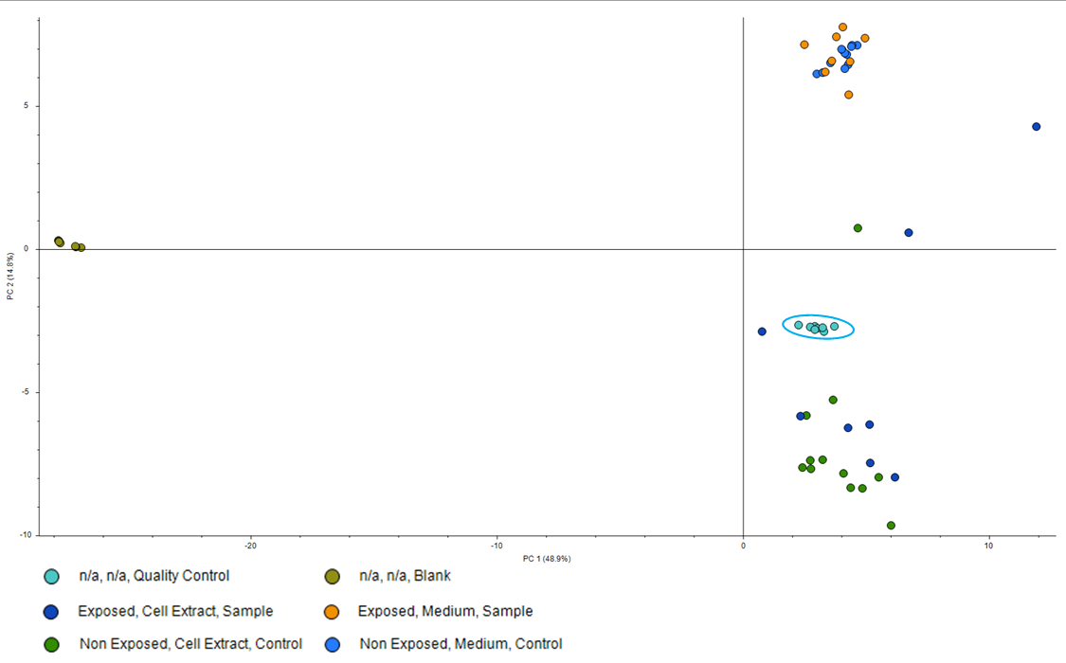
Figure S2. Scores plot from principal component analysis of the whole dataset including solvent control and quality control samples. The quality control samples are emphasized with an ellipse, and their overlapping scores show the absence of instrumental drift.

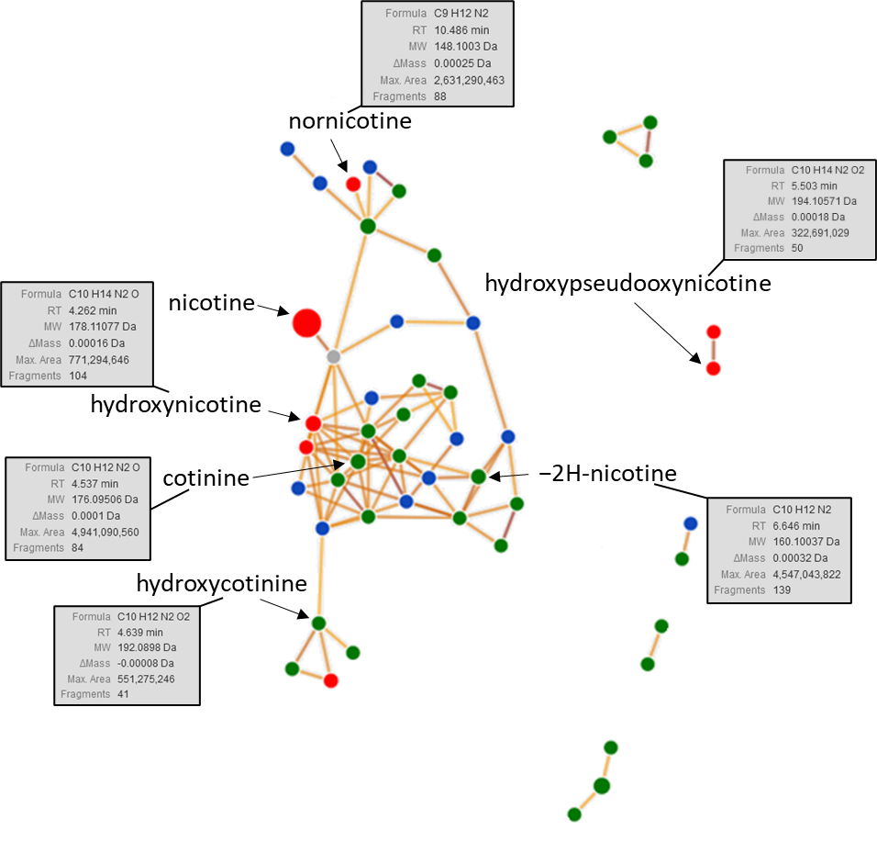
Figure S3. Example of a nicotine molecular network from Compound Discoverer software based on the spectral similarity of compounds in THP-1 cell extracts and culture medium used to annotate putative nicotine biotransformation products. Threshold settings were: score, 50; coverage, 70 and matched fragments, 30. Only compounds that were identical to reference standards or with MS/MS spectra that supported nicotine-related metabolites are labelled.

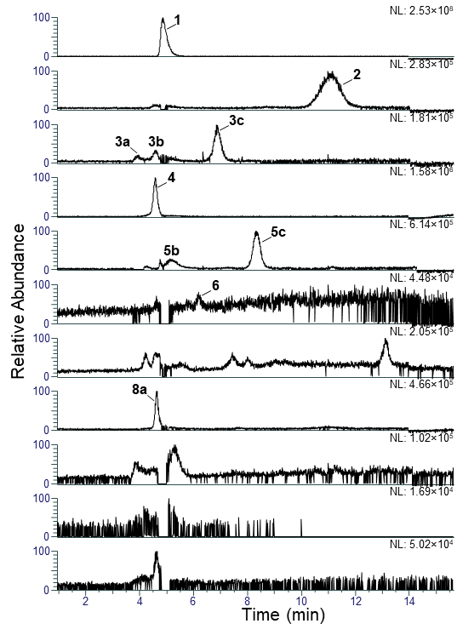
Figure S4. Extracted ion LC-HRMS chromatograms (± 5 ppm) of the protonated molecules for nicotine and nicotine metabolites in THP-1 cell extracts prepared by sonication-assisted cell lysis and SPE using Oasis MCX mixed-mode cation exchange cartridges. Individual m/z traces correspond to those shown in Figure 2 in the main manuscript.

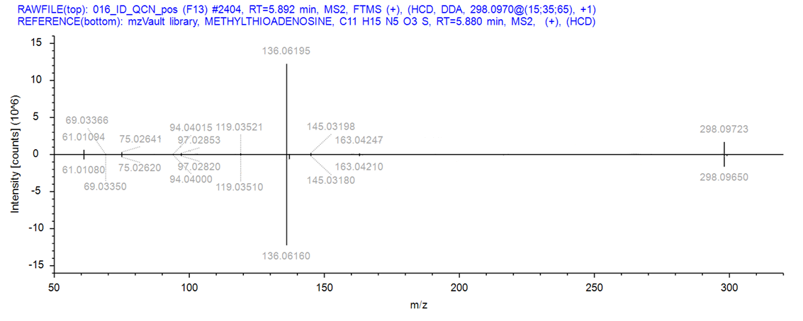
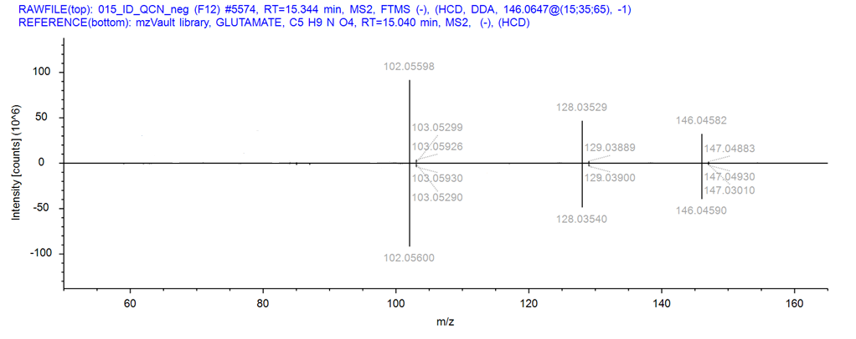
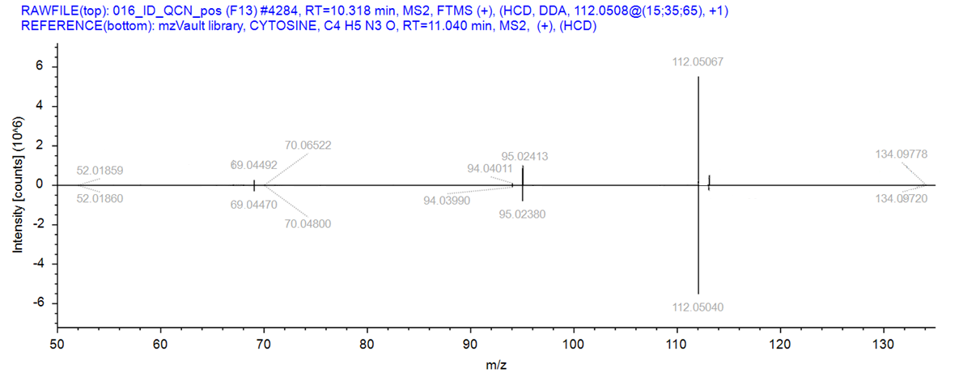
Figure S5. Mirror plots from Compound Discoverer software showing HRMS/MS spectra of discriminating and identified compounds (methylthioadenosine, top; L-glutamate, middle; cytosine, bottom) in a pooled THP-1 quality control sample. Reference spectra are shown in the lower trace.

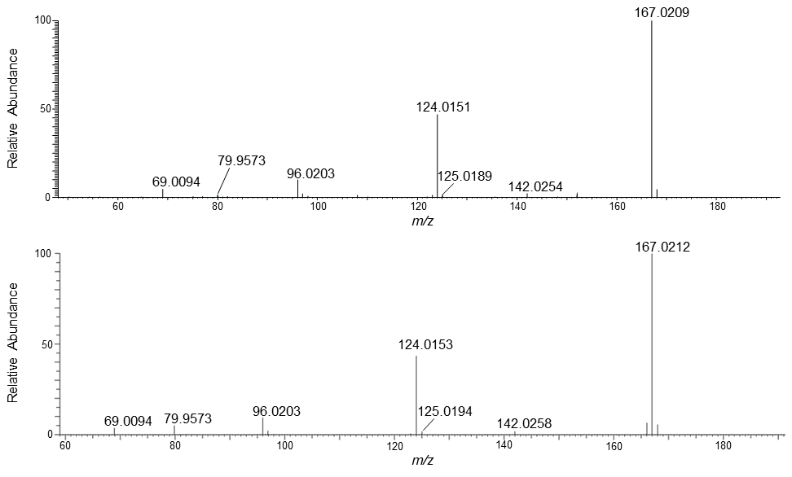
Figure S6. HRMS/MS spectra from data-dependent analysis of uric acid ([M−H]⁻) in a pooled THP-1 quality control sample (above) and a reference standard (below).

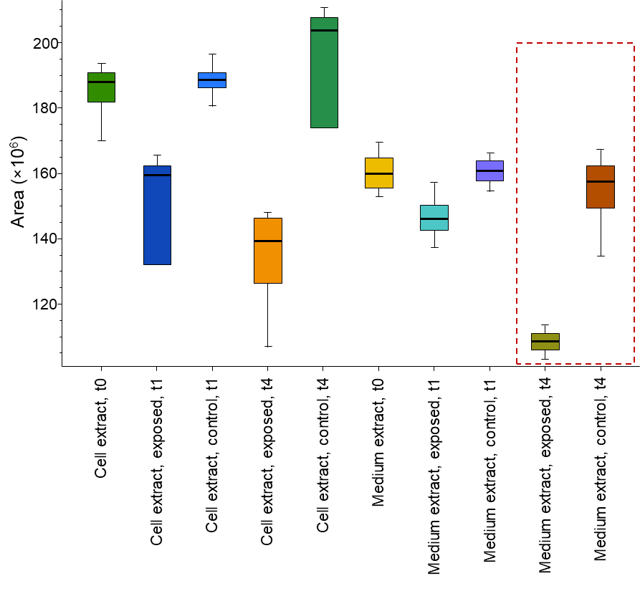
Figure S7. Box and whisker plot for peak areas of the protonated molecules of cytosine from the entire data set. The 4-h-exposure (medium extracts) is emphasized as the metabolite differentiated the medium samples from exposed and unexposed cells at this time point both by multivariate and univariate statistics.

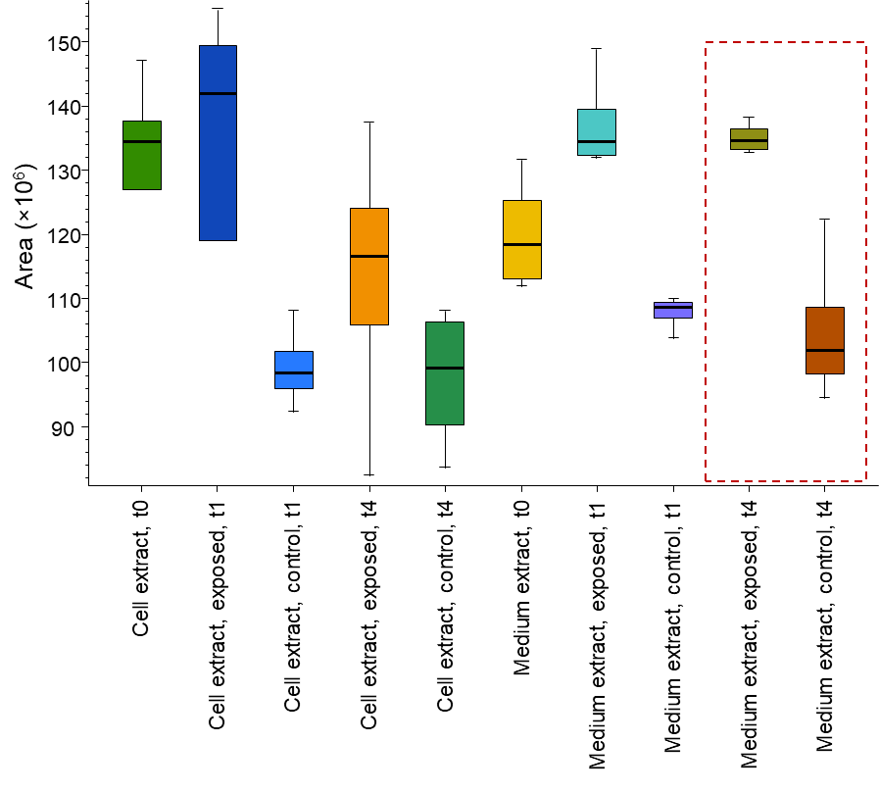
Figure S8. Box and whisker plot for peak areas of the deprotonated molecules of uric acid from the entire data set. The 4-h-exposure (medium extracts) is emphasized as the metabolite differentiated the medium samples from exposed and unexposed cells at this time point both by multivariate and univariate statistics.

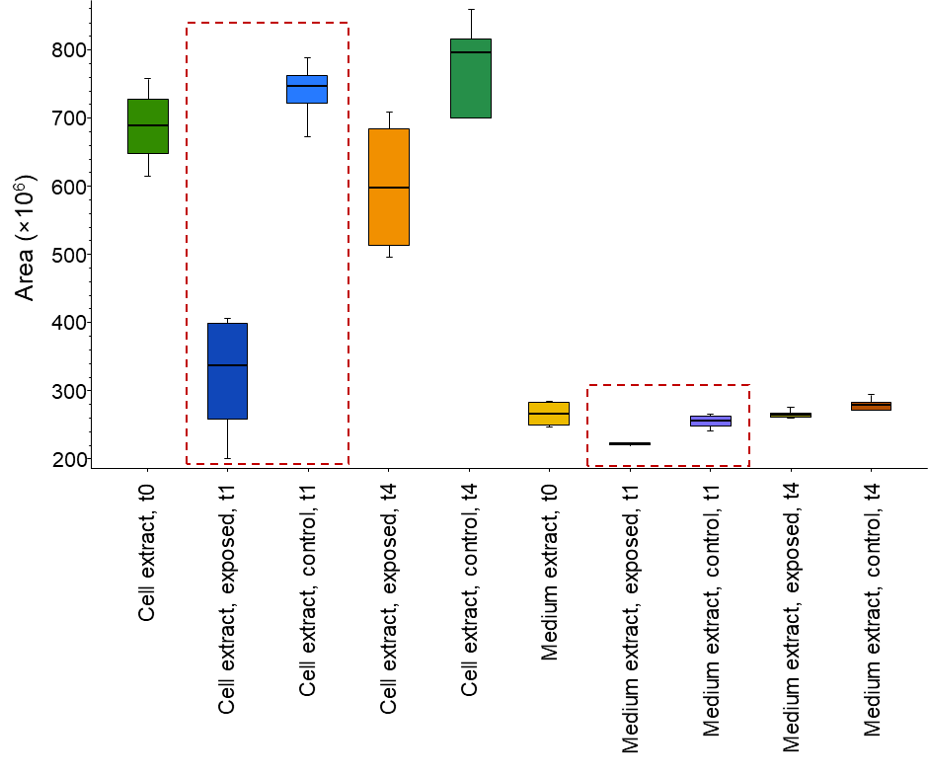Figure S9. Box and whisker plot for peak areas of the protonated molecules of methylthioadenosine from the entire data set. The 1-h-exposure is emphasized as the metabolite differentiated exposed and unexposed cells at this time point in cell extracts and medium both by multivariate and univariate statistics.

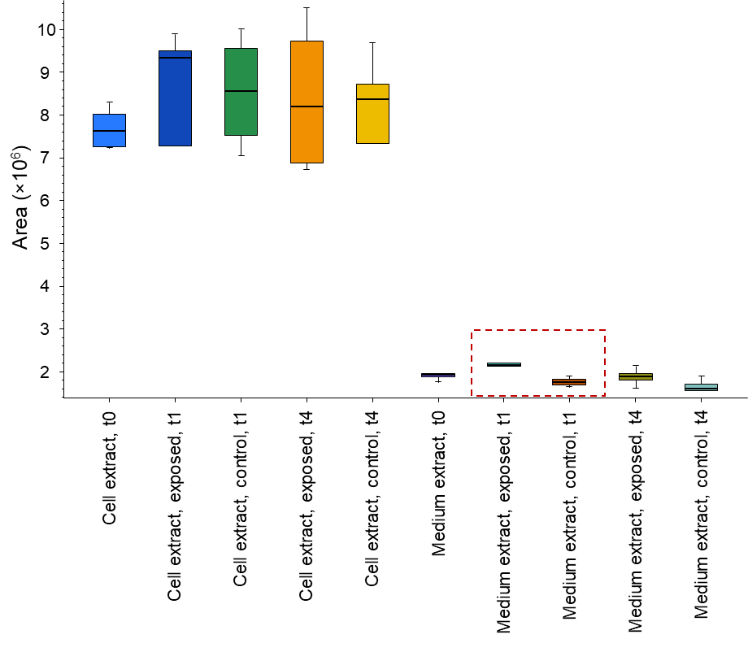
Figure S10. Box and whisker plot for peak areas of the protonated molecules of L-glutamate from the entire data set. The 1-h-exposure (medium extracts) is emphasized as the metabolite differentiated the medium samples from exposed and unexposed cells at this time point both by multivariate and univariate statistics.

Metabolite name | Formula |  | Metabolite name | Formula
BETA-NICOTINAMIDE ADENINE DINUCLEOTIDE | C21H27N7O14P2 |  | URACIL | C4H4N2O2
TRANS-ACONITATE | C6H6O6 |  | ASPARTATE | C4H7NO4
URATE | C5H4N4O3 |  | DEOXYCYTIDINE MONOPHOSPHATE | C9H14N3O7P
GLUTAMINE | C5H10N2O3 |  | HYPOXANTHINE | C5H4N4O
HYPOTAURINE | C2H7NO2S |  | CREATINE | C4H9N3O2
N-METYL-ALANINE | C4H9NO2 |  | L-DOPA | C9H11NO4
CITRATE | C6H8O7 |  | ISOCITRATE | C6H8O7
THREONINE | C4H9NO3 |  | FOLATE | C19H19N7O6
PURINE | C5H4N4 |  | NICOTINAMIDE MONONUCLEOTIDE | C11H15N2O8P
N-ACETYLNEURAMINATE | C11H19NO9 |  | 3-METHYL-L-HISTIDINE | C7H11N3O2
N-ACETYLMANNOSAMINE | C8H15NO6 |  | TYROSINE | C9H11NO3
CYTIDINE | C9H13N3O5 |  | GLYCEROL | C3H8O3
CYTOSINE | C4H5N3O |  | ASPARAGINE | C4H8N2O3
ISOLEUCINE | C6H13NO2 |  | VALINE | C5H11NO2
SERINE | C3H7NO3 |  | GUANINE | C5H5N5O
CITRULLINE | C6H13N3O3 |  | HOMOSERINE | C4H9NO3
TAURINE | C2H7NO3S |  | PYRIDOXINE | C8H11NO3
N-ACETYLTRYPTOPHAN | C13H14N2O3 |  | DEOXYADENOSINE MONOPHOSPHATE | C10H14N5O6P
NICOTINATE | C6H5NO2 |  | DIAMINOPIMELATE | C7H14N2O4
INOSINE | C10H12N4O5 |  | THEOPHYLLINE | C7H8N4O2
GAMMA-AMINOBUTYRATE | C4H9NO2 |  | LEUCINE | C6H13NO2
GLUTAMATE | C5H9NO4 |  | TREHALOSE | C12H22O11
MALONATE | C3H4O4 |  | AMINOADIPATE | C6H11NO4
GUANIDINOACETATE | C3H7N3O2 |  | DEOXYCYTIDINE | C9H13N3O4
P-HYDROXYPHENYLACETATE | C8H8O3 |  | NORADRENALINE | C8H11NO3
N-ACETYLGLUCOSAMINE | C8H15NO6 |  | GLUCOSAMINE 6-PHOSPHATE | C6H14NO8P
GLYCOLATE | C2H4O3 |  | TARTRATE | C4H6O6
SARCOSINE | C3H7NO2 |  | 3-DEHYDROSHIKIMATE | C7H8O5
CREATININE | C4H7N3O |  | CAFFEINE | C8H10N4O2
QUINATE | C7H12O6 |  | HOMOCYSTEINE | C4H9NO2S
DIHYDROOROTATE | C5H6N2O4 |  | BETAINE | C5H11NO2
GLYCINE | C2H5NO2 |  | THREITOL | C4H10O4
XANTHINE | C5H4N4O2 |  | GLUCOSAMINE | C6H13NO5
CYSTINE | C6H12N2O4S2 |  | TRYPTOPHAN | C11H12N2O2
METHIONINE | C5H11NO2S |  | 3-SULFINOALANINE | C3H7NO4S
2-PHOSPHOGLYCERATE | C3H7O7P |  | O-SUCCINYL-HOMOSERINE | C8H13NO6
METHYLTHIOADENOSINE | C11H15N5O3S |  | ALLANTOIN | C4H6N4O3
THYMIDINE | C10H14N2O5 |  | GLYCERALDEHYDE | C3H6O3
CYS-GLY | C5H10N2O3S |  | D-GLUCURONOLACTONE | C6H8O6
AMINOISOBUTANOATE | C4H9NO2 |  | (2-AMINOETHYL)PHOSPHONATE | C2H8NO3P
GULOSE | C6H12O6 |  | 2,5-DIHYDROBENZOIC ACID | C7H6O4
CARNOSINE | C9H14N4O3 |  | PARAXANTHINE | C7H8N4O2
SHIKIMATE | C7H10O5 |  | DEOXYGUANOSINE-MONOPHOSPHATE | C10H14N5O7P
DIETHANOLAMINE | C4H11NO2 |  | GLUCURONATE | C6H10O7
URIDINE MONOPHOSPHATE | C9H13N2O9P |  | 2-DEOXY-D-GLUCOSE | C6H12O5
PROLINE | C5H9NO2 |  | 1-METHYL-L-HISTIDINE | C7H11N3O2
THYMINE | C5H6N2O2 |  | GALACTITOL | C6H14O6
SUCCINATE SEMIALDEHYDE | C4H6O3 |  | OXOPROLINE | C5H7NO3
URIDINE | C9H12N2O6 |  | 4-PYRIDOXATE | C8H9NO4
SUCCINATE | C4H6O4 |  | QUINOLINATE | C7H5NO4
GUANOSINE | C10H13N5O5 |  | 1-METHYLADENOSINE | C11H15N5O4
DIHYDROURACIL | C4H6N2O2 |  | DOPAMINE | C8H11NO2
MALATE | C4H6O5 |  | ADENOSINE-MONOPHOSPHATE | C10H14N5O7P
PHENYLALANINE | C9H11NO2 |  | LYSINE | C6H14N2O2
Table S1a. List of reference metabolites that were included in an in-house library.

Metabolite name | Formula |  | Metabolite name | Formula
DEOXYURIDINE | C9H12N2O5 |  | PHOSPHOENOLPYRUVATE | C3H5O6P
GLUCONATE | C6H12O7 |  | MANNOSE 6-PHOSPHATE | C6H13O9P
UROCANATE | C6H6N2O2 |  | 3-PHOSPHOGLYCERATE | C3H7O7P
KYNURENINE | C10H12N2O3 |  | GLYCERATE | C3H6O4
PYROGLUTAMATE | C5H7NO3 |  | CYTIDINE 2',3'-CYCLIC PHOSPHATE | C9H12N3O7P
4-ACETAMIDOBUTANOATE | C6H11NO3 |  | N,N,N-TRIMETHYLLYSINE | C9H20N2O2
TRANS-1,2-CYCLOHEXANEDIOL | C6H12O2 |  | RIBOFLAVIN | C17H20N4O6
CITICOLINE | C14H27N4O11P2 |  | URIDINE DIPHOSPHATE GLUCOSE | C15H24N2O17P2
ARGININE | C6H14N4O2 |  | METHYL GALACTOSIDE | C7H14O6
PHOSPHOSERINE | C3H8NO6P |  | PYRIDOXAL-PHOSPHATE | C8H10NO6P
1-AMINOCYCLOPROPANECARBOXYLATE | C4H7NO2 |  | DIHYDROXYACETONE PHOSPHATE | C3H7O6P
GLUTARYLCARNITINE | C12H21NO6 |  | L-CARNITINE | C7H15NO3
CYSTATHIONINE | C7H14N2O4S |  | P-OCTOPAMINE | C8H11NO2
NORVALINE | C5H11NO2 |  | N-ALPHA-ACETYLLYSINE | C8H16N2O3
3-HYDROXYMETHYLGLUTARATE | C6H10O5 |  | URIDINE DIPHOSPHATEGALACTOSE | C15H24N2O17P2
PHOSPHONOACETATE | C2H5O5P |  | O-PHOSPHOETHANOLAMINE | C2H8NO4P
TRANS-4-HYDROXY-L-PROLINE | C5H9NO3 |  | CYTIDINE MONOPHOSPHATE | C9H14N3O8P
N-METHYLASPARTATE | C5H9NO4 |  | GUANOSINE DIPHOSPHATE MANNOSE | C16H25N5O16P2
GALACTARATE | C6H10O8 |  | ADP-GLUCOSE | C16H25N5O15P2
ALPHA-HYDROXYISOBUTYRATE | C4H8O3 |  | FRUCTOSE 6-PHOSPHATE | C6H13O9P
FUCOSE | C6H12O5 |  | ADENOSINE 3',5'-DIPHOSPHATE | C10H15N5O10P2
HOMOCYSTINE | C8H16N2O4S2 |  | 3-NITRO-L-TYROSINE | C9H10N2O5
N-METHYLGLUTAMATE | C6H11NO4 |  | OROTATE | C5H4N2O4
D-ORNITHINE | C5H12N2O2 |  | LAUROYLCARNITINE | C19H38NO4
XANTHOSINE | C10H12N4O6 |  | 1-METHYLNICOTINAMIDE | C7H9N2O
THYROTROPIN RELEASING HORMONE | C16H22N6O4 |  | PYRIDOXAMINE | C8H12N2O2
CYSTEATE | C3H7NO5S |  | 5-AMINOLEVULINATE | C5H9NO3
GLYCOLALDEHYDE DIMER | C4H8O4 |  | DEOXYURIDINE-MONOPHOSPHATE | C9H13N2O8P
N-ACETYLASPARAGINE | C6H10N2O4 |  | 5'-DEOXYADENOSINE | C10H13N5O3
PIPECOLATE | C6H11NO2 |  | XANTHOSINE-MONOPHOSPHATE | C10H13N4O9P
GLUCOSE 6-PHOSPHATE | C6H13O9P |  | DEOXYGUANOSINE | C10H13N5O4
NADP | C21H28N7O17P3 |  | O-PHOSPHOSERINE | C3H8NO6P
6-PHOSPHOGLUCONATE | C6H13O10P |  | S-ADENOSYLHOMOCYSTEINE | C14H20N6O5S
ISOPENTENYL PYROPHOSPHATE | C5H12O7P2 |  | N-ACETYLMETHIONINE | C7H13NO3S
DTDP-D-GLUCOSE | C16H26N2O16P2 |  | CARBAMOYL PHOSPHATE | CH4NO5P
N-ACETYLGLYCINE | C4H7NO3 |  | AICAR | C9H15N4O8P
2-KETO-3-DEOXY-D-GLUCONIC ACID | C6H10O6 |  | URIDINE DIPHOSPHATE-N-ACETYLGALACTOSAMINE | C17H27N3O17P2
D-SEDOHEPTULOSE | C7H14O7 |  | CYCLIC GMP | C10H12N5O7P
N-ACETYLASPARTATE | C6H9NO5 |  | HOMOCYSTEINE THIOLACTONE | C4H7NOS
PALMITOYLCARNITINE | C23H46NO4 |  | ADENINE | C5H5N5
NORSPERMIDINE | C6H17N3 |  | HISTAMINE | C5H9N3
NICOTINAMIDE HYPOXANTHINE DINUCLEOTIDE | C21H26N6O15P2 |  | INDOXYL SULFATE | C8H7NO4S
S-ADENOSYLMETHIONINE | C15H23N6O5S |  | ETHYL 3-UREIDOPROPIONATE | C6H12N2O3
ERYTHRITOL | C4H10O4 |  | NORMETANEPHRINE | C9H13NO3
GLUCOSAMINATE | C6H13NO6 |  | URIDINE DIPHOSPHATE-N-ACETYLGLUCOSAMINE | C17H27N3O17P2
PUTRESCINE | C4H12N2 |  | GLUTATHIONE REDUCED | C10H17N3O6S
THIAMINE | C12H17N4OS |  | N,N-DIMETHYLARGININE | C8H18N4O2
DEOXYCARNITINE | C7H15NO2 |  | CYTIDINE DIPHOSPHATE | C9H15N3O11P2
ADENOSINE 2',3'-CYCLIC PHOSPHATE | C10H12N5O6P |  | DEOXYRIBOSE | C5H10O4
MEVALOLACTONE | C6H10O3 |  | HYDROXYPYRUVATE | C3H4O4
GALACTOSE 1-PHOSPHATE | C6H13O9P |  | D-MANNOSAMINE | C6H13NO5
PHOSPHORYLCHOLINE | C5H14NO4P |  | TRIMETHYLACETIC ACID | C5H10O2
O-ACETYLCARNITINE | C9H17NO4 |  | URACIL 5-CARBOXYLATE | C5H4N2O4
5-METHYLCYTOSINE | C5H7N3O |  | GLYOXYLATE | C2H2O3
Table S1b. List of reference metabolites that were included in an in-house library, continued.

Metabolite name | Formula |  | Metabolite name | Formula
GUANOSINE MONOPHOSPHATE | C10H14N5O8P |  | CDP-ETHANOLAMINE | C11H20N4O11P2
N-ACETYLALANINE | C5H9NO3 |  | MESOXALATE | C3H2O5
4-GUANIDINOBUTANOATE | C5H11N3O2 |  | TRIGONELLINE | C7H7NO2
DEOXYADENOSINE | C10H13N5O3 |  | EPINEPHRINE | C9H13NO3
2-AMINOISOBUTYRATE | C4H9NO2 |  | 3,4-DIHYDROXYPHENYLGLYCOL | C8H10O4
ANILINE-2-SULFONATE | C6H7NO3S |  | CADAVERINE | C5H14N2
S-CARBOXYMETHYLCYSTEINE | C5H9NO4S |  | 2-HYDROXYBUTYRATE | C4H8O3
N-ACETYLPUTRESCINE | C6H14N2O |  | STACHYOSE | C24H42O21
N-ACETYLGALACTOSAMINE | C8H15NO6 |  | 4-HYDROXY-L-PHENYLGLYCINE | C8H9NO3
N-ACETYLGLUTAMATE | C7H11NO5 |  | N-ACETYLSERINE | C5H9NO4
2,4-DIHYDROXYPTERIDINE | C6H4N4O2 |  | DEOXYCYTIDINE-DIPHOSPHATE | C9H15N3O10P2
6-HYDROXYNICOTINATE | C6H5NO3 |  | 2,3-BUTANEDIOL | C4H10O2
N-ACETYLCYSTEINE | C5H9NO3S |  | D-RIBOSE 5-PHOSPHATE | C5H11O8P
INOSINE-MONOPHOSPHATE | C10H13N4O8P |  | HYDROXYKYNURENINE | C10H12N2O4
PANTOTHENATE | C9H17NO5 |  | GALACTOSAMINE | C6H13NO5
RHAMNOSE | C6H12O5 |  | GLYCEROL 3-PHOSPHATE | C3H9O6P
RAFFINOSE | C18H32O16 |  | CYANOCOBALAMIN | C63H88CoN14O14P
2-ACETAMIDO-2-DEOXY-BETA-D-GLUCOSYLAMINE | C8H16N2O5 |  | METHYGLUTARATE | C6H10O4
THIAMINE PYROPHOSPHATE | C12H18N4O7P2S |  | XANTHURENATE | C10H7NO4
HISTIDINOL | C6H11N3O |  | INDOXYL Î²-GLUCOSIDE | C14H17NO6
THYMIDINE-MONOPHOSPHATE | C10H15N2O8P |  | SORBATE | C6H8O2
UREIDOPROPIONATE | C4H8N2O3 |  | MONOETHYLMALONATE | C5H8O4
5-AMINOPENTANOATE | C5H11NO2 |  | GLUCONOLACTONE | C6H10O6
NORLEUCINE | C6H13NO2 |  | 4-HYDROXYBENZOATE | C7H6O3
N-FORMYLGLYCINE | C3H5NO3 |  | TYRAMINE | C8H11NO
ADENOSINE | C10H13N5O4 |  | CORTISOL | C21H30O5
SACCHARATE | C6H10O8 |  | PRENOL | C5H10O
N1-ACETYLSPERMINE | C12H28N4O |  | TRIMETHYLAMINE | C3H9N
3-METHOXYTYROSINE | C10H13NO4 |  | ISOBUTYRATE | C4H8O2
LACTOSE | C12H22O11 |  | MELATONIN | C13H16N2O2
3-HYDROXYBUTANOATE | C4H8O3 |  | MALEATE | C4H4O4
4-IMIDAZOLEACETATE | C5H6N2O2 |  | PENTANOATE | C5H10O2
GALACTURONATE | C6H10O7 |  | BILIRUBIN | C33H36N4O6
CYCLIC AMP | C10H12N5O6P |  | NICOTINE | C10H14N2
GLUCOSAMINE 6-SULFATE | C6H13NO8S |  | PREGNENOLONE SULFATE | C21H32O5S
5-HYDROXYTRYPTOPHAN | C11H12N2O3 |  | KYNURENATE | C10H7NO3
THEOBROMINE | C7H8N4O2 |  | ACETOIN | C4H8O2
3-METHYLHISTAMINE | C6H11N3 |  | BETA-ALANINE | C3H7NO2
CHOLINE | C5H14NO |  | N-ACETYLPHENYLALANINE | C11H13NO3
METHYL 4-AMINOBUTYRATE | C5H11NO2 |  | N-ACETYLPROLINE | C7H11NO3
N-FORMYL-L-METHIONINE | C6H11NO3S |  | 3,5-DIIODO-L-TYROSINE | C9H9I2NO3
ACETYLCHOLINE | C7H16NO2 |  | MANDELATE | C8H8O3
OXALATE | C2H2O4 |  | TRYPTAMINE | C10H12N2
GUANIDINOSUCCINATE | C5H9N3O4 |  | 4-AMINOBENZOATE | C7H7NO2
BILIVERDIN | C33H34N4O6 |  | GLUTARATE | C5H8O4
5-HYDROXYLYSINE | C6H14N2O3 |  | 5-VALEROLACTONE | C5H8O2
HISTIDINE | C6H9N3O2 |  | CAFFEATE | C9H8O4
ALLOTHREONINE | C4H9NO3 |  | LUMICHROME | C12H10N4O2
PHOSPHOCREATINE | C4H10N3O5P |  | L-TRYPTOPHANAMIDE | C11H13N3O
SPERMIDINE | C7H19N3 |  | PHENYLETHANOLAMINE | C8H11NO
ADENOSINE DIPHOSPHATE RIBOSE | C15H23N5O14P2 |  | THIOPURINE S-METHYLETHER | C6H6N4S
CITRAMALATE | C5H8O5 |  | 2-HYDROXY-4-(METHYLTHIO)BUTANOATE | C5H10O3S
ANSERINE | C10H16N4O3 |  | N-METHYLTRYPTAMINE | C11H14N2
OPHTHALMATE | C11H19N3O6 |  | 2,3-DIHYDROXYBENZOATE | C7H6O4
Table S1c. List of reference metabolites that were included in an in-house library, continued.

Metabolite name | Formula |  | Metabolite name | Formula
INDOLE-3-ETHANOL | C10H11NO |  | N-ACETYLSEROTONIN | C12H14N2O2
FERULATE | C10H10O4 |  | N-ETHYL-5-METHYL-2-(1-METHYLETHYL)-CYCLOHEXANECARBOXAMIDE | C13H25NO
GLYCOCHOLATE | C26H43NO6 |  | ITACONATE | C5H6O4
GLYCOCHENODEOXYCHOLATE | C26H43NO5 |  | PHENYLACETALDEHYDE | C8H8O
10-HYDROXYDECANOATE | C10H20O3 |  | SUBERATE | C8H14O4
DIDECANOYL-GLYCEROPHOSPHOCHOLINE | C28H56NO8P |  | ADIPATE | C6H10O4
2-HYDROXYPYRIDINE | C5H5NO |  | 3-METHYL-2-OXOVALERATE | C6H10O3
BENZOATE | C7H6O2 |  | PORPHOBILINOGEN | C10H14N2O4
3-AMINO-5-HYDROXYBENZOATE | C7H7NO3 |  | DIACETYL | C4H6O2
PYROCATECHOL | C6H6O2 |  | PYRUVATE | C3H4O3
3,4-DIHYDROXYBENZOATE | C7H6O4 |  | TRANS-CINNAMALDEHYDE | C9H8O
CYCLOPENTANONE | C5H8O |  | 2,6-DIHYDROXYPYRIDINE | C5H5NO2
PANTOLACTONE | C6H10O3 |  | VANILLIN | C8H8O3
GUAIACOL | C7H8O2 |  | N-ACETYLLEUCINE | C8H15NO3
2-HYDROXYPHENYLACETATE | C8H8O3 |  | 1-PHENYLETHANOL | C8H10O
3,4-DIHYDROXYPHENYLACETATE | C8H8O4 |  | SALSOLINOL | C10H13NO2
5-METHYLCYTIDINE | C10H15N3O5 |  | SALICYLAMIDE | C7H7NO2
CORTISOL 21-ACETATE | C23H32O6 |  | 2',4'-DIHYDROXYACETOPHENONE | C8H8O3
N6-(DELTA2-ISOPENTENYL)-ADENINE | C10H13N5 |  | BENZYL ALCOHOL | C7H8O
METHYL VANILLATE | C9H10O4 |  | MONOMETHYLGLUTARATE | C6H10O4
LIPOAMIDE | C8H15NOS2 |  | INDOLE-3-METHYL ACETATE | C11H11NO2
3-HYDROXYANTHRANILATE | C7H7NO3 |  | MEVALONATE | C6H12O4
3-(4-HYDROXYPHENYL)PYRUVATE | C9H8O4 |  | 3-METHOXY-4-HYDROXYMANDELATE | C9H10O5
HEXANOATE | C6H12O2 |  | HOMOVANILLATE | C9H10O4
METHYLMALONATE | C4H6O4 |  | OXOGLUTARATE | C5H6O5
HIPPURATE | C9H9NO3 |  | PYRIDOXAL | C8H9NO3
2-QUINOLINECARBOXYLATE | C10H7NO2 |  | SALICYLATE | C7H6O3
SEROTONIN | C10H12N2O |  | SEBACATE | C10H18O4
PTERIN | C6H5N5O |  | ETHYL 3-INDOLEACETATE | C12H13NO2
ETHYLMALONATE | C5H8O4 |  | 3-ALPHA,11-BETA,17,21-TETRAHYDROXY- 5-BETA-PREGNAN-20-ONE | C21H34O5
3,5-DIIODO-L-THYRONINE | C15H13I2NO4 |  | N,N-DIMETHYL-1,4-PHENYLENEDIAMINE | C8H12N2
FUMARATE | C4H4O4 |  | HOMOGENTISATE | C8H8O4
BENZALDEHYDE | C7H6O |  | INDOLEACETALDEHYDE | C10H9NO
4-HYDROXYBENZALDEHYDE | C7H6O2 |  | 4-HYDROXY-3-METHOXYPHENYLGLYCOL | C9H12O4
3-(2-HYDROXYPHENYL)PROPANOATE | C9H10O3 |  | 3-HYDROXYPHENYLACETATE | C8H8O3
3-METHOXYTYRAMINE | C9H13NO2 |  | 4-METHYLCATECHOL | C7H8O2
BENZYLAMINE | C7H9N |  | 3-METHYL-2-OXINDOLE | C9H9NO
BETA-GLYCEROPHOSPHATE | C3H9O6P |  | RESORCINOL MONOACETATE | C8H8O3
GLUCOSE 1-PHOSPHATE | C6H13O9P |  | ACETOACETATE | C4H6O3
2-AMINOPHENOL | C6H7NO |  | 3-METHYLADENINE | C6H7N5
6-CARBOXYHEXANOATE | C7H12O4 |  | HYDROXYPHENYLLACTATE | C9H10O4
DEHYDROASCORBATE | C6H6O6 |  | BIOTIN | C10H16N2O3S
3-AMINO-4-HYDROXYBENZOATE | C7H7NO3 |  | PYRUVIC ALDEHYDE | C3H4O2
3,4 DIHYDROXYMANDELATE | C8H8O5 |  | PYRROLE-2-CARBOXYLATE | C5H5NO2
DIHYDROBIOPTERIN | C9H13N5O3 |  | 5-HYDROXYINDOLEACETATE | C10H9NO3
2-METHOXYESTRONE | C19H24O3 |  | 3-METHYLGLUTACONATE | C6H8O4
AZELATE | C9H16O4 |  | SORBOSE | C6H12O6
OXOADIPATE | C6H8O5 |  | ALLOSE | C6H12O6
2-METHYLGLUTARATE | C6H10O4 |  | MANNITOL | C6H14O6
4-QUINOLINECARBOXYLATE | C10H7NO2 |  | MELIBIOSE | C12H22O11
HYDROQUINONE | C6H6O2 |  | XYLITOL | C5H12O5
DETHIOBIOTIN | C10H18N2O3 |  | RIBITOL | C5H12O5
3-HYDROXYBENZOATE | C7H6O3 |  | MYOINOSITOL | C6H12O6
2-METHYLBUTANAL | C5H10O |  | MANNOSE | C6H12O6
Table S1d. List of reference metabolites that were included in an in-house library, continued.

Metabolite name | Formula |  | Metabolite name | Formula
XYLOSE | C5H10O5 |  | 1-HYDROXY-2-NAPHTHOATE | C11H8O3
SUCROSE | C12H22O11 |  | PHENYLPYRUVATE | C9H8O3
GALACTOSE | C6H12O6 |  | CHOLATE | C24H40O5
ALPHA-D-GLUCOSE | C6H12O6 |  | QUINOLINE | C9H7N
SORBITOL | C6H14O6 |  | DOCOSAHEXAENOATE | C22H32O2
RIBOSE | C5H10O5 |  | DIETHYL 2-METHYL-3-OXOSUCCINATE | C9H14O5
PALATINOSE | C12H22O11 |  | RETINYL PALMITATE | C36H60O2
D-PINITOL | C7H14O6 |  | 2-UNDECANONE | C11H22O
MALTOSE | C12H22O11 |  | TRANS-CINNAMATE | C9H8O2
TAGATOSE | C6H12O6 |  | GLYCEROL-MYRISTATE | C17H34O4
L-GULONOLACTONE | C6H10O6 |  | OLEATE | C18H34O2
ARABINOSE | C5H10O5 |  | STEARATE | C18H36O2
CELLOBIOSE | C12H22O11 |  | 25-HYDROXYCHOLESTEROL | C27H46O2
PSICOSE | C6H12O6 |  | NERVONATE | C24H46O2
ARABITOL | C5H12O5 |  | DESMOSTEROL | C27H44O
LYXOSE | C5H10O5 |  | DEOXYCORTICOSTERONE ACETATE | C23H32O4
VITAMIN D2 | C28H44O |  | OLEOYL-GLYCEROL | C21H40O4
CORTICOSTERONE | C21H30O4 |  | CORTISONE | C21H28O5
LITHOCHOLATE | C24H40O3 |  | URIC ACID | C5H4N4O3
PROTOPORPHYRIN | C34H34N4O4
4-COUMARATE | C9H8O3
NONANOATE | C9H18O2
ESTRADIOL-17ALPHA | C18H24O2
CAPRYLATE | C8H16O2
URSODEOXYCHOLATE | C24H40O4
PETROSELINATE | C18H34O2
DIPALMITOYLGLYCEROL | C35H68O5
HEPTANOATE | C7H14O2
CORTEXOLONE | C21H30O4
LITHOCHOLYLTAURINE | C26H45NO5S
PALMITOLEATE | C16H30O2
MENAQUINONE | C31H40O2
ELAIDATE | C18H34O2
CHENODEOXYCHOLATE | C24H40O4
MYRISTATE | C14H28O2
PALMITATE | C16H32O2
EICOSAPENTAENOATE | C20H30O2
HEPTADECANOATE | C17H34O2
LIOTHYRONINE | C15H12I3NO4
SPHINGANINE | C18H39NO2
LAURATE | C12H24O2
ARACHIDATE | C20H40O2
DEOXYCHOLATE | C24H40O4
KETOLEUCINE | C6H10O3
LINOLEATE | C18H32O2
5,6 DIMETHYLBENZIMIDAZOLE | C9H10N2
RETINOATE | C20H28O2
SPHINGOMYELIN | C41H83N2O6P
7-DEHYDROCHOLESTEROL | C27H44O
BIS(2-ETHYLHEXYL)PHTHALATE | C24H38O4
GAMMA-LINOLENATE | C18H30O2
OMEGA-HYDROXYDODECANOATE | C12H24O3
METHYL JASMONATE | C13H20O3
INDOLE | C8H7N
Table S1e. List of reference metabolites that were included in an in-house library, continued.

Formula¹ | m/z | Ion | Δm (ppm) | t_{R}² (min) | VIP³ | P-value⁴ | Putative annotation | Most specific class⁵ | Probability | Class or subclass⁶ | Direction⁷
C₅H₅NO₃ | 114.019 | [M−H]⁻ | −3.7 | 15.55 | 2.22 | <0.01 | maleamic acid | α-amino acids and derivatives | 0.54 | carboxylic acids and derivatives | ↓
C₁₃H₂₂N₄O₈S₂ | 427.096 | [M+H]⁺ | 0.39 | 17.29 | 2.13 | 0.03 | S-glutathionyl-L-cysteine | γ-glutamyl peptides | 0.99 | - | ↓
C₆H₁₃NO₄ | 164.092 | [M+H]⁺ | 2.1 | 11.44 | 2.12 | <0.01 | - | - | - | - | ↑
C₇H₁₄O₈ | 225.061 | [M−H]⁻ | −1.9 | 17.70 | 2.06 | <0.01 | - | quinic acids and derivatives | 0.54 | cyclic alcohols and derivatives | ↑
C₆H₉NO₄S | 190.018 | [M−H]⁻ | −0.79 | 16.63 | 1.99 | <0.01 | - | α-amino acids | 0.62 | amino acids and derivatives | ↓
C₃₀H₅₀O₂ | 460.415 | [M+NH₄]⁺ | 0.96 | 3.12 | 1.86 | <0.01 | - | prenol lipids | 0.80 | lipids and lipid-like molecules | ↑
C₁₁H₂₁NO₉ | 310.114 | [M−H]⁻ | −1.5 | 14.73 | 1.86 | <0.01 | - | fatty acyl glycosides of mono- and disaccharides | 0.57 | - | ↑
C₁₃H₃₀N₃O₁₀PS₂ | 484.117 | [M+H]⁺ | −2.9 | 16.72 | 1.84 | 0.04 | - | - | - | - | ↓
C₅₂H₈₁N₇O₁₂ | 498.804 | [M+2H]²⁺ | −0.14 | 3.07 | 1.83 | 0.02 | - | - | - | - | ↑
C₅H₈N₈O₅ | 261.070 | [M+H]⁺ | 2.7 | 4.60 | 1.83 | 0.03 | - | - | - | - | ↑
C₅₆H₁₁₁N₈O₉P₃S | 583.378 | [M+2H]²⁺ | 0.38 | 3.08 | 1.82 | 0.02 | - | - | - | - | ↑
C₆H₁₀O₄S | 177.022 | [M−H]⁻ | −2.5 | 7.66 | 1.75 | <0.01 | - | short-chain hydroxy acids and derivatives | 0.67 | organic acids and derivatives | ↑
C₂₅H₂₉N₇O₅S₂ | 286.591 | [M+2H]²⁺ | 1.6 | 15.10 | 1.70 | 0.05 | - | - | - | - | ↑
C₁₄H₁₈ClN₇O₅ | 398.098 | [M−H]⁻ | −1.4 | 15.01 | 1.69 | <0.01 | - | - | - | - | ↑
C₈H₁₆N₂O₉ | 283.078 | [M−H]⁻ | −1.8 | 11.80 | 1.67 | <0.01 | - | - | - | - | ↑
C₁₃H₂₉N₃O₆S | 356.185 | [M+H]⁺ | 0.47 | 11.09 | 1.64 | 0.03 | - | amino acids and derivatives | 0.84 | organic acids and derivatives | ↓
C₄H₁₁NO | 90.0915 | [M+H]⁺ | 2.1 | 17.87 | 1.59 | 0.03 | - | - | - | - | ↑
C₁₃H₂₄N₂O₇S | 351.122 | [M−H]⁻ | −2.0 | 8.75 | 1.58 | 0.02 | - | β-amino acids and derivatives | 0.76 | carboxylic acids and derivatives | ↓
C₃₄H₄₄N₅O₃P | 602.323 | [M+H]⁺ | −4.1 | 3.87 | 1.54 | 0.02 | - | amino acids and derivatives | 0.80 | carboxylic acids and derivatives | ↓
C₁₁H₁₆N₂O₂ | 209.129 | [M+H]⁺ | 1.2 | 8.72 | 1.53 | 0.05 | - | α-amino acids and derivatives | 0.86 | amino acids and derivatives | ↑
C₁₁H₁₉NO₉ | 310.114 | [M+H]⁺ | 0.17 | 16.89 | 1.52 | 0.05 | N-acetylneuraminic acid | N-acylneuraminic acids | 0.81 | sugar acids and derivatives | ↑
¹ Neutral formula from Compound Discoverer software
² t_{R}: retention time
³ Variable importance in projection score from OPLS-DA model
⁴ P-value from pairwise t-test
⁵ ClassyFire most specific compound class from CANOPUS
⁶ ClassyFire level 5, subclass, class or superclass with probability ≥0.85
⁷ Relative change in concentration following exposure with nicotine, i.e., increase (↑) or decrease (↓)
Table S2. Complete list of differential metabolites in THP-1 cell extracts (1 h exposure) for which no reference standards were available. Inclusion criteria were VIP≥1.5, P≤0.05 and available MS/MS data.

Formula¹ | m/z | Ion | Δm (ppm) | t_{R}² (min) | VIP³ | P-value⁴ | Putative annotation | Most specific class⁵ | Probability | Class or subclass⁶ | Direction⁷
C₁₀H₁₇N₃O₆ | 276.119 | [M+H]⁺ | 0.11 | 15.64 | 2.22 | 0.04 | - | - | - | - | ↓
C₇H₁₅N₃O₂ | 174.124 | [M+H]⁺ | 1.9 | 23.45 | 2.18 | 0.04 | - | - | - | - | ↓
C₉H₁₁NO₃ | 182.081 | [M+H]⁺ | 1.4 | 8.10 | 2.18 | <0.01 | - | aryl alkyl ketones | 0.96 | - | ↑
C₆H₁₂O₇ | 195.051 | [M−H]⁻ | −2.7 | 14.44 | 1.89 | 0.03 | - | - | - | - | ↓
C₈H₉NO₂ | 197.104 | [M+NH₄]⁺ | 2.2 | 13.58 | 1.76 | 0.04 | - | - | - | - | ↓
C₉H₁₅N₃O₂S | 230.096 | [M+H]⁺ | 1.1 | 15.12 | 1.71 | 0.04 | - | - | - | - | ↑
C₃H₃N₇O₂ | 168.027 | [M−H]⁻ | −1.1 | 15.32 | 1.69 | 0.04 | - | - | - | - | ↓
C₆H₉N₃O₂ | 154.062 | [M−H]⁻ | 0.97 | 15.64 | 1.56 | 0.05 | - | - | - | - | ↓
C₉H₉NO | 146.061 | [M−H]⁻ | −3.5 | 4.65 | 1.53 | 0.04 | - | - | - | - | ↓
¹ Neutral formula from Compound Discoverer software
² t_{R}: retention time
³ Variable importance in projection score from OPLS-DA model
⁴ P-value from pairwise t-test
⁵ ClassyFire most specific compound class from CANOPUS
⁶ ClassyFire level 5, subclass, class or superclass with probability ≥0.85
⁷ Relative change in concentration following exposure with nicotine, i.e., increase (↑) or decrease (↓)
Table S3. Complete list of differential metabolites in THP-1 medium extracts (1 h exposure) for which no reference standards were available. Inclusion criteria were VIP≥1.5, P≤0.05 and available MS/MS data.

Formula¹ | m/z | Ion | Δm (ppm) | t_{R}² (min) | VIP³ | P-value⁴ | Putative annotation | Most specific class⁵ | Probability | Class or subclass⁶ | Direction⁷
C₁₁H₁₃N₃ | 188.118 | [M+H]⁺ | 1.0 | 3.93 | 2.62 | <0.01 | - | - | - | - | ↑
C₁₀H₁₁NO₂ | 178.087 | [M+H]⁺ | 1.8 | 11.43 | 2.33 | 0.01 | - | - | - | - | ↓
C₉H₉N | 132.081 | [M+H]⁺ | 1.0 | 4.79 | 2.31 | <0.01 | methylindole | indoles | 0.77 | organoheterocyclic compounds | ↑
C₅H₁₀N₂O₂ | 147.077 | [M+H]⁺ | 1.9 | 11.44 | 2.27 | <0.01 | ureidoisobutyric acid | α-amino acids | 0.95 |  | ↑
C₄H₁₀N₂O₂S | 151.054 | [M+H]⁺ | 2.0 | 13.71 | 2.23 | 0.03 | - | monoalkylamines | 0.62 | organonitrogen compounds | ↑
C₆H₆O₄S | 172.991 | [M−H]⁻ | −3.1 | 4.85 | 2.16 | <0.01 | - | phenylsulfates | 0.68 | organic sulfuric acids and derivatives | ↓
C₄H₇NO₂S | 134.027 | [M+H]⁺ | −0.11 | 8.75 | 2.10 | 0.03 | - | α-amino acids | 0.59 | amino acids and derivatives | ↑
C₉H₁₃N₃O₄ | 228.098 | [M+H]⁺ | 1.3 | 10.34 | 2.05 | <0.01 | deoxycytidine | pyrimidine 2'-deoxyribonucleosides | >0.99 |  | ↓
C₄₀H₇₈NO₈P | 732.555 | [M+H]⁺ | 1.3 | 3.25 | 1.99 | <0.01 | PE-Me(16:0/18:1) | phosphatidylcholines | 0.99 |  | ↓
C₅H₄N₄O₃ | 167.021 | [M−H]⁻ | −2.7 | 13.76 | 1.92 | 0.02 | uric acid | xanthines | 0.92 |  | ↑
C₅H₁₁ClN₂O₃ | 181.038 | [M−H]⁻ | −2.7 | 15.35 | 1.82 | 0.03 | - | α-amino acids | 0.53 | amino acids and derivatives | ↑
C₉H₇N | 130.065 | [M+H]⁺ | 1.3 | 4.75 | 1.77 | 0.02 | - | benzenoids | 0.97 |  | ↑
C₁₀H₂₀N₂O₅ | 249.145 | [M+H]⁺ | 1.1 | 7.88 | 1.74 | <0.01 | - | α-amino acids and derivatives | 0.77 | amino acids and derivatives | ↑
C₁₀H₂₀O₁₁ | 315.093 | [M−H]⁻ | −1.5 | 13.69 | 1.66 | <0.01 | - | fatty acyl glycosides of mono- and disaccharides | 0.51 | - | ↑
C₁₀H₁₃ClN₂ | 197.084 | [M+H]⁺ | 1.2 | 4.12 | 1.62 | 0.01 | - | - | - | - | ↑
C₉H₉NO₃⁸ | 180.066 | [M+H]⁺ | 0.75 | 6.88 | 1.59 | 0.02 | - | aryl alkylketones | 0.79 | carbonyl compounds | ↑
C₉H₁₁NO₃⁹ | 182.081 | [M+H]⁺ | 1.4 | 8.10 | 1.57 | 0.01 | - | aryl alkylketones | 0.79 | carbonyl compounds | ↑
C₆H₉N₃O₂ | 156.077 | [M+H]⁺ | 1.4 | 15.24 | 1.56 | 0.03 | - | - | - | - | ↑
¹ Neutral formula from Compound Discoverer software
² t_{R}: retention time
³ Variable importance in projection score from OPLS-DA model
⁴ P-value from pairwise t-test
⁵ ClassyFire most specific compound class from CANOPUS
⁶ ClassyFire level 5, subclass, class or superclass with probability ≥0.85
⁷ Relative change in concentration following exposure with nicotine, i.e., increase (↑) or decrease (↓)
⁸ Putatively annotated as biotransformation product of nicotine, 4-oxo-4-(3-pyridyl)-butanoic acid
⁹ Putatively annotated as biotransformation product of nicotine, 4-hydroxy-4-(3-pyridyl)-butanoic acid

Table S4. Complete list of differential metabolites in THP-1 medium extracts (4 h exposure) for which no reference standards were available. Inclusion criteria were VIP≥1.5, P≤0.05 and available MS/MS data.

Amino acid or amino acid combination | Cell extract, exposed vs non-exposed T1 | Cell extract, exposed vs non-exposed T4 | Medium, exposed vs non-exposed T1 | Medium, exposed vs non-exposed T4 | Cell extract, exposed T1 vs T4 | Cell extract, non-exposed T1 vs T4
Ala | 0.81 | 0.96 | 0.15 | 0.13 | 0.63 | 0.49
Arg | 0.58 | 0.83 | 0.05 | 0.11 | 0.55 | 0.43
Asn | 0.82 | 0.87 | 0.02 | <0.01 | 0.67 | 0.38
Asp | 0.62 | 0.82 | 0.04 | <0.01 | 0.59 | 0.38
Cit | 0.36 | 0.79 | 0.04 | 0.03 | 0.40 | 0.45
Glu | 0.66 | 0.80 | 0.02 | <0.01 | 0.66 | 0.42
Gly | 0.71 | 0.60 | 0.12 | 0.92 | 0.71 | 0.95
Lys | 0.39 | 0.74 | 0.04 | 0.07 | 0.41 | 0.40
Met | 0.54 | 0.81 | 0.06 | 0.01 | 0.53 | 0.39
Orn | 0.31 | 0.68 | 0.10 | 0.19 | 0.41 | 0.43
Phe | 0.12 | 0.76 | 0.44 | 0.62 | 0.35 | 0.29
Pro | 0.85 | 0.92 | 0.11 | 0.11 | 0.69 | 0.41
Ser | 0.37 | 0.85 | 0.05 | <0.01 | 0.32 | 0.21
Thr | 0.55 | 0.87 | 0.04 | 0.04 | 0.51 | 0.42
Tyr | 0.55 | 0.79 | 0.07 | 0.04 | 0.55 | 0.40
SDMA | 0.34 | 0.15 | 0.02 | 0.74 | 0.30 | 0.44
t4-OH-Pro | 0.65 | 0.85 | 0.14 | 0.05 | 0.60 | 0.42
Taurine | 0.85 | 0.74 | 0.08 | 0.45 | 0.61 | 0.45
Asn / Asp | 0.77 | 0.91 | 0.07 | 0.02 | 0.75 | 0.38
Pro / Phe | 0.32 | 0.99 | 0.03 | 0.32 | 0.26 | 0.59
Arg / (Orn + Cit) | 0.05 | 0.83 | 0.23 | 0.19 | 0.06 | 0.43
Gly / Ser | 1.00 | 0.73 | 0.70 | 0.67 | 0.99 | 0.89
Met / Phe | 0.27 | 0.85 | 0.03 | 0.24 | 0.25 | 0.53
Tyr / Phe | 0.27 | 0.82 | 0.02 | 0.23 | 0.26 | 0.54
(Ala + Arg + Asn + Asp + Cys + Gln + Glu + Gly + Pro + Ser + Tyr) / (His + Ile + Leu + Lys + Met + Phe + Thr + Trp + Val) | 0.03 | 0.96 | 0.02 | 0.31 | 0.03 | 0.76
Pro / Cit | 0.06 | 0.85 | <0.001 | 0.07 | 0.05 | 0.46
Ala + Arg + Asn + Asp + Cys + Gln + Glu + Gly + His + Ile + Leu + Lys + Met + Phe + Pro + Ser + Thr + Trp + Tyr + Val | 0.74 | 0.88 | 0.08 | 0.01 | 0.64 | 0.41
Phe + Trp + Tyr | 0.56 | 0.79 | 0.07 | 0.05 | 0.55 | 0.40
His + Ile + Leu + Lys + Met + Phe + Thr + Trp + Val | 0.47 | 0.81 | 0.04 | 0.04 | 0.47 | 0.40
Ala + Arg + Asn + Asp + Cys + Gln + Glu + Gly + Pro + Ser + Tyr | 0.77 | 0.89 | 0.08 | 0.02 | 0.66 | 0.41
Table S5a. P-values from paired t-tests of amino acid levels, selected amino acid ratios, and sums of amino acids from comparisons between exposed vs. control groups, and between time points T1 (1 h exposure) and T4 (4 h exposure). Effects on specific amino acid ratios and sums may give insight into biochemical events that could be related to nicotine exposures. Statistically significant (P≤0.05) outcomes are emphasised.
Amino acid or amino acid combination | Cell extract, exposed vs non-exposed T1 | Cell extract, exposed vs non-exposed T4 | Medium, exposed vs non-exposed T1 | Medium, exposed vs non-exposed T4 | Cell extract, exposed T1 vs T4 | Cell extract, non-exposed T1 vs T4
Ala + Arg + Asn + Asp + Cys + Gln + Glu + Gly + His + Met + Pro + Ser + Thr + Val | 0.76 | 0.89 | 0.08 | 0.02 | 0.65 | 0.41
Cit / Orn | 0.45 | 0.68 | 0.20 | 0.68 | 0.51 | 0.40
Cit / Phe | 0.18 | 0.92 | 0.01 | 0.23 | 0.18 | 0.98
Cit / Arg | 0.33 | 0.60 | 0.03 | 0.16 | 0.38 | 0.40
Orn / Arg | 0.02 | 0.69 | 0.43 | 0.33 | 0.01 | 0.43
Arg/Orn | 0.01 | 0.85 | 0.43 | 0.30 | <0.01 | 0.44
Orn / Cit | 0.70 | 0.64 | 0.20 | 0.67 | 0.81 | 0.40
SDMA¹ / Arg | 0.42 | 0.74 | 0.77 | 0.77 | 0.65 | 0.38
Arg / (Orn + Cit) | 0.05 | 0.83 | 0.23 | 0.19 | 0.06 | 0.43
¹ Symmetric dimethylarginine
Table S5b. P-values from paired t-tests of amino acid levels, selected amino acid ratios, and sums of amino acids from comparisons between exposed vs. control groups, and between time points T1 (1 h exposure) and T4 (4 h exposure). Effects on specific amino acid ratios and sums may give insight into biochemical events that could be related to nicotine exposures. Statistically significant (P≤0.05) outcomes are emphasised.

Amino acid or group of amino acids | Explanation | Diagnostic relevance
Asn / Asp | Ratio of asparagine to aspartate | Indicator of asparagine synthetase activity
Pro / Phe | Ratio of proline to phenylalanine | Altered degradation of the amino acids leucine, isoleucine, and valine
Fischer ratio | Ratio of branched-chain amino acids to aromatic amino acids | Predictor of cardiac events and liver damage
Gly / Ser | Ratio of glycine to serine | Indicator of glycine synthesis
Met / Phe | Ratio of methionine to phenylalanine | Indicator of folate metabolism
Global arginine bioavailability ratio | Ratio of arginine to sum of ornithine and citrulline | Associated with endothelial dysfunction and increased risk of cardiovascular mortality
[Ala + Arg + Asn + Asp + Cys + Gln + Glu + Gly + Pro + Ser + Tyr]/[His + Ile + Leu + Lys + Met + Phe + Thr + Trp + Val] | Fraction of non-essential amino acids relative to essential amino acids | Amino acid metabolism
Pro/Cit | Ratio of proline to citrulline | Activity of ornithine aminotransferase and pyrroline-5-carboxylate reductase and an indirect indicator of the activity of arginase to nitric oxide synthase (NOS)
Ala + Arg + Asn + Asp + Cys + Gln + Glu + Gly + His + Ile + Leu + Lys + Met + Phe + Pro + Ser + Thr + Trp + Tyr + Val | Sum of amino acids | AAs are the basic units of proteins and contain an amino group and a carboxylic group
Phe + Trp + Tyr | Sum of aromatic amino acids | Indicator of the development of insulin resistance and nutritional status
Ile + Leu + Val | Sum of branched chain amino acids | An inndicator for short-term metabolic control
His + Ile + Leu + Lys + Met + Phe + Thr + Trp + Val | Sum of essential amino acids | An inndicator of the nutritional status
Ala + Arg + Asn + Asp + Cys + Gln + Glu + Gly + Pro + Ser + Tyr | Sum of non-essential amino acids | An inndicator for protein turn-over
Ala + Arg + Asn + Asp + Cys + Gln + Glu + Gly + His + Met + Pro + Ser + Thr + Val | Sum of solely glucogenic AAs | An indicator for gluconeogenic activity and endogenous glucose production
Val / Phe | Ratio of valine to phenylalanine | Activity of valine transaminase
ADMA / Arg | Ratio of asymmetrically dimethylated arginine to total unmodified arginine | Inhibition of NO synthase, associated with endothelial  dysfunction and cardiovascular risk in general
t4-OH-Pro / Pro | Ratio of proline to hydroxyproline | Proline hydroxylation linked to the degradation of connective tissue
Cit / Orn | Ratio of citrulline to ornithine | Activity of ornithine carbamoylphosphate transferase
Cit / Arg | Ratio of citrulline to arginine | Activity of nitric oxide synthase (NOS)
Orn / Cit | Ratio of ornithine to citrulline | Urea cycle disorder that leads to the accumulation of ammonia in blood
(Ser + Gly + Ala) / H1 | Ratio of serine, glycine, and alanine to hexose | This ratio is partly affected by the activity of the glycolysis-related enzyme pyruvate kinase
(ADMA + SDMA) / Arg | Sum of asymmetrical and symmetrical arginine methylation | An indicator of protein arginine methyl transferase activity
ADMA + SDMA | Sum of asymmetric dimethylarginine and symmetric dimethylarginine | Methylarginines as predictor of renal and cardiovascular outcome
SDMA / Arg | Ratio of symmetric dimethylarginine to unmodified arginine | The activity of type II protein arginine methyltransferases
Table S6a. Explanations for the diagnostic relevance of changes in amino acid levels, amino acid ratios and sums of amino acids in human settings.

Polyamines | Explanation | Diagnostic relevance
Spermidine / putrescine | Spermidine / putrescine | An indicator of spermidine synthase activity converting the polyamine putrescine to spermidine
Spermine / spermidine | Spermine / spermidine | An indicator of spermine synthase activity converting the polyamine spermidine to spermine
Putrescine + spermidine + spermine | Sum of polyamines | Polyamines are polycations that interact with negatively charged molecules such as DNA, RNA, and proteins: involved in stress resistance
Table S6b. Explanations for the diagnostic relevance of changes in polyamine ratios in human settings.

