SUPPLEMENTARY MATERIAL

Table S1. Population differentiation based on morphometric landmarks on the carapace of Liocarcinus depurator (Mahalanobis quadratic distance). Values in bold correspond to significant estimates according to Hotelling´s T2 (P<0.05). Area abbreviations: CANT: Cantabric Sea, CADI: Cadiz, WALB: Malaga, EALB: Almeria, ALAC: Alicante, VALE: Valencia, DELT: Ebro Delta, CCAT: Central Catalonia, LION: Gulf of Lion

 | Atlantic |  | Mediterranean
 | CANT | CADI | WALB | EALB | ALAC | VALE | DELT | CCAT | LION
CANT | --
CADI | 2.069 | --
WALB | 5.931 | 3.56 | --
EALB | 5.294 | 4.213 | 2.897 | --
ALAC | 2.501 | 1.008 | 3.86 | 3.215 | --
VALE | 3.49 | 2.564 | 2.817 | 2.786 | 2.078 | --
DELT | 4.2367 | 3.819 | 3.685 | 4.267 | 3.852 | 2.749 | --
CCAT | 5.412 | 3.489 | 3.981 | 5.258 | 3.408 | 3.683 | 6.392 | --
LION | 2.405 | 0.961 | 2.639 | 3.193 | 1.077 | 2.121 | 2.85 | 3.262 | --

Table S2. Pairwise COI Gamma_{ST} estimates for Liocarcinus depurator. Significant P values are in bold (P< 0.05).
Area abbreviations as in Table S1.

 | Atlantic |  |  | Mediterranean
 | WALE | CANT | CADI | WALB | ALAC | VALE | DELT | CCAT | LION | ADRI | GREE
WALE | --
CANT | 0.119 | --
CADI | 0.123 | 0.044 | --
WALB | 0.11 | 0.077 | 0.116 | --
ALAC | 0.495 | 0.499 | 0.625 | 0.268 | --
VALE | 0.301 | 0.29 | 0.384 | 0.103 | 0.062 | --
DELT | 0.463 | 0.464 | 0.605 | 0.227 | 0.012 | 0.035 | --
CCAT | 0.401 | 0.403 | 0.505 | 0.202 | 0.041 | 0.046 | 0.045 | --
LION | 0.322 | 0.308 | 0.411 | 0.122 | 0.046 | 0.012 | 0.026 | 0.045 | --
ADRI | 0.513 | 0.52 | 0.641 | 0.309 | 0.073 | 0.104 | 0.069 | 0.099 | 0.098 | --
GREE | 0.554 | 0.565 | 0.708 | 0.326 | 0.016 | 0.099 | 0.032 | 0.071 | 0.075 | 0.078 | --

Table S3. Pairwise population microsatellite loci F_{ST} estimates. Significant P values are in bold (P< 0.05). Area abbreviations as in Table S1.

 | Atlantic |  |  | Mediterranean
 | WALE | CANT | CADI | WALB | ALAC | VALE | DELT | CCAT | ADRI | GREE
WALE | --
CANT | 0.007 | --
CADI | 0.018 | 0.006 | --
WALB | 0.021 | 0.006 | 0.007 | --
ALAC | 0.033 | 0.027 | 0.025 | 0.009 | --
VALE | 0.065 | 0.049 | 0.042 | 0.018 | 0.011 | --
DELT | 0.064 | 0.049 | 0.045 | 0.02 | 0.01 | -0.002 | --
CCAT | 0.056 | 0.046 | 0.03 | 0.018 | 0.001 | 0.005 | 0.003 | --
ADRI | 0.055 | 0.041 | 0.027 | 0.013 | 0.003 | -0.001 | 0.002 | 0 | --
GREE | 0.031 | 0.014 | 0.02 | -0.001 | 0.001 | 0.01 | 0.007 | 0.008 | 0.002 | --

Figure S1. Carapace shape of Liocarcinus depurator showing the location of the 17 landmarks used to describe morphometric variation.

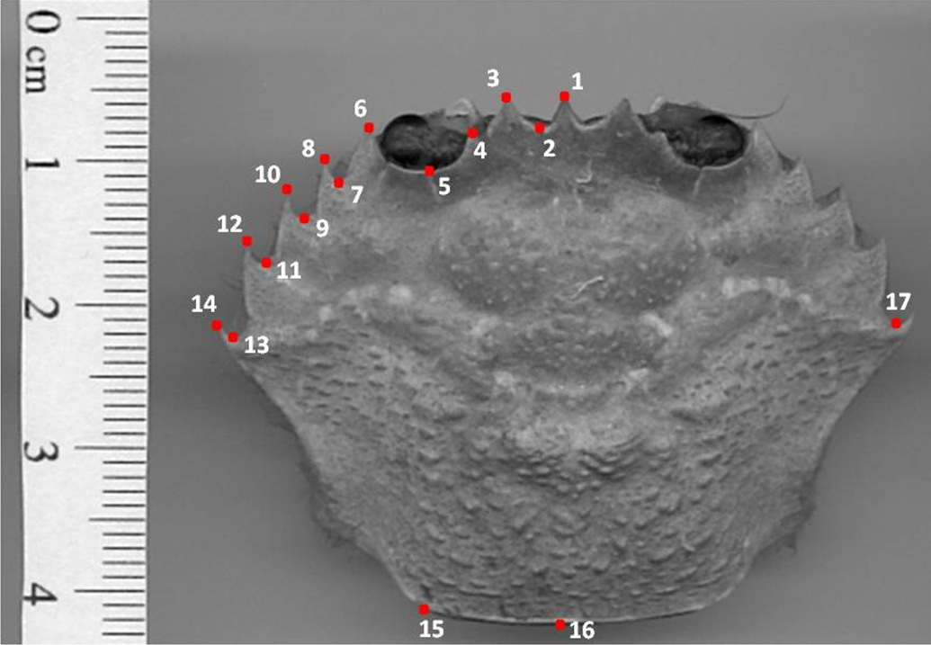

Figure S2. Median–Joining haplotype network of mtDNA COI sequences for Liocarcinus depurator. Black circles represent unobserved haplotypes. Pie sizes are proportional to haplotype frequency. Area abbreviations as in Table S1.
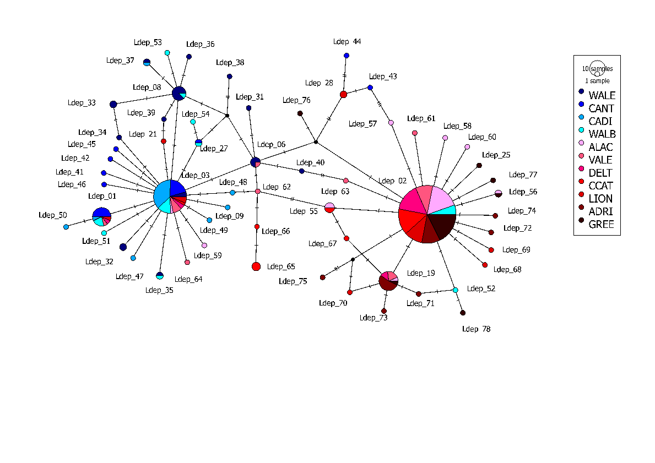
Figure S3. Canonical analysis of landmarks in the carapace shape of Liocarcinus depurator obtained by geometric morphometry. Area abbreviations as in Table S1.

