Online supplementary materials for
Super-enhancer-associated LINC00963 promotes epithelial-mesenchymal transition in gastric cancer
Hong Du ^{1, 2 †}, Tingting Xiang ^{1, 2 †}, Ying Xia ^{1, 3, 4 †}, Yong Jin ⁵, Fahua Deng ², Wansong Xia ¹, Hongyu Li ^{1, 2}, Shuqiang Cheng ¹, Bingxue Lan ^{1, 2}, Sixi Wei ¹, Cunfeng Song ^{6,7 *}and Hai Huang ^{1, 2} ∗
- Center for Clinical Laboratories, The Affiliated Hospital of Guizhou Medical University, Guiyang, 550001, P. R. China.
- School of Clinical Laboratory Science, Guizhou Medical University, Guiyang 550004, P. R. China.
- Department of Clinical Laboratory, The First Affiliated Hospital of Guizhou University of Traditional Chinese Medicine, Guiyang 550001, P. R. China.
- Division of Gastroenterology and Hepatology, Department of Medicine and Department of Oncology, Sidney Kimmel Comprehensive Cancer Center, Johns Hopkins University School of Medicine, Baltimore, MD 21287, USA.
- Clinical Laboratory of the Second People's Hospital of Guizhou Province.
- National Engineering Center for Nanotechnology, Collaborative Innovational Center for System Biology, 28 Jiangchuan Road, Shanghai 200241, China.
- School of Sensing Science and Engineering, School of Electronic Information and Electrical Engineering, Shanghai Jiao Tong University, 800 Dongchuan Road, Shanghai 200240, China.
*. Conrespondence: Cunfeng Song (songcf@sjtu.edu.cn).
Hai Huang (huanghai828@gmc.edu.cn).
†. These authors have contributed equally to this work.

Supplementary Materials and Methods

Table S1. Primers
Name | Sequences
HPRT-F148 | 5’-ATGGCGACCCGCAGCCCT-3’
HPRT-R266 | 5’- CCATGAGGAATAAACACCCT-3’
LINC00963-F687（NR_038955.1） | 5 '- CTGTGCCAGACACTGAAGAT-3'
LINC00963-R807（NR_038955.1） | 5'- GAGATCACACCACTGTACT-3'
LINC00963-F503（ALL） | 5'- GGTCAGGCCACTCTGCTACT-3'
LINC00963-R633（ALL） | 5'- ATGGGCTTCCAACTGCGATG-3'
LINC00963-F598（V1） | 5'- CAAAGGAGAGCACAACCAT-3'
LINC00963-R711（V1） | 5'-ATCTGCACTGGGCTTGAAAT-3'
LINC00963-F631（V2） | 5'- CATGGGGCAGCCCAG-3'
LINC00963-R1557（V2） | 5'-CATGCCTGTAAGTAGCCACT-3'

Table S2. siRNA
Name | Sequences
si-V1-a | 5'- GACACAGUGAGCAUACAAUTT-3'
si-V1-b | 5'-CUGUGGUGUCUUGAUUUCATT-3'
si-NC | 5’-UUCUCCGAACGUGUCACGUTT-3’
LINC00963-V1 has an additional 59 base sequences at the 5 'end of the second exon, with the underlined portion indicating the specific location of the siRNA | 5’-GGCCCAGGACACAGTGAGCATACAAT  AGACATTAGCTGCTGTGGTGTCTTGATTTCA  AG-3’

Table S3. shRNA
Name | Sequences
sh-V1-a | 5'- GACACAGTGAGCATACAATTTAAATTGTATGCTCACTCTCTC-3'
sh-V1-b | 5'-CTGTGGTGTCTTGATTTCATTAATGAAATCAAGACACCACAG-3'
sh-NC | 5’-TTCTCCGAACGTGTCACGTTTAAACGTGACACGTTCGGAGAA -3’

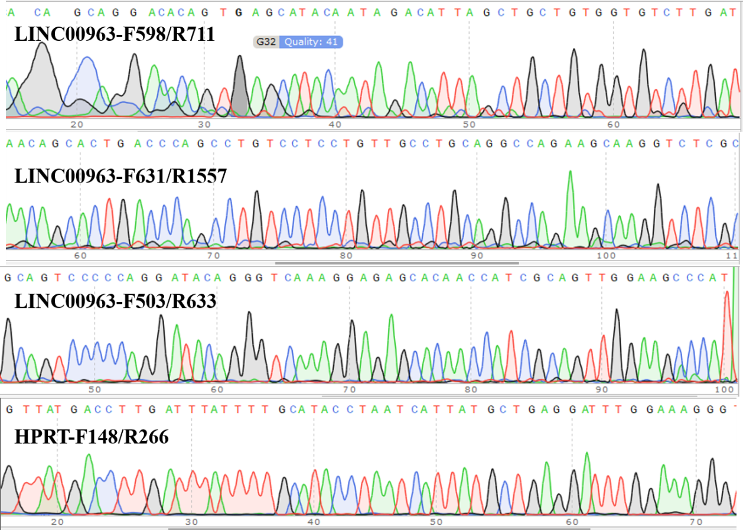
Fig.1 Sequencing results of amplification products from LINC00963

∗ Correspondence: songcf@sjtu.edu.cn; huanghai828@gmc.edu.cn †These authors contributed equally to this work.

