Supplementary Information

L1 retrotransposons exploit RNA m⁶A modification as an evolutionary driving force

Hwang et al.

Supplementary Figure 1-7
Supplementary Table 1-6
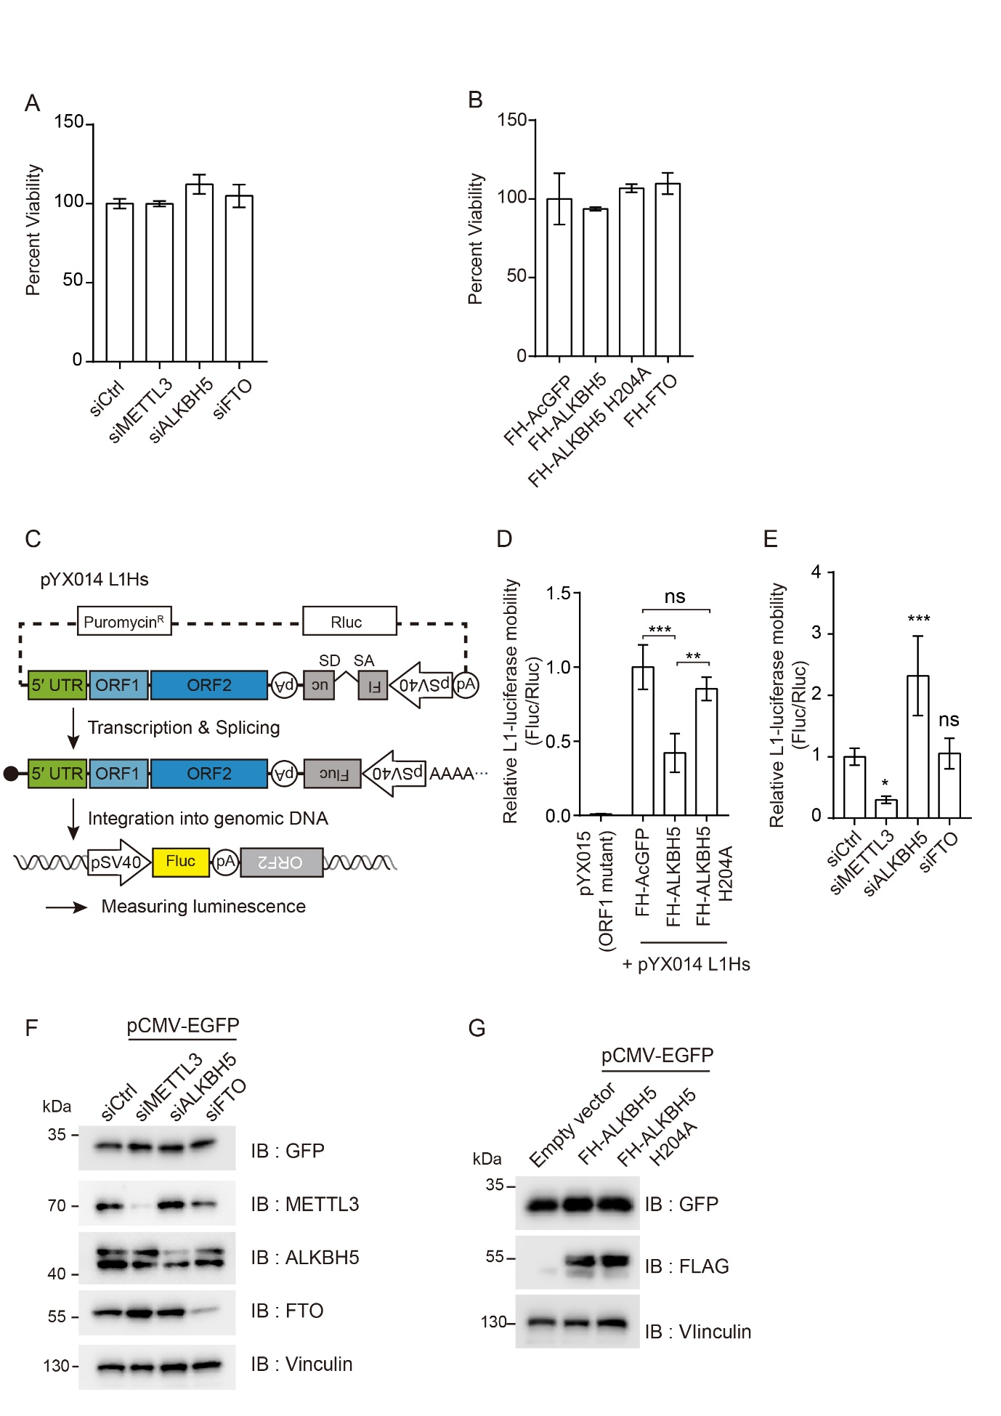

Supplementary Figure 1. RNA methylation machinery controls L1 retrotransposition.
(A and B) Viability of HeLa cells transfected with indicated siRNAs that target m⁶A enzymes (A) or with plasmids-encoding indicated RNA demethylases (B) determined by Cell-Titer GLO assay. (three (A), or two (B) independent samples, error = s.d.) (C) A schematic of the L1-luciferase reporter construct (pYX014) used in this study. This construct drives L1-luciferase expression using its promoter in the 5′ UTR. Firefly luciferase acts as the L1 retrotransposition reporter, while Renilla luciferase is used for the normalization of transfection efficiency. (D) L1-luciferase retrotransposition assays performed in ALKBH5 or ALKBH5 ^{H204A} –overexpressing HeLa cells. In the dual-luciferase assay, the levels of firefly luciferase were measured using the luminescence of Renilla luciferase. The pYX015 L1 construct carries retrotransposition-defective ORF1 mutations. The ratio of the luminescence of firefly and Renilla luciferase (Fluc/Rluc) was normalized to that in AcGFP-overexpressing cells, which served as a control. (E) L1-luciferase retrotransposition assay using m⁶A enzyme-depleted HeLa cells. L1 mobility assessment was performed as in (D). (three (D) or five (E) independent samples, error = s.d., one-way ANOVA with Tukey’s (D) or Dunnett’s multiple comparisons test (E); ***p < 0.001, **p < 0.01 and *p < 0.05, in comparison to control, ns = not significant). (F and G) Plasmid transfection efficiency test after indicated siRNA treatment (F) or co-transfection with indicated plasmids (G). EGFP expression was measured for determining the transfection efficiency of pCMV-EGFP. The protein ladder is marked with the corresponding molecular weight. Vinculin served as a loading control

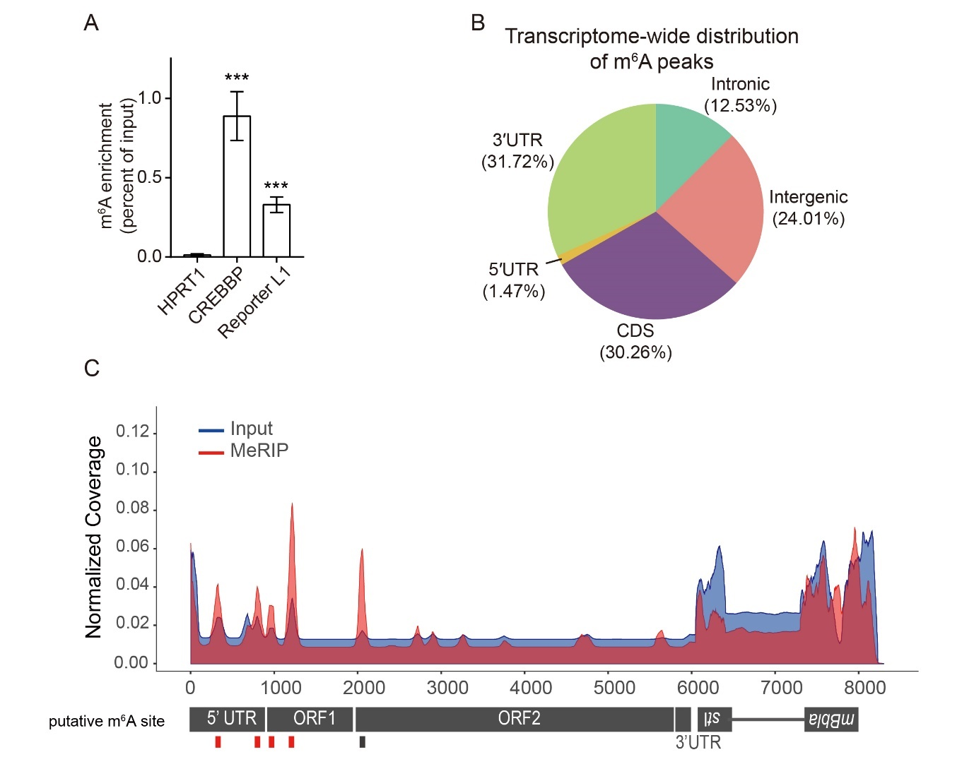
Supplementary Figure 2. L1 RNA is modified by m⁶A. (A) MeRIP-qPCR assay of pL1Hs-expressing HeLa cells. The enrichment of the m⁶A antibody-bound RNA was calculated as a percentage of the input. (n = 3 independent samples, error = s.d., unpaired Student’s t test; ***p < 0.001) (B) Transcriptome-wide distribution of m⁶A peaks from MeRIP-seq data of pL1Hs-expressing HeLa cells. Pie charts indicate the percentage of m⁶A peaks in the marked region. m⁶A is highly enriched in 3′ UTR and CDS compared to the distribution of reads in the input samples. (C) Methylation peaks in the full-length pL1Hs containing a retrotransposition reporter. The pL1Hs construct is presented below. mblastI, the reporter, is antisense and the gamma-globin intron is inserted in it, as described in Fig. 1A. Fragmented poly(A) RNA from pL1Hs-expressing HeLa cells was subjected to RNA-seq and MeRIP-seq, and analyzed as described previously¹. The plot in blue corresponds to the mapping distribution of the input RNA-seq data, while the plot in red corresponds to the MeRIP-seq data.

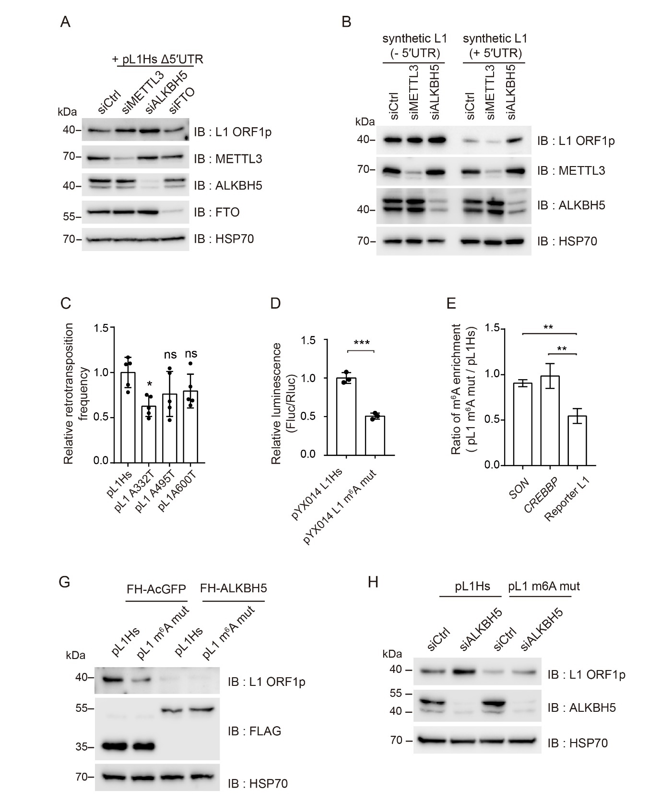
Supplementary Figure 3. L1 5′ UTR m⁶A cluster promotes L1 activity. (A) Immunoblot assay of 5′ UTR deletion L1 construct (pL1Hs Δ5′ UTR) in HeLa cells treated with indicated siRNAs. (B) Immunoblot assay depicting the effect of 5′ UTR using synthetic L1 constructs (L1-neo-TET). siRNA and plasmids transfection were performed as in (A). HSP70 served as a loading control. (C) Retrotransposition assay with a pL1Hs construct with a single m⁶A mutation. The retrotransposition frequency was normalized to that of pL1Hs. (n = 5 independent samples, error = s.d., one-way ANOVA and Dunnett’s multiple comparisons test; *p < 0.05, in comparison to control, ns = not significant). (D) L1-luciferase retrotransposition assay using pYX014 L1Hs- or its m⁶A mut. Ratios of luminescence (Fluc/Rluc) were normalized to those of pYX014 L1Hs. (n = 3 independent samples, error = s.d., unpaired Student’s t test; ***p < 0.001) (E) The ratio of m⁶A enrichment was calculated using MeRIP-qPCR with pL1Hs- or pL1m⁶A mut-expressing HeLa cells. SON and CREBBP served as a transfection-independent control. (n = 3 independent samples, error = s.d., one-way ANOVA and Tukey’s multiple comparisons test; **p < 0.01, in comparison to reporter L1) (G) Immunoblot assay for ORF1p quantification using HeLa cells co-transfected with pL1 construct and AcGFP- or ALKBH5-encoding plasmids. (The predicted molecular weight; 34 kDa for FH-AcGFP and 51 kDa for FH-ALKBH5) (H) Immunoblot assay depicting L1 ORF1p expression of indicated pL1-expressing HeLa cells with knockdown of ALKBH5. The non-targeting siRNA siCtrl served as a control. HSP70 served as a loading control.

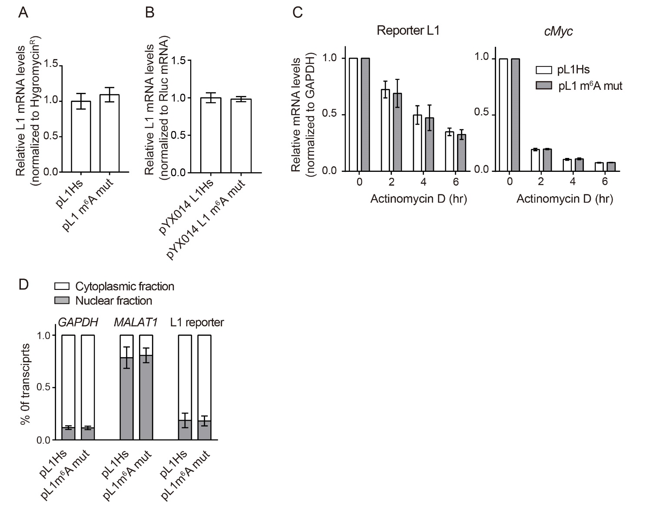

Supplementary Figure 4. L1 5′ UTR m⁶A cluster does not affect RNA expression, stability, and cellular localization. (A and B) The levels of RNA expression of reporter L1. HeLa cells were transfected with pL1Hs and its m⁶A mutant construct (A), or pYX014 L1Hs and its mutant (B). The relative levels of reporter L1 transcripts are normalized to those of pL1Hs-encoded hygromycin-resistant gene (A) or pYX014-encoded Renilla luciferase mRNA. (n = 3 independent samples, error = s.d., unpaired Student’s t test; p = 0.3403 for (A) and p = 0.7003 for (B)) (C) L1 RNA decay assay using pL1Hs-or pL1 m⁶A mut-expressing HeLa cells. The cells were harvested at 0, 2, 4, and 6 h after actinomycin D treatment. mRNA levels were normalized to those of GAPDH. cMyc served as a positive control for this assay. (n = 3 independent samples, error = s.d., two-way ANOVA; p = 0.5003 for reporter L1 and p = 0.2826 for cMyc) (D) Distribution of reporter L1 RNA in the cytoplasmic and nuclear fraction of pL1-expressing HeLa cells. The percentage of transcripts was estimated assuming that the sum of the percentages of cytoplasmic and nuclear transcripts is 100%. (n = 3 independent samples, error = s.d., unpaired Student’s t test; p = 0.8794 for GAPDH, p = 0.7721 for MALAT1, p = 0.9235 for reporter L1).
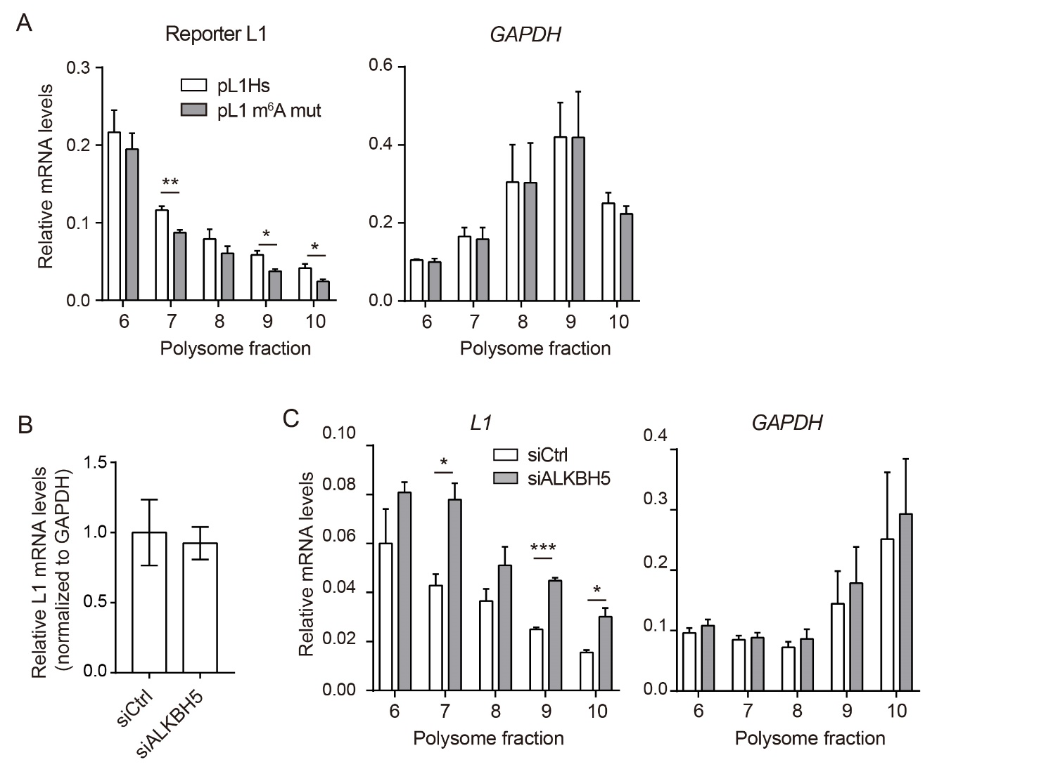

Supplementary Figure 5. m⁶A modification at L1 5′ UTR cluster enhances the translational efficiency of L1 RNA. (A) Relative mRNA levels of polysome-bound reporter L1 and GAPDH. Polysome profiling of pL1-expressing HeLa cells was performed by sucrose gradient sedimentation. Specific mRNA levels were measured using RT-qPCR. The values are normalized to those of spike-in RNA and then to those of input RNA. (n = 3 independent samples, error = s.e.m., unpaired Student’s t test; **p < 0.01, *p < 0.05) (B) Endogenous L1 mRNA expression levels in ALKBH5-depleted PA-1 cells. The RNA levels were estimated using RT-qPCR with the specific primer for L1 5′ UTR and GAPDH. (n = 3 independent samples, error = s.e.m., unpaired Student’s t test; p = 0.7852) (C) Relative mRNA levels of polysome-bound endogenous L1 RNA from ALKBH5-depleted PA-1 cells. The polysome-bound RNA was quantified as in (A). L1 5′ UTR-specific primer was used to detect the endogenous L1 RNA. RNA expression levels were first normalized to those of spike-in RNA and then to those of input RNA. (n = 3 independent samples, error = s.e.m., unpaired Student’s t test; ***p < 0.001, *p < 0.05)

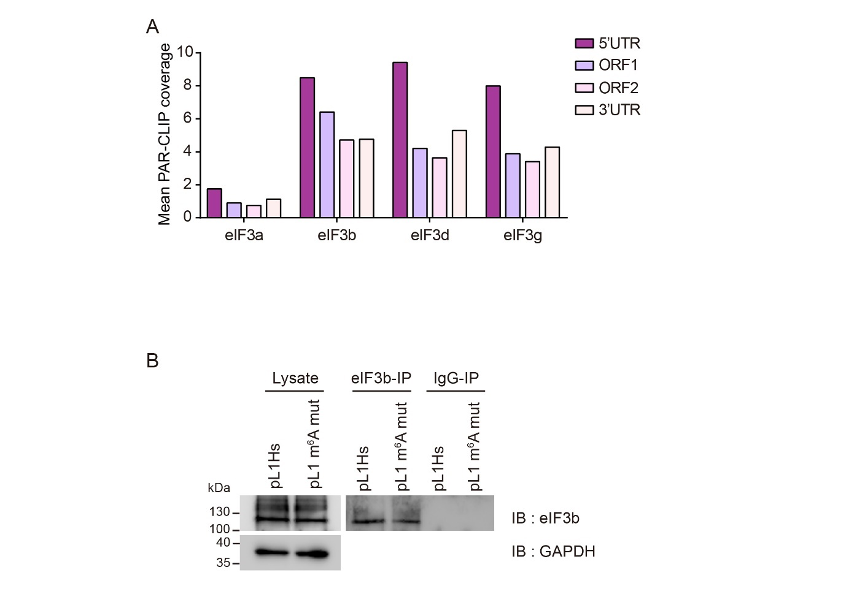
Supplementary Figure 6. The m⁶A cluster at L1 5′ UTR acts as a docking site for eIF3.
(A) Distribution of eIF3 subunit crosslinking sites along the L1Hs consensus sequence. Previously reported data (GSE65004) was used for the analysis. (B) Immunoblot assay of eIF3b-immunoprecipitation sample. HeLa cells were transfected with pL1 constructs. Two days after transfection, the cells were subjected to UV crosslinking and eIF3b immunoprecipitation. The samples were boiled after adding 10 nM MgCl₂ to fragment the crosslinked RNA. GAPDH served as the loading control for the input lysates.

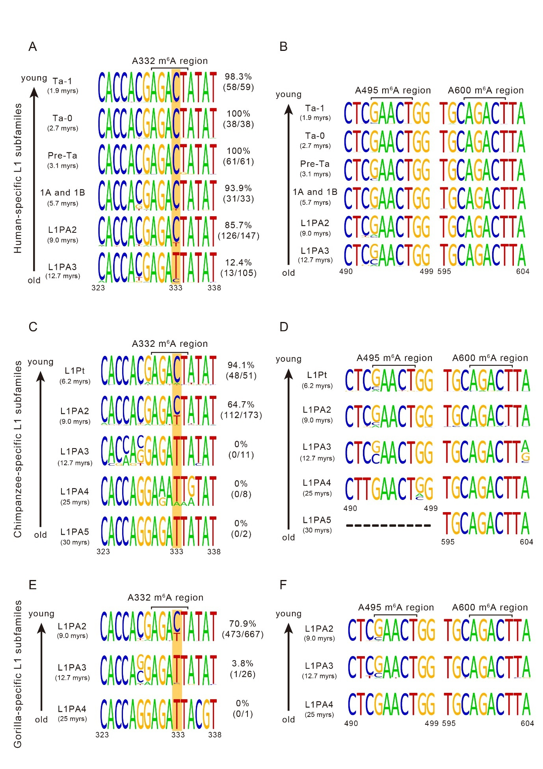

Supplementary Figure 7. Comparative analysis of the m⁶A cluster in speciec-specific full-length L1 subfamilies of three different primates. (A) Comparative analysis of the A332 m⁶A region (A323-A338) in human-specific full-length L1 subfamilies. (B) Comparative analysis of other m⁶A regions at the A495 and the A600 residues in human-specific full-length L1 subfamilies (left: A495, right: A600). Differences in the substitution patterns in different subfamilies were not observable at the two other m⁶A sites. (C) Comparative analysis of the A332 m⁶A region (A323-A338) in chimpanzee-specific full-length L1 subfamilies. (D) Comparative analysis of other m⁶A regions at the A495 and the A600 residues in chimpanzee-specific full-length L1 subfamilies (left: A495, right: A600). The sequence reads of the A495 region were undefined in L1PA5 subfamilies. Differences in the substitution patterns in different subfamilies were not observable at the two other m⁶A sites. (E) Comparative analysis of the A332 m⁶A region (A323-A338) in gorilla-specific full-length L1 subfamilies. (F) Comparative analysis of other m⁶A regions at the A495 and the A600 residues in gorilla-specific full-length L1 subfamilies (left: A495, right: A600). Differences in the substitution patterns in different subfamilies were not observable at the two other m⁶A sites. In (A), (C), and (E), the yellow box indicates the T to C substitution site at the 333rd residue. The percentage indicates the proportion of m⁶A positive L1s to total L1s. The age of the L1 lineage is specified in parentheses. The height of the nucleotide indicates the frequency of the corresponding nucleotide.

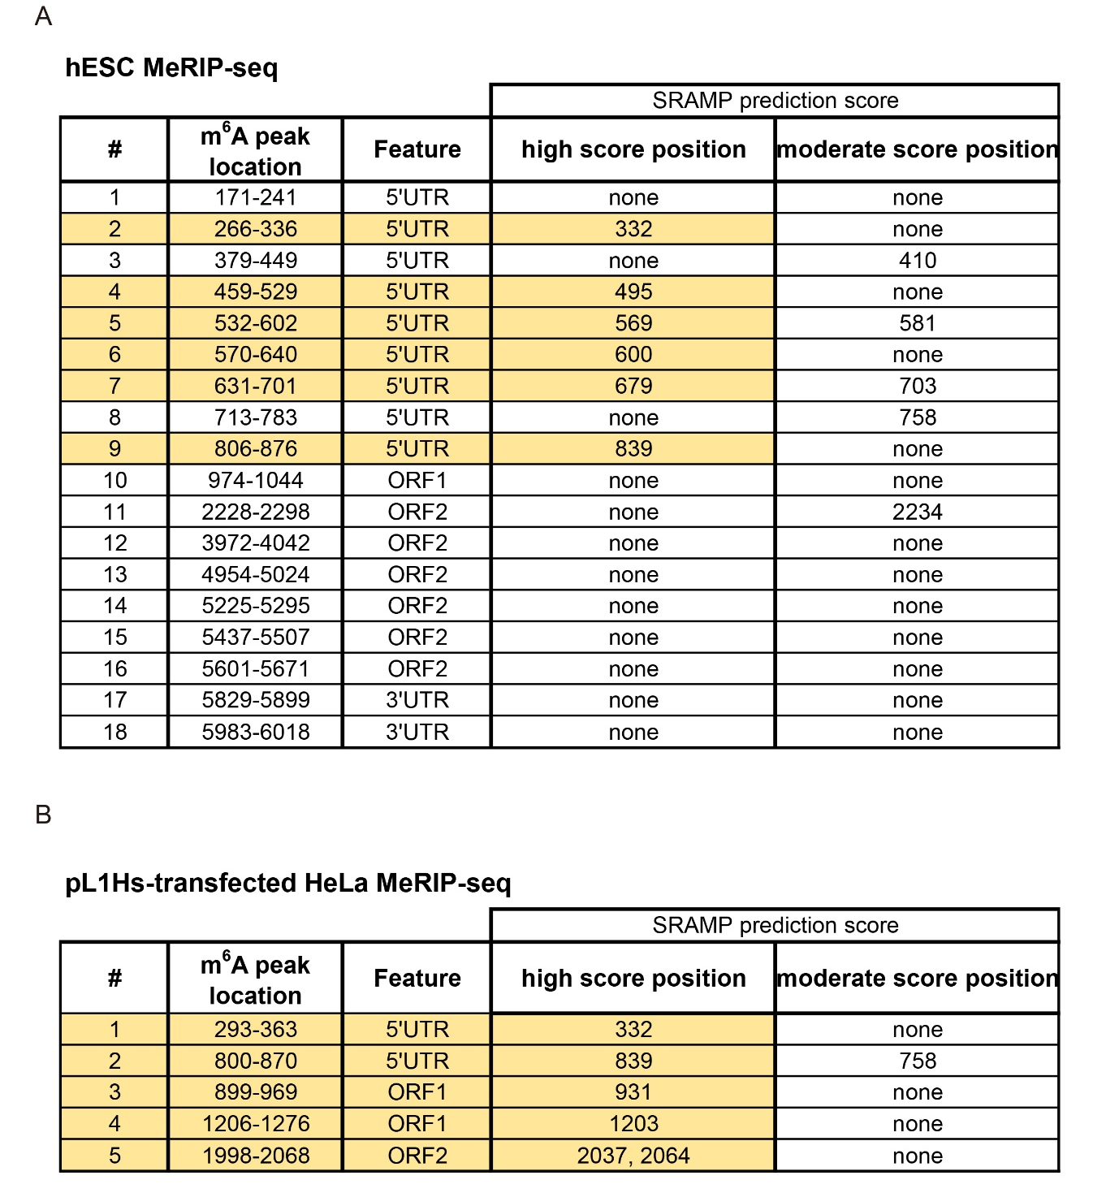
Supplementary Table 1. Identification of putative m⁶A peaks through MeRIP-seq. (A) Identification of endogenous L1 m⁶A peaks by hESC MeRIP-seq. The peaks were identified by manual inspection. The ratio of read coverage (MeRIP/input) from two replicates was measured. The sections with average ratio > 1.3 were selected, and the ± 35 nt regions from the maximum value were assumed to represent m⁶A peaks. The 18 identified peaks and their respective features are indicated. The SRAMP m⁶A tool was used to detect putative m⁶A sites in the peaks. Both high and moderate score positions in the corresponding peaks were noted. Peaks with high score prediction sites were marked in apricot. (B) Identification of m⁶A peaks in reporter L1 through MeRIP-seq of pL1Hs-expressing HeLa. Peaks were identified as in (A), although the cut-off ratio was > 1.4. SRAMP was also conducted to determine the putative m⁶A regions, as in (A). Peaks in apricot indicate high score prediction.

qPCR and RT-PCR primer
HPRT1 |  |  | pYX014 Renilla
F | TGA CAC TGG CAA AAC AAT GCA |  | F | CTT AGG CAG ATC GTC GCT GG
R | GGT CCT TTT CAC CAG CAA GCT |  | R | CTC CCA AGC AAG ATC ATG CGG
SON |  |  | L1 reporter (pYX014; L1-luc)
F | TGA CAG ATT TGG ATA AGG CTC A |  | F | GGA TGA TCT GGT TGC CGA AG
R | GCT CCT CCT GAC TTT TTA GCA A |  | R | CCT TCG TGA CTT CCC ATT TGC C
CREBBP |  |  | L1 LEAP
F | CAT GGC CAA GAT GGG AAT AA |  | F | GGA ATT CGA TGG GCA ATG TGC ACA TGT AC
R | TGC ATC TGA GAC ATA TTT GGC |  | R | GCG AGC ACA GAA TTA ATA CGA CT
L1 5'UTR |  |  | MALAT1
F | AGC CTA ACT GGG AGG CA |  | F | CAT TCG CTT AGT TGG TCT AC
R | TTC CCC ATC TTT GTG GT |  | R | TTC TAC CGT TTT TAG CTT C
L1 ORF1 |  |  | cMYC
F | GCA AGG CAG GCC AAC GTT CA |  | F | CCT ACC CTC TCA ACG ACA GCA G
R | CCT TTC TCT CTG GCT GCC CT |  | R | CTT GTT CCT CCT CAG AGT CGC TG
L1 ORF2 |  |  | cJUN
F | CAG GGC AAT CAG GCA GGA GA |  | F | GAT AAT CCA GTC CAG CAA CGG
R | TTG GGC TGA GAC GAT GGG GT |  | R | GTT CTG GCT GTG CAG TTC G
L1 reporter (pJJ101-L1; pL1Hs) |  |  | PSMB6
F | CAC CCT AAC TGA CAC ACA TTC CAC |  | F | CAA CCA CTG GGT CCT ACA TCG C
R | CAT GTC TGG ATC CGG CCT CCC |  | R | GTT CAA TGC TGT GGA AAC CGA GC
Hygromycin^{R} |  |  | spike in (firefly luciferase)
F | CCT GAA CTC ACC GCG ACG TC |  | F | AAG GTT GTG GAT CTG GAT AC
R | GTC AAG CAC TTC CGG AAT CGG |  | R | GAT TGT TTA CAT AAC CGG AC
GAPDH
F | GCA AAT TCC ATG GCA CCG T
R | TCG CCC CAC TTG ATT TTG G
Supplementary Table 2. Primers used for qPCR or RT-PCR.

5' adapter | 5′-GUU CAG AGU UCU ACA GUC CGA CGA UCN NNN-3′
3' adapter | 5′-rApp NN NNT GGA ATT CTC GGG TGC CAA GG/3ddC/-3′
Reverse transcription primer | 5′-GCC TTG GCA CCC GAG AAT TCC A-3′
PCR forward primer (RP1) | 5′-AAT GAT ACG GCG ACC ACC GAG ATC TAC ACG TTC AGA GTT CTA CAG TCC GA-3′
PCR index reverse primer (RPI X) | 5′-CAA GCA GAA GAC GGC ATA CGA GAT NNN NNN GTG ACT GGA GTT CCT TGG CAC CCG AGA ATT CCA-3′

RPI X | 6 nt index
RPI1 | CGTGAT
RPI10 | AAGCTA
RPI11 | GTAGCC
RPI12 | TACAAG

Supplementary Table 3. Oligonucleotides for the construction of pL1Hs-transfected HeLa MeRIP-seq cDNA library.
The sequences of adaptors and primers were designed to ensure compatibility with the Illumina sequencing platform.

Reference
1 Meyer, K. D. et al. Comprehensive analysis of mRNA methylation reveals enrichment in 3' UTRs and near stop codons. Cell 149, 1635-1646, doi:10.1016/j.cell.2012.05.003 (2012).

