Supplementary Figures and Tables
Figure S1 Diagram of the measurement and removal of toe fringes of the P. mystaceus (A: toe fringes max length and toe fringes area plus toe area measurement of the third finger; B: Pictures of fringe under three states)
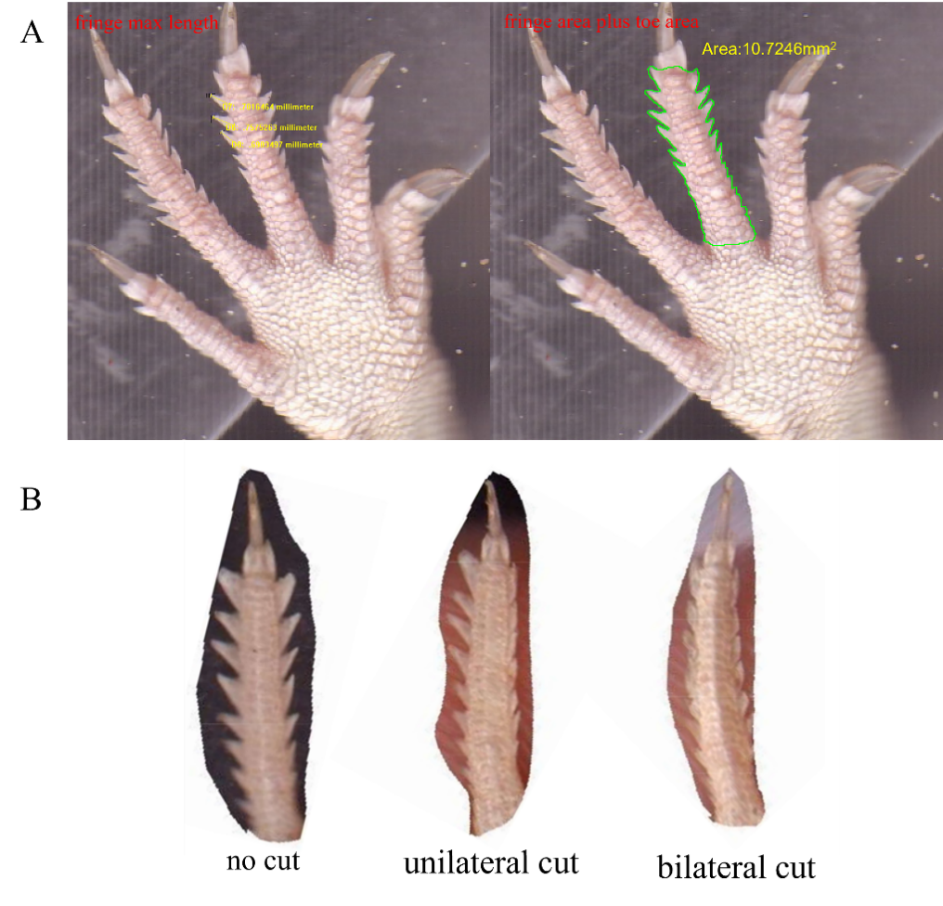

Figure S2 Sand-burying performance of P. mystaceus on different substrates. (●：no cut; ▲:unilateral cut; ■:bilateral cut) Note: Different letters indicate significant differences at the P ＜0.05 level.
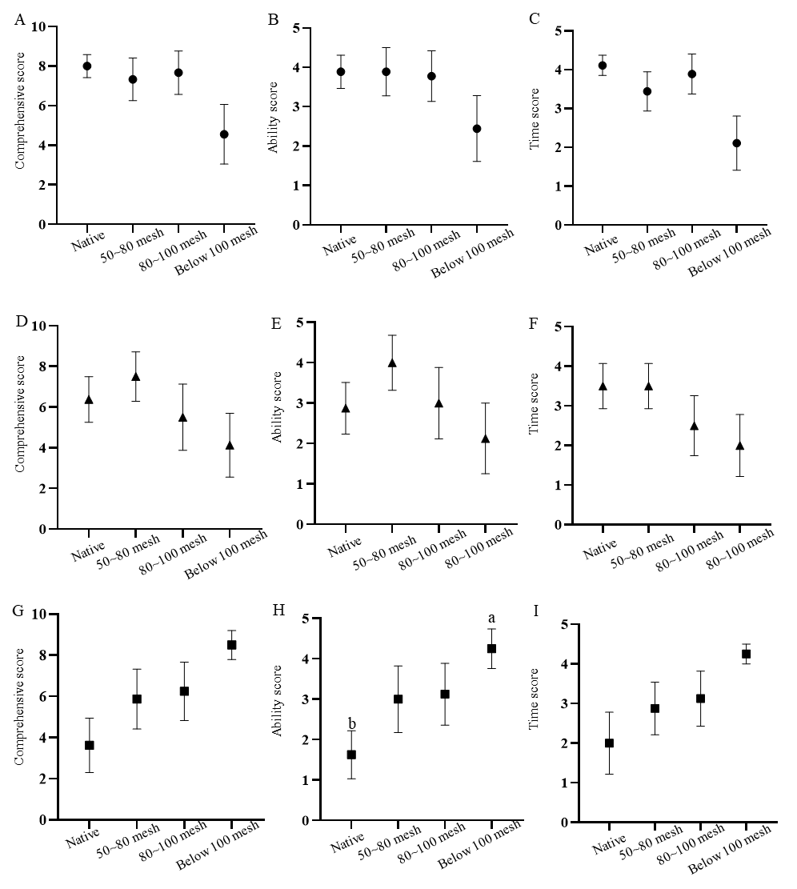

Table S1 Burying styles in lizard families (from Arnold, 1994, 1995 and Halloy, Etheridge & Burghardt 1998).
Family | Burying mode
Chamaeleonidae (Agaminae) | Submerge into sand vertically, with an oscillating lateral movement of limbs and later of head and tail (e.g., Phrynocephalus, Central and Southwest Asia).
Cordylidae | Swim into sand, limbs folded along body, moving with rapid sinusoidal-like waves
Scincidae | Swim into sand, same description as above (e.g., Scincus, North Africa).
Lacertidae | Dive head first, use all their limbs, flexing head and body laterally, tail lashed, back steps (e.g., Meroles, Southwest Africa)
Phrynosomatidae | Dive head first, head twisted about sagittal axis, use mostly hind limbs, forelimbs, placed along body, tail "shimmied", back steps (e.g., Uma, North America).
Phrynosomatidae | Combination of head first diving and vertical sinking with head swung from side to side, followed by hind limbs oscillated from side to side (e.g., Phrynosoma, North) America

Table S2 Multiple comparisons of substrate properties between different substrates
Substrate properties | Substrate type | df | t | P
Density | native vs 50~80 mesh | 36 | 18.215 | 0.000
 | native vs 80~100 mesh | 36 | 2.217 | 0.166
 | native vs below 100 mesh | 36 | -2.082 | 0.178
 | 50~80 mesh vs 80~100 mesh | 36 | -15.999 | 0.000
 | 50~80 mesh vs below 100 mesh | 36 | -20.297 | 0.000
 | 80-100 mesh vs below 100 mesh | 36 | -4.299 | 0.002
Compactness | native vs 50~80 mesh | 36 | 10.314 | 0.000
 | native vs 80~100 mesh | 36 | 0.645 | 0.530
 | native vs below 100 mesh | 36 | -1.510 | 0.917
 | 50~80 mesh vs 80~100 mesh | 36 | -9.670 | 0.000
 | 50~80 mesh vs below 100 mesh | 36 | -11.824 | 0.000
 | 80-100 mesh vs below 100 mesh | 36 | -2.154 | 0.234
Angle of stability | native vs 50~80 mesh | 36 | 1.896 | 0.298
 | native vs 80~100 mesh | 36 | 3.637 | 0.007
 | native vs below 100 mesh | 36 | 7.724 | 0.000
 | 50~80 mesh vs 80~100 mesh | 36 | 1.741 | 0.318
 | 50~80 mesh vs below 100 mesh | 36 | 5.828 | 0.000
 | 80-100 mesh vs below 100 mesh | 36 | 4.087 | 0.002

Table S3 Descriptive statistics of substrate properties between different substrates
Substrate properties | Substrate type | Mean | SE
Density | native | 1.496 | 0.011
 | 50~80 mesh | 1.238 | 0.007
 | 80~100 mesh | 1.464 | 0.007
 | below 100 mesh | 1.525 | 0.013
Compactness | native | 0.835 | 0.068
 | 50~80 mesh | 0.451 | 0.070
 | 80~100 mesh | 0.811 | 0.033
 | below 100 mesh | 0.891 | 0.131
Angle of stability | native | 36.400 | 2.119
 | 50~80 mesh | 35.050 | 1.787
 | 80~100 mesh | 33.810 | 1.014
 | below 100 mesh | 30.900 | 1.197

Table S4 Effects of morphological characteristics on sand burying score of Phrynocephalus mystaceus
State | Score Type | Traits | Coef
No cut | Comprehensive Score | AS | 6.374
No cut | Comprehensive Score | FLL | 0.701
No cut | Comprehensive Score | 2D:4D | -6.376
No cut | Comprehensive Score | TFL | 1.406
No cut | Comprehensive Score | NHS | -4.663
No cut | Comprehensive Score | THS | -3.292
No cut | Time Score | MB | -0.239
No cut | Time Score | THS | -2.048
No cut | Ability Score | AS | 3.826
No cut | Ability Score | HD | 5.194
No cut | Ability Score | 2D:4D | -3.744
No cut | Ability Score | NHS | -4.622
unilateral cut | Comprehensive Score | FLL | 0.472
unilateral cut | Comprehensive Score | TFA | 2.607
unilateral cut | Comprehensive Score | NHS | -4.238
unilateral cut | Time Score | THS | -2.980
unilateral cut | Ability Score | HLL | 4.014
unilateral cut | Ability Score | TFA | 1.839
unilateral cut | Ability Score | NHS | -1.709
unilateral cut | Ability Score | FHS | -3.169
bilateral cut | Comprehensive Score | AS | -15.073
bilateral cut | Comprehensive Score | MB | 6.383
bilateral cut | Comprehensive Score | AW | -2.967
bilateral cut | Comprehensive Score | 2D:4D | -5.147
bilateral cut | Comprehensive Score | NHS | -6.076
bilateral cut | Comprehensive Score | THS | -2.199
bilateral cut | Time Score | AS | -2.002
 | Time Score | AW | -0.725
 | Time Score | NHS | -1.471
 | Time Score | THS | -0.822
 | Ability Score | THS | -3.459

