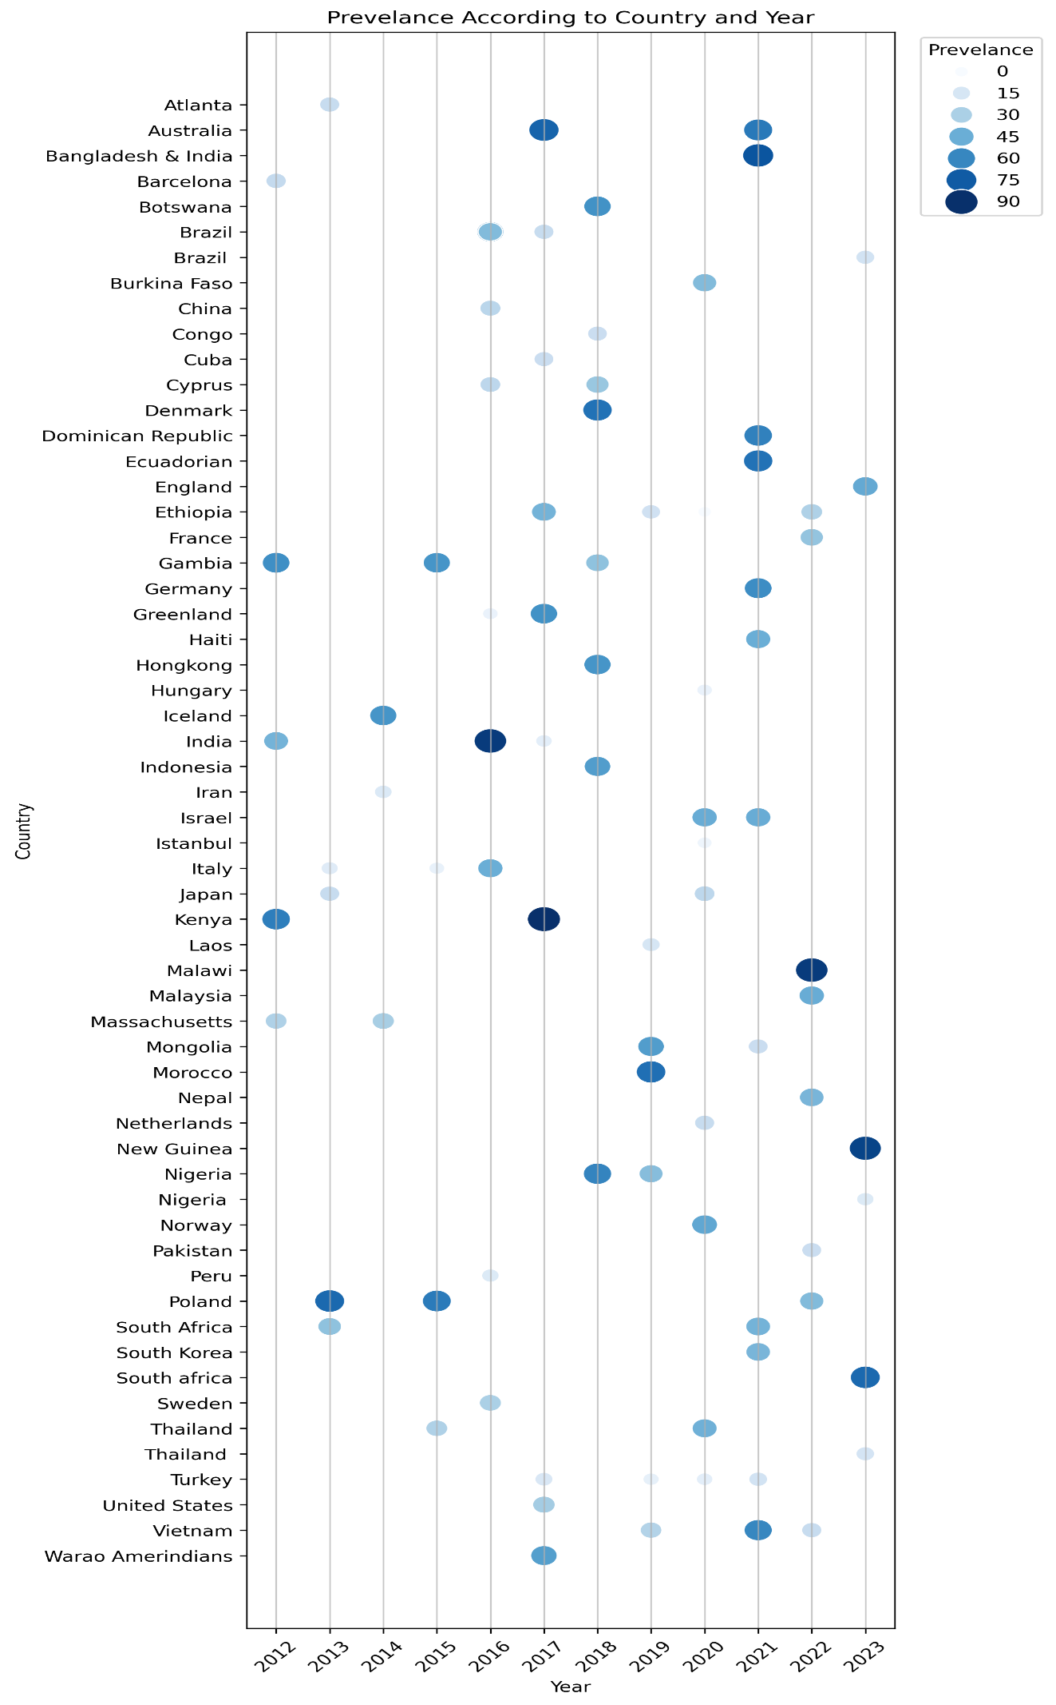
Figure S1 - The year wise prevalence of pneumococcal carriage across various countries.
Table S1 – Pneumococcal Carriage studies with prevalence, risk factors and common serotypes reported.
No. | Study Location | Year of Study | Prevalence | Risk Factors | Common Serotypes reported | Reference
1 | Bangladesh (vaccinated) & India (non-vaccinated) | 2021 | 77.1 | Birth weight (1.46), No of siblings 1 (1.99), 2(1.98), 3 or more (3.44), Children <5 years of age 2 children (1.16), 3 or more (1.19), | Indian children were 6A, 6B, 19F, 23F, 34, and 19A. Bangladesh 3,6A,19A,35B, 15B, 34, 6A, 6B, 19A | (46)
2 | Barcelona, Spain | 2012 | 23.5 | children aged >= 24 (2.45) and attending day care (3.41) | 3,6A,19A, 1,5, 7F, 6B,9V,18C,19F,23F | (87)
3 | Botswana | 2018 | 56 | Elder siblings,lack of electricity in the home and household use of wood as a cooking fuel | not mentioned | (84)
4 | Brazil | 2016 | 55 | household sharing (1.77), contact with children below 2yr (2.0) | 1,5,7F | (85)
5 | Brazil | 2016 | 40.3 | vaccination, day-care, siblings | 1,5, 7F, 6C | (52)
6 | Brazil | 2017 | 22.6 | daycare (13.73),siblings, symptoms (2.74), age (0.7), Rhinitis (2.94), urban residence (1.64), asthma (2.23), co residence (1.36) | 1, 7F,6B | (97)
 |  | 2023 | 17.4 | childcare center attendance, living with young siblings, slum residence, and unstable income | PCV13,PCV10 | (48)
7 | Burkina Faso | 2020 | 40.1 | not vaccinated, day care attendances, antibiotics. | not mentioned | (63)
8 | China | 2016 | 26.6 | non-vaccinated, S. aureus carriage, age, episode of respiratory symptoms, antibiotic use, mothers and fathers’ education, location of kinder garden, female (1.1) | not mentioned | (64)
9 | China | 2016 | 16.6 | non-vaccinated, sex, age, residency, parent education, household income, size of house | 3,6A,19A | (19)
10 | China | 2018 | 55 | age-groups of 12 months (2.88) and 18 months (2.19), presence of siblings younger than 6 years (3.90), recent respiratory symptom (2.13), antibiotics (1.00), hospitalization (1.17) | 6B,9V,18C,19F,23F,3,6A,19A | (33)
11 | Congo | 2018 | 21 | PCV13 vaccination, lived in rural areas, had an enclosed kitchen, were malnourished, or presented with fever. | 9F, 11, 6A/B/C/D and 10A | (53)
12 | Cuba | 2017 | 21.6 | siblings (3.48), previous respiratory infection (2.45), previous hospitalization (2.48), day care attendance (4.33) | 6A, 23F, 6B, 19F and 14 | (34)
13 | Cyprus | 2016 | 25.3 | siblings (1.86), day care (3.08), antibiotic use (0.94-1.66), passive smoke (0.76-1.32), breast feeding (1.21), history of pneumonia (4.11), history of hospitalization (1.12) | 1,5, 7F, 3,6A,19A | (65)
14 | Cyprus | 2018 | 35.3 | smoking (OR 1.43), Age above 2 years (OR 2.31), siblings (OR 2.78) | 6B,9V,18C,19F,23F | (54)
15 | Dominican Republic | 2021 | 62 | non vaccinated (0.38), fully vaccinated (0.14) | 3,6A,19A | (94)
16 | Ecuadorian | 2021 | 67 | age, residence, household members, no. of children per family, income | 3, 6A, 19A, 1 ,5 , 7F,6C | (70)
 | England | 2023 | 47.6 | Daycare (1.03), Siblings (2.11) | PCV10,PCV13 | (49)
17 | Ethiopia | 2017 | 43.8 | children living with siblings (1.96), malnutrition (2.20), residence (2.22), family size (1.61), no. of rooms in the house (1.04) | not applicable | (55)
18 | Ethiopia | 2019 | 21.5 | age 3-4 yr. (3.1), siblings less than 5 yr. old (2.9), day-care (0.7), smoker in house (2.6), sharing bed with parents (3.5), cooking in bedroom (3.6), previous hospitalization (3.5) | not applicable | (50)
19 | Ethiopia | 2019 | 21.5 | passive smoking (3.9), vaccination with2 doses of 1,5, 7F 90.37), living in a house with ≥2 room (0.48) | 19A, 16F, 6A | (57)
20 | Ethiopia | 2019 | 18.4 | children living with siblings (16.06), household >5 person (3.27), breast feeding (6.0), horse cart transportation (2.75) | not mentioned | (51)
21 | Ethiopia | 2020 | 39 | sex (1.220), Age (3-23 yrs.- 2.31), residence (urban - 1.10), family 5 or more (1.31), no. of sibling (1.95), co-sleeping with family (2.09), day care (1.84), height for age (1.70), weight for age (underweight - 1.70) | not mentioned | (56)
22 | Ethiopia | 2022 | 29.9 | early age (4.87), passive smoking (4.75), history of hospitalization (3.5), history of URTI (4.5), no, of students in classroom (5.78), mothers who were illiterate (4.54) | NA | (66)
23 | Gambia | 2012 | 57.4 | non-vaccinated, season, antibiotic use, chest infection in past, travelling | 6B,9V,18C,19F,23F | (91)
24 | Gambia | 2015 | 55 | Age (1.87), season (dry 1.86) | NA | (71)
25 | Gambia | 2018 | 37.2 | passive smoking (1.24), other children in household (4.62), no. of children in school (1.26) season (1.98), mother carrier any time during neonatal period (2.82) | 3,6A,19A | (35)
26 | Germany | 2021 | 58.6 | day care, domestic smoking (Domestic tobacco smoke) | 6B,9V,18C,19F,23F,1,5,7F,3,6A,19A | (67)
27 | Greenland | 2016 | 60 | sex (1.3), day-care (1.0), siblings (1.6), person per room (1.7), tobacco exposure (1.3) | 3,6A,19A (e 6B, 6C, 15B,16 F, 19A, 22 F, 23 F, 33 F and 35 F | (36)
28 |  | 2017 | 56 | non-vaccinated children | 3,6A,19A | (92)
29 | Haiti | 2021 | 45 | Shared bedroom with ≥3 people (OR 2.22) | 3,6A,19A, (6A, 19F, 6B, and 23F) | (98)
30 | Hungary | 2020 | 6.2 | crowded community, sex, antibiotics, siblings, passive smoking | 3,6A,19A, PPV23 | (37)
31 | Iceland | 2014 | 55.6 | day care centre, antibiotic consumption, smoking at home | not mentioned | (82)
32 | India | 2017 | 9 | overcrowding (3.39), poor ventilation (49.65), under age 2 (10.6), underlaying illness (2.104) | 6B,9V,18C,19F,23F | (72)
33 | Indonesia | 2018 | 52 | URTI (2.8), Children age of 5 yrs. (2.17), residence (1.01), parental monthly income (1.55), exposure to smoke (0.72) | NA | (73)
34 | Iran | 2014 | 13.9 | smoker at home (1.6), previous respiratory infections (1.5), antibiotic use (1.89), sex (3.5 - m), asthma (1.15), previous history of hospitalization (1.89) | 9F, 6A/B, 15A, 11, 23F, 1, 19A, 35B | (68)
35 | Italy | 2015 | 7.5 | Vaccination status | 6B,9V,18C,19F,23F/3,6A,19A | (59)
36 |  | 2016 | 45.4 | vaccination status (1.05) | 6B,9V,18C,19F,23F, 3,6A,19A | (58)
37 | Japan | 2013 | 22 | older siblings (3.11), summer (0.36), day care (2.64) | NA | (60)
38 | Japan | 2020 | 25.5 | ageless then 12 months (1.60), gender (.92), day-care (6.21), siblings (2.26) | 3,6A,19A | (38)
39 | Kenya | 2012 | 65.8 | cough in last 2 weeks (1.55-2.55), antibiotic use (0.78), day care (0.98), cooking fuel (1.0-2.9), smoker in the house (1.36) | 4, 6B, 9V, 14, 18C, 19F, and 23F | (89)
40 | Kenya | 2012 | 63.17 | exposure to cigarettes, cooking fumes, and other children in the home | 1,5,7F | (90)
41 | Kenya | 2017 | 90 | tobacco smoke in the home, history of recent illnesses, and antibiotic use and room as the child | 19F,3, 7F, 15B, 19B, 11A, 23F, 6A &6B | (30)
42 | Malawi | 2022 | 86 | household air pollution (1.55), vaccine status, group children (1.36), age, sex, cookstove, current antibiotic use, season. | 3, 6A, 19A | (31)
43 | Massachusetts | 2012 | 29 | younger age, childcare, young siblings, and upper respiratory illness | 6B,9V,18C,19F,23F, 3,6A,19A | (39)
44 | Mongolia | 2019 | 52 | non-vaccinated, passive smoking, minimum income, source of cooking fuel | 3,6A,19A | (83)
45 | Mongolia | 2021 | 21.2 | vaccination, household crowding, use of wood or coal for fuel, age | 3,6A,19A | (61)
46 | Nepal | 2022 | 42.9 | gender (F-1.14) | NA | (74)
 | New Guinea | 2023 | 83 | Vaccination | PCV10, PCV13 | (32)
47 | Nigeria | 2018 | 61.6 | Age 0-2 (OR 2.68), 2-4 (2.08), household cooking oil (1.53), no. of person sharing household (1.55) | 1,5, 7F (1 & 5) | (75)
48 | Nigeria | 2019 | 39.6 | age older than 3 months (except for 24-36 months) (OR 1-2.42), house flooring material of tile (2.87), profession of mother (3.1) and co-carriage with another bacteria (1) or virus | NA | (18)
 |  | 2023 | 12 | Vaccination, age | PCV10 | (81)
49 | Norway | 2020 | 48 | antibiotic use (0.42), vaccinated (0.37) | 3,6A,19A, 6B,9V,18C,19F,23F | (99)
50 | Pakistan | 2022 | 21.8 | OR 2.53 (non-vaccinated), 3.35 (partially vaccinated) | 1,5, 7F | (93)
51 | Poland | 2022 | 40.1 | non-vaccinated, day care, siblings, smoker in a household | 3,6A,19A,1,5, 7F | (40)
52 | South Africa | 2013 | 37 | Age (5.8), URI (2.2), tobacco& alcohol (31.6) | 15A,11A | (16)
53 | South Africa | 2021 | 43.7 | early age (OR 8.1), informal dwelling (OR 2.4), Haemophilus carriage (OR 5.6) | 3,6A,19A, NVT - 23B, 15B/Cand 35B. | (76)
 |  | 2023 | 70 | Vaccination, age | PCV10,PCV13 | (79)
54 | South Korea | 2021 | 42.1 | age (1.03), siblings ((1- 1.1, more then 2- 0.73), past medical history (antibiotics -1.15, hospitalization 1.28), vaccination complete (0.84) | 3,6A,19A, 23A, 15 C &B | (62)
55 | Sweden | 2016 | 30 | age ⩾3months-<3years, having siblings, attending day-care, and having travelled abroad the last 3months | NVT 8, 9N, 12F, and 22F | (41)
56 | Thailand | 2020 | 44.5 | URI month before (68.91), abnormal skin lesion (4.01), dental caries (1.26), tonsil enlargement (2.19) | 6B,9V,18C,19F,23F, 3,6A,19A | (6)
 |  | 2023 | 16.6 | Age, cocurrent infections(6.93), passive smoking (1.65) | PCV13 | (80)
57 | Turkey | 2017 | 14 | vaccination (1.0), respiratory infection (4.117), age (0.604), day care (0.487), antibiotic usage (3.134), siblings (0.844) | 3,6A,19A,6B,9V,18C,19F,23F | (42)
58 | Turkey | 2019 | 8.6 | Number of siblings (1.56) and having sibling with older age of five (1.97) | 6B,9V,18C,19F,23F, 23F | (44)
59 | Turkey | 2020 | 9.8 | day care, number of household members, passive smoking history, breast feeding history, number of siblings, recent and past infections | 3,6A,19A | (43)
60 | Turkey | 2021 | 17.8 | Maternal education level (1.992) | 3,6A,19A | (100)
61 | United States | 2014 | 31 | vaccinated by 3,6A,19A (1.07), young siblings (1-3.03), group childcare attendance (1-3.05), antibiotic use (1.0) | 3,6A,19A | (45)
62 | United States | 2017 | 32 | PCV13 colonization (1.46), non PCV13 colonization (OR 0.86), PCV7 was associated with a higher risk of non-PCV 13 colonization across all study years (OR 1.29) for PCV7; OR 1.66 forPCV13). | 6B,9V,18C,19F,23F, 3,6A,19A | (47)
63 | Vietnam | 2019 | 28.7 | Age (0.89) and day-care attendance (1.30) | 3,6A,19A, 19F | (69)
64 | Vietnam | 2021 | 60 | Age | 1,5,7F | (77)
65 | Vietnam | 2022 | 22 | households with more than four people (1.25), more contacts than infants in smaller households (1.07), day care (1.07) | Not mentioned | (78)

