Supporting Information

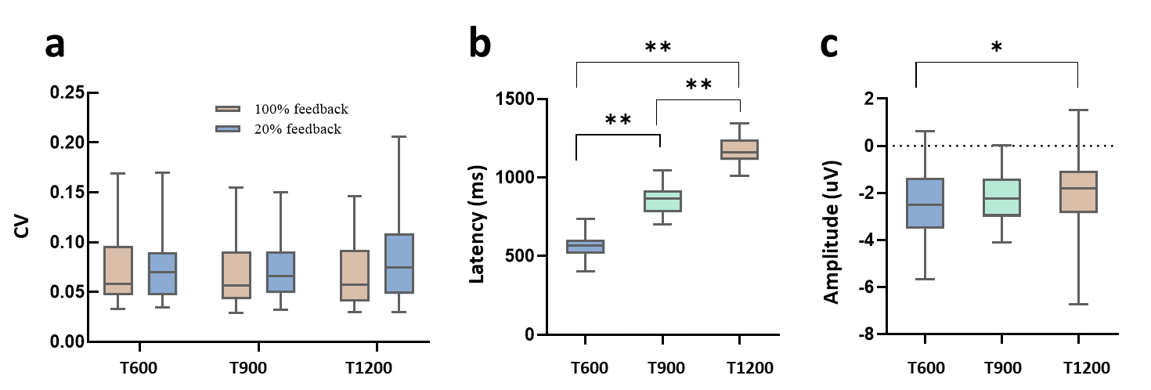

S1 Fig. Behavior result and ERP component of timing in Experiment 1. (a) The results of CV with short (T600), intermediate (T900) and long (T1200) time intervals and two feedback conditions. Group comparisons showed there was no significant difference both in the aspects of time interval and feedback condition. (b) The latency of N1 component was consistent with the produced time interval, longer target time intervals with longer N1 latency, and shorter target time intervals with shorter N1 latency. (c) The amplitude of N1 component (peak value) with different target time intervals. ** P<0.01 in paired t-test, * P<0.05 in paired t-test.

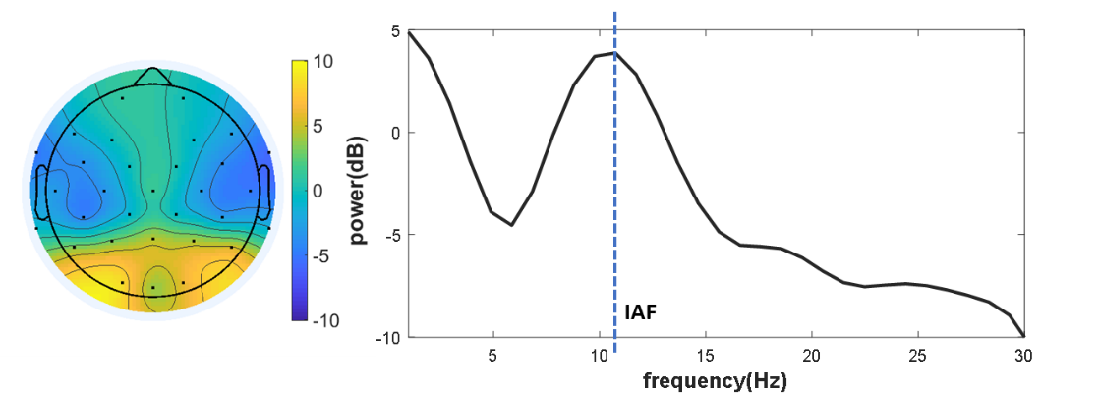
S2 Fig. Topography and power spectrum of alpha. Topography of absolute alpha band power (8–13 Hz) in resting-state EEG and the power spectrum of one subject extracted from the posterior electrodes showing the individual alpha frequency (IAF).

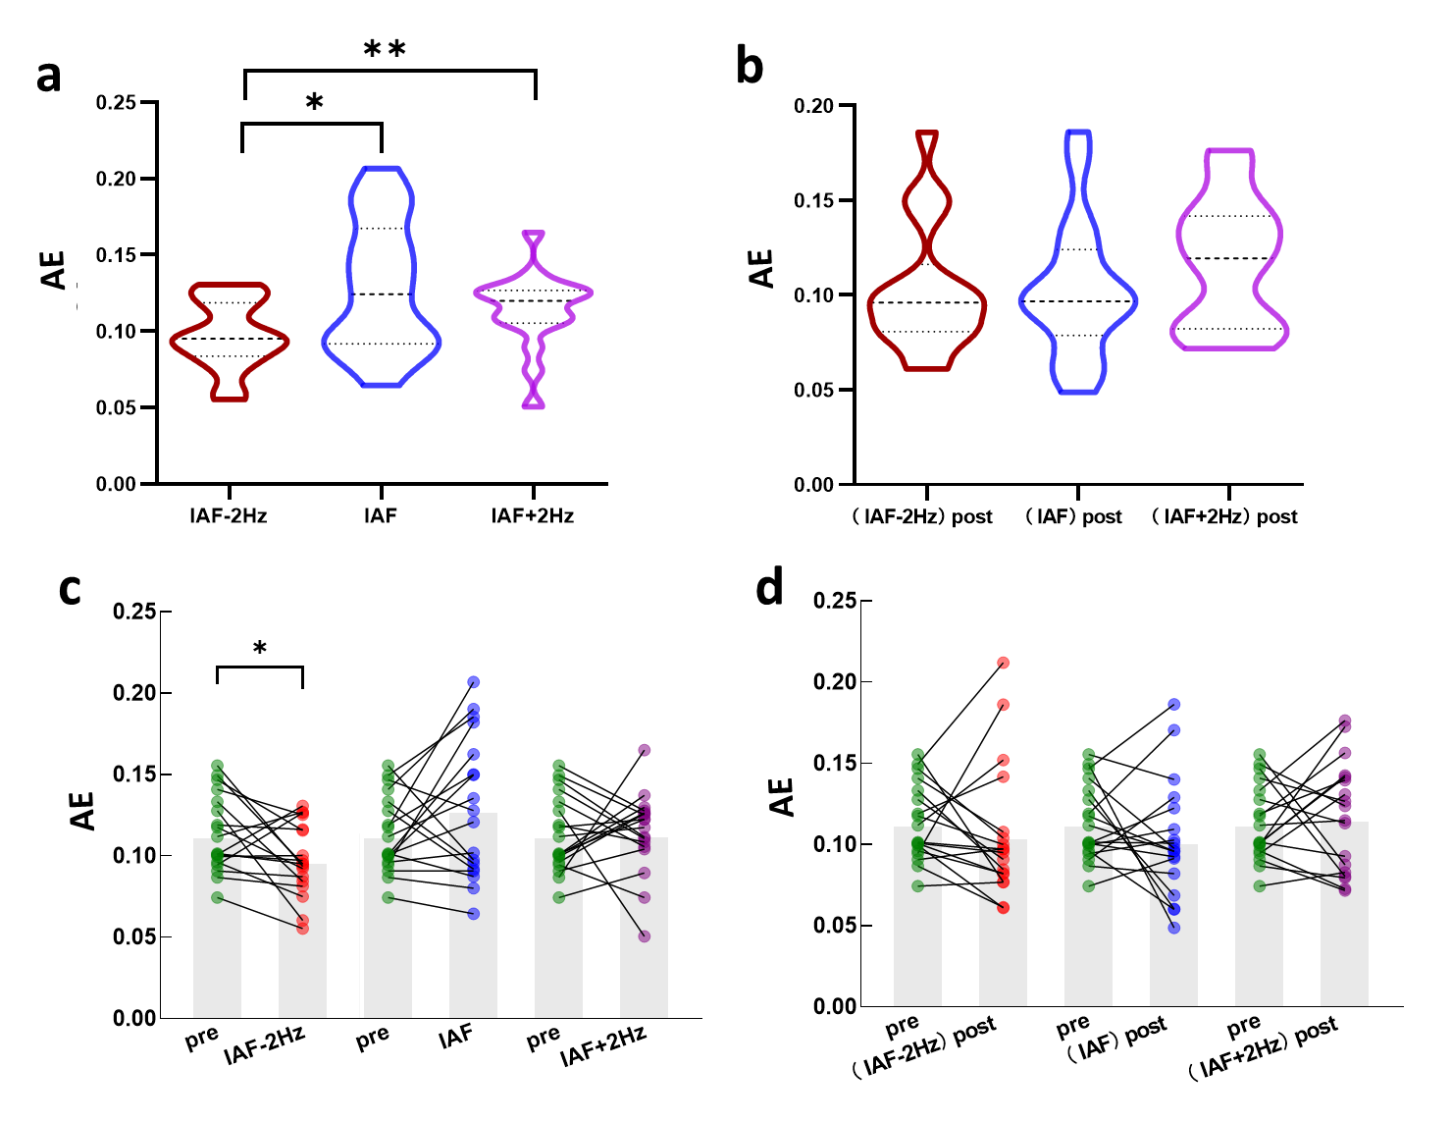
S3 Fig. Effects of tACS on the absolute error (AE) of timing. AE was computed by $\text{AE}\text{=}\frac{\frac{\text{1}}{\text{N}}\sum_{\text{i}\text{=1}}^{\text{N}}{{\text{|e}}_{\text{i}}\text{|}}}{\text{t}}$. Here, ${\text{e}}_{\text{i}}$ is the error between estimated time interval and the target time interval, and t is the target time interval, i.e., 600ms, 900ms or 1200ms. (a)-(b) Violin plots depict data distribution of timing performance (AE) during tACS with different stimulation frequency. Thick dash lines and fine dash lines represent sample medians and quartiles. Comparison analysis showed a significant decrease in AE during IAF-2Hz stimulation than IAF as well as IAF+2Hz stimulation conditions (a), while the effect was disappeared among post-tACS conditions. * P<0.05; ** P<0.01. (c)-(d) Individual AE values in the condition of pre-tACS and tACS (b), as well as post-tACS (c) with difference stimulation frequency (IAF-2Hz, IAF and IAF+2Hz). Comparison analysis showed a significant decrease of AE both in tACS with IAF-2Hz compared to pre-tACS, while this effect was not found in post-tACS condition.

