Synthesis of TPAQ-Br.
N,N-dimethylformamide (105 mL) was introduced to a mixture comprising 4(diphenylamino) phenylboronic acid (0.96 g, 3.3 mmol), 2,6-dibromoanthraquinone (1.10 g, 3 mmol), Pd(PPh₃)₄ (173.34 mg, 0.15 mmol), and K₂CO₃ (4.14 g, 3 M). The reaction proceeded at 80 °C under a N₂ atmosphere for 15 hours. After cooling to room temperature, the reaction solution was quenched with water. The residue was subsequently extracted with dichloromethane (DCM), and the organic phase was dried over anhydrous Na₂SO₄. The crude product was stirred overnight in 15 mL of methanol, extracted, and dried for use in the next step.

Synthesis of TPAQ-Py.
A mixture of TPAQ-Br (1.32 g, 2.49 mmol), pyridin-4-ylboronic acid (0.62 g, 5.04 mmol), and tetrakis(triphenylphosphine)palladium (75 mg, 64.5 μmol) was dissolved in 75 mL of tetrahydrofuran (THF). Subsequently, 15 mL of saturated potassium carbonate solution (2 M) was added to the reaction mixture under stirring. The reaction was conducted at 80 °C under a nitrogen atmosphere overnight. After the mixture was cooled, the solvent was evaporated under reduced pressure. The residue was then extracted, and the organic phase was dried with anhydrous Na₂SO₄. The crude product was subjected to column chromatography on silica gel (petroleum ether/dichloromethane, 5:1, v/v) to obtain a red solid with a yield of 75%.

Synthesis of TPAQ-Py-PF₆.
Under a nitrogen atmosphere, iodomethane (3 mL) was added to acetonitrile (40 mL) containing TPAQ-Py (1.70 g, 3.22 mmol), and the mixture was refluxed for 24 hours at 80 °C. After the reaction solution cooled to room temperature, the mixture was poured into diethyl ether to obtain precipitates, which were then filtered. The resulting solid was redissolved in 20 mL of methanol, followed by adding a saturated KPF₆ solution (2 mL). After stirring for 2 hours, the solvent was evaporated, and the residue was filtered again. The crude product was purified by flash column chromatography on silica gel (DCM: CH3OH, 10:1, v/v) to obtain the product as a dark red solid with a yield of 69%. ¹H NMR (600 MHz, DMSO-d₆) :δ 9.12 (s, 2H), 8.77 (s, 1H), 8.71 (s, 2H), 8.56 (s, 1H), 8.44 (s, 2H), 8.33 (d, J = 9.0 Hz, 1H), 8.25 (s, 1H), 8.19 (s, 1H), 7.82 (d, J = 8.2 Hz, 2H), 7.38 (s, 4H), 7.14 (s, 5H), 7.09 (d, J = 7.6 Hz, 2H), 4.40 (s, 3H). ¹³C NMR (151 MHz, DMSO-d₆): δ 182.21, 181.59, 152.78, 148.83, 147.01, 146.41, 145.77, 139.29, 135.03, 134.30, 133.89, 133.75, 132.00, 131.37, 130.91, 130.17, 129.59, 128.47, 128.34, 126.55, 125.54, 125.39, 124.46, 123.84, 122.32, 47.89. MS (ESI): m/z calcd.for C₃₈H₂₇N₂O₂⁺ [M+H]: 543.2067, found: 543.2060.

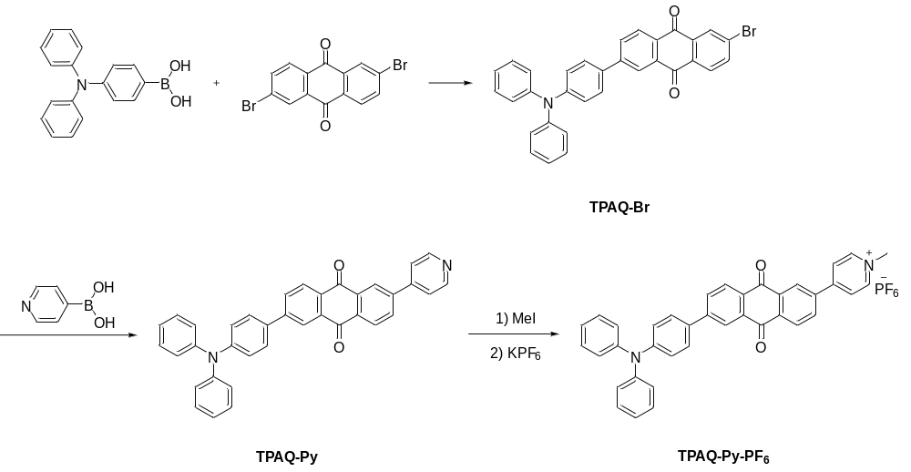
Supplementary Figure 1. Synthetic route of TPAQ-Py-PF₆

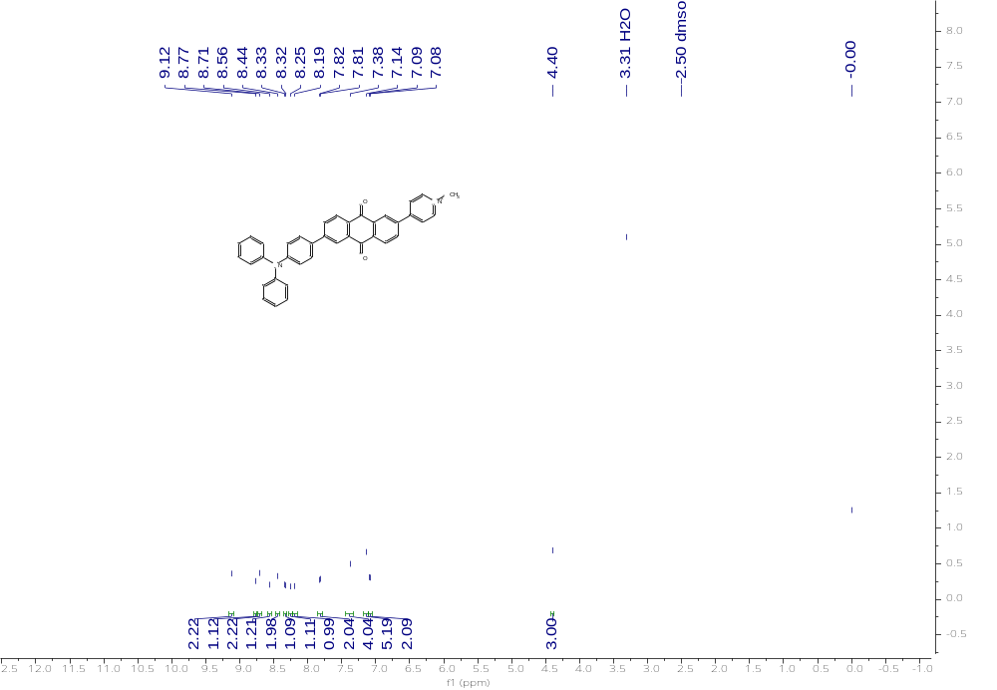
Supplementary Figure 2. ¹H NMR (600 MHz, DMSO-d₆) :δ 9.12 (s, 2H), 8.77 (s, 1H), 8.71 (s, 2H), 8.56 (s, 1H), 8.44 (s, 2H), 8.33 (d, J = 9.0 Hz, 1H), 8.25 (s, 1H), 8.19 (s, 1H), 7.82 (d, J = 8.2 Hz, 2H), 7.38 (s, 4H), 7.14 (s, 5H), 7.09 (d, J = 7.6 Hz, 2H), 4.40 (s, 3H).

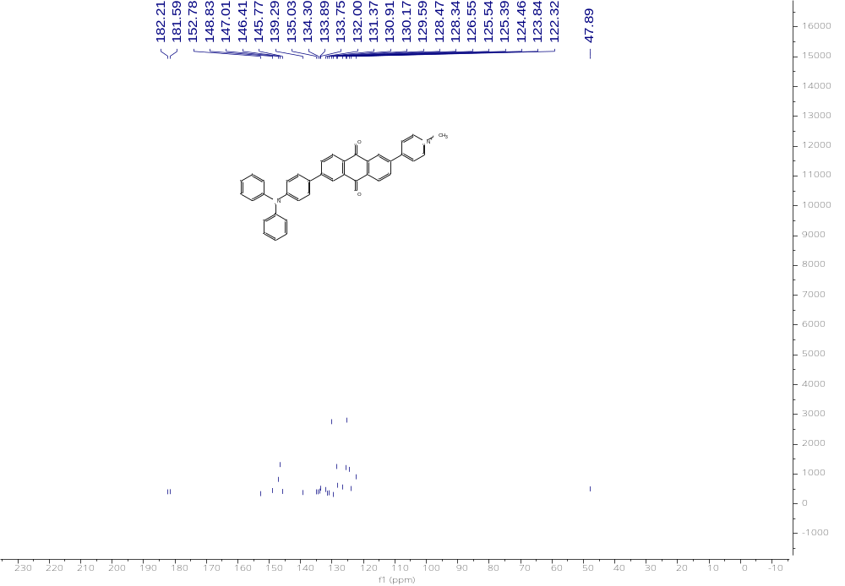
Supplementary Figure 3. ¹³C NMR (151 MHz, DMSO-d6): δ 182.21, 181.59, 152.78, 148.83, 147.01, 146.41, 145.77, 139.29, 135.03, 134.30, 133.89, 133.75, 132.00, 131.37, 130.91, 130.17, 129.59, 128.47, 128.34, 126.55, 125.54, 125.39, 124.46, 123.84, 122.32, 47.89.

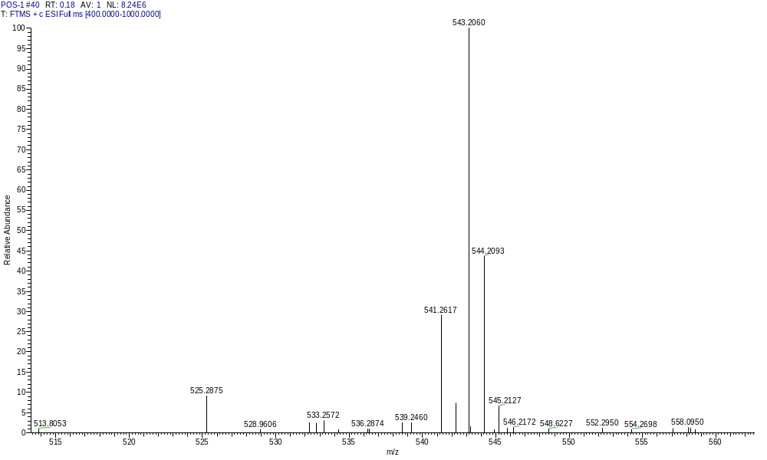
Supplementary Figure 4. MS (ESI): m/z calcd.for C₃₈H₂₇N₂O₂⁺ [M+H]: 543.2067, found: 543.2060.

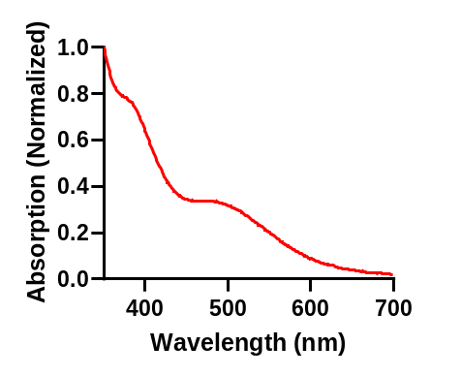
Supplementary Figure 5. UV-Vis absorption of TNPs (20μM) spectra in water.

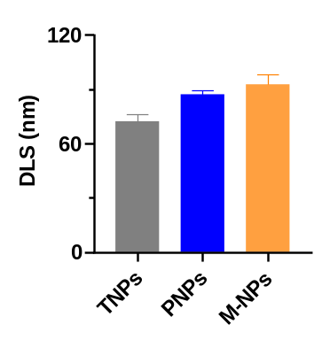
Supplementary Figure 6. Representative DLS results of TNPs, PNPs and M-NPs. Data are presented as mean ± SD (n = 3).

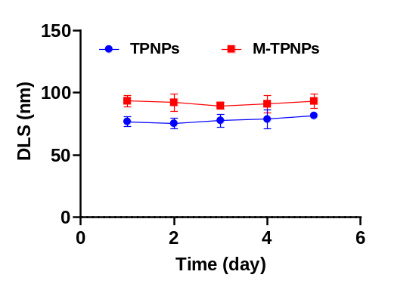
Supplementary Figure 7. The colloidal stability of TPNPs and M-TPNPs in 10% serum measured by DLS. Data are presented as mean ± SD (n = 3).

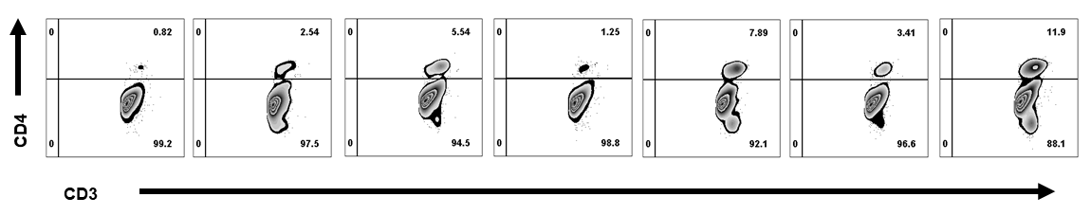
Supplementary Figure 8. Representative flow cytometry plots of the percentages of CD4⁺ T cells in primary tumors collected from bilateral RM-1 tumor bearing mice after various treatments on day 14.

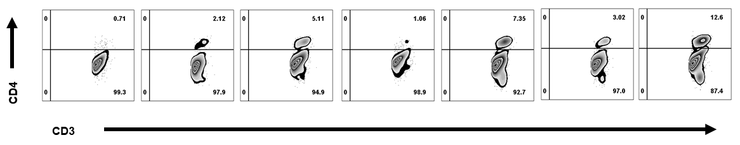
Supplementary Figure 9. Representative flow cytometry plots of the percentages of CD4⁺ T cells in distant tumors collected from bilateral RM-1 tumor bearing mice after various treatments on day 14.

