Supplemental figure
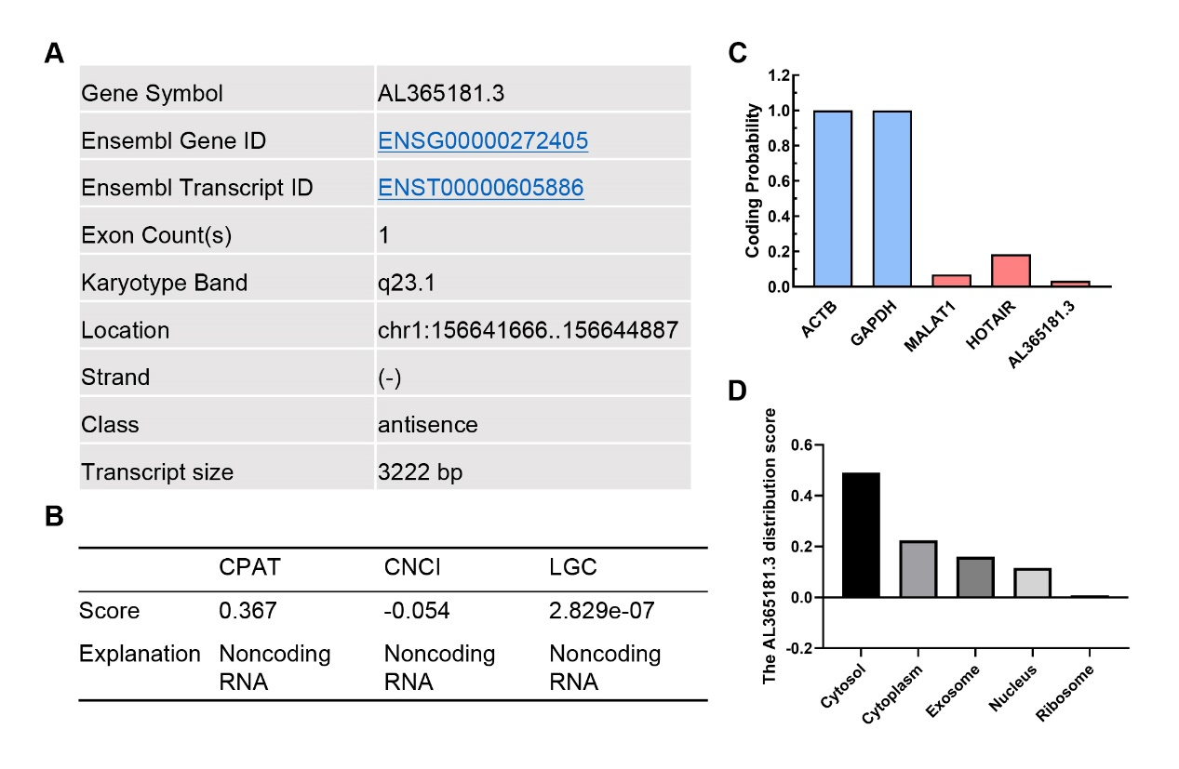
Figure S1. Molecular characteristic analysis of AL365181.3.
(A) The genomic attributes of AL365181.3. (B) The coding potential of AL365181.3 was analyzed via the CPAC, CNCI, and LGC databases. (C) The coding potential of AL365181.3 determined by PLEK analysis. (D) The subcellular localization of AL365181.3.
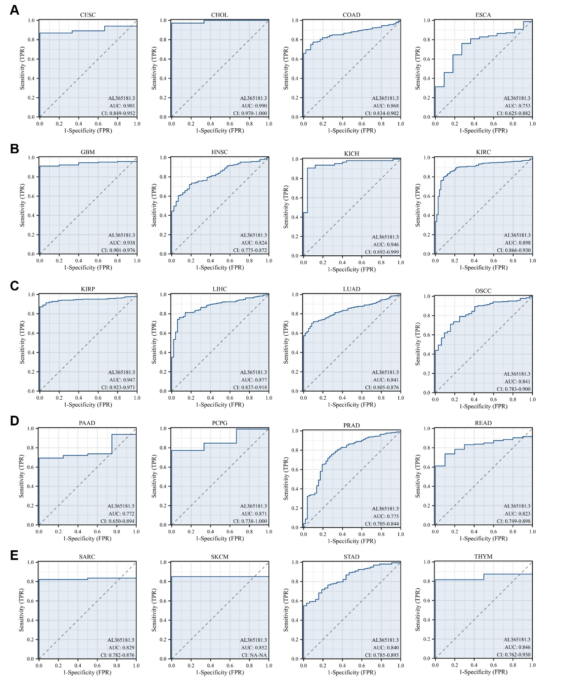
Figure S2. ROC curve analysis of AL365181.3 across cancers.
ROC curve analysis of AL365181.3 in CESC, CHOL, COAD, and ESCA (A); GBM, HNSC, KICH, and KIRC (B); KIRP, LIHC, LUAD, and OSCC (C); PAAD, PCPG, PRAD, and READ (D); and SARC, SKCM, STAD, and THYM (E). TRP: true positive rate, FRP: false positive rate.

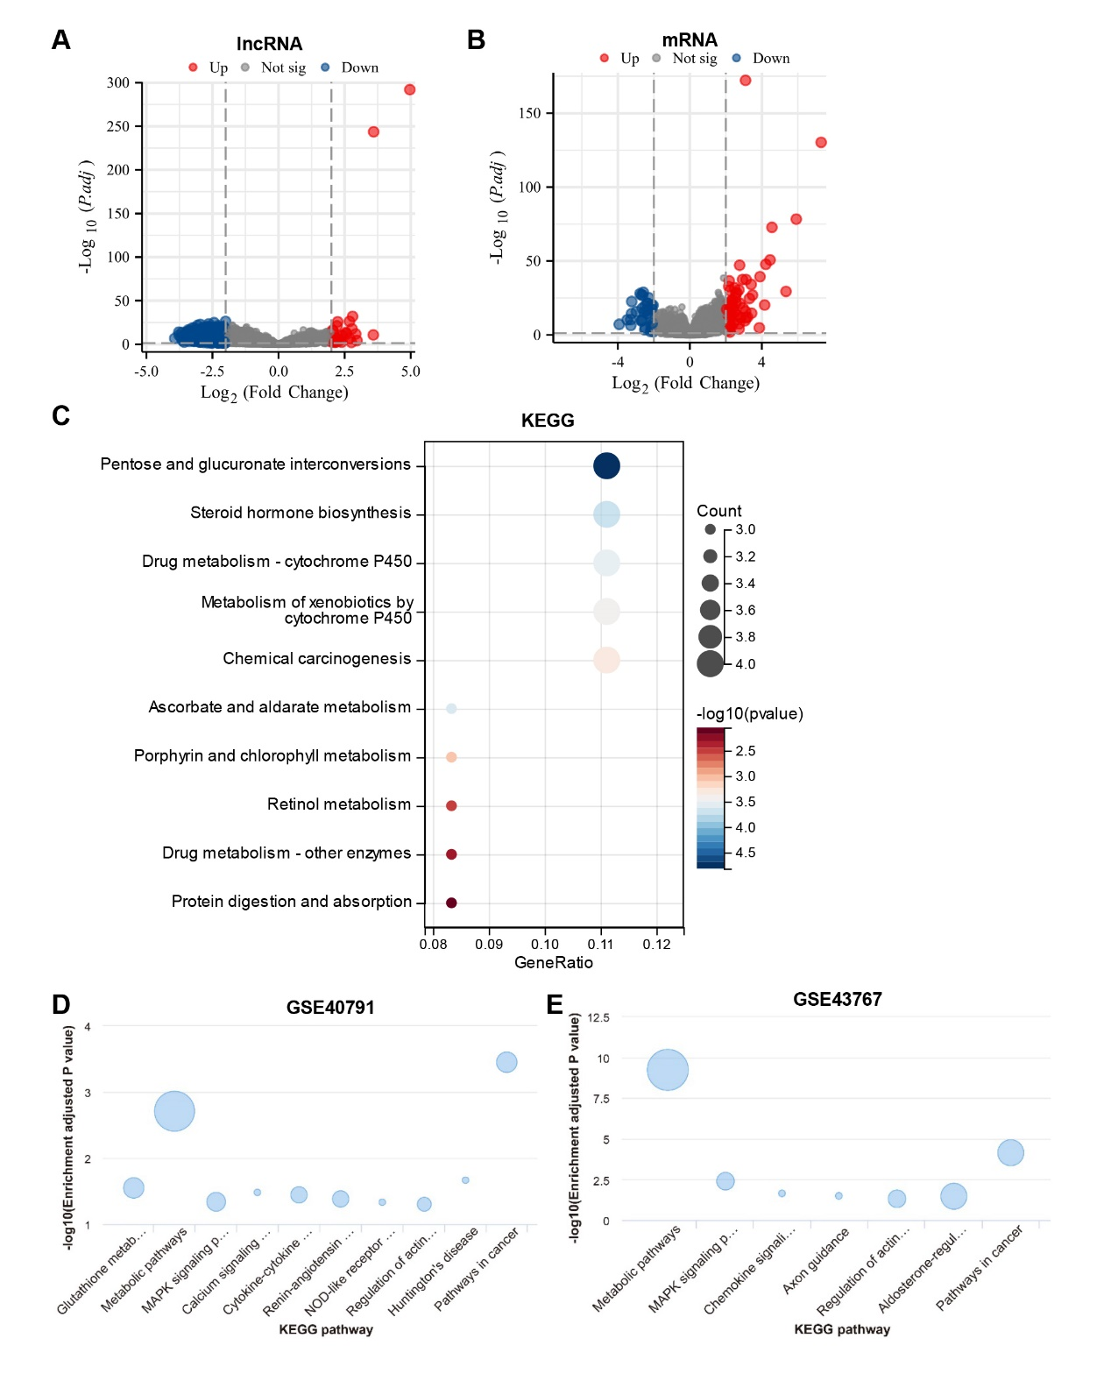
Figure S3. KEGG and GO enrichment analysis for AL365181.3.
(A) Volcano plot of differential lncRNA profiles between patients with high AL365181.3 expression and patients with low AL365181.3 expression. (B) Volcano plot of differential mRNA expression between the AL365181.3 high expression cohort and the AL365181.3 low expression cohort. (C) The KEGG term AL365181.3 analysis of the DEGs. (D-E) The KEGG results for AL365181.3 expression in the GSE40791 and GSE43767 cohorts.

