Supporting Information for
A fluorescent probe for Hg²⁺ specific recognition based on xanthene and its application in food detection and cell imaging
Chenglu Zhang *, Shiru Nie, Chang Liu, Yang Zhang, Jinghao Guo
School of Chemistry and Chemical Engineering, Liaoning Normal University, Dalian, Liaoning 116029, China

Contents

1. Materials and instruments 1
2. Preparation of stock solutions 2
3. Cell Culture 2
4. Experimental section 3
5.Tables 3
5.1 Table S1. Recognition site for Hg²⁺ 3
5.2 Table S2. Recovery rate of Hg²⁺ 4
6. Figures 5
6.1 Fig. S1 ¹H NMR of probe NXH 5
6.2 Fig. S2 ¹C NMR of probe NXH 6
6.3 Fig. S3 HRMS of probe NXH 6
6.4 Fig. S4 Job' s plot of binding of probe NXH and Hg²⁺ 7
6.5 Fig. S5 HRMS of probe NXH reacting with Hg²⁺ 7
6.6 Fig. S6 Density functional theory of probe NXH reacting with Hg²⁺ 7
6.7 Fig. S7 Cytotoxicity of NXH at different concentrations (0 ~ 20 μM) to Hela cells 8

1. Materials and instruments
All purchased reagents are of analytical purity and can be used directly in experiments without purification, and all experiments use deionized water. ¹H NMR (400 MHz) and ¹³C NMR (100 MHz) spectra were obtained using a Bruker Avance-500 spectrometer, with DMSO-d₆ as the solvent and tetramethylsilane (TMS) as the internal standard. Fluorescence measurements were performed using a Hitachi Instruments F-7000 fluorescence spectrophotometer with the specific parameters EX WL: 425 nm, EX slit: 5 nm, EM slit: 5 nm, and voltage: 500 V. IR and UV spectra were measured by a Bruker Tensor 27 FT-IR spectrometer and a Lambda 35 spectrophotometer, respectively. High-resolution mass spectrometry (HRMS) involved a Q-TOF6510 spectrograph (Agilent). The absorbance of MTT was measured by a microplate reader (Tecan Auatria GmbH A-5082). Confocal images of cells and tissues were captured by Nikon A1R MP.

2. Preparation of stock solutions
Preparation of PBS buffer solution (pH = 7.40): The volume was adjusted to 1000 mL by dissolving NaCl (8.0 g), KCl (0.2 g), Na₂HPO₄ (1.44 g) and KH₂PO₄ (0.24 g) in deionized water. Prepare the DMF solution of pH (2.1, 2.5, 3.1, 3.5, 4.1, 4.6, 5.1, 5.6, 6.1, 6.7, 7.1, 7.4, 8.7, 9.7, 10.7, 12.1) required for the experiment. Accurately weigh the NXH solid, dissolve with the prepared DMF solution with a concentration of 10 mM, during the test, the reserve solution is diluted with the DMF of the corresponding pH to 10 µM, test the mixed solution pH again, and then record the UV-visible absorption spectra and fluorescence emission spectra respectively. The initial concentration of the probe was 10 Mm and the final concentration of the probe was 10 µM.

3. Cell Culture
HeLa cells were first cultured in DMEM medium containing 10% fetal bovine serum and then in a 37℃ 5% CO₂ /95% air incubator. Prior to the imaging experiment, cells are seeded in laser confocal dishes and incubated overnight. To image Hg²⁺, Hela cells are divided into three groups. In the first set, HeLa cells were stained with 10 µM NXH in culture medium for 30 min. In the second group, HeLa cells were stained with NXH (10 µM) for 30 min and further incubated with Hg²⁺ (30 µM) for an additional 30 min. In the third group, HeLa cells were stained with NXH (10 µM) for 30 min and further incubated with Hg²⁺ (50 µM) for another 30 min. After rinsing the dish three times with pre-warmed PBS buffer, the cell imaging is observed and recorded under an Olympus FV1200-MPE multiphoton laser scanning confocal microscope.

4. Experimental section
Synthesis of intermediate Xn2: The mixed solution of dimethylformamide (5.6 mL, 72.5 mmol) and 30 mL chloroform was stirred thoroughly under ice bath conditions for 15 min, and the system temperature was maintained at 0 ℃. Phosphorus tribromide (6.2 mL, 65.3 mmol) was slowly added dropwise, stirred for about 45 min, and cyclohexanone (6.2 mL, 65.3 mmol) was added in N₂ atmosphere. The system temperature was restored to room temperature, stirring was continued for 18 h, and TLC was used to monitor the reaction process. After the reaction, the mixture was poured into ice water, the pH of the system was adjusted to neutral with saturated sodium bicarbonate solution, and the mixture was extracted with ethyl acetate (3×50 mL). The organic phase was collected, anhydrous magnesium sulfate was dried, and ethyl acetate was removed by rotary evaporation under reduced pressure to obtain the intermediate Xn1. Xn1 (0.48 g, 2.5 mmol) was dissolved in 10 mL of dimethylformamide, and 2-hydroxy-4-methoxy-benzaldehyde (0.38 g, 2.0 mmol) and cesium carbonate (1.88 g, 6.0 mmol) were stirred at room temperature and in N₂ atmosphere for 16 h, and TLC was used to monitor the reaction process. After the reaction, the mixture was filtered, the filter cake was rinsed three times with 100 mL of water, the filtrate was collected and extracted with ethyl acetate (3×100 mL), the organic phase was dried with anhydrous magnesium sulfate, and the crude product Xn2 was obtained by distillation of ethyl acetate under reduced pressure.

5.Tables

5.1 Table S1. Recognition site for Hg²⁺
Tab. S1. Structure and properties of various Hg²⁺ fluorescent probes
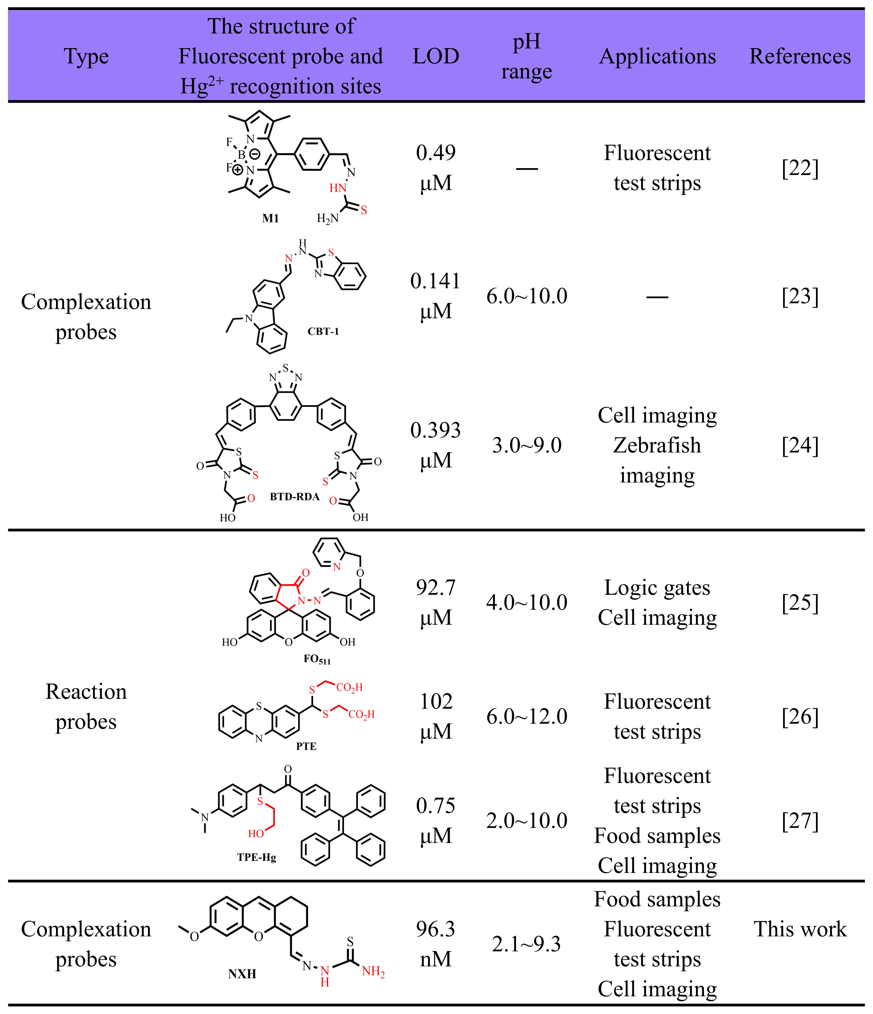

5.2 Table S2. Recovery rate of Hg²⁺

Tab. S2. Experiments on the recovery rate of Hg²⁺ in tea samples determined by probe NXH (10 µM)
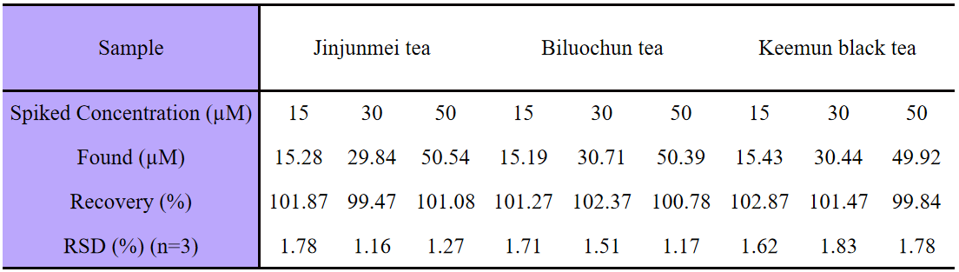

6. Figures

6.1 Fig. S1 ¹H NMR of probe NXH
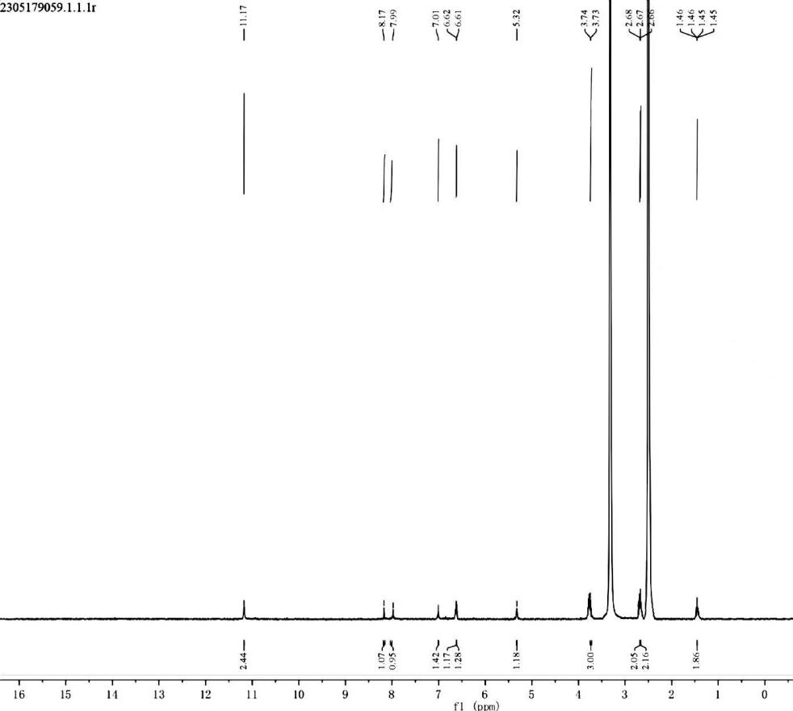
Fig. S1. ¹H NMR of probe NXH

6.2 Fig. S2 ¹C NMR of probe NXH
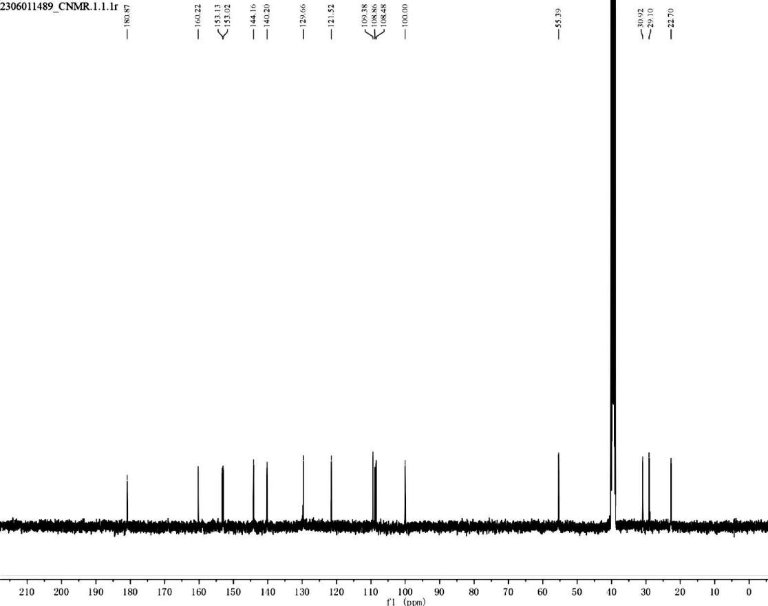
Fig. S2. ¹C NMR of probe NXH

6.3 Fig. S3 HRMS of probe NXH
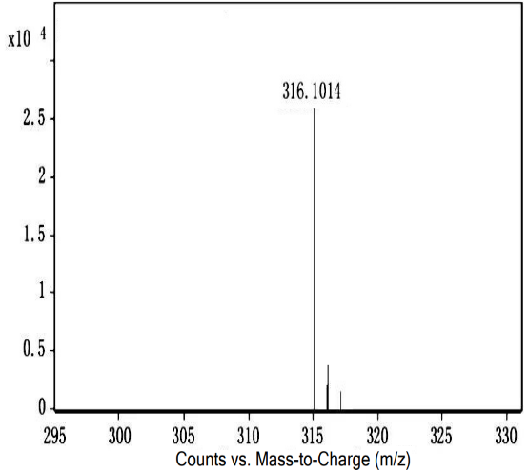
Fig. S3. HRMS of probe NXH

6.4 Fig. S4 Job' s plot of binding of probe NXH and Hg²⁺

Fig. S4. Job' s plot of binding of probe NXH and Hg²⁺

6.5 Fig. S5 HRMS of probe NXH reacting with Hg²⁺

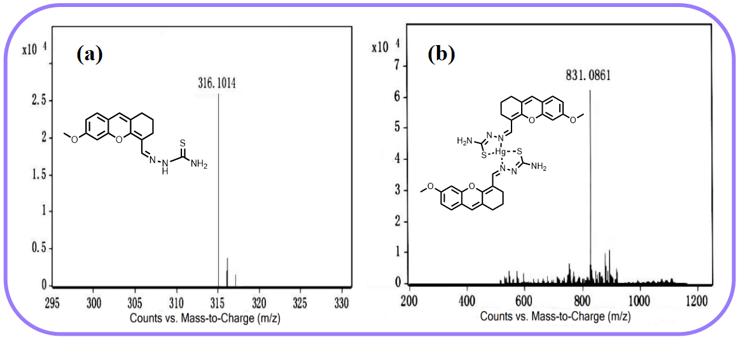
Fig. S5. HRMS of probe NXH reacting with Hg²⁺

6.6 Fig. S6 Density functional theory of probe NXH reacting with Hg²⁺

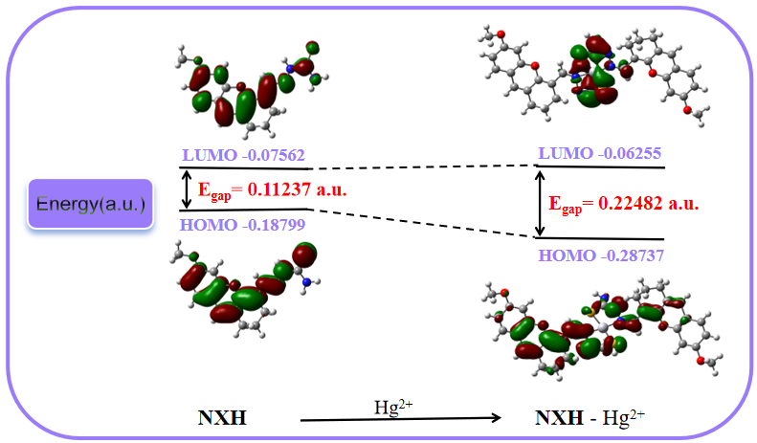
Fig. S6. Optimized structures of NXH and NXH-Hg²⁺ and their spatial distribution of frontline molecular orbitals

6.7 Fig. S7 Cytotoxicity of NXH at different concentrations (0 ~ 20 μM) to Hela cells

Fig. S7. Cytotoxicity of NXH at different concentrations (0 ~ 20 μM) to Hela cells

Corresponding author. Email address: zhangchenglu@lnnu.edu.cn (Chenglu Zhang)

