APPENDIX A: Daily Price Changes presented in ln(unit price) and percentage
Panel A: Milk; Dataset 1
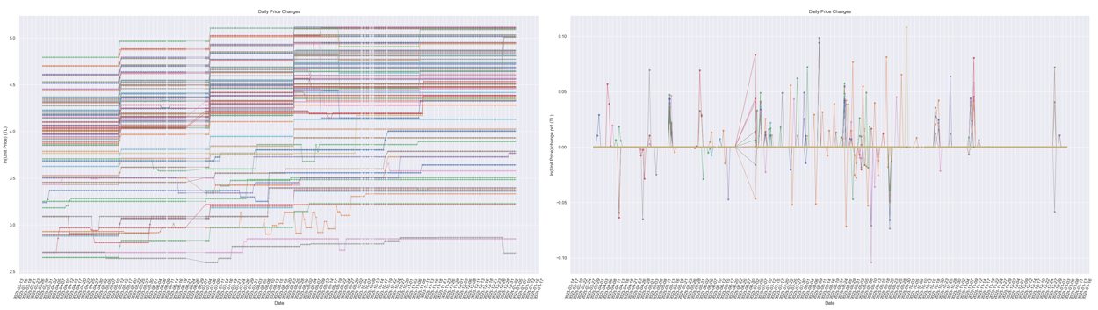
Panel A: Milk; Dataset 2
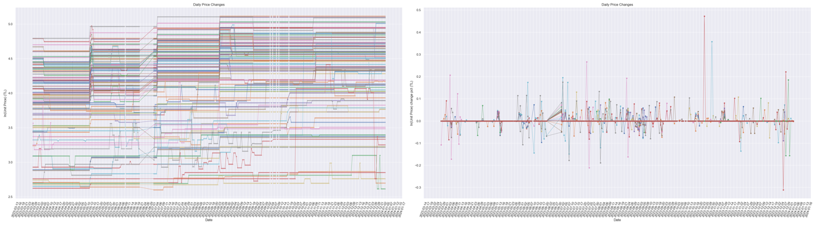
Panel B: Cereal; Dataset 1
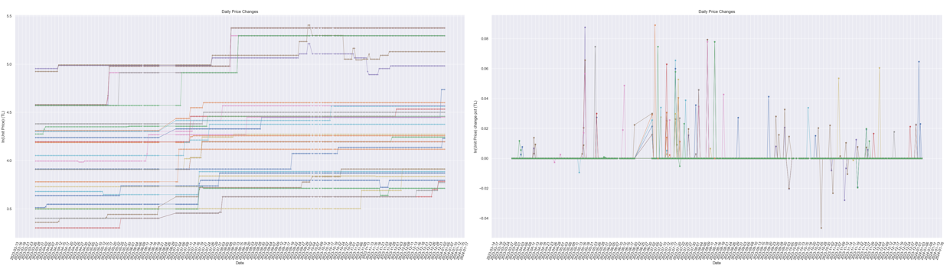
Panel B: Cereal; Dataset 2
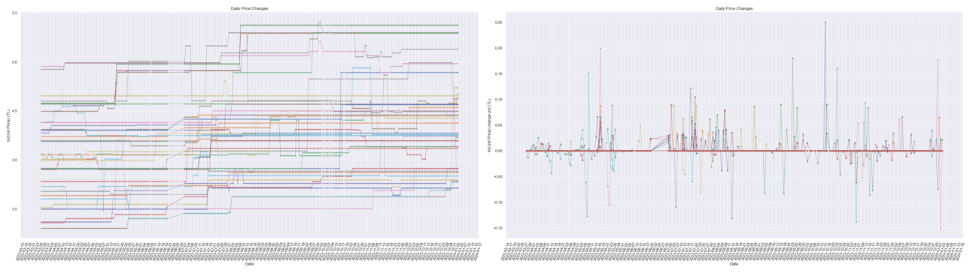
APPENDIX B: Regression Results
Window: 3 days
Tracking: 1 day
ML Technique: Elastic Net
Model Selection Criteria: min(MSE) & [Abs(Training Score – Test Score) < 5%]
High Frequency (HF) Quantile: 0.95 <= q <= 1
Low Frequency (LF) Quantile: 0 <= q < 0.95
 | Panel A: Milk |  | Panel B: Cereal
 | Dataset 1 | Dataset 2 | Dataset 1 | Dataset 2
Model Parameters | α: 0.0001  L1 Reg.: 0.150  Test Data: 30% | α: 0.005  L1 Reg.: 0.750  Test Data: 30% | α: 0.050  L1 Reg.: 0.350  Test Data: 30% | α: 0.050  L1 Reg.: 0.450  Test Data: 30%
Intercept | 0.124 | 0.080 | -0.002 | -0.029
P_{HF}: Periodic high frequency price changes | 0.021 | 0.020 | 0.000 | -0.000
D_{HF}: Periodic high frequency distance changes | 0.007 | 0.000 | 0.000 | 0.000
P_{LF}: Periodic low frequency price changes | -0.089 | -0.066 | 0.001 | 0.005
D_{LF}: Periodic low frequency distance changes | -0.021 | 0.000 | -0.000 | -0.000
∆Ravg: Absolute difference in average rating | -0.103 | -0.000 | -0.000 | -0.000
∆Rcount: Absolute difference in rating count | 0.030 | -0.000 | -0.000 | -0.000
∆C: Absolute difference in coupon availability | 0.001 | -0.000 | -0.011 | -0.004
∆SD: Absolute difference in same day shipping availability | 0.000 | 0.006 | 0.000 | 0.000
∆FS: Absolute difference in free shipping availability | 0.057 | -0.004 | -0.000 | -0.000
∆VC: Absolute difference in video content availability | 0.000 | 0.008 | 0.000 | 0.000
CPIfood: The Consumer Price Index of food | -0.185 | 0.000 | 0.000 | 0.000
PPI: The Producer Price Index | 0.144 | 0.000 | 0.000 | 0.000
PPIdairy: PPI of dairy | 0.126 | 0.000 | 0.005 | 0.000
PPIfeeds: PPI of animal feeds | 0.026 | 0.000 | 0.000 | 0.000
PPI of food | - | - | 0.000 | 0.000
PPI of grain products | - | - | 0.000 | 0.000
Mprod: Monthly production levels of milk | -0.034 | -0.017 | 0.006 | 0.000
Edummy: Election dummy (1) | 0.002 | 0.003 | 0.000 | 0.000
Rdummy: Reference raw milk price announcement dummy (1) | -0.007 | 0.001 | 0.000 | 0.000
CAdummy: The Turkish Competition Authority investigation announcement dummy (1) | 0.003 | -0.002 | 0.000 | 0.000
Training Score (%) | 64.50 | 45.92 | 10.41 | 6.15
Test Score (%) | 59.51 | 40.95 | 5.65 | 1.21
MSE | 0.084 | 0.078 | 9.94 | 0.087
Avg. Cross Validation Score (%)* | 55.08 | 36.10 | 15.73 | 9.42
Std. Cross Validation Score (%)* | 6.24 | 7.23 | 7.31 | 10.51
High Frequency (HF) Quantile: 0.90 <= q <= 1
Low Frequency (LF) Quantile: 0 <= q < 0.90
 | Panel A: Milk |  | Panel B: Cereal
 | Dataset 1 | Dataset 2 | Dataset 1 | Dataset 2
Model Parameters | α: 0.0001  L1 Reg.: 0.000  Test Data: 30% | α: 0.005  L1 Reg.: 0.500  Test Data: 30% | α: 0.010  L1 Reg.: 0.700  Test Data: 30% | α: 0.100  L1 Reg.: 0.250  Test Data: 30%
Intercept | 0.121 | 0.077 | -0.004 | -0.029
P_{HF}: Periodic high frequency price changes | 0.002 | 0.017 | 0.018 | -0.000
D_{HF}: Periodic high frequency distance changes | 0.009 | 0.004 | -0.000 | 0.000
P_{LF}: Periodic low frequency price changes | -0.080 | -0.067 | 0.000 | 0.010
D_{LF}: Periodic low frequency distance changes | -0.023 | 0.000 | -0.008 | -0.000
∆Ravg: Absolute difference in average rating | -0.116 | -0.009 | -0.010 | -0.000
∆Rcount: Absolute difference in rating count | 0.036 | -0.000 | -0.000 | -0.000
∆C: Absolute difference in coupon availability | 0.001 | -0.000 | -0.019 | -0.001
∆SD: Absolute difference in same day shipping availability | 0.000 | 0.009 | 0.015 | 0.000
∆FS: Absolute difference in free shipping availability | 0.059 | -0.000 | -0.000 | -0.000
∆VC: Absolute difference in video content availability | 0.000 | 0.008 | 0.000 | 0.000
CPIfood: The Consumer Price Index of food | -0.177 | 0.000 | 0.000 | 0.000
PPI: The Producer Price Index | 0.130 | 0.000 | 0.000 | 0.000
PPIdairy: PPI of dairy | 0.139 | 0.007 | 0.015 | 0.000
PPIfeeds: PPI of animal feeds | 0.022 | 0.001 | 0.000 | 0.000
PPI of food | - | - | 0.000 | 0.000
PPI of grain products | - | - | 0.000 | 0.000
Mprod: Monthly production levels of milk | -0.044 | -0.029 | 0.003 | 0.000
Edummy: Election dummy (1) | 0.002 | 0.001 | 0.000 | 0.000
Rdummy: Reference raw milk price announcement dummy (1) | -0.009 | 0.003 | 0.005 | 0.000
CAdummy: The Turkish Competition Authority investigation announcement dummy (1) | 0.003 | -0.004 | 0.000 | 0.000
Training Score (%) | 63.98 | 46.62 | 25.89 | 8.19
Test Score (%) | 60.00 | 41.73 | 21.19 | 3.25
MSE | 0.084 | 0.078 | 0.090 | 0.086
Avg. Cross Validation Score (%)* | 55.18 | 36.09 | 24.05 | 20.57
Std. Cross Validation Score (%)* | 6.43 | 7.41 | 8.41 | 11.17
High Frequency (HF) Quantile: 0.70 <= q <= 1
Low Frequency (LF) Quantile: 0 <= q < 0.70
Model Parameters | α: 0.0001  L1 Reg.: 0.000  Test Data: 30% | α: 0.005  L1 Reg.: 0.350  Test Data: 30% | α: 0.050  L1 Reg.: 0.300  Test Data: 30% | α: 7.000  L1 Reg.: 0.000  Test Data: 30%
Intercept | 0.132 | 0.075 | -0.002 | -0.027
P_{HF}: Periodic high frequency price changes | -0.015 | -0.000 | 0.004 | 0.002
D_{HF}: Periodic high frequency distance changes | -0.027 | -0.000 | -0.000 | 0.001
P_{LF}: Periodic low frequency price changes | -0.067 | -0.059 | 0.000 | 0.002
D_{LF}: Periodic low frequency distance changes | 0.010 | -0.000 | -0.000 | -0.001
∆Ravg: Absolute difference in average rating | -0.118 | -0.016 | -0.000 | 0.000
∆Rcount: Absolute difference in rating count | 0.051 | -0.000 | -0.000 | -0.000
∆C: Absolute difference in coupon availability | 0.002 | -0.000 | -0.012 | -0.003
∆SD: Absolute difference in same day shipping availability | 0.000 | 0.008 | 0.000 | 0.000
∆FS: Absolute difference in free shipping availability | 0.039 | -0.000 | -0.000 | -0.001
∆VC: Absolute difference in video content availability | 0.000 | 0.009 | 0.000 | 0.000
CPIfood: The Consumer Price Index of food | -0.206 | 0.000 | 0.000 | 0.000
PPI: The Producer Price Index | 0.133 | 0.000 | 0.000 | 0.000
PPIdairy: PPI of dairy | 0.148 | 0.024 | 0.008 | 0.001
PPIfeeds: PPI of animal feeds | 0.029 | 0.000 | 0.000 | 0.001
PPI of food | - | - | 0.000 | 0.000
PPI of grain products | - | - | 0.000 | 0.001
Mprod: Monthly production levels of milk | -0.039 | -0.044 | 0.007 | 0.000
Edummy: Election dummy (1) | 0.002 | 0.001 | 0.000 | 0.000
Rdummy: Reference raw milk price announcement dummy (1) | -0.008 | 0.000 | 0.000 | 0.000
CAdummy: The Turkish Competition Authority investigation announcement dummy (1) | 0.004 | -0.006 | 0.000 | 0.001
Training Score (%) | 64.20 | 45.39 | 12.81 | 6.15
Test Score (%) | 60.52 | 40.40 | 7.91 | 1.04
MSE | 0.084 | 7.86 | 0.098 | 0.087
Avg. Cross Validation Score (%)* | 53.96 | 33.41 | 19.14 | 15.25
Std. Cross Validation Score (%)* | 8.40 | 6.91 | 9.07 | 7.71
High Frequency (HF) Quantile: 0.50 <= q <= 1
Low Frequency (LF) Quantile: 0 <= q < 0.50
Model Parameters | α: 0.0001  L1 Reg.: 0.000  Test Data: 30% | α: 0.010  L1 Reg.: 0.125  Test Data: 30% | α: 0.050  L1 Reg.: 0.325  Test Data: 30% | α: 0.250  L1 Reg.: 0.075  Test Data: 30%
Intercept | 0.139 | 0.075 | -0.002 | -0.029
P_{HF}: Periodic high frequency price changes | -0.027 | -0.012 | 0.005 | 0.003
D_{HF}: Periodic high frequency distance changes | -0.062 | -0.006 | -0.000 | -0.000
P_{LF}: Periodic low frequency price changes | -0.058 | -0.050 | -0.000 | 0.000
D_{LF}: Periodic low frequency distance changes | 0.038 | -0.000 | -0.000 | -0.000
∆Ravg: Absolute difference in average rating | -0.122 | -0.021 | -0.000 | -0.000
∆Rcount: Absolute difference in rating count | 0.027 | -0.000 | -0.000 | -0.000
∆C: Absolute difference in coupon availability | 0.005 | 0.000 | -0.011 | -0.007
∆SD: Absolute difference in same day shipping availability | 0.000 | 0.009 | 0.000 | 0.000
∆FS: Absolute difference in free shipping availability | 0.066 | -0.000 | -0.000 | -0.000
∆VC: Absolute difference in video content availability | 0.000 | 0.010 | 0.000 | 0.000
CPIfood: The Consumer Price Index of food | -0.176 | 0.000 | 0.000 | 0.000
PPI: The Producer Price Index | 0.145 | 0.000 | 0.000 | 0.000
PPIdairy: PPI of dairy | 0.111 | 0.026 | 0.009 | 0.000
PPIfeeds: PPI of animal feeds | 0.026 | 0.000 | 0.000 | 0.000
PPI of food | - | - | 0.000 | 0.000
PPI of grain products | - | - | 0.000 | 0.000
Mprod: Monthly production levels of milk | -0.036 | -0.051 | 0.006 | 0.000
Edummy: Election dummy (1) | 0.002 | 0.000 | 0.000 | 0.000
Rdummy: Reference raw milk price announcement dummy (1) | -0.006 | 0.001 | 0.000 | 0.000
CAdummy: The Turkish Competition Authority investigation announcement dummy (1) | 0.003 | -0.008 | 0.000 | 0.000
Training Score (%) | 64.61 | 45.60 | 12.90 | 5.86
Test Score (%) | 61.32 | 40.68 | 7.91 | 1.03
MSE | 0.083 | 0.078 | 0.098 | 0.087
Avg. Cross Validation Score (%)* | 53.60 | 33.10 | 24.03 | 10.63
Std. Cross Validation Score (%)* | 8.83 | 7.99 | 6.88 | 7.93
* Cross Validation Scores are calculated by running the regression model 10 times with 30% randomly selected test data from the corresponding dataset each time.

