Supplemental Table 1. Diagnosis and procedure codes used in the present study in condition ascertainment
Supplemental Table 2. Descriptive characteristics of healthcare facilities treating acute type A aortic dissection in two cohorts
Supplemental Table 3. Predictive factors associated with overall survival in Chinese cohort of type A aortic dissection
Supplemental Table 4. Descriptive characteristics of surgical types of acute type A aortic dissection in Chinese cohorts
Supplemental Table 5. Impact of different surgical types on outcomes in Chinese cohorts

Supplemental Figure 1. Survival plot on long-term all-cause mortality in the Chinese cohort
Supplemental Figure 2. Crude and standardized complication trend charts for the Chinese and US cohorts
Supplemental Figure 3. Survival plot for subgroups of long-term all-cause mortality in the Chinese cohort
Supplemental Table 1. Diagnosis and procedure codes used in the present study in condition ascertainment
Projects | ICD-9 codes | ICD-10 codes
Thoracic aortic dissections | 441.01 | I71.01
Dissection of thoracoabdominal aorta | 441.03 | I71.03
Aortic aneurysms | 441.1-441.7,441.9 | I71.1-I71.6, I71.8, I71.9
Dissection repair
Resection of aorta, abdominal or thoracic vessels with replacement | 38.44-38.45 | 04R007Z,04R00JZ,04R00KZ,04R047Z,04R04JZ,04R04KZ,02RP07Z,02RP08Z,02RP0JZ,02RP0KZ,02RP47Z,02RP48Z,02RP4JZ,02RP4KZ,02RQ07Z,02RQ08Z,02RQ0JZ,02RQ0KZ,02RQ47Z,02RQ48Z,02RQ4JZ,02RQ4KZ,02RR07Z,02RR08Z,02RR0JZ,02RR0KZ,02RR47Z,02RR48Z,02RR4JZ,02RR4KZ,02RS07Z,02RS08Z,02RS0JZ,02RS0KZ,02RS47Z,02RS48Z,02RS4JZ,02RS4KZ,02RT07Z,02RT08Z,02RT0JZ,02RT0KZ,02RT47Z,02RT48Z,02RT4JZ,02RT4KZ,02RV07Z,02RV08Z,02RV0JZ,02RV0KZ,02RV47Z,02RV48Z,02RV4JZ,02RV4KZ,02RW07Z,02RW08Z,02RW0JZ,02RW0KZ,02RW47Z,02RW48Z,02RW4JZ,02RW4KZ,02RX07Z,02RX08Z,02RX0JZ,02RX0KZ,02RX47Z,02RX48Z,02RX4JZ,02RX4KZ,03R007Z,03R00JZ,03R00KZ,03R047Z,03R04JZ,03R04KZ,03R107Z,03R10JZ,03R10KZ,03R147Z,03R14JZ,03R14KZ,03R207Z,03R20JZ,03R20KZ,03R247Z,03R24JZ,03R24KZ,03R307Z,03R30JZ,03R30KZ,03R347Z,03R34JZ,03R34KZ,03R407Z,03R40JZ,03R40KZ,03R447Z,03R44JZ,03R44KZ,05R007Z,05R00JZ,05R00KZ,05R047Z,05R04JZ,05R04KZ,05R107Z,05R10JZ,05R10KZ,05R147Z,05R14JZ,05R14KZ,05R307Z,05R30JZ,05R30KZ,05R347Z,05R34JZ,05R34KZ,05R407Z,05R40JZ,05R40KZ,05R447Z,05R44JZ,05R44KZ,05R507Z,05R50JZ,05R50KZ,05R547Z,05R54JZ,05R54KZ,05R607Z,05R60JZ,05R60KZ,05R647Z,05R64JZ,05R64KZ
Resection of aorta or other thoracic vessels with anastomosis | 38.34-38.35 | 02BW0ZZ,02BW4ZZ,02BX0ZZ,02BX4ZZ,04B00ZZ,04B04ZZ,02BP0ZZ,02BP4ZZ,02BQ0ZZ,02BQ4ZZ,02BR0ZZ,02BR4ZZ,02BS0ZZ,02BS4ZZ,02BT0ZZ,02BT4ZZ,02BV0ZZ,02BV4ZZ,03B00ZZ,03B04ZZ,03B10ZZ,03B14ZZ,03B20ZZ,03B24ZZ,03B30ZZ,03B34ZZ,03B40ZZ,03B44ZZ,05B00ZZ,05B04ZZ,05B10ZZ,05B14ZZ,05B30ZZ,05B34ZZ,05B40ZZ,05B44ZZ,05B50ZZ,05B54ZZ,05B60ZZ,05B64ZZ
Repair of blood vessel with synthetic patch graft or unspecified type of patch graft | 39.57-39.58 | 02UP0JZ,02UP3JZ,02UP4JZ,02UQ0JZ,02UQ3JZ,02UQ4JZ,02UR0JZ,02UR3JZ,02UR4JZ,02US0JZ,02US3JZ,02US4JZ,02UT0JZ,02UT3JZ,02UT4JZ,02UV0JZ,02UV3JZ,02UV4JZ,02UW0JZ,02UX0JZ,03U00JZ,03U03JZ,03U04JZ,03U10JZ,03U13JZ,03U14JZ,03U20JZ,03U23JZ,03U24JZ,03U30JZ,03U33JZ,03U34JZ,03U40JZ,03U43JZ,03U44JZ,03U50JZ,03U53JZ,03U54JZ,03U60JZ,03U63JZ,03U64JZ,03U70JZ,03U73JZ,03U74JZ,03U80JZ,03U83JZ,03U84JZ,03U90JZ,03U93JZ,03U94JZ,03UA0JZ,03UA3JZ,03UA4JZ,03UB0JZ,03UB3JZ,03UB4JZ,03UC0JZ,03UC3JZ,03UC4JZ,03UD0JZ,03UD3JZ,03UD4JZ,03UF0JZ,03UF3JZ,03UF4JZ,03UG0JZ,03UG3JZ,03UG4JZ,03UH0JZ,03UH3JZ,03UH4JZ,03UJ0JZ,03UJ3JZ,03UJ4JZ,03UK0JZ,03UK3JZ,03UK4JZ,03UL0JZ,03UL3JZ,03UL4JZ,03UM0JZ,03UM3JZ,03UM4JZ,03UN0JZ,03UN3JZ,03UN4JZ,03UP0JZ,03UP3JZ,03UP4JZ,03UQ0JZ,03UQ3JZ,03UQ4JZ,03UR0JZ,03UR3JZ,03UR4JZ,03US0JZ,03US3JZ,03US4JZ,03UT0JZ,03UT3JZ,03UT4JZ,03UU0JZ,03UU3JZ,03UU4JZ,03UV0JZ,03UV3JZ,03UV4JZ,03UY0JZ,03UY3JZ,03UY4JZ,04U00JZ,04U03JZ,04U04JZ,04U10JZ,04U13JZ,04U14JZ,04U20JZ,04U23JZ,04U24JZ,04U30JZ,04U33JZ,04U34JZ,04U40JZ,04U43JZ,04U44JZ,04U50JZ,04U53JZ,04U54JZ,04U60JZ,04U63JZ,04U64JZ,04U70JZ,04U73JZ,04U74JZ,04U80JZ,04U83JZ,04U84JZ,04U90JZ,04U93JZ,04U94JZ,04UA0JZ,04UA3JZ,04UA4JZ,04UB0JZ,04UB3JZ,04UB4JZ,04UC0JZ,04UC3JZ,04UC4JZ,04UD0JZ,04UD3JZ,04UD4JZ,04UE0JZ,04UE3JZ,04UE4JZ,04UF0JZ,04UF3JZ,04UF4JZ,04UH0JZ,04UH3JZ,04UH4JZ,04UJ0JZ,04UJ3JZ,04UJ4JZ,04UK0JZ,04UK3JZ,04UK4JZ,04UL0JZ,04UL3JZ,04UL4JZ,04UM0JZ,04UM3JZ,04UM4JZ,04UN0JZ,04UN3JZ,04UN4JZ,04UP0JZ,04UP3JZ,04UP4JZ,04UQ0JZ,04UQ3JZ,04UQ4JZ,04UR0JZ,04UR3JZ,04UR4JZ,04US0JZ,04US3JZ,04US4JZ,04UT0JZ,04UT3JZ,04UT4JZ,04UU0JZ,04UU3JZ,04UU4JZ,04UV0JZ,04UV3JZ,04UV4JZ,04UW0JZ,04UW3JZ,04UW4JZ,04UY0JZ,04UY3JZ,04UY4JZ,05U00JZ,05U03JZ,05U04JZ,05U10JZ,05U13JZ,05U14JZ,05U30JZ,05U33JZ,05U34JZ,05U40JZ,05U43JZ,05U44JZ,05U50JZ,05U53JZ,05U54JZ,05U60JZ,05U63JZ,05U64JZ,05U70JZ,05U73JZ,05U74JZ,05U80JZ,05U83JZ,05U84JZ,05U90JZ,05U93JZ,05U94JZ,05UA0JZ,05UA3JZ,05UA4JZ,05UB0JZ,05UB3JZ,05UB4JZ,05UC0JZ,05UC3JZ,05UC4JZ,05UD0JZ,05UD3JZ,05UD4JZ,05UF0JZ,05UF3JZ,05UF4JZ,05UG0JZ,05UG3JZ,05UG4JZ,05UH0JZ,05UH3JZ,05UH4JZ,05UL0JZ,05UL3JZ,05UL4JZ,05UM0JZ,05UM3JZ,05UM4JZ,05UN0JZ,05UN3JZ,05UN4JZ,05UP0JZ,05UP3JZ,05UP4JZ,05UQ0JZ,05UQ3JZ,05UQ4JZ,05UR0JZ,05UR3JZ,05UR4JZ,05US0JZ,05US3JZ,05US4JZ,05UT0JZ,05UT3JZ,05UT4JZ,05UV0JZ,05UV3JZ,05UV4JZ,05UY0JZ,05UY3JZ,05UY4JZ,06U00JZ,06U03JZ,06U04JZ,06U10JZ,06U13JZ,06U14JZ,06U20JZ,06U23JZ,06U24JZ,06U30JZ,06U33JZ,06U34JZ,06U40JZ,06U43JZ,06U44JZ,06U50JZ,06U53JZ,06U54JZ,06U60JZ,06U63JZ,06U64JZ,06U70JZ,06U73JZ,06U74JZ,06U80JZ,06U83JZ,06U84JZ,06U90JZ,06U93JZ,06U94JZ,06UB0JZ,06UB3JZ,06UB4JZ,06UC0JZ,06UC3JZ,06UC4JZ,06UD0JZ,06UD3JZ,06UD4JZ,06UF0JZ,06UF3JZ,06UF4JZ,06UG0JZ,06UG3JZ,06UG4JZ,06UH0JZ,06UH3JZ,06UH4JZ,06UJ0JZ,06UJ3JZ,06UJ4JZ,06UM0JZ,06UM3JZ,06UM4JZ,06UN0JZ,06UN3JZ,06UN4JZ,06UP0JZ,06UP3JZ,06UP4JZ,06UQ0JZ,06UQ3JZ,06UQ4JZ,06UR0JZ,06UR3JZ,06UR4JZ,06US0JZ,06US3JZ,06US4JZ,06UT0JZ,06UT3JZ,06UT4JZ,06UV0JZ,06UV3JZ,06UV4JZ,06UY0JZ,06UY3JZ,06UY4JZ,02UP07Z,02UP08Z,02UP0JZ,02UP0KZ,02UP37Z,02UP3JZ,02UP3KZ,02UP47Z,02UP4JZ,02UP4KZ,02UQ07Z,02UQ08Z,02UQ0JZ,02UQ0KZ,02UQ37Z,02UQ38Z,02UQ3JZ,02UQ3KZ,02UQ47Z,02UQ48Z,02UQ4JZ,02UQ4KZ,02UR07Z,02UR08Z,02UR0JZ,02UR0KZ,02UR37Z,02UR38Z,02UR3JZ,02UR3KZ,02UR47Z,02UR48Z,02UR4JZ,02UR4KZ,02US07Z,02US08Z,02US0JZ,02US0KZ,02US37Z,02US38Z,02US3JZ,02US3KZ,02US47Z,02US48Z,02US4JZ,02US4KZ,02UT07Z,02UT08Z,02UT0JZ,02UT0KZ,02UT37Z,02UT38Z,02UT3JZ,02UT3KZ,02UT47Z,02UT48Z,02UT4JZ,02UT4KZ,02UV07Z,02UV08Z,02UV0JZ,02UV0KZ,02UV37Z,02UV38Z,02UV3JZ,02UV3KZ,02UV47Z,02UV48Z,02UV4JZ,02UV4KZ,02UW07Z,02UW08Z,02UW0JZ,02UW0KZ,02UW37Z,02UW38Z,02UW3JZ,02UW3KZ,02UW47Z,02UW48Z,02UW4JZ,02UW4KZ,02UX07Z,02UX08Z,02UX0JZ,02UX0KZ,02UX37Z,02UX38Z,02UX3JZ,02UX3KZ,02UX47Z,02UX48Z,02UX4JZ,02UX4KZ,03U00KZ,03U03KZ,03U04KZ,03U10KZ,03U13KZ,03U14KZ,03U20KZ,03U23KZ,03U24KZ,03U30KZ,03U33KZ,03U34KZ,03U40KZ,03U43KZ,03U44KZ,03U50KZ,03U53KZ,03U54KZ,03U60KZ,03U63KZ,03U64KZ,03U70KZ,03U73KZ,03U74KZ,03U80KZ,03U83KZ,03U84KZ,03U90KZ,03U93KZ,03U94KZ,03UA0KZ,03UA3KZ,03UA4KZ,03UB0KZ,03UB3KZ,03UB4KZ,03UC0KZ,03UC3KZ,03UC4KZ,03UD0KZ,03UD3KZ,03UD4KZ,03UF0KZ,03UF3KZ,03UF4KZ,03UG0KZ,03UG3KZ,03UG4KZ,03UH0KZ,03UH3KZ,03UH4KZ,03UJ0KZ,03UJ3KZ,03UJ4KZ,03UK0KZ,03UK3KZ,03UK4KZ,03UL0KZ,03UL3KZ,03UL4KZ,03UM0KZ,03UM3KZ,03UM4KZ,03UN0KZ,03UN3KZ,03UN4KZ,03UP0KZ,03UP3KZ,03UP4KZ,03UQ0KZ,03UQ3KZ,03UQ4KZ,03UR0KZ,03UR3KZ,03UR4KZ,03US0KZ,03US3KZ,03US4KZ,03UT0KZ,03UT3KZ,03UT4KZ,03UU0KZ,03UU3KZ,03UU4KZ,03UV0KZ,03UV3KZ,03UV4KZ,03UY0KZ,03UY3KZ,03UY4KZ,04U00KZ,04U03KZ,04U04KZ,04U10KZ,04U13KZ,04U14KZ,04U20KZ,04U23KZ,04U24KZ,04U30KZ,04U33KZ,04U34KZ,04U40KZ,04U43KZ,04U44KZ,04U50KZ,04U53KZ,04U54KZ,04U60KZ,04U63KZ,04U64KZ,04U70KZ,04U73KZ,04U74KZ,04U80KZ,04U83KZ,04U84KZ,04U90KZ,04U93KZ,04U94KZ,04UA0KZ,04UA3KZ,04UA4KZ,04UB0KZ,04UB3KZ,04UB4KZ,04UC0KZ,04UC3KZ,04UC4KZ,04UD0KZ,04UD3KZ,04UD4KZ,04UE0KZ,04UE3KZ,04UE4KZ,04UF0KZ,04UF3KZ,04UF4KZ,04UH0KZ,04UH3KZ,04UH4KZ,04UJ0KZ,04UJ3KZ,04UJ4KZ,04UK0KZ,04UK3KZ,04UK4KZ,04UL0KZ,04UL3KZ,04UL4KZ,04UM0KZ,04UM3KZ,04UM4KZ,04UN0KZ,04UN3KZ,04UN4KZ,04UP0KZ,04UP3KZ,04UP4KZ,04UQ0KZ,04UQ3KZ,04UQ4KZ,04UR0KZ,04UR3KZ,04UR4KZ,04US0KZ,04US3KZ,04US4KZ,04UT0KZ,04UT3KZ,04UT4KZ,04UU0KZ,04UU3KZ,04UU4KZ,04UV0KZ,04UV3KZ,04UV4KZ,04UW0KZ,04UW3KZ,04UW4KZ,04UY0KZ,04UY3KZ,04UY4KZ,05U00KZ,05U03KZ,05U04KZ,05U10KZ,05U13KZ,05U14KZ,05U30KZ,05U33KZ,05U34KZ,05U40KZ,05U43KZ,05U44KZ,05U50KZ,05U53KZ,05U54KZ,05U60KZ,05U63KZ,05U64KZ,05U70KZ,05U73KZ,05U74KZ,05U80KZ,05U83KZ,05U84KZ,05U90KZ,05U93KZ,05U94KZ,05UA0KZ,05UA3KZ,05UA4KZ,05UB0KZ,05UB3KZ,05UB4KZ,05UC0KZ,05UC3KZ,05UC4KZ,05UD0KZ,05UD3KZ,05UD4KZ,05UF0KZ,05UF3KZ,05UF4KZ,05UG0KZ,05UG3KZ,05UG4KZ,05UH0KZ,05UH3KZ,05UH4KZ,05UL0KZ,05UL3KZ,05UL4KZ,05UM0KZ,05UM3KZ,05UM4KZ,05UN0KZ,05UN3KZ,05UN4KZ,05UP0KZ,05UP3KZ,05UP4KZ,05UQ0KZ,05UQ3KZ,05UQ4KZ,05UR0KZ,05UR3KZ,05UR4KZ,05US0KZ,05US3KZ,05US4KZ,05UT0KZ,05UT3KZ,05UT4KZ,05UV0KZ,05UV3KZ,05UV4KZ,05UY0KZ,05UY3KZ,05UY4KZ,06U00KZ,06U03KZ,06U04KZ,06U10KZ,06U13KZ,06U14KZ,06U20KZ,06U23KZ,06U24KZ,06U30KZ,06U33KZ,06U34KZ,06U40KZ,06U43KZ,06U44KZ,06U50KZ,06U53KZ,06U54KZ,06U60KZ,06U63KZ,06U64KZ,06U70KZ,06U73KZ,06U74KZ,06U80KZ,06U83KZ,06U84KZ,06U90KZ,06U93KZ,06U94KZ,06UB0KZ,06UB3KZ,06UB4KZ,06UC0KZ,06UC3KZ,06UC4KZ,06UD0KZ,06UD3KZ,06UD4KZ,06UF0KZ,06UF3KZ,06UF4KZ,06UG0KZ,06UG3KZ,06UG4KZ,06UH0KZ,06UH3KZ,06UH4KZ,06UJ0KZ,06UJ3KZ,06UJ4KZ,06UM0KZ,06UM3KZ,06UM4KZ,06UN0KZ,06UN3KZ,06UN4KZ,06UP0KZ,06UP3KZ,06UP4KZ,06UQ0KZ,06UQ3KZ,06UQ4KZ,06UR0KZ,06UR3KZ,06UR4KZ,06US0KZ,06US3KZ,06US4KZ,06UT0KZ,06UT3KZ,06UT4KZ,06UV0KZ,06UV3KZ,06UV4KZ,06UY0KZ,06UY3KZ,06UY4KZ
Cardiac surgery
Cardioplegia | 39.63 | 3E080GC,3E083GC
Valve repair | 35.00-35.99 | 02NF3ZZ,02NF4ZZ,02NG3ZZ,02NG4ZZ,02NH3ZZ,02NH4ZZ,02NJ3ZZ,02NJ4ZZ,02NF3ZZ,02NF4ZZ,02NG3ZZ,02NG4ZZ,02NH3ZZ,02NH4ZZ,02NJ3ZZ,02NJ4ZZ,02RF37Z,02RF38Z,02RF3JZ,02RF3KZ,X2RF332,02RF37H,02RF38H,02RF3JH,02RF3KH,02RH37Z,02RH38Z,02RH3JZ,02RH3KZ,02RH37H,02RH38H,02RH3JH,02RH3KH,02RF37Z,02RF38Z,02RF3JZ,02RF3KZ,02RG37H,02RG37Z,02RG38H,02RG38Z,02RG3JH,02RG3JZ,02RG3KH,02RG3KZ,02RH37Z,02RH38Z,02RH3JZ,02RH3KZ,02QF0ZZ,02QG0ZZ,02QH0ZZ,02QJ0ZZ,027F04Z,027F0DZ,027F0ZZ,02NF0ZZ,02QF0ZZ,027G04Z,027G0DZ,027G0ZZ,02NG0ZZ,02QG0ZZ,027H04Z,027H0DZ,027H0ZZ,02NH0ZZ,02QH0ZZ,027J04Z,027J0DZ,027J0ZZ,02NJ0ZZ,02QJ0ZZ,02RF07Z,02RF08Z,02RF0JZ,02RF0KZ,02RF47Z,02RF48Z,02RF4JZ,02RF4KZ,02RG07Z,02RG08Z,02RG0JZ,02RG0KZ,02RG47Z,02RG48Z,02RG4JZ,02RG4KZ,02RH07Z,02RH08Z,02RH0JZ,02RH0KZ,02RH47Z,02RH48Z,02RH4JZ,02RH4KZ,02RJ07Z,02RJ08Z,02RJ0JZ,02RJ0KZ,02RJ47Z,02RJ48Z,02RJ4JZ,02RJ4KZ,02RF07Z,02RF08Z,02RF0KZ,02RF47Z,02RF48Z,02RF4KZ,X2RF032,X2RF432,02RF0JZ,02RF4JZ,02RG07Z,02RG08Z,02RG0KZ,02RG37Z,02RG38Z,02RG3KZ,02RG47Z,02RG48Z,02RG4KZ,02RG0JZ,02RG3JZ,02RG4JZ,02RH07Z,02RH08Z,02RH0KZ,02RH47Z,02RH48Z,02RH4KZ,02RH0JZ,02RH4JZ,02RJ07Z,02RJ08Z,02RJ0KZ,02RJ47Z,02RJ48Z,02RJ4KZ,02RJ0JZ,02RJ4JZ,028D0ZZ,028D3ZZ,028D4ZZ,02QD0ZZ,02QD3ZZ,02QD4ZZ,02890ZZ,02893ZZ,02894ZZ,02Q90ZZ,02Q93ZZ,02Q94ZZ,02QF0ZZ,02QF3ZZ,02QF4ZZ,02QG0ZZ,02QG3ZZ,02QG4ZZ,02QH0ZZ,02QH3ZZ,02QH4ZZ,02QJ0ZZ,02QJ3ZZ,02QJ4ZZ,02BK0ZZ,02BK3ZZ,02BK4ZZ,02NK0ZZ,02NK3ZZ,02NK4ZZ,02NL0ZZ,02NL3ZZ,02NL4ZZ,02QF0ZZ,02QF3ZZ,02QF4ZZ,02QA0ZZ,02QA3ZZ,02QA4ZZ,02B50ZZ,02B53ZZ,02B54ZZ,02RM0JZ,02RM4JZ,02U50JZ,02U53JZ,02U54JZ,02UM0JZ,02U50JZ,02U53JZ,02U54JZ,02RM0JZ,02UM0JZ,02UM3JZ,02UM4JZ,024G0J2,024J0J2,02QH4ZZ,02QJ4ZZ,02QJ3ZZ,02QJ0ZZ,02QH3ZZ,02QH0ZZ,02QG4ZZ,02QG3ZZ,02QG0ZZ,02QF4ZZ,02QF3ZZ,02QF0ZZ,02U50JZ,02U53JZ,02U54JZ,02UM0JZ,02UM3JZ,02UM4JZ,02RM4JZ,02RM07Z,02RM0KZ,02RM47Z,02RM4KZ,02U507Z,02U508Z,02U50KZ,02U537Z,02U538Z,02U53KZ,02U547Z,02U548Z,02U54KZ,02UM07Z,02UM0KZ,02UM37Z,02UM3KZ,02UM47Z,02UM4KZ,02U507Z,02U508Z,02U50KZ,02U537Z,02U538Z,02U53KZ,02U547Z,02U548Z,02U54KZ,02RM07Z,02RM0KZ,02RM47Z,02RM4KZ,02UM07Z,02UM0KZ,02UM38Z,02UM48Z,024G072,024G082,024G0K2,024J072,024J082,024J0K2,02RK07Z,02RK0KZ,02RK47Z,02RK4KZ,02RL07Z,02RL0KZ,02RL47Z,02RL4KZ,02U607Z,02U608Z,02U707Z,02U708Z,02U70KZ,02U737Z,02U738Z,02U73KZ,02U747Z,02U748Z,02U74KZ,02UK0KZ,02UK3KZ,02UK4KZ,02UL0KZ,02UL3KZ,02UL4KZ,02Q50ZZ,02Q53ZZ,02Q54ZZ,02QM0ZZ,02QM3ZZ,02QM4ZZ,02Q50ZZ,02Q53ZZ,02Q54ZZ,02QM0ZZ,02QM3ZZ,02QM4ZZ,02QB0ZZ,02QB3ZZ,02QB4ZZ,02QC0ZZ,02QC3ZZ,02QC4ZZ,02RM0JZ,02RP0JZ,02RQ0JZ,02RR0JZ,02BK0ZZ,02NH0ZZ,02170ZR,02170ZP,02170ZQ,02U70JZ,02LS0ZZ,02LT0ZZ,02RM0JZ,024F07J,024F08J,024F0JJ,024F0KJ,02RM0JZ,02LR0ZT,02VR0ZT,02RQ07Z,02RQ0JZ,02RR07Z,02RR0JZ,02S00ZZ,02S10ZZ,02SP0ZZ,02SW0ZZ,02SX0ZZ,02U50JZ,021K4AQ,021K4ZR,021K4ZQ,021K4ZP,021K4AR,021K4JP,021K4JQ,021K4KR,021K4JR,021K08P,021K4KP,021K4KQ,021K49R,021K08Q,021K08R,021K09P,021K09Q,021K09R,021K0AP,021K0AQ,021K0AR,021K0JP,021K0JQ,021K0JR,021K0KQ,021K4AP,021K49Q,021K49P,021K48R,021K48Q,021K48P,021K0ZR,021K0ZQ,021K0ZP,021K0KR,021K0KP,02LH0CZ,02LH0DZ,02LH0ZZ,02LH3CZ,02LH3DZ,02LH3ZZ,02LH4CZ,02LH4DZ,02LH4ZZ,021L0ZW,021L4ZW,021608P,021608Q,021608R,021609P,021609Q,021609R,02160AP,02160AQ,02160AR,02160JP,02160JQ,02160JR,02160KP,02160KQ,02160KR,02160ZP,02160ZQ,02160ZR,021648P,021648Q,021648R,021649P,021649Q,021649R,02164AP,02164AQ,02164AR,02164JP,02164JQ,02164JR,02164KP,02164KQ,02164KR,02164ZP,02164ZQ,02164ZR,02W50JZ,02W54JZ,02WF07Z,02WF08Z,02WF0JZ,02WF0KZ,02WF47Z,02WF48Z,02WF4JZ,02WF4KZ,02WG07Z,02WG08Z,02WG0JZ,02WG0KZ,02WG47Z,02WG48Z,02WG4JZ,02WG4KZ,02WH07Z,02WH08Z,02WH0JZ,02WH0KZ,02WH47Z,02WH48Z,02WH4JZ,02WH4KZ,02WJ07Z,02WJ08Z,02WJ0JZ,02WJ0KZ,02WJ47Z,02WJ48Z,02WJ4JZ,02WJ4KZ,02WM0JZ,02WM4JZ,027F3ZZ,027F4ZZ,027G3ZZ,027G4ZZ,027H3ZZ,027H4ZZ,027J3ZZ,027J4ZZ,02UG3JZ,02Q50ZZ,02Q53ZZ,02Q54ZZ,02QM0ZZ,02QM3ZZ,02QM4ZZ,02QF0ZJ,02QF0ZZ,02QF3ZJ,02QF4ZJ,02QG0ZE,02QG0ZZ,02QG3ZE,02QG4ZE,02QH0ZZ,02QJ0ZG,02QJ0ZZ,02QJ3ZG,02QJ4ZG
Operations on vessels of the heart | 36.00-36.99, 37.0, 37.20-37.29, 37.31-37.90, 37.93-37.99 | 0W9D30Z,0W9D3ZX,0W9D3ZZ,0W9D40Z,0W9D4ZX,0W9D4ZZ,4A02X4Z,4A02XFZ,4A020N6,4A023N6,4A020N7,4A023N7,4A020N8,4A023N8,02BN0ZX,02BN3ZX,02BN4ZX,02B40ZX,02B43ZX,02B44ZX,02B50ZX,02B53ZX,02B54ZX,02B60ZX,02B63ZX,02B64ZX,02B70ZX,02B73ZX,02B74ZX,02B80ZX,02B83ZX,02B84ZX,02B90ZX,02B93ZX,02B94ZX,02BD0ZX,02BD3ZX,02BD4ZX,02BF0ZX,02BF3ZX,02BF4ZX,02BG0ZX,02BG3ZX,02BG4ZX,02BH0ZX,02BH3ZX,02BH4ZX,02BJ0ZX,02BJ3ZX,02BJ4ZX,02BK0ZX,02BK3ZX,02BK4ZX,02BL0ZX,02BL3ZX,02BL4ZX,02BM0ZX,02BM3ZX,02BM4ZX,4A023FZ,3E053KZ,3E063KZ,02K80ZZ,02K83ZZ,02K84ZZ,B244YZZ,B244ZZZ,B245YZZ,B245ZZZ,B246YZZ,B246ZZZ,B24DYZZ,B24DZZZ,02JA3ZZ,0WJD0ZZ,0WJD3ZZ,02BN0ZZ,02BN3ZZ,02BN4ZZ,02TN0ZZ,02TN3ZZ,02TN4ZZ,02B60ZZ,02B63ZZ,02B64ZZ,02B70ZZ,02B73ZZ,02B74ZZ,02BK0ZZ,02BK3ZZ,02BK4ZZ,02BL0ZZ,02BL3ZZ,02BL4ZZ,02560ZZ,02570ZZ,025K0ZZ,025L0ZZ,02B60ZZ,02B70ZZ,02BK0ZZ,02BL0ZZ,02T80ZZ,02563ZZ,02573ZZ,025K3ZZ,025L3ZZ,02B63ZZ,02B73ZZ,02BK3ZZ,02BL3ZZ,02BK0ZZ,02BK3ZZ,02BK4ZZ,02BL0ZZ,02BL3ZZ,02BL4ZZ,02570ZK,02573ZK,02574ZK,02B70ZK,02B73ZK,02B74ZK,02L70ZK,02L73ZK,02L74ZK,02564ZZ,02574ZZ,025K4ZZ,025L4ZZ,02B64ZZ,02B74ZZ,02BK4ZZ,02BL4ZZ,02UA0JZ,02UA3JZ,02UA4JZ,02QA0ZZ,02QA3ZZ,02QA4ZZ,02QN0ZZ,02QN3ZZ,02QN4ZZ,02YA0Z0,02YA0Z1,02YA0Z2,02RK0JZ,02RL0JZ,02RK0JZ,02RL0JZ,02WA0JZ,02PA0JZ,5A02110,5A02210,02WA0QZ,02WA0RZ,02WA3QZ,02WA3RZ,02WA4QZ,02WA4RZ,02PA0QZ,02PA0RZ,02PA3QZ,02PA3RZ,02PA4QZ,02PA4RZ,02HA0QZ,02HA3QZ,02HA4QZ,02QA0ZZ,02QA3ZZ,02QA4ZZ,5A02116,5A0211D,5A02216,5A0221D,02HA3RZ,5A02216,02H40JZ,02H40MZ,02H44JZ,02H44MZ,02H60JZ,02H60MZ,02H63JZ,02H64JZ,02H64MZ,02H70JZ,02H70MZ,02H73JZ,02H74JZ,02H74MZ,02HK0JZ,02HK0MZ,02HK3JZ,02HK4JZ,02HK4MZ,02HL0JZ,02HL0MZ,02HL3JZ,02HL4JZ,02HL4MZ,02HK3JZ,02HK3MZ,02HL3JZ,02HL3MZ,02H63JZ,02H73JZ,02HN0JZ,02HN0MZ,02HN3JZ,02HN3MZ,02HN4JZ,02HN4MZ,02WA0MZ,02WA3MZ,02WA4MZ,02H63JZ,02H63MZ,02H73JZ,02H73MZ,02HK3JZ,02HL3JZ,02PA0MZ,02PA3MZ,02PA4MZ,02PAXMZ,5A1213Z,5A1223Z,0JH602Z,0JH632Z,0JWT02Z,0JWT0PZ,0JWT32Z,0JWT3PZ,0JH60PZ,0JH63PZ,0JH80PZ,0JH83PZ,0JH604Z,0JH634Z,0JH804Z,0JH834Z,0JH605Z,0JH635Z,0JH805Z,0JH835Z,0JH606Z,0JH636Z,0JH806Z,0JH836Z,0JPT0PZ,0JPT3PZ,0JWT0PZ,0JWT3PZ,02L70CK,02L70DK,02L73CK,02L73DK,02L74CK,02L74DK,02QA0ZZ,3E070GC,3E073GC,3E080GC,3E083GC,0JH608Z,0JH638Z,0JH838Z,0JH808Z,02H74KZ,02HL4KZ,02HL3KZ,02HL0KZ,02HK4KZ,02HK3KZ,02HK0KZ,02H73KZ,02H70KZ,02H64KZ,02H63KZ,02H60KZ,0JH808Z,0JH638Z,0JH608Z,0JH838Z,0JPT3PZ,0JPT0PZ,02PA0MZ,02PA3MZ,02PA4MZ,02PAXMZ,02HL3KZ,02HL4KZ,02HL0KZ,02HK4KZ,02HK3KZ,02HK0KZ,02H74KZ,02H73KZ,02H70KZ,02H64KZ,02H63KZ,02H60KZ,02H63KZ,02H73KZ,02HK3KZ,02HL3KZ,02HN0KZ,02HN4KZ,0JH608Z,0JH638Z,0JH808Z,0JH838Z,02H44KZ,02HN4KZ,02HN3KZ,02HN0KZ,02HL4KZ,02HL3KZ,02HL0KZ,02HK4KZ,02HK3KZ,02HK0KZ,02H74KZ,02H73KZ,02H70KZ,02H64KZ,02H63KZ,02H60KZ,02H40KZ,02PA0MZ,02PA3MZ,02PA4MZ,02PAXMZ,0JH608Z,0JH638Z,0JH808Z,0JH838Z,0JPT0PZ,0JPT3PZ,02QA0ZZ,02QA3ZZ,02QA4ZZ,0JPT0PZ,0JPT3PZ,0JWT0PZ,0JWT3PZ,02700ZZ,02710ZZ,02720ZZ,02730ZZ,02C00ZZ,02C10ZZ,02C20ZZ,02C30ZZ,3E07017,3E070PZ,3E07317,3E073PZ,02C03ZZ,02C04ZZ,02C13ZZ,02C14ZZ,02C23ZZ,02C24ZZ,02C33ZZ,02C34ZZ,0210093,02100A3,02100J3,02100K3,02100Z3,0210493,02104A3,02104J3,02104K3,02104Z3,021008W,021009W,02100AW,02100JW,02100KW,021048W,021049W,02104AW,02104JW,02104KW,021108W,021109W,02110AW,02110JW,02110KW,021148W,021149W,02114AW,02114JW,02114KW,021208W,021209W,02120AW,02120JW,02120KW,021248W,021249W,02124AW,02124JW,02124KW,021308W,021309W,02130AW,02130JW,02130KW,021348W,021349W,02134AW,02134JW,02134KW,021008F,021009F,02100AF,02100JF,02100KF,02100ZF,021048F,021049F,02104AF,02104JF,02104KF,02104ZF,0210083,0210093,02100A3,02100J3,02100K3,02100Z3,0210483,0210493,02104A3,02104J3,02104K3,02104Z3,021K0Z5,021L0Z5,021K4Z5,021L4Z5,02QA4ZZ,02QB4ZZ,02QC4ZZ,02QA3ZZ,02QB3ZZ,02QC3ZZ,0210344,02103D4,0210444,02104D4,0211344,02113D4,0211444,02114D4,0212344,02123D4,0212444,02124D4,0213344,02133D4,0213444,02134D4,02QA0ZZ,02QB0ZZ,02QC0ZZ,02Q00ZZ,02Q03ZZ,02Q04ZZ,02Q40ZZ,02Q43ZZ,02Q44ZZ,02Q00ZZ,02Q03ZZ,02Q04ZZ,02Q40ZZ,02Q43ZZ,02Q44ZZ,02HA0RS,02HA3RS,02HA4RS,5A02116,5A02216,02HA0RZ,02HA3RZ,02HA4RZ,5A02116,5A02216,02HA0RZ,02HA4RZ,5A02116,5A02216,02HK3JZ,02HL3JZ,02H63JZ,02H73JZ,02HN0JZ,02HN0MZ,02HN3JZ,02HN3MZ,02HN4JZ,02HN4MZ,02PA0MZ,02PA3MZ,02PA4MZ,02PAXMZ,02H63JZ,02H73JZ,02HK3JZ,02HK3MZ,02HL3JZ,02HL3MZ,02PA0MZ,02PA3MZ,02PA4MZ,02PAXMZ,0JH60PZ,0JH63PZ,0JH80PZ,0JH83PZ,0JPT0PZ,0JPT3PZ,0JH604Z,0JH634Z,0JH804Z,0JH834Z,0JPT0PZ,0JPT3PZ,0JH605Z,0JH635Z,0JH805Z,0JH835Z,0JPT0PZ,0JPT3PZ,0JH606Z,0JH636Z,0JH806Z,0JH836Z,0JPT0PZ,0JPT3PZ
TEVAR | 39.73 | 02UW3JZ,02UW4JZ,02UX3JZ,02UX4JZ,02VW0DZ,02VW3DZ,02VW4DZ,02VX0DZ,02VX3DZ,02VX4DZ
Comorbidity | ICD-9 | ICD-10
Chronic liver disease | 571.0-571.6, 571.8, 571.9, 571.40-571.42, 571.49 | K70.0, K70.10, K70.30, K70.9, K73.9, K73.0, K75.4, K73.2, K73.8, K74.0, K74.60, K74.69, K74.3, K74.4, K74.5, K76.0, K76.89
Type 2 diabetes | 250.00, 250.02, 250.10, 250.12, 250.20, 250.22, 250.30, 250.32, 250.40, 250.42, 250.50, 250.52, 250.60, 250.62, 250.70, 250.72, 250.80, 250.82, 250.90, 250.92 | E11.9, E11.65, E11.69, E13.10, E11.00, E11.01, E11.641, E11.29, E11.21, E11.311, E11.319, E11.36, E11.39, E11.40, E11.51, E11.618, E11.620, E11.621, E11.622, E11.628, E11.630, E11.638, E11.649, E11.8
Hypertension | 401.1, 401.9, 642.00-642.04, 401.0, 402.00, 402.10, 402.90, 403.00, 403.10, 403.90, 404.00, 404.10, 404.90, 405.01, 405.09, 405.11, 405.19, 405.91, 405.99, 642.10-642.24, 642.70-642.94 | I10, I16.9, O10.019, O10.919, O10.011, O10.012, O10.013, O10.02, O10.911, O10.912, O10.913, O10.92, O10.03, O10.93, I11.9, I12.9, I13.10, I15.0, I15.8, O10.419, O10.411, O10.412, O10.413, O10.42, O10.43, O10.119, O10.219, O10.319, O11.9, O10.111, O10.112, O10.113, O10.12, O10.211, O10.212, O10.213, O10.22, O10.311, O10.312, O10.313, O10.32, O11.1, O11.2, O11.3, O10.13, O10.23, O10.33, O11.4, O11.5, O16.9, O16.1, O16.2, O16.3, O16.4, O16.5
Dyslipidemia | 272.0, 272.1, 272.2, 272.3, 272.4 | E78.00, E78.01, E78.1, E78.3, E78.4, E78.5
Chronic kidney disease | 403.01, 403.11, 403.91, 404.02, 404.03, 404.12, 404.13, 404.92, 404.93, 582.x, 583.0-583.7, 585.x, 586.x, 588.0, V42.0, V45.1, V56.x | I12.0, I13.1, N03.2-N03.7, N05.2-N05.7, N18.x, N19.x, N25.0, Z49.0-Z49.2, Z94.0, Z99.2
Coronary artery disease (CAD) | 414.00-414.7 | I25.10, I25.810, I25.811, I25.812
Heart failure | 398.91, 402.01, 402.11, 402.91, 404.01, 404.11, 404.91, 428.20, 428.21, 428.22, 428.23, 428.0, 428.1, 428.30, 428.31, 428.32, 428.33, 428.40, 428.41, 428.42, 428.43, 428.9 | I09.81, I11.0, I13.0, I50.9, I50.1, I50.20, I50.21, I50.22, I50.23, I50.30, I50.31, I50.32, I50.33, I50.40, I50.41, I50.42, I50.43, I50.9
Stroke | 997.02, 431, 432.1, 434.91, 434.11, 434.01 | I61.9, I97.811, I97.812, I62.00, I63.50, I63.30, I63.40
COPD | 416.8, 416.9, 490.x-505.x, 506.4, 508.1, 508.8 | I27.8, I27.9, J40.x-J47.x, J60.x-J67.x, J68.4, J70.1, J70.3
Coagulopathy | 286.0-286.9, 287.1, 287.3-287.5, 289.81-289.82, 286.52, 286.53, 286.59, 287.30, 287.31, 287.32, 287.33, 287.39, 287.41, 287.49 | D66, D67, D68.1, D68.2, D68.0, D68.311, D68.312, D68.318, D65, D68.32, D68.4, D68.8, D68.9, D69.1, D69.49, D69.3, D69.41, D69.42, D69.3, D69.49, D69.51, D69.59, D69.6, D68.51, D68.52, D68.59, D68.61, D68.62, D68.69
Anemia | 280.1, 281.8, 281.9, 285.21, 285.22, 285.29, 285.9 | D50.8, D50.1, D50.9, D63.1, D63.0, D63.8, D64.9
Peripheral neurologic disorders | 330.0-331.9, 332.0, 333.4, 333.5, 334.0-335.9, 340, 341.1-341.9, 345.00-345.11, 345.2-345.3, 345.40-345.91, 348.1, 348.3-348.39, 780.3, 784.3 | E75.23, E75.25, E75.29, E75.02, E75.19, E75.4, G93.89, G93.9, F84.2,G31.81, G31.82, G31.9, G30.9, G31.01, G31.09, G31.1, G91.0, G91.1,G91.2, G31.85, G94, G93.7, G31.83, G31.84, G31.89, G20, G10, G25.4, G25.5, G11.1, G11.4, G11.0, G11.2, G32.81, G11.3, G11.8, G11.9, G12.0, G12.9, G12.1, G12.8, G12.21, G12.22, G12.29, G35, G37.0, G37.5, G37.3, G37.1, G37.2, G37.8, G37.9, G40.A01, G40.A09, G40.A11, G40.A19, G40.309, G40.409, G40.401, G40.311, G40.411, G40.419, G40.301, G40.201, G40.209, G40.101, G40.109, G40.821, G40.821, G40.822, G40.823, G40.824, G40.111, G40.119, G40.501, G40.509, G40.802, G40.804, G40.901, G40.909, G40.911, G40.919, G93.1, G93.40, G93.41, G93.49, I67.83, R56.00, R56.01, R56.1, R56.9,R47.01
Atrial fibrillation | 427.3x | I48.91, I48.92
Obesity | 278.0, 278.00, 278.01 | E66.9, E66.01, E66.3, E66.2
Peripheral vascular disorders | 440.0-440.9, 441.00-441.9, 442.0-442.9, 443.1-443.9, 447.1, 557.1, 557.9, V43.4 | I70.0, I70.1,
Marfan syndrome | 759.82 | Q87.40
Complication | ICD-9 | ICD-10
Respiratory
Hypoxia | 799.02 | R09.02
Pneumonia | 481, 482.0, 482.1, 482.2, 482.30, 482.31, 482.32, 482.39, 482.40, 482.41, 482.42, 482.49, 482.81, 482.82, 482.83, 482.89, 482.9, 483.0, 485, 486, 507.0, 997.31, 997.32 | J13, J18.1, J15.0, J15.1, J14, J15.4, J15.4, J15.3, J15.4, J15.20, J15.211, J15.212, J15.29, J15.8, J15.5, J15.6, J15.8, J15.9, J15.7, J18.0, J18.9, J69.0, J95.851, J95.89
Prolonged ventilation (>96h)a | 96.72 | 5A1955Z
Perioperative reintubation | 96.04, 96.05 | 0BH17EZ,0BH18EZ,0B717DZ,0B718DZ,0BH07DZ,0WHQ7YZ
Acute respiratory distress syndrome | 518.82 | J80
Respiratory failure | 518.5, 518.81, 518.83, 518.84 | J95.821, J96.00, J95.1, J95.2, J95.3, J96.00, J96.90, J96.20, J96.10
Cardiac
Cardiac arrest | 427.5 | I46.9
Prioperative arrhythmia | 427.1, 427.41, 427.42, 427.31, 427.0, 427.89, 427.32 | I47.2, I49.01, I49.02, I48.91, I47.1, I49.8, R00.1, I48.92
Heart conduction disturbance | 997.1 | I97.710, I97.790, I97.88, I97.89
Perioperative myocardial infarction | 410.1-410.6, 410.81, 410.91, 410.71 | I21.09, I21.19, I21.11, I21.29, I21.4, I21.3
Mitral/aortic stenosis/insufficiency | 396.0, 396.1, 396.2, 396.3 | I08.0
Tricuspid insufficiency | 397.0 | I07.1, I07.2, I07.8
Pericardial effusion | 423.0 | I31.2
Cardiac tamponade | 423.3 | I31.4
Renal
Peritoneal dialysis | 54.98 | 3E1M39Z
Hemodialysis | 39.95 | 5A1D00Z, 5A1D60Z, 5A1D70Z, 5A1D80Z, 5A1D90Z
Renal failure (requiring renal replacement therapy) | V42.0, V45.1, V56 | Z94.0, Z99.2, Z91.15, Z49.31, Z49.32
Permanent neurological deficits
Stroke | 433.01, 433.10, 433.11, 433.21, 433.31, 433.81, 433.91, 434.01, 434.11, 434.91, 436, 430, 431, 432.9 | I63.22, I65.29, I63.139, I63.239, I63.019, I63.119, I63.219, I63.59, I63.20, I63.30, I63.40, I63.50, I67.89, I60.9, I61.9, I62.9
Hemiplegia or paraplegia | 344.1, 342.x | G82.20, G81.00, G81.01, G81.02, G81.03, G81.04, G81.10, G81.11, G81.12, G81.13, G81.14, G81.90, G81.91, G81.92, G81.93, G81.94
Spinal cord complications | 952.0x, 952.1x | S14.101A, S14.102A, S14.103A, S14.104A, S14.105A, S14.106A, S14.107A, S14.108A, S14.111A, S14.112A, S14.113A, S14.114A, S14.115A, S14.116A, S14.117A, S14.118A, S14.131A, S14.132A, S14.133A, S14.134A, S14.135A, S14.136A, S14.137A, S14.138A, S14.121A, S14.122A, S14.123A, S14.124A, S14.125A, S14.126A, S14.127A, S14.128A, S14.151A, S14.152A, S14.153A, S14.154A, S14.155A, S14.156A, S14.157A, S14.158A, S24.101A, S24.102A,S24.103A, S24.104A, S24.111A, S24.112A, S24.113A, S24.114A, S24.131A, S24.132A, S24.133A, S24.134A, S24.151A, S24.152A, S24.153A, S24.154A
Temporary neurologic dysfunction
Transient ischemic attack | 435.8, 435.9 | G45.1, G45.8, G45.9, I67.848
Delirium | 290.11, 290.3, 290.41, 292.81, 293, 293.1, 292.11, 292.12 | F03.90, F05, F01.51, F19.921, F06.2, F06.0, F06.30, F06.4, F06.1, F53, F19.950, F19.951
Infectious
Bacteremia | 790.7 | R78.81
Sepsis | 995.91, 995.92, 038.0-038.9 | A41.9, R65.20, A40.9, A41.2, A41.01, A41.02, A41.1, A40.3, A41.4, A41.89, A41.9, A41.50, A41.3, A41.51, A41.52, A41.53
Wound infection | 998.51, 998.59 | T81.4XXA, K68.11
infections of mediastinum | 513.1 | J85.3
Pulmonary infection/pneumonia | 481, 482.0, 482.1, 482.2, 482.30, 482.31, 482.32, 482.39, 482.40, 482.41, 482.42, 482.49, 482.81, 482.82, 482.83, 482.89, 482.9, 483.0, 485, 486, 507.0, 997.31, 997.32 | J13, J18.1, J15.0, J15.1, J14, J15.4, J15.3, J15.20, J15.211, J15.212, J15.29, J15.8, J15.5, J15.6, J15.8, J15.9, J15.7, J18.0, J18.9, J69.0, J95.851, J95.89
Urinary tract infection | 599.0 | N39.0
Endocarditis | 421.0, 421.1, 421.9, 112.81, 364.2, 115.04, 115.14, 115.94, 424.90, 424.91, 424.99 | I33.0, I39, I33.9, B37.6, H20.819, H40.40X0, H20.23, H20.829, B39.4, I39, B39.5, B39.9, I38
Pericarditis | 420.0, 420.9 | I32, I30.9, I30.0, I30.8
Skin/soft tissue infection and infection of unknown site | 682, 686 | K12.2, L03.211, L03.212, L03.213, L03.211, L03.212, L03.221, L03.222, L03.319, L03.329, L03.119, L03.129, L03.317, L03.811, L03.818, L03.891, L03.898, L03.90, L03.91, L08.0, L88, L08.89, L98.0, E83.2, L08.9

Supplemental Table 2. Descriptive characteristics of healthcare facilities treating acute type A aortic dissection in two cohorts
 | US NIS cohort |  | Chinese cohort
 | N | (%) | N | (%)
Hospitals, n | 1115 |  | 11
Annual operation volume
1-9 | 752 | 67.44 | 5 | 45.45
10-49 | 359 | 32.20 | 5 | 45.45
50+ | 4 | 0.36 | 1 | 9.10
Region
Northeast | 191 | 17.1 | NA
Midwest | 277 | 24.8
South | 377 | 33.8
West | 270 | 24.2
Location and teaching status
Urban teaching | 961 | 86.2 | 11 | 100
Urban non-teaching | 136 | 12.2 | 0 | 0
Rural | 18 | 1.6 | 0 | 0
Ownership
Government, non-federal | 119 | 10.7 | 11 | 100
Private, nonprofit | 890 | 79.8 | 0 | 0
Private, investor-owned | 106 | 9.5 | 0 | 0
Bed size*
Large | 815 | 73.1 | 11 | 100
Medium | 231 | 20.7 | 0 | 0
Small | 69 | 6.2 | 0 | 0
Footnotes:
*For hospitals with more than one bed size categories, we considered the bed size category of the earliest occurrence as fixed variable across the study period.
Abbreviations: IQR, inter quartile range; NA, not applicable

Supplemental Table 3. Predictive factors associated with overall survival in Chinese cohort of type A aortic dissection
Characteristics | Crude model |  |  | Fully adjusted model
 | HR | (95% CI) | P-value | HR | (95% CI) | P-value
Demographics
Age | 1.03 | 1.02-1.04 | <.0001
≤49 | reference
50-59 | 0.89 | 0.59-1.33 | 0.56 | 0.78 | 0.48- 1.25 | 0.30
60-69 | 1.5 | 1.03-2.20 | 0.04 | 0.95 | 0.52-1.73 | 0.86
70+ | 2.87 | 1.92-4.29 | <.0001 | 1.87 | 0.95-3.69 | 0.07
Sex | 1.15 | 0.84-1.59 | 0.38 | 0.96 | 0.67-1.36 | 0.80
BMI | 1.03 | 0.93-1.14 | 0.58
Clinical characteristics
Charlson comorbidity index
0-2 | reference
3-4 | 1.79 | 1.28-2.51 | 0.0007 | 1.37 | 0.81-2.33 | 0.23
5+ | 5.8 | 4.05-8.30 | <.0001 | 2.24 | 1.09-4.62 | 0.03
Type 2 diabetes | 1.7 | 1.05-2.73 | 0.03
Hypertension | 1.44 | 0.96-2.15 | 0.08
Dyslipidemia | 1.52 | 0.82-2.80 | 0.18
Chronic kidney disease | 3.05 | 1.94-4.78 | <.0001 | 2.32 | 1.36-3.94 | 0.002
Coronary artery disease | 1.85 | 1.15-2.98 | 0.01
Heart failure | 2.79 | 1.97-3.96 | <.0001 | 1.75 | 1.16-2.65 | 0.007
liver disease | 4.19 | 2.78-6.33 | <.0001 | 2.33 | 1.44-3.78 | 0.001
Stroke | 4.07 | 2.78-5.95 | <.0001 | 2.48 | 1.64-3.76 | <.0001
Total arch | reference
Ascending/hemi-arch | 0.71 | 0.47-1.08 | 0.13 | 0.6 | 0.38-0.95 | 0.03
Single* | reference
Compound** | 1.46 | 1.09-1.95 | 0.01 | 1.49 | 1.08-2.06 | 0.01
Footnotes:
*Only total arch or ascending/ hemi-arch were used in TAAD patients
**TAAD patients were treated with total arch or ascending/hemi-arch in combination with at least one of the following operations: Aortic valve replacement, Root replacement, Aortic valvuloplasty, Coronary artery bypass grafting, Bypass surgery, Mitral valve replacement or plasty and Pacemaker implantation
Supplemental Table 4. Descriptive characteristics of surgical types of acute type A aortic dissection in Chinese cohorts
Surgical types |  | 2012-2013 |  | 2014-2015 |  | 2016-2017 |  | 2018-2019 |  | 2020-2021 |  | Total
 |  | N=108 | % | N=135 | % | N=162 | % | N=274 | % | N=393 | % | N=1073 | %
Total arch |  | 84 | 77.8% | 114 | 84.5% | 144 | 88.9% | 225 | 82.1% | 298 | 75.9% | 865 | 80.7%
Ascending/hemi-arch |  | 24 | 22.2% | 21 | 15.6% | 18 | 11.1% | 49 | 17.9% | 95 | 24.1% | 207 | 19.3%
Single* |  | 54 | 50.0% | 87 | 64.4% | 97 | 59.9% | 210 | 76.6% | 272 | 69.2% | 720 | 67.2%
Compound** |  | 54 | 50.0% | 48 | 35.6% | 65 | 40.1% | 64 | 23.4% | 121 | 30.8% | 352 | 32.8%
Combination
Total arch | single | 47 | 43.5% | 75 | 55.6% | 87 | 53.7% | 165 | 60.2% | 207 | 52.7% | 581 | 54.2%
Total arch | compound* | 37 | 34.3% | 39 | 28.9% | 57 | 35.2% | 60 | 21.9% | 91 | 23.2% | 284 | 26.5%
Ascending  /hemi-arch | single | 7 | 6.5% | 12 | 8.9% | 10 | 6.2% | 45 | 16.4% | 65 | 16.5% | 139 | 13.0%
Ascending  /hemi-arch | compound* | 17 | 15.7% | 9 | 6.7% | 8 | 4.8% | 4 | 1.5% | 30 | 7.6% | 68 | 6.3%
Footnotes:
*Only total arch or ascending/hemi-arch were used in TAAD patients
**TAAD patients were treated with total arch or ascending/hemi-arch in combination with at least one of the following operations: Aortic valve replacement, Root replacement, Aortic valvuloplasty, Coronary artery bypass grafting, Bypass surgery, Mitral valve replacement or plasty and Pacemaker implantation
Supplemental Table 5. Impact of different surgical types on outcomes in Chinese cohorts
Outcomes | Ascending/  hemi-arch  N=207 | Total arch  N=865 | P value | Single*  N=720 | Compound**  N=353 | P value
in-hospital mortality | 9.7 | 14.2 | 0.083 | 11.7 | 16.7 | 0.022
Patients hospitalized for 1-10 days | 61.1 | 82.4 | 0.045 | 70.8 | 92.1 | 0.011
Patients hospitalized for 11-20 days | 4.2 | 5.8 | 0.55 | 4.5 | 7.1 | 0.26
Patients hospitalized for 21-30 days | 3.3 | 6.7 | 0.31 | 5.2 | 8.1 | 0.29
Patients hospitalized for 30+ days | 9.1 | 9.3 | 0.97 | 9.6 | 8.3 | 0.80
Los, days |  |  | 0.51 |  |  | 0.13
Patients hospitalized for 1-10 days | 8.7 | 9.8 |  | 9.0 | 10.8
Patients hospitalized for 11-20 days | 15.9 | 17.5 |  | 39.9 | 44.2
Patients hospitalized for 21-30 days | 29.5 | 32.6 |  | 32.2 | 31.4
Patients hospitalized for 30+ days | 45.9 | 40.1 |  | 18.9 | 13.6
Costs, in 1,000 US dollar# |  |  | 0.0003 |  |  | 0.88
Patients hospitalized for 1-10 days | 26.1 (20.3-29.7) | 30.0 (23.9-33.3) |  | 27.9 (23.0-32.6) | 31.5 (24.0-33.3)
Patients hospitalized for 11-20 days | 28.4 (24.5-32.1) | 31.7 (26.5-33.1) |  | 30.1 (26.1-33.0) | 32.9 (26.8-32.8)
Patients hospitalized for 21-30 days | 33.1 (27.8-35.1) | 35.7 (29.0-38.2) |  | 34.7 (28.5-37.2) | 36.3 (29.3-38.3)
Patients hospitalized for 30+ days | 44.9 (31.8-49.4) | 52.1 (33.6-61.0) |  | 50.7 (34.5-54.6) | 51.0 (31.6-62.8)
Footnotes:
*Only total arch or ascending/hemi-arch were used in TAAD patients
**TAAD patients were treated with total arch or ascending/hemi-arch in combination with at least one of the following operations: Aortic valve replacement, Root replacement, Aortic valvuloplasty, Coronary artery bypass grafting, Bypass surgery, Mitral valve replacement or plasty and Pacemaker implantation
# Use nonparametric test
Supplemental Figure 1. Survival plot on long-term all-cause mortality in the Chinese cohort
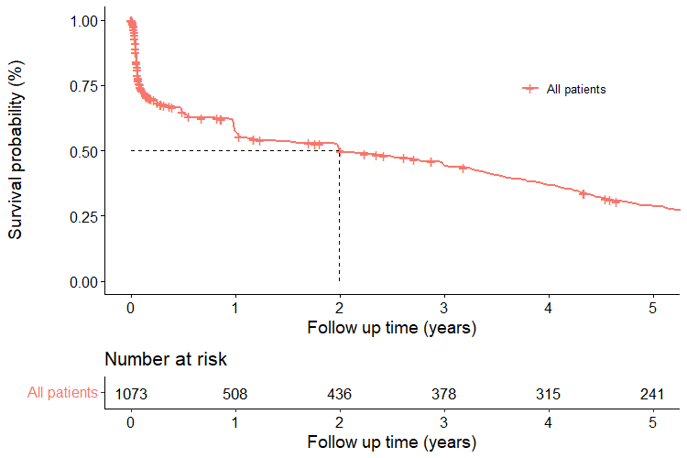

Supplemental Figure 2. Crude and standardized complication trend charts for the Chinese and US cohorts
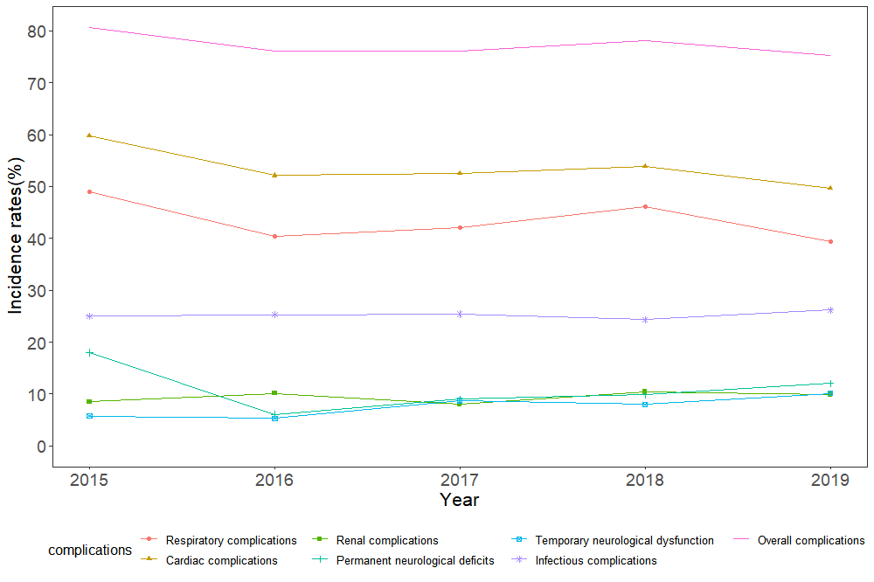
- Crude complication trend for the US cohort
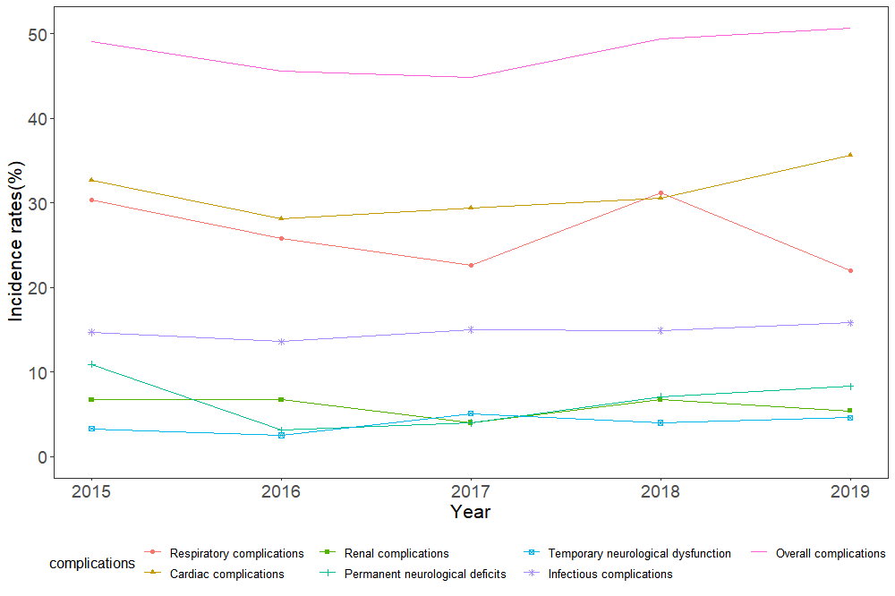
- Standardized complication trend for the US cohort
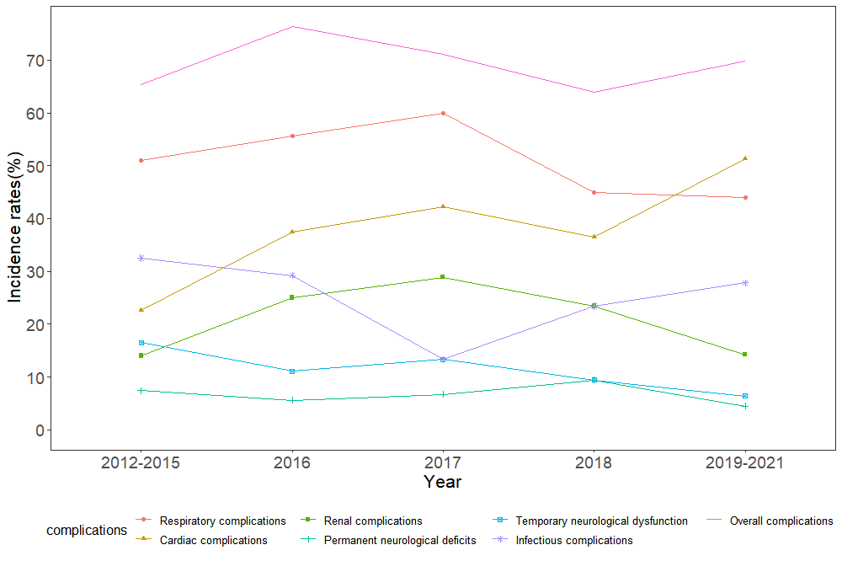
- Crude complication trend for the Chinese cohort
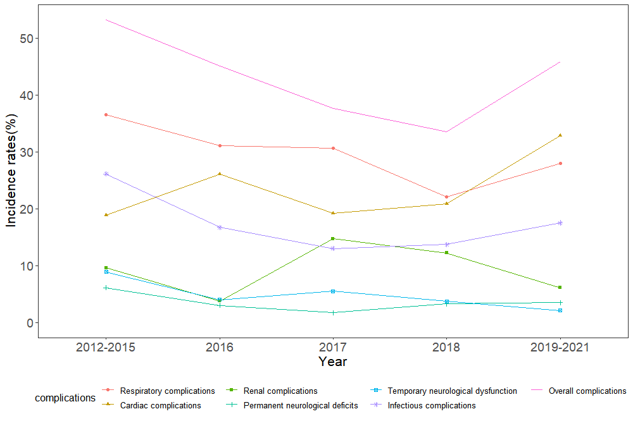
- Standardized complication trend for the Chinese cohort

Supplemental Figure 3. Survival plot for subgroups of long-term all-cause mortality in the Chinese cohort
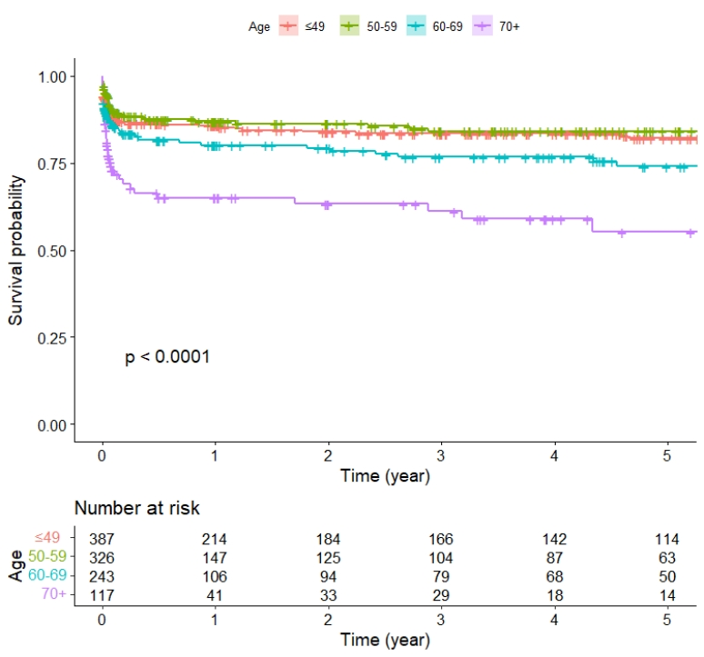
- Age-related survival plot of long-term all-cause mortality
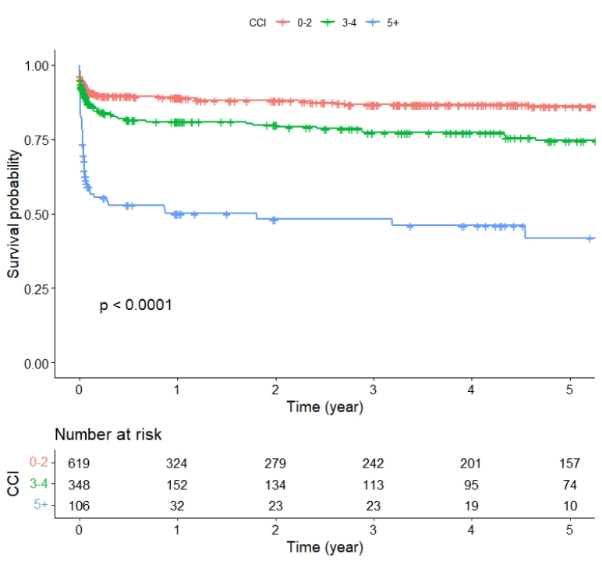
- Charlson comorbidity index-related survival plot of long-term all-cause mortality
Abbreviations: CCI: Charlson comorbidity index.
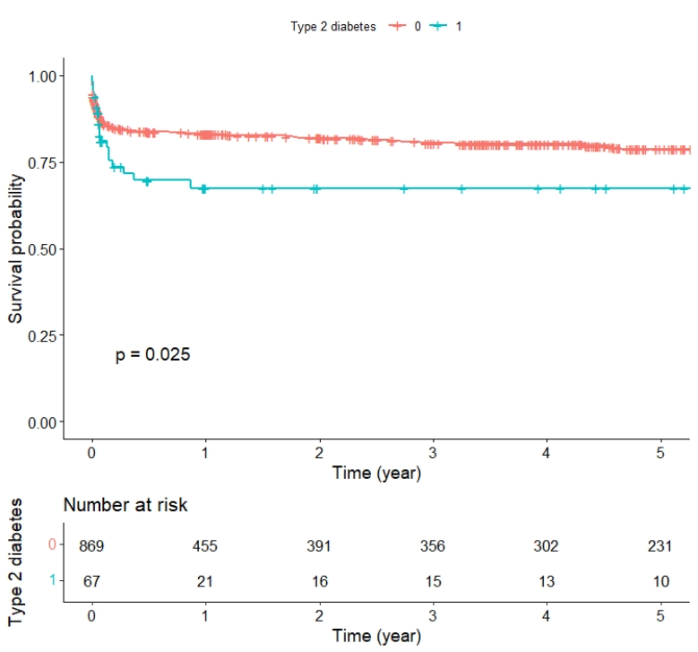
- Type 2 diabetes-related survival plot of long-term all-cause mortality
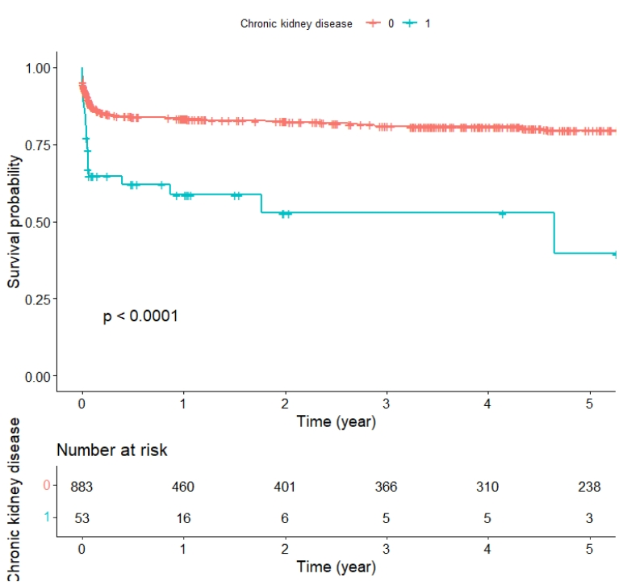
- Chronic kidney disease-related survival plot of long-term all-cause mortality
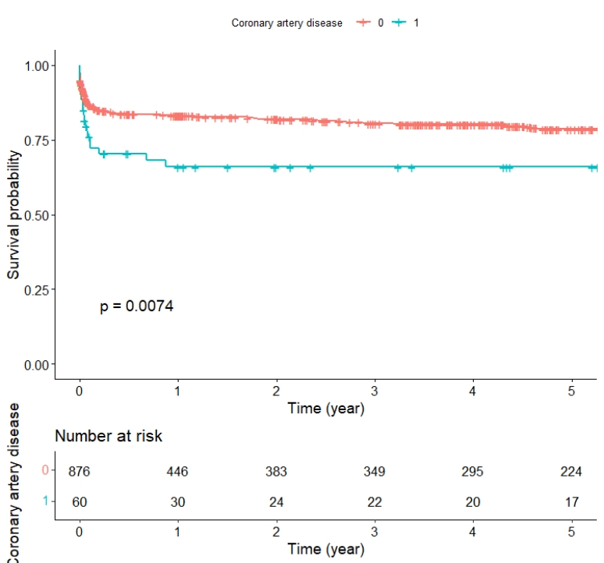
- Chronic artery disease-related survival plot of long-term all-cause mortality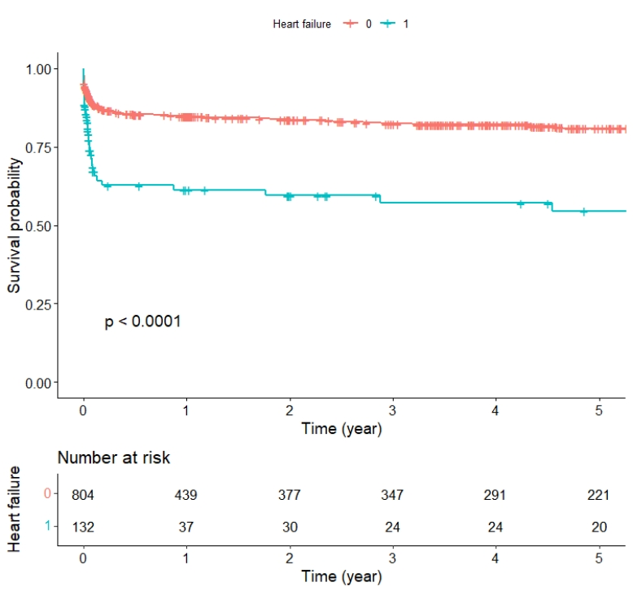
- Heart failure-related survival plot of long-term all-cause mortality
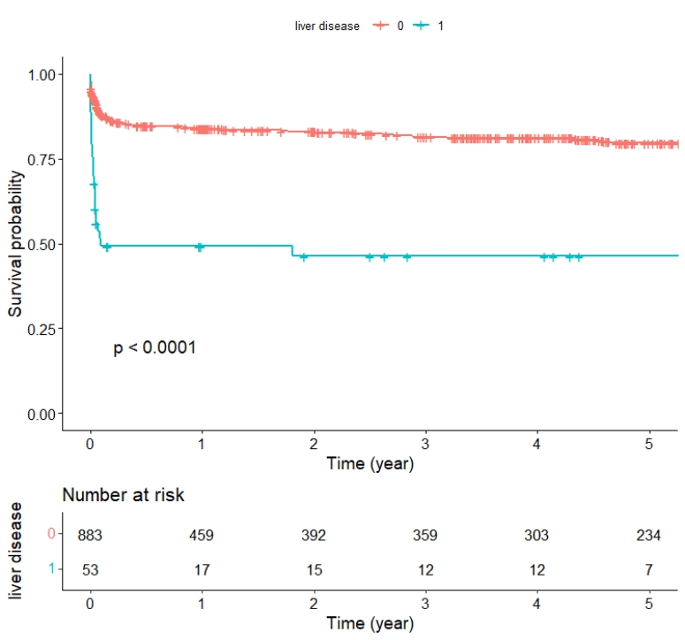
- Liver disease-related survival plot of long-term all-cause mortality
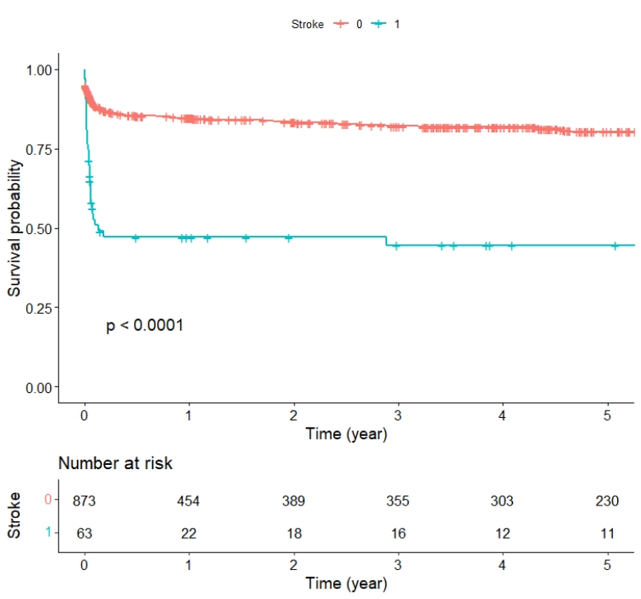
- Stroke-related survival plot of long-term all-cause mortality
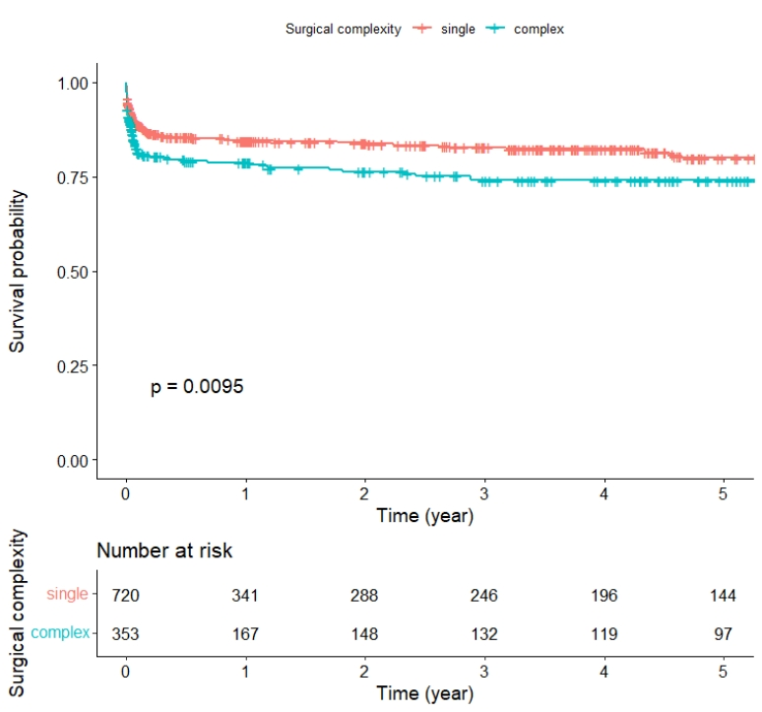
Surgical complexity-related survival plot of long-term all-cause mortality

