Title:

Molybdenum-based Metallic Cluster-type Memristor exhibiting Stochastic Switching and Analog-state Programmable Characteristics and its Utilization for Homomorphic Encryption Hardware

Authors: Woon Hyung Cheong, Jae Hyun In, Jae Bum Jeon, Geunyoung Kim, and Kyung Min Kim

W. H. Cheong
Applied Science Research Institute
Korea Advanced Institute of Science and Technology (KAIST),
Daejeon 34141, Republic of Korea.

J. H. In, J. B. Jeon, G. Kim, Prof. K. M. Kim
Department of Materials Science and Engineering
Korea Advanced Institute of Science and Technology (KAIST),
Daejeon 34141, Republic of Korea.

Supplementary Tables
Test # | Test name | P-value | Result
1 | Frequency (Monobit) | 0.011412036 | Pass
2 | Frequency within a block | 0.550717949 | Pass
3 | Runs | 0.532759772 | Pass
4 | Longest run of ones in a block | 0.348025369 | Pass
5 | Binary matrix rank | 0.015710521 | Pass
6 | Discrete Fourier transform (Spectral) | 0.771670504 | Pass
7 | Non-overlapping template matching | 1.00 | Pass
8 | Maurer’s universal | 0.988785497 | Pass
9 | Linear complexity | 0.999995031 | Pass
10 | Serial | 0.761854261 | Pass
11 | Approximate entropy | 0.999520079 | Pass
12 | Cumulative sums | 0.017345555 | Pass
13 | Random excursions | 0.950167133 | Pass
14 | Random excursions variant | 0.910979293 | Pass
Table S1. NIST test results for evaluating random number generation performance required for homomorphic encryption.

Supplementary Figures

Fig. S1. Electrical characteristics of Ru-ECM (Pt/Ta₂O₅/Ru) memristors. a) I-V characteristic of a Ru-ECM memristor with 5 repetitions, which shows stable and repetitive switching behavior. b) Schematic image for a vertical structure of Ru-ECM memristors. The bottom Pt electrode was deposited using E-beam evaporation with a thickness of 40 nm, followed by a deposition of 20 nm of Ta₂O₅ using DC reactive sputtering with a Ta target. The top Ru electrode was deposited with a thickness of 40 nm using DC sputtering.

Fig. S2. Electrical characteristics of a-Si transistor. a) Transfer characteristics and b) Output characteristics of the a-Si transistor.

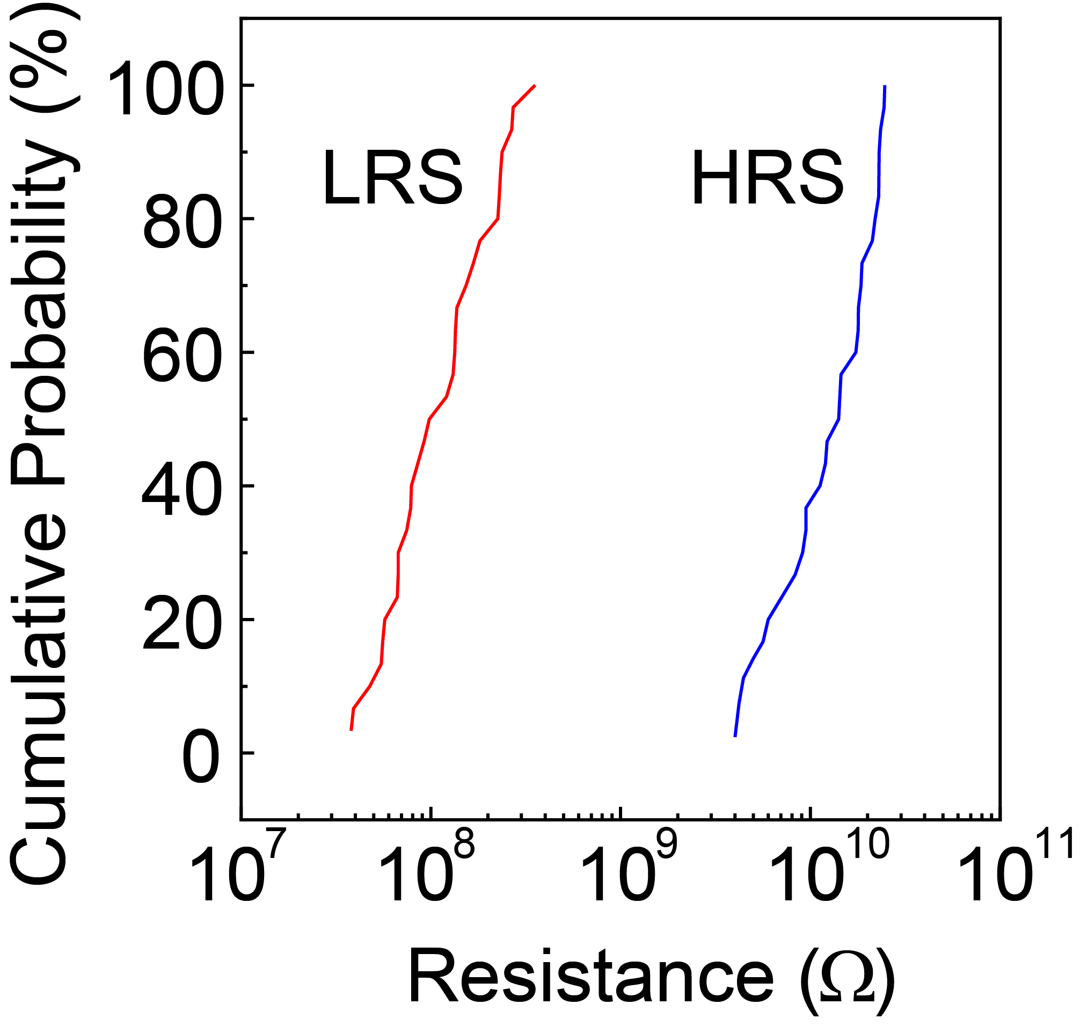
Fig. S3. Device uniformity for stable SET/RESET where a programming pulse condition of 4 V and 1 μs to an HRS is applied in 20 devices.

Fig. S4. Photograph of software interface for 3×3 1T1M array operation. a) Software schema when reading VMM (vector matrix operation) operation and programmed resistance values. b) When operating VMM, it is possible to choose and allocate wordline and bitline and set READ-WRITE voltage value.
Fig. S5. Circuit for generating inverse matrix. The design of circuit is originated from Sun, Zhong et al. The value of the inverse matrix of the matrix programmed in the memristor array appears as the voltage value (V₁₋₃) output through the transimpedance amplifier. For the inverse matrix operation, the current values (I₁₋₃) corresponding to the columns of the unit matrix ($E$) are sequentially entered into each row. Verification of this circuit was performed using linear technology simulation program with integrated circuit emphasis (LTSPICE) memristor library.

