Supporting Information
Linear Low-Density Polyethylene Nanocomposites Reinforced by Multi-Walled Carbon Nanotubes Functionalized with Hyperbranched Poly(ether-ketone)s
Hyo Seon Kang,¹ Seo Jeong Yoon,¹ Jaehoon Baek², In-Yup Jeon^{1,*}

¹ Department of Chemical Engineering/Nanoscale Environmental Sciences and Technology Institute, Wonkwang University, 460 Iksandae-ro, Iksan, Jeonbuk 54538, Republic of Korea
² School of Energy and Chemical Engineering/Center for Dimension-Controllable Covalent Organic Frameworks, Ulsan National Institute of Science and Technology (UNIST), UNIST-gil 50, Ulsan, 44919, Korea

E-mail: iyjeon79@wku.ac.kr

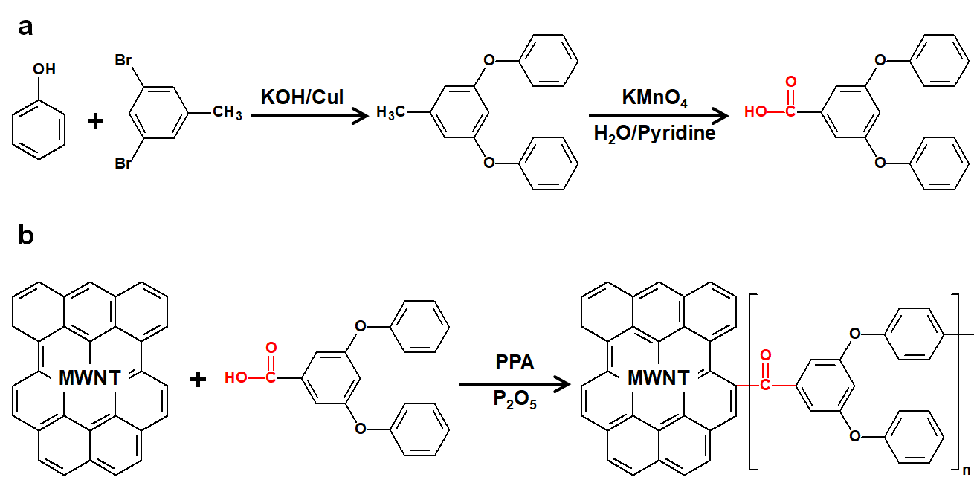
Fig S1. Schematic diagram: (a) 3,5-diphenoxy benzoic acid; (b) Hyperbranched poly(ether-ketone)s functionalized multi-walled carbon nanotubes (H-f-M).

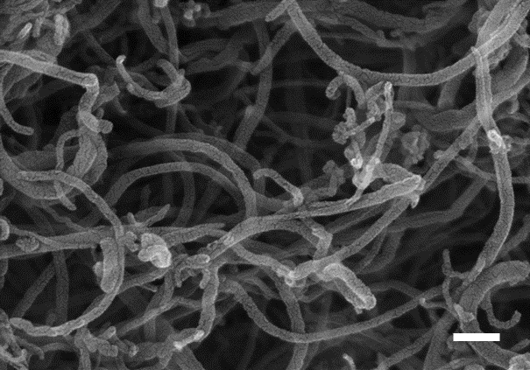
Fig S2. FE-SEM image of the MWCNT. Scale bar is 1 µm.

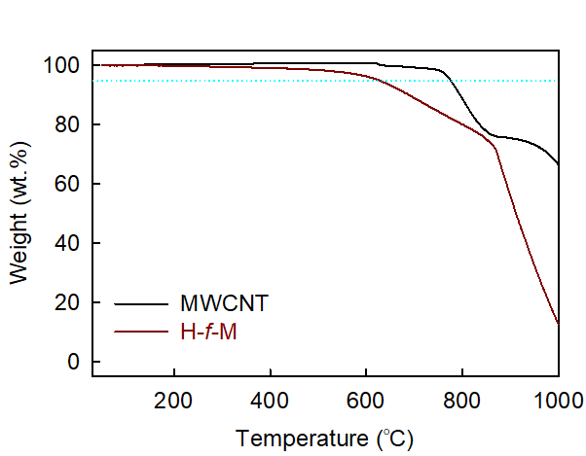
Fig S3. TGA curves of the MWCNT and H-f-M in N₂ condition.

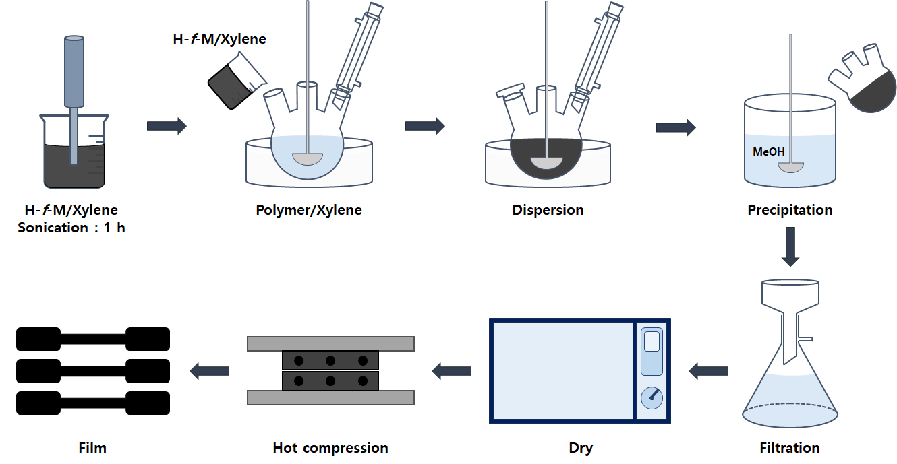
Fig S4. The making process for the H-f-M@LLDPE_X nanocomposite film.

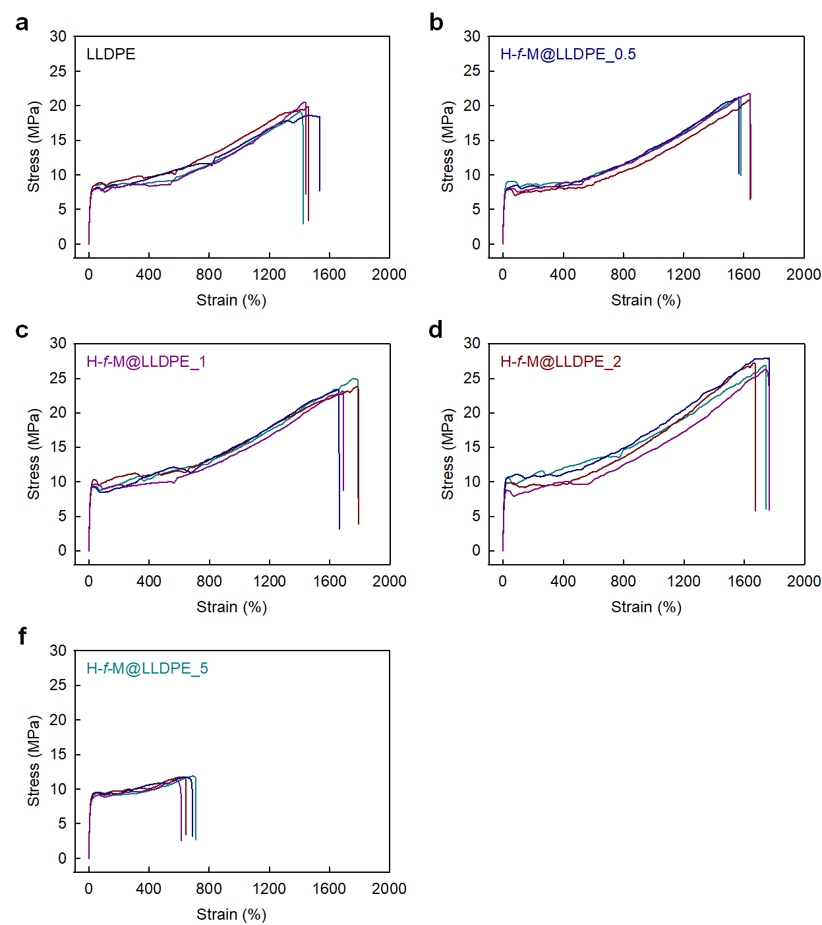
Fig S5. The stress-strain curves of the pure LLDPE and H-f-M@LLDPE_X nanocomposites.

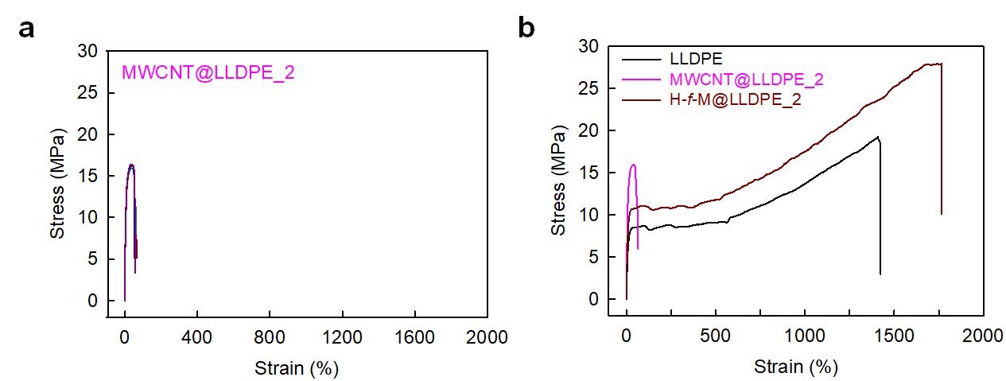Fig S6. (a) Stress-strain curves of MWCNT@LLDPE_2. Comparison of stress-strain curves of the pure LLDPE, MWCNT@LLDPE_2, and H-f-M@LLDPE_2 nanocomposites.

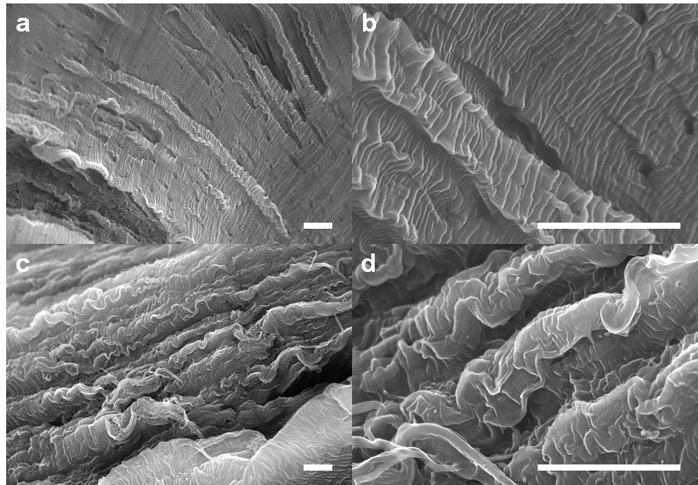
Fig S7. SEM images of the fractured surface of test specimens: (a, b) LLDPE; (b) H-f-M@LLDPE_2. Scale bars are 10 µm.

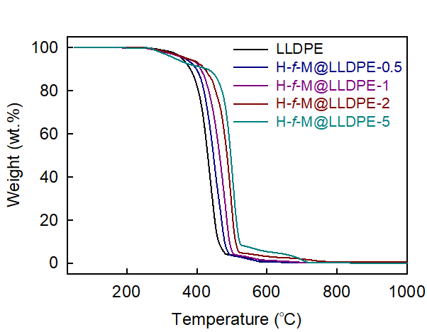
Fig S8. (a) TGA curves of the pure LLDPE and H-f-M@LLDPE_X nanocomposites at the heating rate of 10 °C min^{–1} in air condition.

Table S1. TGA and EA of the MWCNT and H-f-M
Sample | TGA  Char yield at 1000 °C |  |  |  | Element |  | EA  (wt.%)
Sample | N₂ |  | Air
MWCNT | 66.48 | 4.30 |  | C (%) |  | 94.14
MWCNT | 66.48 |  |  | O (%) |  | 0.06
H-f-M | 12.74 | 1.08 |  | C (%) |  | 96.44
H-f-M | 12.74 |  |  | O (%) |  | 1.72
H-f-M | 12.74 |  |  | H (%) |  | 0.30

Table S2. BET surface area, pore volume, and pore size of the MWCNT and H-f-M
Sample | Surface Area  (m²/g) | Pore Volume  (mL/g) | Pore Size  (nm)
MWCNT | 268.63 | 0.4935 | 7.348
H-f-M | 209.47 | 0.7561 | 14.439

Table S3. Comparison of mechanical properties of the pure LLDPE, MWCNT@LLDPE_2, and H-f-M@LLDPE_2 nanocomposite
 | Tensile  strength (MPa) | Young’s modulus (MPa) | Tensile  toughness (MPa) | Elongation  (%)
LLDPE | 19.5±1.0 | 199.7±9.1 | 1600.7±69.7 | 1466.9±70.6
MWCNT@LLDPE_2 | 16.2±0.3 | 381.2±25.3 | 69.0±6.2 | 60.5±5.1
H-f-M@LLDPE_2 | 27.1±0.8 | 265.1±14.4 | 2370.7±108.3 | 1738.4±63.3

Table S4. Thermal properties of the pure LLDPE and H-f-M@LLDPE_X nanocomposite
Sample | TGA (air)ª |  | DSC^{b}
Sample | T_{d5%} (°C) | Char (%) at 600 °C | T_{m} (°C) | T_{c} (°C)
LLDPE | 357.6 | 1.5 | 120.83  (120.58) | 105.67
H-f-M@LLDPE_0.5 | 366.1 | 4.1 | 121.10  (122.20) | 109.10
H-f-M@LLDPE_1 | 369.3 | 4.3 | 121.24  (122.27) | 110.07
H-f-M@LLDPE_2 | 372.7 | 8.1 | 121.31  (122.77) | 113.24
H-f-M@LLDPE_5 | 338.8 | 9.6 | 121.67  (123.21) | 114.62

a. The temperature at which 5% weight loss occurred on TGA thermogram obtained with heating rate of 10 °C min⁻¹.
b. Melting temperature (T_{m}) and crystallization temperature (T_{c}) determined by DSC with heating and cooling rates of 10 °C min⁻¹. The number in the parentheses are melting temperature (T_{m}) determined from the second heating run with heating rate of 10 °C min⁻¹.

