Supplementary Data

XRD Tables
- PVDF/TiO₂ Nanofibers
2θ | θ | Cosθ | Sinθ | FWHM (degree) | FWHM  (radian) | ßCosθ | Size(D)  (nm) | d spacing  (nm)
18.35083 | 09.1754 | 0.9872 | 0.1594 | 04.3746 | 0.0763 | 0.0753 | 020.05 | 4.83
19.82264 | 09.9113 | 0.9850 | 0.1721 | 00.4471 | 0.0078 | 0.0077 | 196.07 | 4.47
26.34602 | 13.1730 | 0.9737 | 0.2279 | 02.7564 | 0.0481 | 0.0468 | 032.26 | 3.38
41.79987 | 20.8999 | 0.9342 | 0.3567 | 00.2948 | 0.0051 | 0.0047 | 321.23 | 2.16
38.23996 | 19.1199 | 0.9448 | 0.3275 | 01.7917 | 0.0313 | 0.0295 | 051.18 | 2.35
41.87133 | 20.9356 | 0.9339 | 0.3573 | 15.1039 | 0.2635 | 0.2461 | 006.13 | 2.15
48.62198 | 24.3109 | 0.9113 | 0.4117 | 00.4492 | 0.0078 | 0.0071 | 212.64 | 1.87

Average d spacing – 3.03 nm

- PVP/TiO₂ Nanofibers

2θ | Θ | Cosθ | Sinθ | FWHM (degree) | FWHM  (radian) | ßCosθ | Size(D)  (nm) | d spacing  (nm)
25.7998 | 12.8999 | 0.9748 | 0.2232 | 0.47221 | 0.00824 | 0.00803 | 17.26 | 0.34498
27.9198 | 13.9599 | 0.9705 | 0.2412 | 0.43737 | 0.00763 | 0.00741 | 18.71 | 0.31924
38.3598 | 19.1799 | 0.9445 | 0.3285 | 0.64401 | 0.01123 | 0.01061 | 13.07 | 0.23439
48.6004 | 24.3002 | 0.9114 | 0.4115 | 0.51993 | 0.00907 | 0.00827 | 16.76 | 0.18712
54.4802 | 27.2401 | 0.8890 | 0.4577 | 0.88872 | 0.01550 | 0.01378 | 10.06 | 0.16823
55.6398 | 27.8199 | 0.8844 | 0.4667 | 0.62406 | 0.01089 | 0.00963 | 14.39 | 0.16498
63.1998 | 31.5999 | 0.8517 | 0.5239 | 0.70653 | 0.01232 | 0.01049 | 13.21 | 0.14697
69.4397 | 34.7198 | 0.8219 | 0.5695 | 0.68453 | 0.01194 | 0.00981 | 14.12 | 0.13521
70.7198 | 35.3599 | 0.8155 | 0.5787 | 0.85528 | 0.01492 | 0.01216 | 11.39 | 0.13306
75.6400 | 37.8200 | 0.7899 | 0.6132 | 0.71667 | 0.01250 | 0.00987 | 14.04 | 0.12557

Average d spacing – 0.1959 nm

Tauc plot for band gap
- PVP/TiO₂-NFs
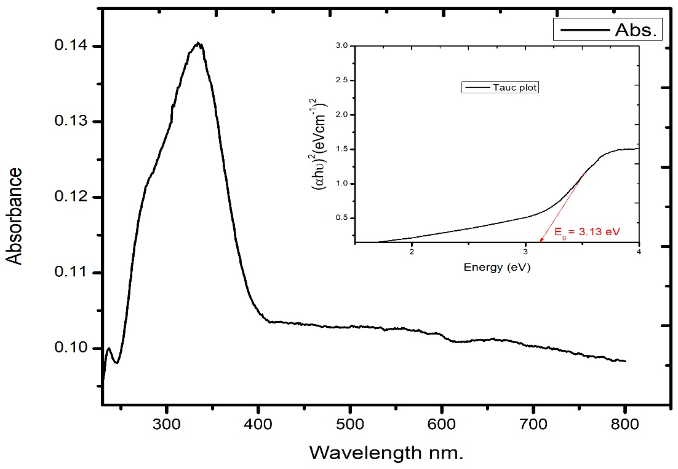
- TiO₂-NP
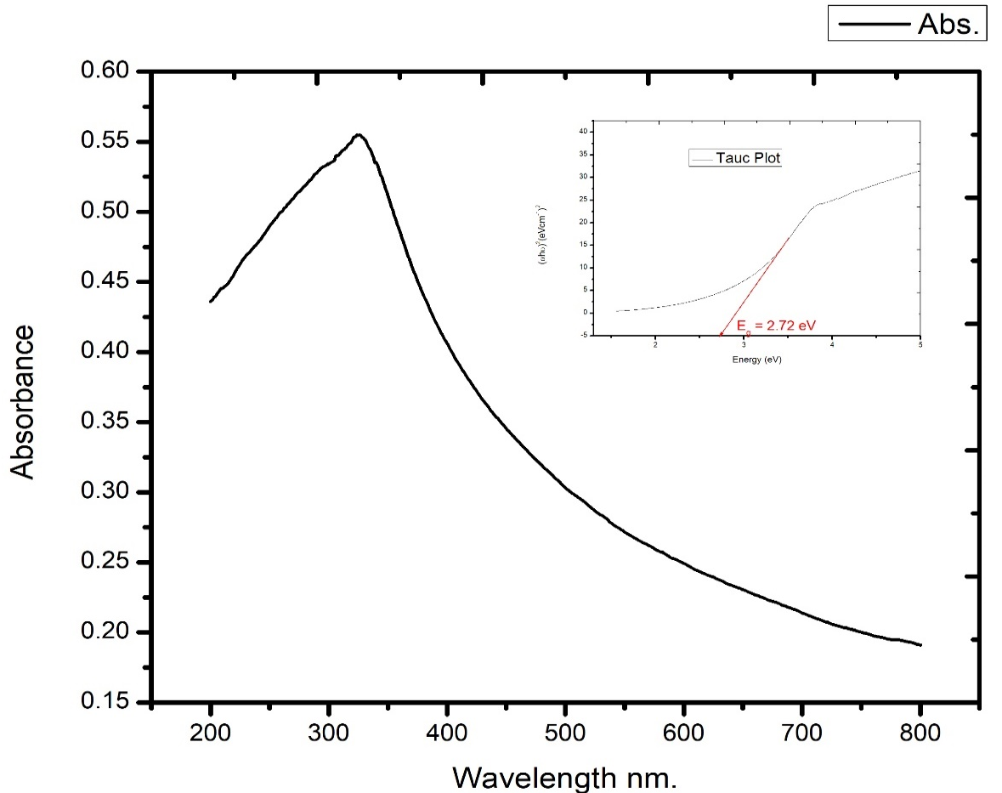
TiO2 nanopowder is use for comparison
Analyzing an Energy-Dispersive X-Ray Spectroscopy (EDS) layered image of TiO2 nanopowder typically involves quantitative determination of the elemental composition at various locations within the samples.
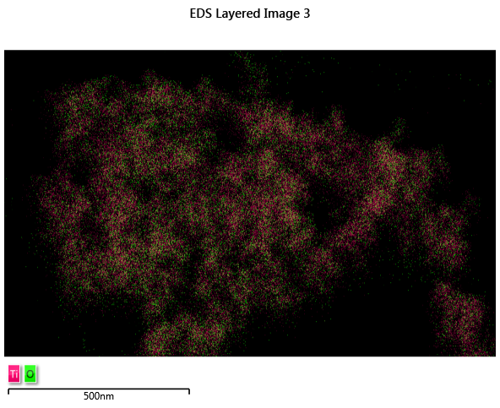

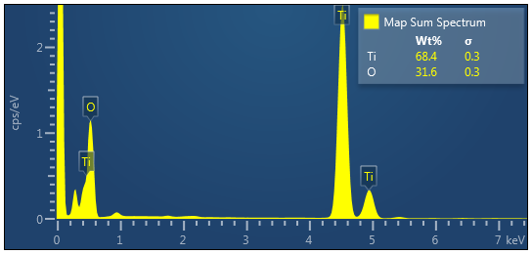
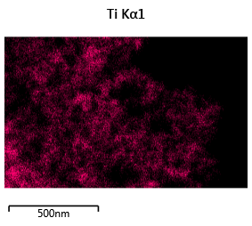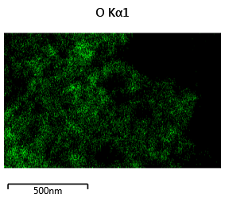

PVP/TiO₂ Nanofibers

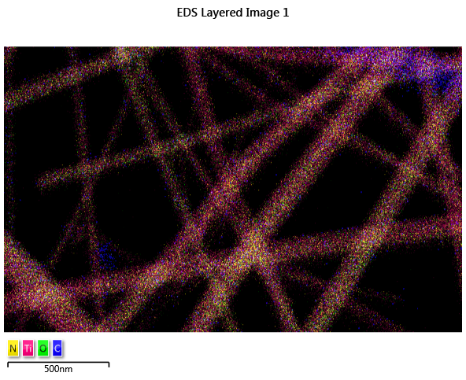

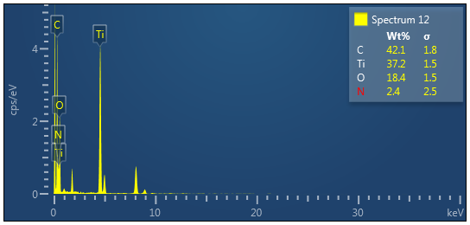

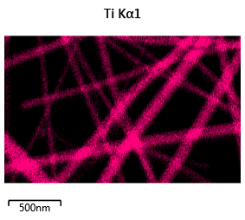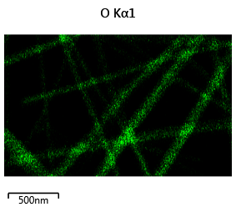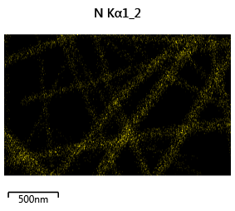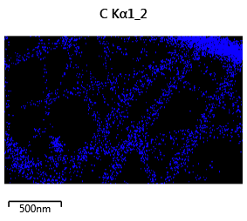
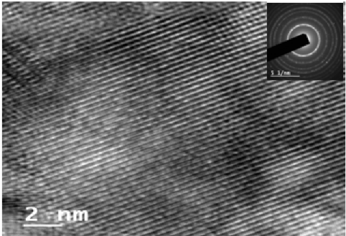
TEM images of PVP/TiO₂ nanofibers

