Table 3. EEM spectra of humic substances isolated from treated coal samples: a – EKI, b – OIQ and с – KAR.
Sample name | Ex/Em (nm) | Contour plot
EKI | Peak E- 310/425  Peak E1- 255/440 | 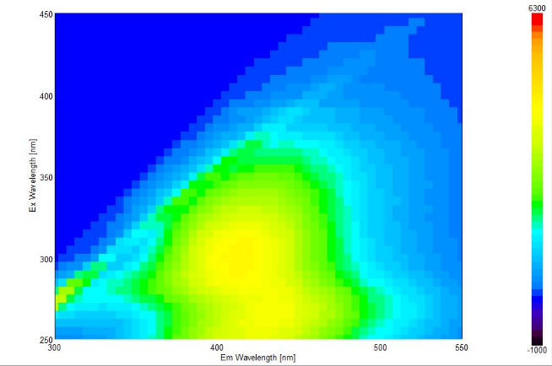
OIQ | Peak O - 310/415  Peak O 1 - 280-350 | 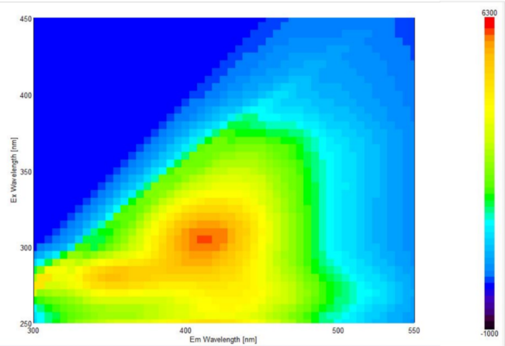
KAR | Peak K- 300/420  Peak K1- 270/440 | 