Supporting Information for the paper:
Oviposition strategies of amphibians in ephemeral streams: a multi-species perspective

Dogeun Oh, Jaehoon Lee, Uhram Song, JeongYoon Ahn, Changku Kang

Table S1. Summary statistics of the abiotic factor analysis, with significant relationships highlighted in yellow.
Species | Abiotic variable | Estimate | S.E. | z | P
Rana uenoi | PoolVolume | 1.10 | 0.16 | 6.95 | <0.001
Rana uenoi | Dry | -4.17 | 2.07 | 2.02 | 0.04
Rana uenoi | Leaves | -0.35 | 0.30 | 1.16 | 0.25
Rana uenoi | CanopyCover | -0.01 | 0.01 | 0.62 | 0.54
Rana uenoi | Stones | -0.11 | 0.22 | 0.48 | 0.63
Hynobius quelpaertensis | PoolVolume | 0.95 | 0.24 | 3.85 | <0.001
Hynobius quelpaertensis | Dry | -11.53 | 5.55 | 2.07 | 0.04
Hynobius quelpaertensis | Leaves | 1.32 | 0.47 | 2.81 | 0.005
Hynobius quelpaertensis | CanopyCover | 0.01 | 0.01 | 1.16 | 0.24
Hynobius quelpaertensis | Stones | 0.19 | 0.32 | 0.60 | 0.55
Bombina orientalis | PoolVolume | 1.50 | 0.26 | 5.82 | <0.001
Bombina orientalis | PoolVolume^2 | -0.06 | 0.01 | 5.44 | <0.001
Bombina orientalis | Dry | -3.13 | 0.64 | 4.85 | <0.001
Bombina orientalis | Leaves | 2.13 | 0.51 | 4.19 | <0.001
Bombina orientalis | Leaves^2 | -0.58 | 0.14 | 3.98 | <0.001
Bombina orientalis | CanopyCover | 0.00 | 0.00 | 1.57 | 0.12
Bombina orientalis | Stones | 0.04 | 0.06 | 0.79 | 0.43
Dryophytes japonicus | PoolVolume | 0.93 | 0.43 | 2.12 | 0.03
Dryophytes japonicus | PoolVolume^2 | -0.03 | 0.02 | 1.53 | 0.13
Dryophytes japonicus | Dry | -2.83 | 0.87 | 3.26 | 0.001
Dryophytes japonicus | Leaves | 1.13 | 1.10 | 1.02 | 0.31
Dryophytes japonicus | Leaves^2 | -0.30 | 0.34 | 0.88 | 0.38
Dryophytes japonicus | CanopyCover | -0.03 | 0.01 | 4.78 | <0.001
Dryophytes japonicus | Stones | -0.12 | 0.09 | 1.31 | 0.19

Table S2. Summary statistics of the biotic factor analysis, with significant relationships highlighted in yellow.
Species | Biotic variable | χ² (d.f. = 1) | P_{adj}
Rana uenoi | ConEggs and ConTadpoles | 5.13 | 0.03
Rana uenoi | HeteroEggs and HeteroTadpoles | 4.91 | 0.03
Rana uenoi | Predators | N.A. | N.A.
Rana uenoi | MosqLarvae | N.A. | N.A.
Hynobius quelpaertensis | ConEggs and ConTadpoles | 17.55 | <0.001
Hynobius quelpaertensis | HeteroEggs and HeteroTadpoles | 0.09 | 0.77
Hynobius quelpaertensis | Predators | N.A. | N.A.
Hynobius quelpaertensis | MosqLarvae | N.A. | N.A.
Bombina orientalis | ConEggs and ConTadpoles | 0.41 | 0.52
Bombina orientalis | HeteroEggs and HeteroTadpoles | 2.28 | 0.17
Bombina orientalis | Predators | 4.49 | 0.07
Bombina orientalis | MosqLarvae | 4.52 | 0.07
Dryophytes japonicus | ConEggs and ConTadpoles | 48.84 | <0.001
Dryophytes japonicus | HeteroEggs and HeteroTadpoles | 5.38 | 0.02
Dryophytes japonicus | Predators | 41.89 | <0.001
Dryophytes japonicus | MosqLarvae | 26.44 | <0.001

Table S3. Summary statistics of the biotic factor analysis (conspecific and heterospecific juveniles). P values were adjusted to control for false discovery rates within each species.
 |  | Egg |  | Tadpole |  | Egg+Tadpole
 |  | 𝛘₁² | P_{adj} | 𝛘₁² | P_{adj} | 𝛘₁² | P_{adj}
Conspecific | R. uenoi | 3.72 | 0.081 | 15.44 | 0.00024 | 1.36 | 0.24
Conspecific | H. querpartensis | 4.56 | 0.064 | 1.67 | 0.2 | NA | NA
Conspecific | B. orientalis | 0 | 1 | 0.21 | 1 | 0.16 | 1
Conspecific | D. japonicus | 5.88 | 0.015 | 6.75 | 0.00135 | 29.02 | 0.00002
Heterospecific | R. uenoi | 1.6 | 0.42 | NA | NA | 0 | 1
Heterospecific | H. querpartensis | 0.52 | 0.7 | 0.6 | 0.7 | 0.14 | 0.7
Heterospecific | B. orientalis | 15.98 | 0.00009 | 20.334 | 0.00002 | 0.41 | 0.53
Heterospecific | D. japonicus | 0.07 | 1 | 6.84 | 0.0267 | 0 | 1

Figure S1. The biotic factor (conspecific juveniles) emerged from analysing conspecific eggs and tadpoles separately. Pools containing (i) only eggs, (ii) only tadpoles, and (iii) both eggs and tadpoles were analysed individually. The table summarises the significance, where coloured cells indicate significant relationships. It also shows the trend: a ‘-’ signifies that females avoided pools with conspecifics, while a ‘+’ indicates that females laid more eggs in pools with conspecifics compared to what would be expected by chance.

Figure S2. The biotic factor (heterospecific juveniles) emerged from analysing heterospecific eggs and tadpoles separately. Pools containing (i) only eggs, (ii) only tadpoles, and (iii) both eggs and tadpoles were analysed individually. The table summarises the significance, where coloured cells indicate significant relationships. It also shows the trend: a ‘-’ signifies that females avoided pools with conspecifics, while a ‘+’ indicates that females laid more eggs in pools with conspecifics compared to what would be expected by chance.
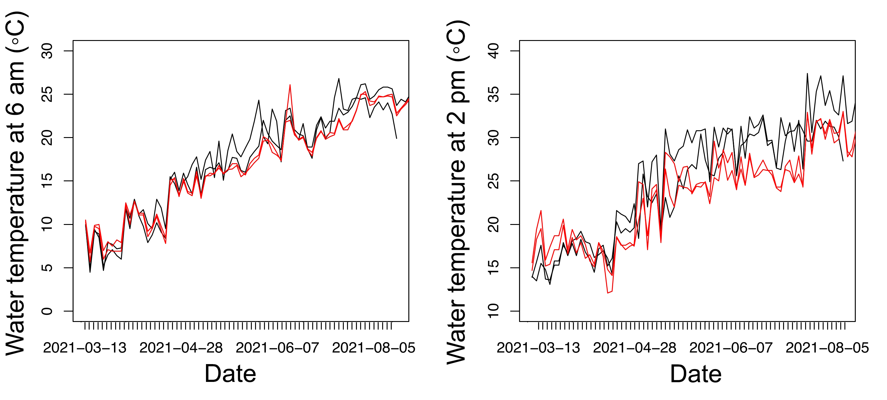
Figure S3. Plots showing the water temperature changes throughout the study period, measured for two small-sized (black lines) and large-sized (red lines) pools. The temperature was measured twice daily at 6 am and 2 pm, representing the (roughly) minimum and maximum temperatures of each day, respectively. The difference between small and large pools was not apparent in the minimum temperature. However, during the breeding seasons of B. orientalis and D. japonicus (from May to August), large pools were consistently cooler than smaller pools at 2 pm.

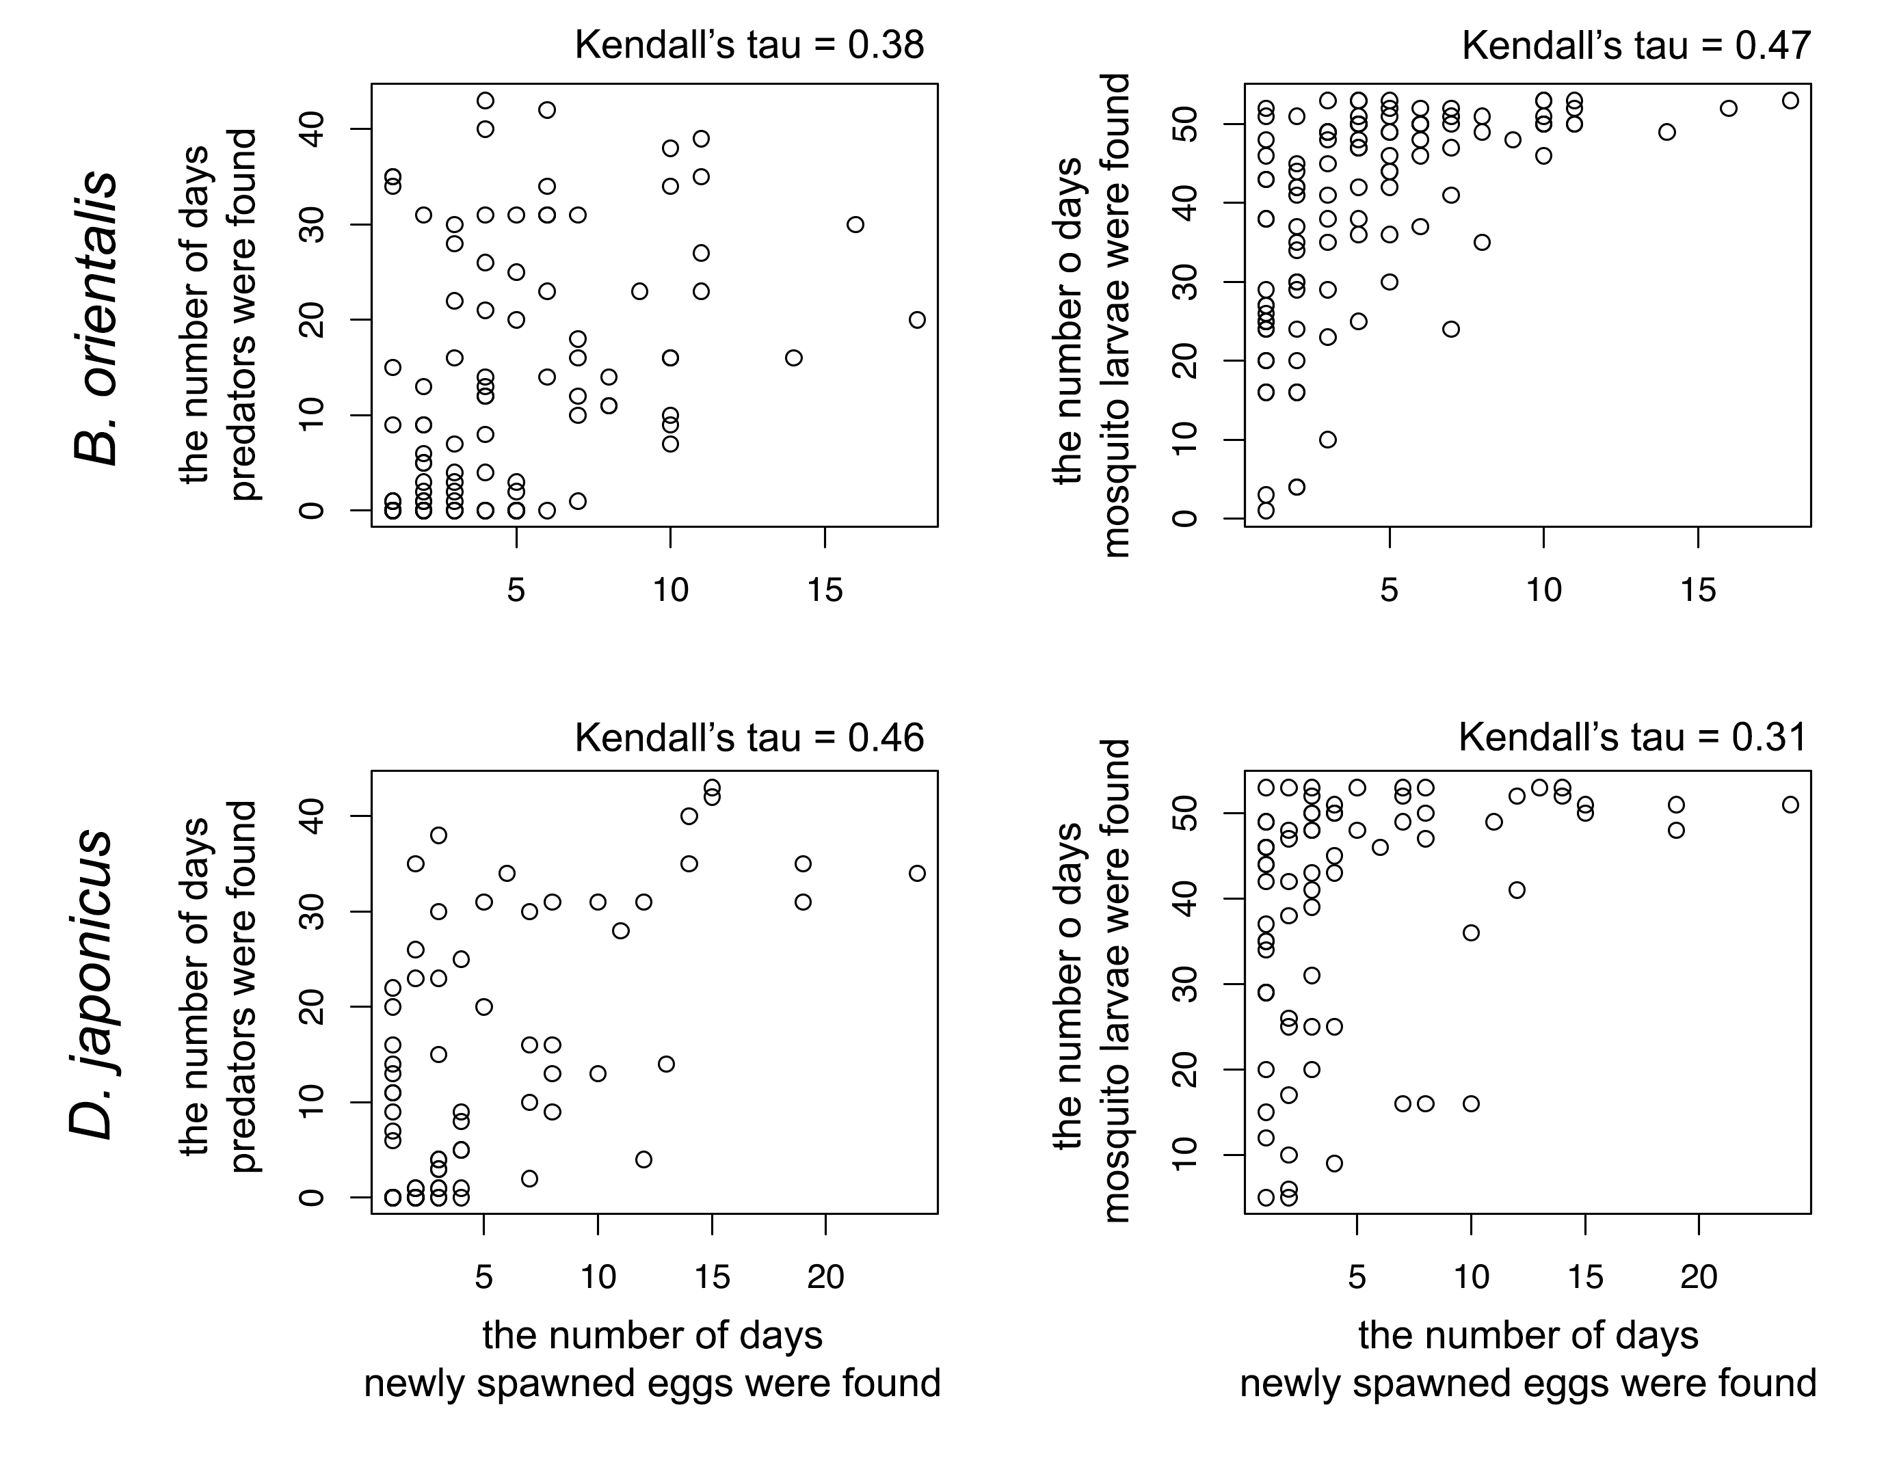
Figure S4. The correlation patterns of oviposition choice between amphibians and aquatic predators (left panels), and between amphibians and mosquito larvae (right panels), are shown. The points represent the number of days predators, mosquito larvae, or newly spawned eggs were observed in each pool.

