Table S1 The primers and sequences for qRT-PCR
Gene | Forward primer (5′-3′) | Reverse primer (5′-3′)
OsActin | TGGCATCTCTCAGCACATTCC | TGCACAATGGATGGGTCAGA
LOC_Os01g62290 | TGGCATCCTCAACGTCTCTG | TCTTGGCGTCCACCTTCTTC
LOC_Os01g50100 | TGCTGGACTATGGCAGGAGA | AGCTTCCCTCCTACCTTCTCA
LOC_Os09g37240 | CCTCCTTTCTCTGCTGAGCC | GCATGCTGGGTATCTGGACA
LOC_Os08g12950 | AAATCAGCCTCTCAGTGCCC | TCTTCGGTCCAGTTGACGTG
LOC_Os03g50130 | TGTCGATCGAGCTGACCAAG | TTGTACTTTCTGCGGGCCTT
LOC_Os03g59170 | CTGAAGGTTGCAGCGCATTT | GAACACGCACGACCAAGAAC
LOC_Os03g03410 | GGCGCTTATAGGATGCTCGT | GTTAGTGGGCTCACTTCCCC
LOC_Os04g52780 | CGGGGATCTGTCCAATCTCG | GCTGAGGTCAACGACCATGA
LOC_Os07g31500 | AACAGTGCCATCGGAGATCG | GGACAAGAGATTCCGCGACA
LOC_Os02g39795 | AACAGTGCCATCGGAGATCG | GGACAAGAGATTCCGCGACA
LOC_Os01g58420 | GTACCTACGACACGGCAGAG | TCGACTGTGATGCAAACGGA
LOC_Os02g46030 | CGTGGATCATCTCAGGAGCC | ATGTGCTCTTGTATACGGCG
LOC_Os02g08440 | TGGATTAGCACCCAGCCTTC | AGGCTGCTGGTGAAAGAAGT
LOC_Os03g53340 | AACTTCTCCAGCTTCGTCCG | CGCGAACTCCCATCTATCCG
LOC_Os01g67480 | CGGCATGGATGACTTCTTGC | TTTGCTTGTCCATGTTCGGC
LOC_Os01g62460 | GTCGCAATCTTCGTCGTTCG | ACATCAGGCAAGACACCAGC
LOC_Os01g64310 | CGGAGGAGGAGCTGATATGC | ATCTCTGAGAGCTGCAACGG
LOC_Os05g37190 | CCGTTCTTCGAGTGGCTCA | AGGAGGATTGTTCATCGCCC

Table S2 Transcriptome data quality and mapping information
Samples | Total Reads | Clean reads | Clean bases | GC Content | %≥Q30 | Mapped Reads | Uniq Mapped Reads | Multiple Map Reads
CK-1 | 41,886,382 | 20,943,191 | 6,270,744,812 | 54.15% | 94.17% | 39,477,765 (94.25%) | 38,578,048 (92.10%) | 899,717 (2.15%)
CK-2 | 48,692,692 | 24,346,346 | 7,291,085,104 | 54.48% | 94.14% | 44,865,248 (92.14%) | 43,651,702 (89.65%) | 1,213,546 (2.49%)
CK-3 | 43,891,420 | 21,945,710 | 6,572,206,156 | 53.75% | 93.65% | 41,182,215 (93.83%) | 39,784,732 (90.64%) | 1,397,483 (3.18%)
RI-1 | 42,727,318 | 21,363,659 | 6,397,674,152 | 53.46% | 94.09% | 40,262,037 (94.23%) | 39,290,093 (91.96%) | 971,944 (2.27%)
RI-2 | 44,005,924 | 22,002,962 | 6,589,531,952 | 54.78% | 94.01% | 41,542,082 (94.40%) | 40,301,006 (91.58%) | 1,241,076 (2.82%)
RI-3 | 43,351,530 | 21,675,765 | 6,489,818,092 | 53.54% | 94.10% | 40,792,861 (94.10%) | 39,913,994 (92.07%) | 878,867 (2.03%)
FS-1 | 47,335,502 | 23,667,751 | 7,088,188,814 | 54.56% | 94.42% | 44,744,708 (94.53%) | 43,054,130 (90.96%) | 1,690,578 (3.57%)
FS-2 | 50,379,264 | 25,189,632 | 7,542,463,560 | 54.05% | 94.19% | 47,479,908 (94.24%) | 46,113,356 (91.53%) | 1,366,552 (2.71%)
FS-3 | 45,122,248 | 22,561,124 | 6,757,569,414 | 54.60% | 94.04% | 42,635,930 (94.49%) | 41,546,029 (92.07%) | 1,089,901 (2.42%)

Table S3 DEGs related to related to selenium absorption/endocytosis
Gene name | CK_FPKM | RI_FPKM | FS_FPKM | log2(RI_FPKM/CK_FPKM) | Regulation trend | log2(FS_FPKM/CK_FPKM) | Regulation trend | Functional annotation
LOC_Os03g16860 | 1450.376099 | 923.7968647 | 422.4245707 | -0.500193759 | normal | -1.547920036 | down | Heat shock cognate 70 kDa protein 2
LOC_Os03g16920 | 10.54978767 | 6.439643 | 1.198735667 | -0.557540457 | normal | -2.912589201 | down | Heat shock cognate 70 kDa protein
LOC_Os01g08560 | 227.7354603 | 117.7225103 | 59.43447533 | -0.792374461 | normal | -1.706061367 | down | Heat shock 70 kDa protein 15
LOC_Os01g62290 | 863.7381037 | 235.7024867 | 50.50138633 | -1.713438184 | down | -3.873815537 | down | Heat shock 70 kDa protein 4
LOC_Os05g38530 | 437.3640443 | 212.8171943 | 90.230863 | -1.039219905 | down | -2.051255462 | down | Heat shock 70 kDa protein 4
LOC_Os03g11910 | 80.55952767 | 32.02653433 | 8.597247667 | -1.167991229 | down | -3.008982253 | down | Heat shock 70 kDa protein 8
LOC_Os11g08020 | 21.49503 | 67.86272 | 42.19560167 | 1.791783566 | up | 1.218705838 | up | Protein ACCELERATED CELL DEATH 6

Table S4 DEGs related to related to selenium transport
Gene name | CK_FPKM | RI_FPKM | FS_FPKM | log2(RI_FPKM/CK_FPKM) | Regulation trend | log2(FS_FPKM/CK_FPKM) | Regulation trend | Functional annotation
LOC_Os01g50100 | 8.821889333 | 47.791809 | 39.17670633 | 2.583873663 | up | 2.407378621 | up | ABC transporter B family member 11
LOC_Os01g50160 | 2.979184667 | 4.335573 | 5.990738333 | 0.707986341 | normal | 1.24844314 | up | ABC transporter B family member 9
LOC_Os09g23640 | 2.317091 | 3.176928667 | 7.361749 | 0.625209955 | normal | 1.901287855 | up | ABC transporter G family member 17
LOC_Os01g42380 | 6.783609667 | 10.409899 | 11.717903 | 0.777341473 | normal | 1.024424799 | up | ABC transporter G family member 36
LOC_Os01g52130 | 0.559911333 | 0.297812 | 0.029258 | -0.773752259 | normal | -3.951840116 | down | Sulfate transporter 3.5
LOC_Os03g09940 | 22.568234 | 27.56133233 | 40.88250333 | 0.473805981 | normal | 1.091793117 | up | Low affinity sulfate transporter 3
LOC_Os03g05640 | 1.259549 | 1.023674 | 2.326011 | -0.127388815 | normal | 1.111104924 | up | Inorganic phosphate transporter 1-2
LOC_Os04g46880 | 83.54550533 | 139.4913813 | 145.9133707 | 0.910811992 | normal | 1.044159186 | up | Putative glycerol-3-phosphate transporter 1
LOC_Os06g29790 | 3.069803667 | 3.690416333 | 8.254755333 | 0.442269084 | normal | 1.667017694 | up | Phosphate transporter PHO1-3
LOC_Os08g25624 | 3.170752667 | 2.472247 | 0.742573333 | -0.214504422 | normal | -1.860005613 | down | Phosphoenolpyruvate/phosphate translocator 2

Table S5 DEGs related to selenium metabolism
Gene name | CK_FPKM | RI_FPKM | FS_FPKM | log2(RI_FPKM/CK_FPKM) | Regulation trend | log2(FS_FPKM/CK_FPKM) | Regulation trend | Functional annotation
LOC_Os03g19427 | 1.183622 | 1.430269667 | 9.241416667 | 0.465477897 | normal | 3.188800932 | up | Nicotianamine synthase 1
LOC_Os03g19420 | 0.899270333 | 1.249999333 | 5.837660667 | 0.661777956 | normal | 2.917706146 | up | Nicotianamine synthase 2
LOC_Os02g04170 | 14.070408 | 15.71534167 | 24.68397933 | 0.352573122 | normal | 1.052961437 | up | L-aspartate oxidase
LOC_Os03g59170 | 13.90436967 | 44.29422633 | 35.71836967 | 1.805283675 | up | 1.599290542 | up | 5'-adenylylsulfate reductase-like 5
LOC_Os12g41500 | 10.32981667 | 6.407365 | 3.64636 | -0.530593258 | normal | -1.274322704 | down | Thiosulfate/3-mercaptopyruvate sulfurtransferase 2
LOC_Os02g39795 | 150.8969423 | 66.27779667 | 67.366691 | -1.024858175 | down | -1.16345623 | down | S-adenosylmethionine decarboxylase proenzyme
LOC_Os02g36550 | 5.931952 | 8.270191 | 10.89994067 | 0.67574552 | normal | 1.113899 | up | Phosphopantothenate-cysteine ligase 1
LOC_Os03g03410 | 12.03461033 | 34.16952767 | 43.48364633 | 1.649217768 | up | 2.105555792 | up | Probable serine/threonine-protein kinase
LOC_Os04g52780 | 1.414584 | 3.921595667 | 4.040095333 | 1.595850449 | up | 1.757652924 | up | LRR receptor-like serine/threonine-protein kinase FLS2
LOC_Os05g03620 | 58.54780167 | 25.344404 | 15.62084967 | -1.043402765 | down | -1.669729388 | down | Putative serine/threonine-protein kinase-like protein CCR3
LOC_Os06g10160 | 29.39190367 | 71.83210767 | 68.02863433 | 1.480386354 | up | 1.455842781 | up | Serine/threonine-protein kinase RIPK
LOC_Os06g50100 | 14.19474333 | 10.631526 | 5.570612 | -0.271877938 | normal | -1.109832124 | down | Probable serine/threonine-protein kinase PBL19
LOC_Os07g31500 | 0.637403333 | 0.118383667 | 0.188334333 | -2.246745061 | down | -1.506425942 | down | LRR receptor-like serine/threonine-protein kinase GSO1
LOC_Os12g44320 | 7.008591667 | 5.523337667 | 13.05338067 | -0.150446462 | normal | 1.123113283 | up | G-type lectin S-receptor-like serine/threonine-protein kinase
LOC_Os08g25390 | 2.896651667 | 2.149703333 | 1.164237667 | -0.274228935 | normal | -1.065514468 | down | Bifunctional aspartokinase/homoserine dehydrogenase 1

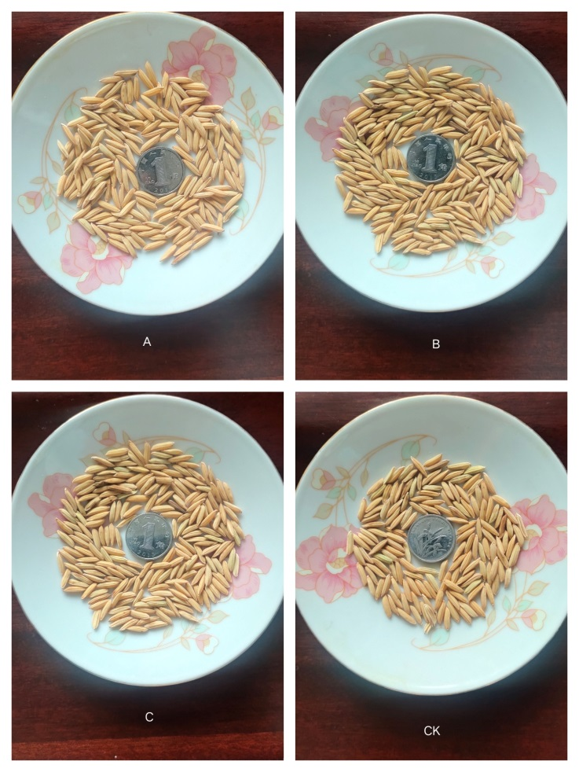
Figure S1 Rice grain morphology treated with three kinds of exogenous selenium (A, B, C and CK)
A, B, C and CK were rice TX leaf treated with medium concentration of three kinds of exogenous selenium, and the grain morphology of treated rice were significantly be better than CK. A: T2-SS (100 mg L⁻¹ of SS), B: T2-SeMet (100 mg L⁻¹ of SeMet), C:T2-NS (450 μg L⁻¹),and CK.

