Supporting Information for “A roadmap towards sustainable intensification for a larger global rice bowl” by Yuan et al.

CONTENTS

- Description of data sources ………………………………………………….. 2

- Estimation of yield gaps ……………………………………………………... 3

- Estimation of greenhouse gas emissions and energy inputs ………………. 4

- Estimation of nitrogen balance …………………………………………...… 7

- Pesticide application and toxicity ……………………………...……………. 8

- Estimation of labor inputs …………………………………………………... 9

Supplementary Figs. 1-10 ……………………………………………………….. 10-19
Supplementary Tables 1-11 ……………………………………………………... 20-30
Additional References associated with Supplementary Information ………… 31

1. Description of data sources
Global annual rice production and harvested area averaged respective 757 million metric tons and 165 million ha during the 2015-2017 period¹. The 18 countries selected for our study account for 88% and 86% of the global rice production and harvested area, respectively (Supplementary Table 1). These countries over a wide range of biophysical and socio-economic background (Supplementary Figs. 1 and 2 and Supplementary Table 1), leading to rice yields ranging from 2.0 to 10.4 Mg ha⁻¹ (Supplementary Fig. 3). In each country, the dominant rice cropping system(s) was (were) identified. A rice cropping system is defined as a unique combination of ecosystem (lowland, upland), water regime (irrigated, rainfed), and rice cropping intensity (single, double, triple) as defined by the number, type, and temporal cycle of crops planted on the same piece of land over a 12-month period. We distinguished between rice-based cropping systems sowing hybrid versus inbred cultivars in the southern USA. In total, our study included 32 rice cropping systems (Supplementary Table 2). In our study, rice cropping systems are single-, double-, or triple-season rice, none of the cropping systems are ratoon rice. All the rice cropping systems were classified into tropical and non-tropical regions^{2,3,4} (Supplementary Fig. 1).
Data on yield, applied inputs, and dominate crop management practices were retrieved for each rice crop cycle in each of the 32 rice cropping systems, including field size, tillage method (full tillage or minimum tillage), crop establishment method (transplanting or direct seeding), degree of mechanization of different farm operations (including land preparation, sowing or transplanting, fertilization, pesticide application, weeding, harvesting, threshing, and drying), rice seeding rate, crop establishment and harvest dates, nutrient fertilizer rates, manure type and rate, pesticides including herbicide, insecticide, fungicide inputs (number of applications, products, and rates), irrigation amount (in irrigated systems), energy source for irrigation pumping, labor input, and straw management (left in field, burn, or remove out of field). We only collected data from the rice crop cycle(s) within each cropping system. Rice grain yield was reported at a standard moisture content of 140 g H₂O kg⁻¹ grain, separately for each rice crop cycle in each cropping system from at least three cropping seasons. Key information on each rice cropping system was given in Supplementary Tables 3 and 4. Data from each country were provided by agricultural specialists via structure questionnaires. Yield and dominant on-farm practices/ input applications information were reported based on on-farm survey data, official statistics, and/ or expert opinion (Supplementary Table 5). Average values for each cropping system were retrieved by country experts from on-farm survey data available from previous projects. An exception is the irrigated rice cropping system in Nigeria and Mali, where data is only available for one crop cycle in double-season rice. In this case, we assumed management and actual yield to be identical in the two crop cycles. Management and yield data compiled for this study were cross-validated with other independent datasets whenever possible (e.g., FAOSTAT, World Bank, and IFA).
Daily measured weather data including solar radiation and maximum and minimum temperature, and total rainfall during the rice growing season were retrieved for at least five years at each site where each of the 32 rice cropping systems dominated (Supplementary Fig. 3 and Supplementary Table 6). Additionally, data on per-capita gross domestic product (GDP) during 2015-2017 were retrieved for each country to explore relationships between yield gap and economic development⁵ (Supplementary Fig. 9 and Supplementary Table 1).

2. Estimation of yield gaps
Estimates of yield potential (or water-limited yield potential for rainfed rice) for each rice crop cycle in each of the 32 rice cropping systems were retrieved from the Global Yield Gap Atlas (www.yieldgap.org) and best alternative publications for Australia (AUIS) where no values were reported by GYGA^{6,7} (Supplementary Tables 5 and 7). Estimates of yield potential in GYGA followed these main steps: (1) selection of representative climate zones based on dominant crop areas, (2) selection of reference weather stations (RWS) buffer that represent the selected CZs, (3) selection of dominant soil types and cropping systems in a 100 km radius around the RWS buffer, and (4) crop model simulations to establish rainfed or irrigated yield potential³. For each buffer-year-water regime combination, each rice crop cycle (in each cropping system) x soil type combination was simulated, and then weighted by their relative proportion to retrieve an average yield potential for each buffer. Yield potential simulation in GYGA was performed using the crop growth and development model ORYZA2000 or ORYZA (v3) (except for APSIM in the case of India) and based on best available source daily weather data (giving preference to measured weather) and local soils and crop calendar and for the most representative rice varieties planted in each region^{6,8,9}.
For estimating yield potential for each of 32 rice cropping systems, yield potential (or water-limited yield potential for rainfed rice) of each rice crop cycle in each cropping system was retrieved from GYGA for available years for the major rice-producing buffers within the region where the data on this specific rice cropping system come from⁶. Then for each rice crop cycle, data on yield potential were averaged across years and buffers to represent yield potential of the corresponding rice crop cycle in each system (Supplementary Fig. 3). The coefficient of variation (CV) of yield potential (or water-limited yield potential for rainfed rice) across years was determined for each cropping system, and was plotted against average yield (% of potential) (Supplementary Fig. 4). It was noted that CV of yield potential of irrigated rice in Australia (AUIS) was assumed to be equal to that of actual yield, as there was only average yield potential reported in Lacy et al⁷. The yield gap was calculated as the difference between yield potential (or water-limited yield potential for rainfed rice) and the 3-y average actual yield. For cropping systems including more than one rice crop cycle, the average yield potential for rice was estimated by averaging yield potential across rice crop cycles. Average yield and yield gap were expressed as % of the yield potential (Fig. 1 and Supplementary Fig. 5).

3. Estimation of greenhouse gas emissions and energy inputs
The CO₂, methane (CH₄), and nitrous oxide (N₂O) emissions were estimated for each rice crop. Emissions from various agricultural inputs were calculated by multiplying input amount by corresponding emission factor for each input and summing emissions across inputs in a rice crop (Supplementary Table 7). In the case of fossil fuel used for field operations, it was calculated based on the number and type of farm operations and associated fuel requirements (Supplementary Table 8).
The CH₄ emissions from rice paddy field were calculated following Intergovernmental Panel on Climate Change (IPCC) methodology¹⁰, as follows:
$${CH}_{4} emission (kg {CH}_{4} {ha}^{-1})=T×{EF}_{C}×{SF}_{W}×{SF}_{P}×{SF}_{O}$$
where T is rice cultivation period for each rice cycle, which was derived from the reported crop establishment and harvest dates; EF_{C} is a baseline emission factor for continuously flooded fields without organic amendments; SF_{W} and SF_{P} are scaling factors to account for differences in water regime during the cultivation period and during the pre-season before the cultivation period, respectively, and SF_{O} is a scaling factor which varies for both type and amount of organic amendment applied (e.g., straw, manure, compost) and is calculated as follows:
$${SF}_{O}={\left(1+\sum_{i}{{ROA}_{i}×{CFOA}_{i}}\right)}^{0.59}$$
where ROA_{i} is the application rate of organic amendment i; CFOA_{i} is the conversion factor for organic amendment i.
Total N₂O emissions were calculated as the sum of direct and indirect N₂O emissions. Following van Groenigen et al.¹¹, direct soil N₂O emissions for a given rice cycle were calculated based on the magnitude of the N surplus as:
$$N_{2}O emissions \left(kg N_{2}O-N {ha}^{-1}\right)=1.435+0.081×e^{0.0443×N-surplus}$$
where N surplus is calculated as the total applied N input from fertilizers and manures minus plant N accumulated in the crop (grain plus residue) at physiological maturity.
Indirect N₂O emissions were estimated based on the IPCC methodology¹², assuming indirect N₂O emissions represent 20% of direct N₂O emissions.
All emissions were converted to CO₂-eq (also called GWP), with GWP for CH₄ set at 25 relatives to CO₂ and for N₂O set at 298 on a per mass basis over a 100-year time horizon¹³. For each rice crop in each of 32 rice cropping systems, GWP (kg of CO₂-eq) was calculated as the sum of CO₂, CH₄, and N₂O emissions expressed as CO₂-eq. For cropping systems including more than one rice crop, the GWP for rice cropping system on a per crop basis (kg CO₂-eq ha⁻¹ crop⁻¹) was estimated by averaging the GWP across rice crops (Fig. 2), and total GWP for the cropping system on an annual basis (kg CO₂-eq ha⁻¹) was calculated by summing CO₂-eq across crops (Supplementary Fig. 6). Yield-scaled GWP (kg CO₂-eq Mg⁻¹ of rice grain) was calculated as the quotient between GWP and grain yield for each of the 32 cropping systems¹⁴ (Fig. 2).

Similar to GHG emissions invention, fossil-fuel energy input was calculated based on input rates and their associated embodied energy associated with their manufacturing, packaging, and transportation (Supplementary Table 9). Energy input from labor was estimated by multiplying labor requirement by energy cost of agricultural labor.
Energy input from machinery associated with field operation was estimated based on an embodied energy value of 125.4 MJ kg⁻¹ and assumptions on machinery size as proposed by Stout¹⁵, machinery lifespan of 10 years¹⁶, and machinery working time in each field operation (Supplementary Table 8). Energy inputs from diesel fuel consumed in mechanical field operations including tillage, rice planting, fertilizing, spraying, weeding, and harvesting was calculated based on type and number of field operations per rice cycle and associated fuel requirement (Supplementary Table 8). Rice grain threshing is operated manually in countries where grain is reported to be harvested manually, so there is no additional diesel requirement in grain threshing in these cases.
Irrigation is via canal without the need of pumping in most cases, but irrigation water is pumped in some other rice-cropping systems in regions such as southern Brazil, China, and Uruguay (Supplementary Table 4). For these cases, energy use from diesel or electricity for irrigation pumping was estimated based on applied irrigation volume, percentage of pumping for irrigation, energy source, and water depth. Average operating pressure and pumping efficiency were assumed to be 30 psi and 80%, respectively, which are considered typical values for farmer-owned pumping plants¹⁷. Irrigation pumps are normally powered by diesel or electric engines. Diesel and electric motor efficiency of 40% and 90% was assumed, respectively¹⁸.
Drying of grain is operated with traditional drying system (e.g., sun drying, field drying and stacking) in most rice-producing countries or regions, while rice grain is exposed to artificial drying in Australia, Brazil, Uruguay, and the USA. Grain drying process is assumed to be fueled by LPG¹⁹. LPG use for grain drying in these cases was calculated by considering that rice grain is harvested at a moisture content of 200 g H₂O kg⁻¹ fresh weight and it is artificially dried to a moisture content of 130 g H₂O kg⁻¹ to enable long storage with minimal losses²⁰. Energy use for grain drying was estimated by assuming that energy input needed by a conventional dryer is 5 MJ kg⁻¹ of removed water²¹. LPG usage during grain drying process was calculated as the ratio between energy use in grain drying and embodied energy per liter of LPG (25.6 MJ l⁻¹)²².
For each rice crop cycle in each of 32 rice cropping systems, energy input rate (GJ ha⁻¹) was calculated as the sum of fossil-fuel energy inputs (including labor input). For cropping systems including more than one rice crop, the energy input for rice cropping system on a per-crop basis (GJ ha⁻¹ crop⁻¹) was estimated by averaging the energy input across rice crops, and total energy input for the system on an annual basis (GJ ha⁻¹ y⁻¹) was calculated by summing energy input across the rice crops (Supplementary Fig. 10). Similarly, net energy yield was calculated as the difference between energy output and input (GJ ha⁻¹) ²³, which was expressed on both per-crop and annual basis (Supplementary Fig. 10).
There was a strong correlation between energy input and GWP on both per-crop (r=0.81; p<0.01) and annual basis (r=0.92; p<0.01) at a global scale, so we are only showing GWP in the main text to avoid redundancy. The relationship between average yield (expressed as % of potential) and energy input as well as net energy yield on both per-crop and annual basis are shown in the Supplementary Fig. 10.

4. Estimation of nitrogen balance
Nitrogen (N) balance was calculated as the external N input including from synthetic N fertilizer, manure, and biological N fixation minus N removal with the harvested grain (and straw if it was burned or removed out of field) following Dobermann and Witt²⁴. The N input and N removal were estimated for each rice crop cycle. The N input via manure was calculated based on the amount and source of manure and average N concentration; the latter was assumed to be 0.6% and 0.3% for animal manure and plant compost, respectively^{25,26}. We used a global mean value for biological N fixation in lowland rice fields of 30 kg N ha⁻¹ crop⁻¹ ^{27,28}; biological N fixation in upland rice was assumed to represent 10% of that in lowland rice²⁹. The N inputs from atmospheric deposition and irrigation water or precipitation were not available, and they were not considered in our estimates as N input from these two sources would almost be offset by N losses through leaching, lixiviation, and denitrification²⁶.
Grain N removal was calculated based on the average grain yield and rice grain N concentration of 1.06%³⁰. The removal of N from crop residues was estimated from the total removal assuming (1) a typical fraction of straw remaining in the field in different straw managements (left in field, burn, or remove out of field), (2) a typical fraction of N lost from the crop residues in each of these three situations, and (3) a typical rice residue N concentration of 0.63%^{26,30} (Supplementary Table 10). The production of rice residue was estimated by multiplying grain yield by an assumed average grain-to-straw ratio of 1.0³¹.
The N balance was estimated for each rice crop cycle. For cropping systems including more than one rice crop, N balance for each rice cropping system on a per-crop basis (kg N ha⁻¹ crop⁻¹) was estimated by averaging the N balance across rice crops (Fig. 3), and N balance for the system on an annual basis (kg N ha⁻¹) was calculated by summing the N balance across crops (Supplementary Fig. 8). The yield-scaled N balance was estimated as the quotient between N balance and grain yield, and expressed as kg of N per Mg of rice grain (Fig. 3).

5. Pesticide application and toxicity
Number of pesticide application (including insecticide, herbicide, and fungicide) was used to measure the environmental impact associated with pesticides use in rice production. We also assessed the toxicity level by calculating the amount of active ingredient applied per hectare and by estimating Environmental Impact Quotient (EIQ) following Kovach et al. environmental risk assess methodology³². For each pesticide item in a rice crop cycle, EIQ was calculated by multiplying the quantity of this pesticide in active ingredient (a.i.) by the corresponding EIQ index. Total EIQ for a rice crop cycle was the sum of EIQ corresponding to each pesticide usage.
There is a significant and positive relationship between the two toxicity level indices (pesticide application rate in a.i. and EIQ per hectare) on a per-crop basis (r=0.96; p<0.01) as EIQ is based on a.i. amount. The EIQ was also significantly and positively correlated with number of pesticides application on a per-crop basis (r=0.87; p<0.01). However, there might be some uncertainties in EIQ estimation associated with sketchy reporting of pesticide products and application rate, and there was considerable variation in the reliability of such data among countries or regions. Therefore, number of pesticide applications, instead of toxicity, was used to evaluate environmental impact. Yield-scaled number of pesticide applications (expressed as number of pesticide applications per Mg of rice grain) was also estimated (Fig. 2).

6. Estimation of labor inputs
Labor input involved in land preparation, seed preparation, crop establishment, water irrigation, fertilization, pesticide application, weeding, harvesting, threshing, and drying was calculated for each rice crop cycle in each of 32 rice cropping systems (Supplementary Tables 3 and 4). Rice crops can be either direct seeded or transplanted. Seeds are sown directly in the field in direct-seeded rice, while in transplanted rice, seedlings are first raised in seedbeds before they are planted in the field. Direct seeded rice is less labor-intensive as compared with transplanted rice^{33,34}. Therefore, we analyzed labor input of each cropping systems considering the crop establishment methods.
The degree of mechanization (high, intermediate, and low) was based on the degree to which the different on-farm operations were mechanized or manual, including land preparation, sowing or transplanting, fertilization, pesticide application, weeding, harvesting, threshing, and grain drying. For cropping systems including more than one rice crop cycle, the total labor input was estimated by summing the labor input across rice crops (Fig. 4 and Supplementary Fig. 6). Yield-scaled labor (expressed as number of hours per Mg of rice grain) was calculated for each of 32 rice cropping systems (Fig. 4).

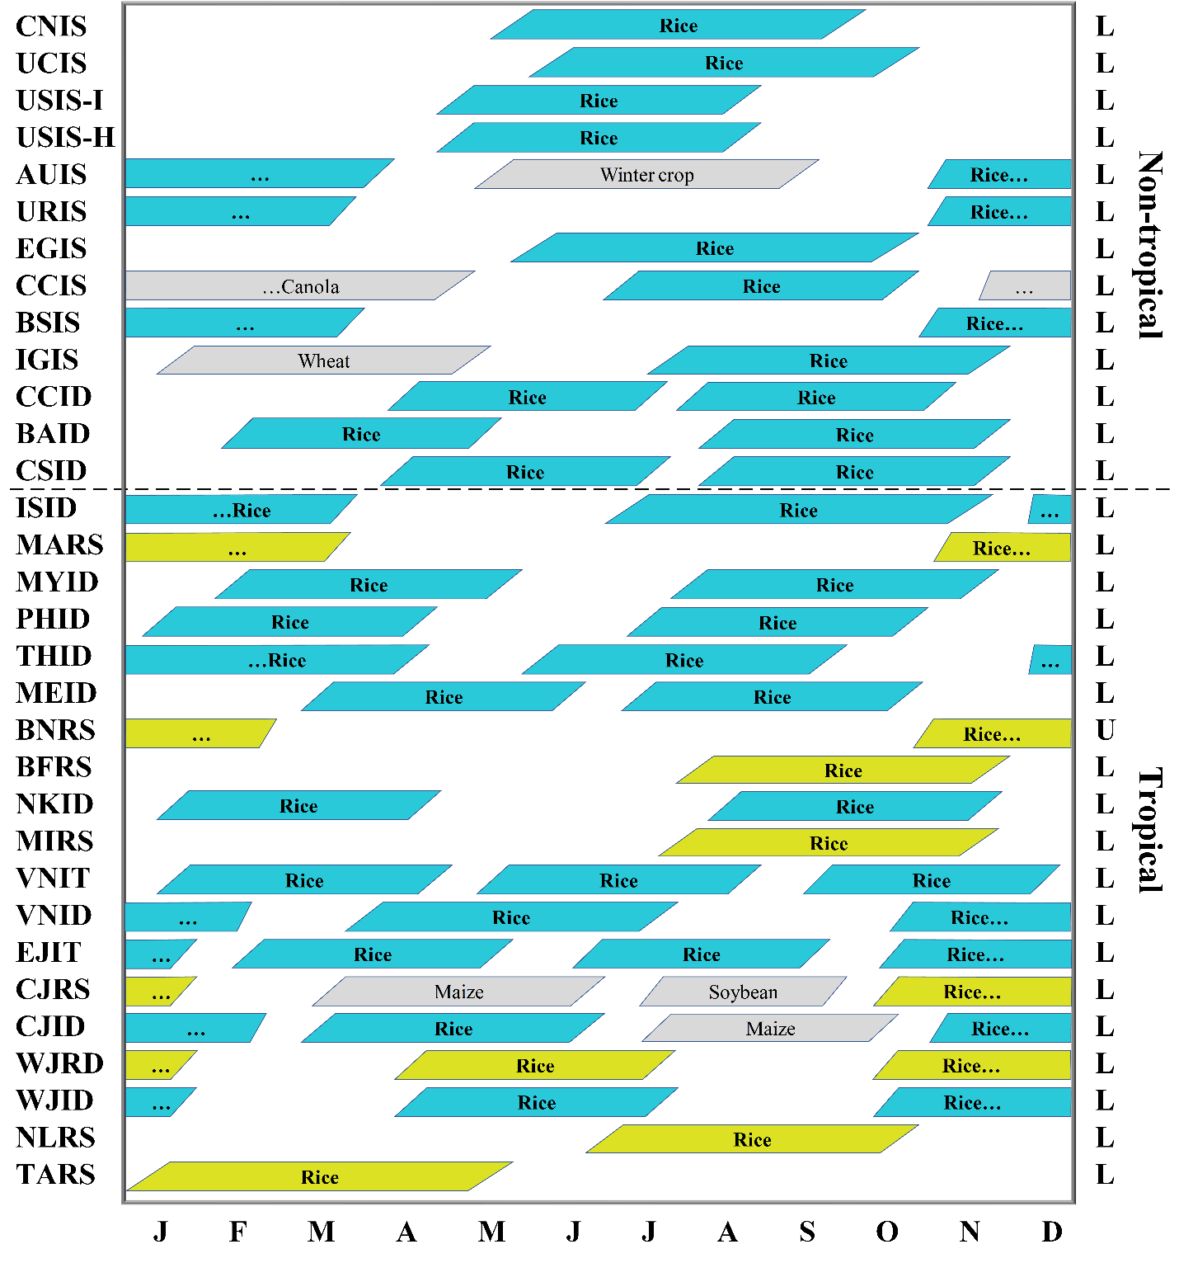
Supplementary Figure 1. Crop calendars for 32 rice cropping systems. Cropping systems were sorted according to latitude, from non-tropical (top) to tropical regions (bottom). Each box represents a crop cycle, from establishment (either transplanting or direct seeding) to harvest maturity. Colors indicate water regime: irrigated (blue) or rainfed (yellow). Letters on the right axis indicate ecosystem: lowland (L) or upland (U). Cropping system codes are shown in Supplementary Table 2.
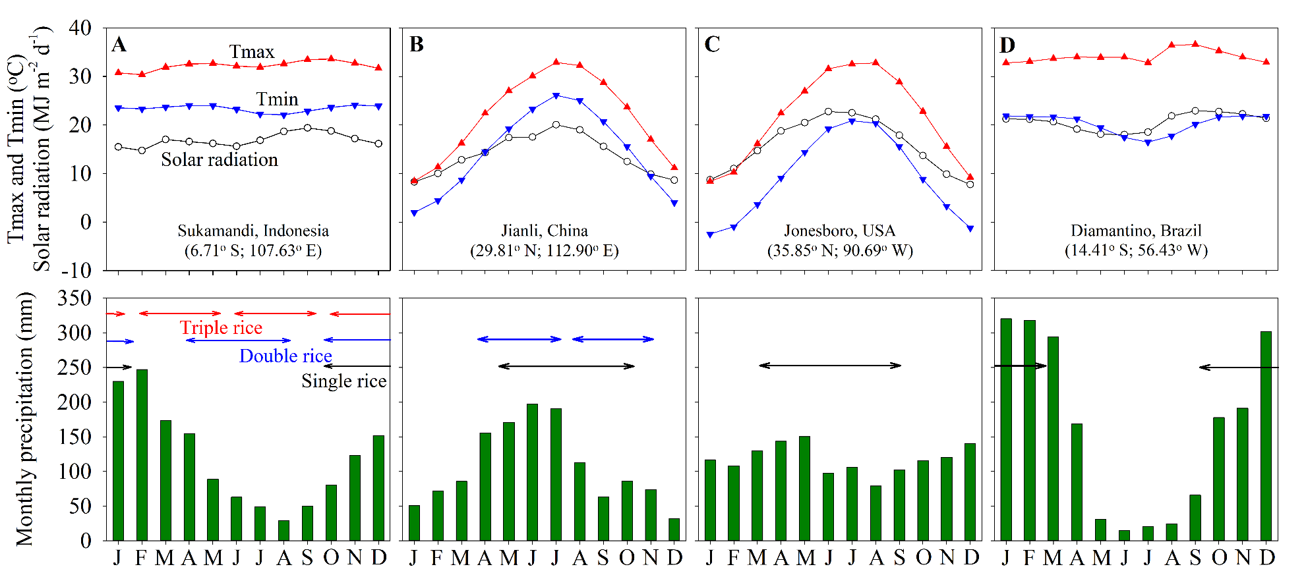
Supplementary Figure 2. Monthly means of solar radiation, maximum (Tmax) and minimum (Tmin) temperatures, and total precipitation. Four sites were selected to illustrate weather patterns for (A) tropical lowland irrigated rice in South-East Asia (Sukamandi, Indonesia), (B) non-tropical lowland irrigated rice in East Asia (Jianli, China), (C) non-tropical lowland irrigated rice in North America (Jonesboro, USA), and (D) tropical upland rainfed rice in South America (Diamantino, Brazil). Arrows indicate the approximate duration of the rice crop cycle(s) at each site.

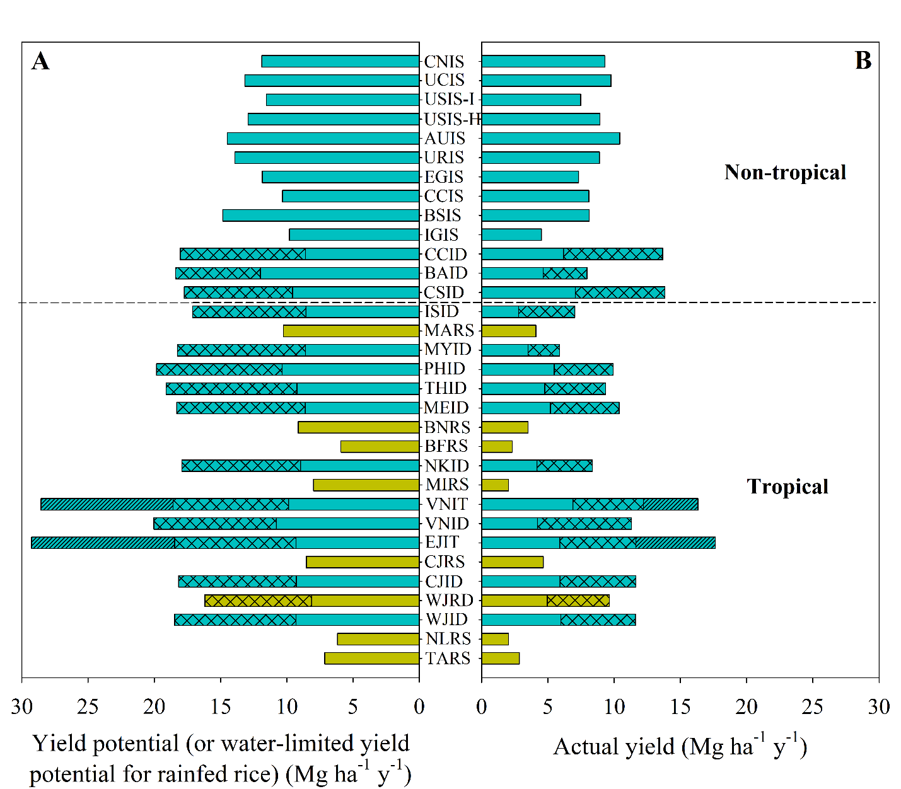
Supplementary Figure 3. Average annual rice yield potential or water-limited yield potential for rainfed rice (left panel) and actual yield (right panel) for each of the 32 rice cropping systems. Cropping systems were sorted according to latitude, from non-tropical (top) to tropical regions (bottom). Blue and brown bars denote irrigated and rainfed systems, respectively. Different bar patterns are used to distinguish yield potential (or water limited yield potential) for each crop cycle in each cropping system. Cropping system codes are shown in the Supplementary Table 2.

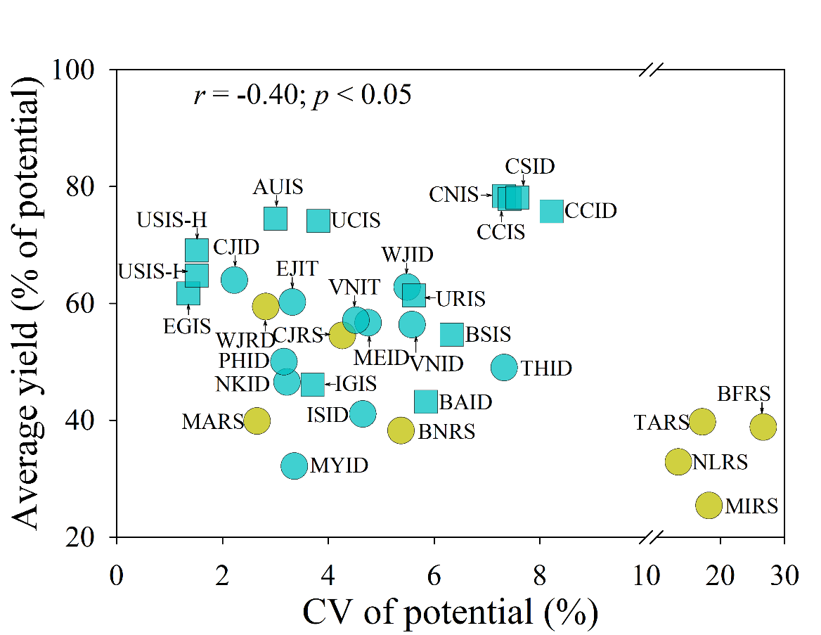
Supplementary Figure 4. Average rice yield, expressed as percentage of yield potential (or water-limited yield potential for rainfed rice) plotted against coefficient of variation (CV) of yield potential across years for each of the 32 rice cropping systems. Symbol type and color are used to distinguish tropical versus non-tropical regions (circles and squares, respectively) and irrigated versus rainfed systems (blue and yellow, respectively). The Pearson correlation coefficient (r) and associated p-value are shown. Cropping system codes are shown in Supplementary Table 2.

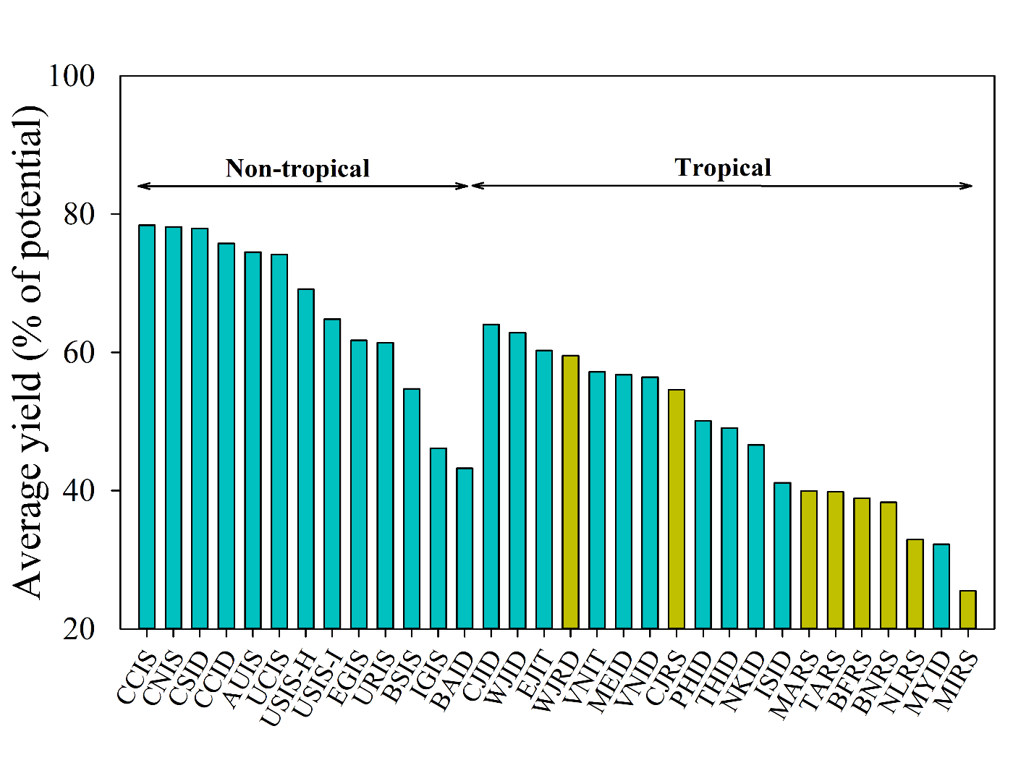
Supplementary Figure 5. Average rice yield, expressed as percentage of yield potential (or water-limited yield potential for rainfed rice) for each of the 32 rice cropping systems, which are grouped into non-tropical and tropical regions, and sort from highest to lowest in each group. Blue and brown bars denote irrigated and rainfed systems. Cropping system codes are shown in Supplementary Table 2.

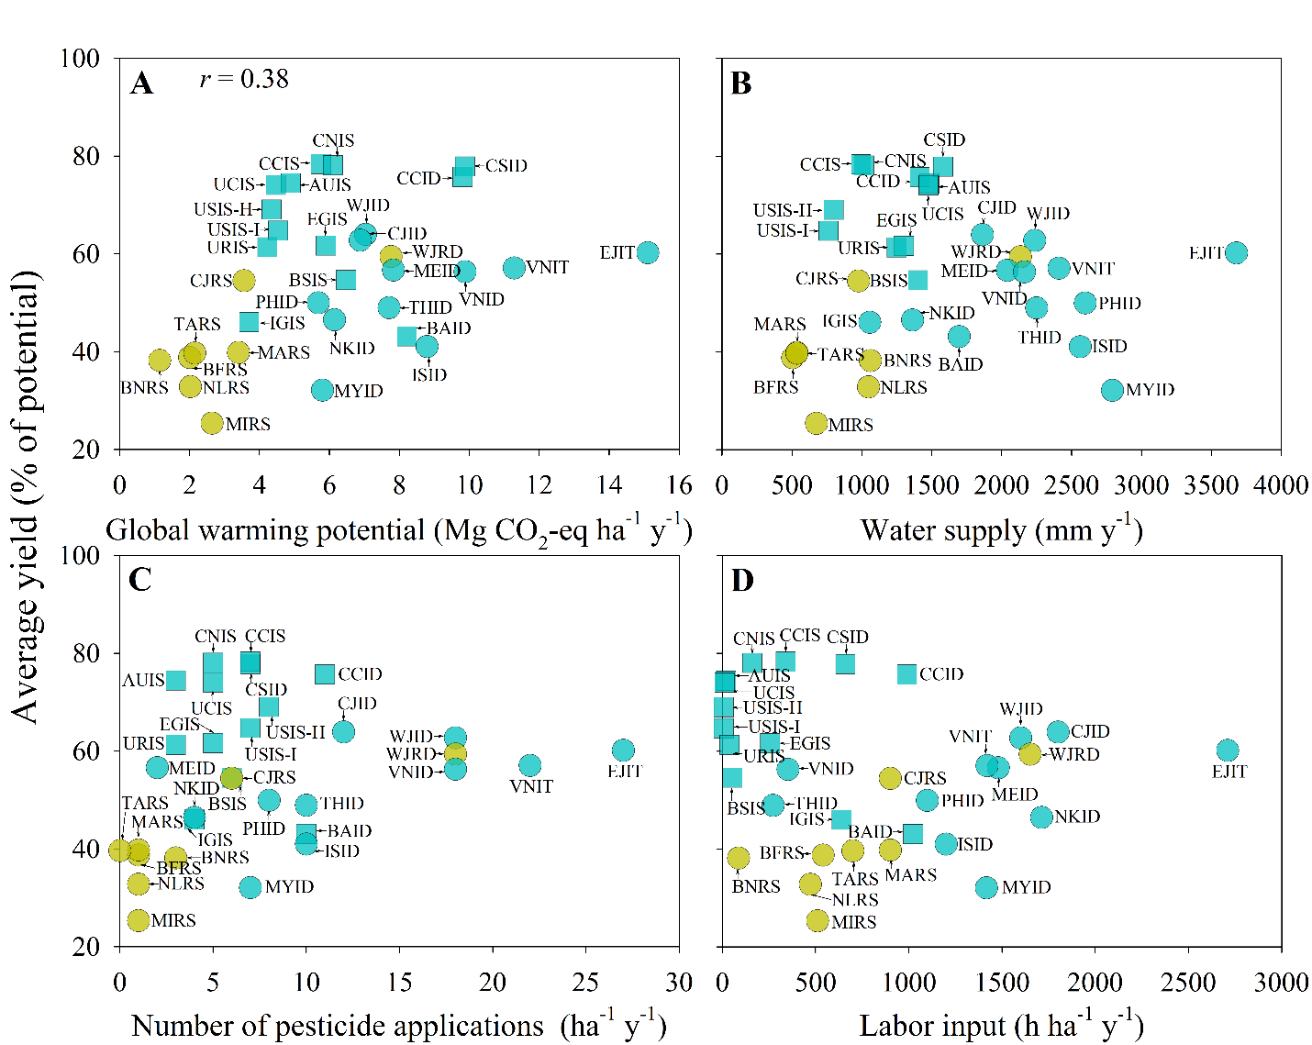
Supplementary Figure 6. Average rice yield, expressed as percentage of yield potential (or water-limited yield potential for rainfed rice) plotted against (A) global warming potential, (B) water supply (irrigation plus in-season precipitation), (C) number of pesticide applications, and (D) labor input per hectare per year. Symbol type and color are used to distinguish tropical versus non-tropical regions (circles and squares, respectively) and irrigated versus rainfed systems (blue and yellow, respectively). Pearson correlation coefficient (r) is shown only when associations between variables were statistically significant (p<0.05). Cropping system codes are shown in Supplementary Table 2.

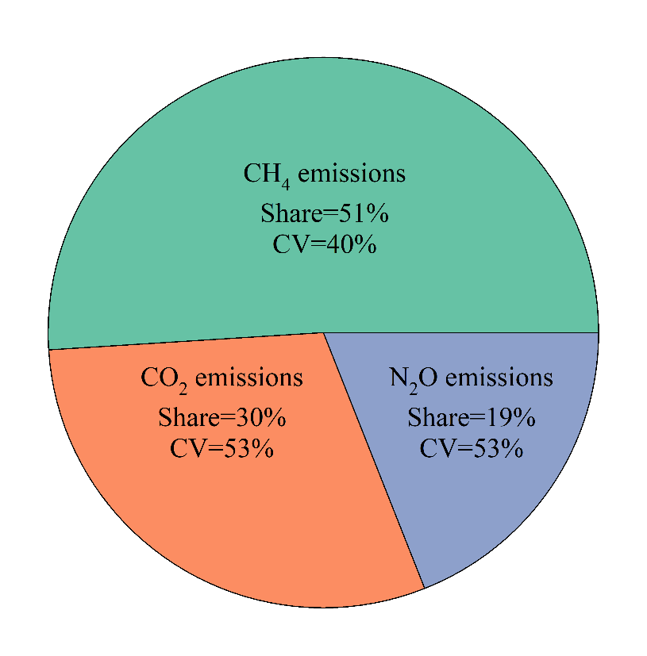
Supplementary Figure 7. Proportion of methane (CH₄) emissions from flooded rice, CO₂ emissions associated with manufacturing, packaging, and transportation of agricultural inputs, and soil nitrous oxide (N₂O) emissions derived from fertilizer nitrogen (N) application expressed in CO₂-eq to total global warming potential and coefficient of variation (CV) in CH₄, CO₂, and N₂O emissions across the 32 cropping systems.

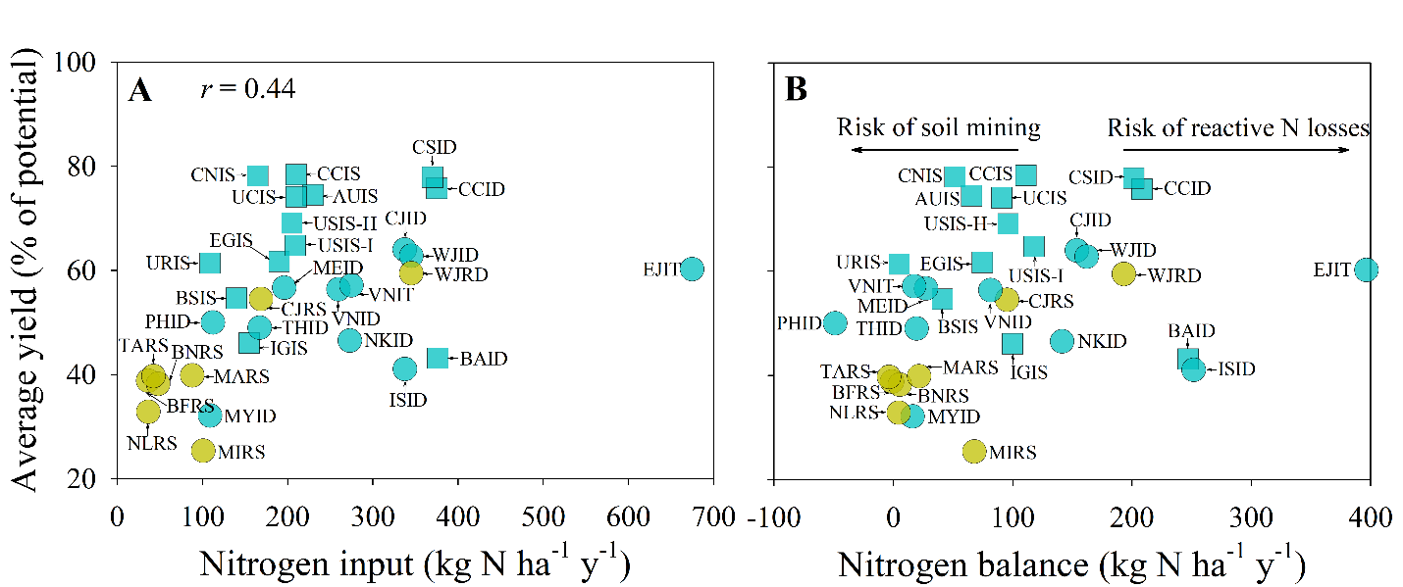
Supplementary Figure 8. Average rice yield, expressed as percentage of yield potential (or water-limited yield potential for rainfed rice) plotted against (A) total nitrogen (N) input (from fertilizer, manure, and fixation) and (B) N balance calculated as external N input minus N removal per hectare per year. Symbol type and color are used to distinguish tropical versus non-tropical regions (circles and squares, respectively) and irrigated versus rainfed systems (blue and yellow, respectively). Pearson correlation coefficient (r) is shown only when associations between variables were statistically significant (p<0.05). Cropping system codes are shown in Supplementary Table 2.

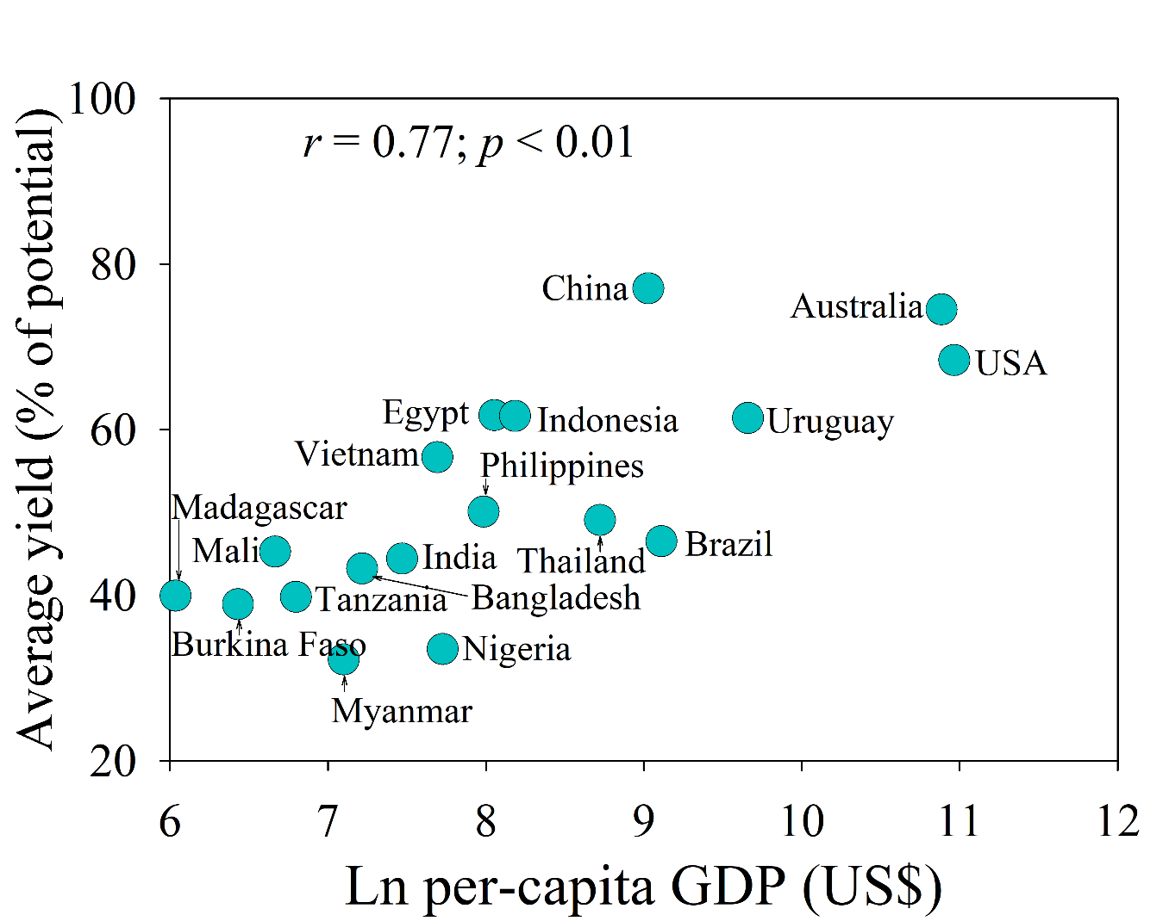
Supplementary Figure 9. Average rice yield, expressed as percentage of yield potential (or water-limited yield potential for rainfed rice) plotted against per-capita gross domestic product (GDP) for each of the 18 rice-producing countries. Data on per-capita GDP have been log-transformed. Each data point represents an area-weighted value of average rice yield, with the weighting depending upon the rice harvested area of each system in a country. The Pearson correlation coefficient (r) and associated p-value are shown.

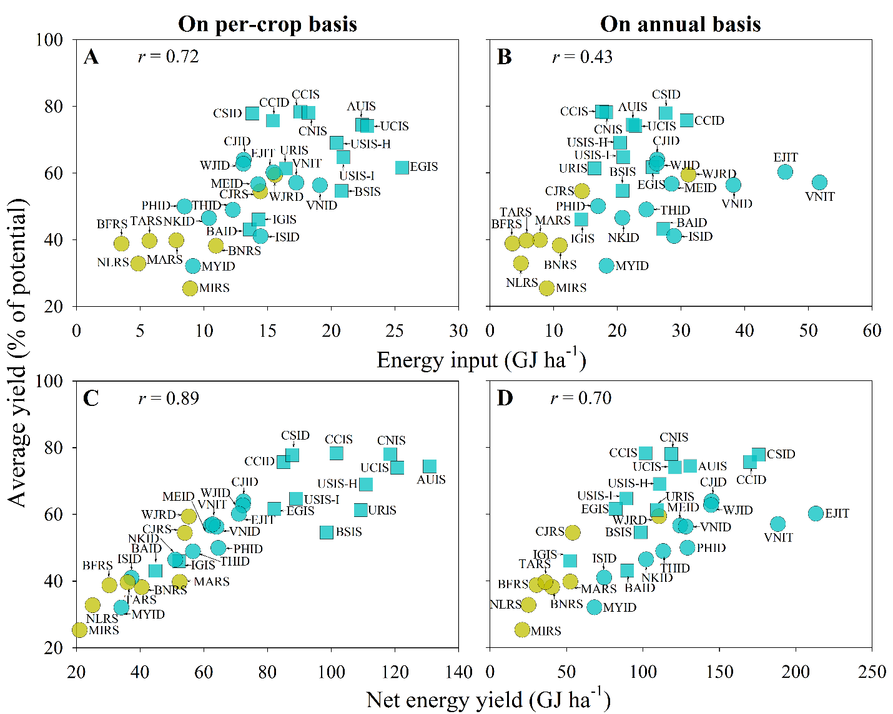
Supplementary Figure 10. Average rice yield, expressed as percentage of yield potential (or water-limited yield potential for rainfed rice) plotted against (A, B) total fossil-fuel energy input (including labor) and (C, D) net energy yield calculated as the difference between energy output and input on a per-crop (A, C) and annual basis (B, D). Symbol type and color are used to distinguish tropical versus non-tropical regions (circles and squares, respectively) and irrigated versus rainfed systems (blue and yellow, respectively). Pearson correlation coefficient (r) is shown only when associations between variables were statistically significant (p<0.05). Cropping system codes are shown in Supplementary Table 2.

Supplementary Table 1. Annual rice harvested area (and percentage of global total), rice production (and percentage of global total), and per-capita gross domestic product (GDP) across 18 countries during the 2015-2017 period. Countries were sorted in a descending order of rice harvested area. Sources: FAO¹; World Bank⁵.
Country | Rice harvested area (kha) | % global rice area | Rice production (MMT) | % global rice production | Per-capita GDP (× 10³ US$)
India | 43456 | 26 | 163 | 22 | 1.8
China | 31030 | 19 | 214 | 28 | 8.3
Indonesia | 15020 | 9 | 79 | 10 | 3.6
Bangladesh | 11218 | 7 | 50 | 7 | 1.4
Thailand | 9891 | 6 | 29 | 4 | 6.1
Vietnam | 7757 | 5 | 44 | 6 | 2.2
Myanmar | 6746 | 4 | 26 | 3 | 1.2
Philippines | 4675 | 3 | 18 | 2 | 2.9
Nigeria | 4547 | 3 | 9 | 1 | 2.3
Brazil | 2030 | 1 | 12 | 2 | 9.1
Tanzania | 1186 | 1 | 3 | < 1 | 0.9
USA | 1085 | 1 | 9 | 1 | 57.9
Madagascar | 827 | 1 | 4 | < 1 | 0.4
Mali | 788 | < 1 | 3 | < 1 | 0.8
Egypt | 588 | < 1 | 6 | 1 | 3.1
Uruguay | 162 | < 1 | 1 | < 1 | 15.7
Burkina Faso | 159 | < 1 | < 1 | < 1 | 0.6
Australia | 59 | < 1 | 1 | < 1 | 53.4
Total |  | 86 |  | 88
Thousand hectares (kha), million metric tons (MMT).

Supplementary Table 2. Overview of 32 rice cropping systems in 18 countries.
Country | Region | Ecosystem | Water regime | Number of rice cycles* | Dominant plant cultivar | Cropping system code†
Australia (AU) | New South Wales | L | I | S | I | AUIS
Bangladesh (BA) | North | L | I | D | I | BAID
Burkina Faso (BF) | Cascades | L | R | S | I | BFRS
Brazil | North (BN) | U | R | S | I | BNRS
 | South (BS) | L | I |  |  | BSIS
China | Central (CC) | L | I | S | H | CCIS
 |  |  |  | D |  | CCID
 | North (CN) |  |  | S | I | CNIS
 | South (CS) |  |  | D | H | CSID
Egypt (EG) | Delta | L | I | S | I | EGIS
Indonesia | Central Java (CJ) | L | I | D | I | CJID
 |  |  | R | S |  | CJRS
 | East Java (EJ) |  | I | T |  | EJIT
 | West Java (WJ) |  |  | D |  | WJID
 |  |  | R |  |  | WJRD
India | Indo-Gangetic Plains (IG) | L | I | S | I | IGIS
 | Southern (IS) |  |  | D |  | ISID
Madagascar (MA) | Ambohibary | L | R | S | I | MARS
Mali | Segou (ME) | L | I | D | I | MEID
 | Sikasso (MI) |  | R | S |  | MIRS
Myanmar (MY) | Ayeyarwady delta | L | I | D | I | MYID
Nigeria | Kano (NK) | L | I | D | I | NKID
 | Lafia (NL) |  | R | S |  | NLRS
Philippines (PH) | Central Luzon | L | I | D | I | PHID
Thailand (TH) | Central region | L | I | D | I | THID
Tanzania (TA) | Kahama | L | R | S | I | TARS
USA | South (US) | L | I | S | H | USIS-H
 |  |  |  |  | I | USIS-I
 | California (UC) |  |  |  |  | UCIS
Uruguay (UR) | North, Central and East | L | I | S | I | URIS
Vietnam (VN) | Mekong delta | L | I | D | I | VNID
 |  |  |  | T |  | VNIT
Ecosystems: lowland (L); upland (U). Water regimes: irrigated (I) and rainfed (R). Number of rice cycles: single (S), double (D), and triple (T) season rice. Dominant plant cultivar: inbred (I), hybrid (H). *It does not include other crops such as maize, wheat, or soybean (see Supplementary Fig. 1). † Cropping system code consists of country or region ID (first two letters), water regime (third letter), and rice cropping intensity (fourth letter). In the case of the southern USA, hybrid and inbred rice are also distinguished.
Supplementary Table 3. Key information on crop management in each rice cropping system. Cropping system codes are shown in Supplementary Table 2. See footnote for abbreviations.
Cropping system code | Tillage method | Establishment method | Mechanization level | Straw management | Weed control | Field size (ha)
AUIS | F | D | H | B | C | 60
BAID | M | T | I | R | C | 0.2
BFRS | F | D | L | R | C | 0.2
BNRS | F | D | H | L | C | 75
BSIS |  |  |  |  |  | 114
CCIS | F | T | I | L | C | 0.3
CCID |  |  |  |  |  | 0.1
CNIS |  |  | H |  |  | 0.9
CSID |  |  | I |  |  | 0.1
EGIS | F | D | I | B | C | 0.5
CJID | F | T | L | B | C+M | 0.2
CJRS |  |  |  |  |  | 0.2
EJIT |  |  |  |  |  | 1
WJID |  |  |  |  |  | 1
WJRD |  |  |  |  |  | 1
IGIS | F | T | I | L | C | 1.2
ISID |  |  |  |  |  | 1.2
MARS | F | T | L | R | M | 0.1
MEID | F | T | L | R | C+M | 1.3
MIRS |  | D |  |  |  | 0.4
MYID | F | T | I | B | M | 2.5
NKID | F | T | L | B | C+M | 0.5
NLRS |  | D |  |  |  | 0.3
PHID | M | T | I | R | C+M | 1.1
THID | F | D | I | B | C+M | 2.8
TARS | F | T | L | R | M | 1.5
USIS-H | F | D | H | L | C | 84
USIS-I |  |  |  |  |  | 84
UCIS |  |  |  |  |  | 40
URIS | M | D | H | L | C | 90
VNID | M | D | I | B | C+M | 2.1
VNIT |  |  |  |  |  | 2.6
Tillage method: full (F), minimum (M); crop establishment method: direct seeded (D), transplanted (T); Mechanization level: high (H), intermediate (I), low (L); straw management: left in field (L), burn (B), remove out of the field (R); weed control: manual (M), chemical (C).
Supplementary Table 4. Key information on agronomic and labor inputs and grain yield in each rice cropping system. Values on applied inputs and yields are expressed per hectare on a per-crop basis. Cropping system codes are shown in Supplementary Table 2.
Cropping system code | SR  (kg) | Fertilizer (kg) |  |  |  | Manure |  |  | Pesticide |  | Irrigation (mm) | Labor (h) | Yield (Mg)
Cropping system code | SR  (kg) | N | P | K |  | Rate | Type |  | No. | Rate | Irrigation (mm) | Labor (h) | Yield (Mg)
AUIS | 150 | 200 | 25 | 0 |  | 0 |  |  | 3 | 2.6 | 1250 (0) | 19 | 10.4
BAID | 9 | 158 | 60 | 57 |  | 175 | P |  | 5 | 4.1 | 350 (0) | 512 | 4.0
BFRS | 65 | 6 | 4 | 4 |  | 19 | A |  | 1 | 0.2 | 0 (0) | 540 | 2.3
BNRS | 70 | 45 | 33 | 62 |  | 0 |  |  | 3 | 2 | 0 (0) | 86 | 3.5
BSIS | 90 | 110 | 58 | 62 |  | 0 |  |  | 6 | 4.6 | 900 (100%) | 55 | 8.1
CCIS | 21 | 180 | 70 | 100 |  | 0 |  |  | 7 | 4.8 | 500 (100%) | 340 | 8.1
CCID | 23 | 158 | 59 | 90 |  | 0 |  |  | 6 | 3.5 | 240 (100%) | 495 | 6.8
CNIS | 75 | 135 | 55 | 75 |  | 0 |  |  | 5 | 3.5 | 700 (100%) | 160 | 9.3
CSID | 30 | 155 | 17 | 94 |  | 0 |  |  | 4 | 1.5 | 299 (100%) | 330 | 6.9
EGIS | 100 | 160 | 38 | 57 |  | 0 |  |  | 5 | 3.9 | 1300 (100%) | 256 | 7.3
CJID | 20 | 135 | 50 | 35 |  | 600 | A |  | 6 | 4.3 | 184 (0) | 900 | 5.8
CJRS | 20 | 135 | 50 | 35 |  | 600 | A |  | 6 | 4.3 | 174 (100%) | 900 | 4.7
EJIT | 30 | 192 | 30 | 35 |  | 500 | A |  | 9 | 3.3 | 798 (20%) | 903 | 5.9
WJID | 27 | 143 | 34 | 44 |  | 0 |  |  | 9 | 6.1 | 777 (0) | 800 | 5.8
WJRD | 27 | 143 | 34 | 44 |  | 0 |  |  | 9 | 6.1 | 725 (50%) | 825 | 4.8
IGIS | 75 | 125 | 30 | 30 |  | 0 |  |  | 4 | 2.3 | 307 (100%) | 640 | 4.5
ISID | 70 | 135 | 45 | 45 |  | 1250 | P |  | 5 | 2.2 | 620 (0) | 600 | 3.5
MARS | 107 | 28 | 0 | 0 |  | 5000 | A |  | 1 | 0.1 | 0 (0) | 900 | 4.1
MEID | 50 | 68 | 19 | 4 |  | 72 | A |  | 1 | 0.2 | 750 (100%) | 740 | 5.2
MIRS | 76 | 71 | 11 | 10 |  | 14 | P |  | 1 | 0.1 | 0 (0) | 510 | 2.0
MYID | 129 | 24 | 1 | 0 |  | 0 |  |  | 4 | 2.8 | 347 (0) | 708 | 2.9
NKID | 35 | 107 | 16 | 31 |  | 0 |  |  | 2 | 0.2 | 550 (0) | 856 | 4.2
NLRS | 117 | 7 | 0 | 1 |  | 0 |  |  | 1 | 0.2 | 0 (0) | 472 | 2.0
PHID | 86 | 26 | 7 | 6 |  | 0 |  |  | 4 | 3.2 | 565 (30%) | 550 | 5.0
THID | 125 | 53 | 9 | 3 |  | 75 | A |  | 5 | 4.2 | 689 (50%) | 136 | 4.7
TARS | 62 | 12 | 1 | 0 |  | 40 | A |  | 0 | 0 | 0 (0) | 700 | 2.8
USIS-H | 25 | 175 | 20 | 56 |  | 0 |  |  | 8 | 3.5 | 333 (100%) | 7 | 8.9
USIS-I | 67 | 179 | 20 | 56 |  | 0 |  |  | 7 | 3.5 | 296 (100%) | 7 | 7.5
UCIS | 170 | 180 | 22 | 29 |  | 0 |  |  | 5 | 6.3 | 1450 (0) | 11 | 9.8
URIS | 147 | 79 | 17 | 28 |  | 0 |  |  | 3 | 2.3 | 690 (50%) | 38 | 8.5
VNID | 101 | 100 | 65 | 61 |  | 0 |  |  | 9 | 6.9 | 718 (100%) | 176 | 5.7
VNIT | 204 | 62 | 26 | 21 |  | 0 |  |  | 7 | 5.6 | 478 (70%) | 473 | 5.4
SR: seeding rate; synthetic fertilizer nutrient application: nitrogen (N), phosphorus (P), and potassium (K) expressed as elemental nutrient; other nutrient application: animal manure (A) or plant compost (P) and associated rates in fresh weight (kg ha⁻¹); number of pesticide applications: number and total amount (kg a.i. ha⁻¹), irrigation water amount (and percentage of pumping for irrigation), labor input, and grain yield at 14% MC.
Supplementary Table 5. Sources of data on crop management practices, applied inputs, and actual yield, and yield potential and yield potential (or water-limited yield potential for rainfed rice). Cropping system codes are shown in Supplementary Table 2.
Cropping system code | Crop management practices, applied inputs, and actual yield | Yield potential
AUIS | Rice Marketing Board Annual Report | Lacy et al.⁷
BAID | Metrics and Indicators for Tracking in GRiSP (MISTIG) survey, Bureau of Statistics | GYGA⁶
BFRS | Yield Gap Survey | GYGA
BNRS | Field survey | GYGA
BSIS
CCIS | Field survey | GYGA
CCID
CNIS
CSID
EGIS | National Rice Campaign, Expert opinion | GYGA
CJID | Field survey, The Office of Agriculture at Grobogan Regency | GYGA
CJRS
EJIT | Field survey, Agricultural services
WJID | Field survey, Statistics Indonesia
WJRD
IGIS | Crop Production Statistics Information System, India | GYGA
ISID
MARS | Field survey | GYGA
MEID | Yield Gap Survey | GYGA
MIRS
MYID | MISTIG survey, Metrics and Indicators for Tracking in RICE CRP (MISTIR) survey | GYGA
NKID | Field survey, Expert opinion | GYGA
NLRS | Yield Gap Survey
PHID | MISTIG and MISTIR survey, Philippine Statistics Authority | GYGA
THID | Closing Rice Yield Gaps in Asia (CORIGAP) survey | GYGA
TARS | Yield Gap Survey | GYGA
USIS-H | United States Department of Agriculture (USDA) | GYGA
USIS-I
UCIS | UC Cooperative Extension, USDA
URIS | Agricultural statistical yearbook (DIEA, MGAP), Summary of Rice seasons data base reports, Rice working group (INIA), Scientific and local publications, Experts opinion | GYGA
VNID | MISTIG and MISTIR survey, General Statistics Office | GYGA
VNIT
*GYGA: Global Yield Gap Atlas (www.yieldgap.org)
Supplementary Table 6. Means of daily solar radiation and maximum (Tmax) and minimum (Tmin) temperature, and total rainfall during the rice growing season based on at least five years of measured weather data at each site. Values are averages across crop cycles in the case of systems with more than one cycle. Cropping system codes are shown in Supplementary Table 2.
Cropping system code | Weather station | Latitude (degree) | Longitude (degree) | Radiation (MJ m⁻² d⁻¹) | Tmax (°C) | Tmin (°C) | Total rainfall (mm)
AUIS | Wagga Wagga | -35.11 | 147.36 | 24.1 | 28.8 | 13.7 | 232
BAID | Dhaka | 23.81 | 90.41 | 17.5 | 31.7 | 22.8 | 498
BFRS | Fada Ngourma | 12.06 | 0.37 | 20.1 | 33.5 | 22.6 | 494
BNRS | Diamantino | -14.41 | -56.43 | 18.1 | 28.0 | 18.1 | 1061
BSIS | Santa Maria | -29.69 | -53.81 | 23.2 | 25.4 | 15.9 | 501
CCIS | Jianli | 29.81 | 112.90 | 16.9 | 29.5 | 22.1 | 495
CCID | Yongzhou | 26.42 | 111.61 | 18.0 | 29.2 | 21.6 | 457
CNIS | Fujin | 47.25 | 132.04 | 18.1 | 23.7 | 13.2 | 316
CSID | Gaoyao | 23.03 | 112.46 | 17.9 | 30.1 | 23.1 | 492
EGIS | Cairo | 30.04 | 31.24 | 26.6 | 34.0 | 20.7 | 1
CJID | Blora | -7.01 | 111.38 | 17.9 | 28.0 | 22.8 | 747
CJRS |  |  |  | 19.1 | 28.7 | 22.9 | 802
EJIT | Perak II | -7.21 | 112.73 | 18.3 | 33.6 | 24.9 | 427
WJID | Sukamandi | -6.71 | 107.63 | 16.6 | 32.2 | 23.6 | 341
WJRD
IGIS | Modipuram | 29.07 | 77.71 | 16.0 | 29.8 | 17.4 | 749
ISID | Bhubaneshwar | 20.30 | 85.82 | 17.0 | 33.0 | 21.9 | 661
MARS | Ambohibary | -19.62 | 47.13 | 20.8 | 21.3 | 12.4 | 534
MEID | Segou | 13.43 | -6.25 | 22.0 | 35.8 | 24.5 | 270
MIRS | Sikasso | 11.32 | -5.70 | 19.4 | 30.4 | 21.8 | 675
MYID | Bago | 17.32 | 96.47 | 18.6 | 33.7 | 23.0 | 1049
NKID | Kano | 12.00 | 8.59 | 22.0 | 34.0 | 19.1 | 131
NLRS | Enugu | 6.46 | 7.55 | 15.4 | 31.4 | 22.6 | 1046
PHID | Dagupan | 16.09 | 120.35 | 19.1 | 32.2 | 23.3 | 734
THID | Nakhon Sawan | 15.7 | 100.12 | 19.2 | 34.7 | 24.2 | 436
TARS | Mwanza | -2.52 | 32.92 | 19.8 | 28.2 | 17.6 | 535
USIS-H | Jonesboro | 35.85 | -90.69 | 21.1 | 29.3 | 16.8 | 465
USIS-I
UCIS | Colusa | 39.21 | -122.01 | 23.8 | 30.5 | 12.5 | 27
URIS | Treinta y Tres | 33.23 | -54.36 | 21.7 | 26.7 | 14.6 | 560
VNID | Can Tho | 10.05 | 105.75 | 19.8 | 32.3 | 24.7 | 364
VNIT |  |  |  | 19.7 | 32.2 | 24.8 | 325

Supplementary Table 7. Emission factors used for estimating greenhouse gases emissions from manufacturing, packaging, and transportation of agricultural inputs.
Inputs | Unit | Emission factor (CO₂-eq kg unit⁻¹) | References
Machinery | MJ | 0.071 | Dyer and Desjardins³⁵; Khoshnevisan et al.³⁶
Diesel | l | 2.76 | Khoshnevisan et al.³⁶; Pishgar-Komleh et al.³⁷
LPG | l | 1.50 | EPA²²
Electricity | kWh | 0.78 | Casey and Holden³⁸; Mondani et al.³⁹
Nitrogen (N) | kg | 4.77 | Lal⁴⁰; Pathak and Wassman⁴¹
Phosphorus (P₂O5) | kg | 0.73 | Lal⁴⁰; Pathak and Wassman⁴¹
Potassium (K₂O) | kg | 0.55 | Lal⁴⁰; Pathak and Wassman⁴¹
Manure | kg | 0.13 | Li and Kotelko⁴²; Mondani et al.³⁹
Pesticides | kg a.i. * | 18.7 | Lal⁴⁰; Yang et al.⁴³
Seed | kg | 0.78 | Guo et al.⁴⁴
* a.i., active ingredient.

Supplementary Table 8. Fuel consumption and operation time of machine in different field operations in rice production.
Field operation | Fuel consumption (l ha⁻¹) | Operation time (h ha⁻¹) | References
Land preparation (full tillage) | 38 | 5.0 | Hokazono and Hayashi⁴⁵; Sims et al.²¹
Land preparation (minimum tillage) | 23 | 3.5 | Hokazono and Hayashi⁴⁵; Sims et al.²¹
Sowing | 5 | 0.2 | Fusi et al.⁴⁶; Sims et al.²¹
Transplanting | 15 | 3.0 | Harada et al.⁴⁷
Fertilizing | 2.5 | 0.25 | Fusi et al.⁴⁶
Spraying | 1.5 | 0.2 | Fusi et al.⁴⁶; Sims et al.²¹
Weeding | 1.5 | 0.2 | Fusi et al.⁴⁶; Sims et al.²¹
Harvesting | 10 | 1.0 | Fusi et al.⁴⁶; Sims et al.²¹

Supplementary Table 9. Embodied energy of agricultural inputs and output.
Inputs | Unit | Energy equivalent (MJ unit⁻¹) | References
Machinery | kg*y | 12.5 | Pellegrini and Fernández¹⁶; Mikkola and Ahokas⁴⁸
Diesel | l | 45.5 | Alluvione et al.⁴⁹; Arizpe et al.⁵⁰
Nitrogen (N) | kg | 45.5 | Pellegrini and Fernández¹⁶; IEA⁵¹
Phosphorus (P₂O₅) | kg | 14.2 | Pellegrini and Fernández¹⁶; Meul et al.⁵²
Potassium (K₂O) | kg | 10.0 | Pellegrini and Fernández¹⁶
Manure | kg | 0.3 | Wu et al.⁵³; Mondani et al.³⁹
Pesticides | kg a.i. * | 120 | Lal et al.⁵⁴
Seed † | kg | 30.6 | West and Marland⁵⁵; EIA⁵⁶
Electricity | kWh | 3.6 | Zhang et al.⁵⁷
Labor | h | 1.96 | Singh et al.⁵⁸
Rice grain | kg | 14.7 | Lal et al.⁵⁴
* a.i., active ingredient
† Using dollar to energy conversion of 5.45 MJ US $⁻¹ (an average from 2015-2017) for rice seed⁵⁶ following West and Marland⁵⁵. Seed prices are from Xie and Hardy⁵⁹ and Peng⁶⁰.

Supplementary Table 10. The assumed fraction of the total amount of straw remaining in the field and the assumed fraction of nitrogen nutrient lost from crop residues by burning or leaching under different straw managements.
Straw management | Straw remaining, % | Nitrogen lost, %
Left in field | 90 | 20
Burn | 90 | 90
Remove out of field | 10 | 90
Data from Dobermann et al²⁶.

Supplementary Table 11. Pearson’s correlation coefficients among average yield (% of potential), resource inputs, resource-use efficiency, and environmental impact parameters. Metrics are shown on area and yield-scaled basis and computed based on average across the rice crop cycles within each cropping system.
Metric | Yield | On area basis (per ha) |  |  |  |  |  |  |  | On yield-scaled basis (per Mg)
 | (% Yp) | GWP | Water | Pest | N | Labor | Energy | NB |  | GWP | Water | Pest | Labor | NB
GWP | 0.72***
Water | 0.21 | 0.36**
Pest | 0.53*** | 0.52*** | 0.29
N | 0.73*** | 0.73*** | 0.23 | 0.62***
Labor | -0.36** | -0.37** | -0.31* | -0.09 | -0.16
Energy | 0.72*** | 0.81*** | 0.48*** | 0.58*** | 0.76*** | -0.56***
NB | 0.43** | 0.50*** | -0.03 | 0.54*** | 0.89*** | 0.07 | 0.48***
YGWP | -0.59*** | -0.06 | -0.17 | -0.17 | -0.18 | 0.39** | -0.35** | 0.14
YWater | -0.75*** | -0.54*** | 0.25 | -0.31* | -0.55*** | 0.24 | -0.53*** | -0.31* |  | 0.54***
YPest | 0.04 | 0.14 | 0.25 | 0.82*** | 0.29 | 0.22 | 0.20 | 0.40** |  | 0.19 | 0.15
YLabor | -0.71*** | -0.62*** | -0.40** | -0.43** | 0.48*** | 0.83*** | -0.79*** | -0.16 |  | 0.61*** | 0.55*** | -0.01
YNB | -0.04 | 0.20 | -0.08 | 0.28 | 0.56*** | 0.28 | 0.15 | 0.84*** |  | 0.53*** | 0.05 | 0.41** | 0.20
NEY | 0.89*** | 0.73*** | 0.38** | 0.38** | 0.66*** | -0.59*** | 0.78*** | 0.27 |  | -0.64*** | -0.70*** | -0.15 | -0.81*** | -0.17
Asterisks indicate significance at * P<0.1, ** P<0.05, *** P<0.01. Variables: average yield expressed as % of potential (Yp); GWP: global warming potential (Mg CO₂-eq); water supply, which is the sum of irrigation and in-season precipitation (Water, mm); number of pesticide applications (Pest, unitless); nitrogen (N) input and balance (NB, kg N); labor (h); energy input (Energy) and net energy yield (NEY) (GJ); yield-scaled GWP (YGWP, Mg CO₂-eq Mg⁻¹ grain); yield-scaled water supply (YWater, mm Mg⁻¹ grain); yield-scaled number of pesticide applications (YPest, No. Mg⁻¹ grain); yield-scaled labor (YLabor, h Mg⁻¹ grain); yield-scaled nitrogen balance (YNB, kg N Mg⁻¹ grain).

Additional references associated with Supplementary Information
- FAO. FAOSTAT production data. (accessed 5 July 2019); www.fao.org/faostat/en/#data.
- Global Agro-Ecological Zones. GAEZ-Global Agro-Ecological Zones. (accessed 5 July 2019); http://www.fao.org/nr/gaez/en/.
- Jena, K. K. & Hardy, B. Advances in temperate rice research (International Rice Research Institute, Los Baños, Philippines, 2012).
- GRiSP (Global Rice Science Partnership). Rice almanac, 4th edition (International Rice Research Institute, Los Baños, Philippines, 2013).
- World Bank. DataBank. (accessed 5 July 2019); www.databank.worldbank.org/home.aspx.
- GYGA. (accessed 5 July 2019); www.yieldgap.org/home.
- Lacy, J., Clampett, W. & Nagy, J. Bridging the rice yield gap in Australia. Bridging the rice yield gap in the Asia-Pacific region (Food and Agriculture Regional Office for Asia and the Pacific, Bangkok, Thailand, 2000).
- Bouman, B. A. M., Kropff, M. J., Tuong, T. P., Wopereis, M. C. S., ten Berge, H. F. M. & van Laar, H. H. ORYZA2000: modeling lowland rice (International Rice Research Institute and Wageningen University and Research Centre, Los Baños, Philippines and Wageningen, Netherlands, 2001).
- Yuan, S., Peng, S. & Li, T. Evaluation and application of the ORYZA rice model under different crop managements with high-yielding rice cultivars in central China. Field Crops Res. 212, 115-125 (2017).
- IPCC. IPCC 2019 Refinement to the 2006 IPCC guidelines for national greenhouse gas inventories (Switzerland, 2019).
- van Groenigen, J. W., Velthof, G., Oenema, O., van Groenigen, K. J. & van Kessel, C. Towards an agronomic assessment of N₂O emissions: a case study for arable crops. Eur. J. Soil Sci. 61, 903-913 (2010).
- IPCC. 2006 IPCC guidelines for national greenhouse gas inventories (Institute for Global Environmental Strategies, Hayama, Kanagawa, Japan, 2006).
- IPCC. Climate change 2007: The Physical Science Basis. Contribution of Working Group I to the Fourth Assessment Report of the Intergovernmental Panel on Climate Change (Cambridge University Press, Cambridge, United Kingdom and New York, USA, 2007).
- Mosier, A. R., Halvorson, A. D., Reule, C. A. & Liu, X. J. Net global warming potential and greenhouse gas intensity in irrigated cropping systems in northeastern Colorado. J. Environ. Qual. 35, 1584-1598 (2006).
- Stout, B. A. Handbook of energy for world agriculture (Elsevier, New York, USA, 1991).
- Pellegrini, P. & Fernández, R. J. Crop intensification, land use, and on-farm energy-use efficiency during the worldwide spread of the green revolution. Proc. Natl Acad. Sci. USA 115, 2335-2340 (2018).
- Daccache, A., Ciurana, J. S., Diaz, J. R. & Knox, J. W. Water and energy footprint of irrigated agriculture in the Mediterranean region. Environ. Res. Lett. 9, 124014 (2014).
- Keller, J. & Bliesner, R. B. Sprinkler and Trickle Irrigation (Chapman and Hall, New York, USA, 1990).
- Billiris, M. A. Measuring the Energy Required to Dry Rice in Commercial Rice Dryers, Theses and Dissertations (University of Arkansas, Fayetteville, Arkansas, USA, 2013).
- Jittanit, W., Saeteaw, N. & Charoenchaisri, A. Industrial paddy drying and energy saving options. J. Stored Prod. Res. 46, 209-213 (2010).
- Sims, R., Flammini, A., Puri, M. & Bracco, S. Opportunities for agri-food chains to become energy-smart (UN Food and Agricultural Organization, Rome and GIZ, 2015).
- EPA. Emission Factors for Greenhouse Gas Inventories (US Environmental Protection Agency, Washington DC, USA, 2014).
- Grassini, P. & Cassman, K. G. High-yield maize with large net energy yield and small global warming intensity. Proc. Natl Acad. Sci. USA 109, 1074-1079 (2012).
- Dobermann, A. & Witt, C. The potential impact of crop intensification on carbon and nitrogen cycling in intensive rice systems. Carbon and nitrogen dynamics in flooded soils (International Rice Research Institute, Los Baños, Philippines, 2000).
- Connor, D. J., Loomis, R. S. & Cassman, K. G. Crop ecology: productivity and management in agricultural systems (Cambridge Univ Press, Cambridge, United Kingdom, 2011).
- Dobermann, A., Witt, C. & Dawe, D. Increasing productivity of intensive rice systems through site-specific nutrient management (Science Publishers Inc. and International Rice Research Institute, Enfield NH, USA and Los Baños, Philippines, 2004).
- Herridge, D. F., Peoples, M. B. & Boddey, R. M. Global inputs of biological nitrogen fixation in agricultural systems. Plant Soil 311, 1-18 (2008).
- Lassaletta, L., Billen, G., Grizzetti, B., Anglade, J. & Garnier, J. 50 year trends in nitrogen use efficiency of world cropping systems: the relationship between yield and nitrogen input to cropland. Environ. Res. Lett. 9, 105011 (2014).
- Yoshida, T. & Ancajas, R. R. Nitrogen fixing activity in upland and flooded rice fields. Soil Sci. Soc. Am. Proc. 37, 45-46 (1973).
- Dobermann, A. & Fairhurst, T. H. Nutrient disorders and nutrient management (Potash and Phosphate Institute, Potash and Phosphate Institute of Canada and International Rice Research Institute, Singapore, 2000).
- Khush, G. Productivity improvements in rice. Nutr. Rev. 61, S114-116 (2003).
- Kovach, J., Petzoldt, C., Degni, J. & Tette, J. A method to measure the environmental impact of pesticides. NY Food Life Sci. Bull. 139, 1-8 (1992).
- Pandey, S. et al. Rice in the global economy: strategic research and policy issues for food security (International Rice Research Institute, Los Baños, Philippines, 2010).
- Kumar, V. & Ladha, J. K. Direct seeding of rice: recent developments and future research needs. Adv. Agron. 111, 297-413 (2011).
- Dyer, J. A. & Desjardins, R. L. Carbon dioxide emissions associated with the manufacturing of tractors and farm machinery in Canada. Biosyst. Eng. 93, 107-118 (2006).
- Khoshnevisan, B., Rafiee, S., Omid, M., Yousefi, M. & Movahedi, M. Modeling of energy consumption and GHG (greenhouse gas) emissions in wheat production in Esfahan province of Iran using artificial neural networks. Energy 52, 333-338 (2013).
- Pishgar-Komleh, S. H., Omid, M. & Heidari, M. D. On the study of energy use and GHG (greenhouse gas) emissions in greenhouse cucumber production in Yazd province. Energy 59, 63-71 (2013).
- Casey, J. W. & Holden, N. M. Analysis of greenhouse gas emissions from the average Irish milk production system. Agric. Syst. 86, 97-114 (2005).
- Mondani, F., Aleagha, S., Khoramivafa, M. & Ghobadi, R. Evaluation of greenhouse gases emission based on energy consumption in wheat agroecosystems. Energy Rep. 3, 37-45 (2017).
- Lal, R. Carbon emission from farm operations. Environ. Int. 30, 981-990 (2004).
- Pathak, H. & Wassmann, R. Introducing greenhouse gas mitigation as a development objective in rice-based agriculture: I. Generation of technical coefficients. Agric. Syst. 94, 807-825 (2007).
- Li, X. M. & Kotelko, M. An integrated manure utilization system (IMUS): its social and environmental benefits. The 3rd international methane and nitrous oxide mitigation conference, Lecture No.: AG056 (Beijing, China, 2003).
- Yang, X., Gao, W., Zhang, M., Chen, Y. & Sui, P. Reducing agricultural carbon footprint through diversified crop rotation systems in the North China Plain. J. Clean. Prod. 76, 131-139 (2014).
- Guo, J., Song, Z., Zhu, Y., Wei, W., Li, S. & Yu, Y. The characteristics of yield-scaled methane emission from paddy field in recent 35-year in China: A meta-analysis. J. Clean. Prod. 161, 1044-1050 (2017).
- Hokazono, S. & Hayashi, K. Variability in environmental impacts during conversion from conventional to organic farming: a comparison among three rice production systems in Japan. J. Clean. Prod. 28, 101-112 (2012).
- Fusi, A., Bacenetti, J., González-García, S., Vercesi, A., Bocchi, S. & Fiala, M. Environmental profile of paddy rice cultivation with different straw management. Sci. Total Environ. 494, 119-128 (2014).
- Harada, H., Kobayashi, H. & Shindo, H. Reduction in greenhouse gas emissions by no-tilling rice cultivation in Hachirogata polder, northern Japan: Life-cycle inventory analysis. Soil Sci. Plant Nutr. 53, 668-677 (2007).
- Mikkola, H. J. & Ahokas, J. Indirect energy input of agricultural machinery in bioenergy production. Renew. Energy 35, 23-28 (2010).
- Alluvione, F., Moretti, B., Sacco, D. & Grignani, C. EUE (energy use efficiency) of cropping systems for a sustainable agriculture. Energy 36, 4468-4481 (2011).
- Arizpe, N., Giampietro, M. & Ramos-Martin, J. Food security and fossil energy dependence: An international comparison of the use of fossil energy in agriculture (1991-2003). Crit. Rev. Plant Sci. 30, 45-63 (2011).
- IEA. Chemical and petrochemical industry. Tracking Industrial Energy Efficiency and CO₂ Emissions (IEA, Paris, France, 2007).
- Meul, M., Nevens, F., Reheul, D. & Hofman, G. Energy use efficiency of specialized dairy, arable and pig farms in Flanders. Agric. Ecosyst. Environ. 119, 135-144 (2007).
- Wu, H. et al. Temporal trends and spatial patterns of energy use efficiency and greenhouse gas emissions in crop production of Anhui Province, China. Energy 133, 955-968 (2017).
- Lal, B. et al. Input-output energy analysis of rainfed rice-based cropping systems in Eastern India. Agron. J. 107, 1750-1756 (2015).
- West, T. O. & Marland, G. A synthesis of carbon sequestration, carbon emissions, and net carbon flux in agriculture: comparing tillage practices in the United States. Agr. Ecosyst. Environ. 91, 217-232 (2002).
- EIA. Annual Energy Review. Energy consumption, expenditures, and emissions indicators estimates. (accessed 10 October 2020); www.eia.gov/totalenergy/data/annual/.
- Zhang, W. et al. New technologies reduce greenhouse gas emissions from nitrogenous fertilizer in China. Proc. Natl Acad. Sci. USA 110, 8375-8380 (2013).
- Singh, P., Singh, G. & Sodhi, G. P. Energy auditing and optimization approach for improving energy efficiency of rice cultivation in south-western Punjab, India. Energy 174, 269-279 (2019).
- Xie, F. & Hardy, B. Accelerating hybrid rice development (International Rice Research Institute, Los Baños, Philippines, 2009).
- Peng, S. Dilemma and way-out of hybrid rice during the transition period in China. Acta. Agron. Sin. 42, 313-319 (2016).

