Comparison of models for estimating the year-round range of Spodoptera frugiperda (Lepidoptera: Noctuidae) and predictions for New Zealand under current and future climates
Biological Invasions
Craig B. Phillips¹ (ORCID 0000-0003-2352-3544), Yujie Han¹ (ORCID 0000-0003-1751-9004), Nicholas Davies¹ (ORCID 0000-0001-8511-9657), John Kean² (ORCID 0000-0002-4012-1048)
¹AgResearch Tuhiraki, Private Bag 4749, Christchurch 8140
²AgResearch, Ruakura Research Centre, Private Bag 3123, Waikato Mail Centre, Hamilton 3240
Corresponding author: Craig B. Phillips (craig.phillips@agresearch.co.nz)

Supplementary Information

China isotherms based on Climond data (1975 & 2030)
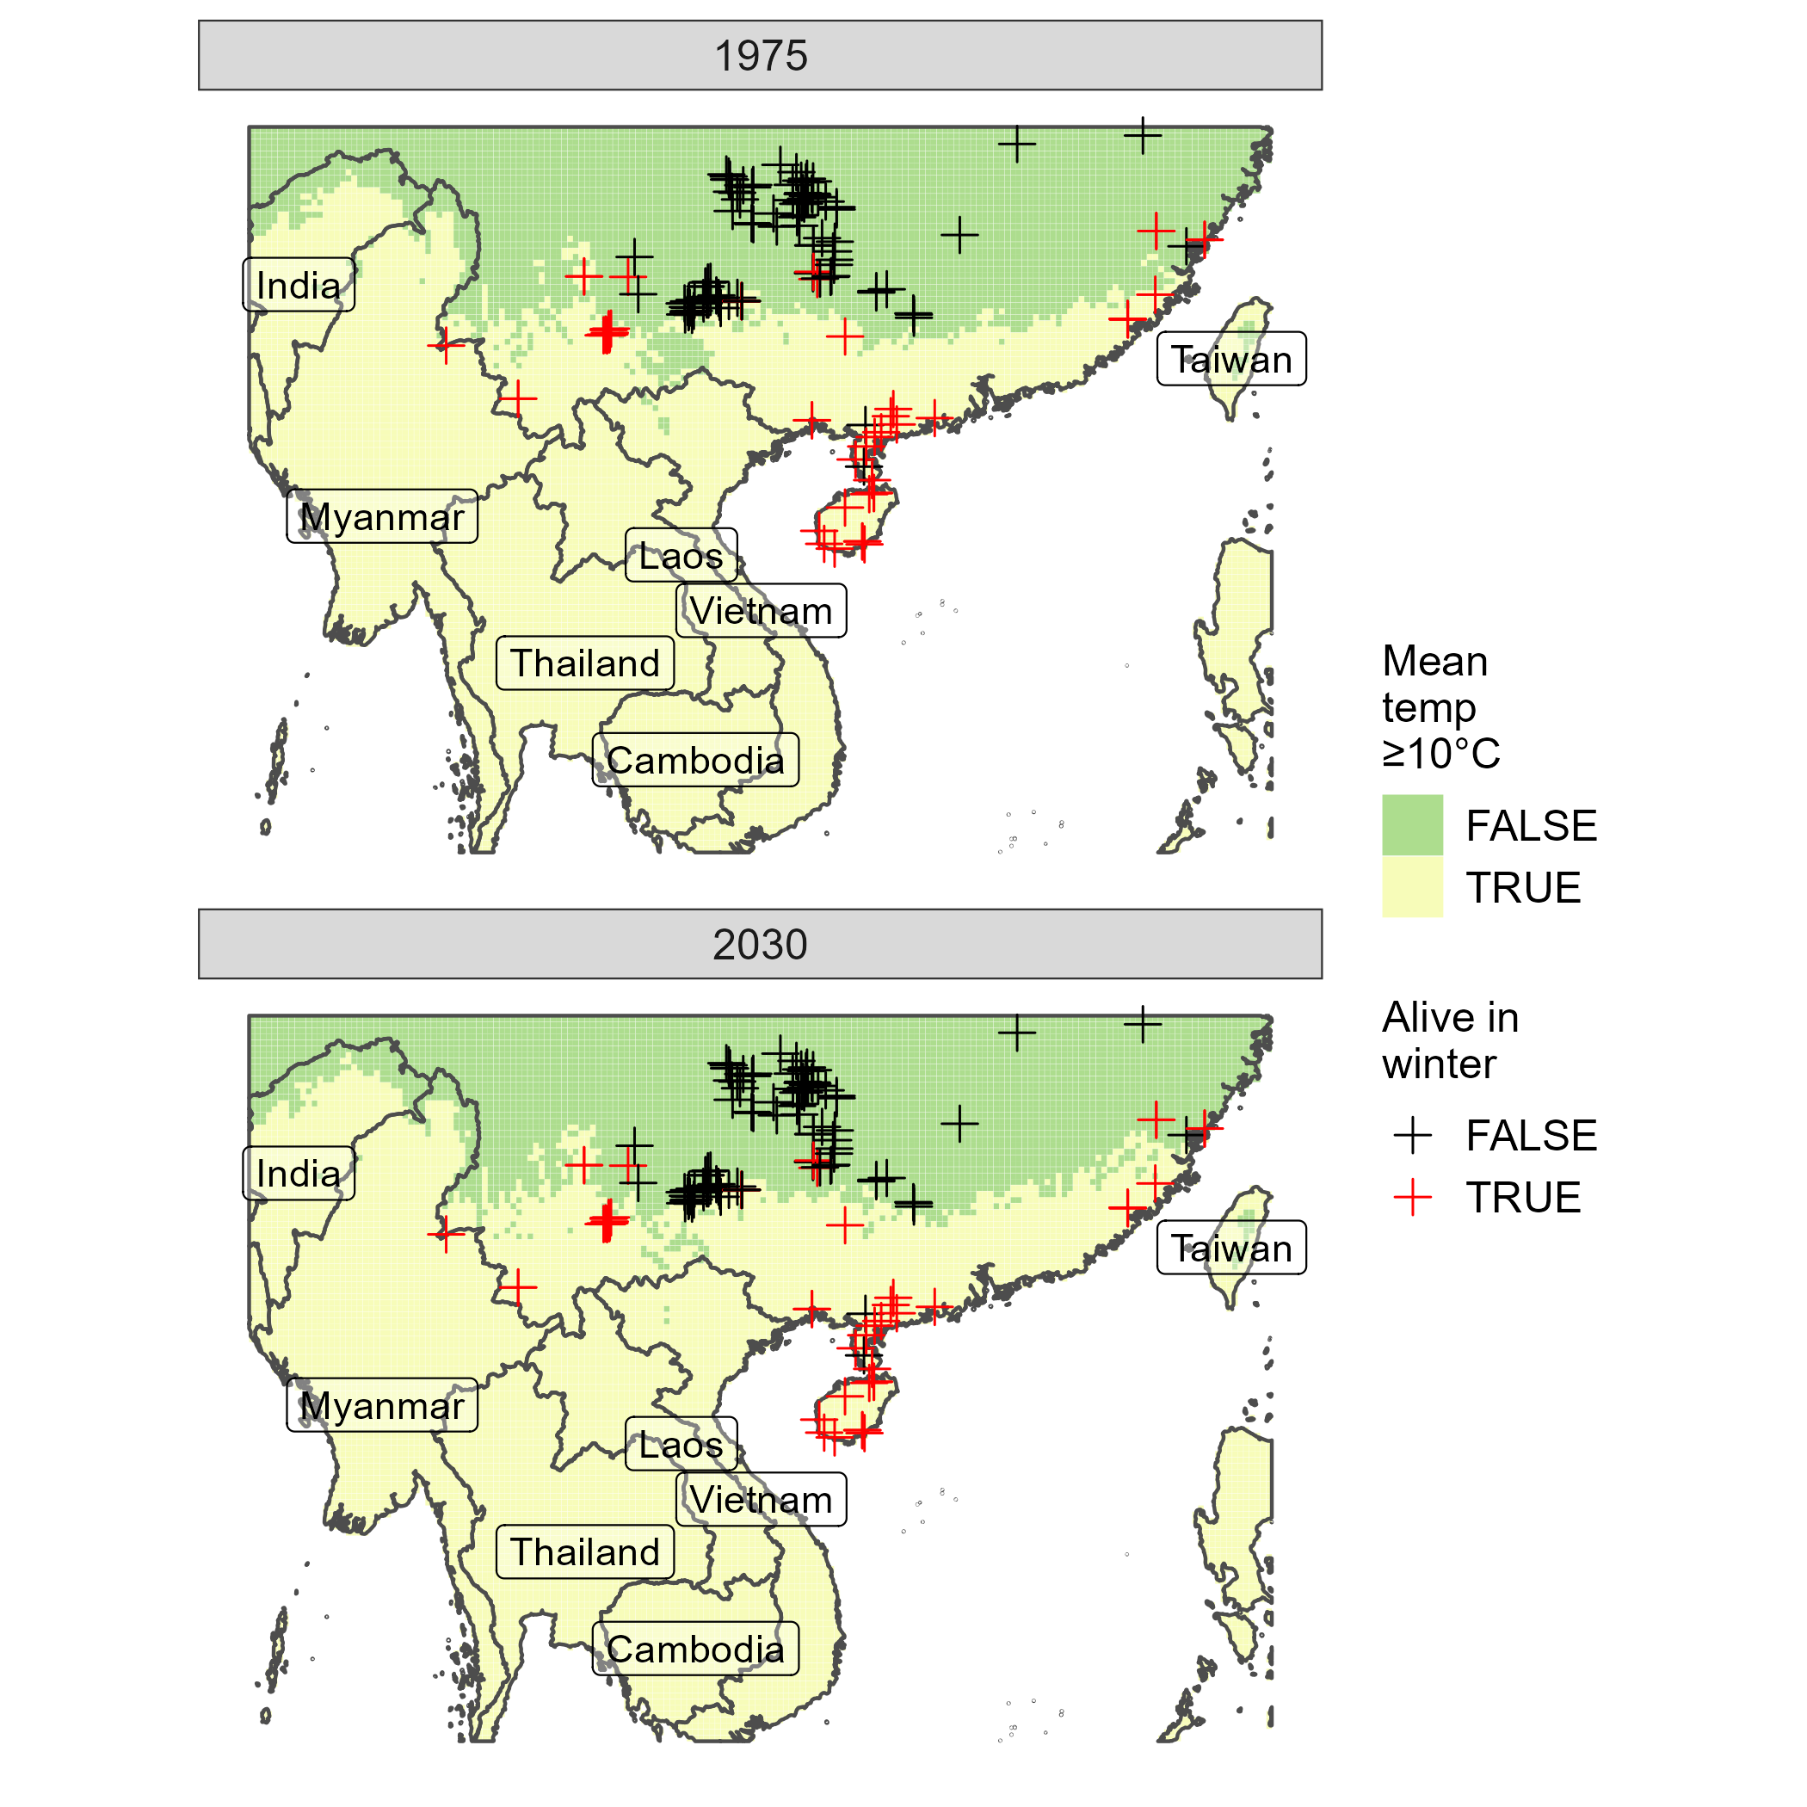
Fig. S1. Locations in China that had annual mean monthly temperatures ≥10 °C based on Climond climate data for 1975 (1961-1990) and 2030 (2021-2040). Crosses show locations where Spodoptera frugiperda has been observed either surviving (red) or dying (black) during winter.

China and USA isotherms based on CRU 1975 data
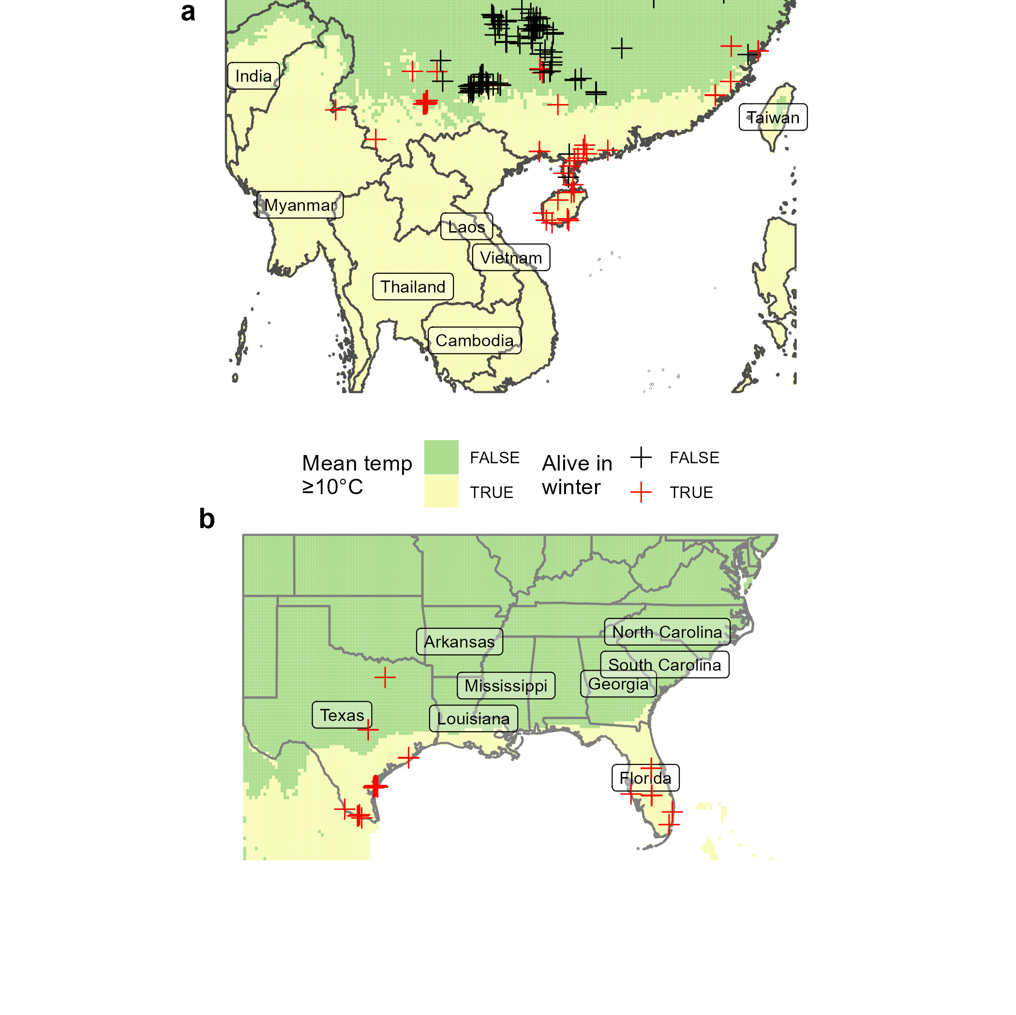
Fig. S2. Locations in China (a) and the USA (b) that had annual mean monthly temperatures ≥10 °C based on Climatic Research Unit climate data for 1975 (1961-1990). Crosses show locations where Spodoptera frugiperda has been observed either surviving (red) or dying (black) during winter.

USA isotherms based on Climond data (1975 & 2030)
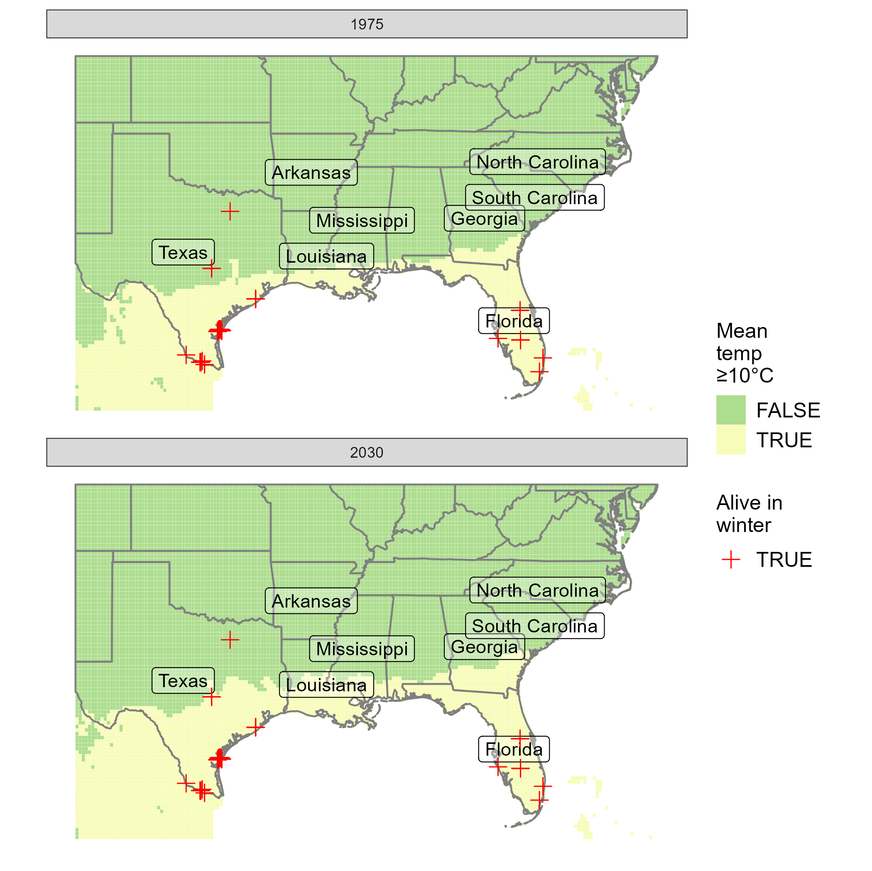
Fig. S3. Locations in the USA that had annual mean monthly temperatures ≥10 °C based on Climond climate data for 1975 (1961-1990) and 2030 (2021-2040). Crosses show locations where Spodoptera frugiperda has been observed surviving during winter.

China Climex ensemble model EIs
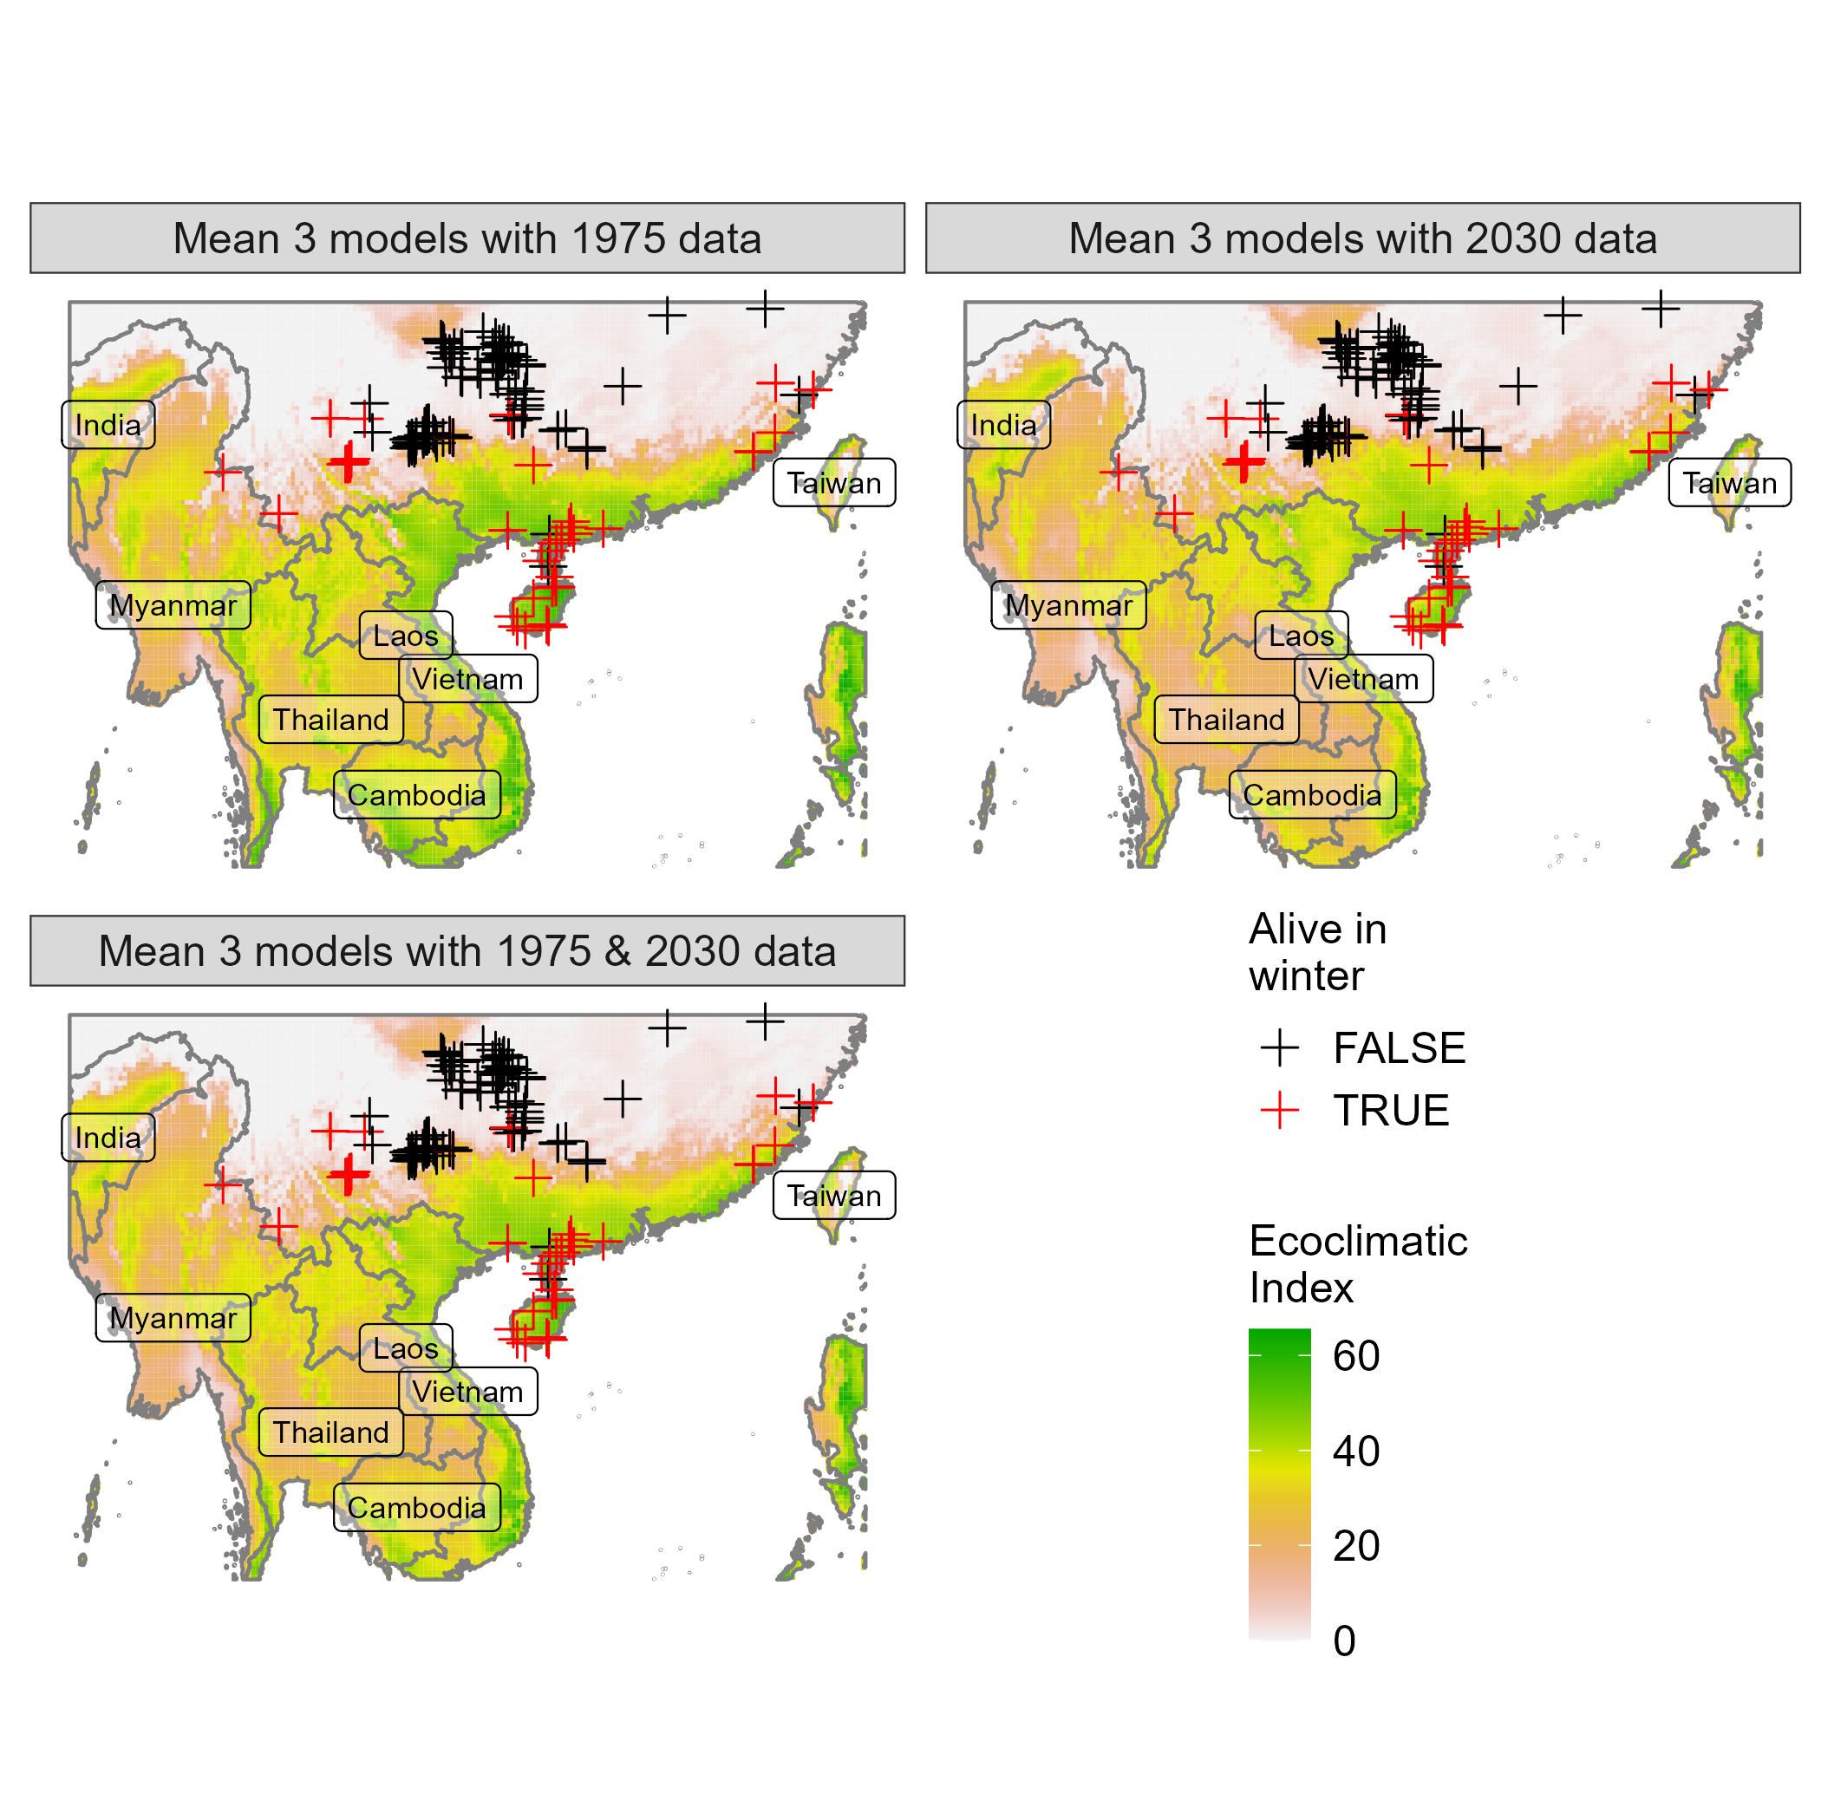
Fig. S4. Ensemble (mean) Ecoclimatic Indices for SE Asia from the Climex models of du Plessis et al. (2018), Nagoshi et al. (2020) and Paudel Timilsena et al. (2022) for SE China based on Climond climate data for 1961-1990 (1975), 2021-2040 (2030), or both. Crosses show locations where FAW has been recorded either surviving (red) or dying (black) during winter.

USA Climex ensemble model EIs
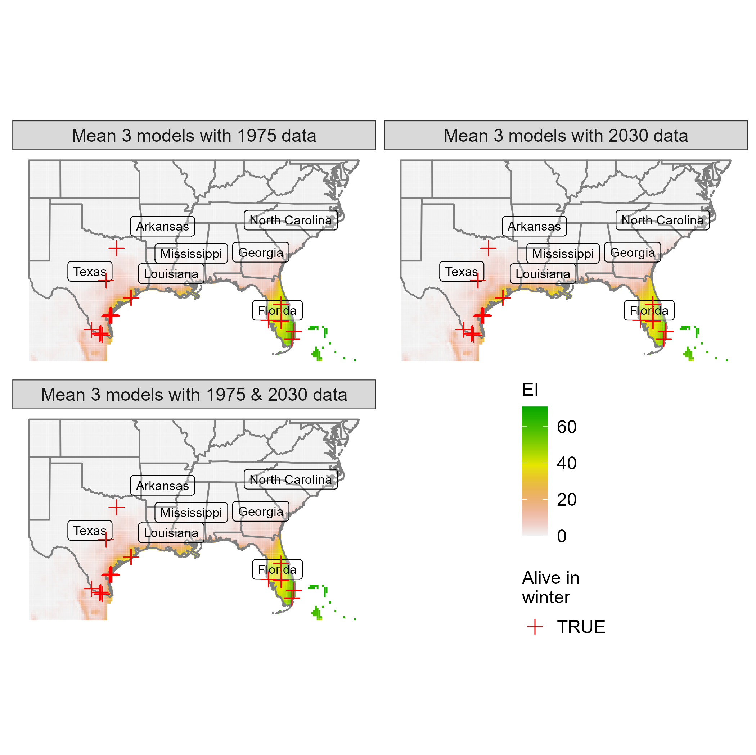
Fig. S5. Ensemble (mean) Ecoclimatic Indices for SE USA from the Climex models of du Plessis et al. (2018), Nagoshi et al. (2020) and Paudel Timilsena et al. (2022) for SE China based on Climond climate data for 1961-1990 (1975), 2021-2040 (2030), or both. Crosses show locations where FAW has been recorded surviving winter.

Isotherm model performance
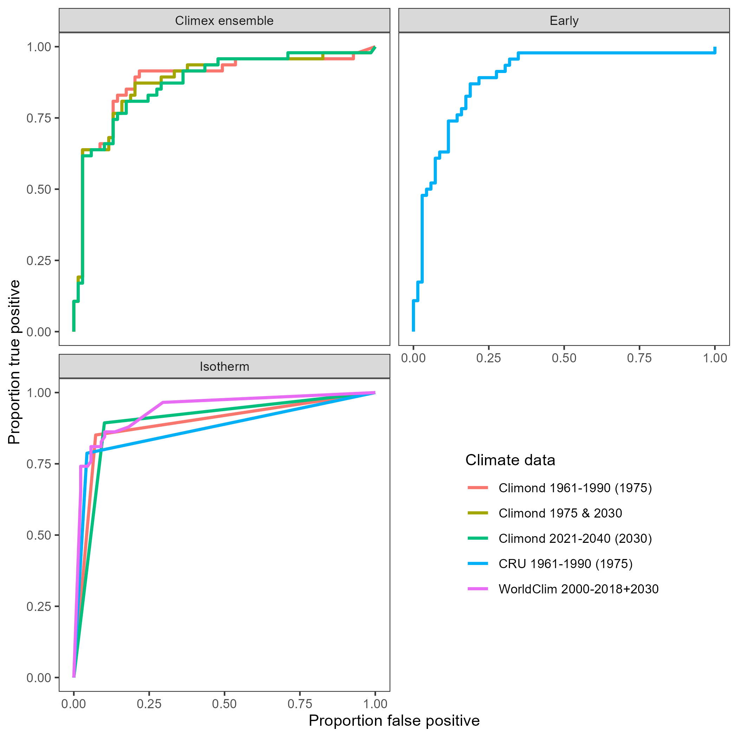
Fig. S6. ROC curves for the Climex ensemble model, Early et al. (2018) model and Isotherm model for each climate dataset tested.

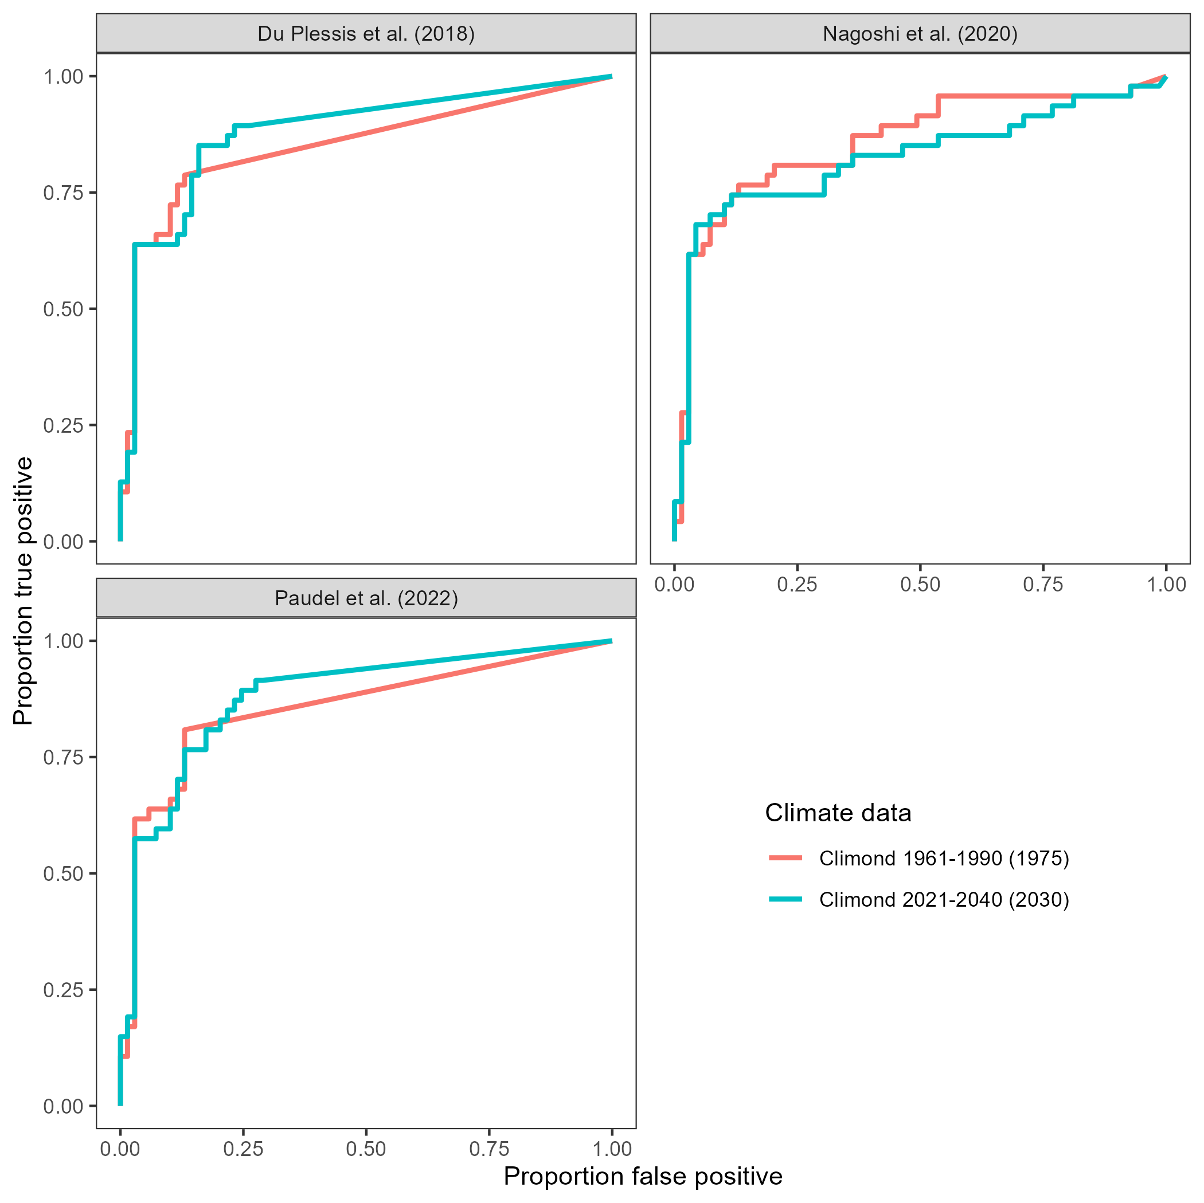
Fig. S7. ROC curves for each Climex model by climate dataset.

NZ predictions of Early et al. (2018)
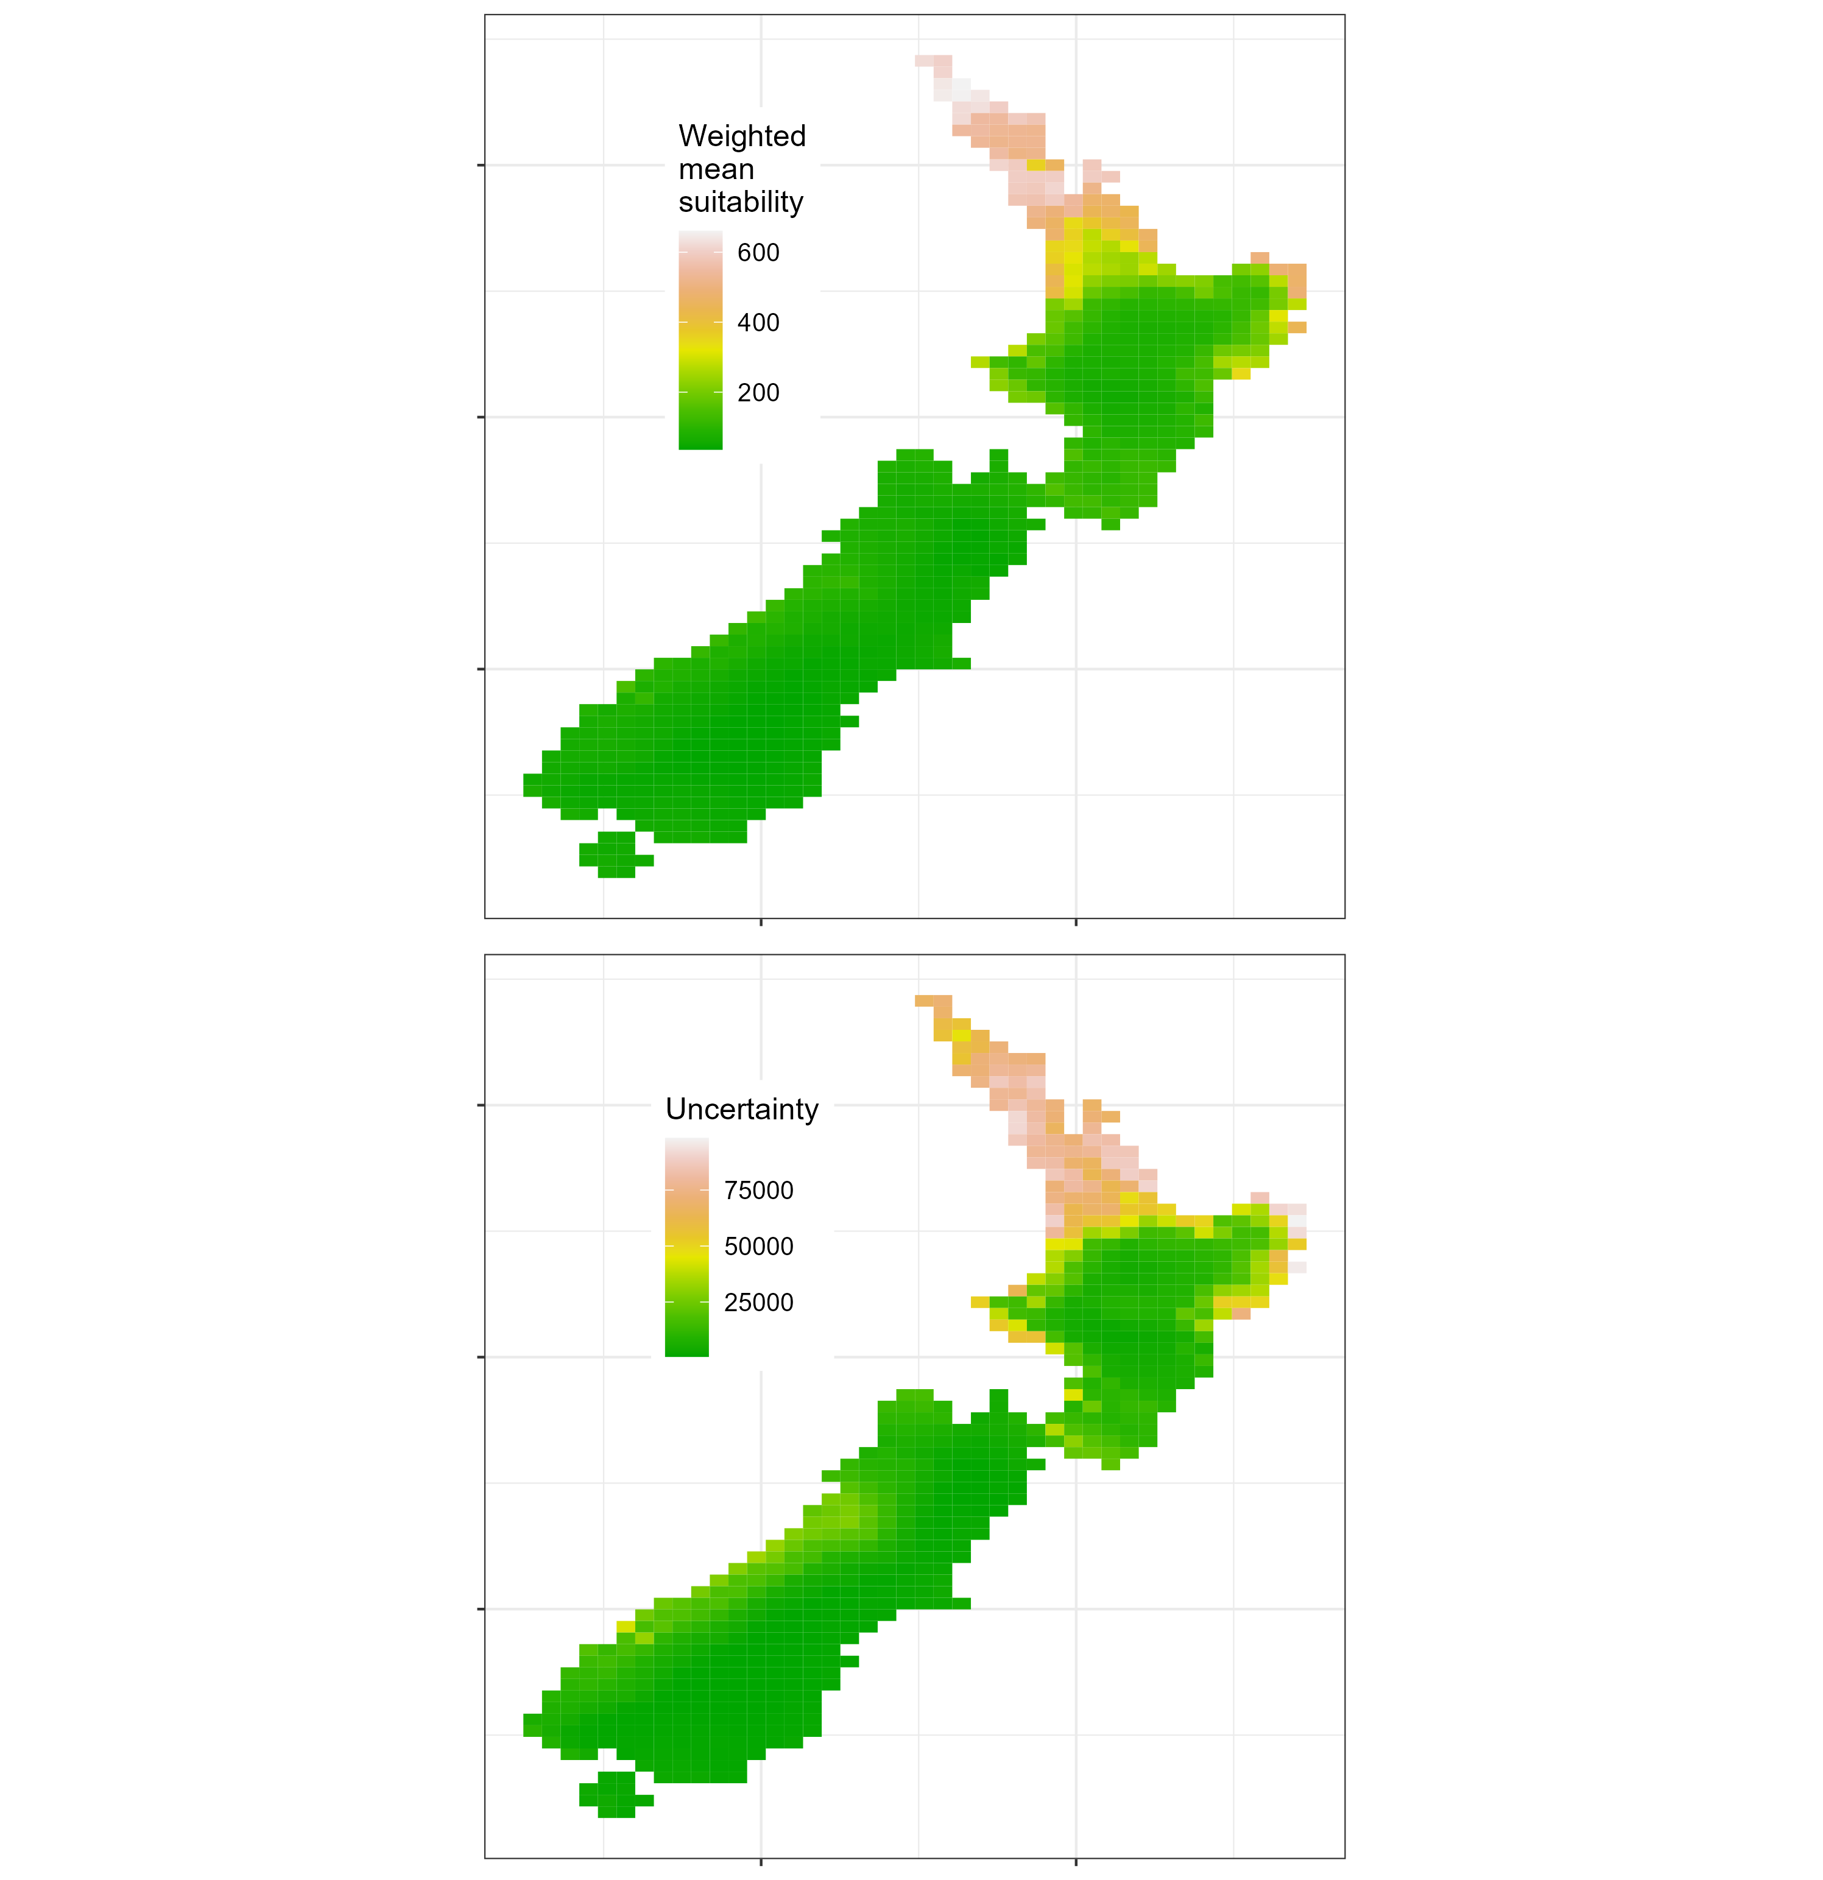
Fig. S8. New Zealand predictions of Early et al. (2018).

NZ isotherm predictions by climate dataset
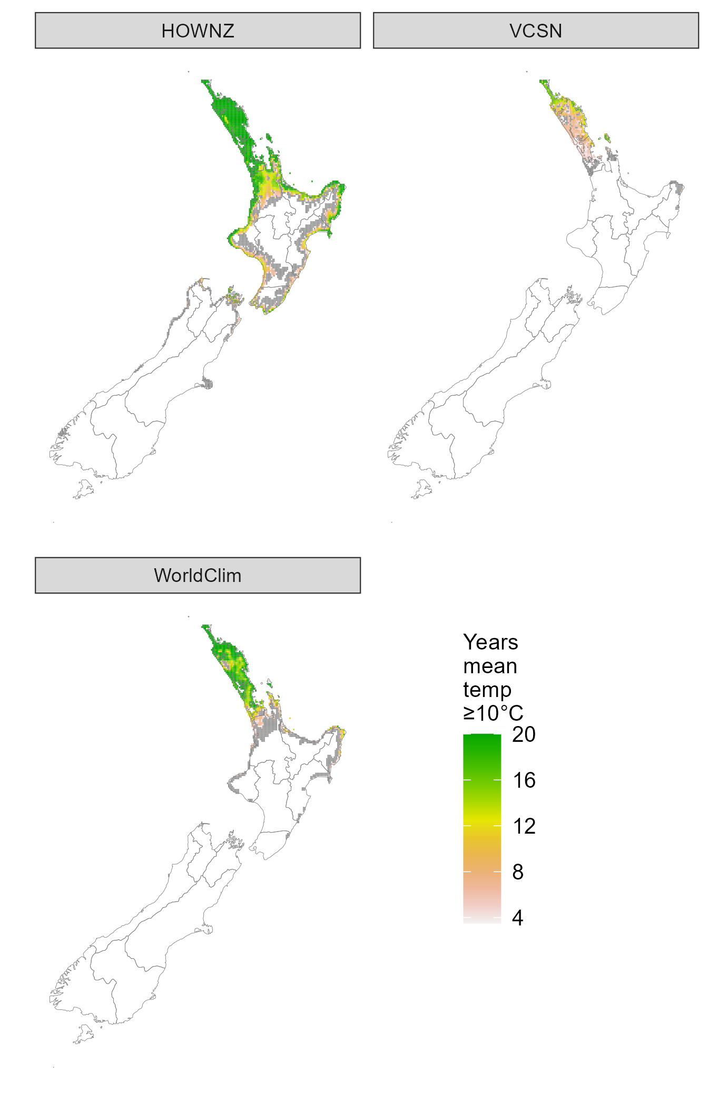
Fig. S9. New Zealand isotherm results from HOWNZ 2000-2019, VCSN 2000-2019 and WorldClim 2000-2018 plus 2030. Coloured locations had annual mean weekly temperatures ≥10 °C for ≥3.5 years of the 20, and grey shaded locations had annual mean weekly temperatures ≥10 °C for 0 > years < 3.5. Lines show regional council boundaries.

NZ Climex EIs by model and climate dataset
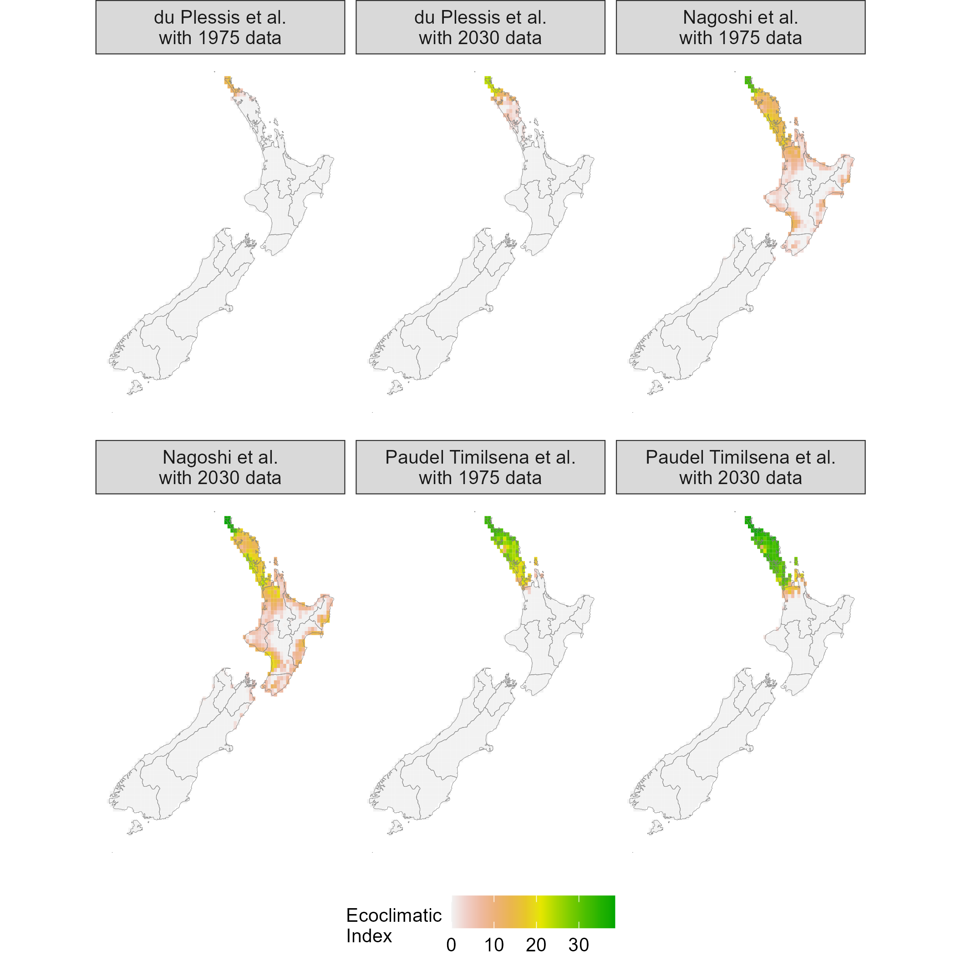
Fig. S10. Ecoclimatic Indices for New Zealand from the Climex models of du Plessis et al. (2018), Nagoshi et al. (2020) and Paudel Timilsena et al. (2022) based on Climond climate data for 1961-1990 (1975) and 2021-2040 (2030).

NZ annual generations by Climex model and climate dataset
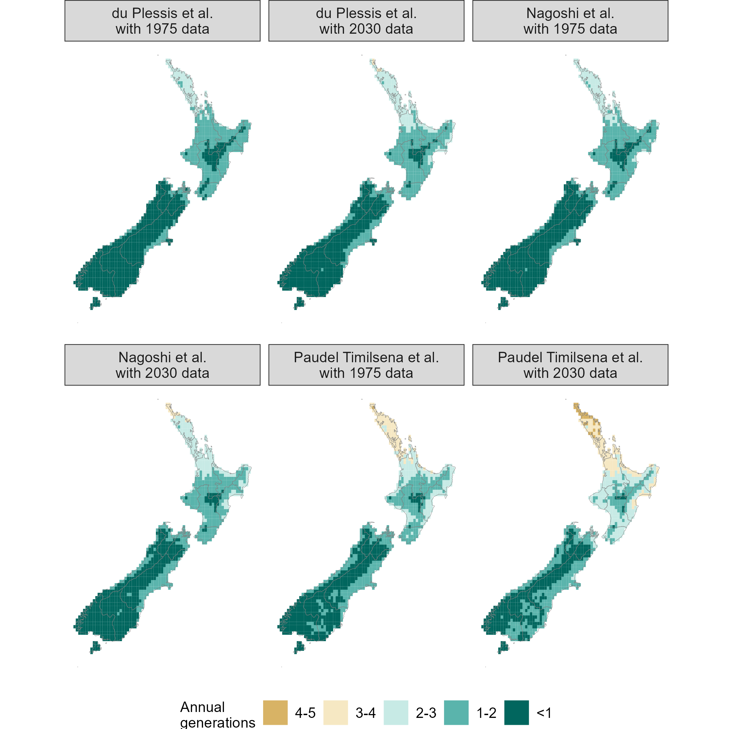
Fig. S11. Predicted fall armyworm annual generations in New Zealand from the Climex models of du Plessis et al. (2018), Nagoshi et al. (2020) and Paudel Timilsena et al. (2022) based on Climond climate data for 1961-1990 (1975) and 2021-2040 (2030).

NZ EIs from ensemble Climex model for 2040, 2060 and 2080 assuming RCP4.5
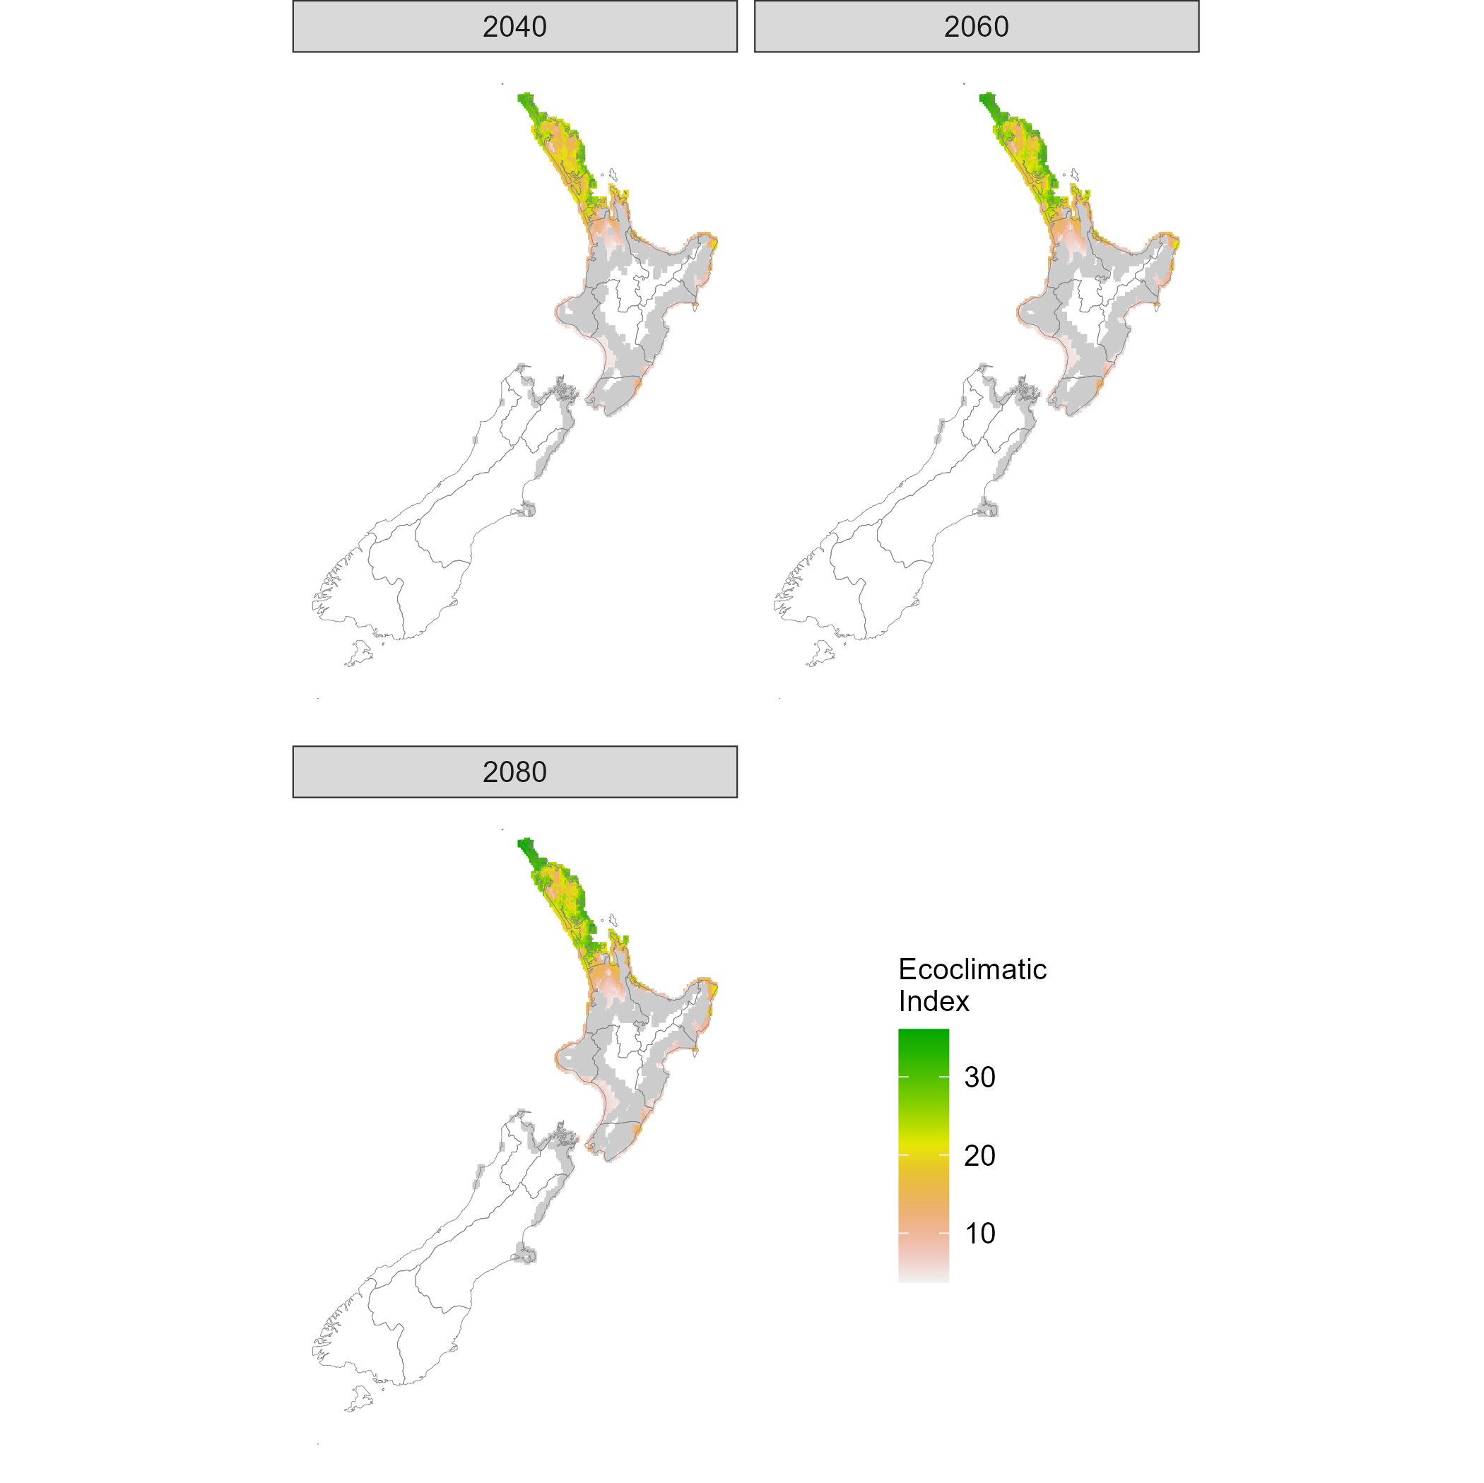
Fig. S12. Mean Ecoclimatic Indices for NZ from the Climex models of du Plessis et al. (2018), Nagoshi et al. (2020) and Paudel Timilsena et al. (2022) using ensemble predictions from six Global Circulation Models assuming Representative Concentration Pathway 4.5

CV in NZ EIs from ensemble Climex model for 2040, 2060 and 2080 assuming RCP4.5
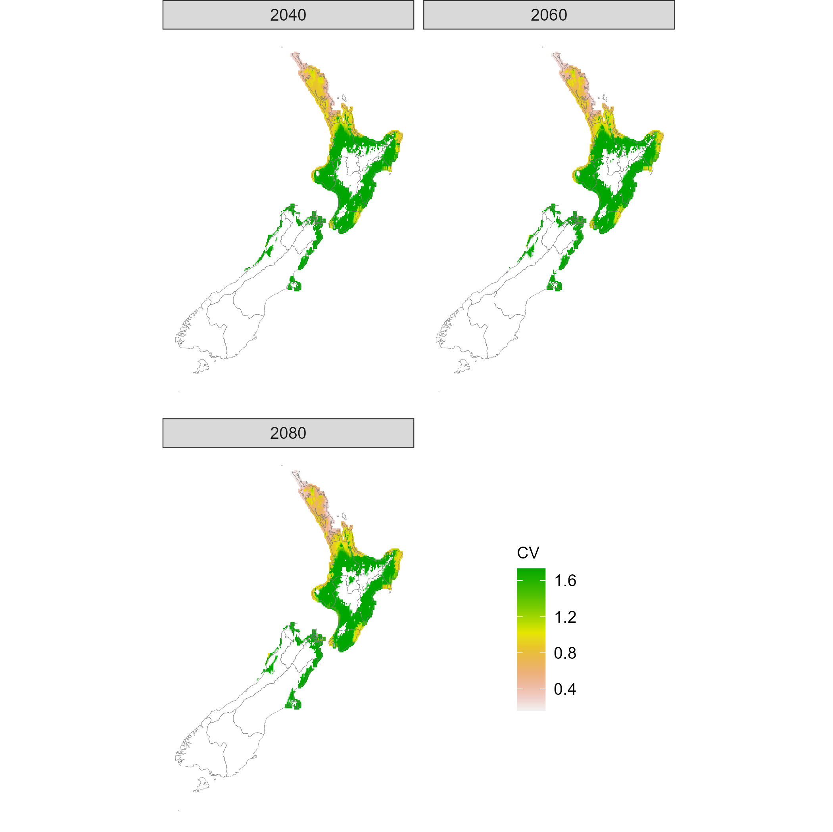
Fig. S13. Coefficient of variation in mean Ecoclimatic Indices for NZ from the Climex models of du Plessis et al. (2018), Nagoshi et al. (2020) and Paudel Timilsena et al. (2022) using ensemble predictions from six Global Circulation Models assuming Representative Concentration Pathway 4.5

NZ EIs from ensemble Climex model for 2040, 2060 and 2080 assuming RCP8.5
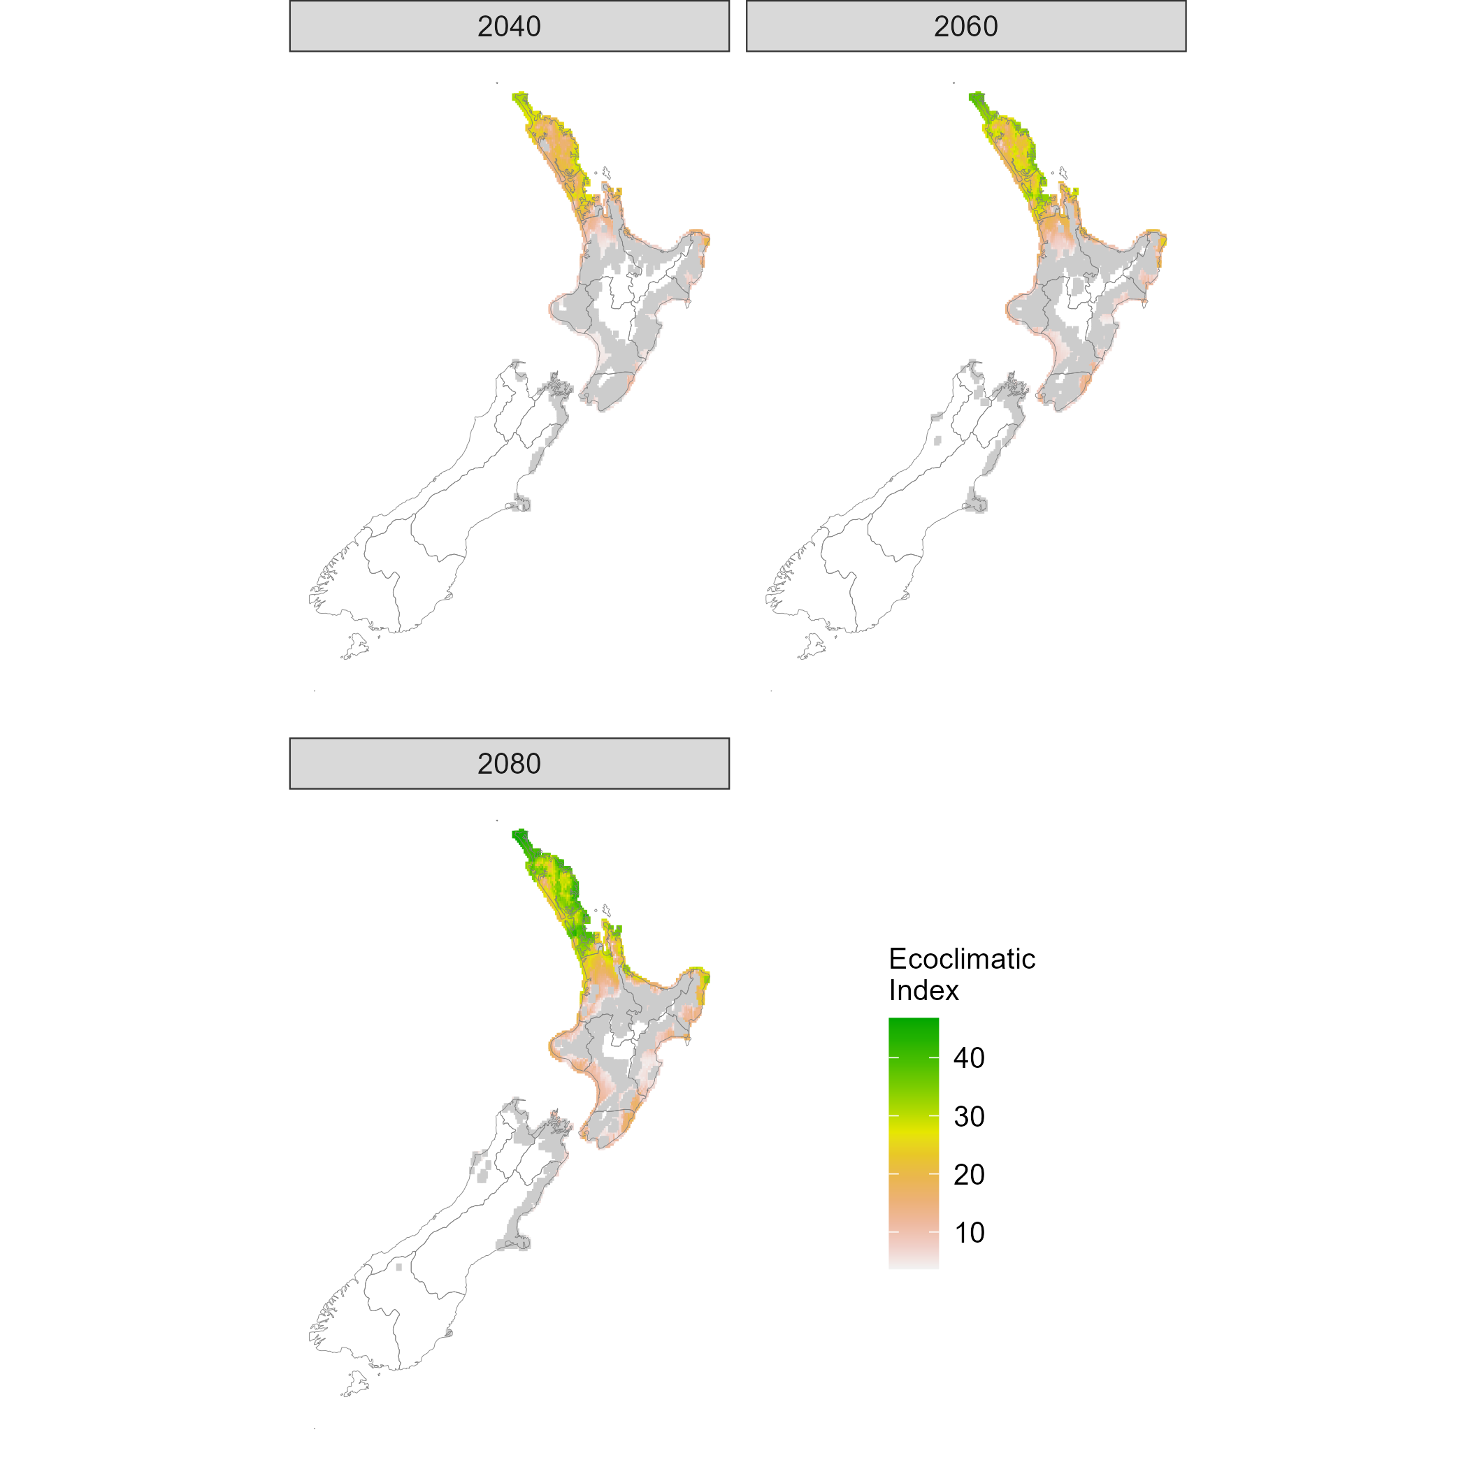
Fig. S14. Mean Ecoclimatic Indices for NZ from the Climex models of du Plessis et al. (2018), Nagoshi et al. (2020) and Paudel Timilsena et al. (2022) using ensemble predictions from six Global Circulation Models assuming Representative Concentration Pathway 8.5

CV in NZ EIs from ensemble Climex model for 2040, 2060 and 2080 assuming RCP8.5
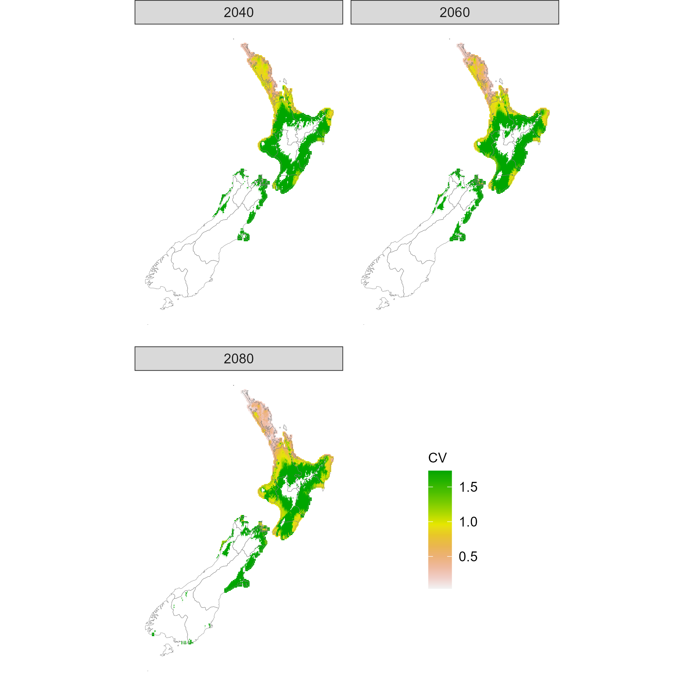
Fig. S15. Coefficient of variation in mean Ecoclimatic Indices for NZ from the Climex models of du Plessis et al. (2018), Nagoshi et al. (2020) and Paudel Timilsena et al. (2022) using ensemble predictions from six Global Circulation Models assuming Representative Concentration Pathway 8.5

NZ annual generations from ensemble Climex model for 2040, 2060 and 2080 assuming RCP4.5
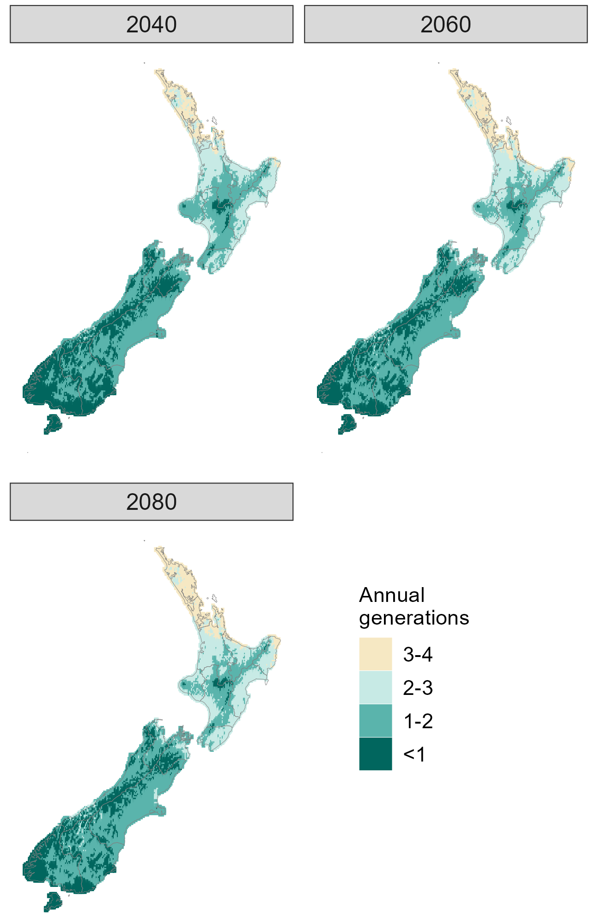
Fig. S16. Mean predicted annual generations in NZ from the Climex models of du Plessis et al. (2018), Nagoshi et al. (2020) and Paudel Timilsena et al. (2022) using ensemble predictions from six Global Circulation Models assuming Representative Concentration Pathway 4.5
With RCP 4.5, there was relatively little variation between Climex models in estimates of annual generations and the 2040, 2060 and 2080 periods all had mean and median coefficients of variation of 0.19 (2040 range 0 to 1.41; 2060 range 0 to 0.35; 2080 range 0 to 0.35).

NZ annual generations from ensemble Climex model for 2040, 2060 and 2080 assuming RCP8.5
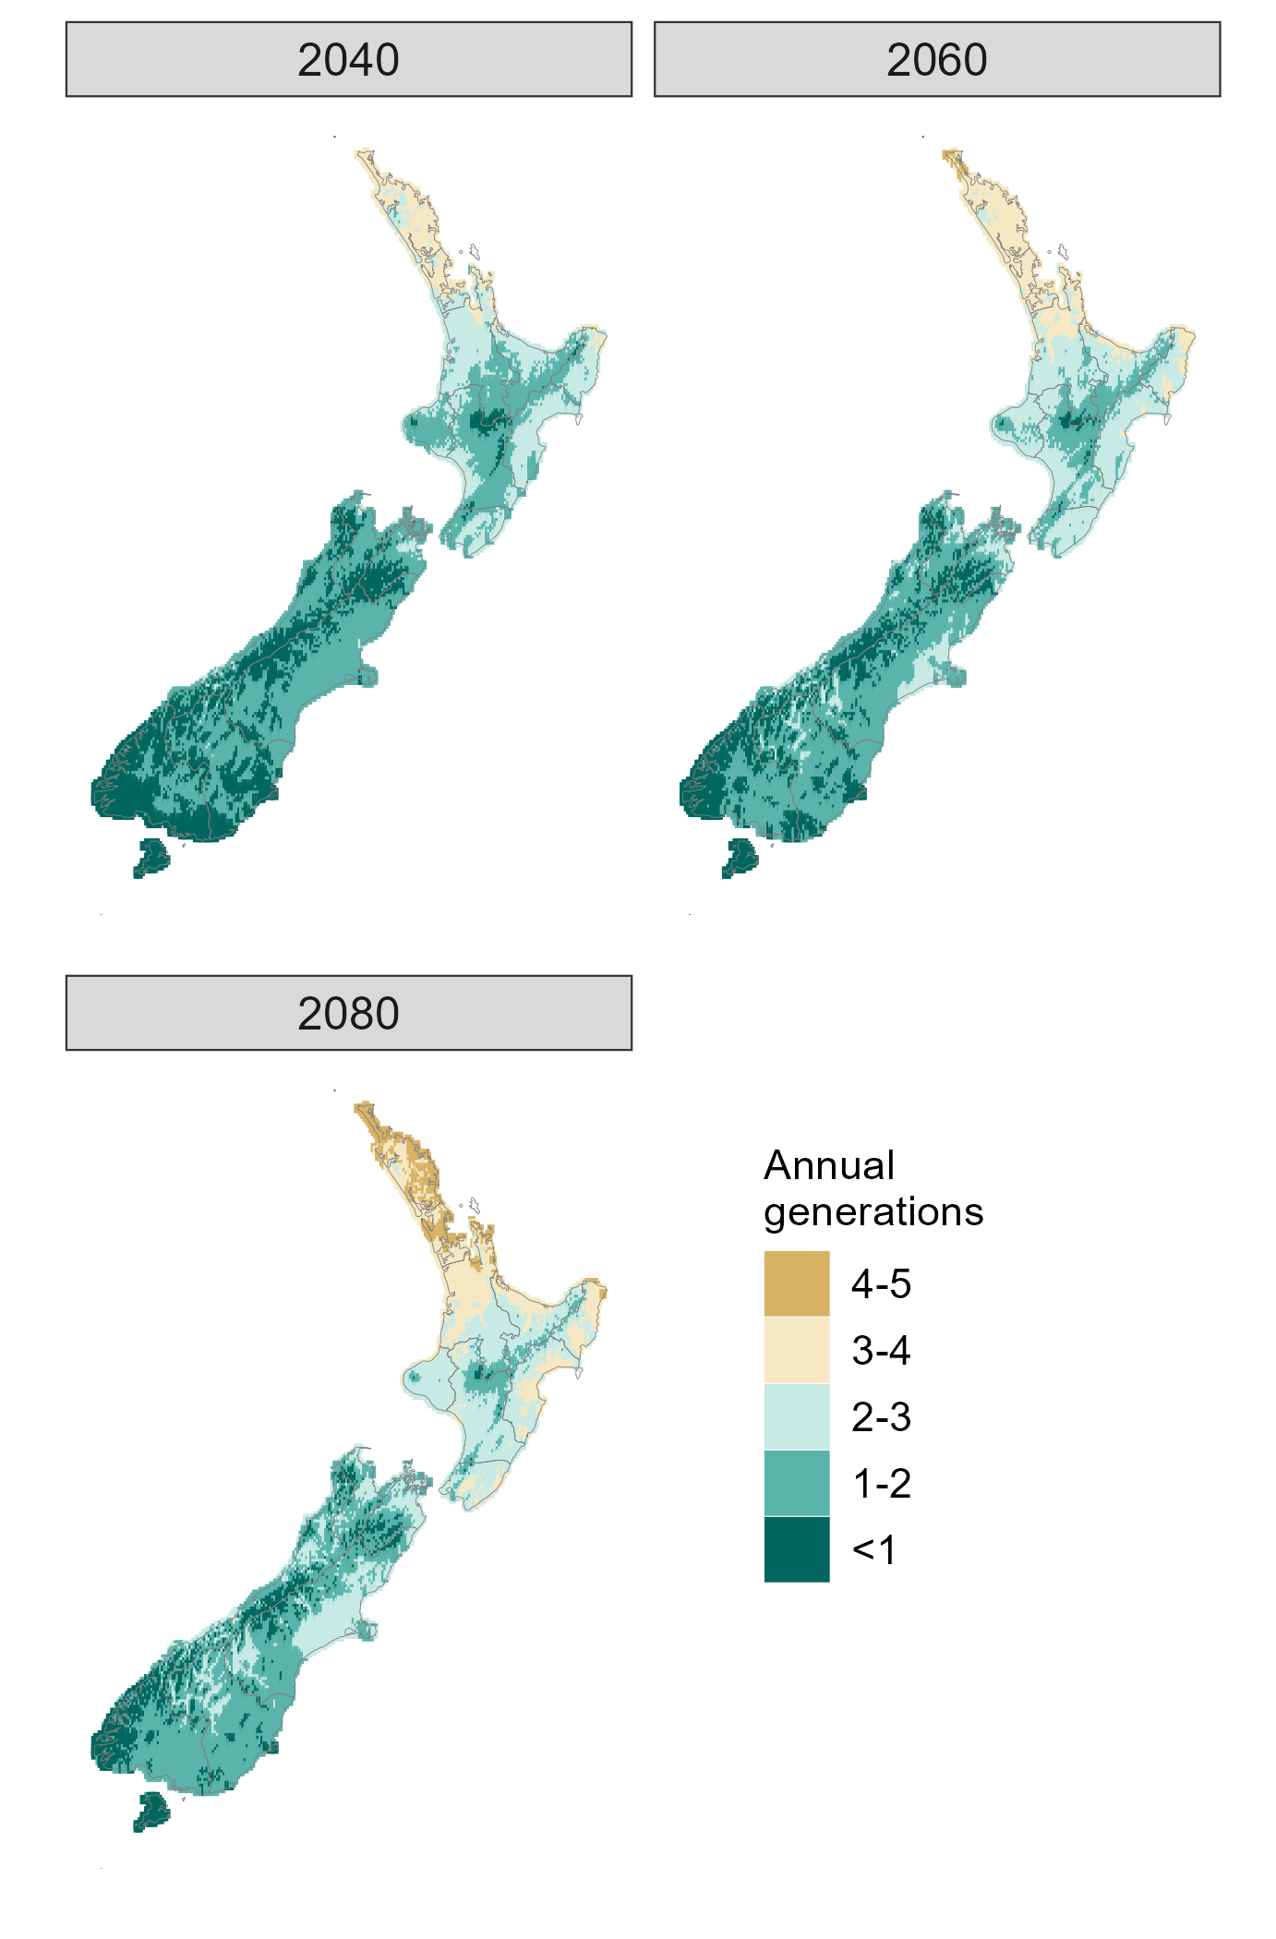
Fig. S17. Mean predicted annual generations in NZ from the Climex models of du Plessis et al. (2018), Nagoshi et al. (2020) and Paudel Timilsena et al. (2022) using ensemble predictions from six Global Circulation Models assuming Representative Concentration Pathway 8.5
With RCP 8.5, there was relatively little variation between Climex models in estimates of annual generations and the 2040, 2060 and 2080 periods all had mean and median coefficients of variation of 0.19 (2040 range 0 to 0.35; 2060 range 0.14 to 0.35; 2080 range 0.15 to 0.26).

