Determination of adulteration in evening primrose oil capsules by ¹H NMR analysis and chemometric techniques

Alisson L. Figueiredoª, Cleverton S. Fernandesª, Ingrid L. Fernandesª, Patricia D. S. Santosª, Amanda C. Assakawa^{b}, Ernani A. Bassoª, Oscar O. Santos^{a,b}*

ªDepartmentofChemistry, StateUniversityof Maringá (UEM), Colombo Avenue, 5790, 87020-900, Maringá, PR, Brazil.
^{b}Departamentof Food Science, StateUniversityof Maringá (UEM), Colombo Avenue, 5790, 87020-900, Maringá, PR, Brazil.

*e-mail: oosjunior@uem.br: https://orcid.org/0000-0002-9631-8480
Supplementary material
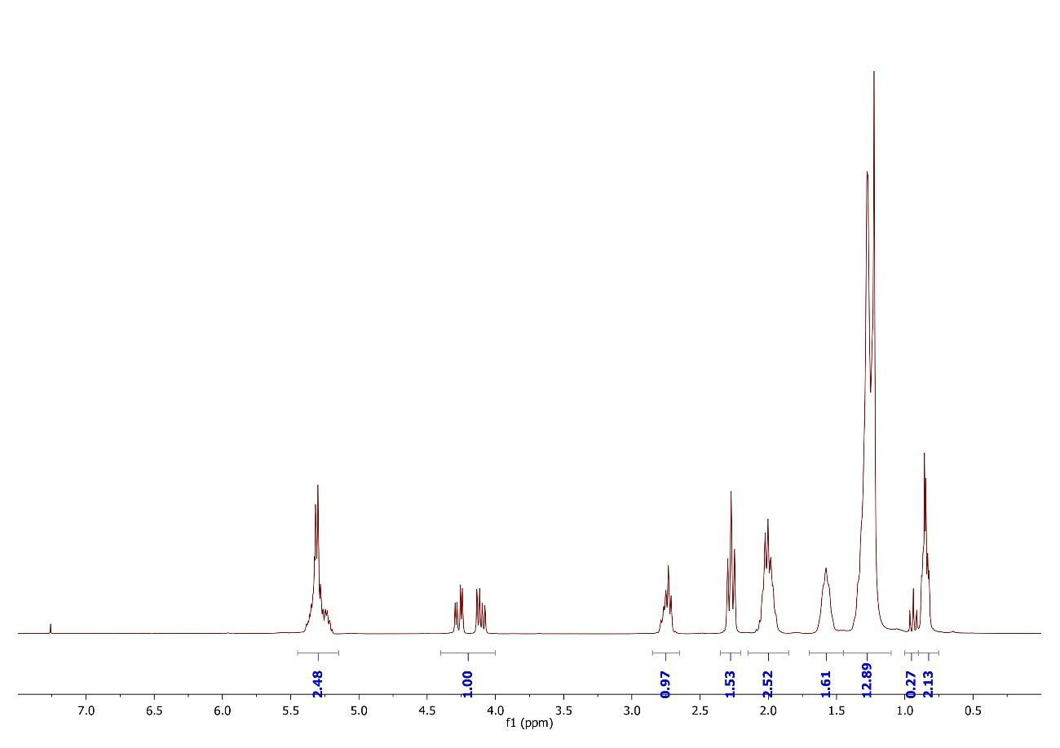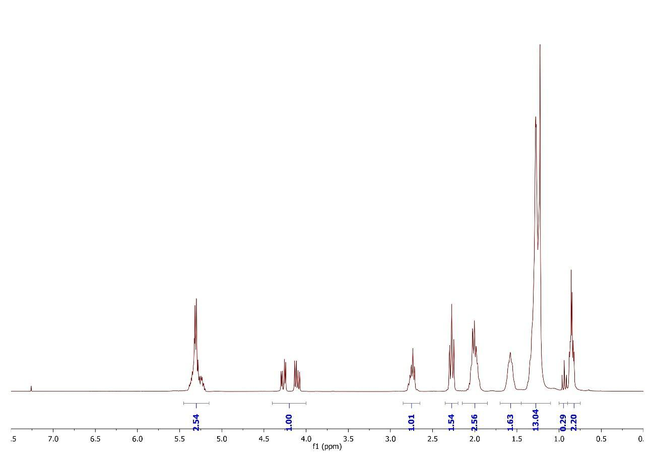
A
B
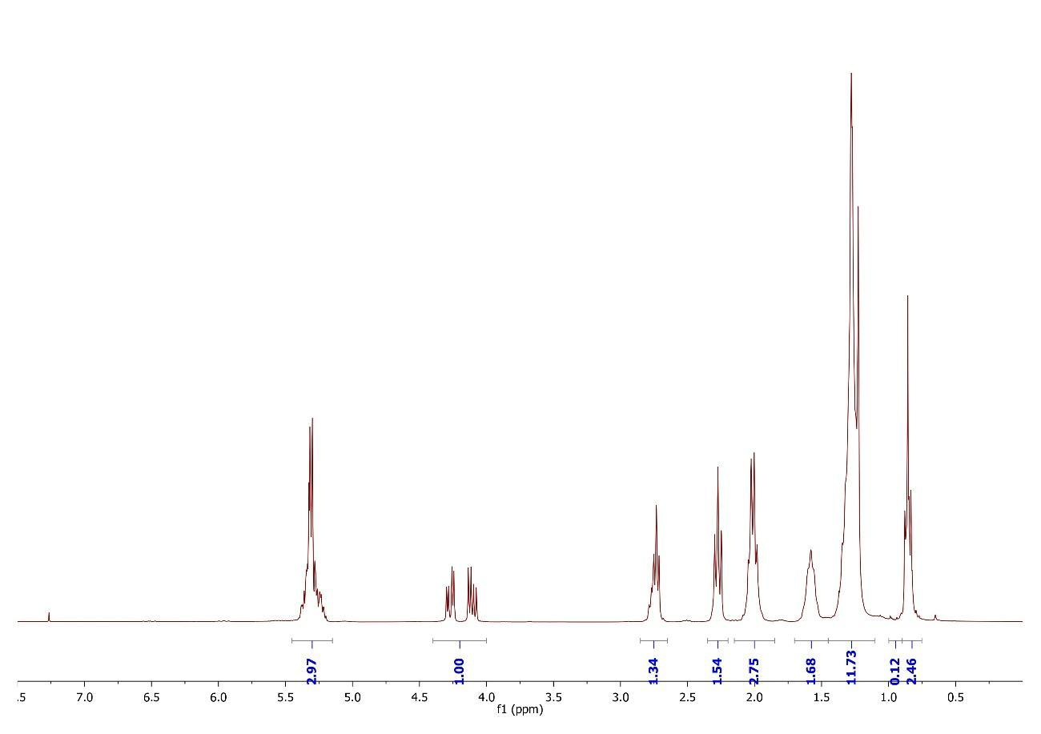
C
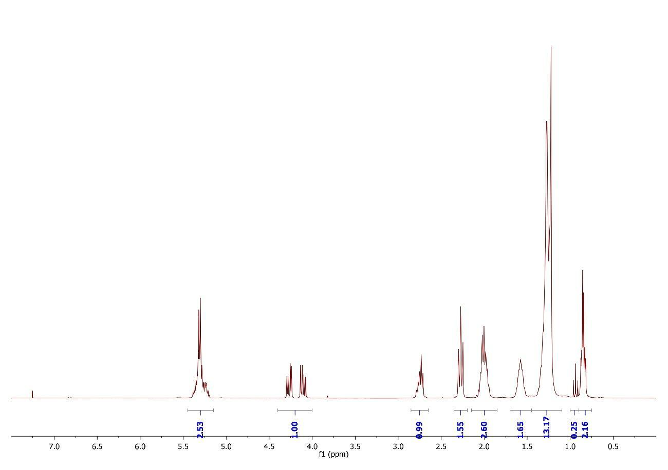
D
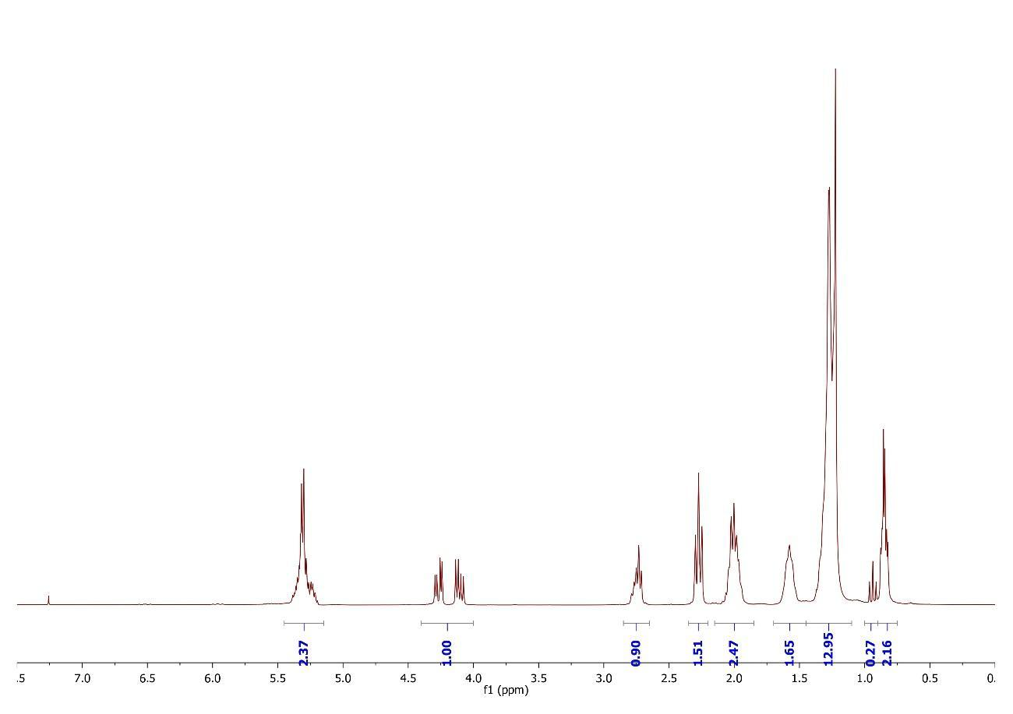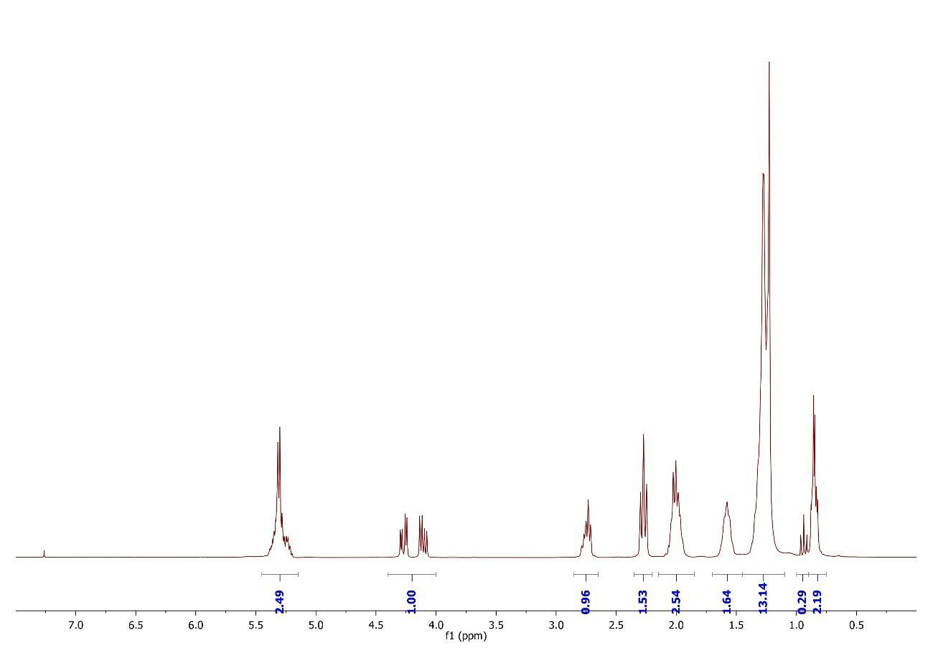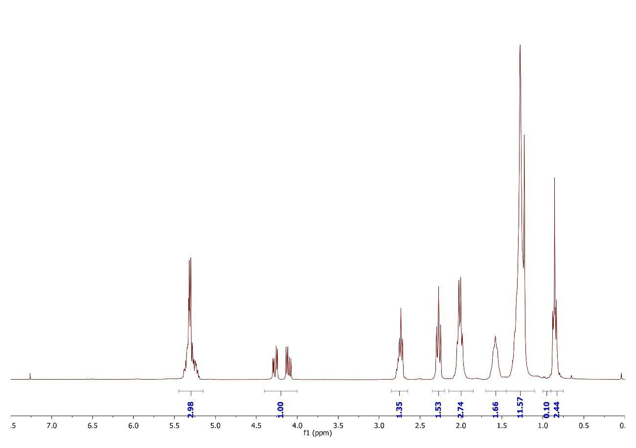
E
F
G
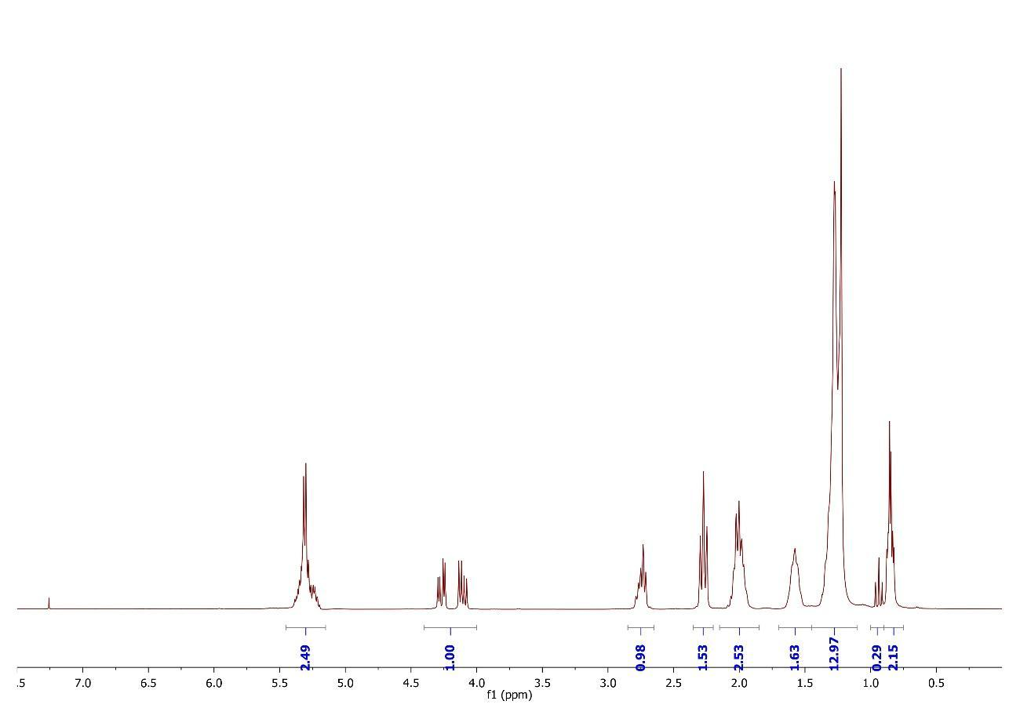
H
H
Fig. 1 ¹H NMR spectra of evening primrose oil capsules

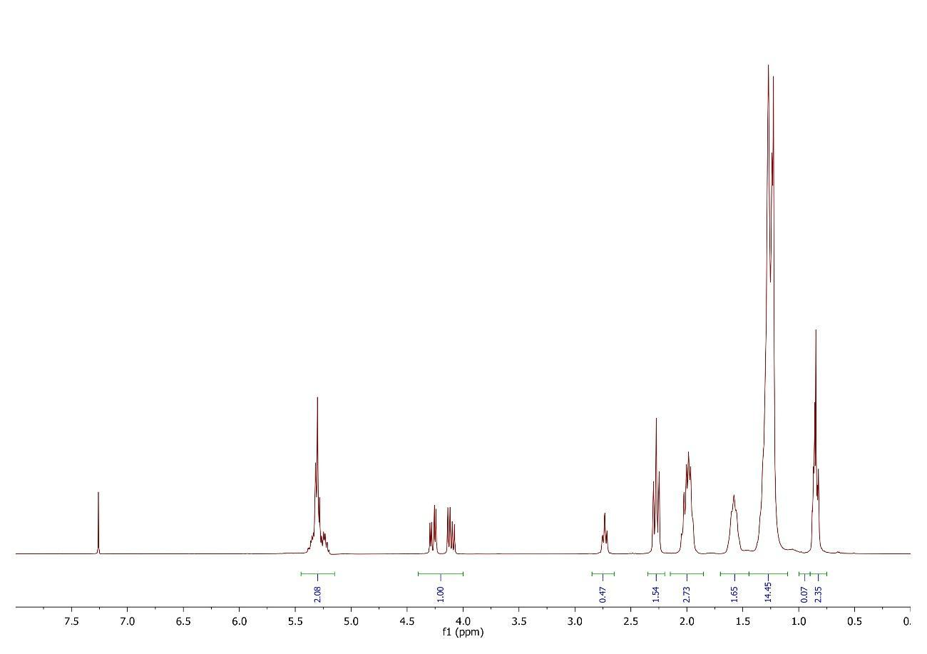
SFO
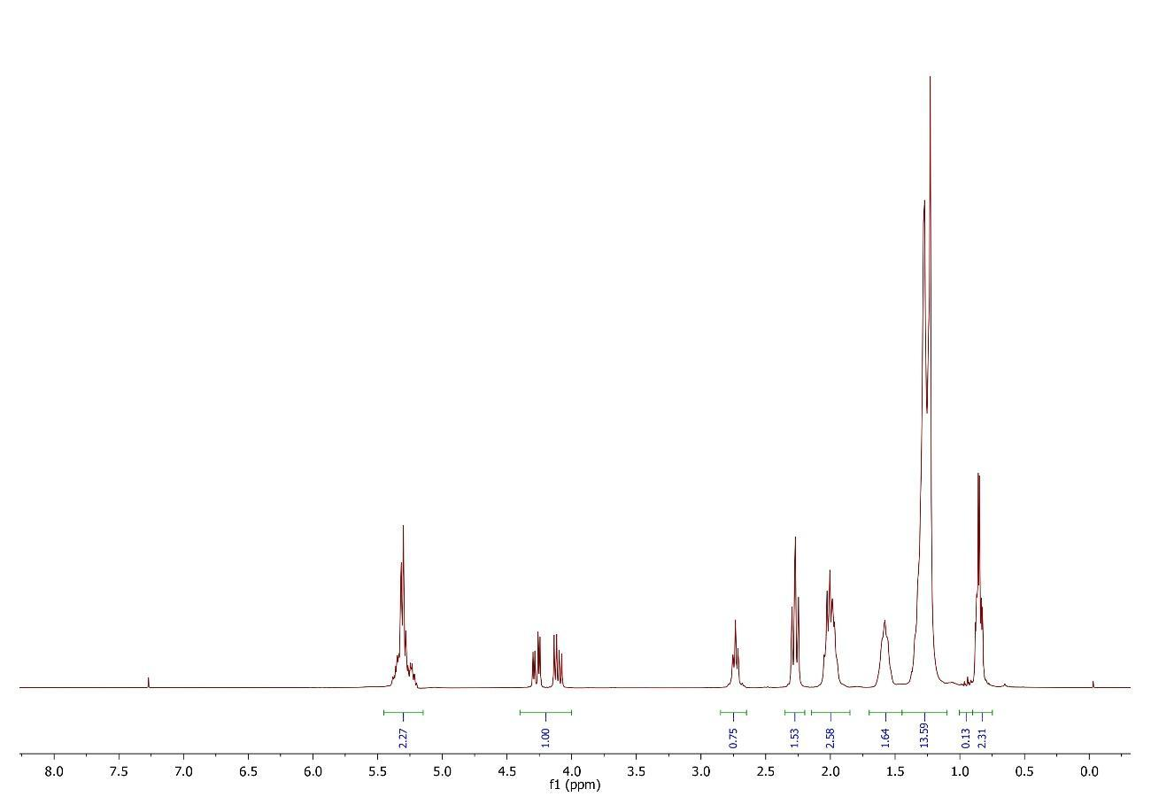
CO

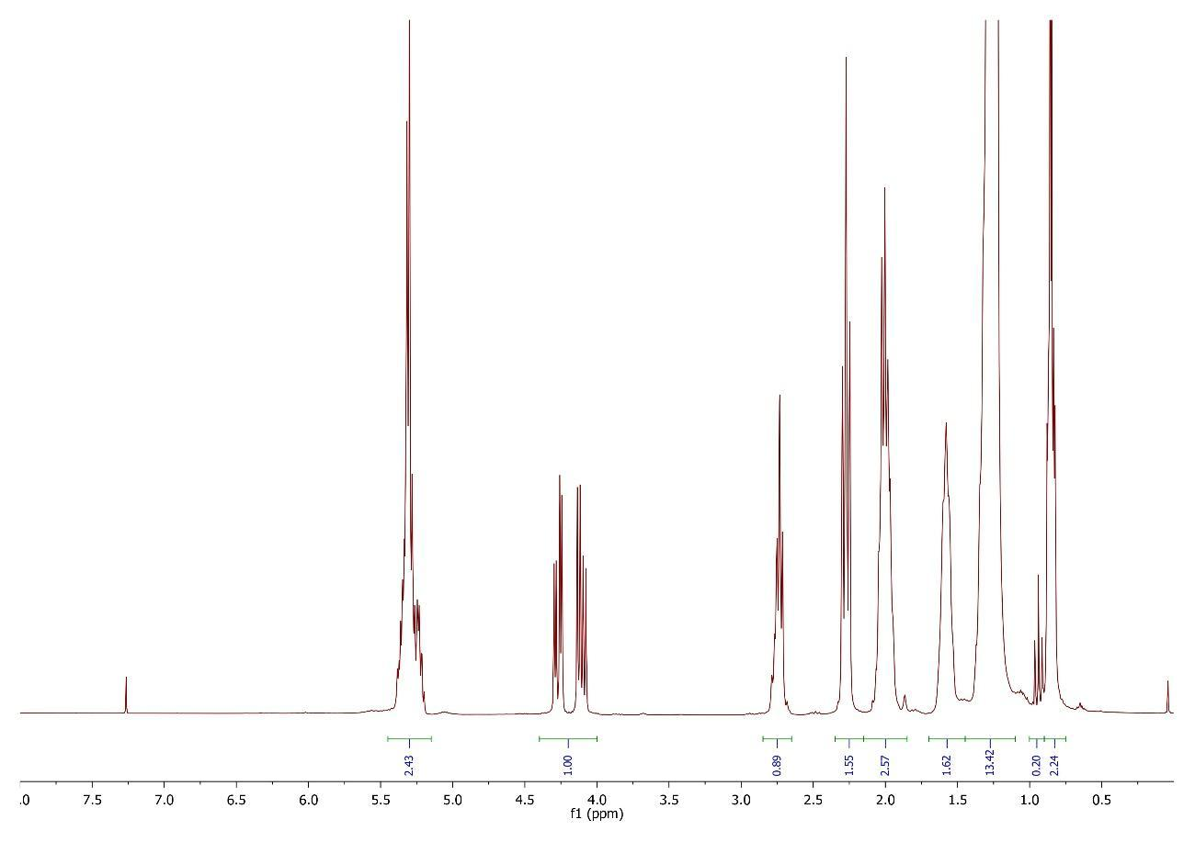
SBO

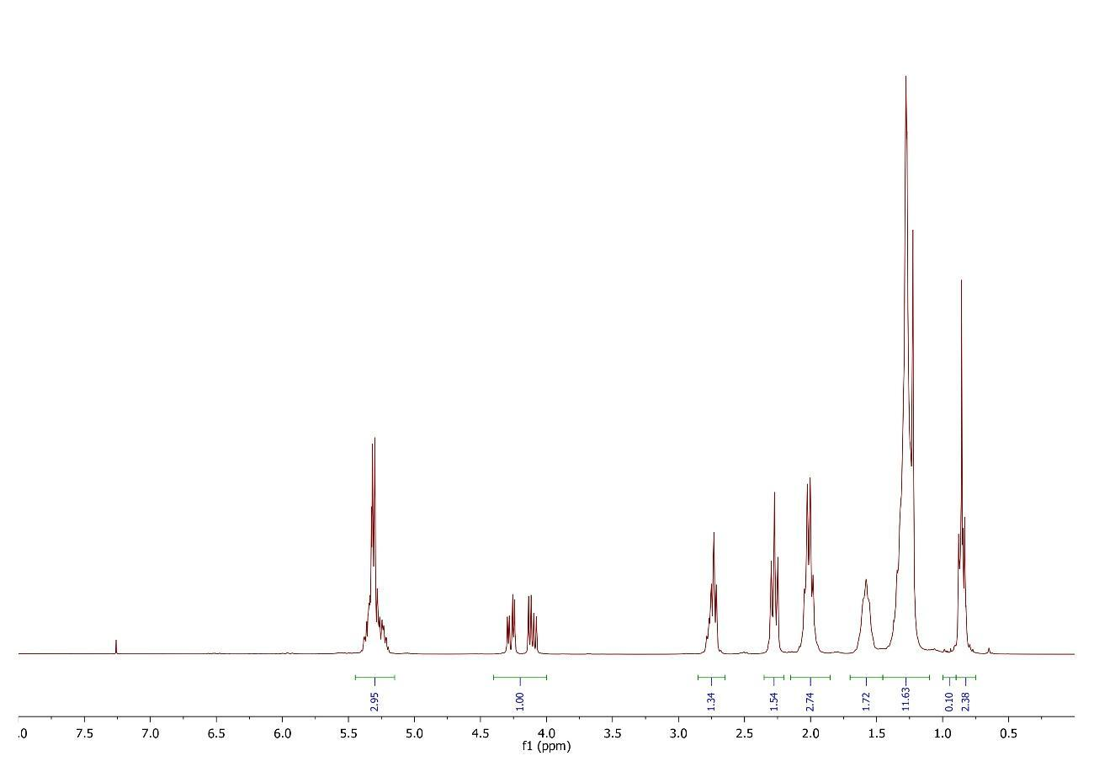
EPO
Fig. 2 ¹H NMR spectra of reference vegetable oils. SFO: sunflower oil; CO: corn oil; SBO: soybean oil; EPO: evening primrose oil

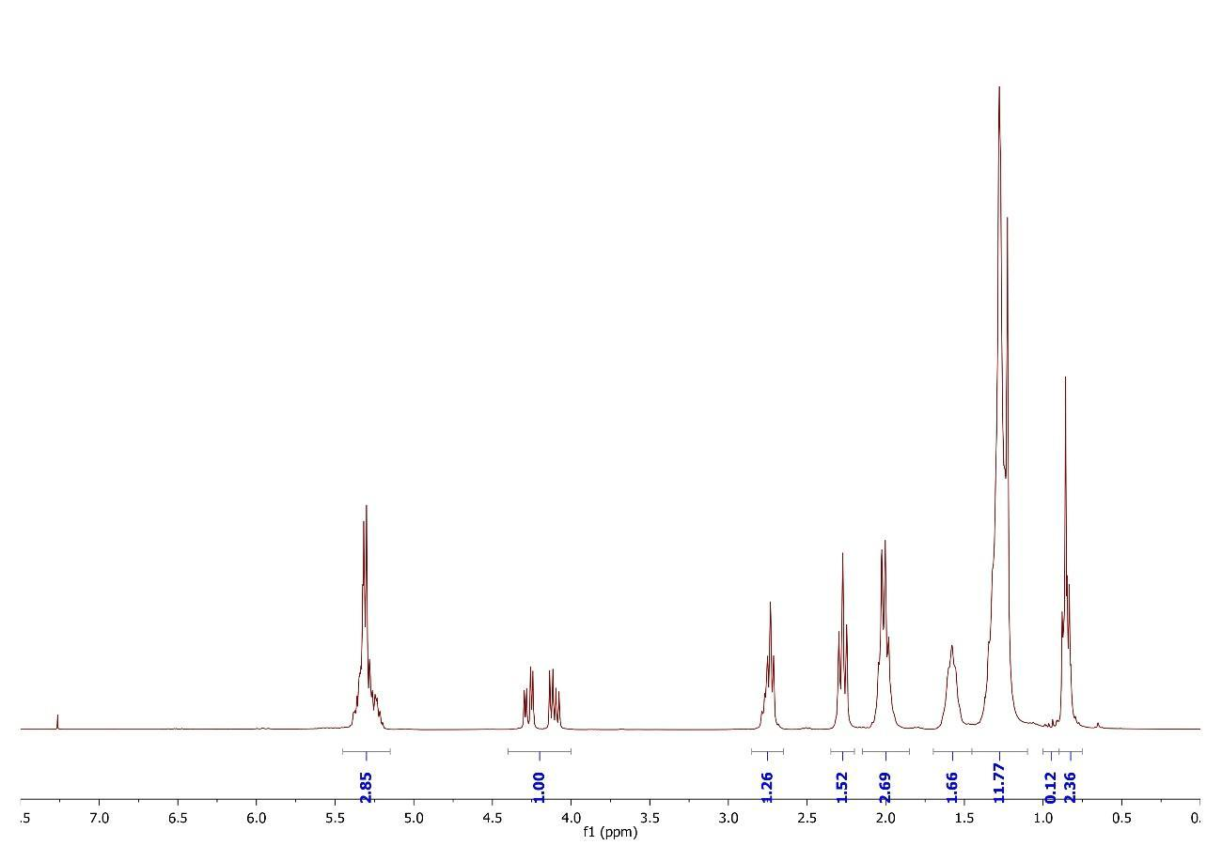
SBO-5%

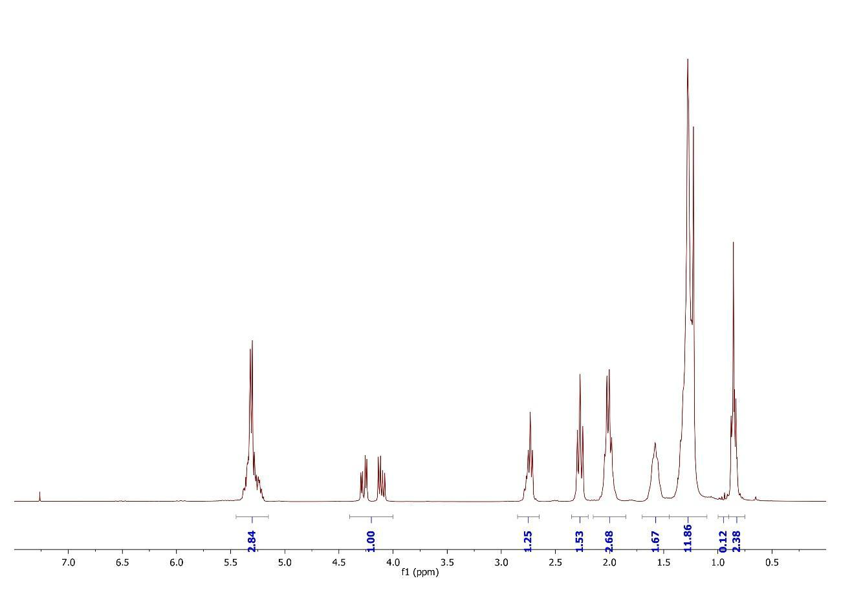
SBO-10%

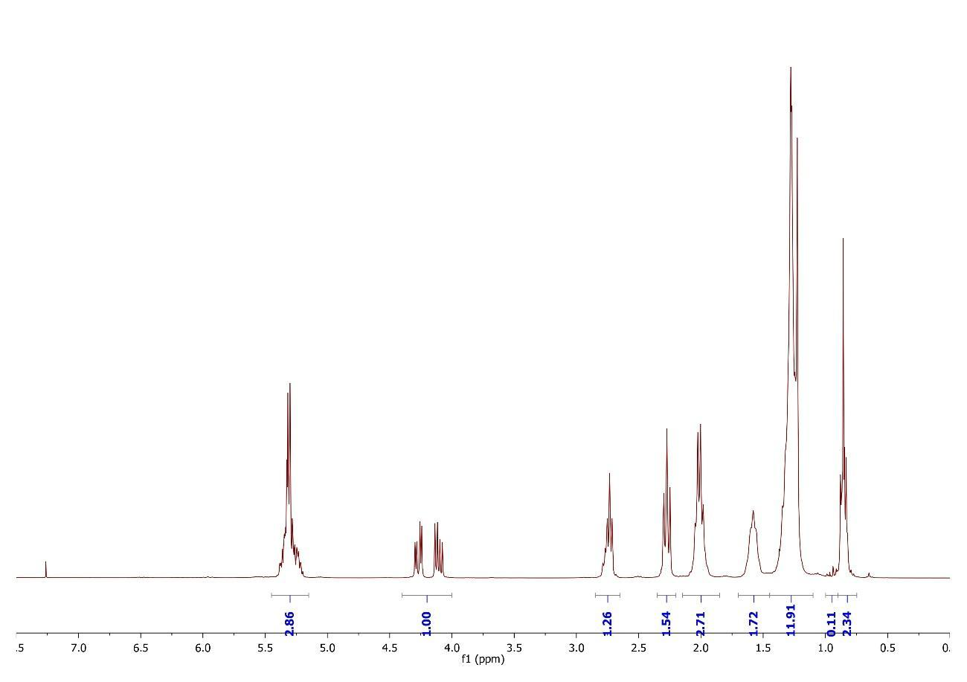
SBO-15%

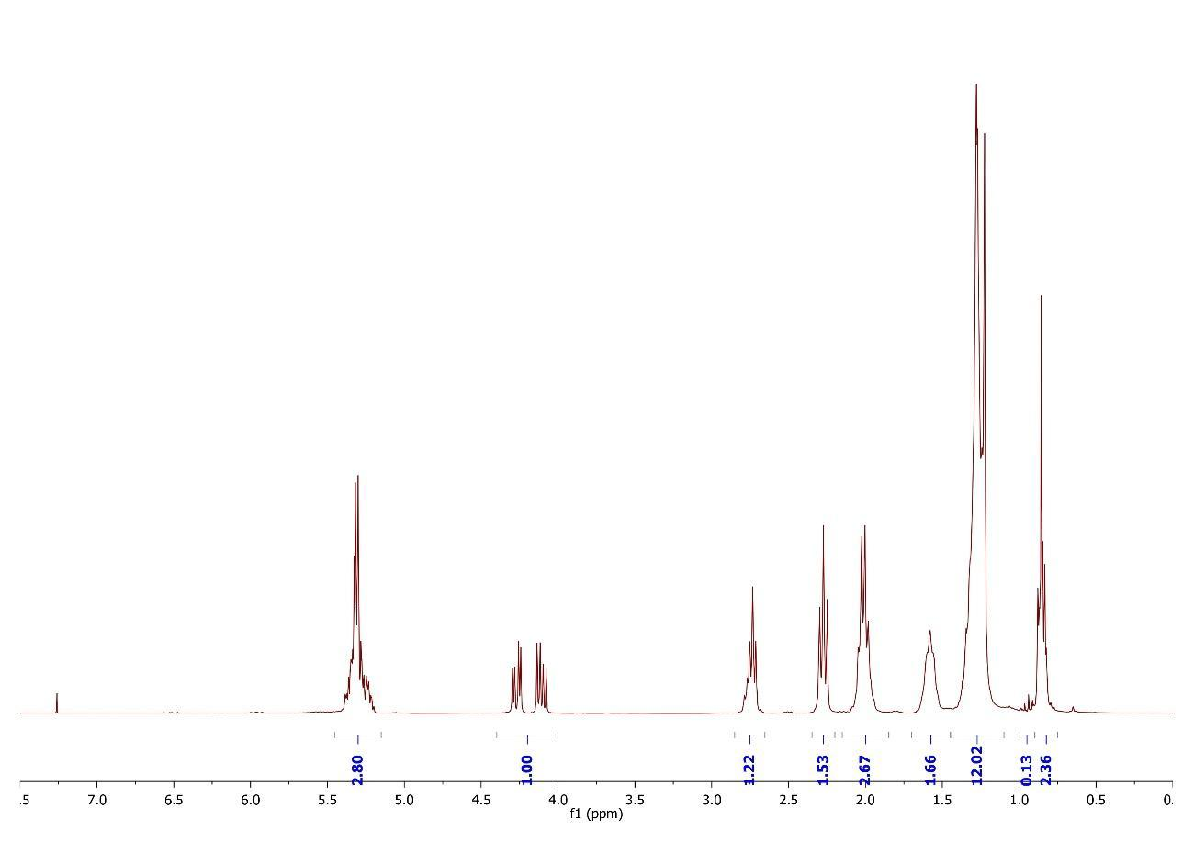
SBO-20%

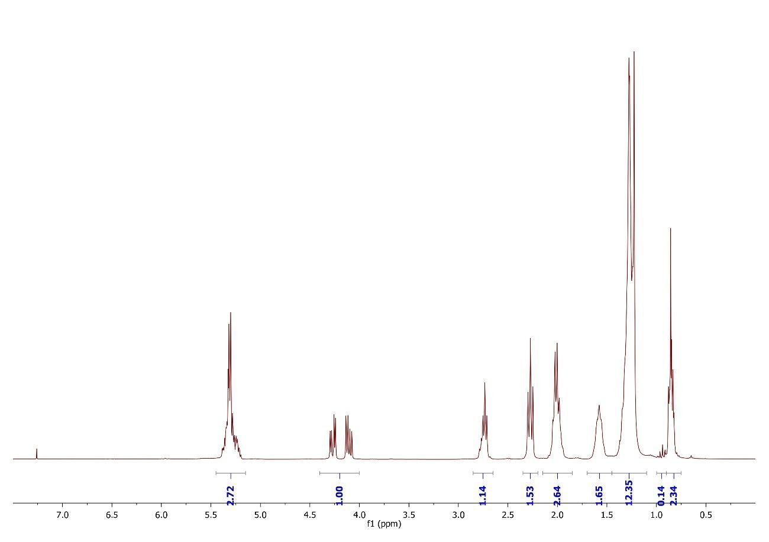
SBO-40%

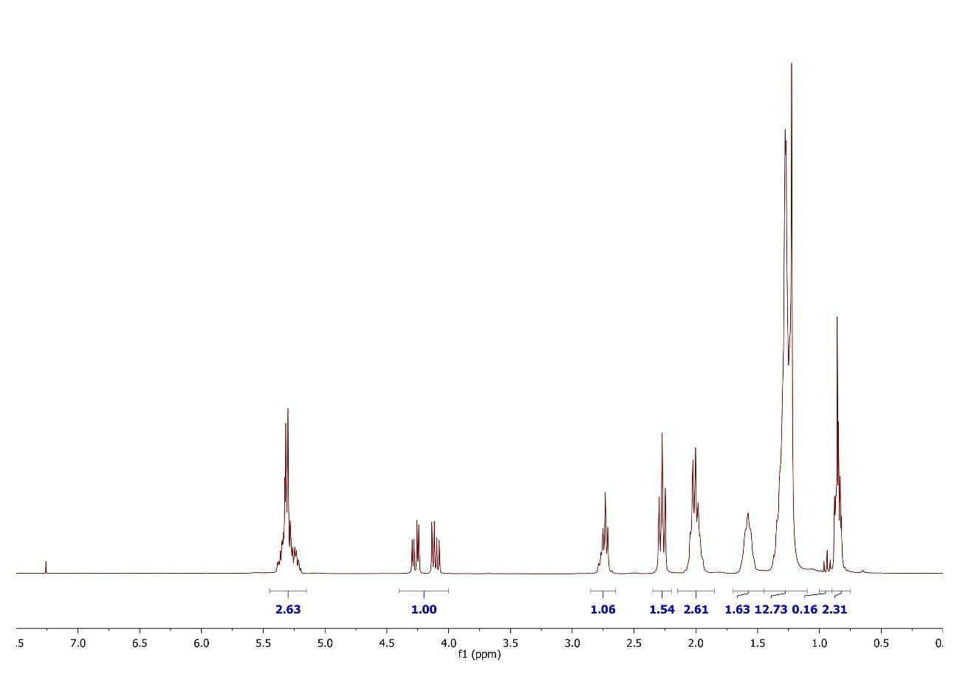
SBO-60%

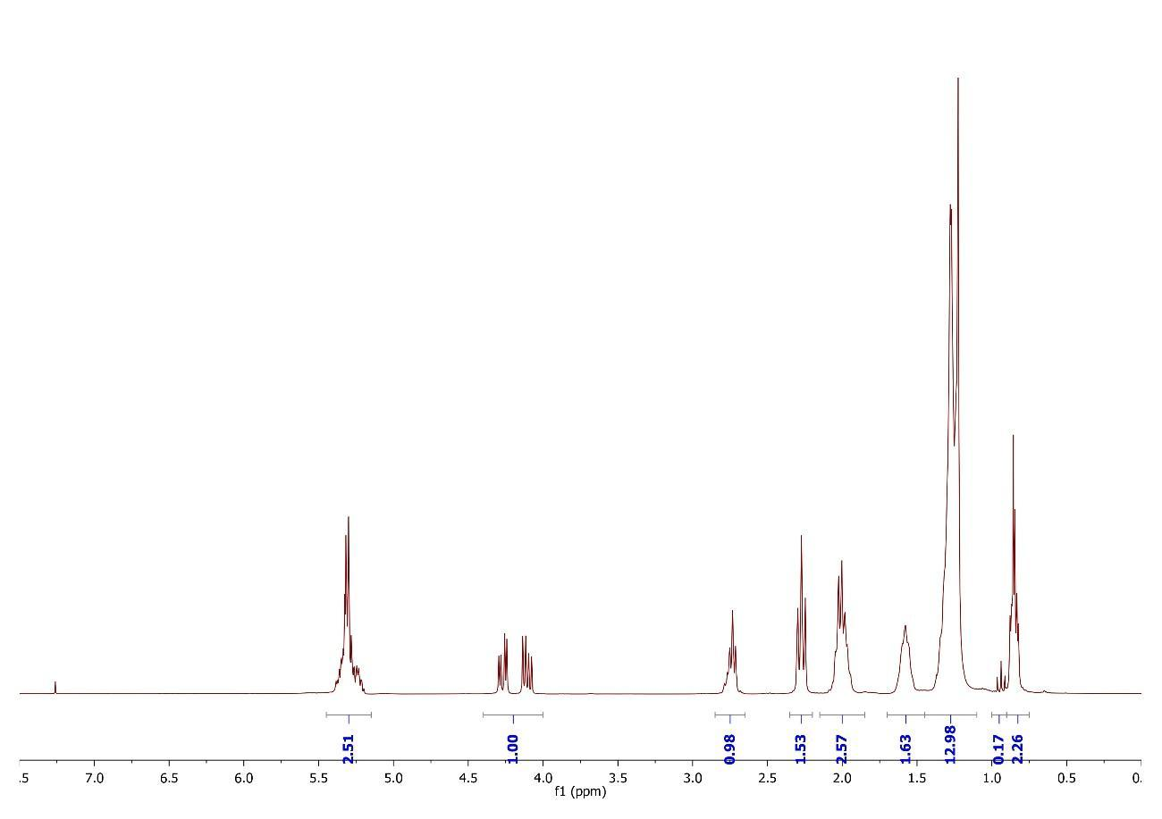
SBO-80%
Fig. 3 ¹H NMR spectra of spikes with soybean oil

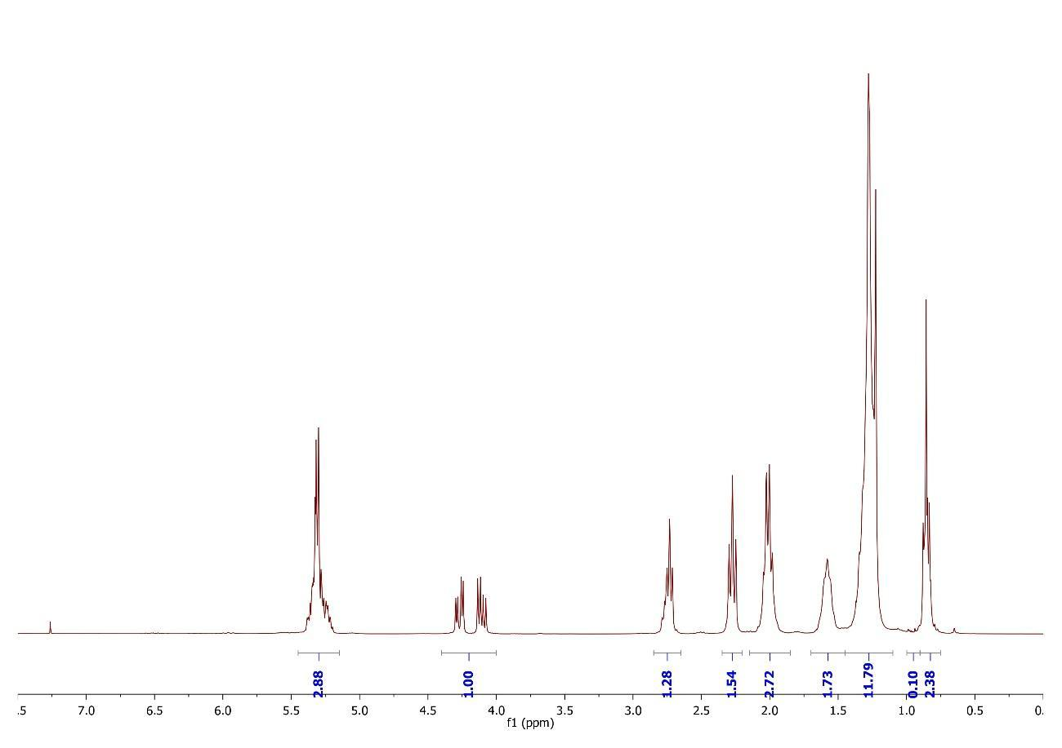
CO-5%

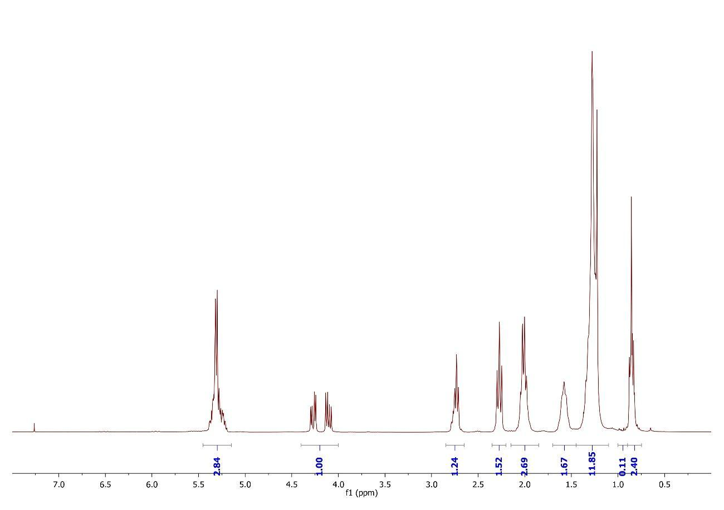
CO-10%

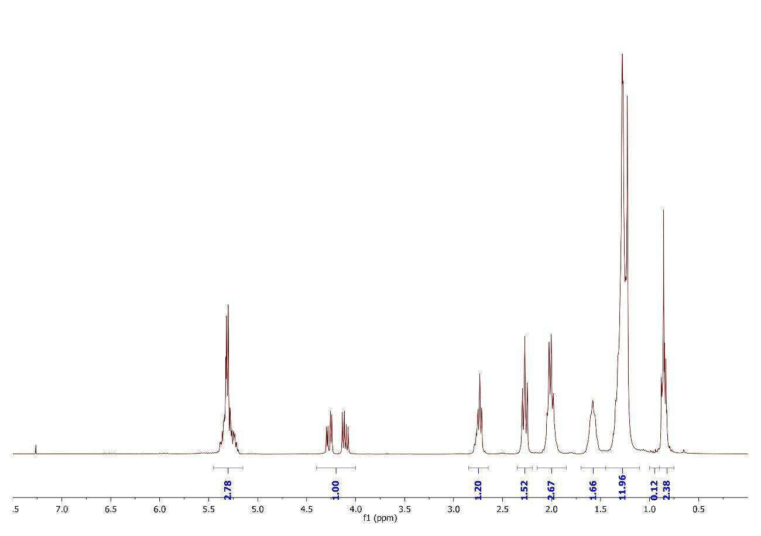
CO-15%

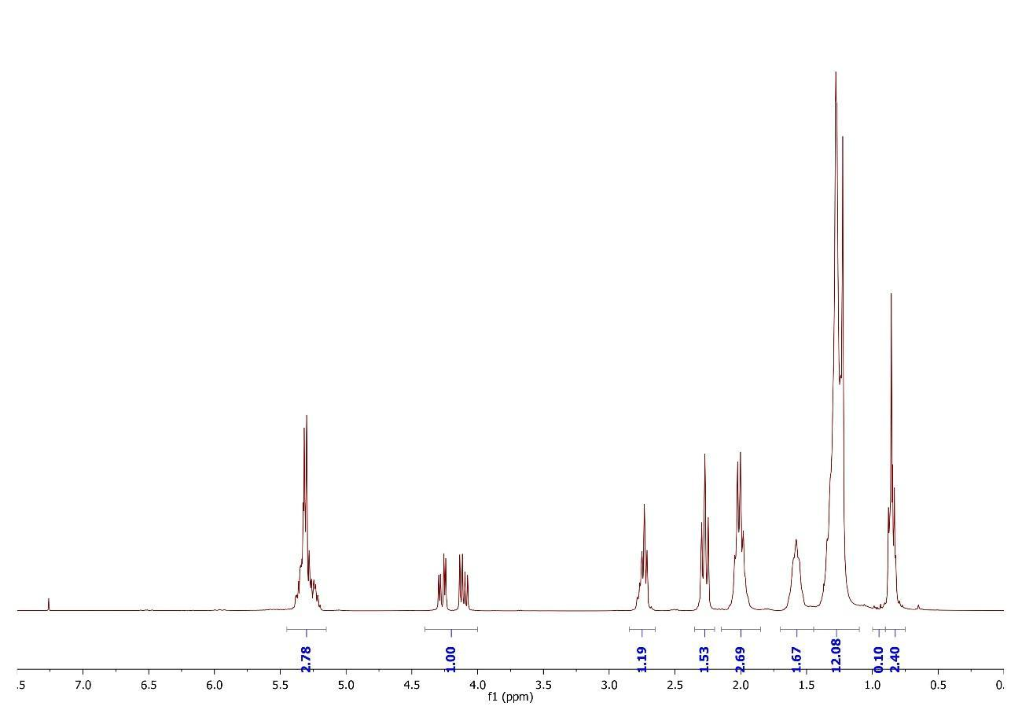
CO-20%

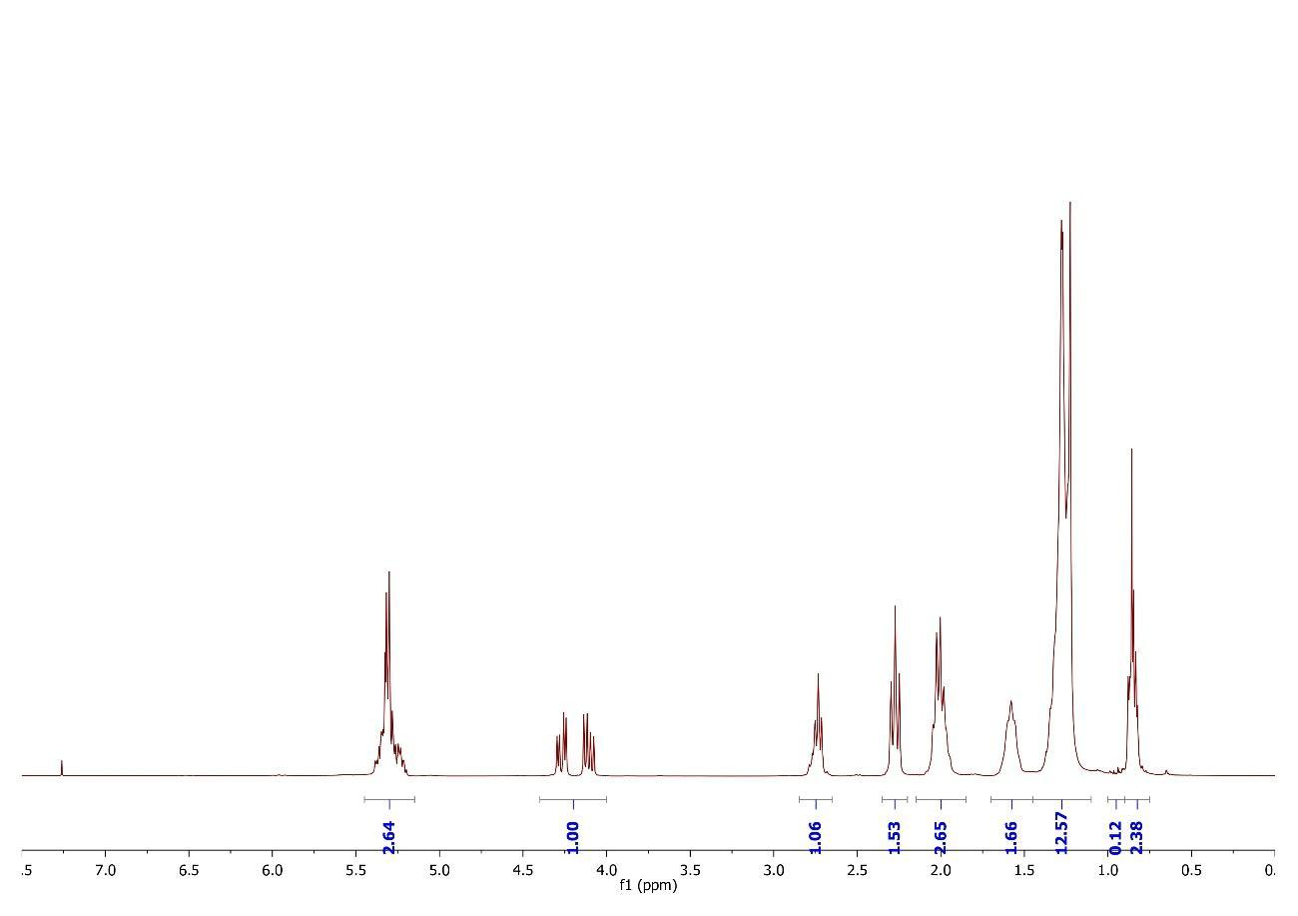
CO-40%

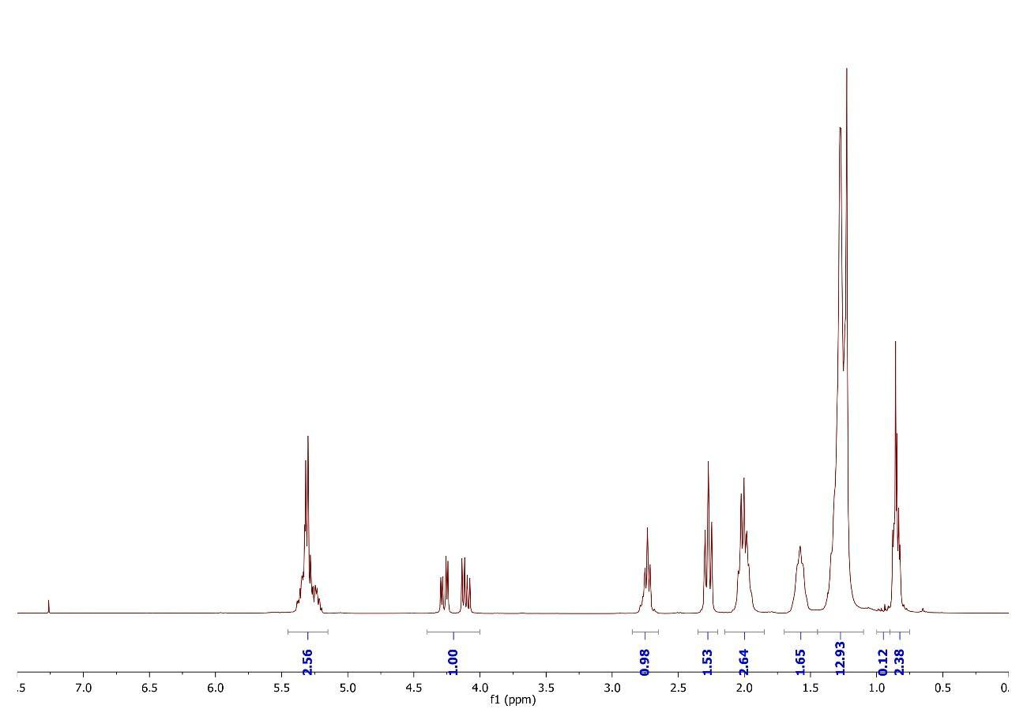
CO-60%

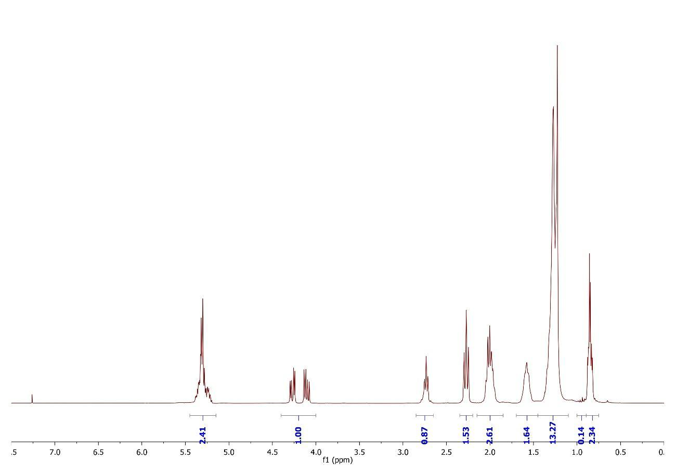
CO-80%
Fig. 4 ¹H NMR spectra of spikes with corn oil

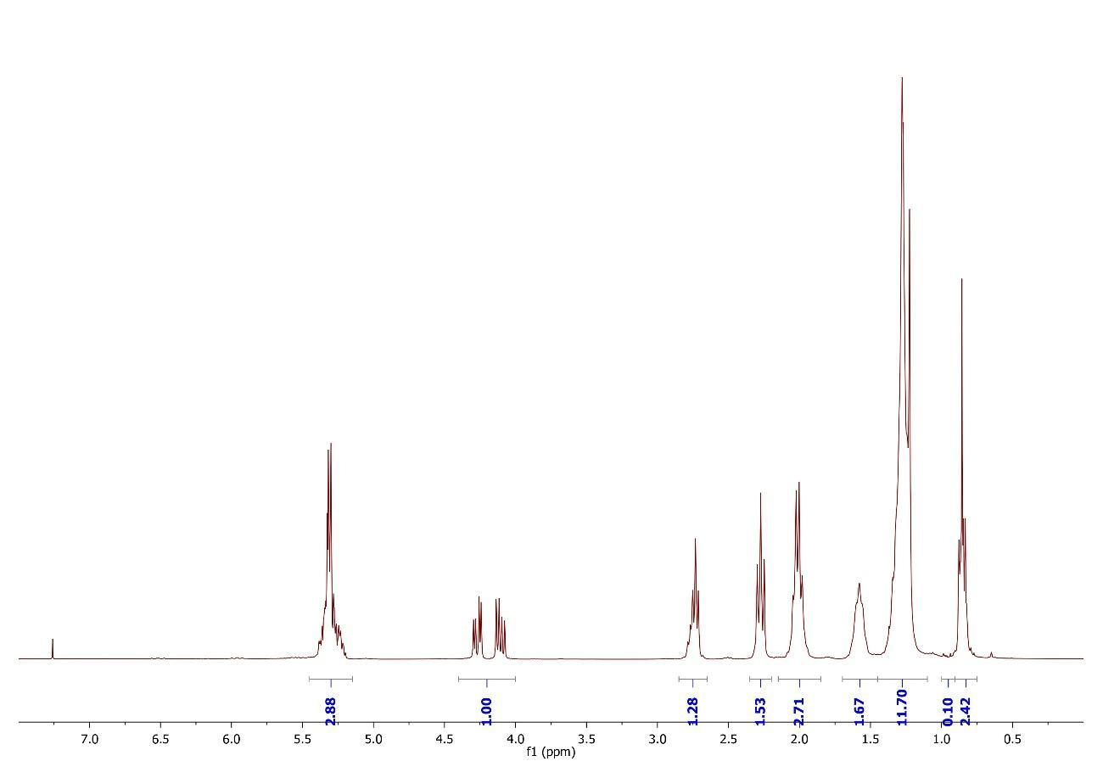
SFO-5%

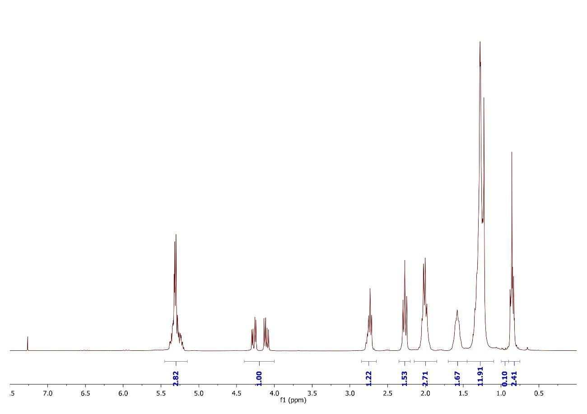
SFO-10%

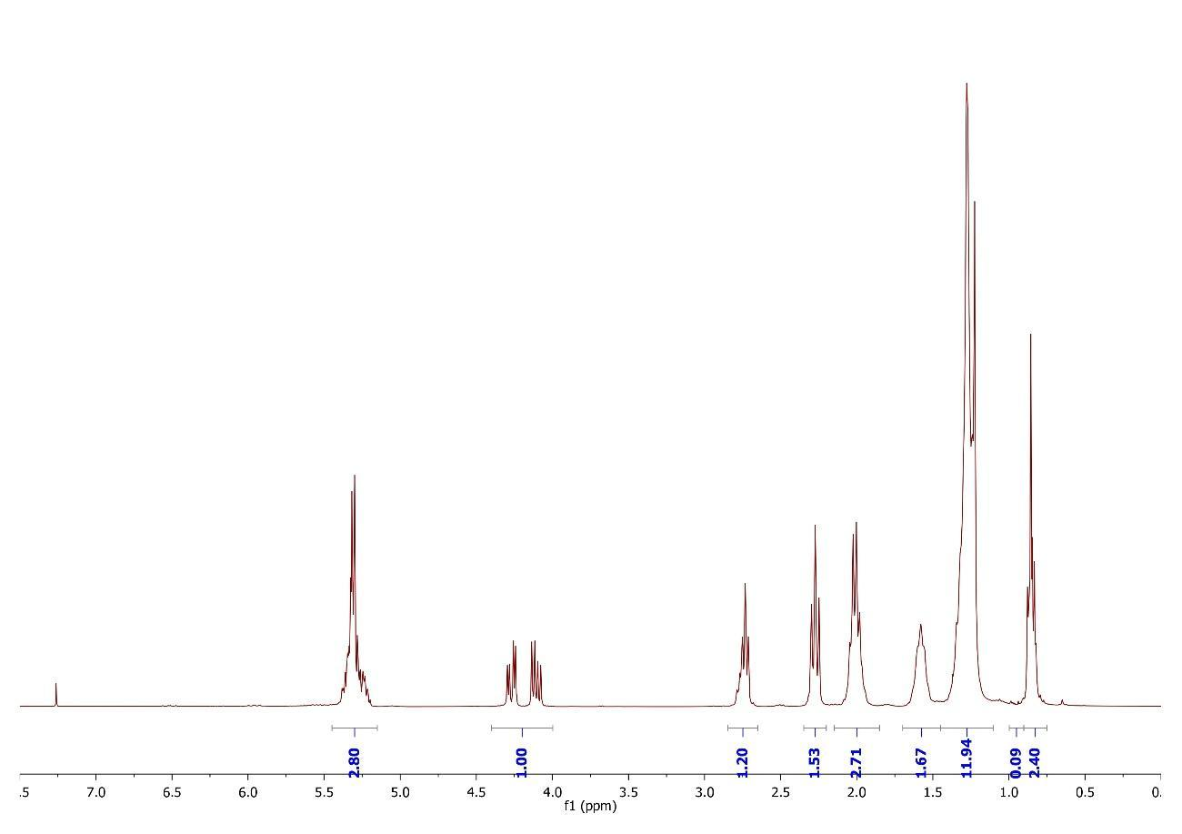
SFO-15%

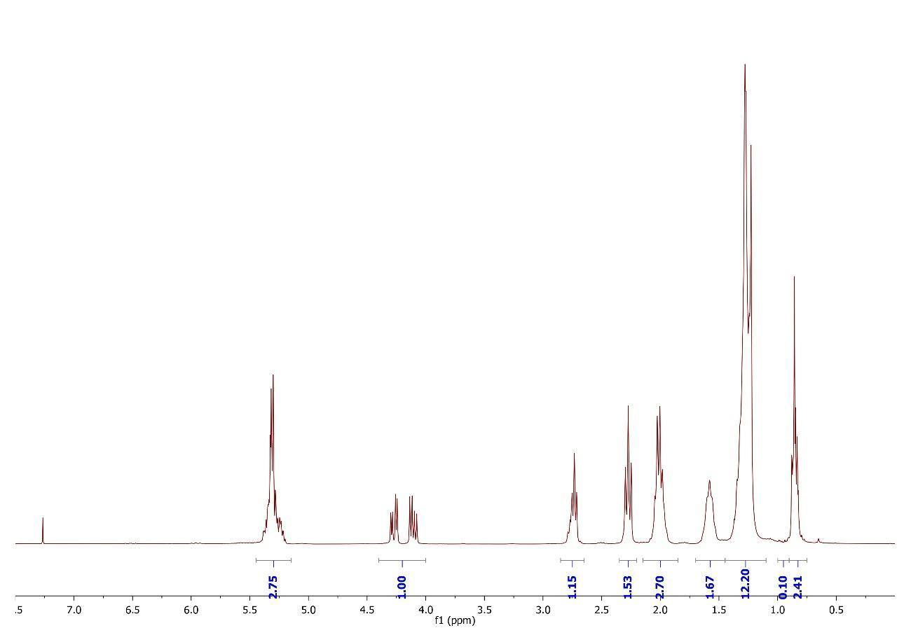
SFO-20%

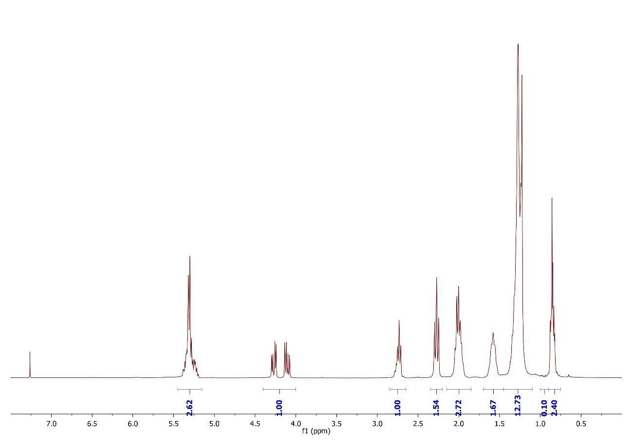
SFO-40%

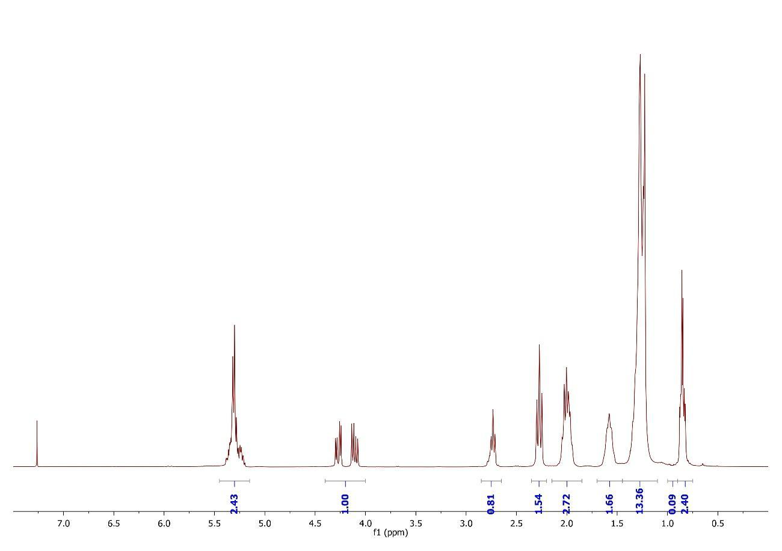
SFO-60%

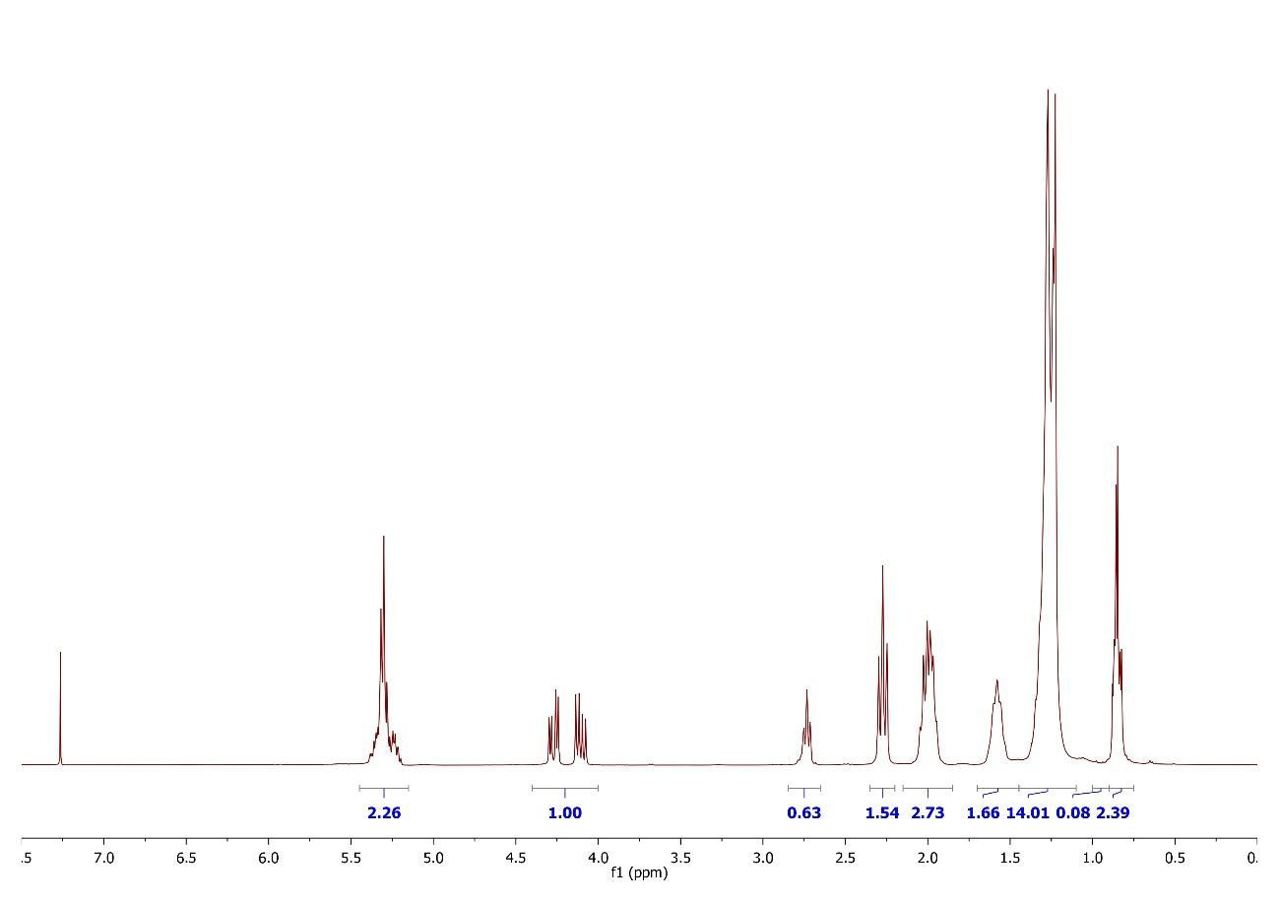
SFO-80%
Fig. 5 ¹H NMR spectra of the spikes with sunflower oil

