Supplementary Material 2
Shallot (Allium ascalonicum L.)-enriched Plantain (Musa paradisiaca L.) Biscuits ameliorates Diabetes, Hypertension and Oxidative Stress in Streptozotocin/High-Fat Diet induced Diabetic Rats.

Aanuoluwapo Elizabeth Adeyemo^{1*}, Sunday Solomon Josiah^{2,3}, Olufunmilayo Sade Omoba¹, Aderonke Ibidunni Olagunju¹

¹Department of Food Science and Technology, School of Agriculture and Agricultural Technology, Federal University of Technology, P.M.B. 704, Akure 340252, Nigeria. adeyemoelizabeth90@gmail.com (A.E.A; ID: https://orcid.org/0000-0003-3447-8048), osomoba@futa.edu.ng (O.S.O; ID: https://orcid.org/0000-0003-3447-8048), aiolagunju@futa.edu.ng (A.I.O; ID: https://orcid.org/0000-0003-3447-8048)
²Department of Biochemistry, School of Life Sciences, Federal University of Technology, P.M.B. 704, Akure 340252, Nigeria. ssjosiah@futa.edu.ng (S.S.J; ID: https://orcid.org/0000-0003-3447-8048)
³Department of Clinical and Biomedical Sciences, Faculty of Health and Life Sciences, University of Exeter, EX4 4PS, Exeter, United Kingdom.

*Corresponding author:
Aanuoluwapo E. Adeyemo (adeyemoelizabeth90@gmail.com)
Supplementary Results
Histopathological Status in Kidney and Liver of STZ-induced Diabetic Rats fed with SEPB
The histopathological analysis of renal tissues from the experimental animals is shown in Fig. S1. The control group showed no sign of deformation observed while the diabetic group showed destruction of the glomerular room, glomerular tuft, and vacuolization of the endothelial cells lining renal tubules. This may be attributed to the damage done by STZ which was used to induce diabetes. The tissues from experimental rats showed signs of gradual healing in the kidney, with the group fed with SB20 showing the most recovery from the vacuolization process almost similar to the normal group.
The histopathological analysis of hepatic tissues from the experimental animals is shown in Fig. S2. The control group showed almost near-normal liver architecture. The diabetic group showed severe hemorrhage and dilated sinusoid liver damage which may be attributed to the damage done by STZ chemical which was used to induce diabetes. The experimental samples showed signs of gradual healing in the liver of rats fed with SB20 showing almost recovery of the liver with just slight dilation of sinusoid and hemorrhage almost similar to the normal group. Rats that were fed with SB0 also showed improvement in the recovery process while those that received COMBIS and metformin showed little improvement.
The incidence of oxidative stress can provoke mitochondrial dysfunction, thereby instigating the release of apoptotic markers, which are the main culprit that leads to cellular degeneration; and reports have shown that these cascades of oxidative stress events multi-organ histo-morphological changes [1, 2]. Our findings on the histopathological analysis of hepatic and renal tissues revealed that tissues from STZ/HFD diabetic rats showed severe abnormalities characterized by impaired histoarchitectural features which may be attributed to the damage done by STZ chemical which was used to induce diabetes. Unlike the diabetic rats, the control animals showed no signs of deformed tissues while the diabetic rats fed with shallot-enriched biscuits improved the histopathological changes and reinstated the histopathological patterns of the tissues by reinstating the tissue redox system. The ability of the shallot-enriched plantain biscuit to facilitate the elevation of enzymatic antioxidant activities coupled with the inhibition of lipid peroxidation could be responsible for the amelioration of the hepato-renal injuries as observed in the representative photomicrographs taken from the stained tissues.

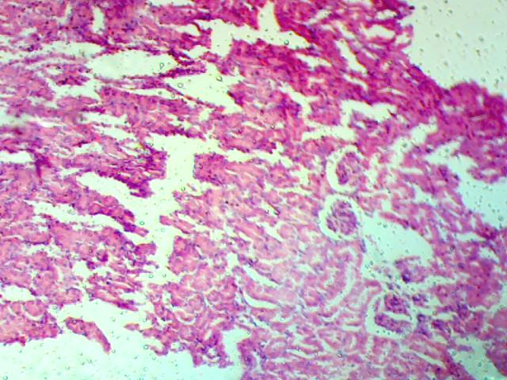
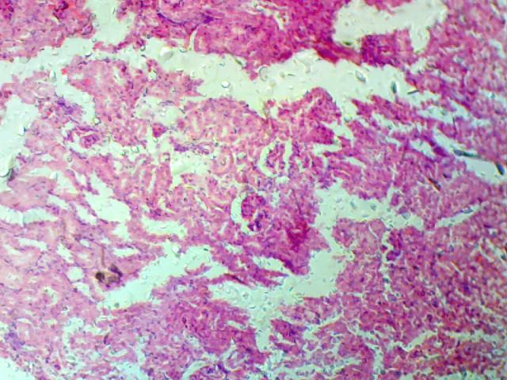
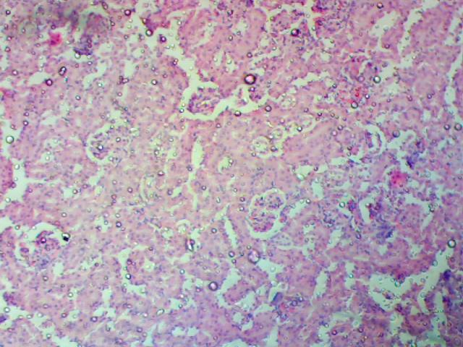
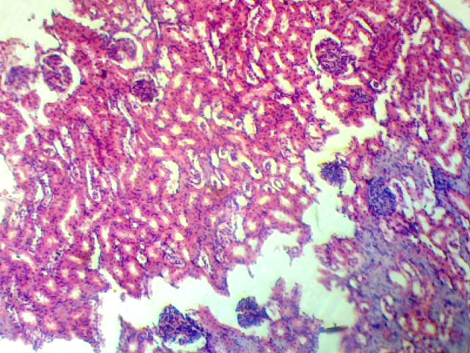
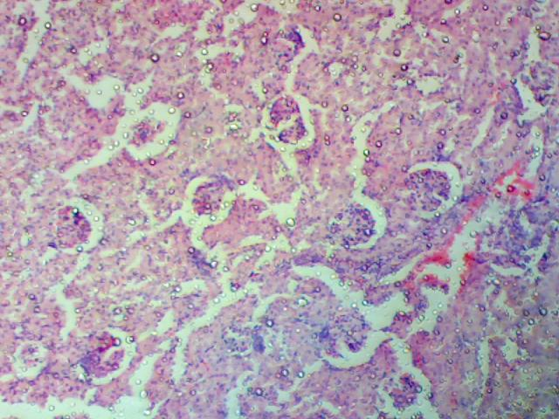
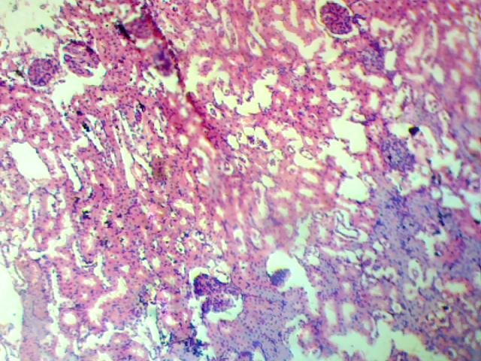
f
GT
e
d
c
a
b
V
V
GR
V
V
GR
GR
V
Fig. S1 Representative photomicrographs showing hematoxylin and eosin-stained sections of kidney (Mag 100×). (a) Control: No histologic deformation was observed in the tissue section. (b) HFD/STZ group: The tissue section showed destruction of the glomerular room, glomerular tuft, and vacuolization (V) of the endothelial cells lining renal tubules. (c) HFD/STZ+SB0: Focal destruction of glomerular room (GR) with intact glomerular tuft and vacuolization (V) of the endothelial cells lining renal tubules were observed. (d) HFD/STZ+SB20: The tissue section showed vacuolization (V) of the linings of the glomerular room. (e) HFD/STZ+COMBIS: Focal destruction of the glomerular room, glomerular tuft, and vacuolization (V) of the endothelial cells lining renal tubules were observed in the tissue section. (f) HFD/STZ+METh: The tissue section showed focal destruction of the glomerular tuft and vacuolization (V) of the endothelial cells lining renal tubules.
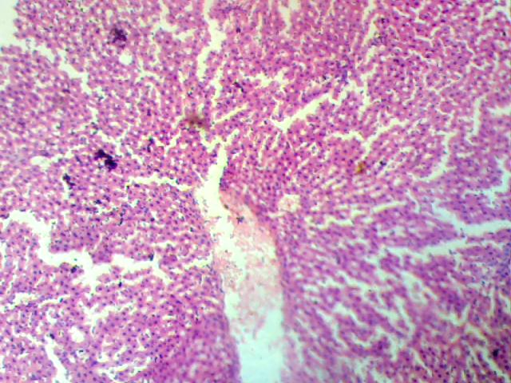
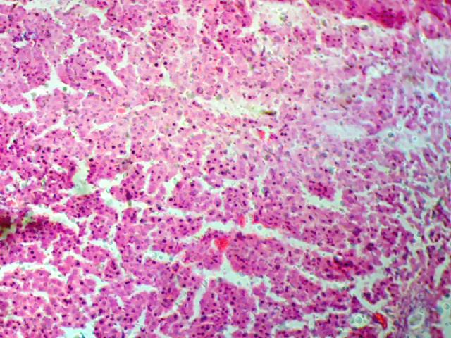
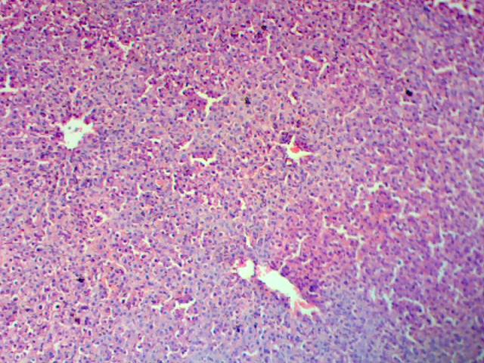
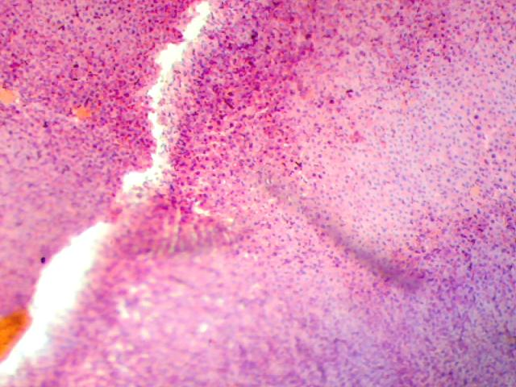
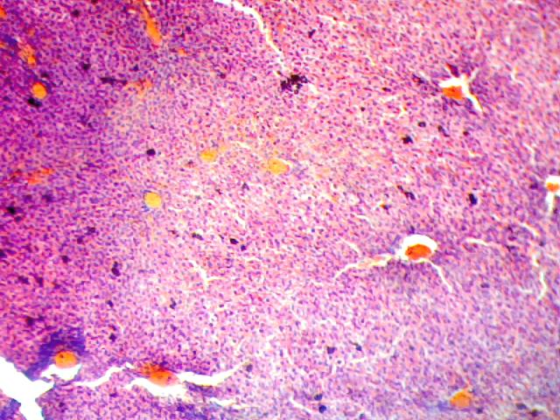
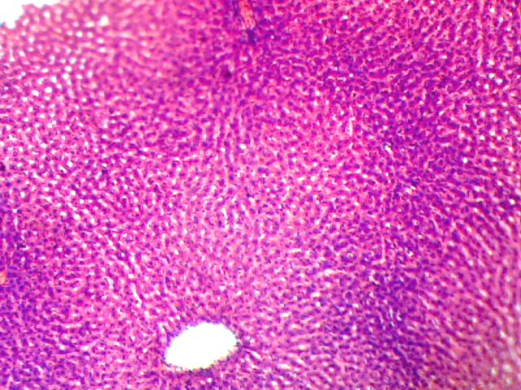
c
e
f
d
b
a
DS
HM
DS
HM
HM
DS
DS
HM
HM
GR
Fig. S2 Representative photomicrographs showing hematoxylin and eosin-stained sections of the liver for the control group (Mag 100×). (a) Control: The tissue section showed almost near-normal liver architecture. (b) HFD/STZ group: Several hemorrhages (HM) and dilated sinusoids (DS) lined by Kupffer cells were observed in the tissue section. (c) HFD/STZ+SB0 group: The tissue section showed dilation of the sinusoid (DS) and hemorrhage (HM). (d) HFD/STZ+SB20 group: Almost near normal liver architecture but with a slight dilation of sinusoid and hemorrhage was observed in the tissue section. (e) HFD/STZ+COMBIS group: The tissue section showed great dilation of the sinusoid (DS) and hemorrhage (HM). (f) HFD/STZ+MET group: Haemorrhage (HM) and dilated sinusoid (DS) lined by Kupffer cells were observed in the tissue.
References
1. Hazzaa SM, El-Roghy ES, Abd Eldaim MA, Elgarawany GE (2020) Monosodium glutamate induces cardiac toxicity via oxidative stress, fibrosis, and P53 proapoptotic protein expression in rats. Environ Sci Pollut Res 27:20014–20024. https://doi.org/10.1007/s11356-020-08436-6
2. Abd Elwahab D, Alim M, Sharkawi S, Nabil S (2020) Detection of cardiac tissues toxicity caused by Monosodium Glutamate and the protective role of vitamin C by Immunohistochemical method, Heart tissue oxidative stress biomarkers and Cardiac dysfunction biomarkers. The Egyptian Journal of Forensic Sciences and Applied Toxicology 20:13–21. https://doi.org/10.21608/ejfsat.2020.17652.1098

