Extended Data
Sulfur Poisoning on Rh Nanoparticles but Sulfur Promotion on its Single-Site Catalyst for Carbonylation

Siquan Feng^{1#}, Jiali Mu^{1#}, Xiangsong Lin^{2#}, Xiangen Song^{1*}, Olga Safonova³, Nachtegaal Maarten³, Siyue Liu⁴, Qiao Yuan^{1,5}, Xingju Li^{1,6}, Weiqing Zhang⁴, Guorong Wu⁴, Jiayue, Yang⁴, Wenrui Dong^{4*}, Xueming Yang^{4,7}, Jingwei Li¹, Zheng Jiang⁸, Yunjie Ding^{1,9*}

¹ Dalian National Laboratory for Clean Energy, Dalian Institute of Chemical Physics, Chinese Academy of Sciences, 116023 Dalian, China;
² School of Materials and Textile Engineering, Jiaxing University, 314001 Jiaxing, China;
³ Paul Scherrer Institut CH-5232 Villigen, Switzerland;
⁴ State Key Laboratory of Molecular Reaction Dynamics, Dalian Institute of Chemical Physics, Chinese Academy of Sciences, 116023, Dalian, China;
⁵ University of Chinese Academy of Sciences, 100049 Beijing, China;
⁶ Department of Chemical Physics, University of Science and Technology of China, Hefei 230026, China;
⁷ Department of Chemistry, Southern University of Science and Technology, Shenzhen 518055, China
⁸ Shanghai Synchrotron Radiation Facility, Shanghai Institute of Applied Physics, and Shanghai Advanced Research Institute, Chinese Academy of Sciences, 201204 Shanghai, China;
⁹ State Key Laboratory of Catalysis, Dalian Institute of Chemical Physics, Chinese Academy of Sciences, Dalian, China.

#These authors contributed equally: Siquan Feng, Jiali Mu, Xiangsong Lin.
* Corresponding authors:
Xiangen Song (xiangensong@dicp.ac.cn); Wenrui Dong (wrdong@dicp.ac.cn);
Yunjie Ding (dyj@dicp.ac.cn);

Table of Contents
Supplementary Figures
1. Effect of H₂S on the catalytic performance and status of Rh NPs catalysts (Rh/CMK-3 and Rh/AC) for methanol carbonylation 3
2. Effect of H₂S on the catalytic performance of single-site Rh₁ catalysts (Rh₁/AC) for methanol carbonylatio 4
3. Molecular configuration identification of single-site Rh₁/AC catalyst 5
4. HR-TEM and HAADF-STEM images of spent Rh₁/AC in normal feed and S-feed 6
5. In-situ EXAFS data fitting in k³[χ(k)] for spent Rh₁/AC catalyst in normal feed and S-feed 7
6. Ex-situ EXAFS data fitting in k³[χ(k)] for spent Rh₁/AC catalyst in normal feed and S-feed 8
7. Rh 3d and S 2p XPS spectra of Rh₁/AC and Rh/CMK-3 catalysts 9

8. FT-IR of the scrubbing solution of spent Rh₁/AC in S-feed or normal feed 10

9.The laser desorption ionization time of flight mass spectrum (LDI-TOF MS) for spent Rh₁/AC in normal feed and S-feed 11
10. HR-TEM image and EDS-mapping of fresh Rh/CMK-3 catalyst 12
11. HAADF-STEM image and EDS mapping of spent Rh/CMK-3 in normal feed 13
12. HAADF-STEM image and EDS mapping of spent Rh/CMK-3 in S-feed 14
13. In-situ FEL/TOF MS with different wavelengths for Rh₁/AC catalyst in S-feed 15

14. In-situ DRIFT of Rh₁/AC for heterogeneous methanol carbonylation in normal feed and S-feed 16
15. In-situ EPR/ESR of Rh₁/AC catalyst for methanol carbonylation in normal feed and S-feed 17
16. DFT minimum energy of the molecular structures of Rh mononuclear complex 18
17. DFT calculation of I--CH₃ bond length for CH₃I adsorption 19
18. DFT calculation of transition state energy barrier for CH₃I oxidative addition 20
Supplementary Tables

1. Effect of H₂S on the catalytic activity of supported Rh nanoparticles (Rh/AC) and single-site Rh (Rh₁/AC) catalyst 21

2. EX-situ EXAFS quantitative analysis of spent Rh₁/AC in normal feed and S-feed 22

3. XPS results of Rh/CMK-3 and Rh₁/AC 23

Extended Data Figure 1 ǀ Effect of H₂S on the catalytic performance andstatus of Rh NPs catalysts (Rh/AC) for methanol carbonylation. (a) effect of H₂S on the catalytic activity of Rh NP (Rh/AC) for methanol carbonylation, (b) HR-TEM image of Rh NPs (Rh/AC), (c) HR-TEM image of spent Rh/AC after methanol carbonylation in normal feed, (d) HR-TEM image of spent Rh/AC after methanol carbonylation in S-feed, (e) HAADF-STEM image of spent Rh/AC after methanol carbonylation in normal feed, (f) HAADF-STEM image of spent Rh/AC after methanol carbonylation in S-feed, (g) and (h) are XPS fit and fitting result of spent Rh/AC after methanol carbonylation in normal feed and S-feed .
Conditions: (a) Cat: 0.3 g, 0.5 ml, 513 K, 1.7 MPa, CO/CH₃OH = 1.0 (mole ratio), CO/H₂ = 10 (mole ratio), CH₃I/CH₃OH =3/7 (mass ratio), H₂S content = 1000 ppm, LHSV = 12 h⁻¹.

Extended Data Figure 2 ǀ Effect of H₂S on the catalytic performance of single-site Rh₁ catalysts (Rh₁/AC) for methanol carbonylation.
Conditions: 1wt.% Rh₁/AC catalyst, Cat: 0.3 g, 513 K, 1.7 MPa, CO/CH₃OH = 1.0 (mole ratio), CO/H₂ = 10 (mole ratio), CH₃I/CH₃OH = 3/7 (mass ratio), H₂S content = 1000 ppm, LHSV = 12 h⁻¹.

Extended Data Figure 3 ǀ Molecular configuration identification of single-site Rh₁/AC catalyst.
(a) HR-TEM image of single-site Rh₁/AC, (b) HAADF-STEM image of single-site Rh₁/AC, and (c) Rh EAXFS k-edge fitting in R space of fresh Rh₁/AC catalyst, (d) quantitative analyses of Rh-CO, Rh-(O=AC), Rh-I bond contributions in the first shell of single-site Rh₁/AC catalyst as measured by EXAFS path fitting in Extended Data Figure 1c, Hanning window, R range: 1.26–3.00 Å; k range: 2.49–13.0Å⁻¹; N, coordination number; R, the distance between absorber and backscatter; σ², Debye–Waller factor; Standard sample RhI₃; amp 0.858; k-weight=1, 2, 3; E₀, energy shift; Feff calculations：Single scattering, Rh-CO, reference CIF: [C₄I₂O₄Rh₂], COD 2202025, Reff=1.854 Å, Rh-I, Reff=2.661 Å；Rh-O, first quick shell path, Reff=2.1 Å. (e) the molecular model of single-site Rh₁/AC catalyst.

Extended Data Figure 4 ǀ HR-TEM and HAADF-STEM images of spent Rh₁/AC in normal feed and S-feed. (a) The HR-TEM and (b) HAADF-STEM images of spent Rh₁/AC in normal feed for methanol carbonylation, respectively. (c) The HR-TEM and (d) HAADF-STEM images of spent Rh₁/AC in S-feed for methanol carbonylation, respectively.

Extended Data Figure 5 ǀ In-situ EXAFS data fitting in k²[χ(k)] for spent Rh₁/AC catalyst in normal feed and S-feed. (a) k²[χ(k)] fitting result in k space for spent Rh₁/AC catalyst in normal feed. (b) k²[χ(k)] fitting result in k space for spent Rh₁/AC catalyst in p S-feed.

Extended Data Figure 6 ǀ Ex-situ EXAFS data fitting in k²[χ(k)] for spent Rh₁/AC catalyst in normal feed and S-feed. (a) k²[χ(k)] fitting result in k space for spent Rh₁/AC catalyst in normal feed, (b) k²[χ(k)] fitting result in k space for spent Rh₁/AC catalyst in S-feed.

Extended Data Figure 7 ǀ Rh 3d and S 2p XPS spectra of Rh₁/AC and Rh/CMK-3 catalysts. (a) Rh 3d XPS of spent Rh₁/AC in normal feed and S-feed. (b) Rh 3d XPS of spent Rh/CMK-3 in normal feed and S-feed. (c) S 2p XPS of spent Rh₁/AC and Rh/CMK-3 catalysts in S-feed.

Extended Data Figure 8 ǀ Fourier transformations infrared spectroscopy of the ethanol scrubbing solution of spent Rh₁/AC in S-feed or normal feed.
The peaks at 2052 cm⁻¹ 2004 cm⁻¹ 1966 cm⁻¹ and 1956 cm⁻¹ were ascribed to ν(CO) in carbonyl rhodium complex. The peaks of 420 cm⁻¹ and 417 cm⁻¹ on spent Rh₁/AC in S-feed were probably belonged to ν(Rh-S) in Rh(CH₃SH) and Rh(CH₃SCH₃), respectively. AC support itself contained trace of sulfur. The weaker peak of 417 cm⁻¹ on spent Rh₁/AC in normal feed belonged to the bond between Rh and sulfur in AC support.
Reference:
- Forster, D. In Advances in organometallic chemistry, Elsevier: 1979; Vol. 17, pp 255-267.
- El-Hendawy A. Transition metal complexes of 2-formylpyridinethiosemicarbazone (HFpyTSC) and X-ray crystal structures of [Pd (FpyTSC)(PPh3)] PF6 and [Pd (FpyTSC)(SCN)][J]. Damietta University Publication, 2014, 1(1).

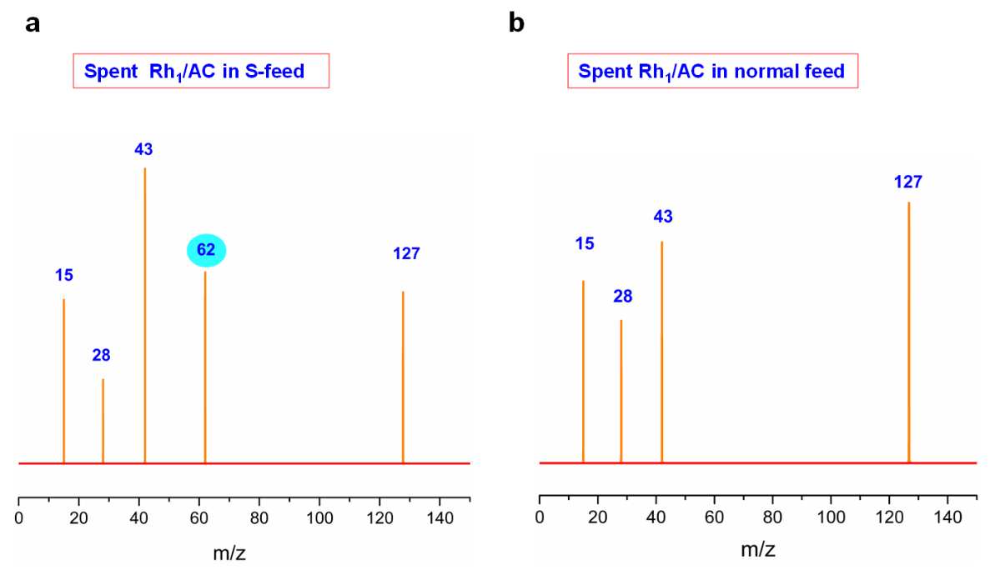
Extended Data Figure 9 ǀ The mass spectra for spent Rh₁/AC in normal feed and S-feed, obtained by laser desorption ionization time-of-flight mass spectrometry (LDI-TOF MS). (a) Spent Rh₁/AC in S-feed; (b) Spent Rh₁/AC in normal feed. The fluence of the 266 nm desorption laser is about 35 mJ/cm², and the fluence of the 118 nm ionization laser is about 40 uJ/cm².

Extended Data Figure 10 ǀ HR-TEM image and EDS-mapping of fresh Rh/CMK-3 catalyst.
(a) HAADF-STEM images, (b) STEM-EDS line scan profile of a single NP, (c) EDS analysis and elemental mapping of C, Rh, O.

Extended Data Figure 11 ǀ HAADF-STEM image and EDS mapping of spent Rh/CMK-3 in normal feed. (a) HAADF-STEM image and corresponding NP size distribution, (b) STEM-EDS line scan profile of a single NP, (c) EDS mapping of spent Rh/CMK-3 catalyst in normal feed and the corresponding mapping of C, Rh, O, I elements.

Extended Data Figure 12 ǀ HAADF-STEM image and EDS mapping of spent Rh/CMK-3 in S-feed. (a) HAADF-STEM image and corresponding NP size distribution, (b) STEM-EDS line scan profile of a single NP, (c) EDS mapping of spent Rh/CMK-3 in S-feed and the corresponding mapping of C, Rh, O, I, S elements.

Extended Data Figure 13 ǀ In-situ FEL/TOF MS with different wavelengths for Rh₁/AC catalyst in S-feed. Conditions: Heterogeneous methanol carbonylation on Rh₁/AC catalyst at 513 K, 0.1bar with the FEL at 125, 140, 150 nm (with laser fluence of 40 uJ/cm²) to ionize the radicals and the intermediate species. (The ionization energy of (CH₃)₂S is 8.6 eV (144.2 nm); while the ionization energy of CH₃SH is 9.4 eV (131.9 nm). By changing the wavelength of free-electron laser, we further confirmed that the species at m/z 48 and m/z 62 were CH₃SH and CH₃SCH₃, respectively).

Extended Data Figure 14 ǀ In-situ diffuse reflectance infrared Fourier transformations spectroscopy of Rh₁/AC for heterogeneous methanol carbonylation in normal feed and S-feed. In-situ DRFTIS methanol carbonylation experiment in (a) normal feed, (b) in S-feed, (c) CH₃OH and CH₃I (d) CH₃OH, CH₃I and H₂S.

Extended Data Figure 15 ǀ In-situ electron paramagnetic resonance/electron spin resonance (EPR/ESR) of Rh₁/AC for methanol carbonylation in normal feed and S-feed. Methanol carbonylation conditions: Cat: Rh₁/AC 5mg, 240°C, ambient atmosphere, CO: 10 ml/min, H₂: 1 ml/min, CH₃OH/CH₃I = 7/3 (wt%). The mixture of CH₃OH/CH₃I was bubbled with CO and H₂. EPR/ESR test center field: 3300 G, sweep width: 6400 G, static field: 100 G, microwave bridge frequency: 9.5 GHz and the power is set as 10 mW.

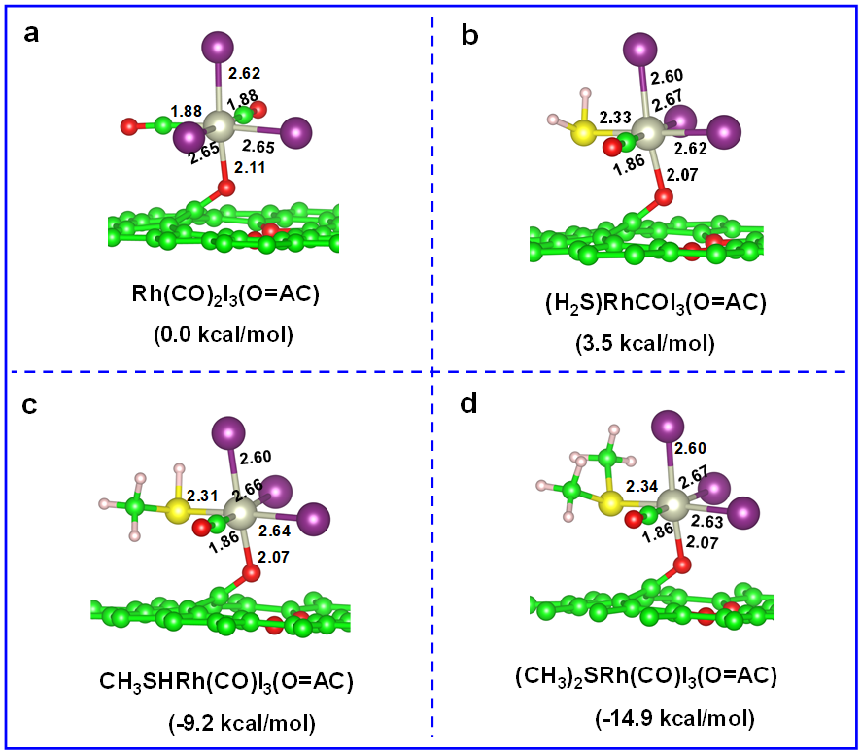

Extended Data Figure 16 ǀ DFT minimum energy of the molecular structures of Rh mononuclear complex. (a) (b) (c) (d) are the molecular structures of Rh(CO)₂I₃(O=AC), (H₂S)Rh(CO)₂I₃(O=AC), CH₃SHRh(CO)I₃(O=AC), and (CH₃)₂SRh(CO)I₃(O=AC), respectively. It could be easy to find that the (CH₃SR)Rh(CO)I₃(O=AC) has lower energy for CH₃SH, (CH₃)₂S ligands, and higher energy for CH₃SH ligand, when compared with Rh(CO)₂I₃(O=AC), suggesting that the new formed CH₃SH and (CH₃)₂S species from H₂S favored to coordinate with Rh mononuclear complex to obtain a more stable structure than Rh(CO)₂I₃(O=AC). Gray ball represents Rh atom; red ball represents O atom; purple ball represents I atom; yellow ball represents S atom; green ball represents C atom; pink ball represents H atom.

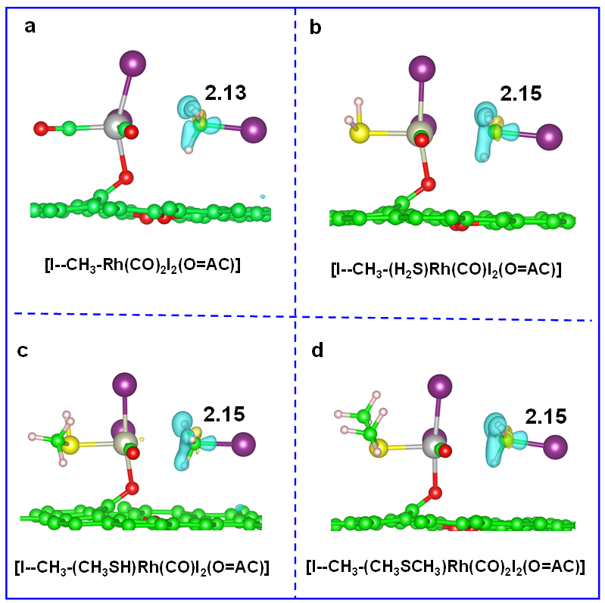

Extended Data Figure 17 ǀ DFT calculation of I--CH₃ bond length in the Rh single nuclear complex structures for CH₃I adsorption. (a) [I--CH₃-Rh(CO)₂I₂(O=AC)]，(b) [I--CH₃-(SH₂)Rh(CO)I₂(O=AC)], (c) [I--CH₃-(CH₃SH)Rh(CO)₂I₂(O=AC)], and (d) [I--CH₃-(CH₃SCH₃)Rh(CO)₂I₂(O=AC)]. The adsorpted structures of [I--CH₃-(SR)Rh(CO)I₂(O=AC)] has a longer bond length of I--CH₃ than [Rh(CO)₂I₂(O=AC)], implying that the coordination of H₂S, CH₃SH and (CH₃)₂S with [Rh(CO)I₂(O=AC)] mononuclear complex could lower the adsorption energy of CH₃I than CO. Gray ball represents Rh atom; red ball represents O atom; purple ball represents I atom; yellow ball represents S atom; green ball represents C atom; pink ball represents H atom.
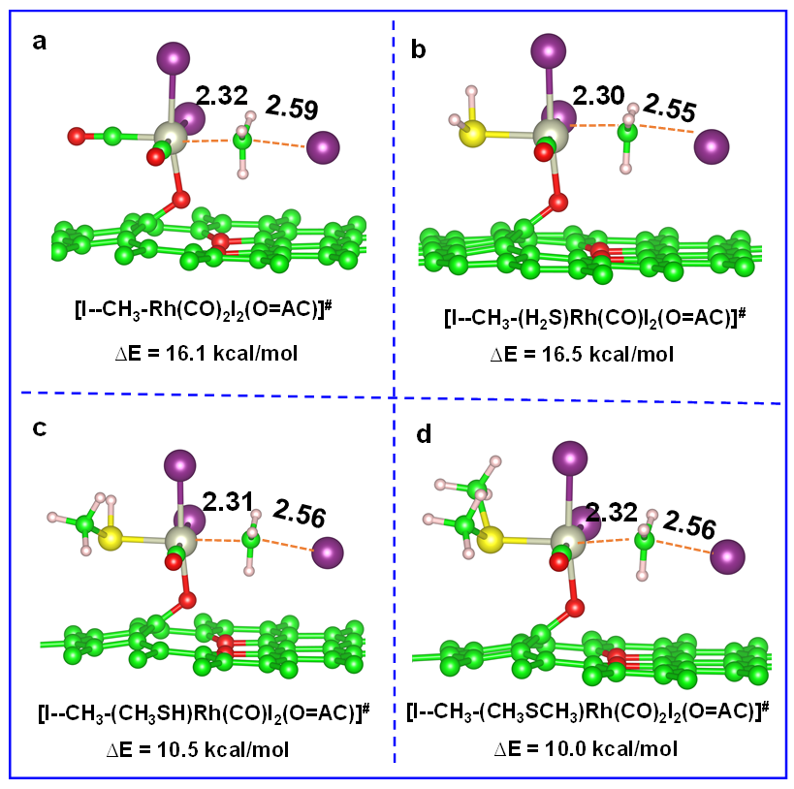

Extended Data Figure 18 ǀ DFT transition state calculation of Rh single nuclear complexes for CH₃I oxidative addtion. (a) [I--CH₃-Rh(CO)₂I₂(O=AC)]#, (b) [I--CH₃-(H₂S)Rh(CO)₂I₂(O=AC)]#, (c) [I--CH₃-(CH₃SH)Rh(CO)I₂(O=AC)]#, (d) [I--CH₃-(CH₃SCH₃)Rh(CO)I₂(O=AC)]#. The transition structure of [I--CH₃-(SR)Rh(CO)I₂(O=AC)] with H₂S coordination has a higher energy barrier of CH₃I oxidative addtion than that of CO, while those with CH₃SH or (CH₃)₂S ligands have a lower energy barrier of CH₃I oxidative addtion than that of CO, implying that the coordination of CH₃SH or (CH₃)₂S are beneficial to lower the energy barrier of CH₃I oxidative addition. Gray ball represents Rh atom; red ball represents O atom; purple ball represents I atom; yellow ball represents S atom; green ball represents C atom; pink ball represents H atom.

Extended Data Table 1 ǀ Effect of H₂S on the catalytic activity of supported Rh nanoparticles (Rh/AC) and single-site Rh (Rh₁/AC) catalyst

Catalysts | Conditions | Yield of products (%) | mole_{acetyl}/mole_{Rh}/h
Rh/AC | Normal feed ª | 6.5 | 64.9
Rh/AC | S-feed ª | 0.3 ↓ | 3.2 ↓
Rh₁/AC | Normal feed ª | 39.2 | 136.2
Rh₁/AC | S-feed ª | 68.8 ↑ | 215.2 ↑
Rh/AC | Normal feed ^{b} | 19.6 | 15.1
Rh/AC | S-feed ^{b} | 8.8 ↓ | 6.9 ↓
Rh₁/AC | Normal feed ^{b} | 37.7 | 9.4
Rh₁/AC | S-feed ^{b} | 56.7 ↑ | 14.2 ↑

ªAutoclave reactor, 0.22 g catalyst (Rh content = 1 wt.%), acetic acid (100 mmol), CH₃I (2.77 mmol) and ultra-pure water (30 mmol), 0.2 MPa ethylene, 1.0 MPa normal CO or CO containing 1000 ppm H₂S, 453 K, 1h for Rh/AC, 3h for Rh₁/AC. ^{b}Autoclave reactor, 0.3g catalysts (Rh content = 1wt.%), acetylene (4mmol), CH₃I (8mmol) and ultrapure water (500 mmol), 2.5 MPa normal CO or CO containing 1000ppm H₂S, 453 K, 1.5h for Rh/AC, 5h for Rh₁/AC.

Extended Data Table 2 ǀ Ex-situ EXAFS quantitative analysis of the paths of Rh-SR, Rh-CH₃, Rh-(O=AC), Rh-CO and Rh-I path contributions in the first shell of single-site Rh₁/AC catalyst in the normal feed and S-feed for methanol carbonylation according to Figure 1c.
Samples | Shell | N | R(Å) | σ²(10⁻³ Å²) | ΔE ₀(eV) | R-factor
RhI₃ | Rh-I | 6.0 | 2.7±0.0 | 4.2±0.2 | 0.1±0.1 | 0.003
Spent Rh₁/AC in normal feed | Rh-CO | 1.6±0.4 | 1.9±0.0 | 9.8 | 2.3±0.8 | 0.013
Spent Rh₁/AC in normal feed | Rh-(O=AC) | 1.0 | 2.1±0.0 | 3.0 | 2.3±0.8 | 0.013
Spent Rh₁/AC in normal feed | Rh-I | 2.7±0.2 | 2.7±0.2 | 3.0 | 2.3±0.8 | 0.013
Spent Rh₁/AC in S-feed | Rh-CO | 0.5±0.4 | 2.0±0.1 | 5.5 | 2.6±0.5 | 0.003
Spent Rh₁/AC in S-feed | Rh-(O=AC) | 1.0 | 2.1±0.1 | 3.0 | 2.6±0.5 | 0.003
Spent Rh₁/AC in S-feed | Rh-SR | 0.8±0.2 | 2.3±0.0 | 3.0 | 2.6±0.5 | 0.003
Spent Rh₁/AC in S-feed | Rh-I | 3.4±0.3 | 2.7±0.0 | 3.0±0.5 | 2.6±0.5 | 0.003

Standard Sample RhI₃, R range: 1.3–2.9 Å; k range: 2.4–14.4 Å⁻¹, k-weight=1, 2, 3. S₀²=0.80. Spent Rh₁/AC in normal feed, S₀²=0.80; R range: 1.2–3.2 Å; k range: 2.5–11.7 Å⁻¹, k-weight=1, 2, 3. Spent Rh₁/AC in S-feed, R range: 1.1–3.0 Å; k range: 2.4–13.1 Å⁻¹, k-weight =1, 2, 3.
N, coordination number; R, distance between absorber and backscatter; σ², Debye–Waller factor; ΔE₀, energy shift. Feff calculations: Single scattering, Rh-Rh, reference CIF: Rh Fm-3m COD 2100454, Reff=2.539 Å; Rh-CO, reference CIF: [C₄I₂O₄Rh₂] COD 2202025, Reff=1.854 Å; Rh-I, reference CIF: RhI₃ sm_isp_SD0541773, Reff=2.661 Å; Rh-O, first quick shell path, Reff=2.1 Å, according to the result of DFT calculation; Rh-S, Reference CIF: RhCl₃(SMe₂)₃ COD 2214350, Reff=2.335 Å.

Extended Data Table 3 ǀ The analysis result of XPS spectra in Extended Data Figure 7

Samples | Spent Rh₁/AC in normal feed |  |  | Spent Rh₁/AC  in S-feed |  |  | Spent Rh/CMK-3 in normal feed |  |  |  | Spent Rh/CMK-3 in S-feed
Samples | B. E. (eV) | Area % |  | B. E. (eV) | Area % |  | B. E. (eV) |  | Area % |  | B. E. (eV) |  | Area %
Rh⁰ | - |  | - | - |  | - |  | 306.8 |  | 25.4 |  | 307.8 |  | 51.3
Rh³⁺ | 309.0 |  | 68.5 | 309.0 |  | 63.8 |  | 308.7 |  | 43.8 |  | 309.2 |  | 24.8
Rh⁴⁺ | 311.5 |  | 31.5 | 311.8 |  | 36.2 |  | 310.5 |  | 30.8 |  | 310.7 |  | 23.9
CH₃-S-CH₃ | - |  | - | 162.8 |  | 56.2 |  | - |  | - |  | 162.9 |  | 34.9
CH₃-SH/Rh-S | - |  | - | 163.8 |  | 43.8 |  | - |  | - |  | 164.0 |  | 65.1

