Appendix Table 1. Features of the model
Type | Feature
Demographics | Age, Gender
Vital signs | Temperature, Respiration, Systolic and Diastolic BP, O2 Staturation, MAP, Heartrate
Laboratory measurements | BUN, Calcium, Chloride, Creatinine, CRP, Ferritin, Glucose, Bicarbonate, Hematocrit, Hemoglobin, INR, Magnesium, Phosphate, Platelets, Potassium, PTT, Sodium

Appendix Table 2. Performance metrics along with the 95th percentile Interval for the models trained on Sepsis-3, ASE and consensus label, given specificity of 0.8

Model | Performance metrics
Model Trained using Sepsis 3 Label | AUC: 0.881 [0.872,0.889]  SE: 0.805 [0.783,0.828]  SP: 0.800 ,  PPV: 0.480 [0.465, 0.494]  NPV: 0.947 [ 0.941, 0.953]
Model Trained using ASE | AUC: 0.883 [0.873, 0.893]  SE: 0.809 [0.785, 0.831]  SP: 0.800  PPV: 0.349 [0.334, 0.365]  NPV: 0.971 [0.966, 0.973]
Model Inference using Sepsis 3 and ASE consensus | AUC: 0.9000 [0.891, 0.909]  SE: 0.837 [0.814, 0.860]  SP: 0.800  PPV: 0.359 [0.343, 0.374]  NPV: 0.973 [0.969, 0.977]

Appendix Table 3.
604 patients get a culture order after the first 24 hours, of which 41% have Sepsis. For these 604 patients, we compute the performance of the model based on the labs in the first 24 hours, i.e., before the hospital suspects Sepsis or orders culture. To compare to the hospital performance, we choose an operating point such that it has the same precision as the Hospital decision, i.e. 41%. At this operating point, the model can identify 88% of people with sepsis within the first 24 hours.

(a)
Model prediction | Ground truth concordant Sepsis label
Model prediction | False | True
False | 283 | 17
True | 178 | 226

(b)
Model performance in identifying patients with delayed culture order | AUC: 0.84  SE: 0.88  SP: 0.61  PPV: 0.41  NPV: 0.94

Appendix Table 4. Sepsis codes

SEPSIS | ICD-9 | ICD-10
Sepsis | 995.91/995.92 | A26.7/A41.9/A42.7
Septicemia | 038/038.3/038.8/038.9/054.5/449 | A41.4/A41.8/A41.9/A42.7/B00.7
Septic shock | 785.52 | nan
Gram positive septicemia | 022.3/038.1/038.10/038.11/038.12/038.19/038.2 | A22.7/A40.3/A41.0/A41.1/A41.2
Gram negative septicemia | 003.1/020.2/036.2/038.0/038.4/038.40/038.41/038.42/038.43/038.44/038.49 | A02.1/A20.7/A39.2/A39.3/A39.4/A40/A40.0/A40.1/A40.2/A40.8/A40.9/A41.3/A41.5

Appendix Table 5. Billing codes for underlying kidney disease

Underling Kidney Disease | ICD-9 | ICD-10
Hypertensive chronic kidney disease | 403/403.0/403.00/403.01/403.1/403.10/403.11/403.9/403.90/403.91 | I12/I12.0/I12.9
Kidney replaced by transpant | 996.81/V42.0 | Z94.0
End stage renal disease | 585.5/585.6 | nan
Renal dialysis | 792.5/996.73/E870.2/E871.2/E872.2/E874.2/E879.1/V45.1/V45.11/V45.12/V56/V56.0/V56.1/V56.2/V56.31/V56.32/V56.8 | Y60.2/Y61.2/Y62.0/Y84.1/Z49.1/Z49.2/Z99.2
Chronic Kidney Disease, Stage III | 585.3 | nan
Chronic renal failure [CKD] | 585/585.0/585.9 | N18/N18.0/N18.9
Hypertensive heart and/or renal disease | 404/404.0/404.00/404.01/404.02/404.03/404.1/404.10/404.11/404.12/404.13/404.9/404.90/404.91/404.92/404.93 | I13/I13.0/I13.1/I13.2/I13.9
Chronic Kidney Disease, Stage IV | 585.4 | nan
Cystic kidney disease | 753.1/753.10/753.11/753.12/753.13/753.14/753.15/753.16/753.17/753.19 | Q61/Q61.0/Q61.1/Q61.2/Q61.3/Q61.4/Q61.5/Q61.8/Q61.9

Appendix Table 6. Billing codes for hemorrhage/coagulation conditions
Hemorrhage/Coagulation disorder | ICD-9 | ICD-10
Acute posthemorrhagic anemia | 285.1 | D62
Acquired coagulation factor deficiency | 286.7 | D68.4
Myeloid leukemia, acute | 205.0/205.00/205.01/205.02 | C92.0/C92.4/C92.5/D46.3
Hemorrhage of gastrointestinal tract | 578.9 | K92.2
Hemorrhage or hematoma complicating a procedure | 958.2/998.1/998.11/998.12/998.13 | T81.0
Esophageal bleeding (varices/hemorrhage) | 456.0/456.1/456.2/456.20/456.21/530.82 | I85/I85.0/I85.9/I98.2/K22.8
Secondary malignancy of lymph nodes | 196/196.0/196.1/196.2/196.3/196.5/196.6/196.8/196.9/209.71 | C77/C77.0/C77.1/C77.2/C77.3/C77.4/C77.5/C77.8/C77.9
Splenomegaly | 789.2 | R16/R16.1/R16.2

Appendix Table 7. Billing codes for underlying liver disease
Underlying Liver condition | ICD-9 | ICD-10
Malignant neoplasm of liver, primary | 155.0/V10.07 | C22.0/C22.2/C22.3/C22.4/C22.7
Cirrhosis of liver without mention of alcohol | 571.5 | K74.0/K74.6
Secondary malignant neoplasm of liver | 197.7/209.72 | C78.7
Malignant neoplasm of gallbladder and extrahepatic bile ducts | 156/156.0/156.1/156.2/156.8/156.9 | C23/C24/C24.0/C24.1/C24.8/C24.9

Appendix Table 8. Billing codes for infection
INFECTION | ICD-9 | ICD-10
Pneumonia | 130.4/483/483.8/484/484.8/486/V12.61 | B58.3/J10.0/J11.0/J16.8/J17.2/J18/J18.8/J18.9
Bacterial pneumonia | 003.22/020.3/020.4/020.5/021.2/022.1/031.0/039.1/073.0/083.0/482/482.0/482.2/482.3/482.30/482.31/482.32/482.39/482.4/482.40/482.42/482.49/482.8/482.81/482.82/482.83/482.84/482.89/482.9/483.0/483.1/484.3/484.5 | A20.2/A21.2/A22.1/A31.0/A42.0/A43.0/A48.1/A78/B96.0/B96.1/J14/J15.0/J15.2/J15.3/J15.4/J15.5/J15.6/J15.7/J15.8/J15.9/J16.0
Candidiasis | 112/112.0/112.1/112.2/112.5/112.8/112.82/112.84/112.85/112.89/112.9 | B20.4/B37/B37.0/B37.3/B37.4/B37.7/B37.8/B37.9
Streptococcus infection | 034/034.1/041.0/041.00/041.01/041.02/041.03/041.04/041.05/041.09 | A38/A40.1/A40.2/A49.1/B95.0/B95.1/B95.2/B95.3/B95.4/B95.5/J03.0/J20.2/M00.2
MRSA pneumonia | 482.41 | nan
Postoperative infection | 519.01/530.86/536.41/998.5/998.51/998.59/999.3/999.39 | N98.0/T81.4/T88.0
Pseudomonal pneumonia | 482.1 | J15.1
Bacterial infection NOS | 020/020.0/020.8/020.9/021/021.8/021.9/022/022.8/022.9/023/023.0/023.1/023.2/023.3/023.8/023.9/024/025/026/026.0/026.9/027/027.0/027.1/027.2/027.8/027.9/032/032.8/032.89/032.9/033/033.0/033.1/033.8/033.9/036/036.3/036.8/036.81/036.89/036.9/037/039/039.2/039.3/039.4/039.8/039.9/040/040.0/040.1/040.2/040.3/040.4/040.42/040.8/040.81/040.82/040.89/041/041.2/041.3/041.5/041.6/041.7/041.8/041.81/041.82/041.83/041.84/041.85/041.89/041.9/795.31 | A15.9/A20/A20.0/A20.3/A20.8/A20.9/A21/A21.7/A21.8/A21.9/A22/A22.8/A22.9/A23/A23.0/A23.1/A23.2/A23.3/A23.8/A23.9/A24/A24.0/A24.1/A24.2/A24.3/A24.4/A25/A25.0/A25.9/A26/A26.0/A26.7/A26.8/A26.9/A28.0/A28.2/A28.8/A28.9/A32/A32.0/A32.1/A32.7/A32.8/A32.9/A35/A36/A36.8/A36.9/A37/A37.0/A37.1/A37.9/A39/A39.1/A39.8/A39.9/A42/A42.1/A42.2/A42.8/A42.9/A43/A43.8/A43.9/A48.0/A48.2/A48.3/A48.4/A48.8/A49/A49.2/A49.3/A49.8/A49.9/B47/B47.1/B47.9/B96.3/B96.4/B96.5/B96.6/B96.7/B96.8/J20.0/J20.1/M00.1
Infection/inflammation of internal prosthetic device; implant; and graft | 996.6/996.60/996.61/996.62/996.63/996.64/996.65/996.66/996.67/996.68/996.69/999.31 | T82.6/T83.5/T83.6/T84.6/T84.7/T85.7
Other CNS infection and poliomyelitis | 045/045.0/045.00/045.01/045.02/045.03/045.1/045.10/045.11/045.12/045.13/045.2/045.20/045.21/045.22/045.23/045.9/045.90/045.91/045.92/045.93/046/046.0/046.3/046.7/046.71/046.72/046.79/046.8/046.9/048/048.0/049/138/138.0/324/324.0/324.1/324.9/326/V12.02/V12.42 | A80/A80.0/A80.1/A80.2/A80.3/A80.4/A80.9/A81/A81.2/A81.8/A81.9/A88.0/B91/G06/G06.0/G06.1/G06.2/G07/G09/I67.3
Intestinal infection due to C. difficile | 8.45 | A04.7
Infective connective tissue disorders | 567.31/710.5/728.0/728.86 | M60.0
Pneumococcal pneumonia | 481/481.0 | J13/J18.1
Bronchopneumonia and lung abscess | 485/485.0/513/513.0/513.1/517.1 | J18.0/J85/J85.0/J85.1/J85.2/J85.3
Mycoses | 117/117.0/117.1/117.2/117.4/117.5/117.6/117.7/117.8/117.9/118 | B42/B42.0/B42.1/B42.7/B42.8/B42.9/B43.0/B43.1/B43.2/B43.8/B43.9/B45/B45.0/B45.2/B45.3/B45.7/B45.8/B45.9/B46/B46.0/B46.1/B46.2/B46.3/B46.4/B46.5/B46.8/B46.9/B47.0/B48.1/B48.2/B48.3/B48.7/B48.8/B49/G02.1/J17.2
Aspergillosis | 117.3/518.6 | B44/B44.0/B44.1/B44.2/B44.7/B44.8/B44.9/B48.4
Acute upper respiratory infections of multiple or unspecified sites | 032.0/032.1/032.2/032.3/034.0/460/464.3/464.30/464.31/464.5/464.50/464.51/465/465.0/465.8/465.9 | A36.0/A36.1/A36.2/J00/J02.0/J03.0/J05.1/J06/J06.0/J06.8/J06.9
Viral Enteritis | 008.6/008.61/008.62/008.63/008.64/008.65/008.66/008.67/008.69/008.8 | A08/A08.0/A08.1/A08.2/A08.3/A08.4/A08.5
Infection with drug-resistant microorganisms | V09/V09.0/V09.1/V09.2/V09.3/V09.4/V09.5/V09.50/V09.51/V09.6/V09.7/V09.70/V09.71/V09.8/V09.80/V09.81/V09.9/V09.90/V09.91 | nan
Pneumonia due to fungus (mycoses) | 112.4/114.0/114.4/114.5/136.3/484.6/484.7 | B20.6/B37.1/B38.0/B38.1/B38.2/B44.0/B59/J17
Methicillin sensitive Staphylococcus aureus | 41.11 | nan
Staphylococcus infections | 041.1/041.10/041.19 | A49.0/B95.6/B95.7/B95.8/M00.0
Herpes simplex | 054/054.0/054.1/054.10/054.11/054.12/054.13/054.19/054.2/054.6/054.7/054.71/054.73/054.74/054.79/054.8/054.9/058/058.1/058.10/058.11/058.12/058.8/058.81/058.82/058.89 | A60/A60.0/A60.1/A60.9/B00/B00.0/B00.1/B00.2/B00.8/B00.9/B08.2
Candidiasis of skin and nails | 112.3 | B37.2
Methicillin resistant Staphylococcus aureus | 041.12/V12.04 | nan
Influenza | 487/487.0/487.1/487.8/488/488.0/488.01/488.02/488.09/488.1/488.11/488.12/488.19/488.81/488.82/488.89 | J10.0/J10.1/J10.8/J11.0/J11.1/J11.8
Viral infection | 050/050.0/050.1/050.2/050.9/051/051.0/051.01/051.02/051.1/051.2/051.9/055/055.7/055.79/055.8/055.9/056/056.0/056.00/056.09/056.7/056.79/056.8/056.9/057/057.0/057.8/057.9/059/059.0/059.00/059.01/059.09/059.1/059.10/059.11/059.12/059.19/059.2/059.20/059.21/059.22/059.8/059.9/060/060.0/060.1/060.9/061/065/065.0/065.1/065.2/065.3/065.4/065.8/065.9/066/066.0/066.1/066.3/066.4/066.40/066.41/066.42/066.49/066.8/066.9/071/072/072.0/072.3/072.7/072.71/072.72/072.79/072.8/072.9/073/073.7/073.8/073.9/074/074.0/074.1/074.3/074.8/078/078.0/078.2/078.3/078.4/078.5/078.6/078.7/078.8/078.81/078.82/078.88/078.89/079/079.0/079.1/079.2/079.3/079.5/079.50/079.51/079.52/079.59/079.6/079.8/079.81/079.82/079.83/079.88/079.89/079.9/079.98/079.99/999.0 | A28.1/A70/A74/A74.8/A74.9/A82/A82.0/A82.1/A82.9/A88.1/A90/A91/A92/A92.0/A92.1/A92.3/A92.4/A92.8/A92.9/A93/A93.0/A93.1/A93.2/A93.8/A94/A95/A95.0/A95.1/A95.9/A96/A96.0/A96.1/A96.2/A96.8/A96.9/A98/A98.0/A98.1/A98.2/A98.3/A98.4/A98.5/A98.8/A99/B00.8/B03/B04/B05/B05.1/B05.4/B05.8/B05.9/B06/B06.0/B06.8/B06.9/B08.0/B08.1/B08.3/B08.4/B08.5/B08.8/B09/B20.2/B23.0/B25/B25.2/B25.8/B25.9/B26/B26.0/B26.3/B26.8/B26.9/B33.0/B33.1/B33.3/B33.8/B34/B34.0/B34.1/B34.2/B34.3/B34.4/B34.8/B34.9/B97.0/B97.1/B97.3/B97.4/B97.5/B97.6/B97.7/B97.8/H81.2/J20.3/J20.4/J20.5/J20.6/J20.7/K67.0/L44.4
Other infectious and parasitic diseases | 080/081/081.0/081.1/081.2/081.9/082/082.0/082.1/082.2/082.3/082.4/082.40/082.41/082.49/082.8/082.9/083/083.1/083.2/083.8/083.9/134.2/136/136.0/136.2/136.21/136.29/136.4/136.5/136.8/136.9/139/139.8/V12.0/V12.00/V12.09 | A75/A75.0/A75.1/A75.2/A75.3/A75.9/A77/A77.0/A77.1/A77.2/A77.3/A77.8/A77.9/A79/A79.0/A79.1/A79.8/A79.9/B20.7/B23.0/B60.1/B60.2/B60.8/B64/B83.4/B88.3/B89/B92/B94.2/B94.8/B94.9/B99/J17.3/L94.6/T61.1
Dermatophytosis | 110.0/110.2/110.6/110.8/110.9 | B35/B35.0/B35.2/B35.8/B35.9/B36.9
Althete's foot | 110.4 | B35.3

Appendix Figure 1. SHAP analysis for Sepsis-3 model
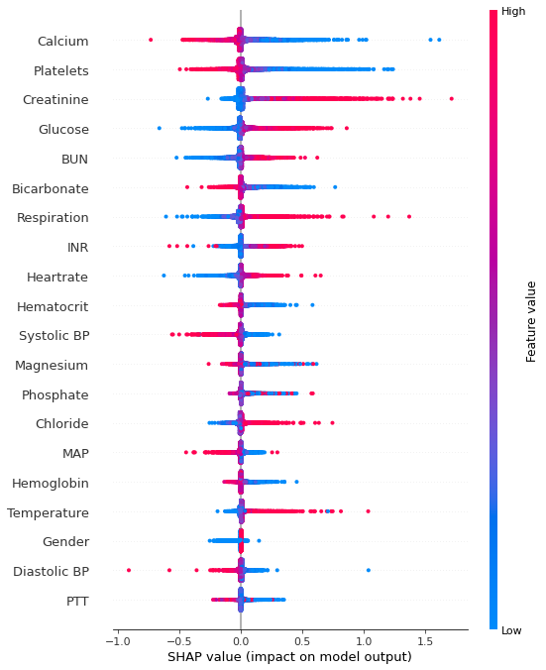

Appendix Figure 2. SHAP analysis for ASE model

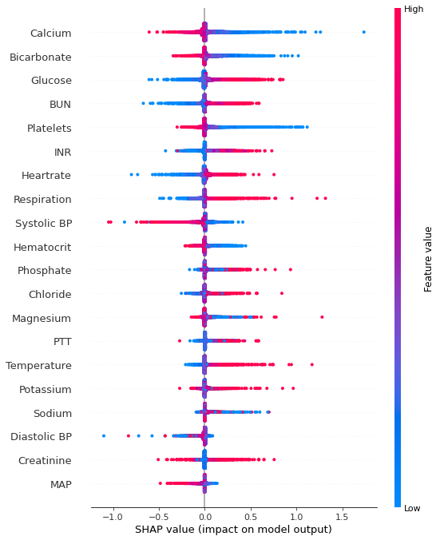

Appendix Figure 3. Model Architecture

