Table S 1: Average composition of citrus peel waste (Bustamante et al., 2016; Negro et al., 2016; Pourbafrani et al., 2007)
Component | Wt%
Water | 82
Cellulose | 3.6
Pectin | 4.3
Hemicellulose | 1.9
Protein | 1.1
Lignin | 0.4
Flavonoids | 0.8
Ash | 0.6
Limonene | 0.6
Other essential oils | 0.1
Glucose | 1.4
Fructose | 2.1
Sucrose | 0.5
Rhamnose | 0.1
Arabinose | 0.2
Xylose | 0.1
Mannose | 0.1
Galactose | 0.1

Table S 2: Composition of olive, coconut, and waste cooking oil. (Cárdenas et al., 2021; Mannu et al., 2019)
Triglyceride | Carbon number of fatty acid in triglyceride | Wt%
Triglyceride | Carbon number of fatty acid in triglyceride | Olive oil | Coconut oil | Waste cooking oil
Glyceryl trihexanoate | 6:0 |  | 0.5
Glyceryl tricaprylate | 8:0 |  | 8
Glyceryl tricaproate | 10:0 |  | 7
Glyceryl trilaurate | 12:0 |  | 48
Glyceryl trimyristate | 14:0 |  | 18
Glyceryl tripalmitate | 16:0 | 18 | 9 | 9.3
Glyceryl tripalmitolein | 16:1 | 2 |  | 0.56
Glyceryl tristearate | 18:0 | 3 | 3 | 2.6
Glyceryl trioleate | 18.:1 | 57 | 7 | 48
Glyceryl trilinoleate | 18:2 | 19 | 2 | 31
Trilinoline | 18:3 | 0.8 |  | 2.9
Glyceryl triarachidate | 20:0 | 0.2 | 0.1

Table S 3: Saponification values for olive oil, WCO, treated WCO and coconut oil.
Oil | Saponification value (mg KOH/g oil)
Olive (OL) | 185.7 ± 4.3
Waste cooking oil (WCO) | 194.0 ± 8.5
Treated wasted cooking oil (TWO) | 200.3 ± 13.5
Coconut oil | 267.0 ± 6.7

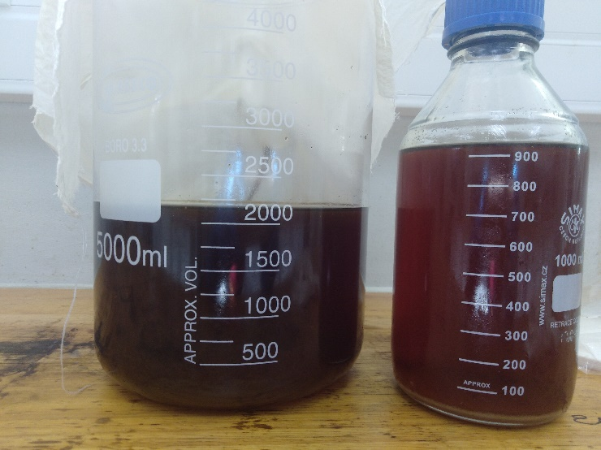
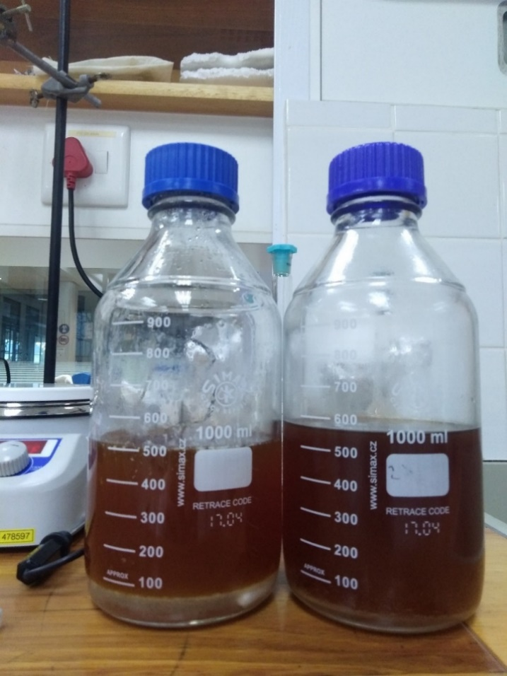
Fig. S 1: Results of waste cooking oil pre-treatment experiments. (A): filtered waste cooking oil (left) alongside washed waste cooking oil (right). (B): washed waste cooking oil (left) alongside bleached waste cooking oil (right).
a)
b)

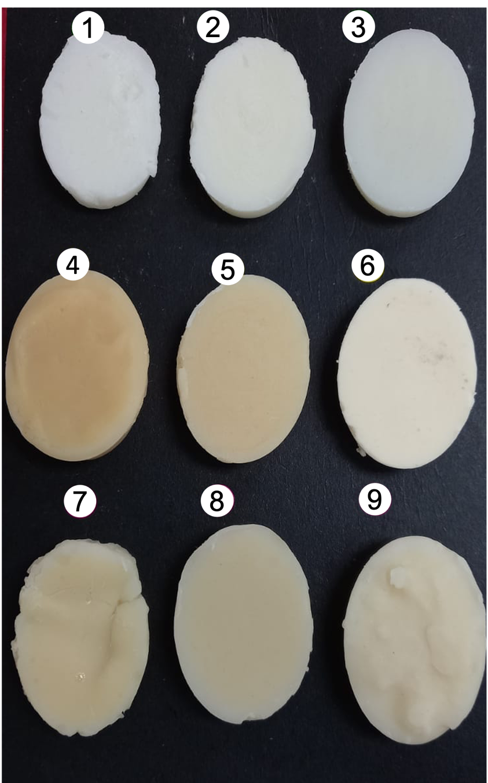
Fig. S 2: Soaps produced in first (left), second (middle), and third (right) runs of cold saponification reactions. R1 – olive oil samples; R2 – waste cooking oil samples; R3 – treated waste cooking oil samples. C1 – 78% soft oil; C2 – 62% soft oil; C3 – 47% soft oil. R stands for row and C for column.

Fig. S 3: Average pH values of formulated soaps after 4 weeks of curing. Green bars represent olive oil (OL) formulations; yellow bars are filtered waste cooking oil (WCO) formulations; blue bars are treated waste cooking oil formulations (TWCO). Dashed bars represent samples containing D-Limonene.

Fig. S 4: Average moisture content of formulated soaps after 4 weeks of curing. Green bars represent olive oil (OL) formulations; yellow bars are filtered waste cooking oil (WCO) formulations; blue bars are treated waste cooking oil formulations (TWCO). Dashed bars represent samples containing D-Limonene.

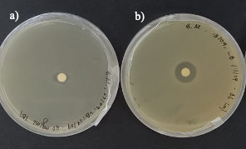
Fig. S 5: Comparison of inhibition zones of a) treated waste cooking oil soap at 40 mg/ml and b) D-Limonene against E.coli.

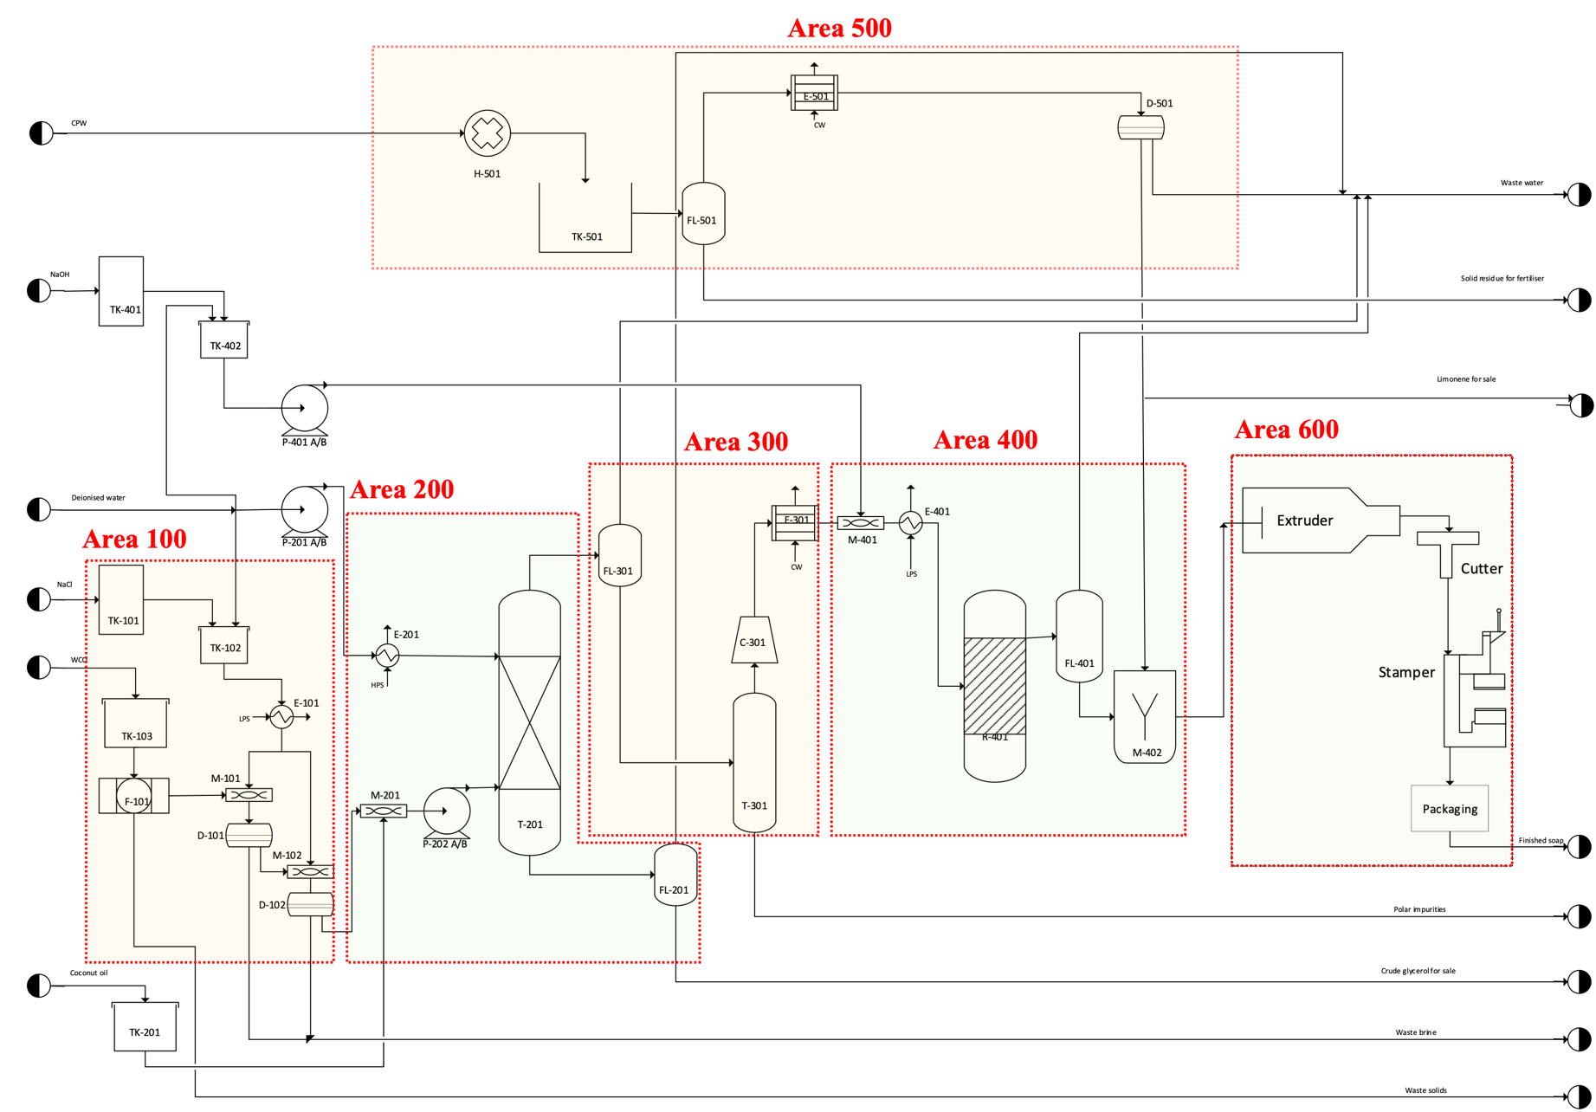
Fig. S 6: Process flow diagram of soap production plant using WCO and CPW as raw feed. Area 100 - WCO oil treatment, Area 200 - Oil hydrolysis and crude glycerol removal, Area 300 - Fatty acid drying and distillation, Area 400 - Fatty acid neutralisation, Area 500 - D-Limonene extraction from CPW and Area 600 – Soap finishing

