Supplementary information for:
The Epitaxy of 2D materials growth
Jichen Dong¹, Feng Ding^{1,2,*}

¹ Centre for Multidimensional Carbon Materials, Institute for Basic Science, Ulsan 44919, Korea
² School of Materials Science and Engineering, Ulsan National Institute of Science and Technology, Ulsan 44919, Korea
* Email: f.ding@unist.ac.kr

Contents
- Atomic models for density functional theory calculations
- Experimental observation of alignment of 2D materials on various substrates

1 Atomic models used in density functional theory calculations
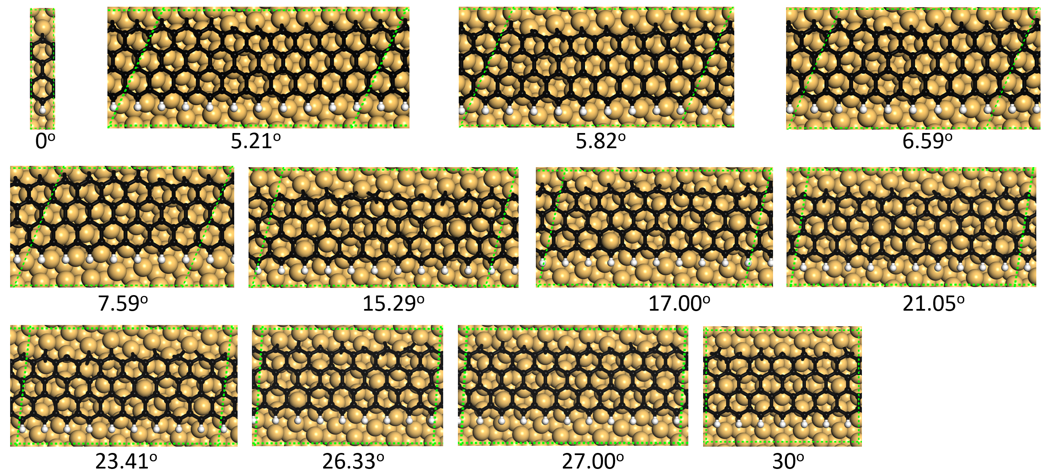
Figure S1 Structures for calculating the binding energy of a graphene ZZ edge to the Cu(111) surface. The angle between the graphene ZZ edge and the <110> crystallographic direction of the Cu substrate is given for each structure. The unit cell of each structure is denoted by green dashed rhomb.

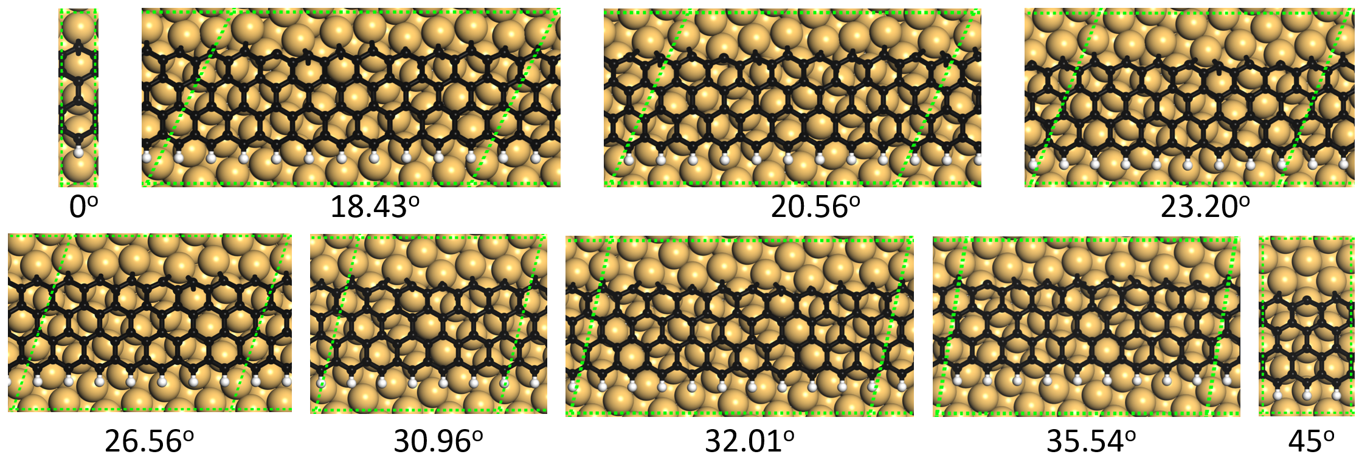
Figure S2 Structures for calculating the binding energy of graphene ZZ edge to Cu(100) surface. The angle between graphene ZZ edge and the <110> crystallographic direction of the Cu substrate is given for each structure. The unit cell of each structure is denoted by green dashed rhomb.

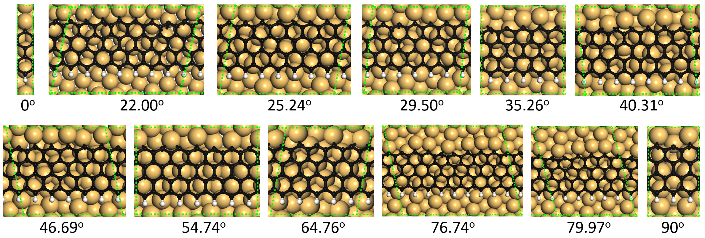
Figure S3 Structures for calculating the binding energy of graphene ZZ edge to Cu(110) surface. The angle between the graphene ZZ edge and the <110> crystallographic direction of the Cu substrate is given for each structure. The unit cell of each structure is denoted by green dashed rhomb.

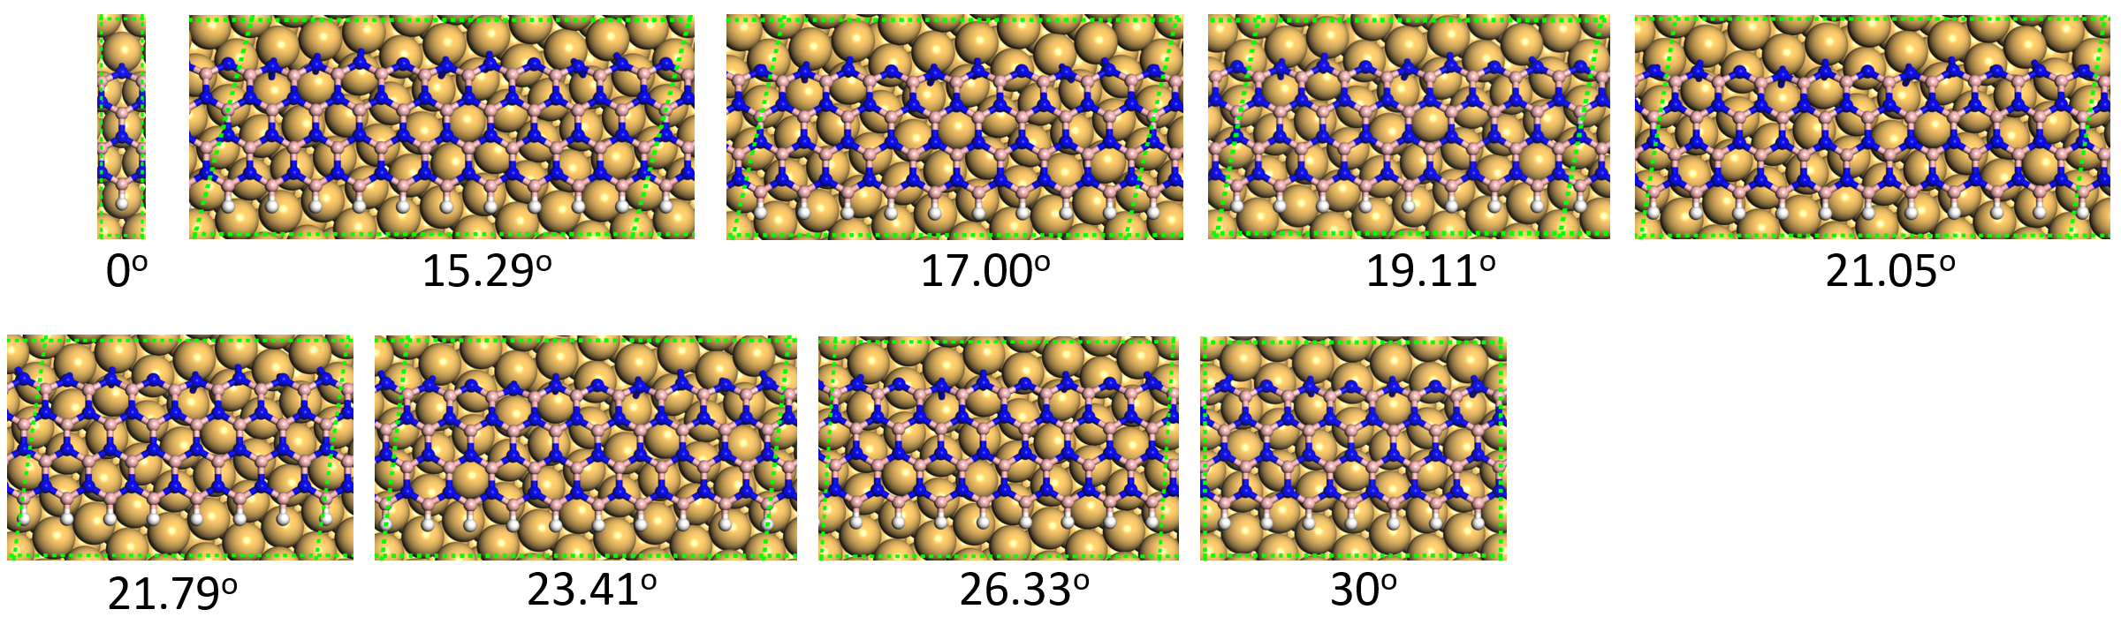
Figure S4 Structures for calculating the binding energy of hBN ZZN edge to Cu(111) surface. The angle between the hBN ZZ edge and the <110> crystallographic direction of the Cu substrate is given for each structure. The unit cell of each structure is denoted by green dashed rhomb.

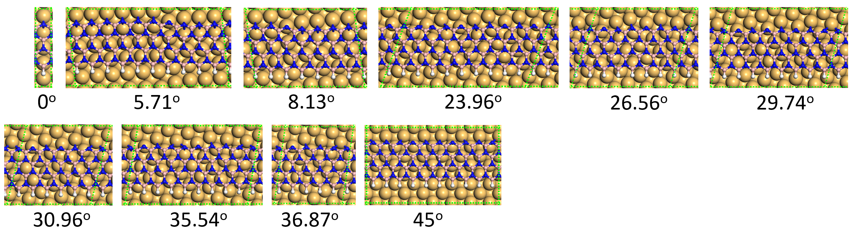
Figure S5 Structures for calculating the binding energy of hBN ZZN edge to Cu(100) surface. The angle between the hBN ZZ edge and the <110> crystallographic direction of the Cu substrate is given for each structure. The unit cell of each structure is denoted by green dashed rhomb.
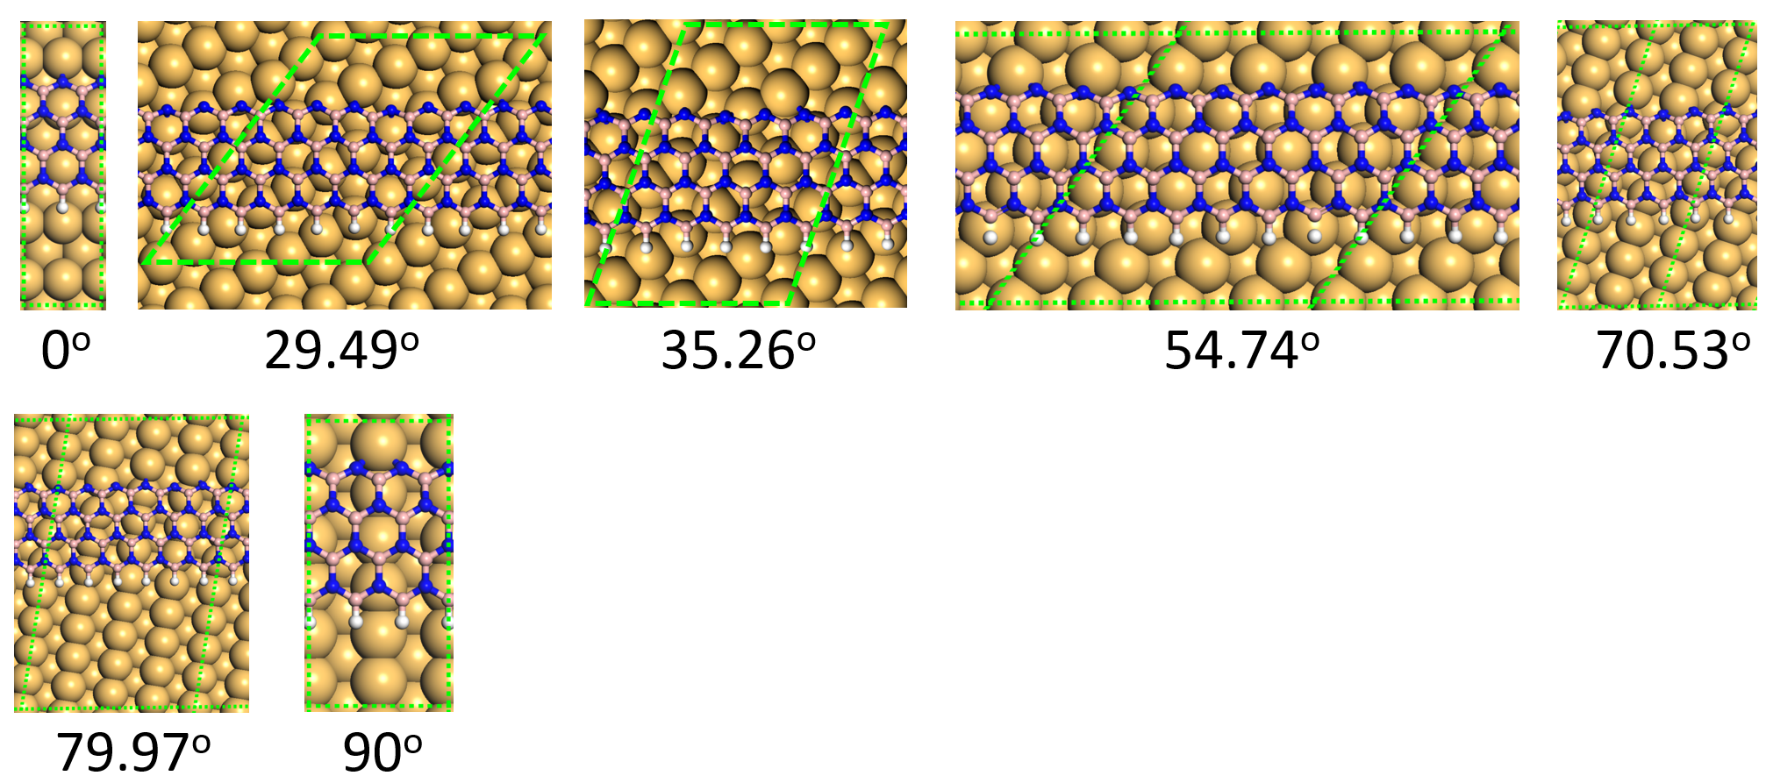
Figure S6 Structures for calculating the binding energy of hBN ZZN edge to Cu(110) surface. The angle between the hBN ZZ edge and the <110> crystallographic direction of the Cu substrate is given for each structure. The unit cell of each structure is denoted by green dashed rhomb.

2 Experimental observation of various 2D materials epitaxial growth on various substrates and the comparison with theoretical predictions.
Table S1 shows the experimentally observed alignments of graphene on various low-index Cu surfaces. In perfect agreement with above theoretical predictions, the number of non-alignments of graphene islands on Cu(111), Cu(100) and Cu(110) are 1, 2, 1 respectively, which have been clearly seen in a large number of experiments. The misalignment of the two types of graphene domains on the Cu(100) surface with a 30 degree misorientation angle has been observed ^{1,2}. Besides, the alignment of graphene ZZ edge along the Cu<110> direction has also been confirmed ^{1,2,3}.
Table S2 shows the experimental observations of hBN on various Cu surfaces. As the theoretical analyses shown in Fig. 3, antiparallelly aligned triangular hBN grains on both Cu(111) and Cu(110) surfaces and the four different orientations of triangular hBN grains on Cu(100) surface have been clearly seen^{4,5,6,7}. The alignment of ZZN edge of hBN domains along the <110> direction of the substrate has been shown in many experimental observations as well^{4,5,6} .
Table S3 presents a summary of the epitaxial grown TMDCs on various substrates, including both metallic Au surface and the nonmetallic substrates. Most TMDCs have a C_{3V} symmetry as hBN and the predicted alignment of a TMDC on a substrate are exactly same as that of hBN. Antiparallel domains of TMDCs on the six-fold symmetric Au(111)⁸, Al₂O₃ ^{9,10,11}and GaN(0001) surfaces ¹² are clearly seen; the unidirectionally aligned WS₂ islands were observed to grown on a C_{3V} symmetric hBN surface ¹³.
The unidirectional alignment of hBN on high index Cu surface have been observed (Table S4). Very recently, Liu and Chen et al. successfully synthesized large-sized single crystalline h-BN on a vicinal Cu(110) and Cu(111) surface, respectively, where all the triangular h-BN grains are unidirectionally aligned ^{14,15}. Guo and Wang at al. also observed unidirectionally aligned hBN grains grown on many vicinal Cu(110) surfaces ^{16,17}. Moreover, unidirectionally aligned WSe₂ islands have also been observed on a vicinal Al₂O₃(0001) surface with parallel step edges ¹⁸. Centimeter scale single crystalline MoS₂ has been obtained by seamless coalescence of unidirectionally aligned MoS₂ grains grown on a vicinal Au(111) surface¹⁹. These studies strongly validate our theoretical analysis that using substrates with a high-index surface and a low symmetry might be a new direction on synthesizing large-sized single crystalline 2D materials.

Table S1 Alignment of graphene on low-index Cu surfaces. N represents the number of alignments and θ represents the misorientation angle of graphene grains, respectively. ZZ represents the zigzag edge of graphene. In which, ZZ//Cu(110) represents the zigzag edge of graphene parallel to a Cu<110> direction of the Cu surface and etc.
2D Material | Substrate type | Experimental Observations |  |  |  | Ref. | Theoretical Predictions
2D Material | Substrate type | Graphene  Alignment | N | θ | Figures | Ref. | Graphene  Alignment | N | θ
Graphene  (C_{6V}) | Cu(111)  (C_{6V}) | ZZ//Cu<110> | 1 | 0º | 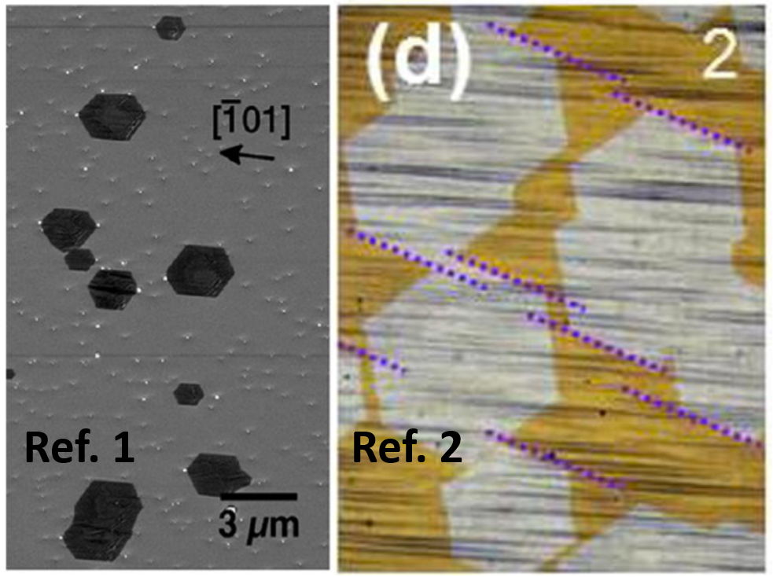 | 1,2,3 | ZZ//Cu<110> | 1 | 0º
Graphene  (C_{6V}) | Cu(110)  (C_{2V}) | ZZ//Cu<110> | 1 | 0º | 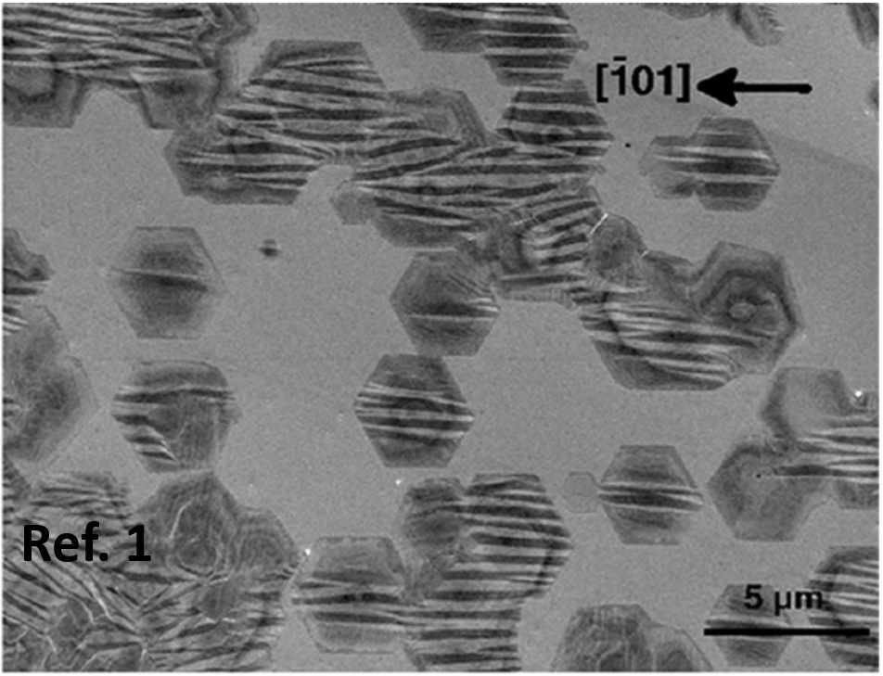 | 1 | ZZ//Cu<110> | 1 | 0º
Graphene  (C_{6V}) | Cu(100)  (C_{4V}) | ZZ//Cu<110> | 2 | 30º | 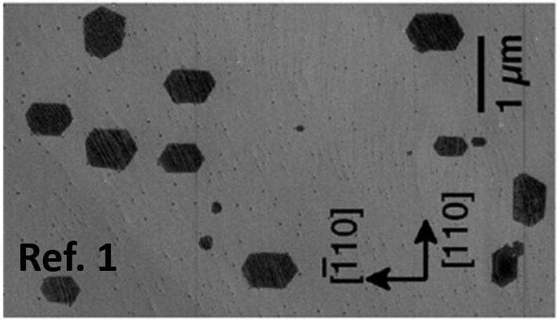 | 1,2 | ZZ//Cu<110> | 2 | 30º

Table S2 Alignment of hBN on low-index Cu surfaces. N represents the number of alignments and θ represents the misorientation angle of hBN grains, respectively. ZZ represents the zigzag edge of hBN.
2D Material | Substrate  type | Experimental Observation |  |  |  | Ref. | Theoretical Prediction
2D Material | Substrate  type | hBN  Alignment | N | θ | Figures | Ref. | hBN  Alignment | N | θ
hBN  (C_{3V}) | Cu(111)  (C_{6V}) | ZZ //Cu<110> | 2 | 60º | 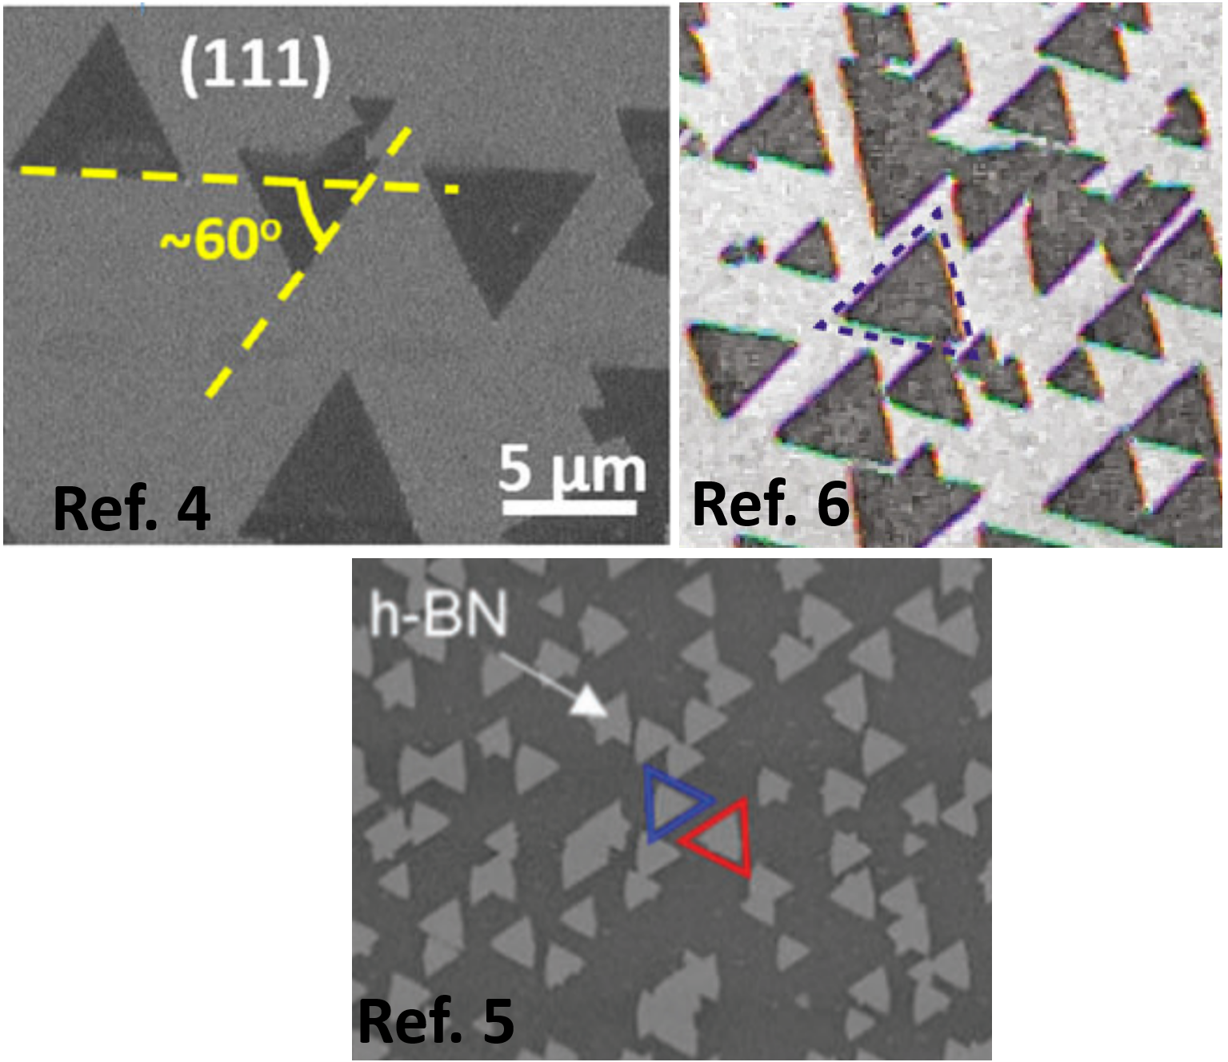 | 4,5,6 | ZZ //Cu<110> | 2 | 60º
hBN  (C_{3V}) | Cu(110)  (C_{2V}) | N/A | 2 | 60º | 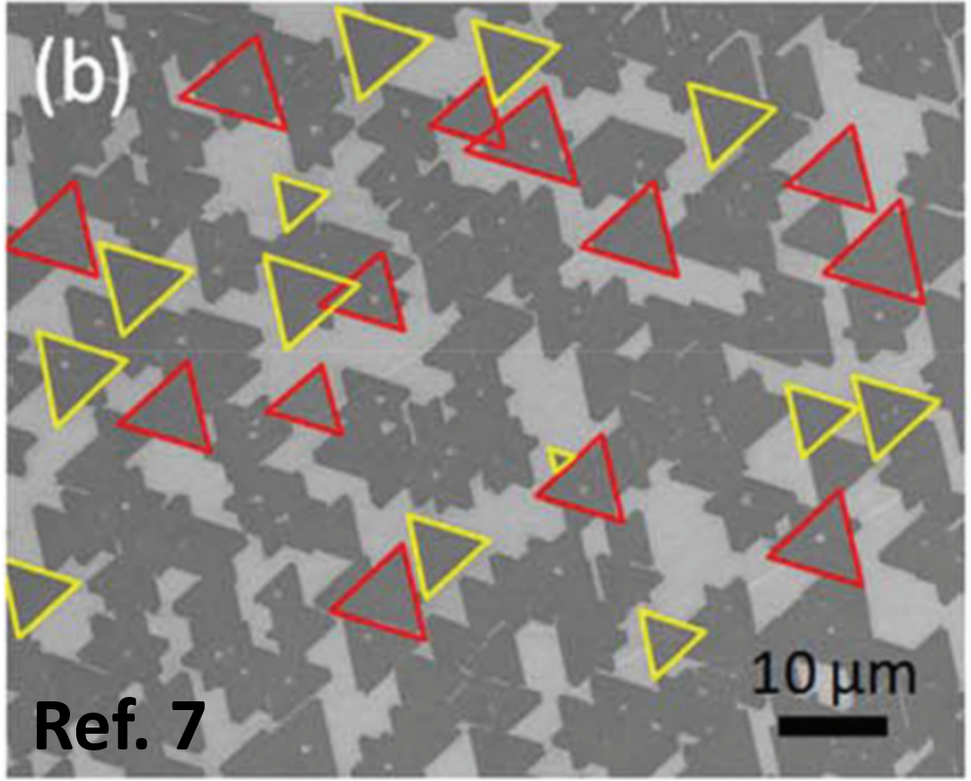 | 7 | ZZ //Cu<110> | 2 | 60º
hBN  (C_{3V}) | Cu(100)  (C_{4V}) | ZZ //Cu<110> | 4 | 30º, 60º and 90º | 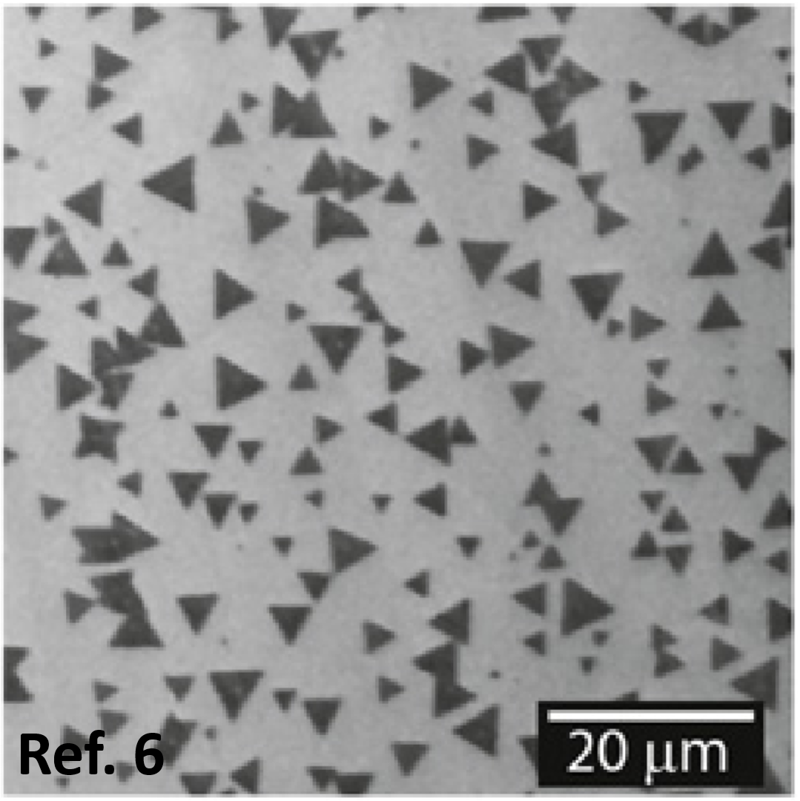 | 6 | ZZ //Cu<110> | 4 | 30º, 60º and 90º
hBN  (C_{3V}) | Cu(100)  (C_{4V}) | N/A | 4 | 30º, 60º and 90º | 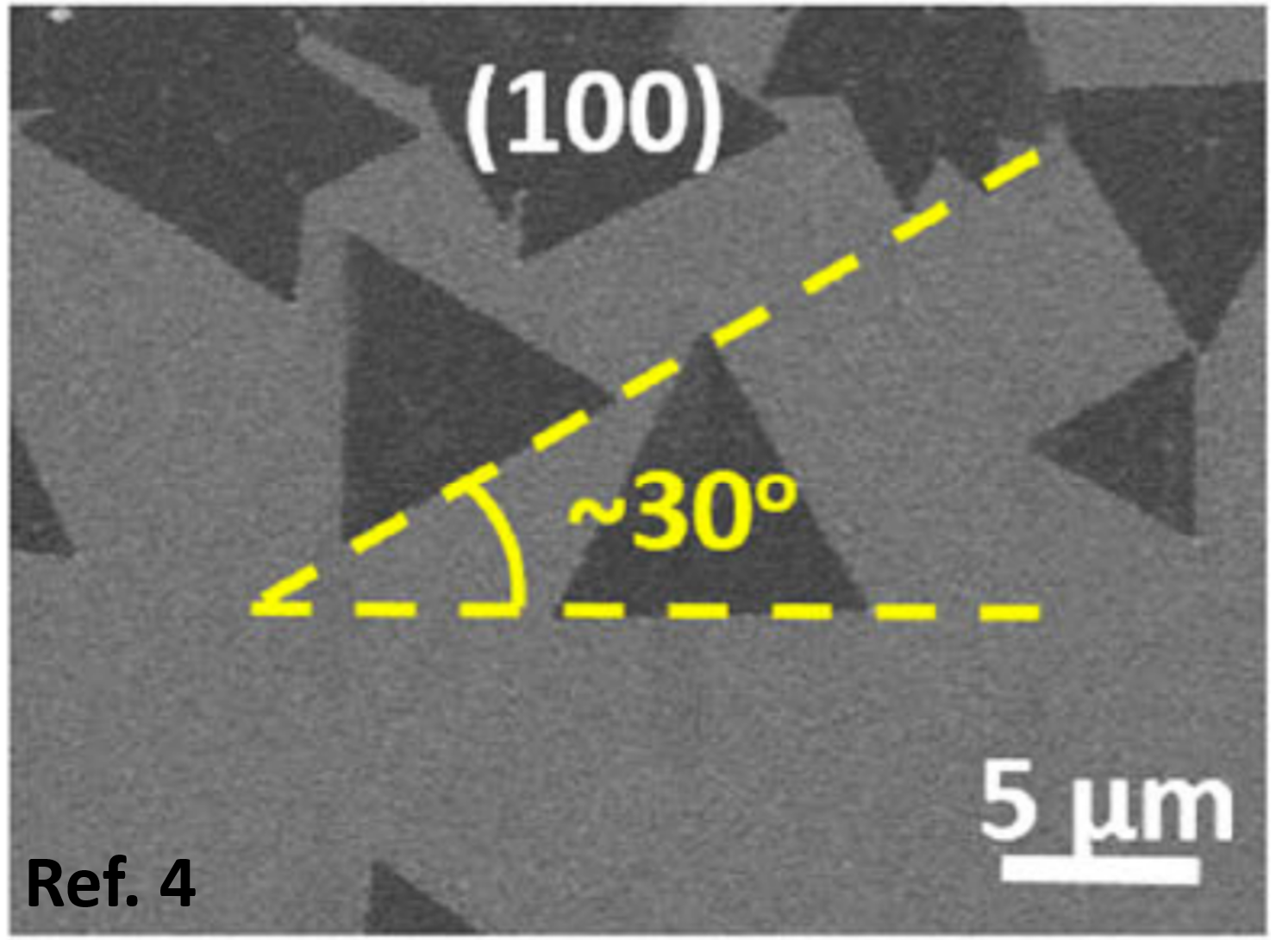 | 4 | ZZ //Cu<110> | 4 | 30º, 60º and 90º

Table S3 Alignment of TMDCs on low-index substrate surfaces. N represents the number of alignments and θ represents the misorientation angle of TMDC grains, respectively. ZZ represents the zigzag edge of TMDCs.
2D Material | Substrate  type | Experimental Observation |  |  |  | Refs. | Theoretical Prediction
2D Material | Substrate  type | TMDC  Alignment | N | θ | Figures | Refs. | TMDC  Alignment | N | θ
MoS₂  (D_{3h}) | Au(111)  (C_{6V}) | ZZ//  Au<110> | 2 | 60º | 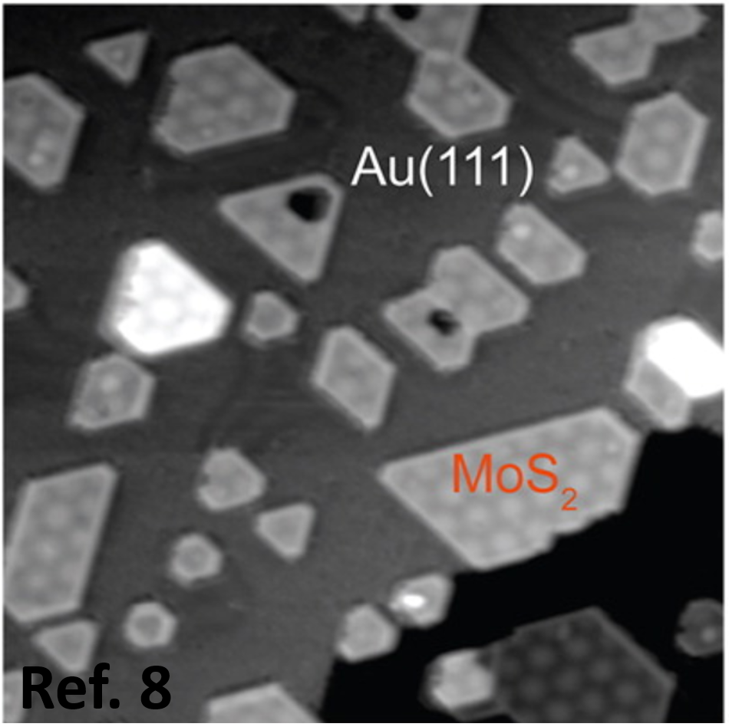 | 8 | ZZ//Au<110> | 2 | 60º
MoS₂  (D_{3h}) | Al₂O₃(0001)  (C_{3V}) | N/A | 2 | 60º | 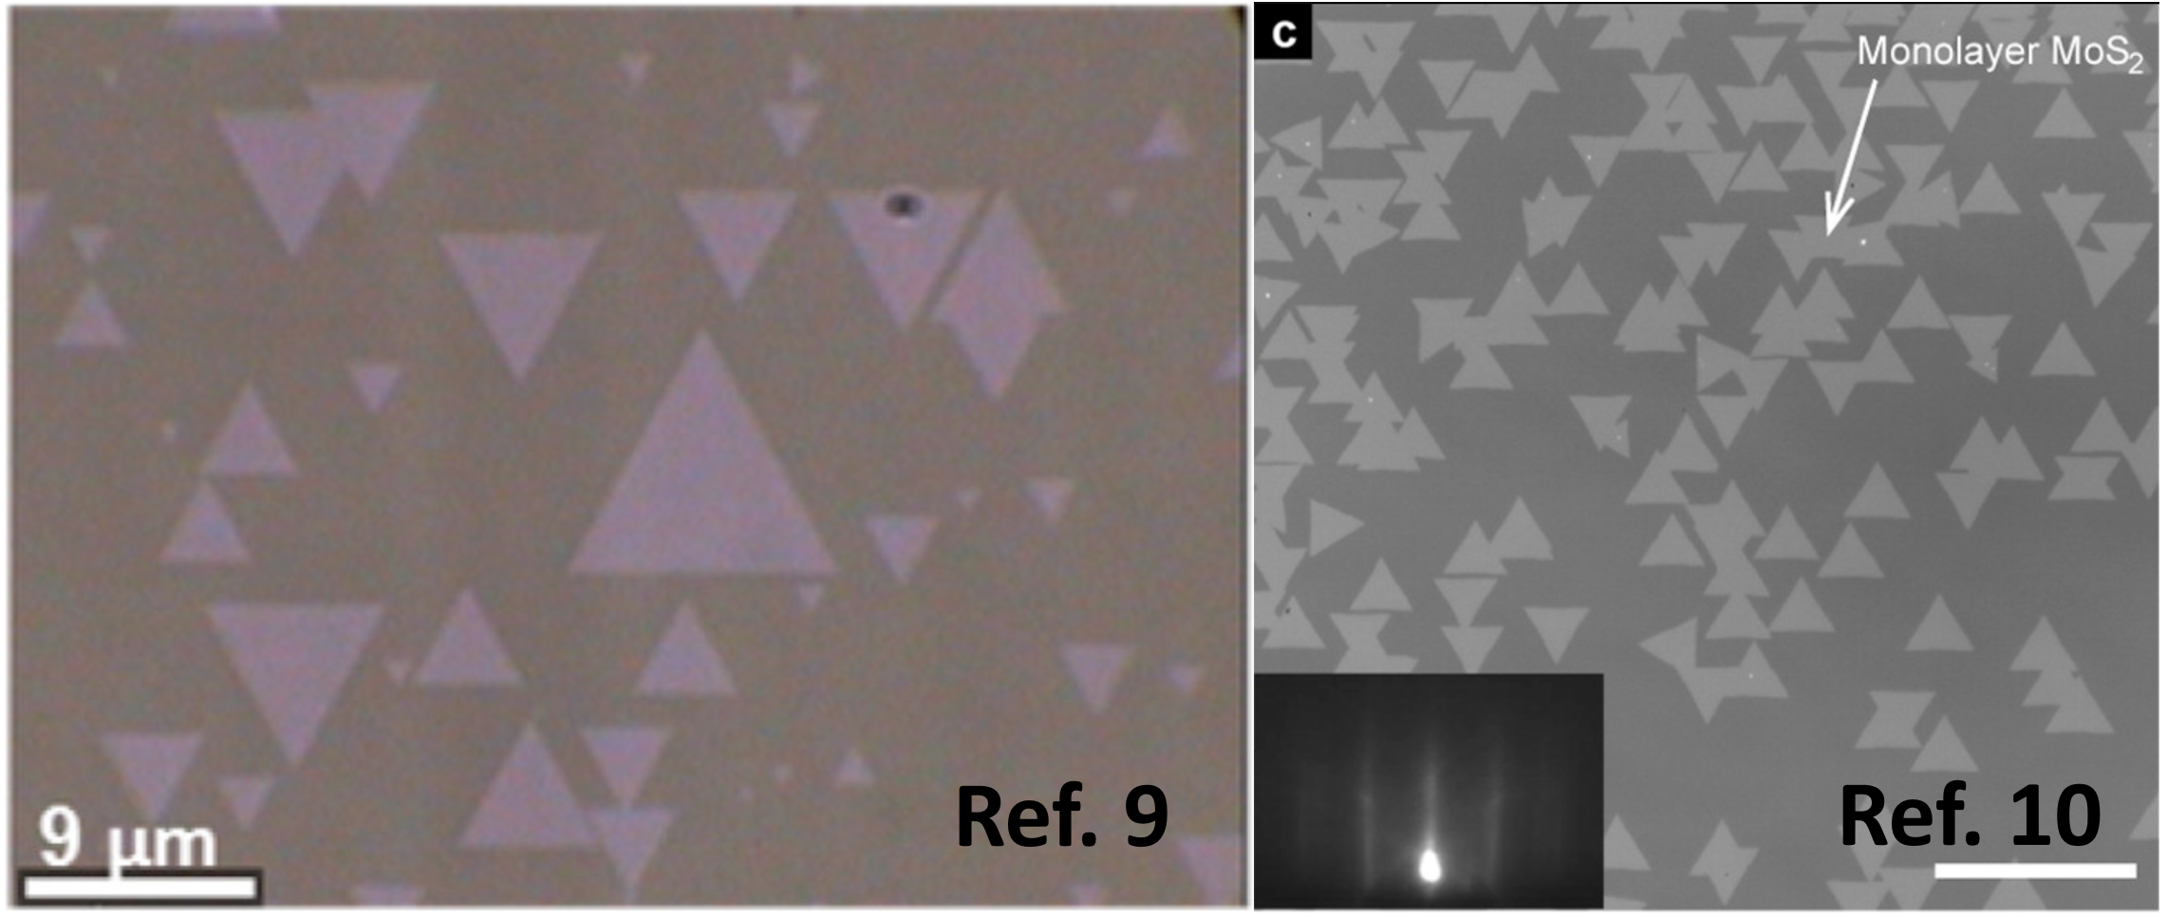 | 10,11 | ZZ//  Al₂O₃<11$\overline{2}$0> | 2 | 60º
WSe₂  (D_{3h}) | Al₂O₃(0001)  (C_{3V}) | ZZ//  Al₂O₃<11$\overline{2}$0> | 2 | 60º | 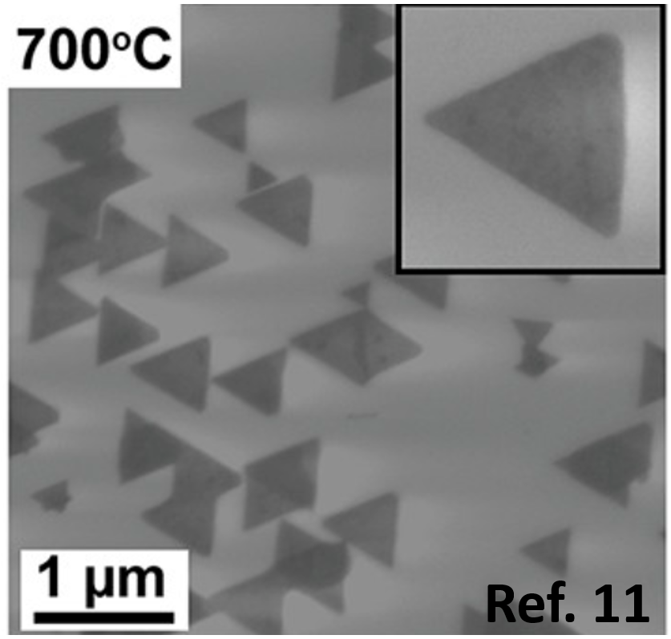 | 9 | ZZ//  Al₂O₃<11$\overline{2}$0> | 2 | 60º
MoS₂  (D_{3h}) | GaN(0001)  (C_{6V}) | ZZ//  GaN<11$\overline{2}$0> | 2 | 60º | 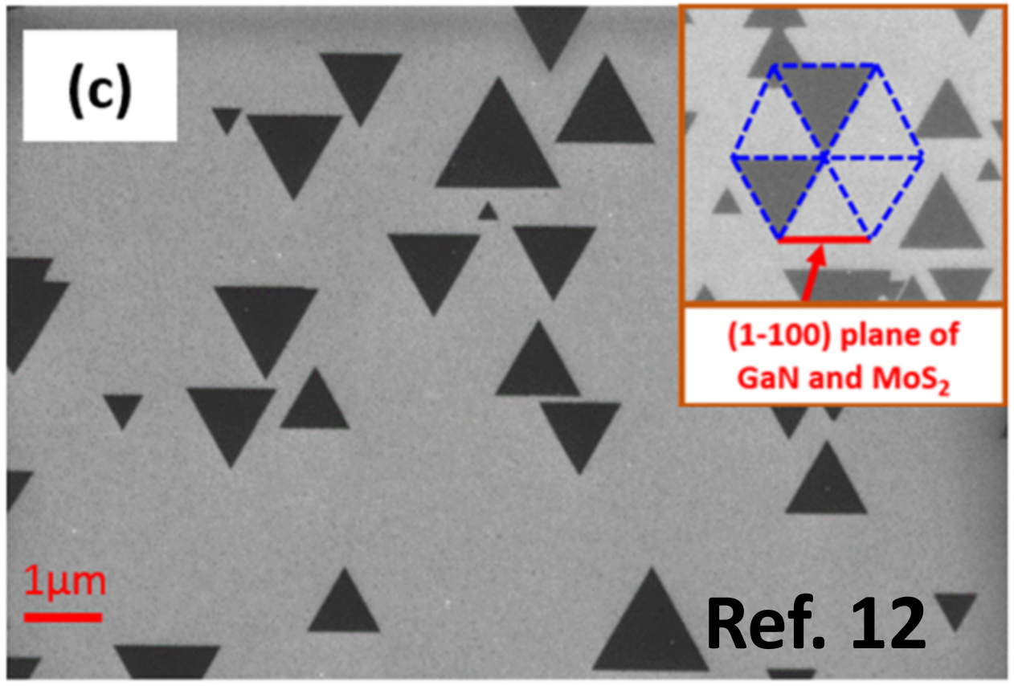 | 12 | ZZ//  GaN<11$\overline{2}$0> | 2 | 60º
WS₂  (D_{3h}) | hBN(0001)  (C_{3V}) | ZZ//  hBN<11$\overline{2}$0> | 1 | 0º | 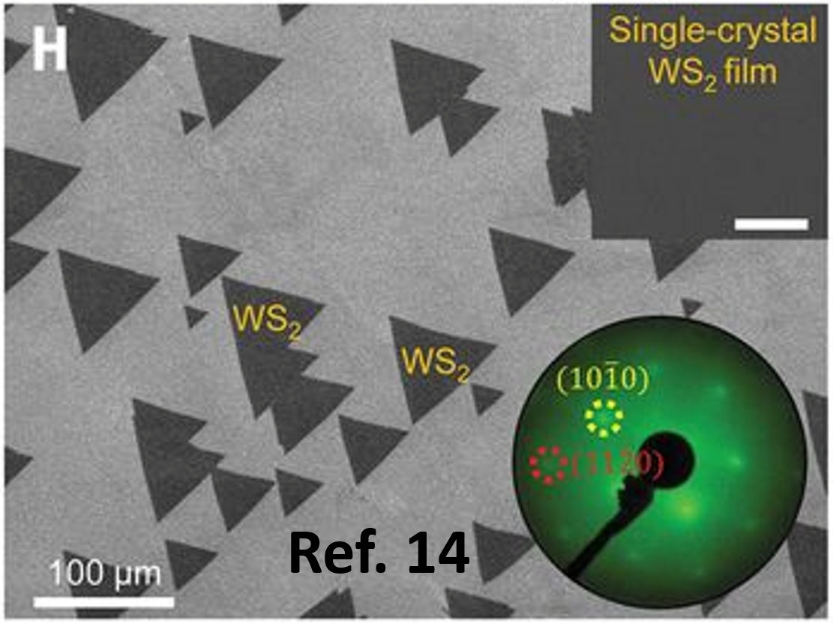 | 13 | ZZ//  hBN<11$\overline{2}$0> | 1 | 0º

Table S4 Alignment of 2D materials on high-index substrate surfaces. N represents the number of alignments and θ represents the misorientation angle of 2D grains, respectively. ZZ represents the zigzag edge of 2D grains.
2D Material | Substrate  type | Experimental Observation |  |  |  | Refs. | Theoretical Prediction
2D Material | Substrate  type | 2D materials  Alignment | N | θ | Figures | Refs. | 2D materials  Alignment | N | θ
hBN  (C_{3V}) | Vicinal Cu(110)  (C₁ or C_{s}) | ZZ // Cu step edges | 1 | 0º | 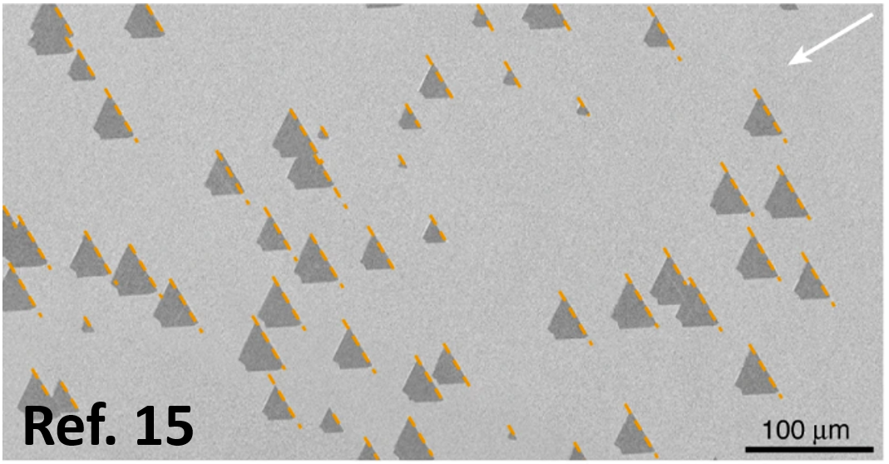 | 14 | ZZ // Cu step edges | 1 | 0º
hBN  (C_{3V}) | Cu(14 1 15)  (C₁) | ZZ // Cu step edges | 1 | 0º | 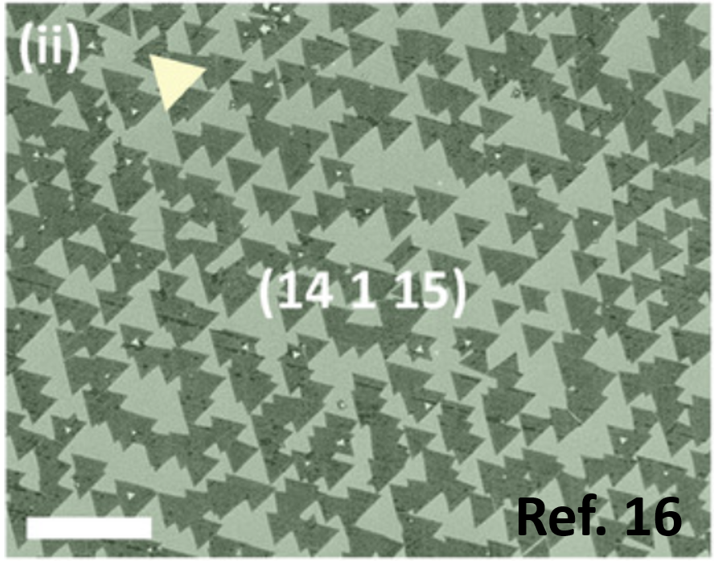 | 16 | ZZ // Cu step edges | 1 | 0º
hBN  (C_{3V}) | Cu(1 0 2) Cu(1 0 3)  (C₁) | ZZ // Cu step edges | 1 | 0º | 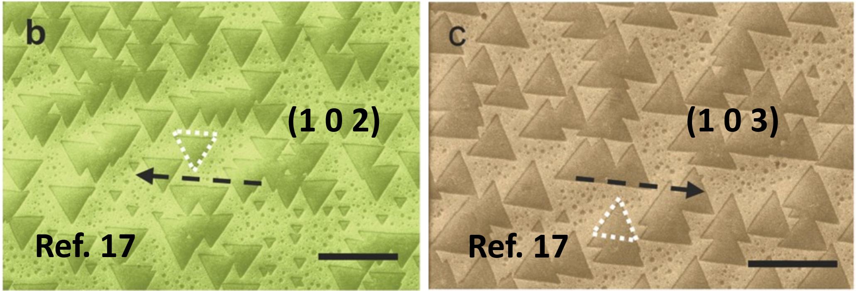 | 17 | ZZ // Cu step edges | 1 | 0º
hBN  (C_{3V}) | Vicinal Cu(111)  (C₁ or C_{s}) | ZZ // Cu step edges | 1 | 0º | 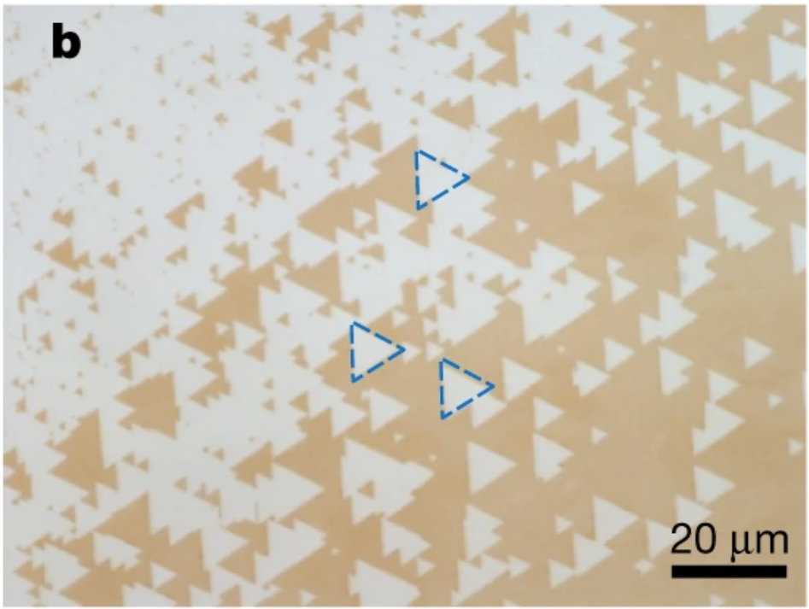 | 15 | ZZ // Cu step edges | 1 | 0º
WSe₂  (D_{3h}) | Vicinal Al₂O₃(0001)  (C₁ or C_{s}) | ZZ // Al₂O₃ step edges | 1 | 0º | 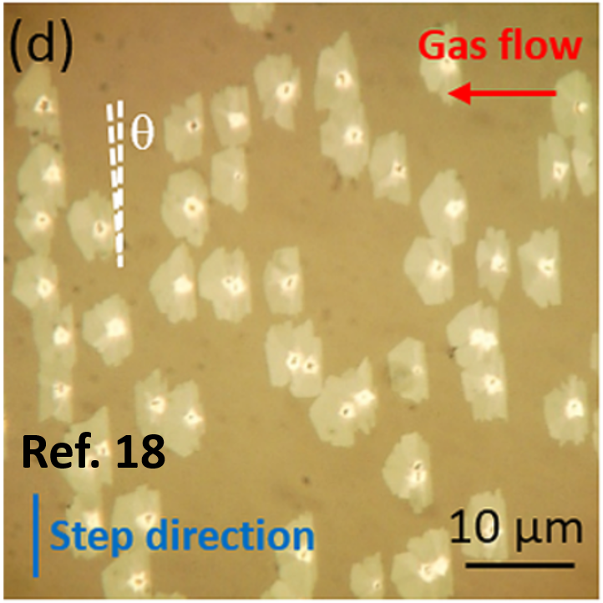 | 18 | ZZ // Al₂O₃ step edges | 1 | 0º
MoS₂  (D_{3h}) | Vicinal Au(111)  (C₁ or C_{s}) | ZZ // Au step edges | 1 | 0º | 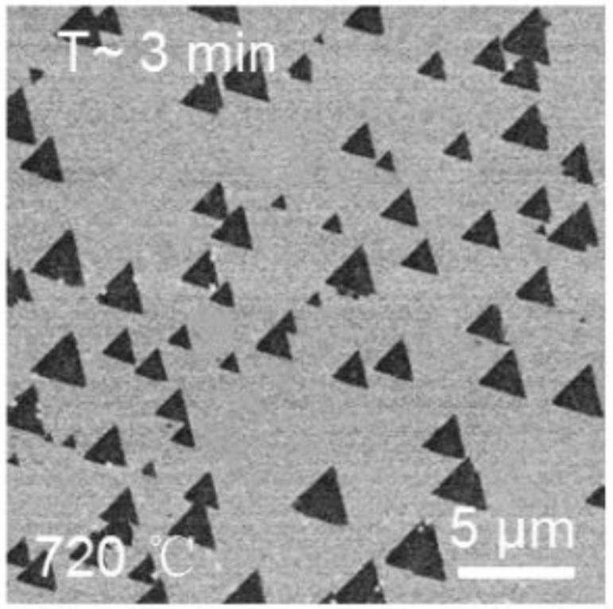 | 19 | ZZ // Au step edges | 1 | 0º

*It should be noted that only the top atomic layer is considered for determining the symmetries of the substrates, because the 2D material mainly interacts with the top atomic layer of the substrate, as has exemplified in Figure 2 in the main text.

References
1 Murdock, A. T. et al. Controlling the Orientation, Edge Geometry, and Thickness of Chemical Vapor Deposition Graphene. ACS Nano 7, 1351-1359 (2013).
2 Ogawa, Y. et al. Domain Structure and Boundary in Single-Layer Graphene Grown on Cu(111) and Cu(100) Films. The Journal of Physical Chemistry Letters 3, 219-226 (2012).
3 Xu, X. et al. Ultrafast epitaxial growth of metre-sized single-crystal graphene on industrial Cu foil. Science Bulletin 62, 1074-1080 (2017).
4 Song, X. et al. Chemical vapor deposition growth of large-scale hexagonal boron nitride with controllable orientation. Nano Research 8, 3164-3176 (2015).
5 Uchida, Y., Iwaizako, T., Mizuno, S., Tsuji, M. & Ago, H. Epitaxial chemical vapour deposition growth of monolayer hexagonal boron nitride on a Cu(111)/sapphire substrate. Physical Chemistry Chemical Physics 19, 8230-8235 (2017).
6 Wood, G. E. et al. van der Waals epitaxy of monolayer hexagonal boron nitride on copper foil: growth, crystallography and electronic band structure. 2D Materials 2, 025003 (2015).
7 Tay, R. Y. et al. Synthesis of aligned symmetrical multifaceted monolayer hexagonal boron nitride single crystals on resolidified copper. Nanoscale 8, 2434-2444 (2016).
8 Grønborg, S. S. et al. Synthesis of Epitaxial Single-Layer MoS2 on Au(111). Langmuir 31, 9700-9706 (2015).
9 Zhang, X. et al. Diffusion-Controlled Epitaxy of Large Area Coalesced WSe2 Monolayers on Sapphire. Nano Letters 18, 1049-1056 (2018).
10 Aljarb, A. et al. Substrate Lattice-Guided Seed Formation Controls the Orientation of 2D Transition-Metal Dichalcogenides. ACS Nano 11, 9215-9222 (2017).
11 Dumcenco, D. et al. Large-Area Epitaxial Monolayer MoS2. ACS Nano 9, 4611-4620 (2015).
12 Ruzmetov, D. et al. Vertical 2D/3D Semiconductor Heterostructures Based on Epitaxial Molybdenum Disulfide and Gallium Nitride. ACS Nano 10, 3580-3588 (2016).
13 Lee, J. S. et al. Wafer-scale single-crystal hexagonal boron nitride film via self-collimated grain formation. Science 362, 817-821 (2018).
14 Wang, L. et al. Epitaxial growth of a 100-square-centimetre single-crystal hexagonal boron nitride monolayer on copper. Nature 570, 91-95 (2019).
15 Chen, T.-A. et al. Wafer-scale single-crystal hexagonal boron nitride monolayers on Cu (111). Nature 579, 219-223 (2020).
16 Wang, S. et al. Catalyst-Selective Growth of Single-Orientation Hexagonal Boron Nitride toward High-Performance Atomically Thin Electric Barriers. Advanced Materials 31, 1900880 (2019).
17 Li, J. et al. Growth of Polar Hexagonal Boron Nitride Monolayer on Nonpolar Copper with Unique Orientation. Small 12, 3645-3650 (2016).
18 Chen, L. et al. Step-Edge-Guided Nucleation and Growth of Aligned WSe2 on Sapphire via a Layer-over-Layer Growth Mode. ACS Nano 9, 8368-8375 (2015).
19 Yang, P. et al. Epitaxial Growth of Centimeter-Scale Single-Crystal MoS2 Monolayer on Au (111). ACS Nano (2020).

