Supplementary Table 1 Univariable analysis of the clinical data
Variables | Control (n = 662) | Case (n = 750) | Z/x² | P value
Age, years | 44(34–51) | 59(52–68) | -23.007 | ＜0.001
Gender Male, n(%) | 335(50.6) | 473(63.1) | 22.311 | ＜0.001
Smoking, n(%) | 115(17.4) | 223(29.7) | 29.512 | ＜0.001
Drinking, n(%) | 70(10.6) | 113(15.1) | 6.292 | 0.012
Hypertension, n(%) | 301(45.5) | 404(53.9) | 9.921 | 0.002
Diabetes, n(%) | 107(16.2) | 222(29.6) | 35.524 | ＜0.001
Mfn2 | 6.03(5.04–6.89) | 5.04(4.06–6.00) | -12.552 | ＜0.001
BMI, kg/m² | 25.96(23.72–28.64) | 27.05(24.22–30.04) | -4.042 | ＜0.001
WBC,10⁹/L | 6.55(5.48–7.86) | 6.77(5.91–7.65) | -2.168 | 0.030
RBC, 10¹²/L | 4.71(4.36–5.12) | 4.78(4.37–5.21) | -2.103 | 0.035
PLT, 10⁹/L | 235.00(204.00–256.00) | 229.00(196.00–262.00) | -0.905 | 0.365
HGB, g/L | 138.00(130.00–145.00) | 133.50(120.00–143.00) | -6.746 | ＜0.001
AST, ug/L | 28.29(22.28–39.75) | 28.17(21.76–44.20) | -0.139 | 0.889
ALT, ug/L | 25.84(18.26–42.03) | 25.94(18.06–42.67) | -0.053 | 0.957
CR, µmol/L | 71.36(60.00–90.48) | 73.72(62.70–88.24) | -1.903 | 0.057
BUN, mmol/L | 6.04(5.01–7.14) | 6.22(4.95–7.39) | -0.377 | 0.706
Albumin, g/L | 39.93(38.57–43.00) | 41.00(38.20–43.35) | -0.056 | 0.956
Total bilirubin, g/L | 11.70(8.57–14.90) | 12.00(8.37–16.22) | -1.796 | 0.073
TC, mmol/L | 3.58(2.63–4.16) | 4.44(2.70–4.16) | -0.130 | 0.896
TG, mmol/L | 1.19(1.05–1.76) | 1.19(1.03–1.76) | -1.936 | 0.053
HDL-C, mmol/L | 1.05(0.89–1.23) | 1.06(0.89–1.21) | -0.574 | 0.566
LDL-C, mmol/L | 2.41(1.98–2.90) | 2.50(1.88–3.14) | -2.576 | 0.010
NT-pro BNP, ng/L | 105.00(48.00–183.00) | 149.00(135.00–278.00) | -12.664 | ＜0.001
Ejection fraction,% | 62.63(61.30–64.13) | 59.11(41.67–63.39) | -12.343 | ＜0.001
LVDD,mm | 48(46–51) | 52(48–61) | -13.774 | ＜0.001

Supplementary Table 2 Univariable regression of SNPs within the Mfn2 gene
SNP | Genotype | Case (n = 662) | Control (n= 750) | X² | P-value
rs1042837 |  |  |  | 2.873 | 0.238
 | CC | 568(85.8) | 661(88.1)
 | CT | 89(13.4) | 87(11.6)
 | TT | 5(0.8) | 2(0.3)
Dominant model | CC | 568(85.8) | 661(88.1) | 1.696 | 0.193
 | CT+TT | 94(14.2) | 89(11.9)
rs1042842 |  |  |  | 143.00 | ＜0.001
 | AA | 172(26.0) | 54(7.2)
 | AG | 323(48.8) | 311(41.5)
 | GG | 167(25.2) | 385(51.3)
Dominant model | AA | 172(26.0) | 54(7.2) | 92.27 | ＜0.001
 | AG+GG | 490(74.0) | 696(92.8)
rs141692260 |  |  |  | 3.11 | 0.211
 | AA | 523(79.0) | 565(75.3)
 | AG | 129(19.5) | 175(23.3)
 | GG | 10(1.5) | 10(1.3)
Dominant model | AA | 523(79.0) | 565(75.3)) | 2.68 | 0.102
 | AG+GG | 139(21.0) | 185(24.7)
rs14305 |  |  |  | 2.74 | 0.255
 | CC | 517(78.1) | 567(75.6)
 | CT | 132(19.9) | 173(23.1)
 | TT | 13(2.0) | 10(1.3)
Dominant model | CC | 517(78.1) | 567(75.6) | 1.22 | 0.268
 | CT+TT | 145(21.9) | 183(24.4)
rs2236054 |  |  |  | 6.38 | 0.041
 | AA | 117(17.7) | 134(17.9)
 | AG | 332(50.2) | 330(44.0)
 | GG | 213(32.2) | 286(38.1)
Dominant model | AA | 117(17.7) | 134(17.9) | 0.01 | 0.925
 | AG+GG | 545(82.4) | 616(82.1)
rs2295281 |  |  |  | 81.32 | ＜0.001
 | CC | 249(37.6) | 139(18.5)
 | CT | 302(45.6) | 369(49.2)
 | TT | 111(16.8) | 242(32.3)
Dominant model | CC | 249(37.6) | 139(18.5) | 64.24 | ＜0.001
 | CT+TT | 413(62.4) | 611(81.5)
rs3088064 |  |  |  | 4.68 | 0.097
 | GG | 99(15.0) | 107(14.3)
 | GC | 339(51.2) | 348(46.4)
 | CC | 224(33.8) | 295(39.3)
Dominant model | GG | 99(15.0) | 107(14.3) | 0.134 | 0.715
 | GC+CC | 563(85.0) | 643(85.7)
rs41278638
 | AA | 589(89.0) | 684(91.2) | 1.97 | 0.161
 | AG | 73(11.0) | 66(8.8)
rs4240897 |  |  |  | 3.64 | 0.162
 | GG | 145(21.9) | 151(20.1)
 | GA | 324(48.9) | 345(46.0)
 | AA | 193(29.2) | 254(33.9)
Dominant model | GG | 145(21.9) | 151(20.1) | 0.67 | 0.415
 | GA+AA | 517(78.1) | 599(79.9)
rs59658986 |  |  |  | 1.57 | 0.457
 | TT | 475(71.8) | 546(72.8)
 | TC | 174(26.3) | 183(24.4)
 | CC | 13(2.0) | 21(2.8)
Dominant model | TT | 475(71.8) | 546(72.8) | 0.19 | 0.661
 | TC+CC | 187(28.2) | 204(27.2)
rs6675934 |  |  |  | 0.38 | 0.828
 | GG | 1(0.2) | 3(0.4)
 | GA | 42(6.3) | 47(6.3)
 | AA | 619(93.5) | 700(93.3)
Dominant model | GG | 1(0.2) | 3(0.4) | 0.77 | 0.38
 | GA+AA | 661(99.8) | 747(99.6)
rs76084874 |  |  |  | 0.55 | 0.760
 | GG | 438(66.2) | 509(67.9)
 | GA | 199(30.1) | 212(28.3)
 | AA | 25(3.8) | 29(3.9)
Dominant model | GG | 438(66.2) | 509(67.9) | 0.46 | 0.497
 | GA+AA | 224(33.8) | 241(32.1)

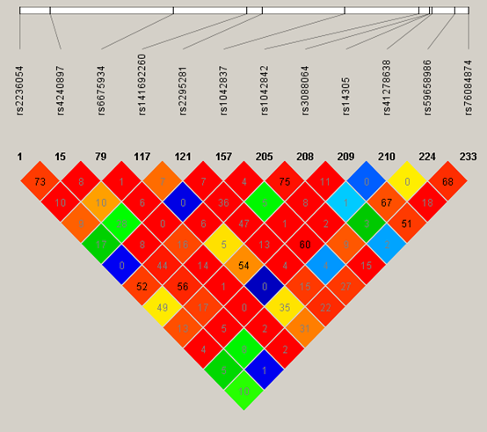
Supplementary Figure 1 Linkage disequilibrium (LD) map of SNPs of the Mfn2 gene. The values on the map represent the LD degree (r²) between the SNPs.

