Irrigation tends to reduce daytime urban heat stress in North America

TC Chakraborty¹, Yun Qian¹, Jianfeng Li¹, Ruby Leung¹, and Chandan Sarangi²
¹Pacific Northwest National Laboratory, Richland, WA, USA
²Department of Civil Engineering, IIT Madras, Chennai, India

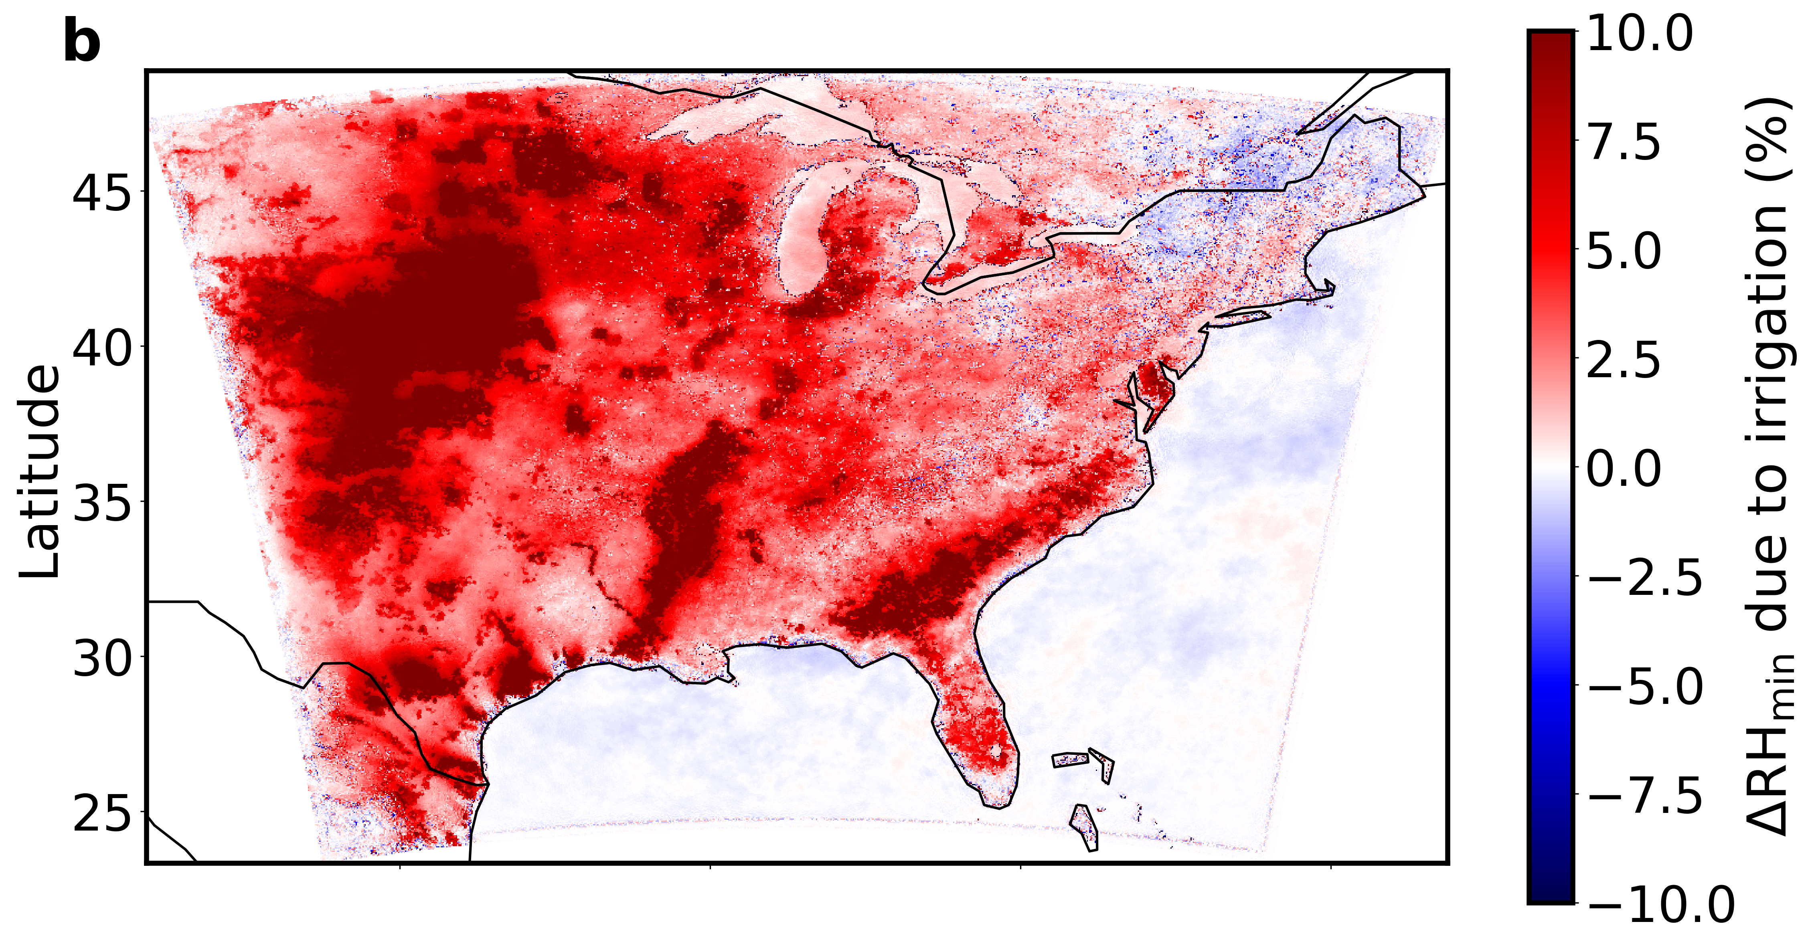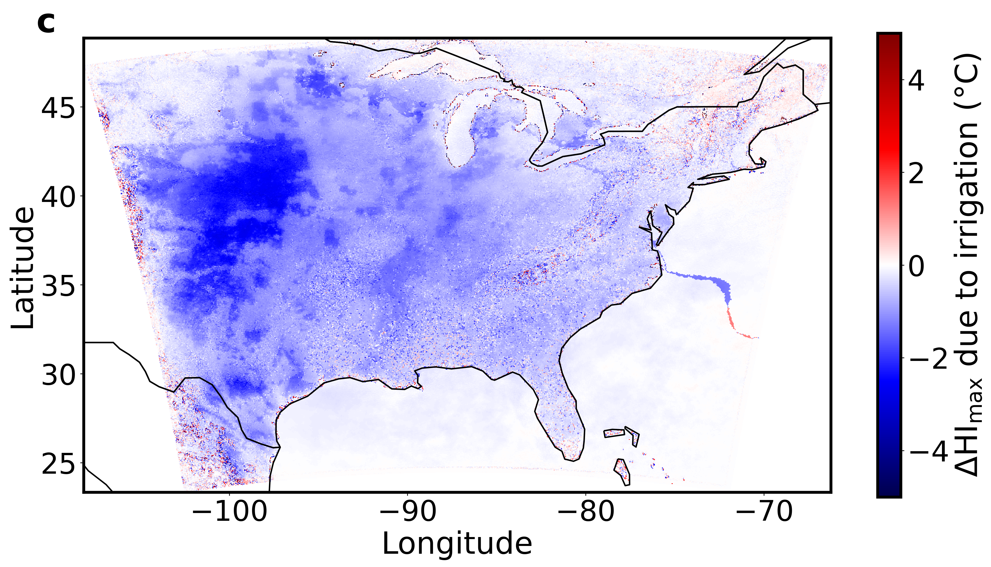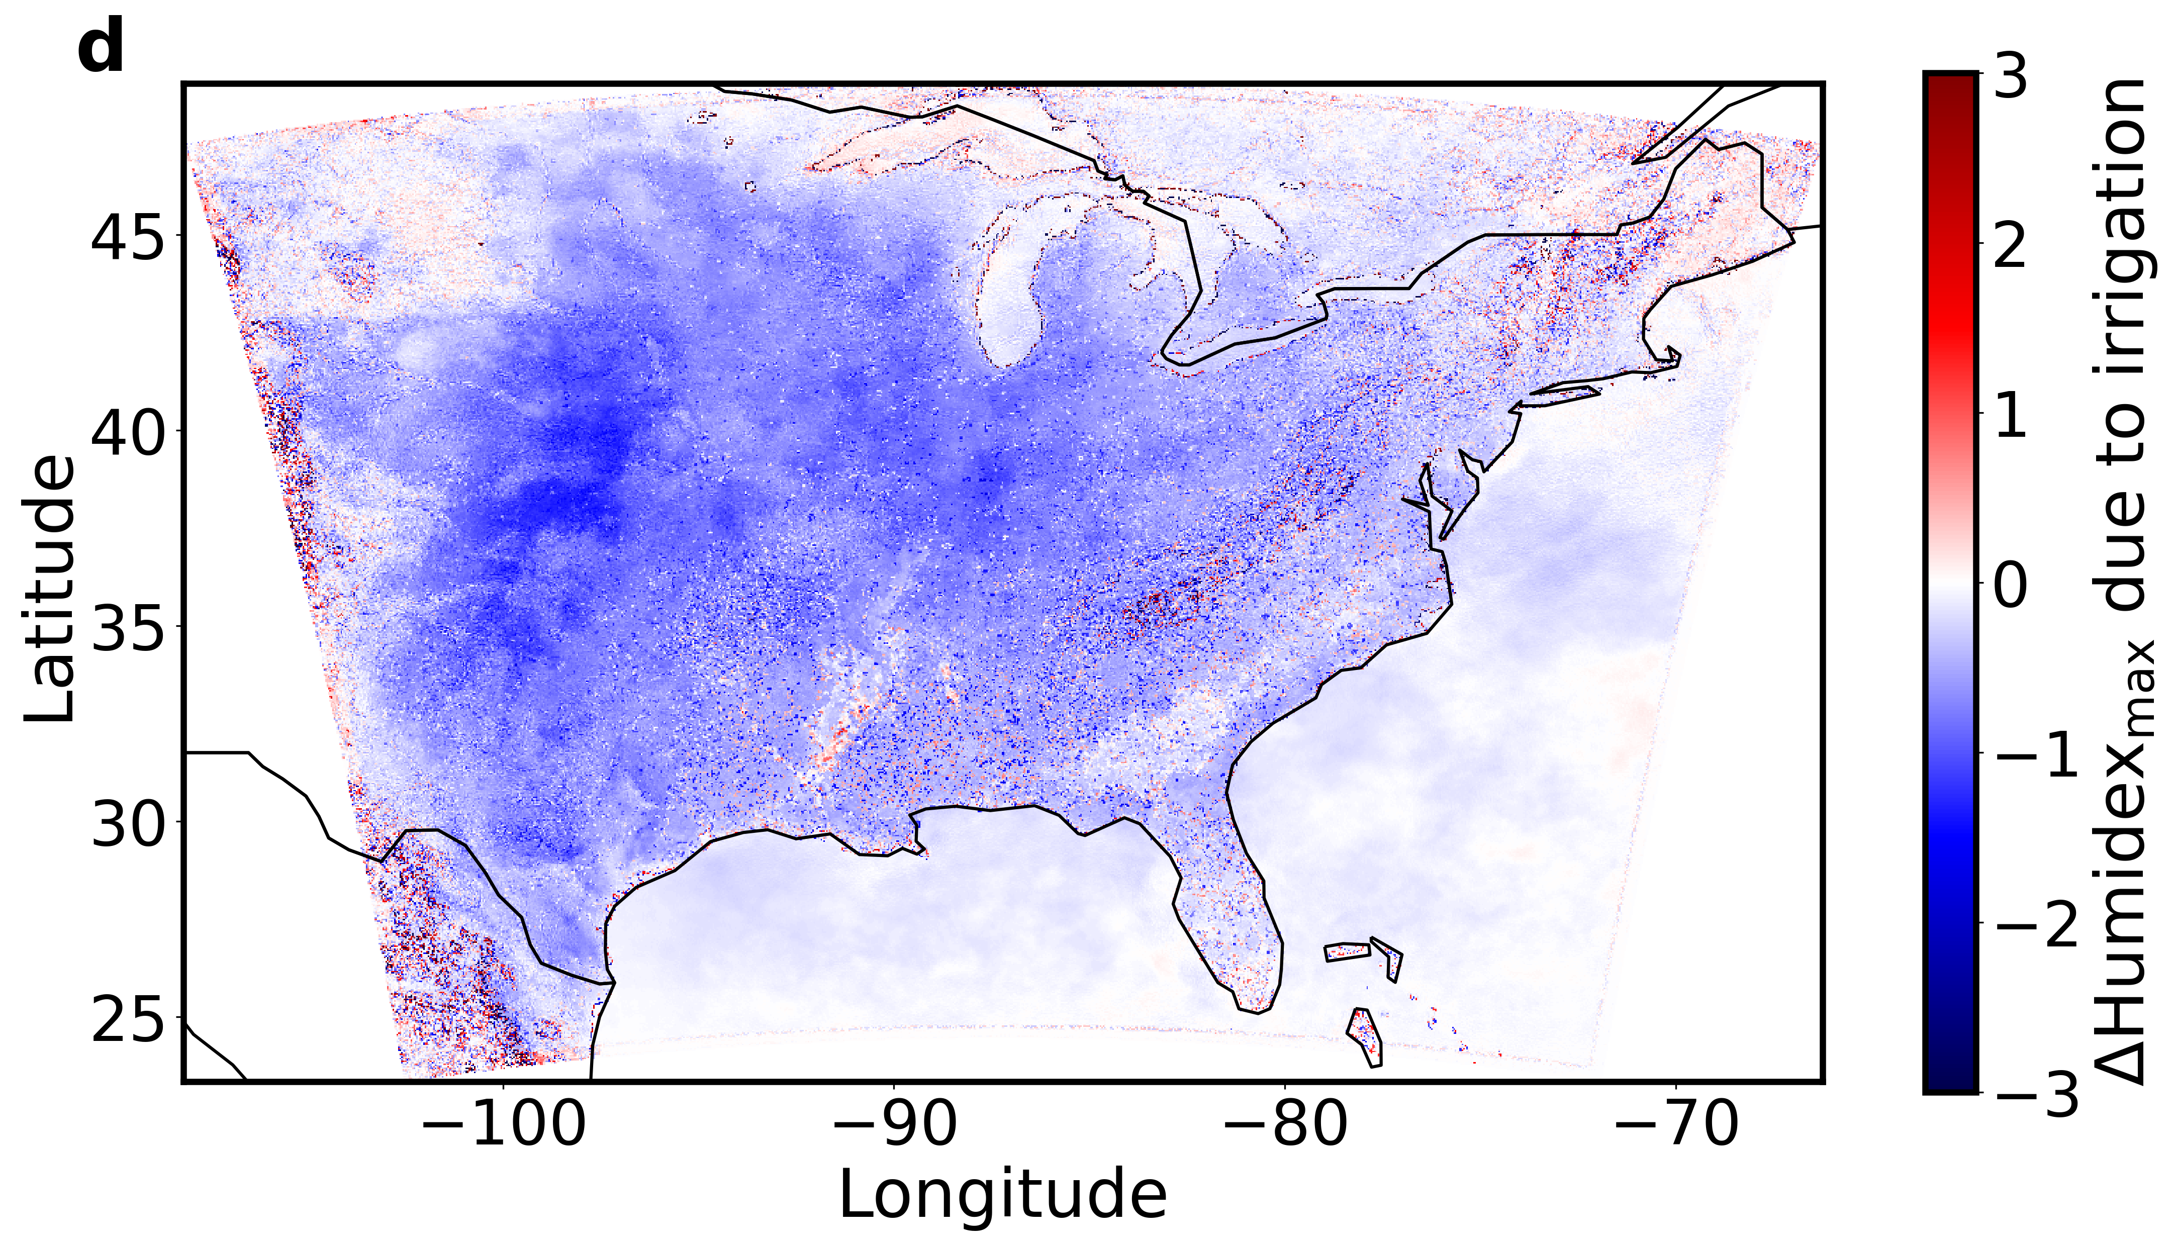Fig. S1 | Domain-wide daytime changes in surface climate and heat stress due to irrigation | Grid-wise changes in a maximum air temperature (ΔT_{max}), b minimum relative humidity (ΔRH_{min}), c maximum heat index (ΔHI_{max}), and d maximum Humidex (ΔHumidex_{max}) due to irrigation over the model domain.

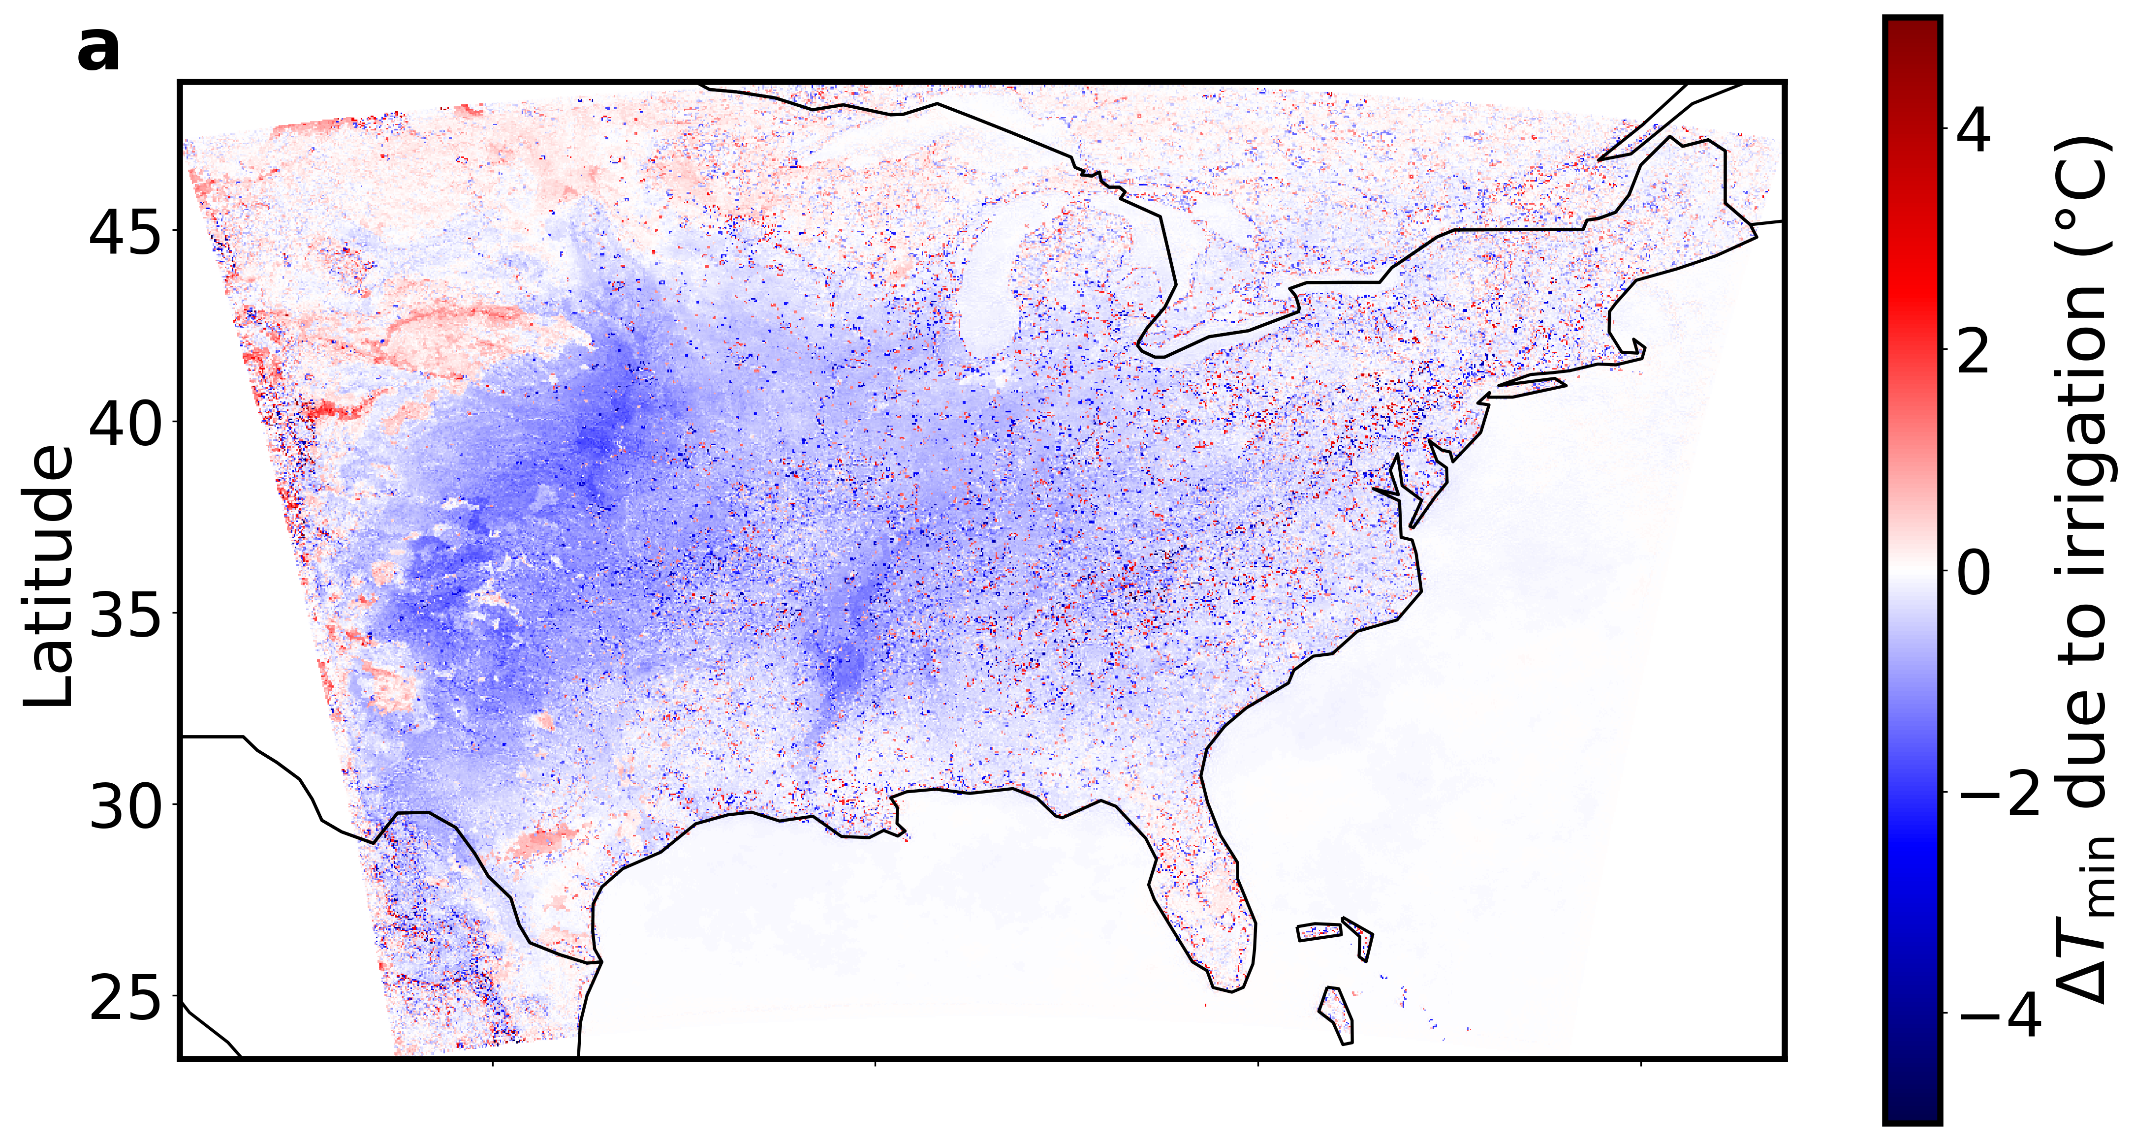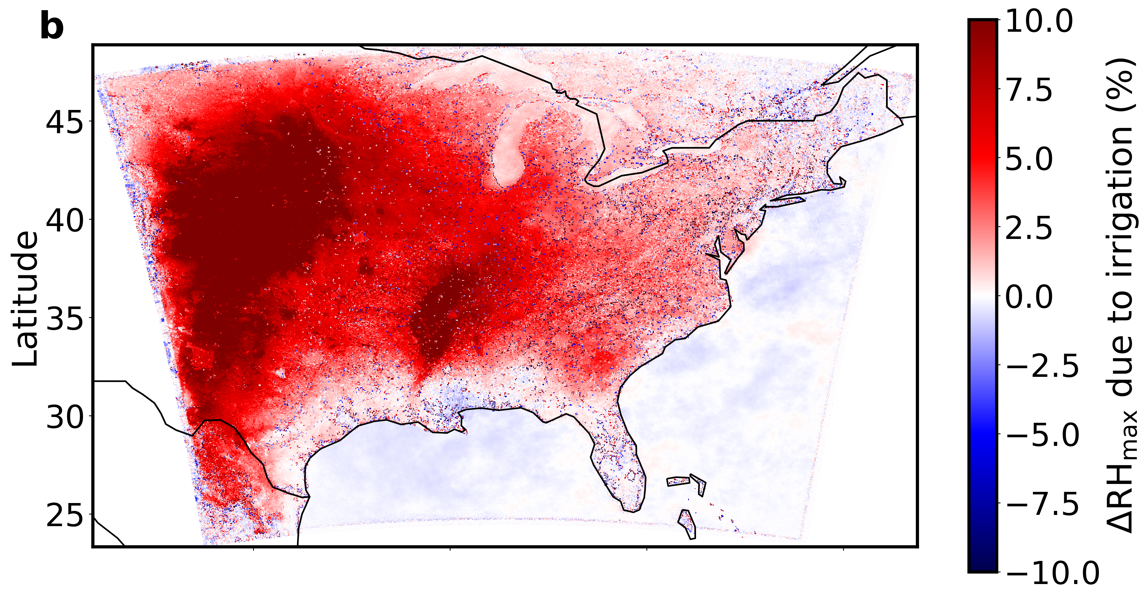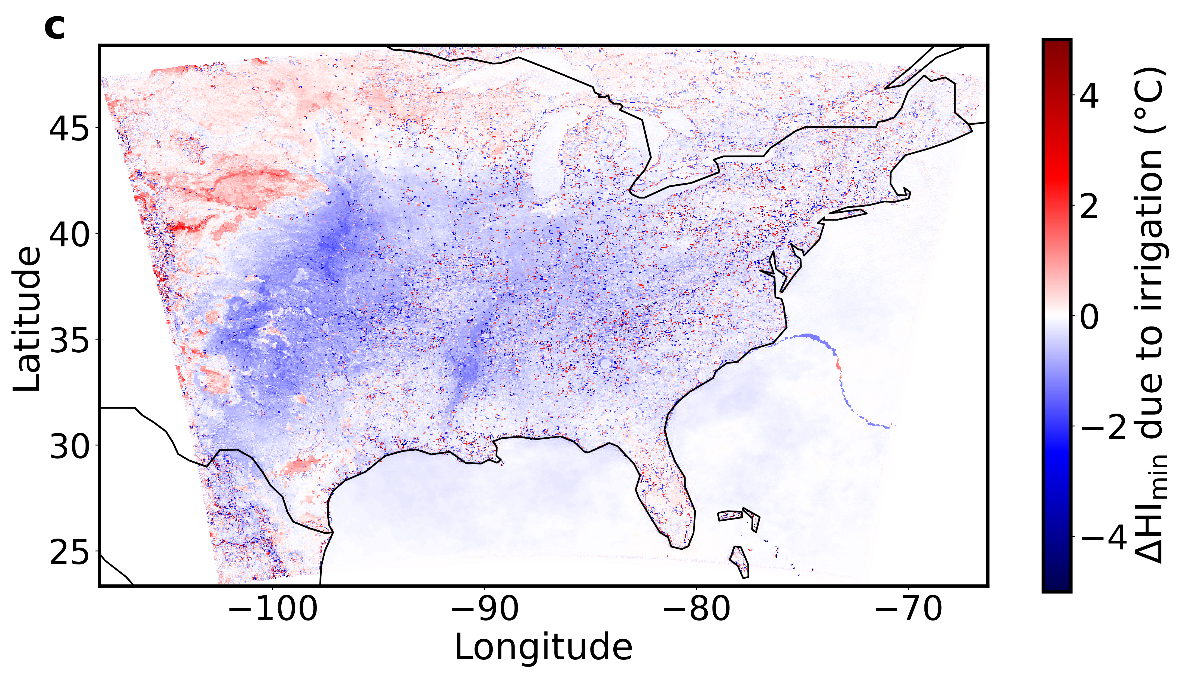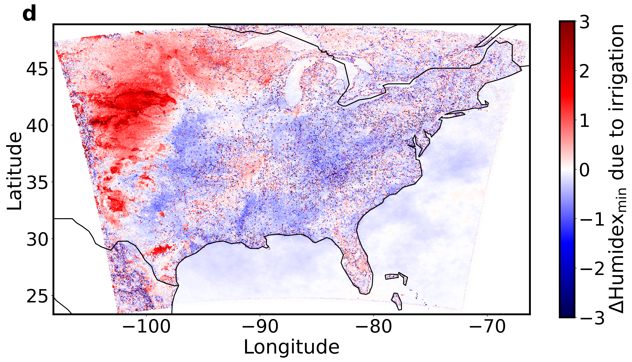
Fig. S2 | Domain-wide nighttime changes in surface climate and heat stress due to irrigation | Grid-wise changes in a minimum air temperature (ΔT_{min}), b maximum relative humidity (ΔRH_{max}), c minimum heat index (ΔHI_{min}), and d minimum Humidex (ΔHumidex_{min}) due to irrigation over the model domain.

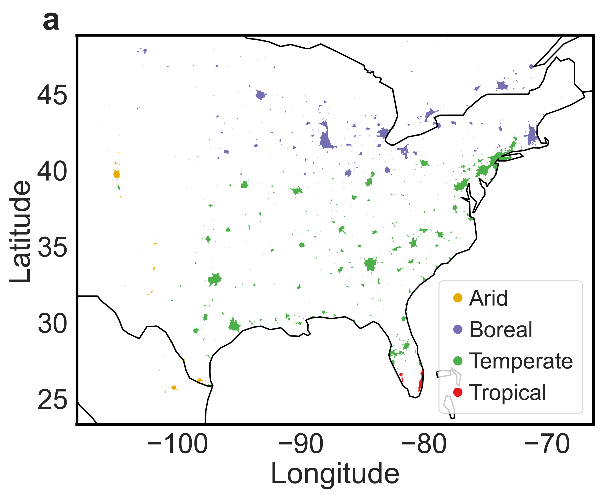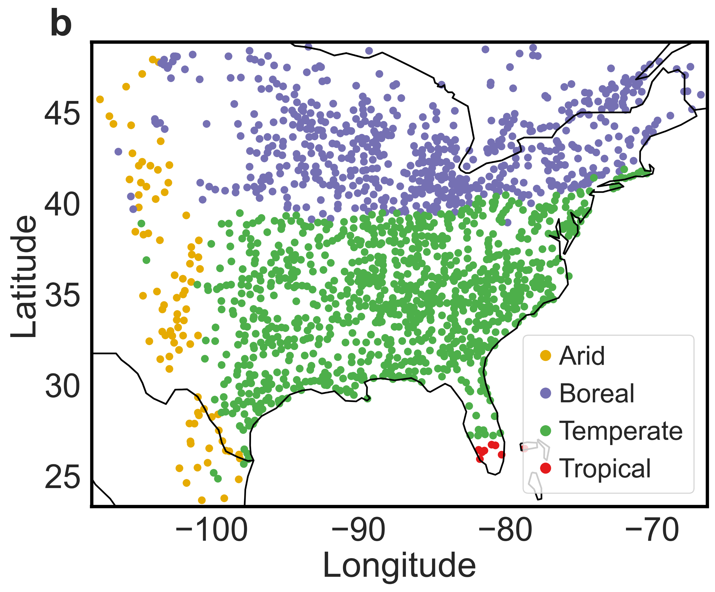Fig. S3 | Generated urban clusters for region of interest | Sub-figure a shows the location, extent, and background Köppen-Geiger climate zone of all 1662 urban clusters generated in the region of interest from the model’s surface dataset. Sub-figure b is similar to a, but shows the centroids of the clusters instead of their extent for easier visibility.

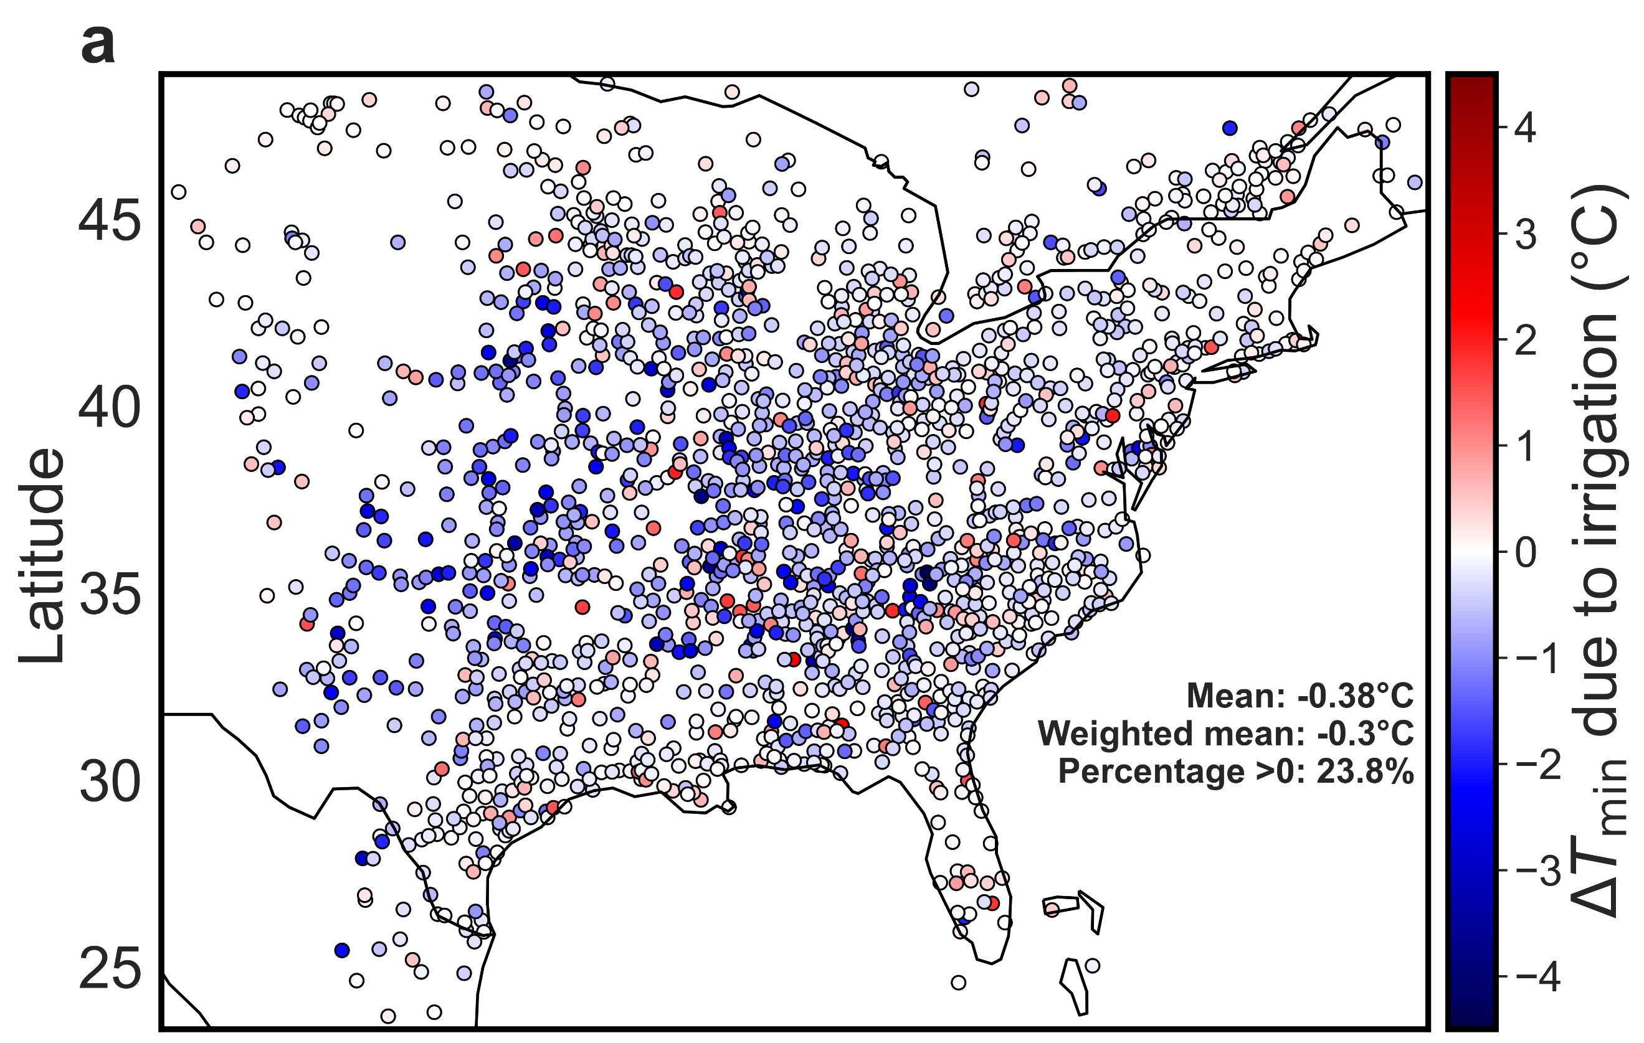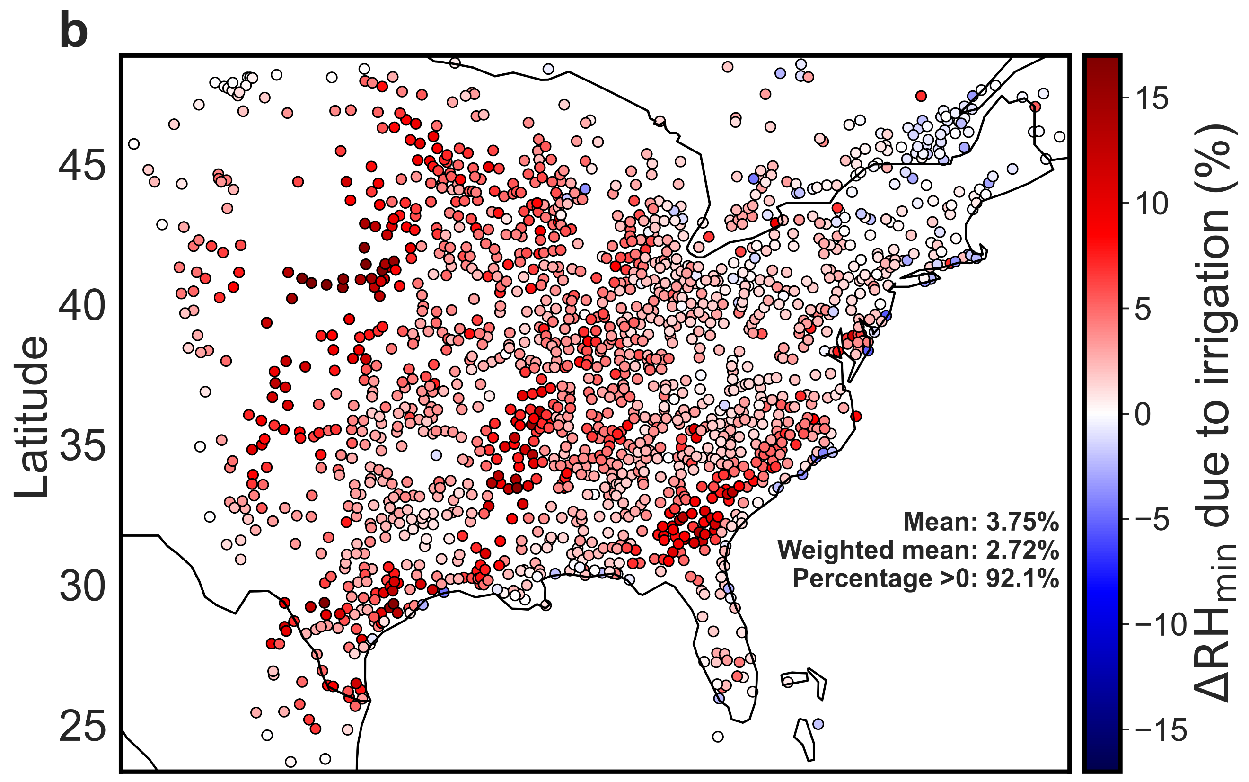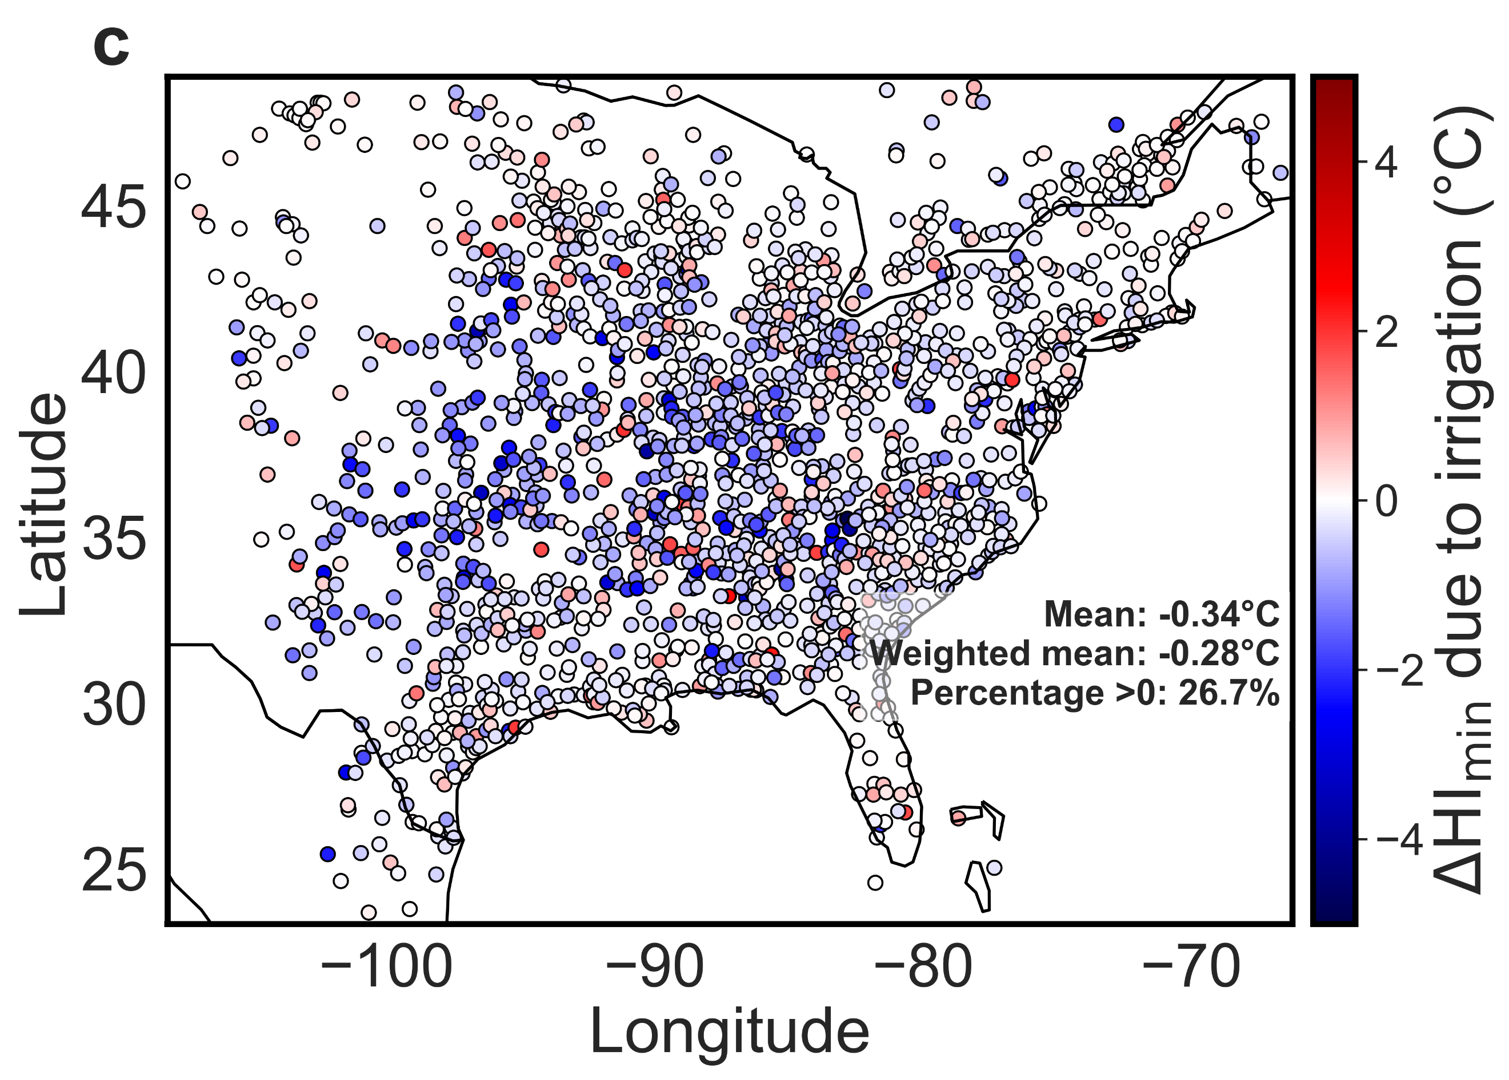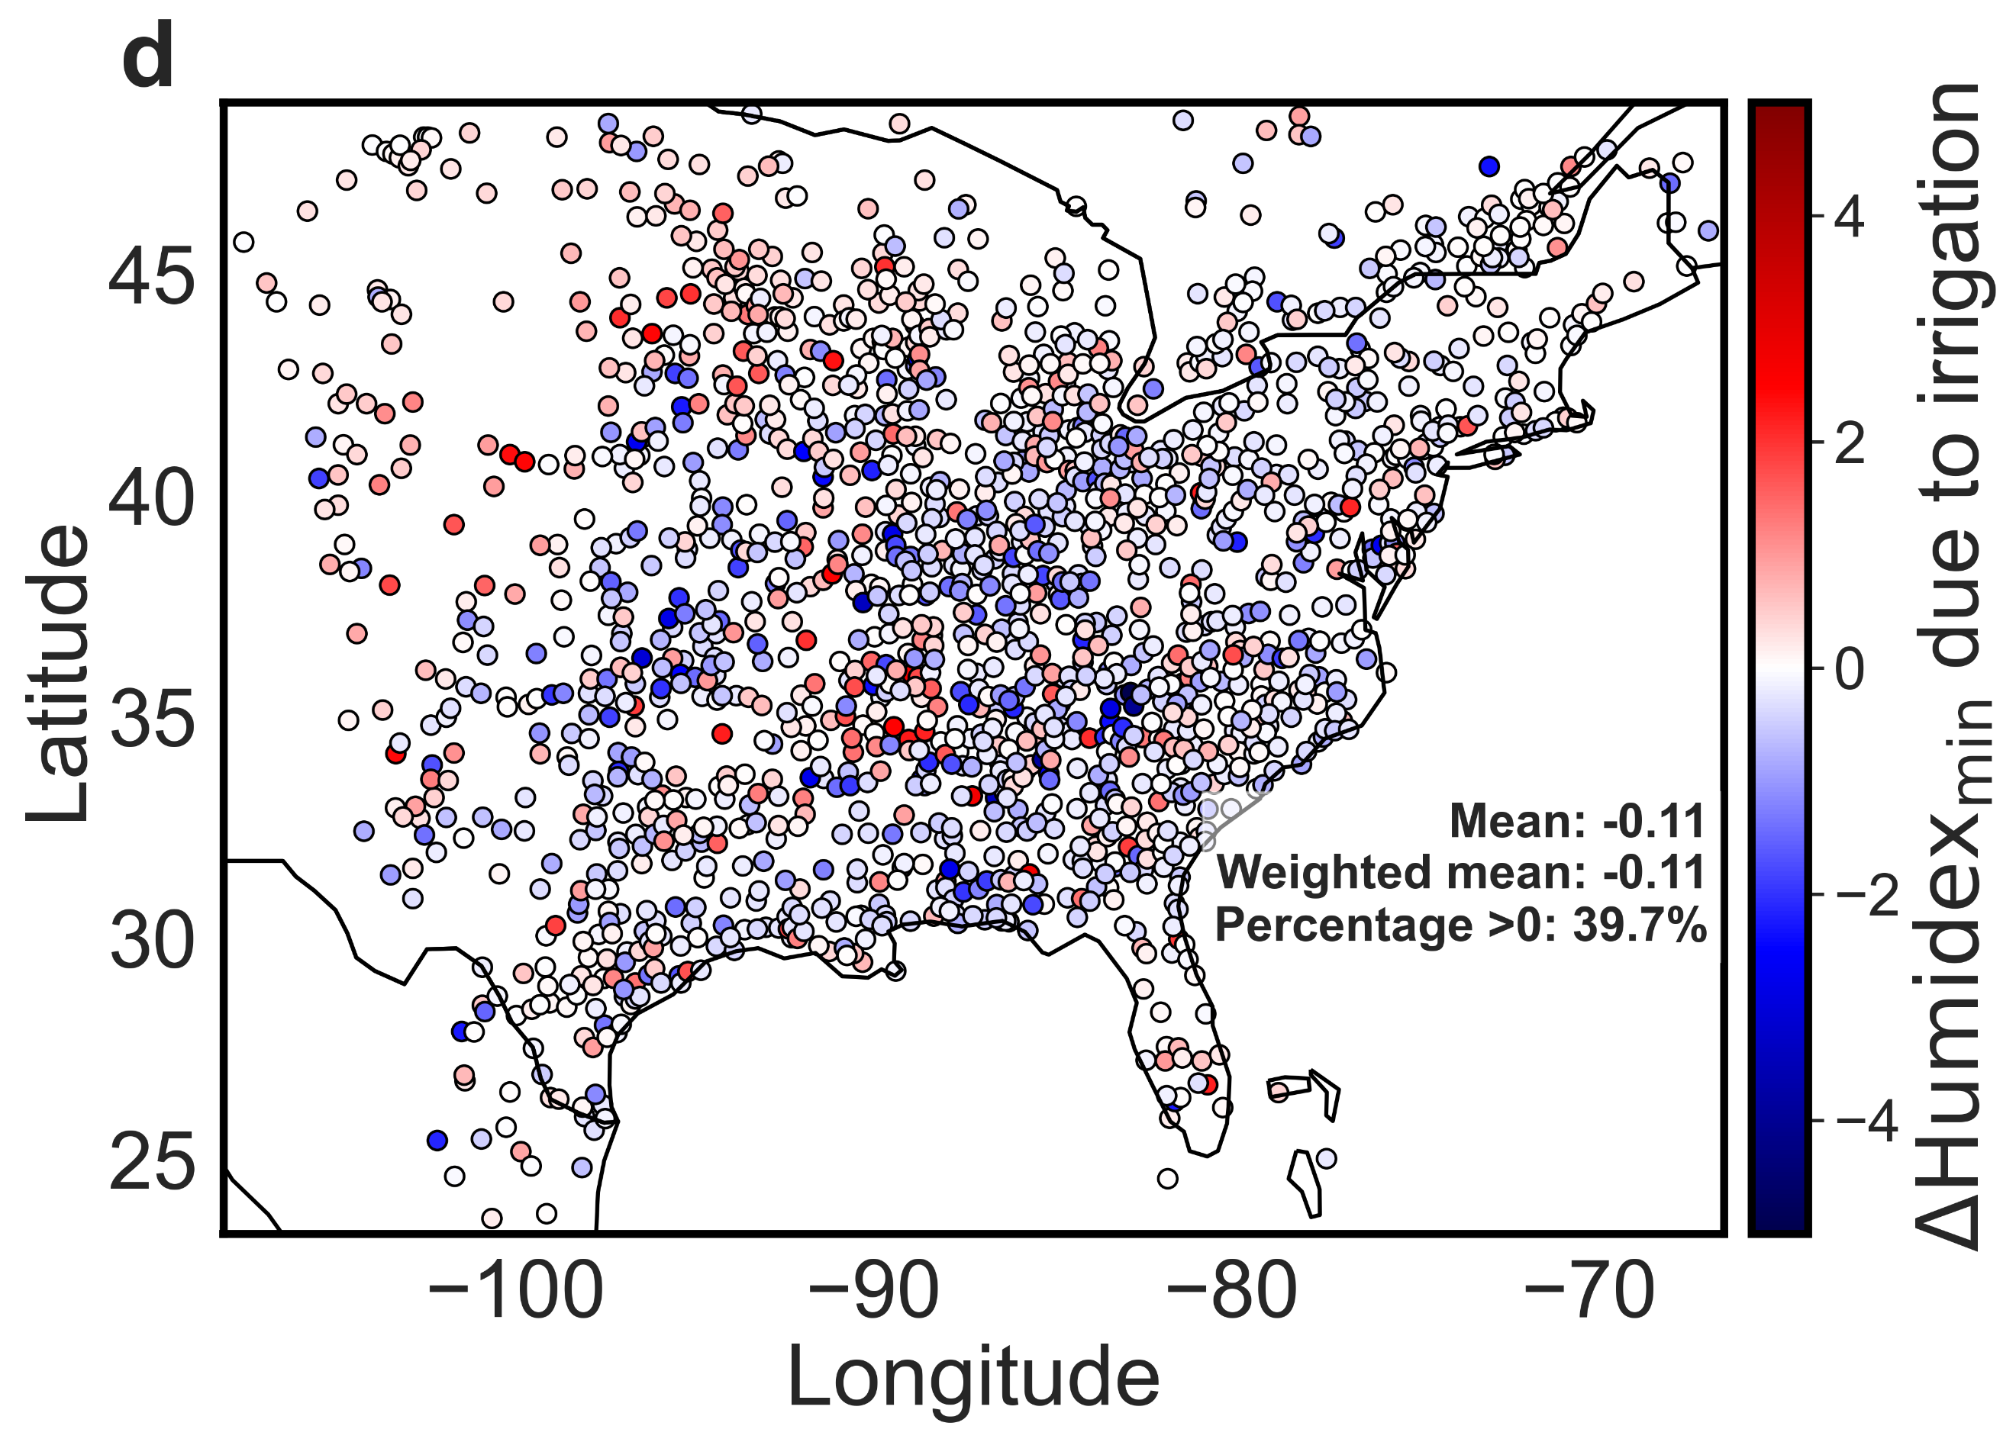
Fig. S4 | Changes in nighttime urban climate and moist heat stress due to irrigation | Urban-scale changes in a minimum air temperature (ΔT_{min}), b maximum relative humidity (ΔRH_{max}), c minimum heat index (ΔHI_{min}), and d minimum Humidex (ΔHumidex_{min}) due to irrigation for every urban cluster in the model domain. Each dot represents the spatial mean for an urban cluster. The urban spatial means, area weighted spatial means, and percentage of urban clusters with values above 0 are also noted.
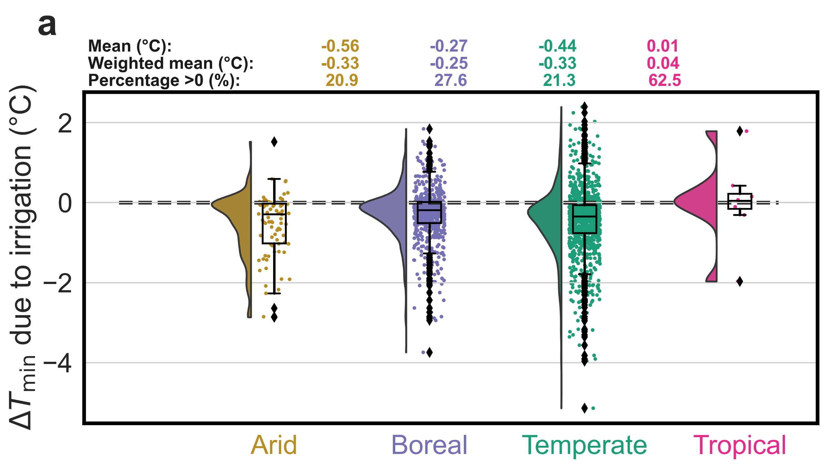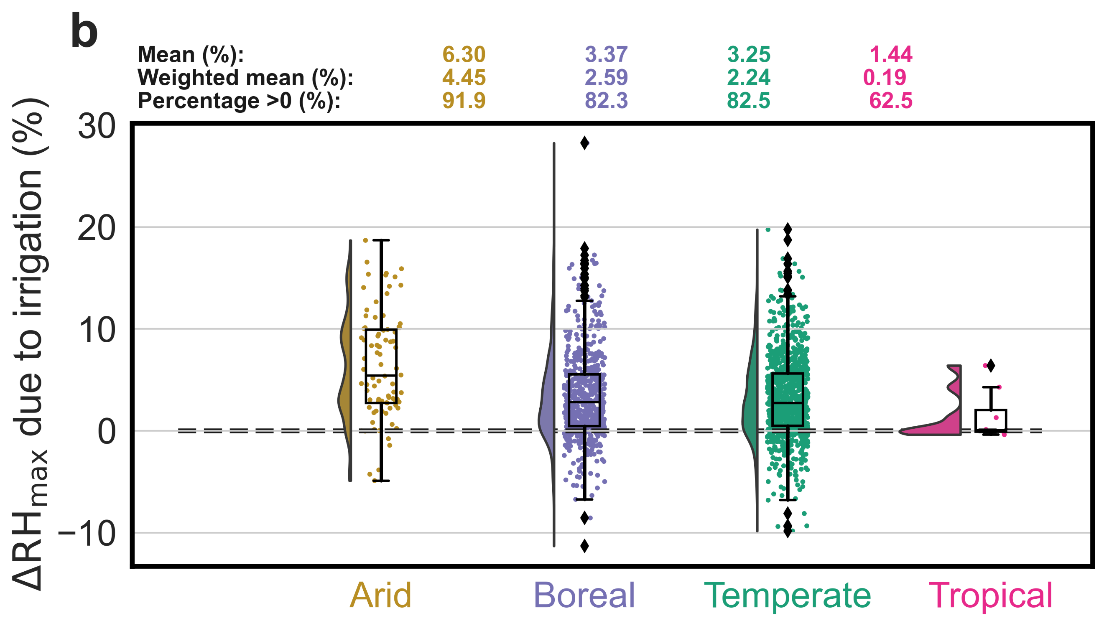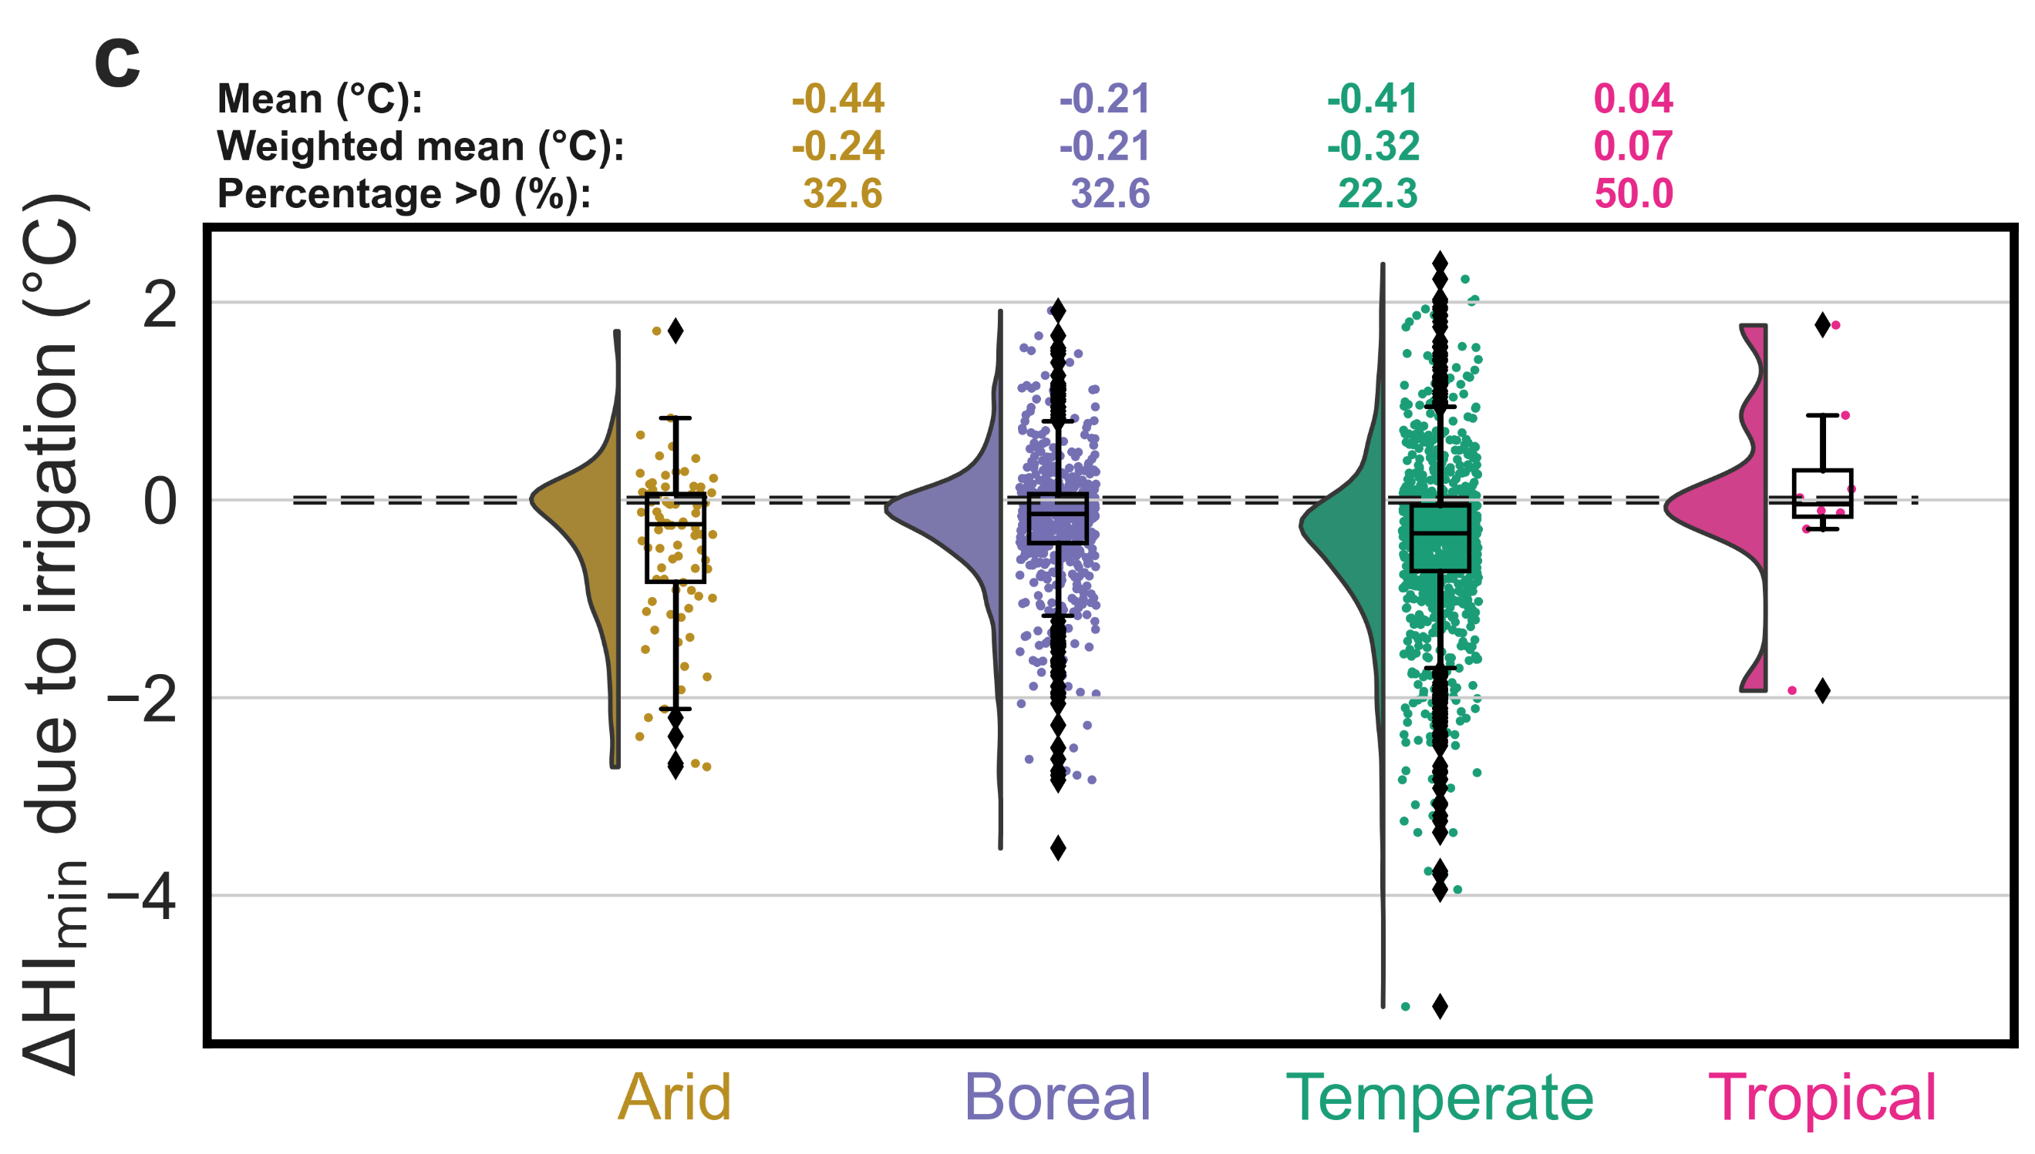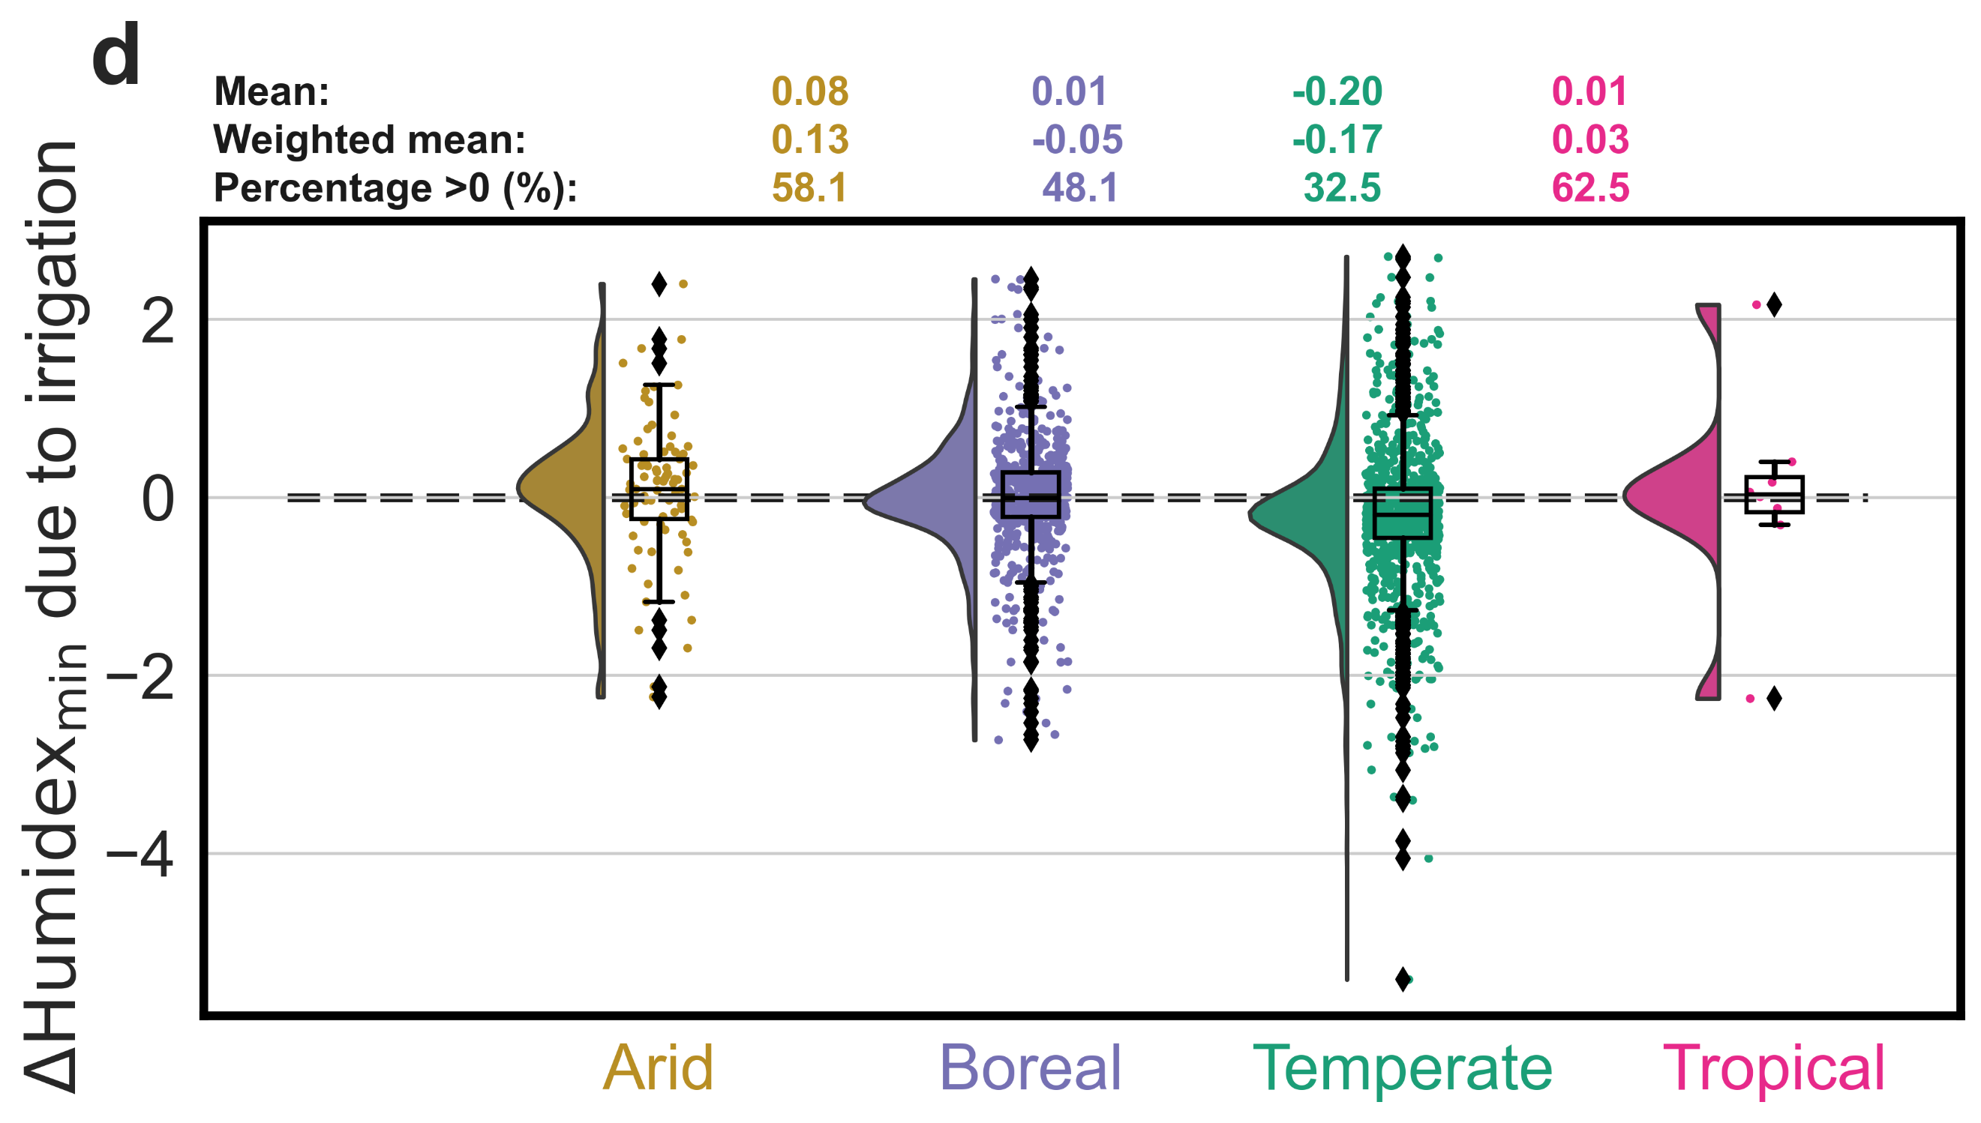
Fig. S5 | Irrigation impacts on nighttime urban climate and moist heat stress across climate zones | Distribution of changes in a minimum air temperature (ΔT_{min}), b maximum relative humidity (ΔRH_{max}), c minimum heat index (ΔHI_{min}), and d minimum Humidex (ΔHumidex_{min}) due to irrigation for every urban cluster in the model domain by climate zone. The urban means, area weighted means, and percentage of urban clusters with values above 0 are also noted for each case. Each dot represents the spatial mean for an urban cluster. The number of clusters in arid, boreal, temperate, and tropical climate are 86, 605, 961, and 8, respectively.
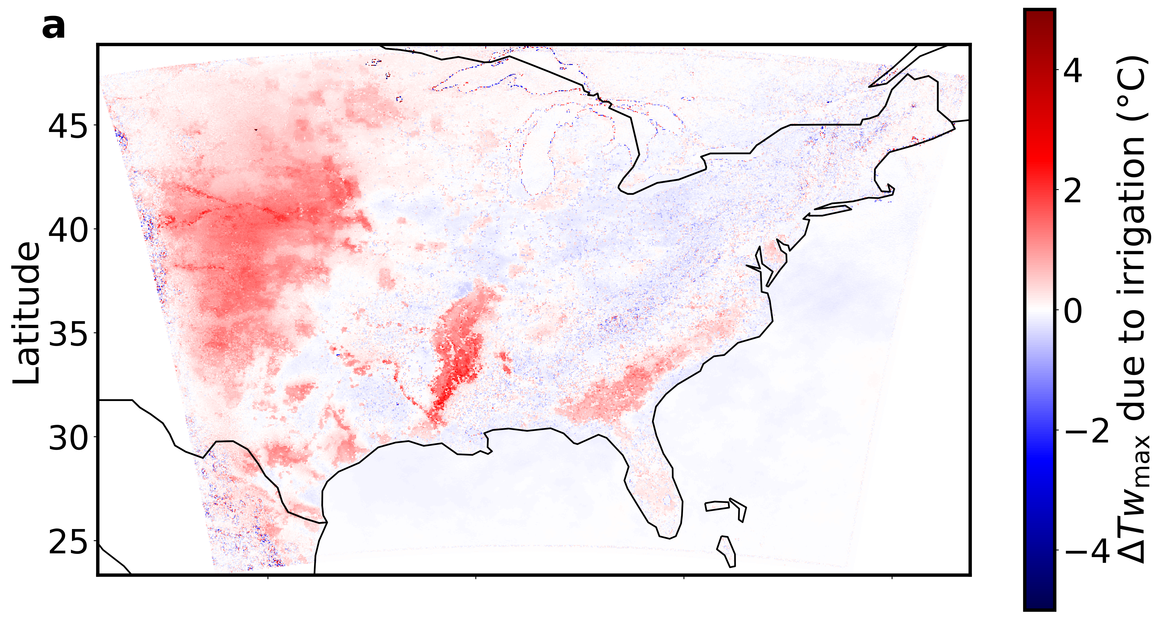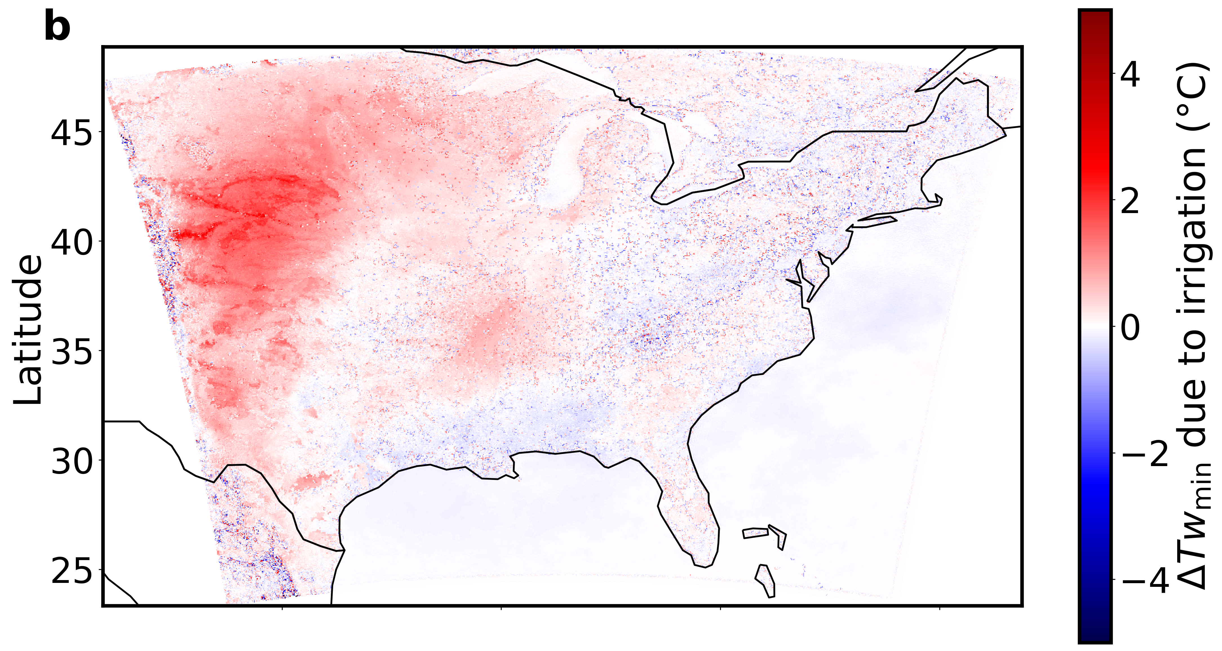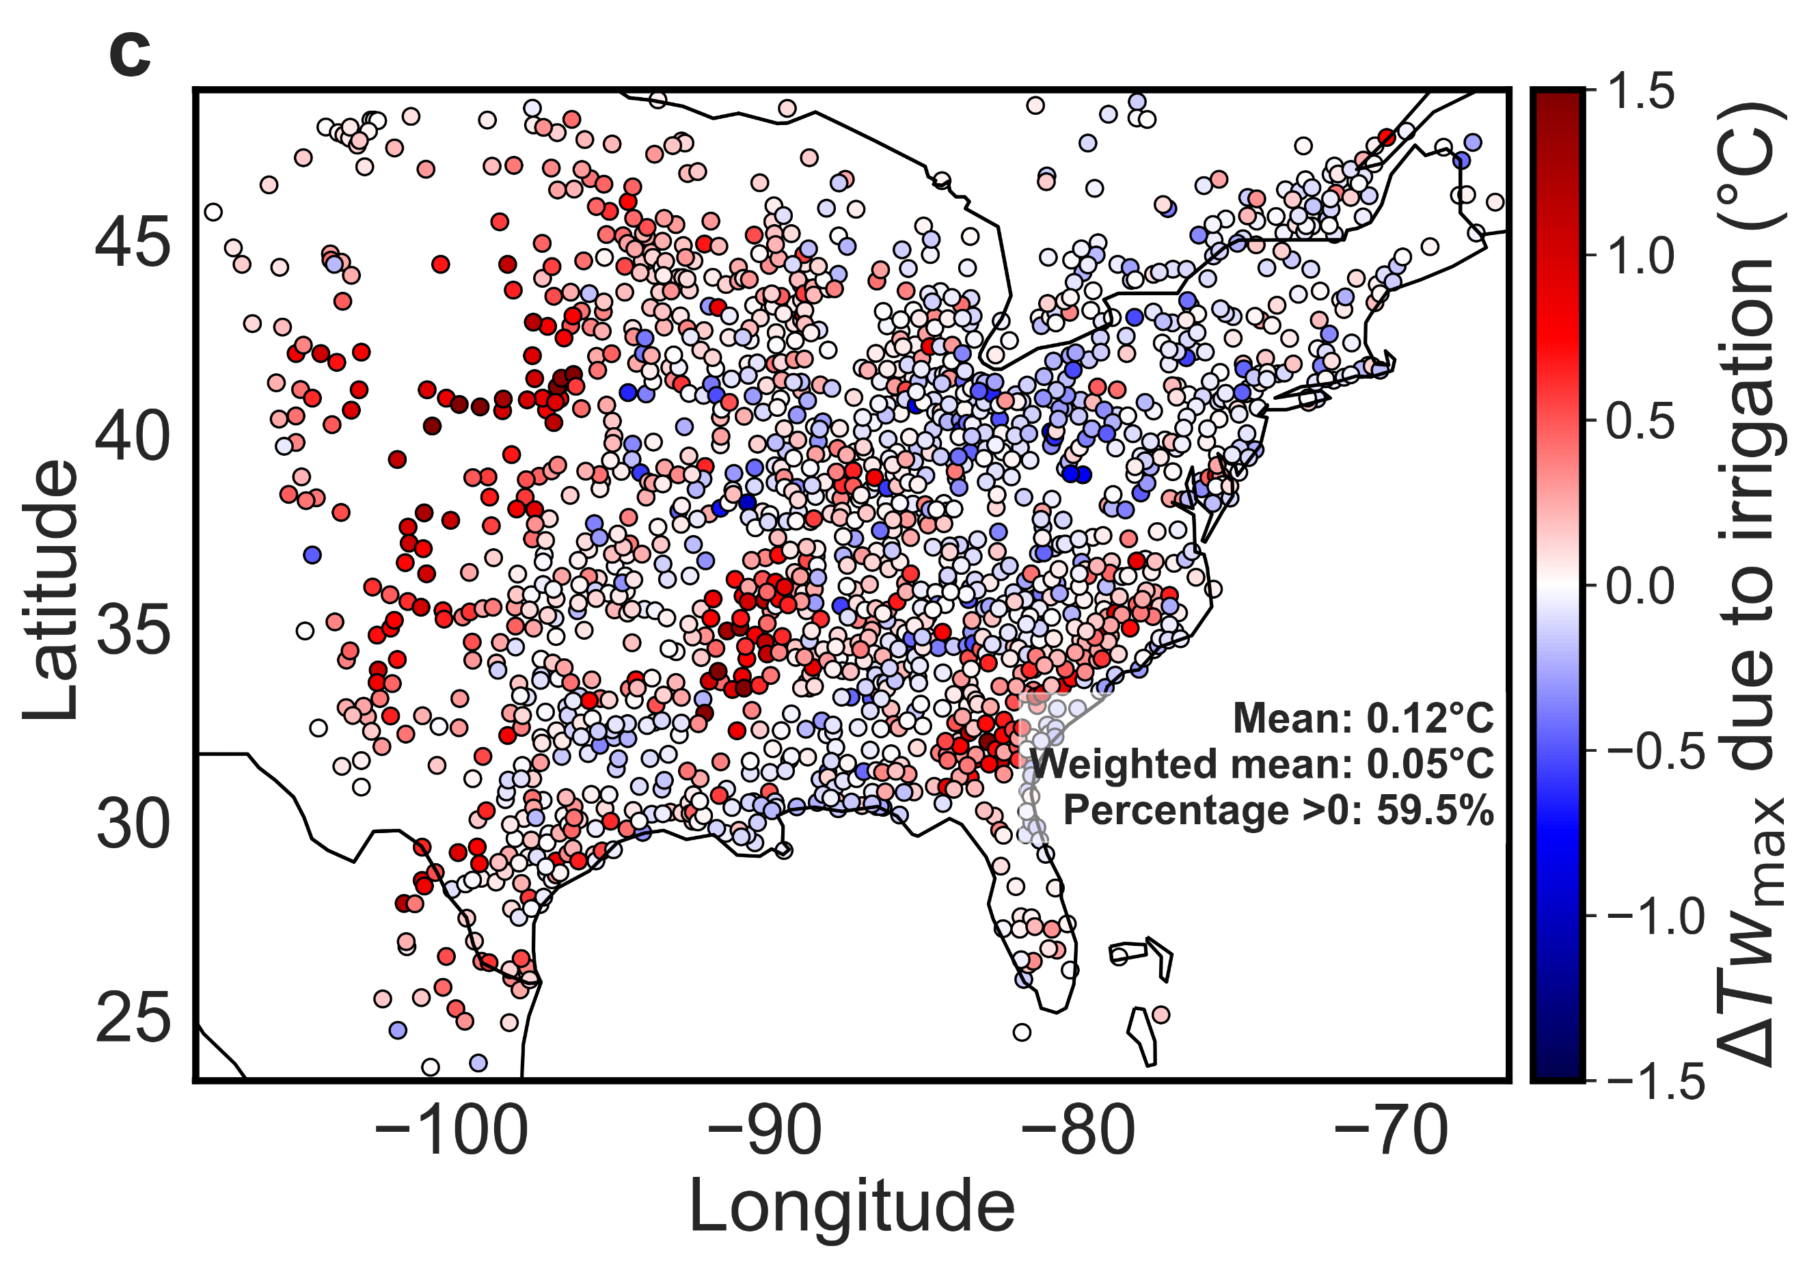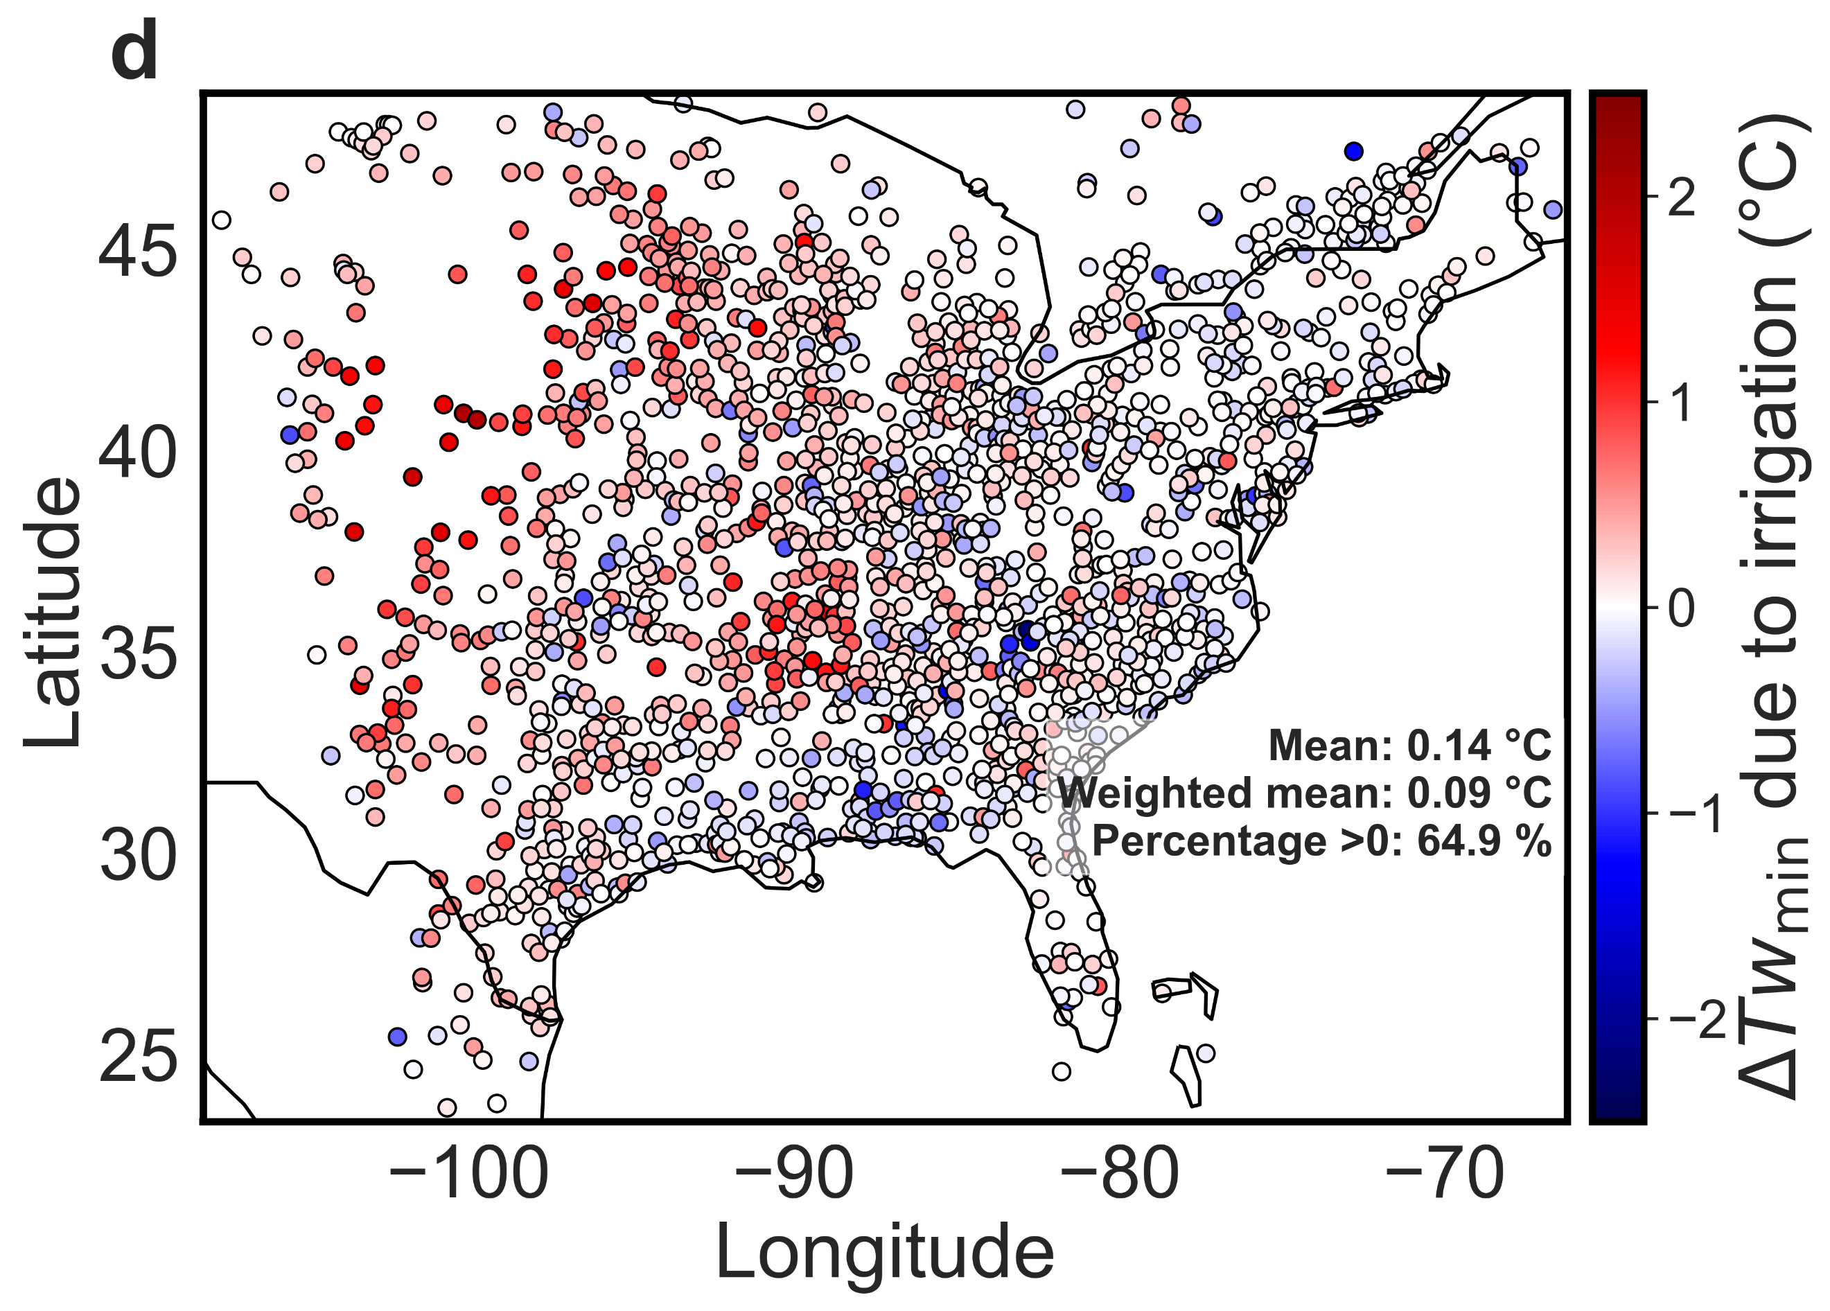
Fig. S6 | Changes in wet-bulb temperature | Grid-wise changes in a maximum and, b minimum wet-bulb temperature (ΔTw_{max} and ΔTw_{min}, respectively) due to irrigation over the model domain. Sub-figures c and d are similar to a and b, but for urban-scale changes. Each c and d, each dot represents the spatial mean for an urban cluster. The urban spatial means, area weighted spatial means, and percentage of urban clusters with values above 0 are also noted for these.

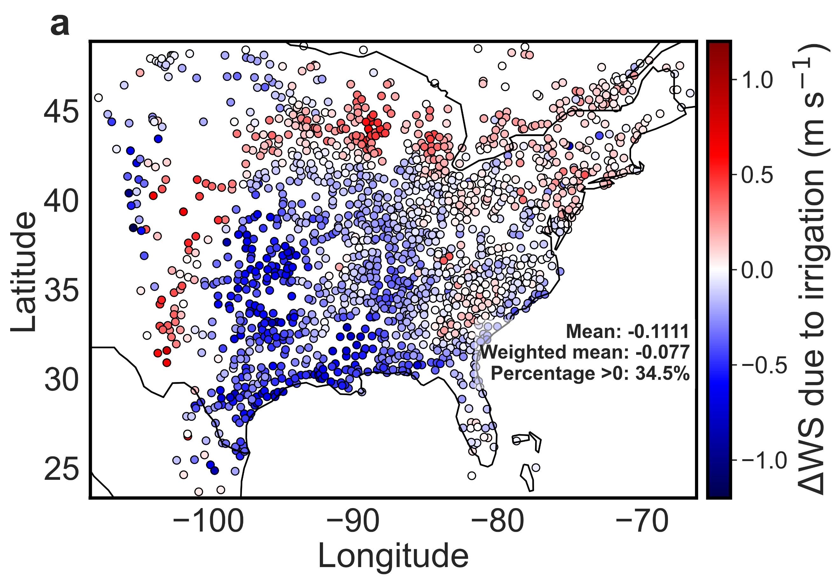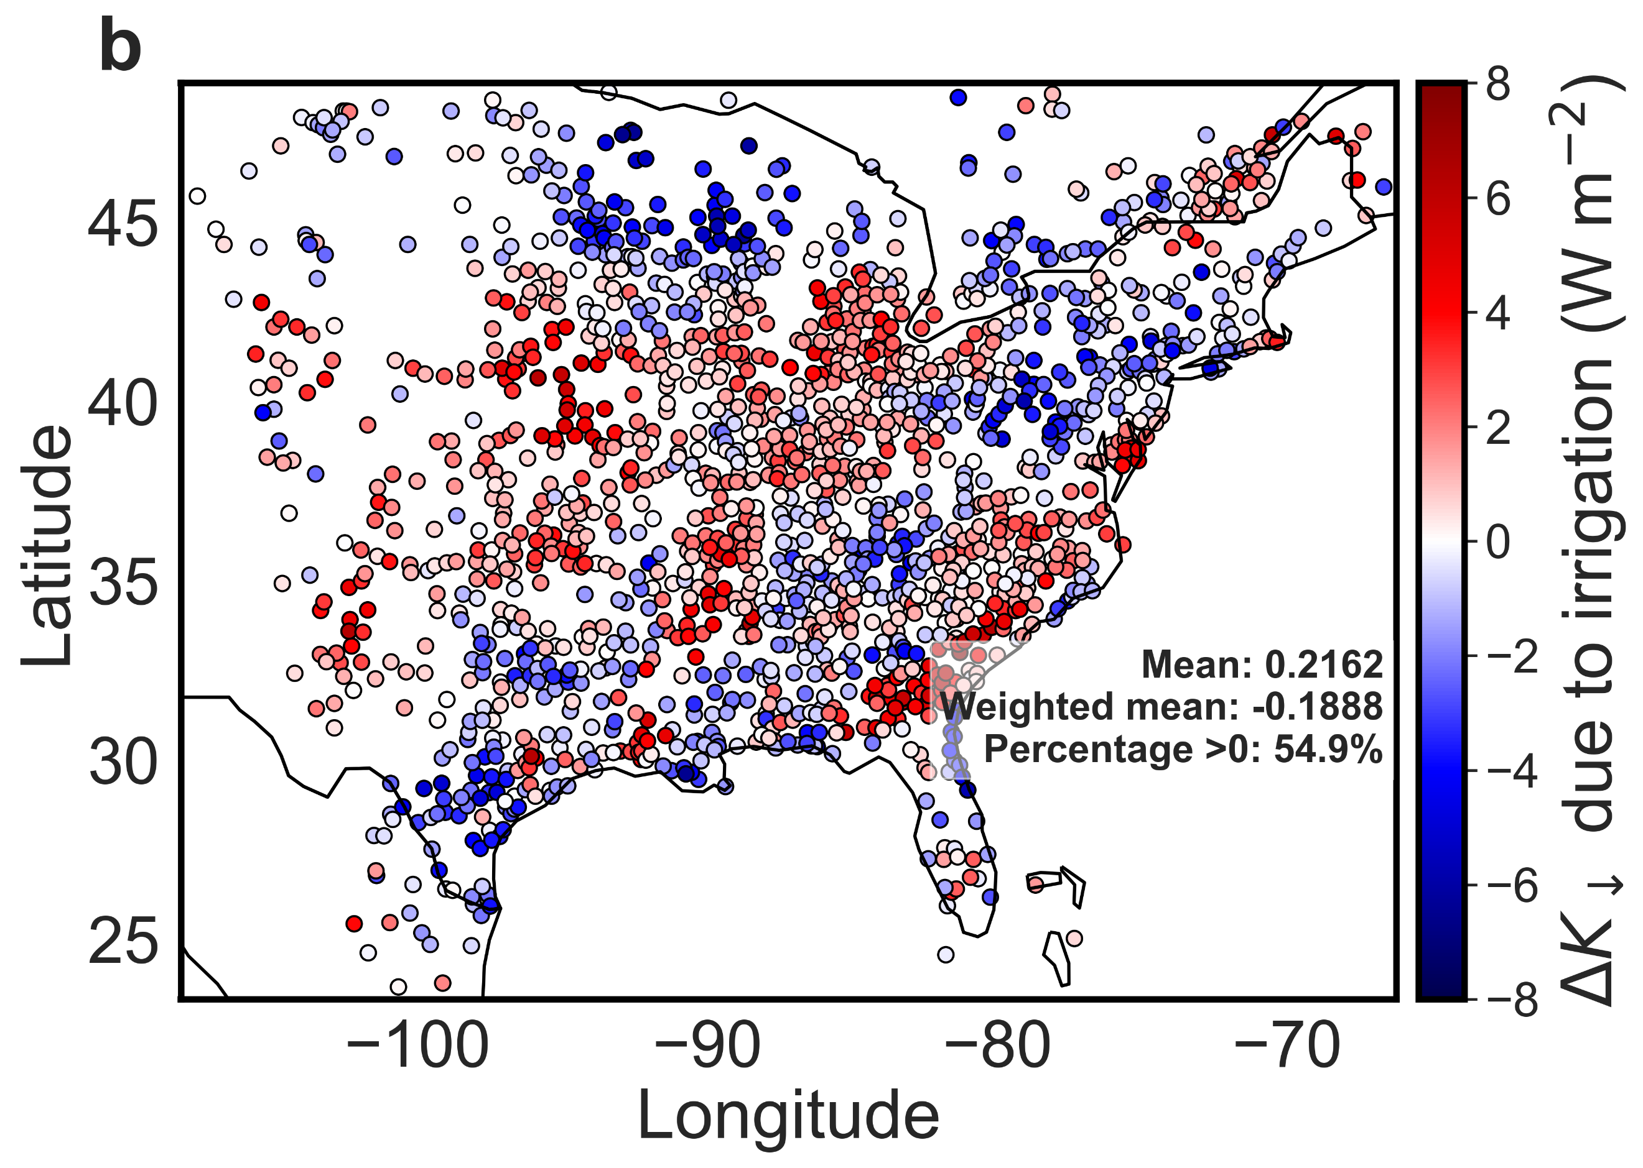
Fig. S7 | Changes in wind speed and incoming shortwave radiation due to irrigation | Urban-scale changes in a average wind speed (ΔWS), and b incoming shortwave radiation (ΔK↓) due to irrigation for every urban cluster in the model domain. Each dot represents the spatial mean for an urban cluster. The urban spatial means, area weighted spatial means, and percentage of urban clusters with values above 0 are also noted.

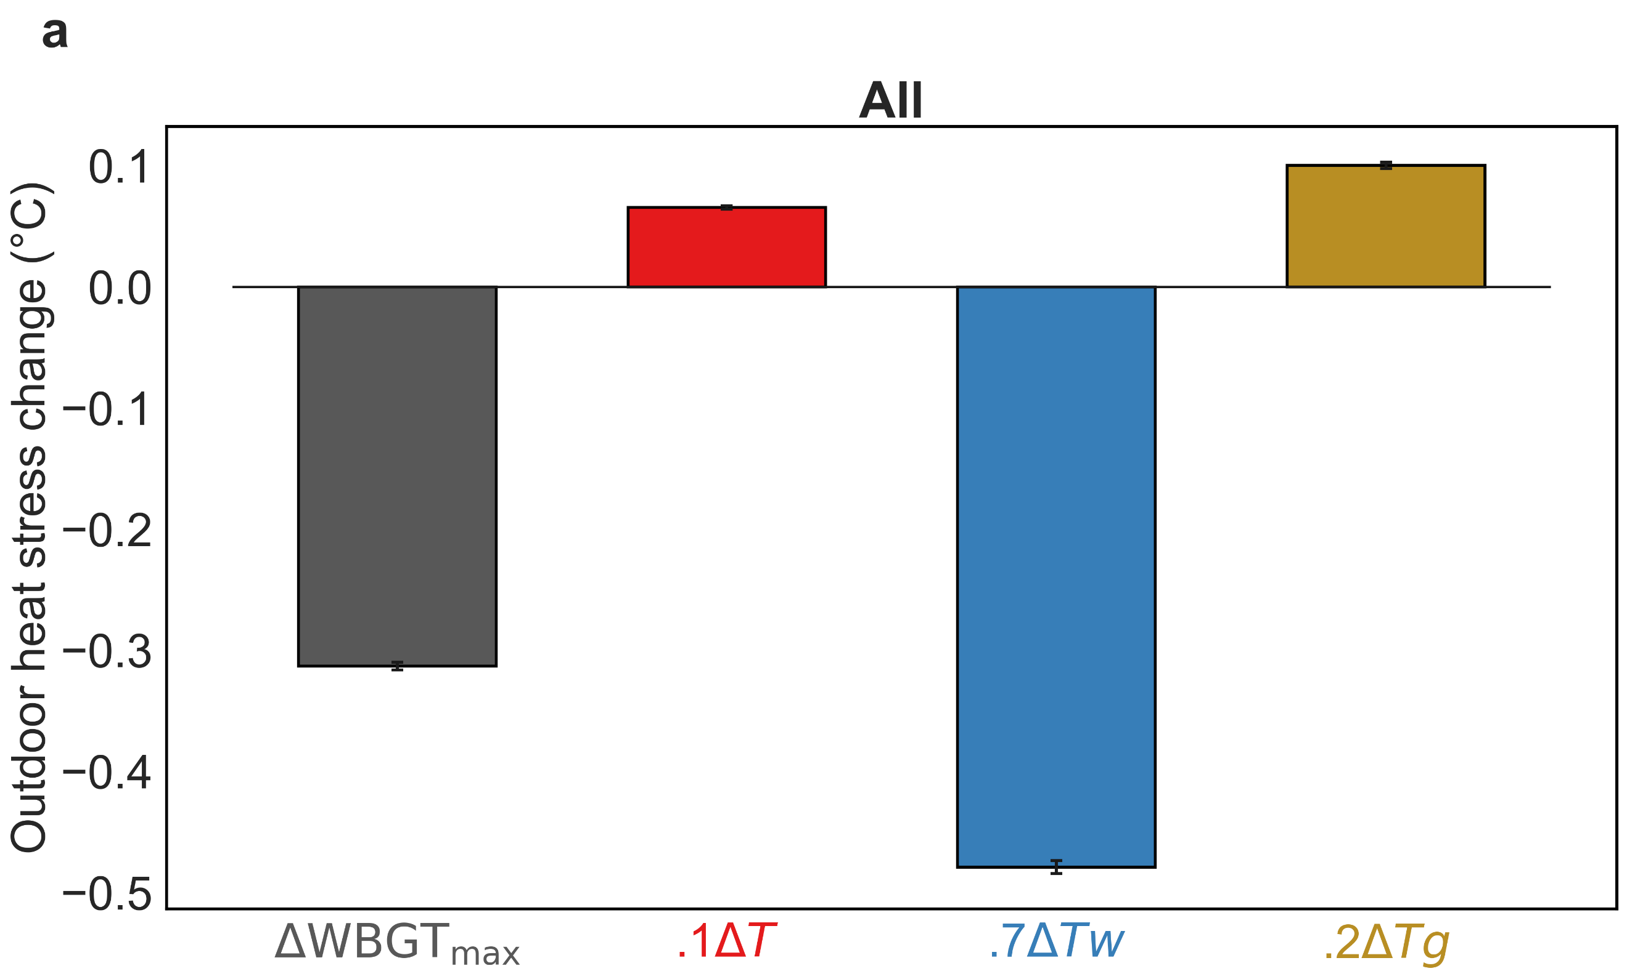
Fig. S8 | Changes in urban outdoor wet bulb globe temperature and its contributors due to urbanization | Changes in average a maximum and b minimum outdoor wet bulb globe temperature (ΔWBGT_{max} and ΔWBGT_{min}, respectively) in urban clusters due to urbanization. Sub-figures c, d, e, and f are similar to a (for ΔWBGT_{max}), but for arid, boreal, temperate, and tropical urban clusters, respectively. Similarly, sub-figures g, h, i, and j are for ΔWBGT_{min} by climate zone. The contributions of change in dry bulb or air temperature (ΔT), wet-bulb temperature (ΔTw), and black globe temperature (ΔTg) corresponding to the time of ΔWBGT_{max} and ΔWBGT_{min} are shown for all cases, where 0.1, 07, and 0.2 are the weighing factors as per Eq. 1. The bars show changes in the area weighted means and the error bars show area weighted standard errors.
Fig. S9 | Changes in urban indoor wet bulb globe temperature and its contributors | Changes in average a maximum and b minimum outdoor wet bulb globe temperature (ΔWBGT_{max} and ΔWBGT_{min}, respectively) in urban clusters due to irrigation. Sub-figures c, d, e, and f are similar to a (for ΔWBGT_{max}), but for arid, boreal, temperate, and tropical urban clusters, respectively. Similarly, sub-figures g, h, i, and j are for ΔWBGT_{min} by climate zone. The contributions of change in wet-bulb temperature (ΔTw), and black globe temperature (ΔTg) corresponding to the time of ΔWBGT_{max} and ΔWBGT_{min} are shown for all cases, where 07, and 0.3 are the weighing factors as per Eq. 5 in Methods. The bars show changes in the area weighted means and the error bars show area weighted standard errors.
Fig. S10 | Model evaluation | Evaluation of maximum and minimum air temperature (T_{max} and T_{min}, respectively) in a ‘no urban’ simulation, b ‘urban’ simulation, and c ‘irrigation’ simulation against the Zhang et al. dataset for the 2008-2012 summer (June, July, August) period. Each datapoint is one urban cluster. The lines of best fit, coefficient of determination (r²), root mean square error (RMSE), mean bias error (MBE), and mean percentage error (MPE) are noted for each case. The color indicates the density of data points.

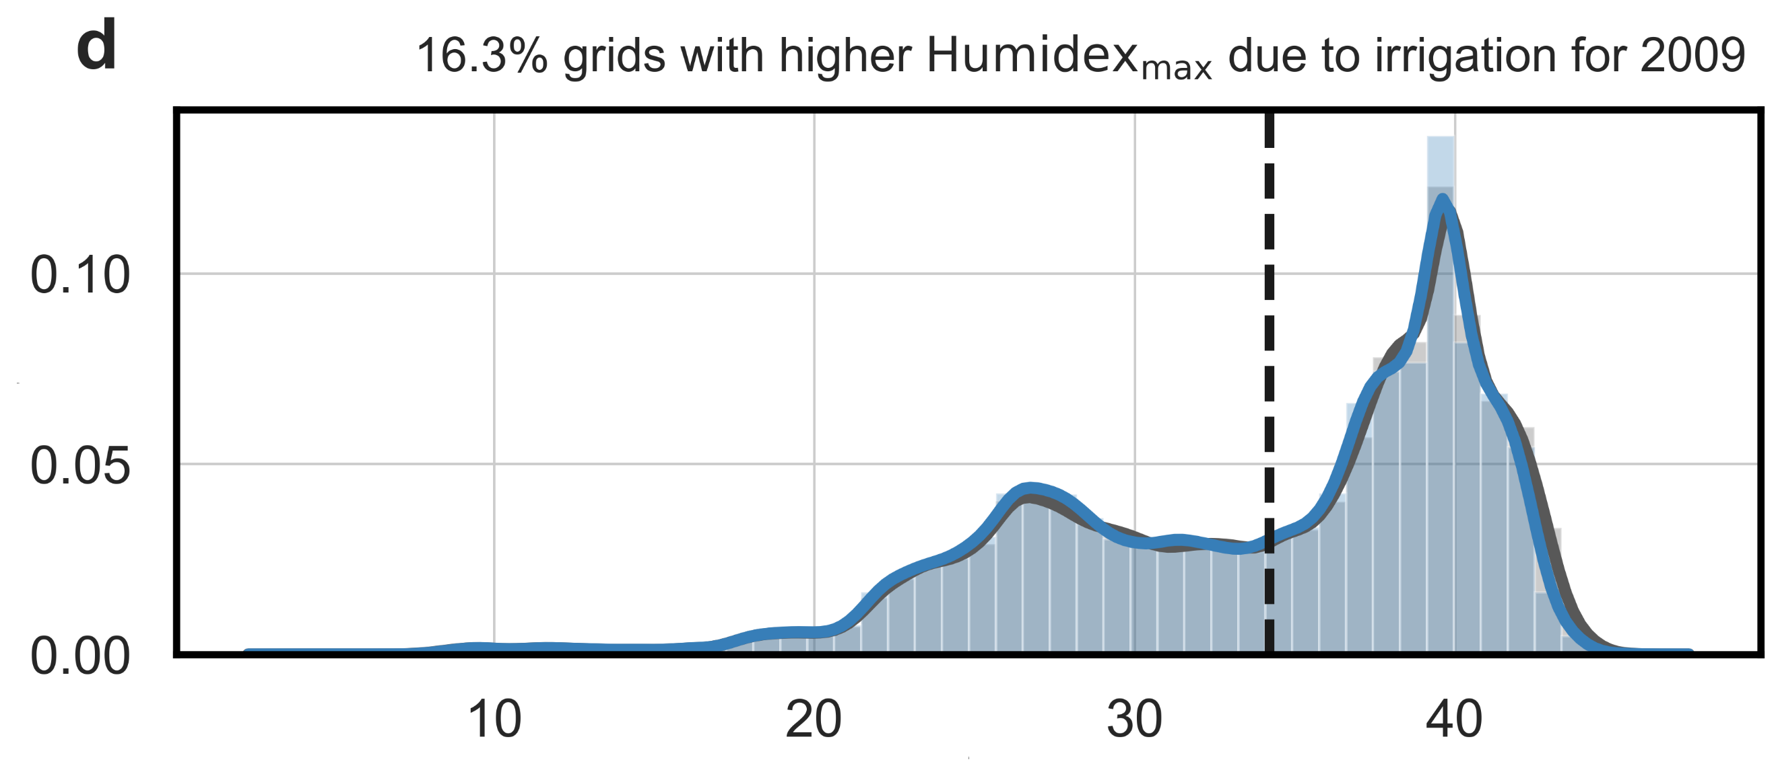
Fig. S11 | Consistency across ensemble members | Probability density distributions of grid-averaged maximum heat index (HI_{max}) for a 2008, c 2009, e 2010, g 2011, and i 2012. Sub-figures b, d, f, h, and j are similar to a, c, e, g, and I, but for maximum Humidex (Humidex_{max}). The vertical black dashed lines represent the mean values and the percentage of grids where the values increase due to irrigation is noted for each case.

