Supporting Information (SI)
Copies of ¹H, ¹³C NMR, and Mass spectra:

Table 2, entry 4a
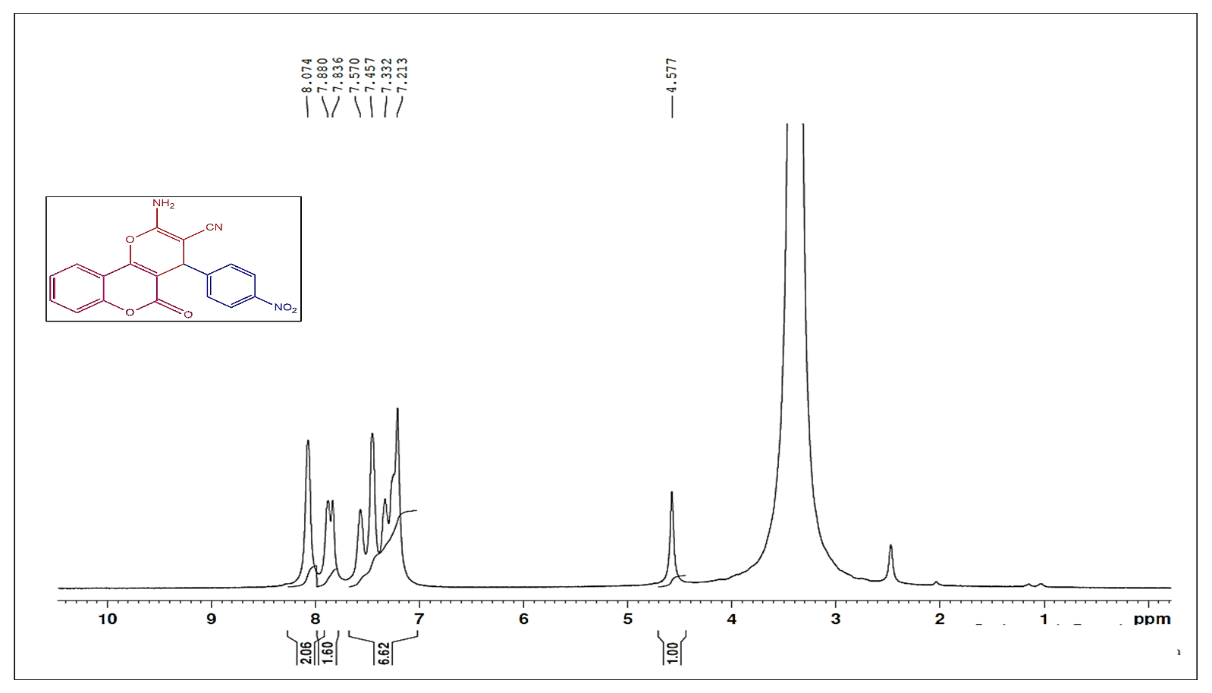
Figure C1: The¹H NMR spectrum of 2-amino-4(4-nitrophenyl)-5-oxo-4,5-dihydroxypyrano[3,2-c] chromene-3-carbonite (4a).
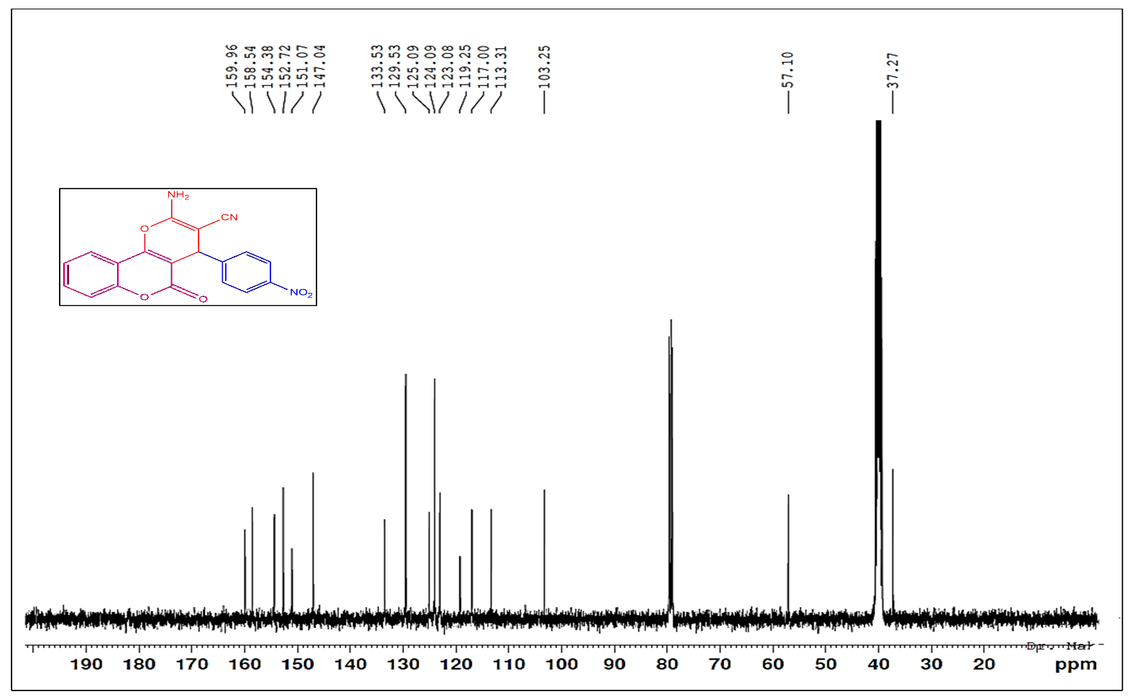
Figure C1: The¹³C NMR spectrum of 2-amino-4(4-nitrophenyl)-5-oxo-4,5-dihydroxypyrano[3,2-c]
chromene-3- carbonite (4a).
Table 2, entry 4b
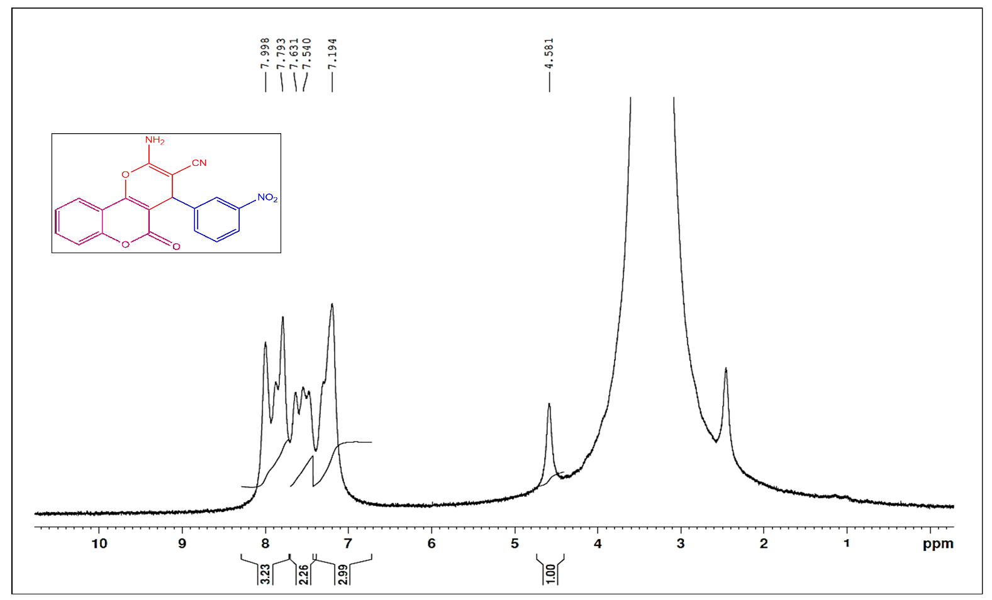
Figure C2: The¹H NMR spectrum of 2-amino-4(3-nitrophenyl)-5-oxo-4,5-dihydroxypyrano[3,2-c] chromene-3-carbonite (4b).
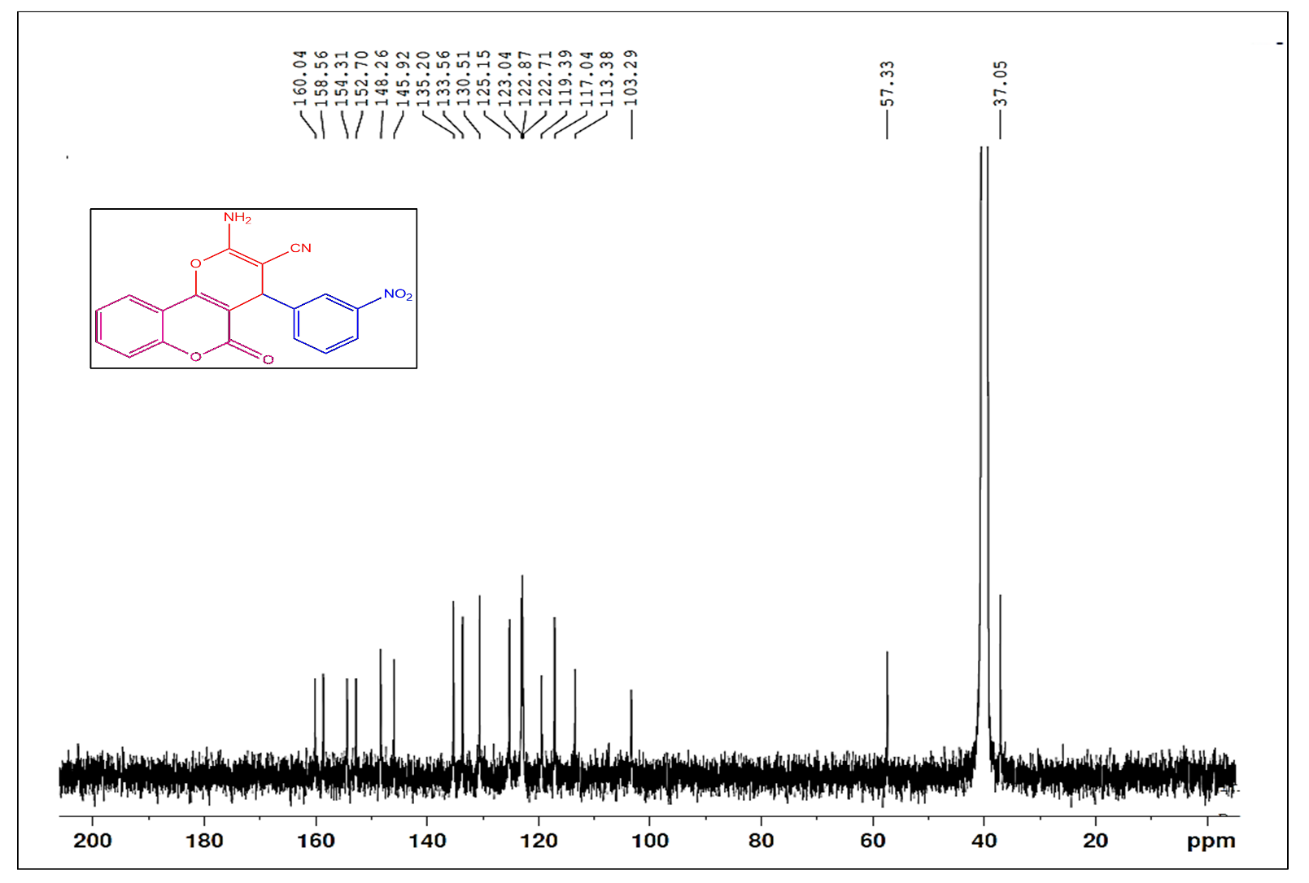Figure C2: The¹³C NMR spectrum of 2-amino-4(3-nitrophenyl)-5-oxo-4,5-dihydroxypyrano[3,2-c] chromene-3-carbonite (4b).
Table 2, entry 4c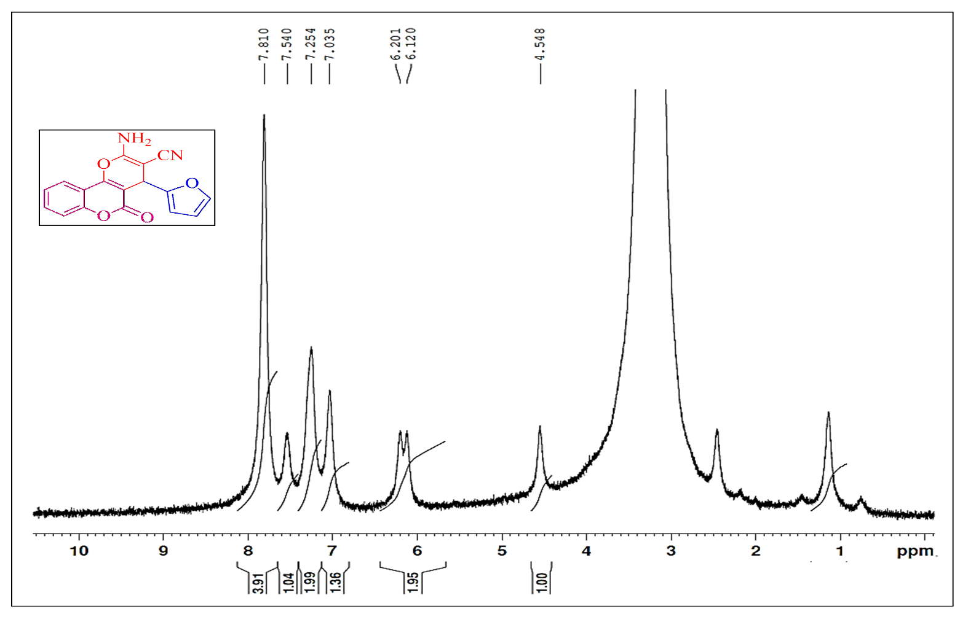Figure C3: The¹H NMR spectrum of 2-amino-4-(Furan-2-yl)-5-oxo-4,5-dihydroxypyrano[3,2-c]
chromene-3-carbonite (4c).
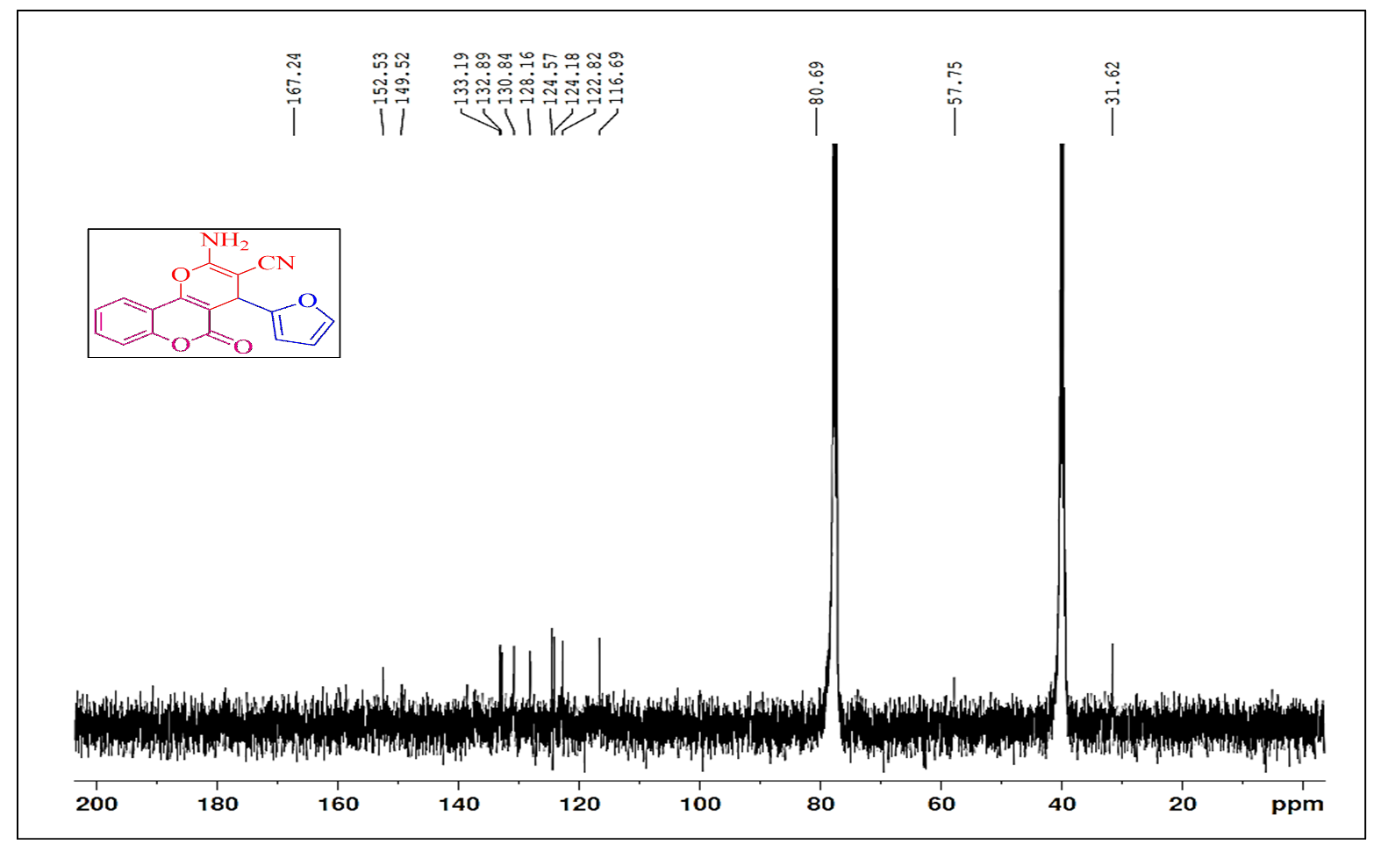
Figure C3: The¹³C NMR spectrum of 2-amino-4-(Furan-2-yl)-5-oxo-4,5-dihydroxypyrano[3,2-c]
chromene-3-carbonite (4c).

Table 2, entry 4d
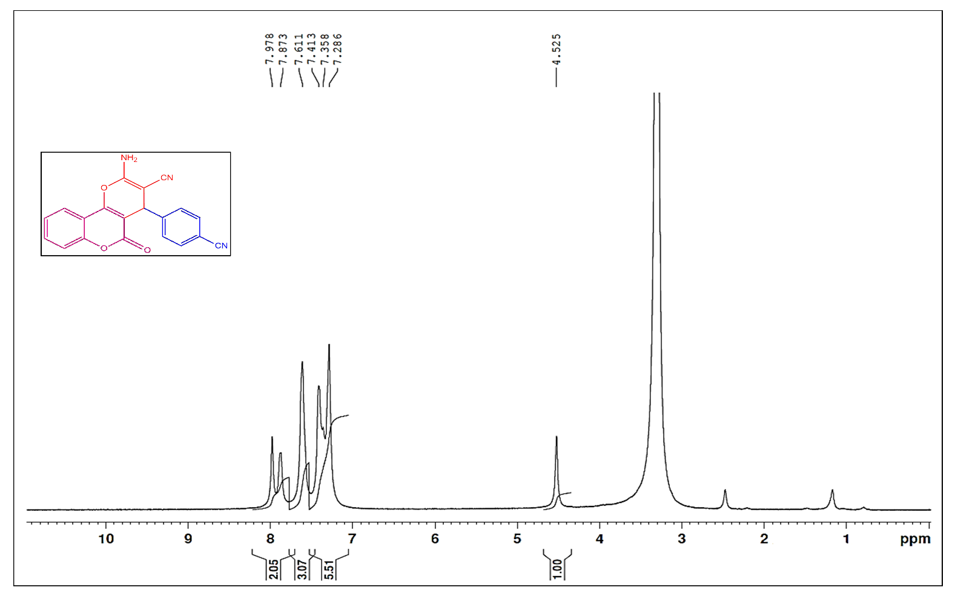Figure C4: The¹H NMR spectrum of 2-amino-4(4-cynophenyl)-5-oxo-4,5-dihydroxypyrano[3,2-c] chromene-3-carbonite (4d).
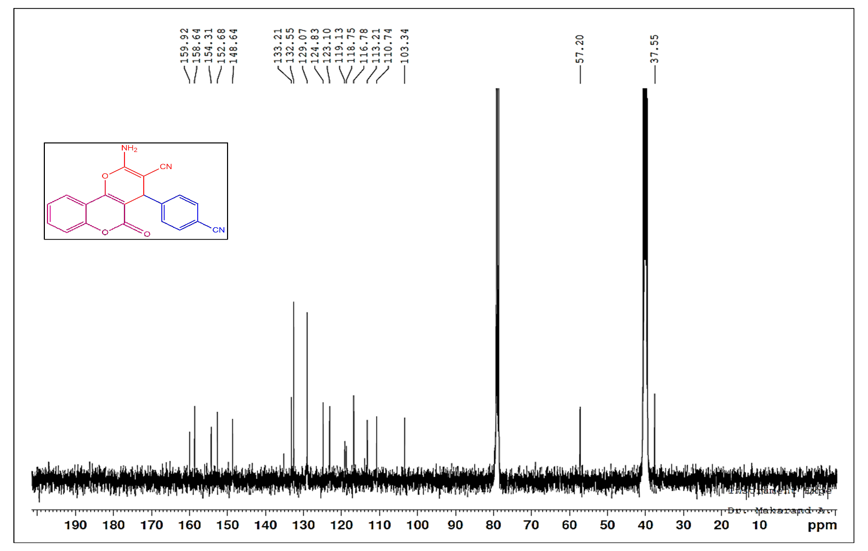Figure C4:The¹³C NMR spectrum of 2-amino-4(4-cynophenyl)-5-oxo-4,5-dihydroxypyrano[3,2-c] chromene-3-carbonite (4d).
Table 2, entry 4e
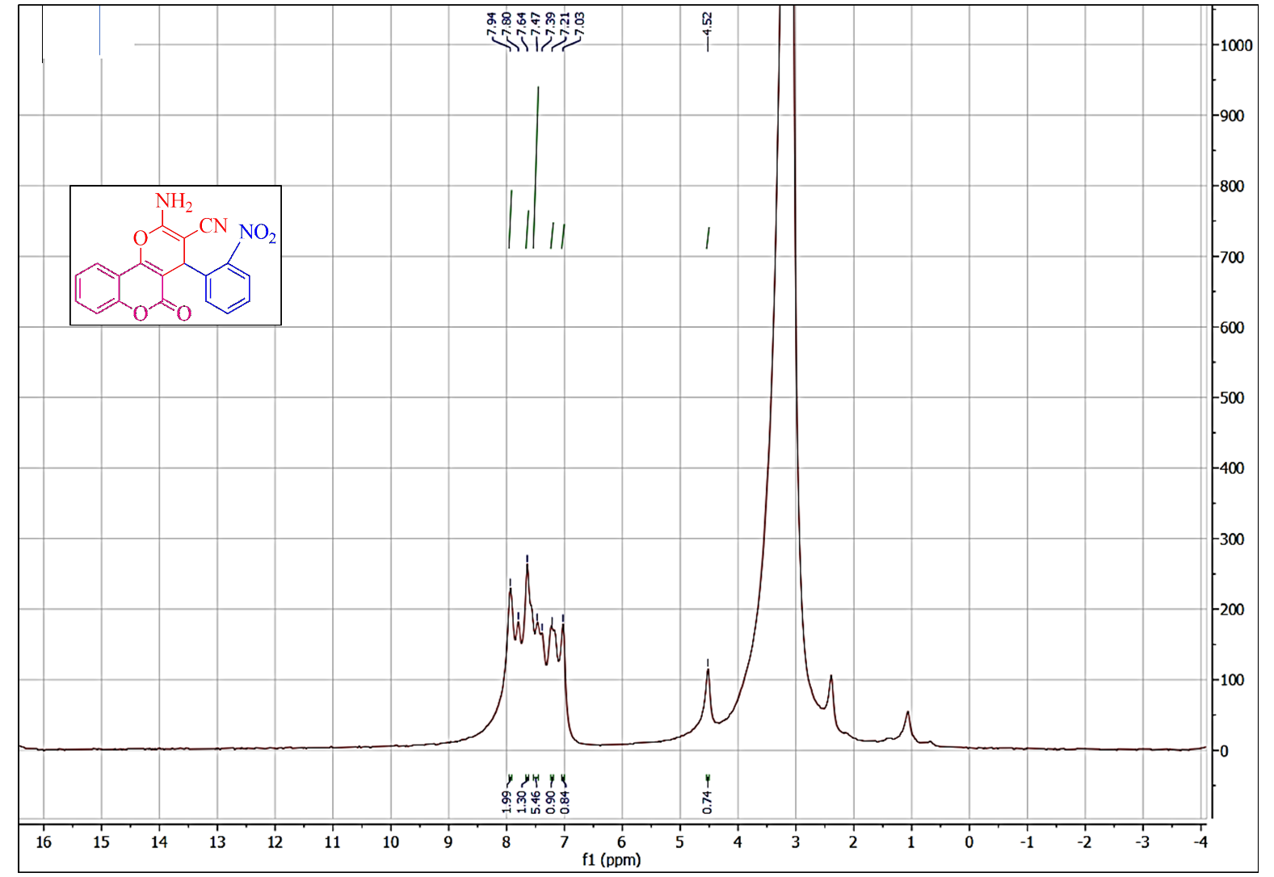
Figure C5: The¹H NMR spectrum of 2-amino-4(2-nitrophenyl)-5-oxo-4,5-dihydroxypyrano[3,2-c] chromene-3-carbonite (4e).
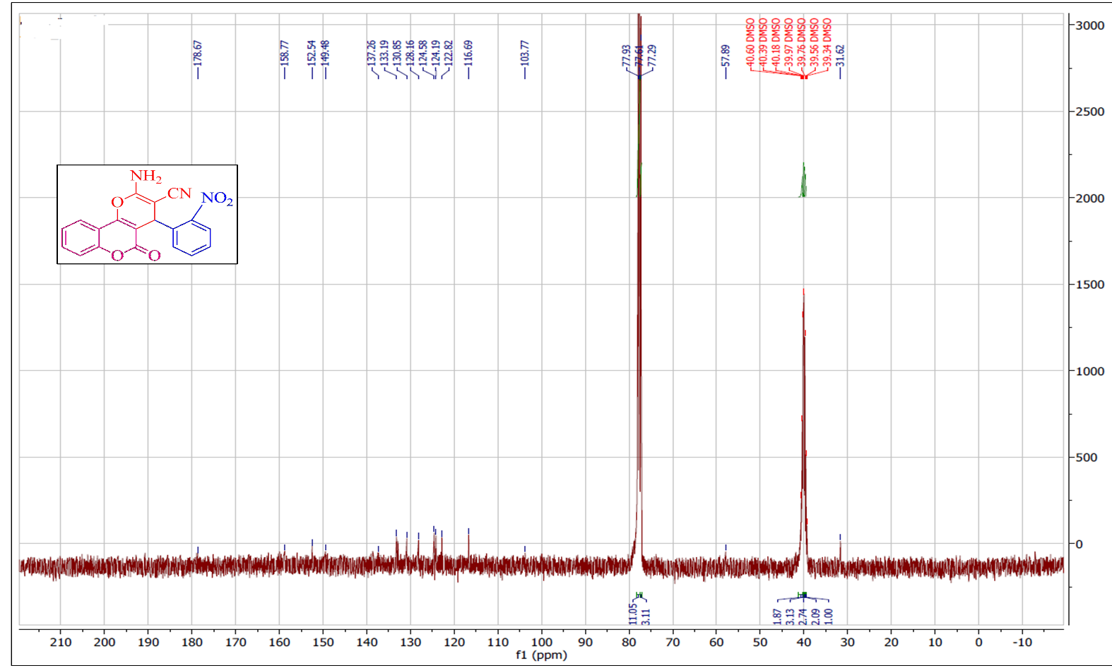
Figure C5:The¹³C NMR spectrum of 2-amino-4(4-bromophenyl)-5-oxo-4,5-dihydroxypyrano[3,2-c]
chromene-3-carbonite (4e).
Table 2, entry 4f
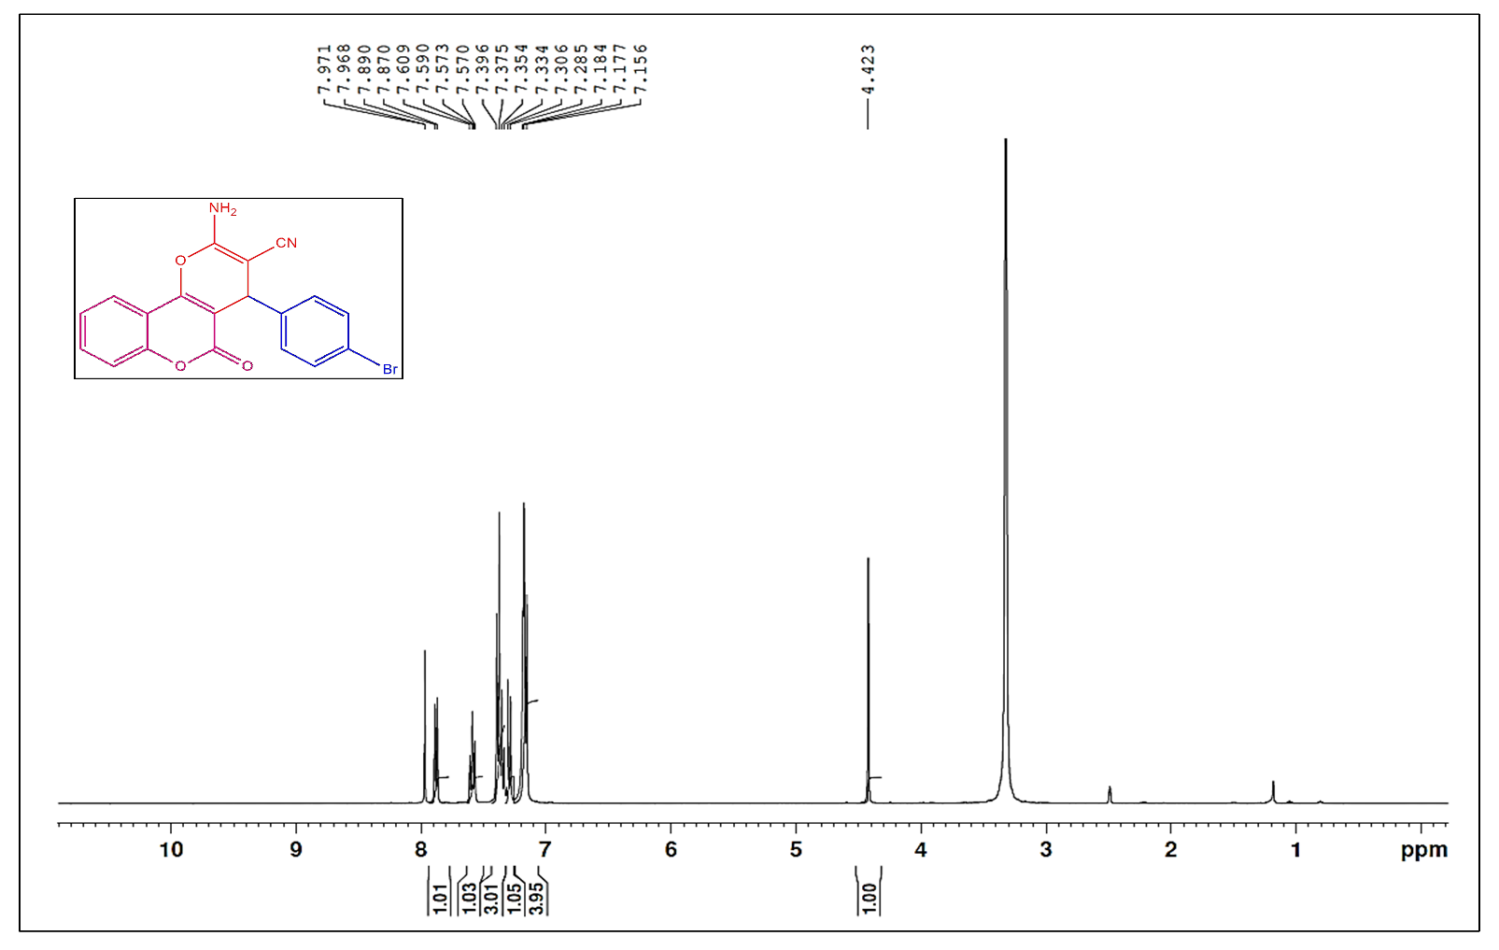Figure C6: The¹H NMR spectrum of 2-amino-4(4-bromophenyl)-5-oxo-4,5-dihydroxypyrano[3,2-c] chromene-3-carbonite (4d).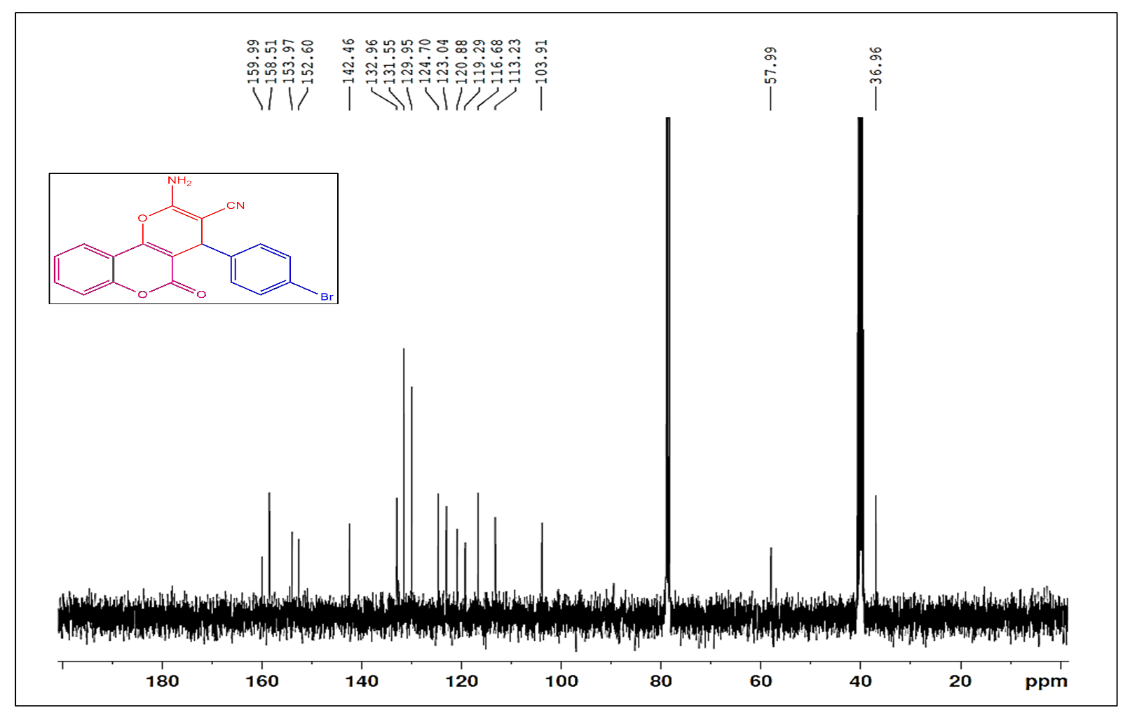
Figure C6:The¹³C NMR spectrum of 2-amino-4(4-bromophenyl)-5-oxo-4,5-dihydroxypyrano[3,2-c] chromene-3-carbonite (4d).
Table 2, entry 4g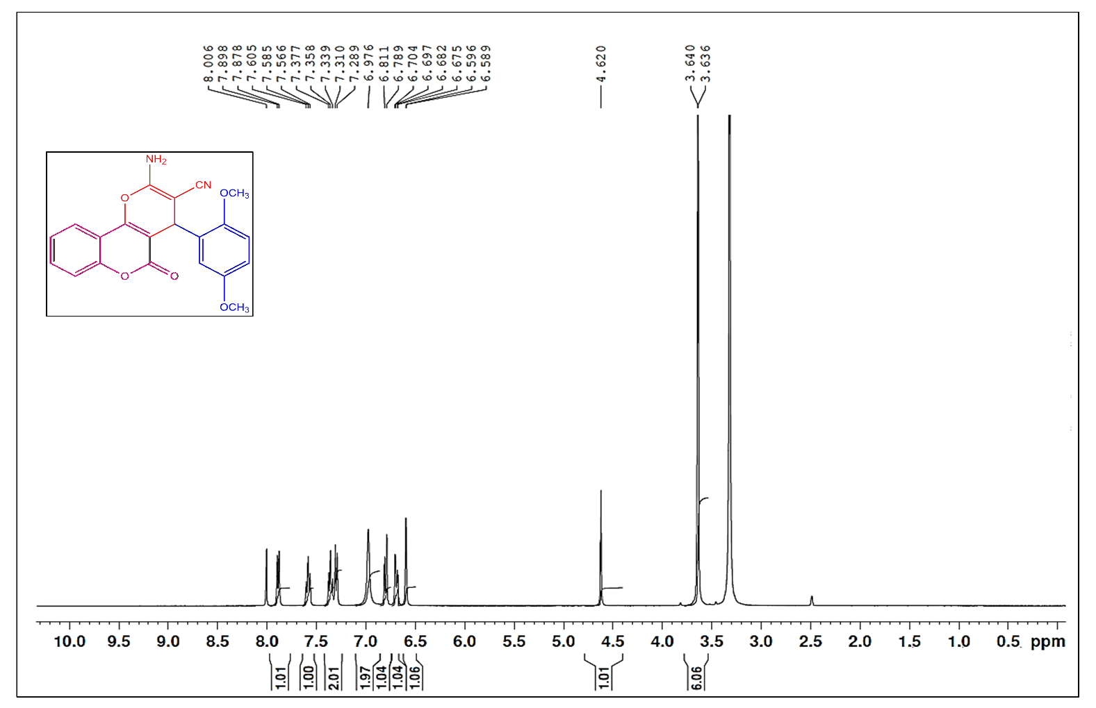Figure C7: The¹H NMR spectrum of 2-amino-4(2,5-dimethoxyphenyl)-5-oxo-4,5-dihydroxypyrano[3,2-c]
chromene-3-carbonitrle(4g).
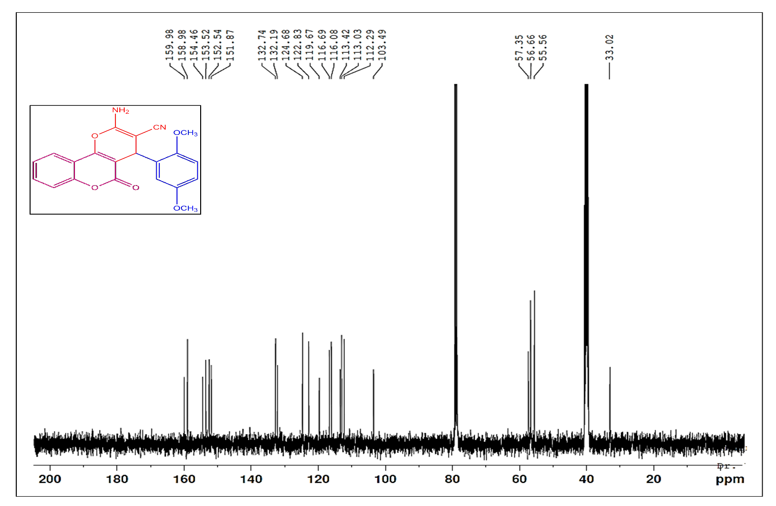
Figure C7:The¹³C NMR spectrum of 2-amino-4(2,5-dimethoxyphenyl)-5-oxo-4,5-dihydroxypyrano[3,2-c] chromene-3-carbonitrle(4g).
Table 2, entry 4h
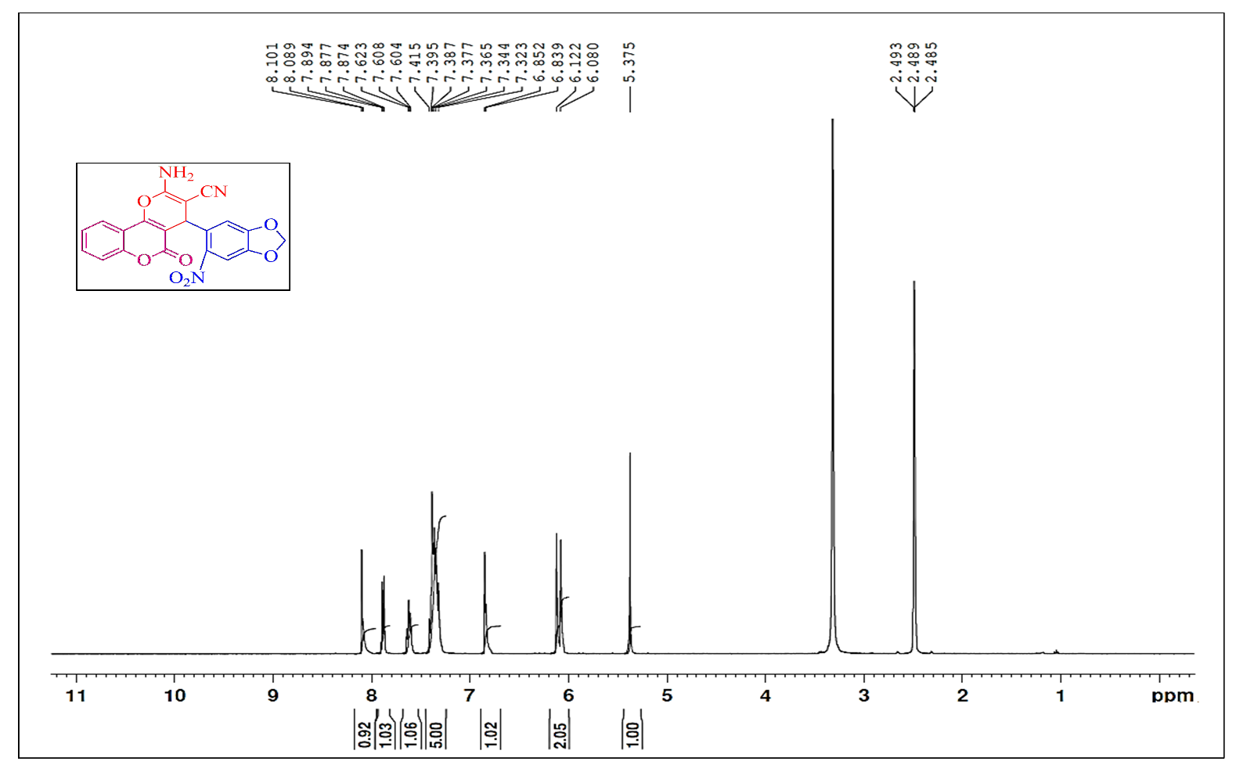Figure C8: The¹H NMR spectrum of 2-amino-4(6 nitrobenzo[d] [1,3] diaoxol-5-yl)-5-oxo-4,5-
dihydroxypyrano[3,2-c] chromene-3-carbonitrle(4h).
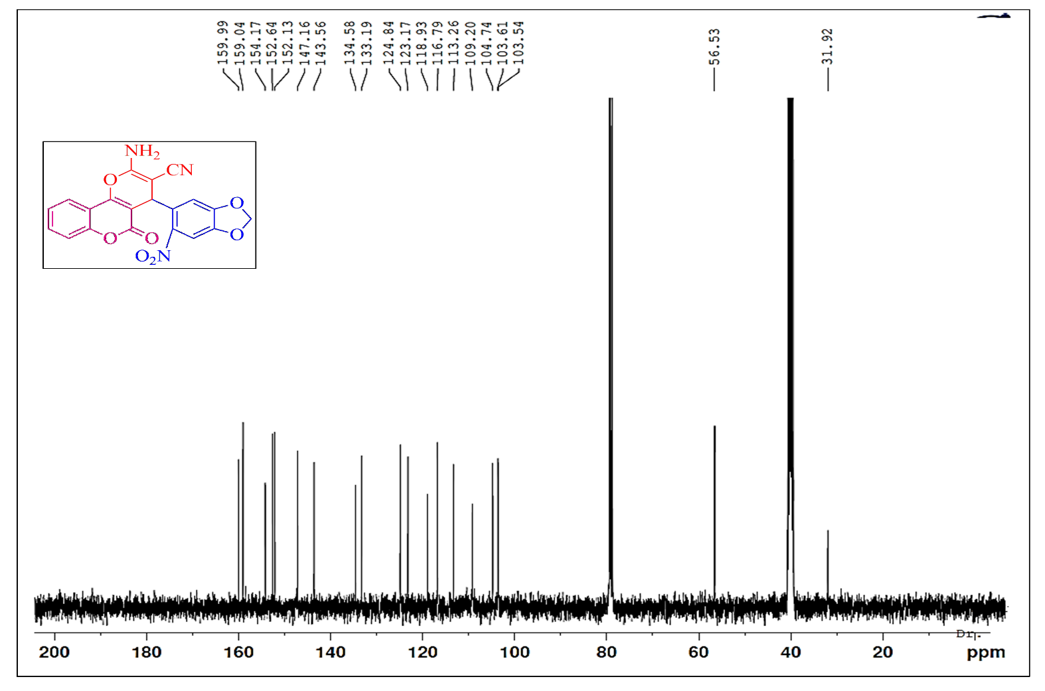
Figure C8: The¹³C NMR spectrum of 2-amino-4(6 nitrobenzo[d] [1,3] diaoxol-5-yl)-5-oxo-4,5-
dihydroxypyrano[3,2-c] chromene-3-carbonitrle(4h).
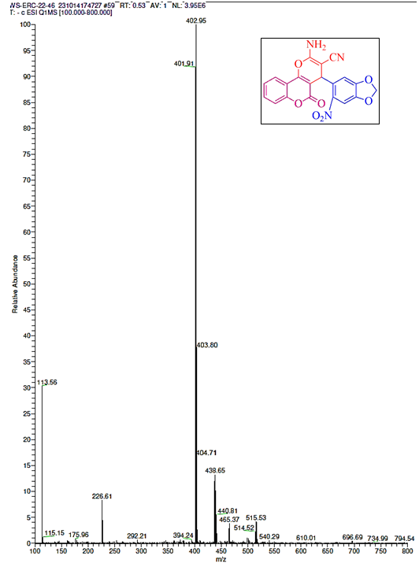
Figure C8: The Mass spectrum of 2-amino-4(6 nitrobenzo[d] [1,3] diaoxol-5-yl)-5-oxo-4,5-
dihydroxypyrano[3,2-c] chromene-3-carbonitrle(4h).

