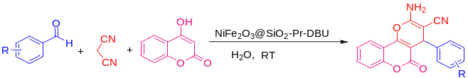
Scheme 1 Synthesis of 2,3-dihydroquinazolin-4(1H)-ones.

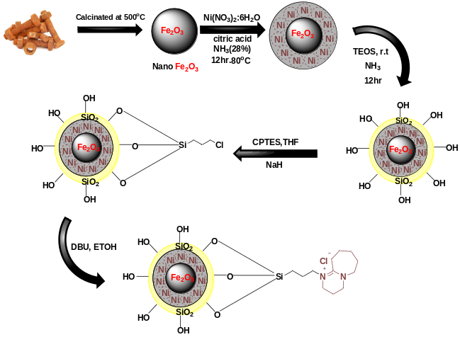
SCHEME 2 The schematic synthetic pathway of magnetically separable core-shell NiFe₂O₃@SiO₂-Pr-DBU

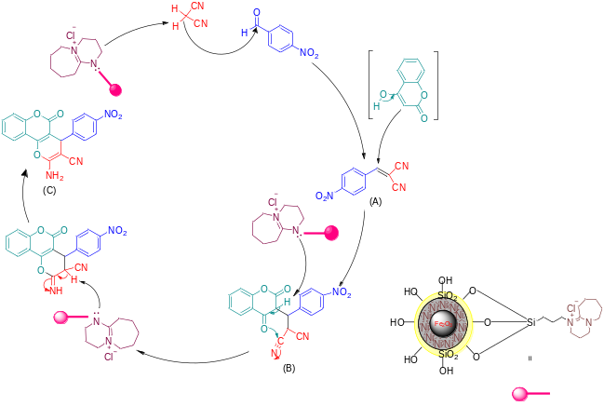
Scheme 3 A tenable chemical pathway using NiFe₂O₃@SiO₂-Pr-DBU catalyst to synthesize dihydropyrano[3,2-c] chromenes.

