Table 1 Screening of reaction parameters for the synthesis of
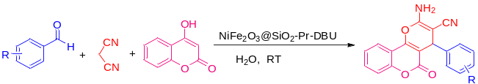
Entry | Catalyst (mg) | Solvent | Time  (min) | Yield (%)
1 | Catalyst Free | Ethanol | 480 | 15
2 | CuCr₂O₄ (10) | Water | 100 | 60
3 | [Sipim]HSO₄ (100) | Water (Reflux) | 75 | 75
4 | [Sipim]HSO₄ (100) | Ethanol: Water (1:1) (Reflux) | 60 | 86
5 | NiFe₂O₃@SiO₂-Pr-DBU nanocatalyst (5) | Ethanol | 50 | 80
6 | NiFe₂O₃@SiO₂-Pr-DBU nanocatalyst (10) | Ethanol | 35 | 85
7 | NiFe₂O₃@SiO₂-Pr-DBU nanocatalyst (10) | Water | 25 | 92
8 | NiFe₂O₃@SiO₂-Pr-DBU nanocatalyst (15) | Water | 15 | 96

Table 2 Synthesis of dihydropyrano[3,2-c] chromenes using NiFe₂O₃@SiO₂-Pr-DBU nanocatalyst. ^{a, b}
