Figure S1. Neighbour-joining tree of cytochrome c oxidase subunit 1 (COI) sequences of sand fly species from Coban, Guatemala. The tree was built with 10000 bootstraps. The numbers indicate bootstrap values above 70. The identification of the genus Lutzomyia, Brumptomyia and Dampfoyia to species level was hampered by the lack of diagnostic characters in the stored individuals.
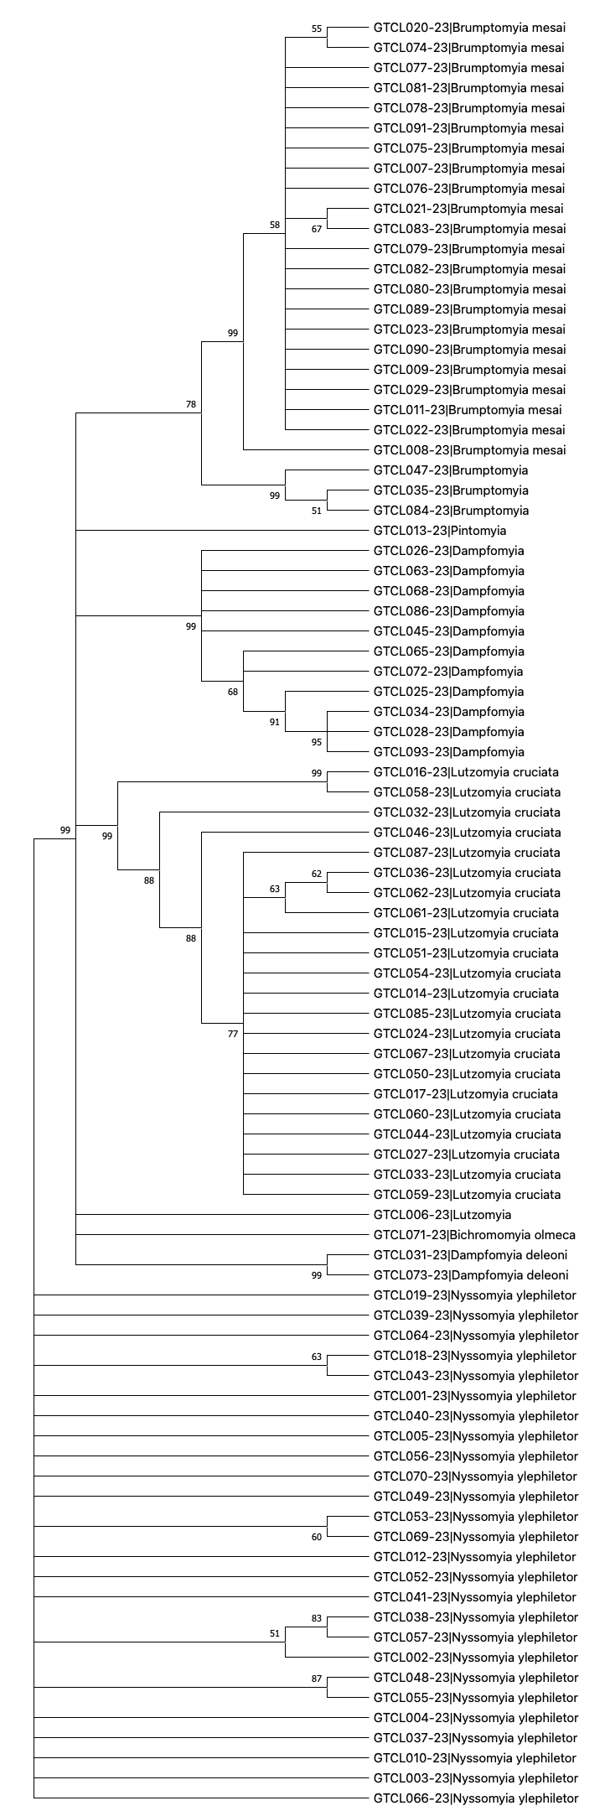

Table S1. Assigned Barcode Index Number (BIN) for the sand flies of Coban, Guatemala. The individuals identified to genus level (Lutzomyia, Brumptomyia, Dampfomyia) were assigned a unique BIN as identification to species level was not achieved. Two individuals of Lutzomyia cruciata were also assigned a unique BIN. The remaining species were grouped into the BIN of the same species already stored in the Barcode of Life Data System (BOLD).

Unique BIN (4)
BIN | Total Members (BOLD) | Taxa | Count in project
BOLD:AFH1678 | 2 | Lutzomyia cruciata | 2
BOLD:AFH2483 | 11 | Dampfomyia | 11
BOLD:AFH2606 | 1 | Lutzomyia | 1
BOLD:AFI6352 | 2 | Brumptomyia | 2
Non-unique BIN(6)
BIN | Total Members (BOLD) | Taxa | Count in project
BOLD:AAM9640 | 31 | Brumptomyia mesai | 21
BOLD:ACT9235 | 7 | Dampfomyia deleoni | 1
BOLD:ADB0332 | 183 | Pintomyia | 1
BOLD:ADP3520 | 21 | Lutzomyia cruciata | 19
BOLD:ADW1198 | 2 | Bichromomyia olmeca | 1
BOLD:AEV1344 | 29 | Nyssomyia ylephiletor | 26

