Title
Equisetum diffusum methanol extract attenuates RA by modulating the expression of key biomarkers like COX-2, TNF-α, IL-6, PPAR-γ, and Iκβ in Adjuvant-induced rats.

Sourav Sarkar¹, Debabrata Modak¹, Sudipta Kumar Roy¹, Gouhar Jahan Ashraf², Ayan Chakrabarty³, Ranabir Sahu², and Soumen Bhattacharjee^{1*}

¹Cell and Molecular Biology Laboratory, Department of Zoology, University of North Bengal, Darjeeling, 734013, West Bengal, India.
²Department of Pharmaceutical Technology, University of North Bengal, Darjeeling, 734013, West Bengal, India.
³Virus Research and Diagnostic Laboratory (ICMR), North Bengal Medical College and Hospital, Darjeeling, 734012, West Bengal, India.

E. mail address of all the co-authors:
Sourav Sarkar: rs_sourav@nbu.ac.in; Debabrata Modak: debabratacmbl@nbu.ac.in; Sudipta Kumar Roy: roysudipto16@nbu.ac.in; Gouhar Jahan Ashraf: rs_gouhar@nbu.ac.in; Ayan Chakrabarty: ayanchakraborty.vrdl@gmail.com; Ranabir Sahu: ranabirsahu@nbu.ac.in; Soumen Bhattacharjee: soumenb@nbu.ac.in.

*Corresponding author
Prof. (Dr.) Soumen Bhattacharjee,
Department of Zoology,
University of North Bengal,
Raja Rammohunpur,
Darjeeling 734013
West Bengal, India.
Phone: +91-9474674013 (M)
E. Mail: soumenb@nbu.ac.in / soumenb123@rediffmail.com

Supplementary Table S1: Effect of Equisetum diffusum whole plant methanol extract (EDME) on the paw circumference (mm) of different experimental rat groups (n=6).
Results are represented as Mean ± S.E.M and analysed by two-way ANOVA following Dunnett’s multiple comparisons test. α indicates p≤ 0.001; β indicates p≤ 0.01; and γ indicates p≤ 0.05 as compared to arthritic control group.

Group | Arthritic Control group | Low Dose group of EDME | High Dose group of EDME
Day 0 | 33.961 ± 0.592 | 33.732 ± 0.568^{ns} | 33.042 ± 0.651^{ns}
Day 3 | 50.230 ± 0.413 | 48.623 ± 0.280^{ns} | 47.208 ± 0.553^{γ}
Day 6 | 56.176 ± 0.681 | 52.769 ± 0.986^{β} | 51.163 ± 0.770^{α}
Day 9 | 57.808 ± 0.392 | 53.157 ± 0.830^{α} | 49.706 ± 0.893^{α}
Day12 | 56.761 ± 0.939 | 51.611 ± 0.738^{α} | 48.648 ± 0.928^{α}
Day 15 | 61.435 ± 1.141 | 60.127 ± 0.561^{ns} | 58.227 ± 0.310^{β}
Day 18 | 61.964 ± 0.727 | 58.407 ± 0.832^{β} | 55.166 ± 0.772^{α}
Day 21 | 61.038 ± 0.967 | 57.749 ± 0.659^{β} | 53.357 ± 0.962^{α}
Day 24 | 60.510 ± 0.945 | 56.022 ± 0.763^{α} | 52.952 ± 0.644^{α}
Day 27 | 60.311 ± 0.629 | 54.639 ± 0.919^{α} | 51.846 ± 0.856^{α}

Supplementary Table S2: Effect of EDME on the arthritic score of different experimental rat groups (n=6).
Day | Arthritic Control group | Low dose group of EDME | High dose group of EDME
Day 1 | 0.500 ± 0.224 | 0.333 ± 0.211^{ns} | 0.333 ± 0.211^{ns}
Day 7 | 3.167 ± 0.105 | 2.583 ± 0.154^{γ} | 2.333 ± 0.211^{α}
Day 14 | 2.917 ± 0.083 | 2.250 ± 0.112^{β} | 1.917 ± 0.08^{α}
Day 21 | 3.333 ± 0.105 | 2.667 ± 0.167^{β} | 2.500 ± 0.129^{α}
Day 28 | 3.083 ± 0.083 | 2.417 ± 0.083^{β} | 2.167 ± 0.105^{α}
Results are represented as Mean ± S.E.M and analysed by two-way ANOVA following Dunnett’s multiple comparisons test. α indicates p≤ 0.001; β indicates p≤ 0.01; and γ indicates p≤ 0.05 as compared to arthritic control group.

Supplementary Table S3: Effect of EDME on the haematological parameters of different experimental rat groups (n=6).
Results are represented as Mean ± S.D and analysis was done by One-way ANOVA following Dunnett’s post hoc test where ***indicates p≤ 0.001, **indicates p≤ 0.01, and *indicates p≤ 0.05 as compared to arthritic control group.

Group | RBC count  (×10^6/uL) | Haemoglobin content g/dL) | WBC count (×10^3/uL) | Platelet count (×10^3/uL)
Arthritic control | 7.10 ± 0.222 | 12.5 ± 0.172 | 6.08 ± 0.640 | 803 ± 39.1
Low dose of EDME | 7.61 ± 0.264** | 13.3 ± 0.548** | 5.17 ± 0.516* | 716 ± 59.4*
High dose of EDME | 7.65 ± 0.187** | 13.5 ± 0.423** | 4.96 ± 0.577** | 686 ± 70.8**
Vehicle control | 7.90 ± 0.355*** | 13.7 ± 0.143*** | 4.88 ± 0.528** | 601 ± 57.8***

Supplementary Table S4: Effect of EDME on the biochemical parameters of different experimental rat groups (n=6).
Results are represented as Mean ± S.D and analysis was done by One-way ANOVA following Dunnett’s post hoc test where ***indicates p≤ 0.001, **indicates p≤ 0.01, and *indicates p≤ 0.05 as compared to arthritic control group.

Group | Total Protein (g/dl) | Albumin (g/dl) | Ceruloplasmin (mg/dl) | Creatinine (mg/dl)
Arthritic Control | 6.30 ± 0.0761 | 2.96 ± 0.113 | 28.0 ± 1.64 | 0.472 ± 0.0224
Low Dose of EDME | 6.90 ± 0.493* | 3.21 ± 0.163* | 24.5 ± 1.58** | 0.468 ± 0.0379^{ns}
High Dose of EDME | 6.96 ± 0.282** | 3.23 ± 0.118** | 22.2 ± 1.25*** | 0.447 ± 0.0526^{ns}
Vehicle Control | 7.04 ± 0.295** | 3.24 ± 0.123** | 19.5 ± 2.21*** | 0.435 ± 0.0380^{ns}

Supplementary Table S5: Effect of EDME on the on the mRNA expression of inflammatory biomarkers of different experimental rat groups.
Results are represented as Mean ± S.D and analysis was done by One-way ANOVA following Dunnett’s post hoc test, where ***indicates p ≤ 0.001, **indicates p≤ 0.01, *indicates p≤ 0.05, ^{ns}indicates p> 0.05 as compared to arthritic control group.

Group | COX-2 (fold change) | TNF-α (fold change) | IL-6 (fold change) | PPAR-γ (percentage change) | Iκβ (percentage change)
Low Dose of EDME | 1.39 ± 0.753** | 5.86 ± 2.11* | 1.80 ± 0.713** | 20.6 ± 4.00* | 38.2 ± 3.30^{ns}
High Dose of EDME | 1.38 ± 0.120** | 3.99 ± 1.74** | 1.02 ± 0.497** | 68.7 ± 0.40*** | 53.3 ± 3.65**
Arthritic Control | 3.27 ± 0.165 | 11.0 ± 0.195 | 5.01 ± 1.24 | 14.3 ± 1.55 | 31.8 ± 4.85

Group | COX-2 concentration (ng/ml) |  | TNF-α concentration (pg/ml) |  | IL-6 concentration (pg/ml)
Vehicle Control | 3.62 ± 0.292*** | 6.48-fold /64.85% | 113 ± 14.9*** | 7.15-fold /71.53% | 24.2 ± 8.07*** | 7.54-fold /75.48%
Low Dose of EDME | 6.03 ± 0.287*** | 4.14-fold /41.45% | 272 ± 23.0*** | 3.14-fold /31.48% | 64.2 ± 7.20*** | 3.49-fold /34.95%
High Dose of EDME | 5.08 ± 0.505*** | 5.06-fold /50.67% | 174 ± 32.8*** | 5.61-fold /56.17% | 43.7 ± 4.59*** | 5.57-fold /55.72%
Arthritic Control | 10.3 ± 0.967 |  | 397 ± 36.5 |  | 98.7 ± 16.20
Supplementary Table S6: Effect of EDME on the serum concentration of key inflammatory mediators of different experimental rat groups (n=6).
Results are represented as Mean ± S.D and analysis was done by One-way ANOVA following Dunnett’s post hoc test, where ***indicates p≤ 0.001 as compared to arthritic control group.

Supplementary Table S7: Effect of Equisetum diffusum whole plant methanol extract on the liver oxidative stress markers of different experimental rat groups (n=6).
Results are represented as Mean ± S.D and analysis was done by One-way ANOVA followed by Dunnett’s post hoc test, where ***indicates p≤ 0.001, and **indicates p≤ 0.01, as compared to arthritic control group. MDA: Malondialdehyde; GSH: Reduced Glutathione; CAT: Catalase; SOD: Superoxide dismutase.

Table: Effect of EDME on MDA level, GSH level, and CAT activity in the liver of experimental rats.
Group | Liver MDA level (nmol/gm tissue) | Liver GSH level  (nmol/gm tissue) | Liver CAT activity  (U/min/gm tissue) | Liver SOD activity  (U/gm tissue)
Arthritic Control | 45.50 ± 5.04 | 0.000402 ±  1.59e-005 | 9.44 ± 0.927 | 6.70 ± 0.615
Low Dose of EDME | 35.90 ± 4.67** | 0.000473 ±  5.90e-005** | 12.50 ± 1.97** | 7.70 ± 0.470**
High Dose of EDME | 33.20 ± 3.53*** | 0.000645 ±  2.68e-005*** | 16.40 ± 1.01*** | 9.57 ± 0.421***
Vehicle Control | 32.00 ± 5.62*** | 0.000688 ±  3.09e-005*** | 18.80 ± 0.685*** | 10.0 ± 0.346***

Supplementary Table S8: Phytochemical composition of EDME using the HR-LCMS technique at Positive ESI.

No. | Identified Compound Name with Formula | Retention  Time (min) | Chemical Class | Mass | DB diff (ppm) | Hits (DB) | Score (DB) | Volume (%) | m/z | Biological Properties with  References (related to anti-inflammatory activity)
1. | D-1-Aminopropan-2-ol O-phosphate [C₃H₁₀NO₄P] | 1.073 | Conjugate acid | 155.0332 | 9.7 | 8 | 75.37 | 0.68 | 156.0405 | Not reported
2. | Isoamyl nitrite [C₅H₁₁NO₂] | 1.149 | Alkyl nitrite | 117.0777 | 11.06 | 9 | 77.74 | 3.78 | 140.0669 | Not reported
3. | 3beta,6beta-Dihydroxynortropane [C₇H₁₃NO₂] | 1.182 | Alkaloid | 143.0921 | 17.68 | 3 | 50.81 | 1.06 | 144.1003 | Not reported
4. | Retronecine [C₈H₁₃NO₂] | 1.242 | Pyrrolizidine Alkaloid | 155.0929 | 10.88 | 3 | 73.76 | 1.71 | 156.1002 | Antineoplastic activity  (1)
5. | Paramethasone [C₂₂H₂₉FO₅] | 5.048 | Steroid | 392.1995 | 0.91 | 10 | 78.88 | 0.47 | 393.2068 | Anti-inflammatory and anti-rheumatic activity  (2,3)
6. | Flurandrenolide [C₂₄H₃₃FO₆] | 5.418 | Steroid | 436.2255 | 1.35 | 4 | 74.84 | 0.42 | 437.2329 | Anti-inflammatory and anti-allergic properties  (3,4)
7. | Lucidenic acid A [C₂₇H₃₈O₆] | 5.789 | Triterpenoid | 458.2693 | -5.48 | 3 | 60.39 | 0.42 | 481.2586 | Anti-inflammatory and anti-cancer activity  (5–7)
8. | Isobutyl 2-furanpropionate [C₁₁H₁₆O₃] | 6.73 | Fatty acid | 196.1076 | 12.12 | 3 | 66.22 | 0.52 | 219.0968 | Not reported
9. | Garcinia lactone dibutyl ester [C₁₄H₂₂O₇] | 8.866 | Carbonyl compound | 302.1342 | 7.81 | 6 | 82.3 | 1.61 | 325.1235 | Antitumour-promoting effect  (8)
10. | HC Blue No.1 [C₁₁H₁₇N₃O₄] | 9.231 | C-nitro compound | 255.1237 | -7.14 | 4 | 71.44 | 1.35 | 278.113 | Not reported
11. | 3-(Acetyloxy)-9-mercaptoandrosta-3,5-diene-11,17-dione [C₂₁H₂₆O₄S] | 9.868 | Steroid ester | 374.1548 | 1.06 | 5 | 73.13 | 0.44 | 397.144 | Not reported
12. | 2-[Methyl(3-phenylpropanoyl) amino] benzoic acid [C₁₇H₁₇NO₃] | 11.736 | Acylaminobenzoic acid | 283.1184 | 8.63 | 7 | 67.39 | 1.84 | 306.1076 | Not reported
13. | Pseudouridine [C₉H₁₂N₂O₆] | 12.078 | C-glycosyl pyrimidine | 244.0692 | 1.32 | 10 | 85.9 | 1.47 | 245.0765 | Not reported
14. | Valdiate [C₁₇H₂₆O₅] | 12.731 | Monoterpenoid | 310.1753 | 8.72 | 3 | 66.06 | 0.38 | 333.1646 | Not reported
15. | 2,6-Diamino-7-hydroxy-azelaic acid [C₉H₁₈N₂O₅] | 12.917 | Dicarboxylic acid | 234.1233 | -7.18 | 6 | 73.28 | 0.47 | 257.1124 | Not reported
16. | Spectinomycin [C₁₄H₂₄N₂O₇] | 12.947 | Pyranobenzodioxin | 332.1573 | 3.26 | 4 | 79.73 | 0.36 | 333.1645 | Not reported
17. | 5-Heptyltetrahydro-2-oxo-3-furancarboxylic acid [C₁₂H₂₀O₄] | 14.853 | Gamma-lactone | 228.1337 | 10.9 | 3 | 65.98 | 0.4 | 251.1229 | Not reported
18. | Isolimonic acid [C₂₆H₃₄O₁₀] | 15.236 | Naphthofuran | 506.2179 | -5.29 | 2 | 85.65 | 12.99 | 529.207 | Antibacterial and anti-tumour activity  (9)
19. | Pergolide [C₁₉H₂₆N₂S] | 15.636 | Diamine | 314.1831 | -4.65 | 10 | 69.93 | 0.92 | 315.1904 | Anti-inflammatory and neuroprotective activity  (10,11)
20. | 10-Oxo-11-octadecen-13-olide [C₁₈H₃₀O₃] | 16.519 | Macrolides | 294.2166 | 10 | 10 | 63.21 | 0.44 | 317.2058 | Not reported
21. | Schidigeragenin B [C₂₇H₄₀O₄] | 16.728 | Triterpenoid | 428.2898 | 6.77 | 4 | 77.92 | 1.08 | 451.2788 | Not reported
22. | Phthalic acid Mono-2-ethylhexyl Ester [C₁₆H₂₂O₄] | 16.837 | Dicarboxylic acid ester | 278.1496 | 7.89 | 5 | 84.2 | 11.49 | 301.1389 | Not reported
23. | 7,8-Dehydroastaxanthianthin [C₄₀H₅₀O₄] | 17.77 | Triterpenoid | 594.3707 | 0.38 | 2 | 70.41 | 0.64 | 595.378 | Not reported
24. | Acetylvalerenolic acid [C₁₇H₂₄O₄] | 17.789 | Sesquiterpenoid | 292.1646 | 9.75 | 8 | 63.99 | 0.98 | 315.1539 | Anti-inflammatory activity  (12)
25. | Hericene B [C₃₇H₅₈O₅] | 18.391 | Monoterpenoid | 582.4307 | -3.89 | 2 | 63.86 | 0.44 | 605.42 | Anti-proliferative and anti-oxidant properties  (13)
26. | Methyl (7Z,9Z,9'Z)-6'-apo-y-caroten-6'-oate [C₃₃H₄₄O₂] | 18.494 | Not found | 472.3347 | -1.16 | 3 | 71.35 | 0.43 | 473.342 | Not reported
27. | Pheophorbide a [C₃₅H₃₆N₄O₅] | 20.565 | Porphyrin derivatives | 592.2654 | 5.39 | 1 | 82.78 | 3.87 | 593.2728 | Anti-inflammatory and anti-tumour activity  (14,15)
28. | Euphornin [C₃₃H₄₄O₉] | 22.219 | Diterpenoid | 584.2981 | 0.72 | 2 | 98.58 | 0.87 | 607.2875 | Not reported
29. | D8'-Merulinic acid A [C₂₄H₃₈O₄] | 23.101 | Hydroxybenzoic acid. | 390.2739 | 7.93 | 10 | 78.22 | 1.44 | 413.2632 | Not reported

References
1. Singh B, Sahu PM, Jain SC, Singh S. Antineoplastic and antiviral screening of pyrrolizidine alkaloids from Heliotropium subulatum. Pharm Biol. 2002;40(8):581–6.
2. Boland EW. Nonspecific Anti-Inflammatory Agents. Some Notes on Their Practical Application, Especially in Rheumatic Disorders. Calif Med. 1964;100(3):145–55.
3. Boris A, Hurley JF. Assessment of topical anti-inflammatory activity in rats with cantharidin induced inflammation. Vol. 68, Journal of Investigative Dermatology. 1977. p. 161–4.
4. James J, Thomas J. Anticancer Activity of Micro-Algae Extract on Human Cancer Cell Line (MG-63). Asian J Pharm Clin Res. 2019;12(1):139.
5. Sahoo AK, Dash UC, Kanhar S, Mahapatra AK. In vitro biological assessment of Homalium zeylanicum and isolation of lucidenic acid A triterpenoid. Toxicol Reports. 2017;4:274–81.
6. Feng X, Wang Y. Anti-inflammatory, anti-nociceptive and sedative-hypnotic activities of lucidone D extracted from Ganoderma lucidum. Cell Mol Biol. 2019;65(4):37–42.
7. Zheng C, Rangsinth P, Shiu PHT, Wang W, Li R, Li J, et al. A Review on the Sources, Structures, and Pharmacological Activities of Lucidenic Acids. Molecules. 2023;28(4):1–16.
8. MacKeen MM, Mooi LY, Amran M, Mat N, Lajis NH, Ali AM. Noncytotoxic and antitumour-promoting activities of garcinia acid esters from Garcinia atroviridis Griff. ex T. Anders (Guttiferae). Evidence-based Complement Altern Med. 2012;2012:1–6.
9. Jayaprakasha GK, Mandadi KK, Poulose SM, Jadegoud Y, Nagana Gowda GA, Patil BS. Novel triterpenoid from Citrus aurantium L. possesses chemopreventive properties against human colon cancer cells. Bioorganic Med Chem. 2008;16(11):5939–51.
10. Bendele AM, Spaethe SM, Benslay DN, Bryant HU. Anti-inflammatory activity of pergolide, a dopamine receptor agonist. J Pharmacol Exp Ther. 1991;259(1):169–75.
11. Uberti D, Carsana T, Francisconi S, Toninelli GF, Canonico PL, Memo M. A novel mechanism for pergolide-induced neuroprotection: Inhibition of NF-κB nuclear translocation. Biochem Pharmacol. 2004;67(9):1743–50.
12. Jacobo‐Herrera NJ, Vartiainen N, Bremner P, Gibbons S, Koistinaho J, Heinrich M. NF‐κB modulators from Valeriana officinalis. Phyther Res. 2006;20(10):917–9.
13. Chen ZG, Bishop KS, Tanambell H, Buchanan P, Smith C, Quek SY. Characterization of the bioactivities of an ethanol extract and some of its constituents from the New Zealand native mushroom: Hericium novae-zealandiae. Food Funct. 2019;10(10):6633–43.
14. Cho ML, Park GM, Kim SN, Amna T, Lee S, Shin WS. Glioblastoma-specific anticancer activity of pheophorbide a from the edible red seaweed Grateloupia elliptica. J Microbiol Biotechnol. 2014;24(3):346–53.
15. Islam MN, Ishita IJ, Jin SE, Choi RJ, Lee CM, Kim YS, et al. Anti-inflammatory activity of edible brown alga Saccharina japonica and its constituents pheophorbide a and pheophytin a in LPS-stimulated RAW 264.7 macrophage cells. Food Chem Toxicol. 2013;55:541–8.

Supplementary Table S9: Phytochemical composition of EDME using the HR-LCMS technique at Negative ESI.

No. | Identified Compound Name with Formula | Retention  Time (min) | Chemical Class | Mass | DB diff (ppm) | Hits (DB) | Score (DB) | Volume (%) | m/z | Biological Properties with  References (related to anti-inflammatory activity)
1. | Theophylline [C₇H₈N₄O₂] | 1.095 | Alkaloid xanthine | 180.0654 | -3.55 | 10 | 45.52 | 0.21 | 215.0348 | Anti-inflammatory and anti-arthritic activity  (1–3)
2. | Sulochrin [C₁₇H₁₆O₇] | 1.11 | Benzophenone | 332.0891 | 1.58 | 10 | 61.28 | 1.26 | 377.0891 | Not reported
3. | Enprofylline [C₈H₁₀N₄O₂] | 1.142 | Alkaloid xanthine | 194.0813 | -4.7 | - | 79.15 | - | 193.0739 | Anti-inflammatory activity  (4)
4. | Debromohymenialdisine [C₁₁H₁₁N₅O₂] | 1.259 | Pyrroloazepines | 245.0926 | -5.41 | 6 | 77.57 | 1.65 | 290.0908 | Not reported
5. | Chlorogenic acid [C₁₆H₁₈O₉] | 4.514 | Polyphenols | 354.098 | -8.14 | - | 78.15 | - | 353.0907 | Anti-arthritic and anti-inflammatory activity  (5–7)
6. | Quinic acid [C₇H₁₂O₆] | 4.569 | Polyphenols | 192.0653 | -9.78 | - | 82.57 | - | 191.0581 | Anti-inflammatory activity  (8,9)
7. | Calendoflavobioside [C₂₇H₃₀O₁₆] | 5.144 | Flavonoids and glycoside | 610.1579 | -7.48 | 10 | 74.01 | 3.6 | 609.1509 | Not reported
8. | Glisoflavanone [C₂₅H₂₈O₆] | 5.468 | Flavonoids | 424.1877 | 2.02 | 10 | 60.43 | 0.24 | 423.1823 | Not reported
9. | Sulfometuron methyl [C₁₅H₁₆N₄O₅S] | 5.667 | Benzoate ester | 364.0831 | 2.91 | 4 | 70.14 | 0.38 | 423.0969 | Not reported
10. | Kaempferol 7-O-glucoside [C₂₁H₂₀O₁₁] | 5.947 | Flavonoids and glycoside | 448.1035 | -6.45 | - | 74.92 | - | 447.0964 | Anti-inflammatory activity  (10,11)
11. | 4-Hydroxycinnamic acid [C₉H₈O₃] | 6.068 | Polyphenols | 164.049 | -9.79 | - | 73.07 | - | 163.0417 | Anti-arthritic and anti-inflammatory activity  (12,13)
12. | Demeclocycline [C₂₁H₂₁ClN₂O₈] | 6.655 | Semisynthetic tetracycline | 464.0994 | -1.71 | 10 | 58.13 | 0.62 | 463.0922 | Not reported
13. | Plakortic acid [C₁₇H₃₀O₄] | 7.941 | Dioxanes | 298.2172 | -9.4 | 2 | 63.75 | 0.89 | 343.2155 | Not reported
14. | Auxin a [C₁₈H₃₂O₅] | 10.084 | Carbocyclic compound | 328.228 | -9.26 | 4 | 63 | 1.81 | 327.2208 | Anti-inflammatory activity  (14)
15. | 9S,12S,13S-trihydroxy-10E-octadecenoic acid [C₁₈H₃₄O₅] | 10.686 | Trihydroxy fatty acid | 330.2436 | -8.92 | 3 | 64.1 | 0.82 | 329.2363 | Anti-inflammatory activity (15,16)
16. | PGF1α [C₂₀H₃₆O₅] | 11.932 | Unsaturated fatty acid | 356.2592 | -8.26 | 10 | 64.27 | 0.26 | 355.2519 | Not reported
17. | Alangimarckine [C₂₉H₃₇N₃O₃] | 14.078 | Alkaloid | 475.2871 | -7.5 | 4 | 57.45 | 0.19 | 474.2798 | Not reported
18. | Gnididilatin [C₃₇H₄₈O₁₀] | 14.277 | Diterpenoid | 652.3244 | 0.46 | 2 | 64.04 | 0.44 | 711.3401 | Not reported
19. | 10-Oxo-11-octadecen-13-olide [C₁₈H₃₀O₃] | 15.037 | Macrolides | 294.2226 | -10.56 | 10 | 74.96 | 3.74 | 293.2154 | Not reported
20. | Fenothiocarb sulfoxide [C₁₃H₁₉NO₃S] | 15.334 | Aromatic ether | 269.108 | 2.02 | 6 | 75.79 | 1.04 | 268.1007 | Not reported
21. | Hordatine A [C₂₈H₃₈N₈O₄] | 15.745 | Benzofurans | 550.2931 | 15.45 | 1 | 18.56 | 0.17 | 549.2874 | Not reported
22. | Remikiren [C₃₃H₅₀N₄O₆S] | 15.85 | Amino acid derivative | 630.341 | 6.49 | 1 | 47.74 | 0.33 | 689.3558 | Not reported
23. | Tubulosine [C₂₉H₃₇N₃O₃] | 15.961 | Alkaloid | 475.2838 | -0.69 | 2 | 69.03 | 0.16 | 474.2785 | Not reported
24. | Hexazinone [C₁₂H₂₀N₄O₂] | 15.991 | Triazines | 252.1576 | 4.25 | 2 | 80.03 | 0.89 | 297.1557 | Not reported
25. | Geranylfarnesyl diphosphate [C₂₅H₄₄O₇P₂] | 16.195 | Polyprenol diphosphate | 518.2591 | -5.52 | 5 | 64.97 | 0.38 | 577.2729 | Not reported
26. | Lauryl hydrogen sulfate [C₁₂H₂₆O₄S] | 16.599 | Alkyl sulfate | 266.1579 | -10.07 | 1 | 55.06 | 0.48 | 265.1506 | Not reported
27. | 12-epi-Scalaradial [C₂₇H₄₀O₄] | 16.974 | Sesterterpenoid | 428.2973 | -10.76 | 8 | 55.71 | 1.14 | 427.2896 | Anti-inflammatory activity  (17)
28. | Milbemectin [C₃₁H₄₄O₇] | 17.669 | Macrocyclic lactones | 528.3086 | 0.27 | 2 | 62.94 | 0.23 | 527.303 | Not reported
29. | Deoxytubulosine [C₂₉H₃₇N₃O₂] | 17.899 | Alkaloid | 459.2925 | -8.94 | 1 | 55.53 | 0.17 | 458.2854 | Antitumor activity  (18)
30. | APGPR Enterostatin [C₂₁H₃₆N₈O₆] | 18.444 | Peptide | 496.2756 | 0.43 | 6 | 93.95 | 14.03 | 555.2897 | Not reported
31. | Maclurin 3-C-(2''-p-hydroxybenzoyl-6''-galloyl-glucoside) [C₃₃H₂₈O₁₇] | 18.666 | Glycoside | 696.1253 | 10.54 | 2 | 26.58 | 0.34 | 755.1408 | Not reported
32. | G-418 [C₂₀H₄₀N₄O₁₀] | 18.896 | Aminoglycoside | 496.2753 | -1.82 | 6 | 93.43 | 14.47 | 555.2896 | Not reported
33. | Macamide B [C₂₃H₃₉NO] | 19.344 | Secondary carboxamide | 345.3065 | -9.54 | 3 | 58.44 | 0.36 | 390.3046 | Anti-inflammatory activity  (19,20)
34. | Lauroyl peroxide [C₂₄H₄₆O₄] | 19.964 | Dicarboxylic acid | 398.3434 | -9.4 | 10 | 57.33 | 0.34 | 397.336 | Not reported
35. | Pheophorbide a [C₃₅H₃₆N₄O₅] | 20.709 | Porphyrin derivatives | 592.2726 | -6.82 | 1 | 53.03 | 0.88 | 591.2655 | Anti-inflammatory and anti-tumor activity  (21,22)
36. | (2S)-2-hydroxyphytanic acid [C₂₀H₄₀O₃] | 21.228 | Fatty acid | 328.3007 | -8.89 | 5 | 64.24 | 0.28 | 327.2934 | Not reported
37. | Idoxanthin [C₄₀H₅₄O₄] | 21.573 | Xanthophyll | 598.4026 | -0.61 | 4 | 65.26 | 0.31 | 643.4023 | Not reported
38. | DG  (22:5(7Z,10Z,13Z,16Z,19Z)/20:5(5Z,8Z,11Z,14Z,17Z)/0:0) [C₄₅H₆₈O₅] | 23.446 | Diglyceride | 688.506 | 0.96 | 6 | 62.7 | 0.87 | 687.5012 | Not reported
39. | Momordicoside D [C₄₂H₇₀O₁₃] | 23.899 | Glycoside | 782.4759 | 7.35 | 3 | 39.53 | 0.37 | 781.47 | Anti-inflammatory activity  (23,24)
40. | 3-Hydroxy-b, e-caroten-3'-one [C₄₀H₅₄O₂] | 24.219 | Carotenoids | 566.4128 | -0.74 | 10 | 62.83 | 4.47 | 611.4134 | Not reported

References
1. Gomaa A, Elshenawy M, Afifi N, Mohammed E, Thabit R. Enhancement of the anti‐inflammatory and anti‐arthritic effects of theophylline by a low dose of a nitric oxide donor or non‐specific nitric oxide synthase inhibitor. Br J Pharmacol. 2009;158(7):1835–47.
2. Pal R, Chaudhary MJ, Tiwari PC, Babu S, Pant KK. Protective role of theophylline and their interaction with nitric oxide (NO) in adjuvant-induced rheumatoid arthritis in rats. Int Immunopharmacol. 2015 Dec 1;29(2):854–62.
3. Gaafar AGA, Messiha BAS, Abdelkafy AML. Nicorandil and theophylline can protect experimental rats against complete Freund’s adjuvant-induced rheumatoid arthritis through modulation of JAK/STAT/RANKL signaling pathway. Eur J Pharmacol. 2018;822:177–85.
4. Dobbins DE, Soika CY, Buehn MJ, Dabney JM. Anti-inflammatory actions of enprofylline, a modified xanthine, in the canine forelimb. Circ Res. 1989;64(2):235–42.
5. Chen WP, Tang JL, Bao JP, Hu PF, Shi ZL, Wu LD. Anti-arthritic effects of chlorogenic acid in interleukin-1β-induced rabbit chondrocytes and a rabbit osteoarthritis model. Int Immunopharmacol. 2011 Jan;11(1):23–8.
6. Chauhan PS, Satti NK, Sharma VK, Dutt P, Suri KA, Bani S. Amelioration of inflammatory responses by Chlorogenic acid via suppression of pro-inflammatory mediators. J Appl Pharm Sci. 2011;01(2011):67–75.
7. Fu X, Lyu X, Liu H, Zhong D, Xu Z, He F, et al. Chlorogenic Acid Inhibits BAFF Expression in Collagen-Induced Arthritis and Human Synoviocyte MH7A Cells by Modulating the Activation of the NF- κ B Signaling Pathway. J Immunol Res. 2019;2019:1–10.
8. Zeng K, Thompson KE, Yates CR, Miller DD. Synthesis and biological evaluation of quinic acid derivatives as anti-inflammatory agents. Bioorg Med Chem Lett. 2009;19(18):5458–60.
9. Raafat KM. Anti-inflammatory and anti-neuropathic effects of a novel quinic acid derivative from Acanthus syriacus. Avicenna J phytomedicine. 2019;9(3):221–36.
10. Wang J, Fang X, Ge L, Cao F, Zhao L, Wang Z, et al. Antitumor, antioxidant and anti-inflammatory activities of kaempferol and its corresponding glycosides and the enzymatic preparation of kaempferol. Pizzo S V, editor. PLoS One. 2018 May 17;13(5):e0197563.
11. Fang Y, Wang H, Xia X, Yang L, He J. Kaempferol 3-O-(2G-glucosylrutinoside)-7-O-glucoside isolated from the flowers of Hosta plantaginea exerts anti-inflammatory activity via suppression of NF-κB, MAPKs and Akt pathways in RAW 264.7 cells. Biomed Pharmacother. 2022;153:113295.
12. Kim EO, Min KJ, Kwon TK, Um BH, Moreau RA, Choi SW. Anti-inflammatory activity of hydroxycinnamic acid derivatives isolated from corn bran in lipopolysaccharide-stimulated Raw 264.7 macrophages. Food Chem Toxicol. 2012;50(5):1309–16.
13. Neog MK, Joshua Pragasam S, Krishnan M, Rasool M. p-Coumaric acid, a dietary polyphenol ameliorates inflammation and curtails cartilage and bone erosion in the rheumatoid arthritis rat model. BioFactors. 2017;43(5):698–717.
14. Ji Y, Yin W, Liang Y, Sun L, Yin Y, Zhang W. Anti‐inflammatory and anti‐oxidative activity of indole‐3‐acetic acid involves induction of HO‐1 and neutralization of free radicals in RAW264.7 cells. Int J Mol Sci. 2020;21(5):1–14.
15. Arulselvan P, Fard MT, Tan WS, Gothai S, Fakurazi S, Norhaizan ME, et al. Role of Antioxidants and Natural Products in Inflammation. Oxid Med Cell Longev. 2016;2016.
16. Choi HG, Park YM, Lu Y, Chang HW, Na M, Lee SH. Inhibition of prostaglandin D2 production by trihydroxy fatty acids isolated from Ulmus davidiana var. japonica. Phyther Res. 2012;27(9):1376–80.
17. Torregrosa G, Pérez-Asensio FJ, Burguete MC, Castelló-Ruiz M, Salom JB, Alborch E. Chronic intracerebroventricular delivery of the secretory phospholipase A2 inhibitor, 12-epi-scalaradial, does not improve outcome after focal cerebral ischemia-reperfusion in rats. Exp Brain Res. 2007 Jan;176(2):248–59.
18. Rao KN, Venkatachalam SR. Dihydrofolate reductase and cell growth activity inhibition by the β-carboline-benzoquinolizidine plant alkaloid deoxytubulosine from Alangium lamarckii: Its potential as an antimicrobial and anticancer agent. Bioorganic Med Chem. 1999;7(6):1105–10.
19. Ticona LA, Coballes MR, Potente G, Sánchez ÁR. Anti-inflammatory Potential of Macamides Isolated from Yellow Tubers of Mashua (Tropaeolum Tuberosum). Planta Medica Int Open. 2020;07(03):e88–99.
20. Zhu H, Wang R, Hua H, Cheng Y, Guo Y, Qian H, et al. The macamide relieves fatigue by acting as inhibitor of inflammatory response in exercising mice: From central to peripheral. Eur J Pharmacol. 2022;917:174758.
21. Islam MN, Ishita IJ, Jin SE, Choi RJ, Lee CM, Kim YS, et al. Anti-inflammatory activity of edible brown alga Saccharina japonica and its constituents pheophorbide a and pheophytin a in LPS-stimulated RAW 264.7 macrophage cells. Food Chem Toxicol. 2013;55:541–8.
22. Cho ML, Park GM, Kim SN, Amna T, Lee S, Shin WS. Glioblastoma-specific anticancer activity of pheophorbide a from the edible red seaweed Grateloupia elliptica. J Microbiol Biotechnol. 2014;24(3):346–53.
23. Shivanagoudra SR, Perera WH, Perez JL, Athrey G, Sun Y, Wu CS, et al. In vitro and in silico elucidation of antidiabetic and anti-inflammatory activities of bioactive compounds from Momordica charantia L. Bioorg Med Chem. 2019;27(14):3097–109.
24. Perera WH, Shivanagoudra SR, Pérez JL, Kim DM, Sun Y, Jayaprakasha GK, et al. Anti-inflammatory, antidiabetic properties and in silico modeling of cucurbitane-type triterpene glycosides from fruits of an Indian cultivar of momordica charantia L. Molecules. 2021;26(4):1038.

Supplementary Table S10: Details of the different primers used for the RTqPCR obtained from existing literatures.

SL No | Gene Name | Primer sequence (5' to 3') | Reference
1 | COX-2-F | TGTATGCTACCATCTGGCTTCGG | (1)
1 | COX-2-R | GTTTGGAACAGTCGCTCGTCATC | (1)
2 | TNF-α-F | AGCCCTGGTATGAGCCCATGTA | (2)
2 | TNF-α-R | CCGGACTCCGTGATGTCTAAGT | (2)
3 | IL-6-F | CCCACCAGGAACGAAAGTCA | (3)
3 | IL-6-R | ACTGGCTGGAAGTCTCTTGC | (3)
4 | Iκβ-F | TGAGTACCTGGACTTGCAGAACG | (3)
4 | Iκβ-R | TGTAGATGCCTCTCCAAGGATGG | (3)
5 | PPAR-γ-F | CTGGCCTCCCTGATGAATAAG | (4)
5 | PPAR-γ-R | AGGCTCCATAAAGTCACCAAAG | (4)
6 | GAPDH-F | ATGACTCTACCCACGGCAAG | (5)
6 | GAPDH-R | CTGGAAGATGGTGATGGGTT | (5)

References
1. Albertini R, Aimbire F, Villaverde AB, Silva JA, Costa MS. COX-2 mRNA expression decreases in the subplantar muscle of rat paw subjected to carrageenan-induced inflammation after low level laser therapy. Inflamm Res. 2007;56(6):228–9.
2. Paquet J, Goebel J, Delaunay C, Pinzano A, Grossin L, Cournil-Henrionnet C, et al. Cytokines profiling by multiplex analysis in experimental arthritis: which pathophysiological relevance for articular versus systemic mediators? Arthritis Res Ther. 2012;14(2):R60.
3. Saleem A, Saleem M, Akhtar MF, Shahzad M, Jahan S. Moringa rivae leaf extracts attenuate Complete Freund’s adjuvant-induced arthritis in Wistar rats via modulation of inflammatory and oxidative stress biomarkers. Inflammopharmacology. 2020;28(1):139–51.
4. Prabhu YD, Gopalakrishnan AV. γ-Linolenic acid ameliorates DHEA induced pro-inflammatory response in polycystic ovary syndrome via PPAR-γ signaling in rats. Reprod Biol. 2020 Sep;20(3):348–56.
5. Kunst S, Wolloscheck T, Hölter P, Wengert A, Grether M, Sticht C, et al. Transcriptional analysis of rat photoreceptor cells reveals daily regulation of genes important for visual signaling and light damage susceptibility. J Neurochem. 2013;124(6):757–69.
Supplementary Figure S1. Paw images at different experimental days of the adjuvant-induced arthritic rats.

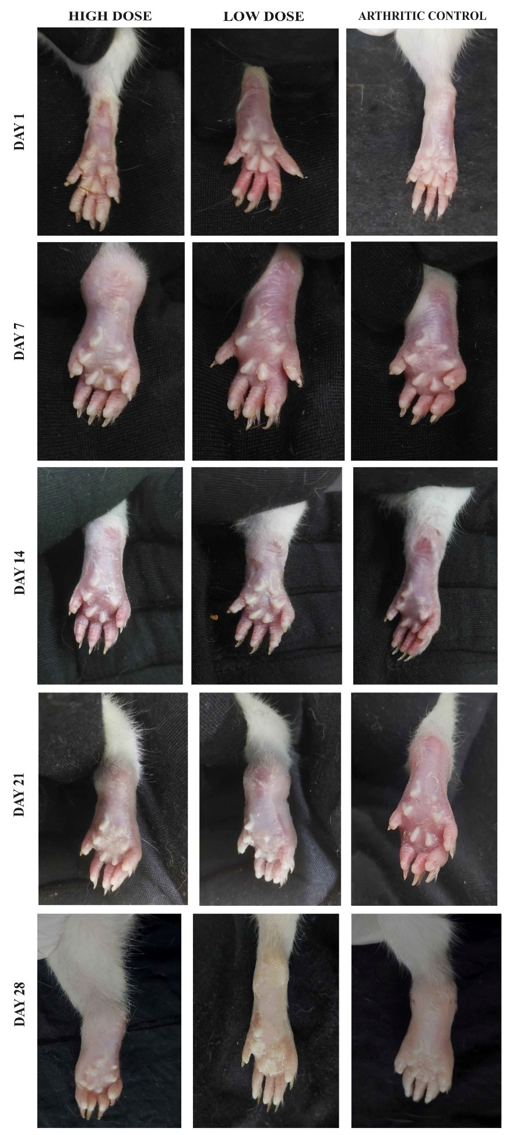

Supplementary Figure S2. HPTLC fingerprints of EDME. Mobile phase: chloroform, ethyl acetate, and formic acid (5:4:1); Wavelength: 254 nm. Track 1: t-cinnamic acid, track 2: 4-hydroxybenzoic acid, track 3: quercetin, track 4: caffeic acid, track 5: gallic acid, track 6: chlorogenic acid, track 7: vanillic acid, track 8: apigenin, track 9: p-coumaric acid, track 10: myricetin, track 11: rosmarinic acid, track 12: naringenin, track 13: caffein, track 14: kaempferol, and track 15: methanol extract of E. diffusum.

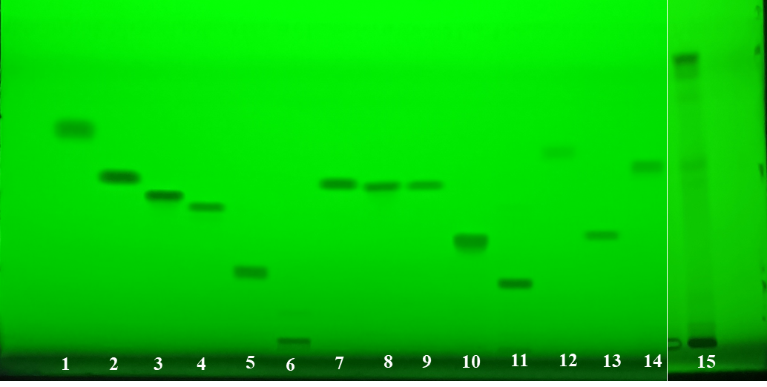

Supplementary Figure S3. LC-MS chromatogram of EDME for both modes of ionization (positive and negative ESI mode).

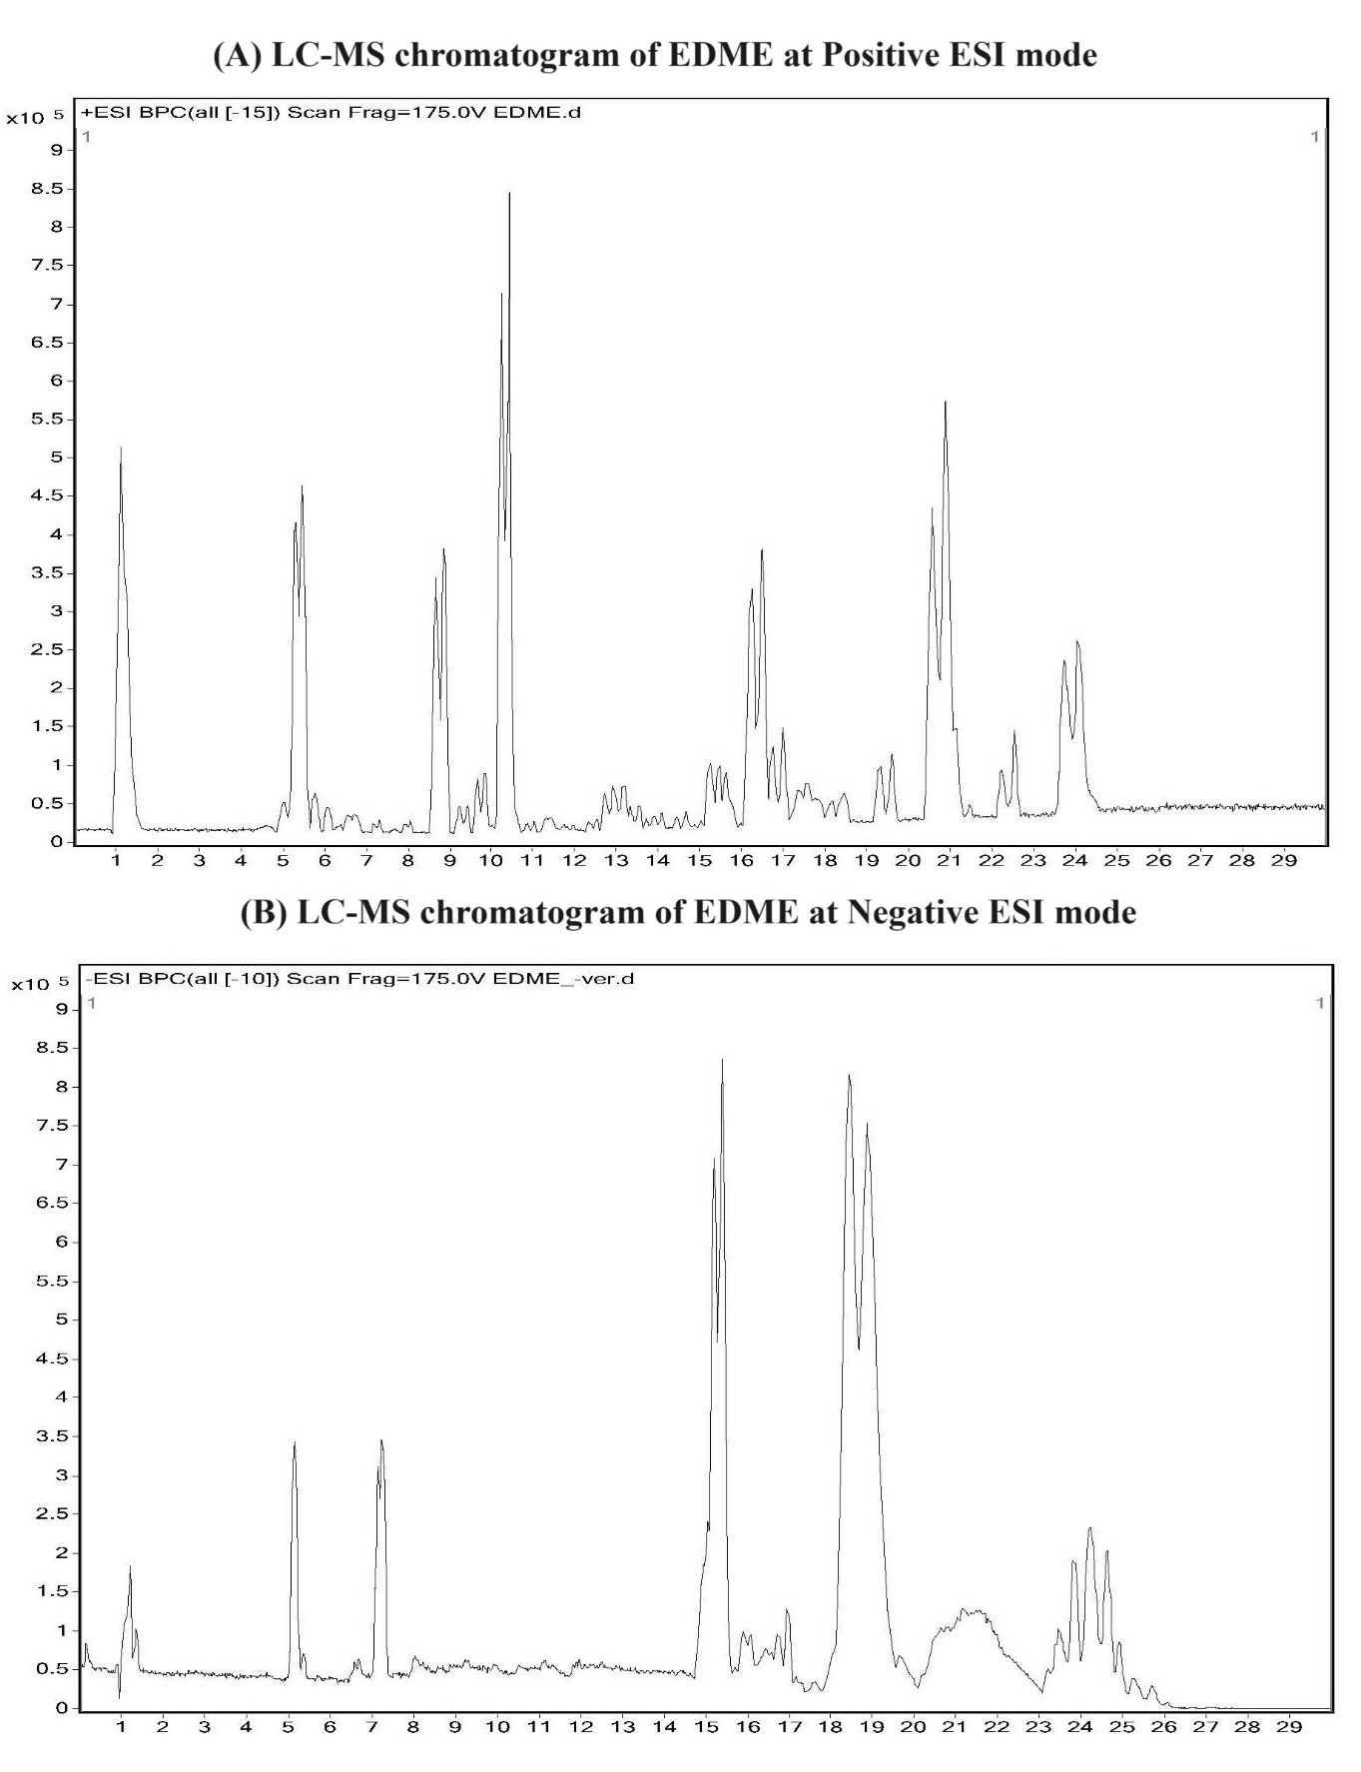

Supplementary Figure S4. Identification certificate provided from BSI, Howrah.

