Additional File 4

Results

Themes and paper structure

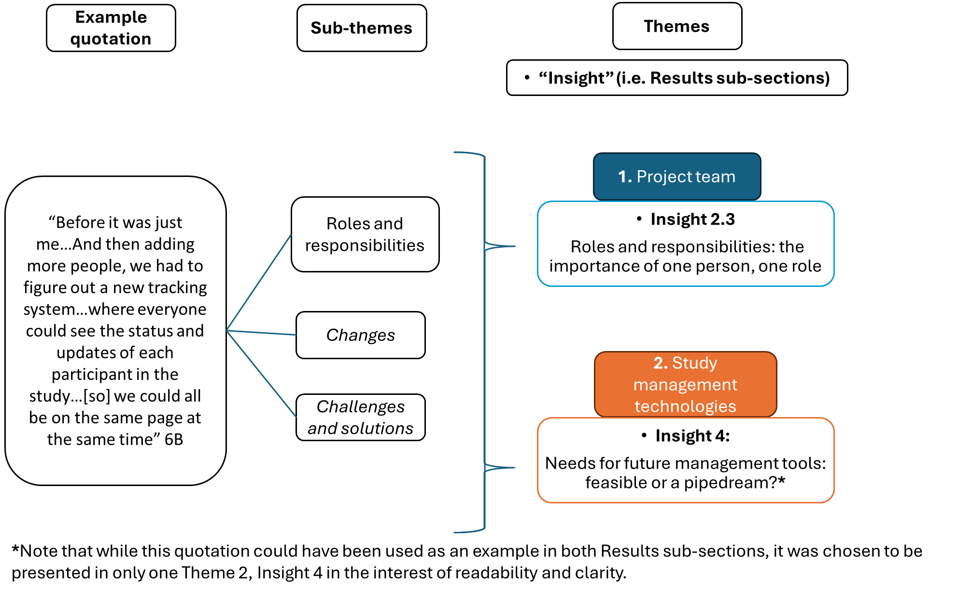
Figure 1. Illustration of how themes and sub-themes were combined to form “Insights”, i.e. the Results sub-sections.

