Title: Psychosocial Risks and Mental Health of Preschool Care Providers in Kuala Lumpur,
Malaysia: A cross-sectional study.
Journal: Social Psychiatry and Psychiatric Epidemiology, The International Journal for Research in Social and Genetic Epidemiology and Mental Health Services

Authors: Tham Sin Wan¹*, Wong Min Fui @ Esther Wong²*, Maslinor Binti Ismail³ and Noriklil Bukhary Binti Ismail Bukhary⁴
Affiliations: Full information for each author
¹Centre for Burden of Disease Research, Institute for Public Health, National Institutes of Health, Malaysia
²Centre for Health Policy Research, Institute for Health Systems Research, National Institute of Health, Malaysia
³Department of Social and Preventive Medicine, Faculty of Medicine, University Malaya, Malaysia
⁴Health office of Lembah Pantai District, Health Department of Kuala Lumpur and Putrajaya, Ministry of Health, Malaysia
*Tham Sin Wan and Wong Min Fui @ Esther Wong contributed equally to this work.

Correspondence:
Wong Min Fui @ Esther Wong, MD
Centre for Health Policy Research, Institute of Health System Research, National Institute of Health, Malaysia
Blok B2, Kompleks Institut Kesihatan Negara (NIH)
No.1, Jalan Setia Murni U13/52, Seksyen U13 Setia Alam, 40170 Shah Alam, Selangor.
E-mail: dr.estherwong@moh.gov.my

Supplementary Materials

- Supplementary Table 1: Sample Size Calculation
- Supplementary Table 2: The formula used for each psychological work exposure variable are listed below:
- Supplementary Figure 1: Karasek Job Strain Model
- Supplementary Questionnaires

Supplementary Table 1: Sample Size Calculation

Objectives |  | Calculated Sample Size
Prevalence |  | 213
Risk factors for Mental Disorders |  | 262
Job strain and Mental Disorders |  | 228

Supplementary Table 2: The formula used for each psychological work exposure variable are listed below:
Domains | Formula | Score
Job skill discretion | [s1 + s3 + s5 + s7 + s9 + 5 - s2] x 2 | 12-48
Job demands | 3(s10 + s11) + 2(15 - s12 - s13 - s14) | 12-48
Job decision-making authority | [S4+s8+(5-s6)]x4 | 12-48
Job insecurity = | s24 + s26 + 5 - s15. | 3-12
Co-worker support | s16 + s17 + s18 + s19. | 4-16
Supervisor support | s20 + s21 + s22 + s23 | 4-16
Job decision latitude | skill discretion + decision-making authority | 24-96

Job decision latitude consists of skill discretion and decision-making authority and each variable will be calculated for the mean and classified accordingly.
The Psychological work exposure is defined as below:
- A score > sample median on job demands: denote high job demand
- A score < sample median on job decision latitude :Denote low Job control
- A score < sample median on co-worker support: low support from co-worker
- A score < sample median supervisor support : low supervisor support
- A score >sample median on job security: Insecurity

The quadrant term formulation will be adopted to calculate for the job strain.

Supplementary Figure 1 Karasek Job Strain Model
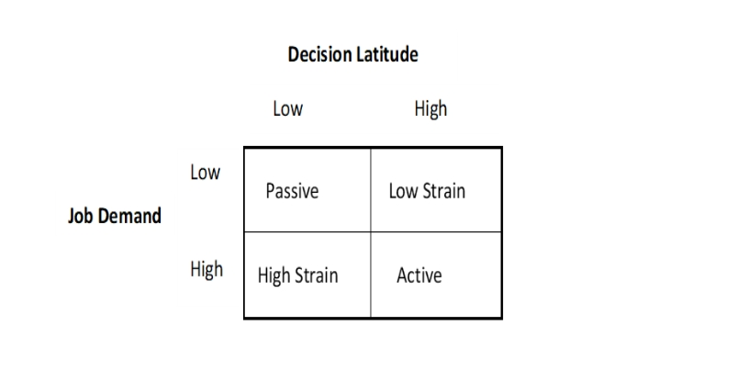

Supplementary Questionnaires


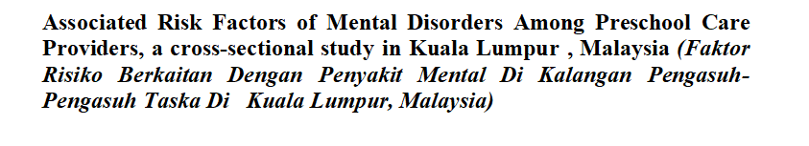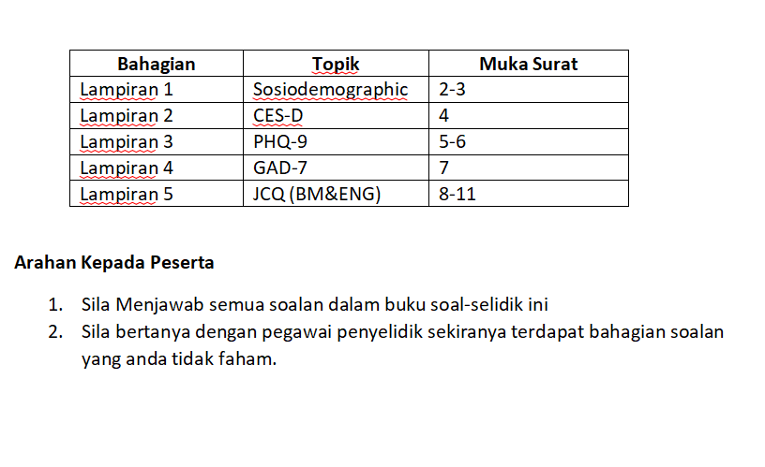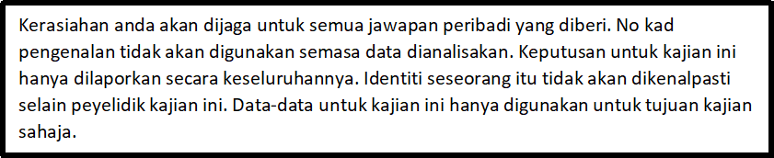
Lampiran 1: Sociodemographic Questionnaire/ Borang Soal Selidik

To be filled by participant / Untuk diisi oleh peserta
Instruction / Arahan: Please tick (√) ONE most appropriate answer.
Sila tandakan (√) SATU pilihan jawapan yang paling tepat.
No. | Question / Soalan | Answer / Jawapan | Remarks/ Catatan
1. | Gender / Jantina | Male / lelaki Female / Perempuan
2. | Place of Origin/Tempat Berasal
3. | Year of birth / Tahun lahir | (example / contoh: 1957)
4. | Race / Bangsa | Malay / Melayu Indian / India
 |  | Chinese / Cina Others / Lain-lain
5. | Marital Status/ Status Perkahwinan | Single/Bujang Married/Kahwin
 | Marital Status/ Status Perkahwinan | Divorced/Bercerai Separated/Berpisah
 |  | Widowed/Balu
6. | Highest education level / Tahap pendidikan tertinggi | No formal education/ Tiada Pendidikan formal
 | Highest education level / Tahap pendidikan tertinggi | Primary school / Sekolah rendah
 | Highest education level / Tahap pendidikan tertinggi | Secondary school / Sekolah menengah
 |  | Diploma and above / Diploma ke atas
7. | Monthly household | B 40 Less than RM2,500 / Kurang dari RM2500
 | income / Pendapatan | M 40 RM2,5001 – RM 11,000
 |  | T 20 RM 11,001 / Lebih dari RM 11,001
8. | Religion/ | Muslim/ Islam
 | Agama | Christianity/Kristian
 |  | Buddhism/ Buddist
 |  | Hindu/ Hindu
 |  | Lain-lain : ____________________________
9. | Strength of religious faith/ Kekuatan kepercayaan dan keagamaan | 1 = strongly disagree 2 = disagree 3 = agree 4 = strongly agree
 |  | - I pray daily/ Saya sembahyang setiap hari
- I look to my faith as providing meaning and purpose in
my life/Pegangan agama saya memberi
makna dan tujuan dalam hidup saya.
- I consider myself active in my religious organization/
Saya bergerak aktif dalam organisasi keagamaan.
- I enjoy being around others who share my faith/ saya
suka dikelilingi oleh individu berkongsi pegangan
agama yang sama
- My faith impacts many of my decisions/ Pegangan
agama saya mempengaruhi banyak keputusan yang saya buat
 |  | Total score (5 : low in religious faith 20 high in religious faith )
 |  | (Adapted from : Santa Clara Strength of Religious Faith Questionnaire Plante et al (1997) copyright: Public Domain)
10. | Any family members having mental illness/ Sejarah ahli keluarga adanya penyakit sakit jiwa | - Yes/ Ya
 |  | - No/ Tidak
 |  | Relatioship?/ Hubungan ?_______________________
11. | Any past medical Illness/Sejarah penyakit Kronik | No/Tidak
 | Any past medical Illness/Sejarah penyakit Kronik | Yes/ Ya Nyatakan_______________________
 | Any past medical Illness/Sejarah penyakit Kronik | Please state/ Tolong nyatakan:
 | Any past medical Illness/Sejarah penyakit Kronik | Years since diagnosed /  Tempoh sejak didiagnosa dengan penyakit (dalam  tahun):_____________
 |  | Treatment/Rawatan: ______________________
12. | Stressful Life Event/Pengalaman Perit dalam Hidup | No/ Tidak
 | Stressful Life Event/Pengalaman Perit dalam Hidup | if Yes/ Ya,  please choose your answer/sila pilih jawapan anda:
1.Assault/ serangan (Physical or sexual/ fizkal atau
sexual)
2.Serious chronic Illness/ Penyakit yang serius dan
Kronik (Seperti Kencing manis atau Darah Tinggi)
3.Abuse or bully during childhood/ didera dan dibuli
semasa zaman kanak- kanak
4.Serious injury due to accident/ kecederaan
disebabkan oleh kemalangan
 | Both Parents | 5.Being an Orphan before the age 10/anak yatim  sebelum umur 10 tahun
 | One of the parents and other relatives | 6.Lost of love ones / kehilangan orang tersayang
7.Serious marital problem/ masalah rumah tangga
yang serius
8.Serious family problem/ masalah keluarga yang
serius
 | 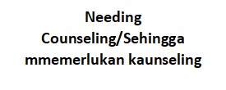 | 9.Serious financial problem/ masalah kewangan yang  Serius(Bankrupsy / Bankrup)
10.Serious housing problem (poor relationship with
Neigbourhood or high crime rate in the neigbourhood)
/masalah tempat kediaman yang serius (masalah
dengan jiran atau kadar jenayah yang tinggi)
11.Serious problem at work (problem with superior)/
masalah di tempat kerja (masalah dengan majikan)
 |  | 12.Lost of Job/ kehilangan pekerjaan
 |  | 13.Court case / Kes mahkamah
13. | Information of the preschool/ Maklumat berkaitan dengan taska | Trained/ dilatih: yes/ya no/tidak
 |  | No. Care providers/ Bilangan Penjaga
No of Children/
Bilangan Kanak-kanak di bawah 4 tahun
LAMPIRAN 2: (CES-D): Centre of EPusat untuk Kajian Epidemiologi Skala Kemurungan
Arahan: Di bawah adalah senarai sebahagian perkara yang anda mungkin rasa atau lakukan.
Please tick (√) ONE most appropriate answer. Tandakan (√) pada kenyataan yang paling tepat dengan diri anda.
Sepanjang minggu lepas | Jarang / tiada | Kadang-kadang  (1-2 hari) | Kerapkali  (3-4 hari) | Pada setiap masa (5-7 hari)
1.I was bothered by things that usually don’t bother me
Fikiran saya diganggu oleh hal yang selalunya tidak menggangu saya
2.I did not feel like eating; my appetite was poor
Saya tiada selera untuk makan
3.I felt that I could not shake off the blues even with help from my family or friends
Saya rasa saya tidak dapat menghapuskan perasaan tertekan walaupun dengan bantuan kawan-kawan saya
4.I felt that I was just as good as other people
Saya rasa saya sebaik orang lain
5.I had trouble keeping my mind on what I was doing.
Saya mempunyai masalah untuk menumpukan perhatian kepada kerja yang saya lakukan
6.I felt depressed.
Saya rasa tertekan
7.I felt that everything I did was an effort
Saya rasa semua yang saya lakukan adalah satu usaha
8.I felt hopeful about the future.
Saya rasa mempunyai harapan yang baik untuk masa depan saya
9.I thought my life had been a failure
Saya fikir hidup saya telah mengalami kegagalan
10.I felt fearful.
Saya merasa sangat takut
11.My sleep was restless
Tidur saya terganggu
12.I was happy
Saya gembira
13.I talked less than usual
Saya bercakap kurang berbanding kebiasaannya
14.I felt lonely.
Saya berasa kesunyian
15.People were unfriendly
Orang di sekeliling saya tidak mesra
16.I enjoyed life.
Saya menikmati hidup saya
17.I had crying spells.
Saya rasa seolah-olah ingin menangis.
18.I felt sad.
Saya berasa sedih
19.I felt that people dislike me.
Saya rasa orang lain tidak sukakan saya
20.I could not get “going.”
Saya tidak dapat meneruskan hidup

Lampiran 3: PATIENT HEALTH QUESTIONNAIRE (PHQ-9) (MALAY VERSION)
Dalam tempoh 2 minggu yang lepas, berapa kerapkali anda terganggu oleh masalah berikut? / Over the last 2 weeks, how often have you been bothered by any of the following problems?
No. | SOALAN | SKALA | SKOR
1. | Sedikit minat atau sedikit keseronokan dalam melakukan kerja-kerja.  Little interest or pleasure in doing things. | Tidak pernah sama sekali / Not at all | 0
1. |  | Beberapa hari / Several days | 1
1. |  | Lebih dari seminggu / More than half the days | 2
1. |  | Hampir setiap hari / Nearly everyday | 3
2. | Merasa murung, sedih atau tiada harapan.  Feeling down, depressed or hopeless. | Tidak pernah sama sekali / Not at all 0 | 0
 |  | Beberapa hari / Several days | 1
 |  | Lebih dari seminggu / More than half the days | 2
 |  | Hampir setiap hari / Nearly everyday | 3
3. | Masalah hendak tidur / semasa tidur, tidur terlalu banyak.  Trouble falling / staying asleep, sleeping too much | Tidak pernah sama sekali / Not at all 0 | 0
 |  | Beberapa hari / Several days | 1
 |  | Lebih dari seminggu / More than half the days | 2
 |  | Hampir setiap hari / Nearly everyday | 3
4 | Merasa letih atau kurang bertenaga.  Feeling tired or having little energy. | Tidak pernah sama sekali / Not at all | 0
 |  | Beberapa hari / Several days | 1
 |  | Lebih dari seminggu / More than half the days | 2
 |  | Hampir setiap hari / Nearly everyday | 3
5 | Kurang selera atau terlalu banyak makan.  Poor appetite or over eating. | Tidak pernah sama sekali / Not at all | 0
 |  | Beberapa hari / Several days | 1
 |  | Lebih dari seminggu / More than half the days | 2
 |  | Hampir setiap hari / Nearly everyday | 3
6 | Mempunyai perasaan buruk terhadap diri sendiri – ataupun merasa gagal terhadap diri sendiri ataupun menghampakan diri atau keluarga.  Feeling bad about yourself – or that you are a failure or have let yourself or your family down? | Tidak pernah sama sekali / Not at all | 0
6 |  | Beberapa hari / Several days | 1
6 |  | Lebih dari seminggu / More than half the days | 2
6 |  | Hampir setiap hari / Nearly everyday | 3
7 | Masalah menumpukan perhatian terhadap perkara-perkara seperti membaca suratkhabar atau menonton televisyen  Trouble concentrating on things, such as reading the newspaper or watching television. | Tidak pernah sama sekali / Not at all | 0
7 |  | Beberapa hari / Several days | 1
7 |  | Lebih dari seminggu / More than half the days | 2
7 |  | Hampir setiap hari / Nearly everyday | 3
8 | Bergerak atau bercakap dengan terlalu lambat sehingga disedari oleh orang lain. Ataupun bertentangan – terlalu resah atau gelisah sehingga anda bergerak lebih dari biasa.  Moving or speaking so slowly that other people could have noticed. | Tidak pernah sama sekali / Not at all | 0
8 |  | Beberapa hari / Several days | 1
8 |  | Lebih dari seminggu / More than half the days | 2
8 |  | Hampir setiap hari / Nearly everyday | 3
9 | Berfikiran bahawa lebih elok jika anda telah mati atau inginmencederakan diri anda dalam sesuatu cara.  Thoughts that you would be better off dead or of hurting yourself in some way. | Tidak pernah sama sekali / Not at all | 0
9 |  | Beberapa hari / Several days | 1
9 |  | Lebih dari seminggu / More than half the days | 2
9 |  | Hampir setiap hari / Nearly everyday | 3

Lampiran 4 : JOB CONTENT QUESTIONNAIRE(BM)

Soal-selidik penilaian risiko pendedahan terhadap hazad psikologi di tempat kerja
Bulatkan jawapan yang betul.
 |  |  |  |  | Sangat tidak setuju | Tidak setuju |  |  | Setuju |  |  | Sangat setuju
- Pekerjaan saya memerlukan saya mempelajari perkara baru. |  |  |  |  | 1 | 2 |  |  | 3 |  |  | 4
- Pekerjaan saya melibatkan kerja yang berulang-ulang. |  |  |  |  | 1 | 2 |  |  | 3 |  |  | 4
- Pekerjaan saya memerlukan kreativiti. |  |  |  |  | 1 | 2 |  |  | 3 |  |  | 4
- Pekerjaan saya membenarkan saya membuat keputusan sendiri. |  |  |  |  | 1 | 2 |  |  | 3 |  |  | 4
- Pekerjaan saya memerlukan kemahiran yang tinggi. |  |  |  |  | 1 | 2 |  |  | 3 |  |  | 4
- Semasa bekerja, saya diberi banyak kebebasan untuk membuat keputusan sendiri. |  |  |  |  | 1 | 2 |  |  | 3 |  |  | 4
- Semasa bekerja, saya berupaya melakukan berbagai perkara yang berbeza-beza. |  |  |  |  | 1 | 2 |  |  | 3 |  |  | 4
- Saya mempunyai banyak hak untuk menentukan pekerjaan saya. |  |  |  |  | 1 | 2 |  |  | 3 |  |  | 4
- Saya berpeluang untuk mengembangkan kebolehan saya. |  |  |  |  | 1 | 2 |  |  | 3 |  |  | 4
- Pekerjaan saya memerlukan saya untuk bekerja dengan sangat pantas. |  |  |  |  | 1 | 2 |  |  | 3 |  |  | 4
- Pekerjaan saya memerlukan saya bekerja bersungguh-sungguh. |  |  |  |  | 1 | 2 |  |  | 3 |  |  | 4
- Saya tidak diminta / disuruh untuk melakukan kerja-kerja secara berlebihan. |  |  |  |  | 1 | 2 |  |  | 3 |  |  | 4
- Saya mempunyai masa yang cukup untuk menyiapkan kerja saya. |  |  |  |  | 1 | 2 |  |  | 3 |  |  | 4
- Saya bebas daripada tekanan-tekanan yang dibuat oleh orang lain. |  |  |  |  | 1 | 2 |  |  | 3 |  |  | 4
- Pekerjaan saya dijamin baik. |  |  |  |  | 1 | 2 |  |  | 3 |  |  | 4
- Rakan-rakan sekerja saya berkemampuan dalam melakukan kerja mereka. |  |  |  |  | 1 | 2 |  |  | 3 |  |  | 4
- Rakan-rakan sekerja mengambil berat tentang saya. |  |  |  |  | 1 | 2 |  |  | 3 |  |  | 4
- Rakan-rakan sekerja saya adalah peramah. |  |  |  |  | 1 | 2 |  |  | 3 |  |  | 4
- Rakan-rakan sekerja saya membantu bagi memastikan kerja-kerja disiapkan. |  |  |  |  | 1 | 2 |  |  | 3 |  |  | 4
- Penyelia saya mengambil berat mengenai kebajikan orang bawahannya. |  |  |  |  | 1 | 2 |  |  | 3 |  |  | 4
- Penyelia saya memberikan perhatian terhadap apa yang saya katakan. |  |  |  |  | 1 | 2 |  |  | 3 |  |  | 4
- Penyelia memberi bantuan dalam memastikan kerja-kerja saya dapat disiapkan. |  |  |  |  | 1 | 2 |  |  | 3 |  |  | 4
- Penyelia saya berjaya mengajak orang lain bekerja bersama-sama. |  |  |  |  | 1 | 2 |  |  | 3 |  |  | 4
 | Tetap dan stabil |  | Ber  musim |  | Kerap  tergendala |  |  | Bermusim dan kerap tergendala |  |  | Lain-lain
- Berapa stabilkah kerja anda? | 1 |  | 2 |  | 3 |  |  | 4 |  |  | 5
 | Tidak pernah |  | Sekali |  | Lebih dari sekali |  |  | Sentiasa |  |  | Diberhentikan
- Dalam tempoh setahun yang lepas, berapa kerap anda berdepan dengan masalah kehilangan pekerjaan? | 1 |  | 2 |  | 3 |  |  | 4 |  |  | 5
 |  | Tidak mungkin |  | Sedikit kemungkinan |  |  | Berkemungkinan |  |  | Berkemungkinan besar
- Kadangkalaseseorang itu kehilangan pekerjaan tetap mereka. Adakah kemungkinan anda akan kehilangan pekerjaan anda sekarang dalam beberapa tahun lagi? |  | 1 |  | 2 |  |  | 3 |  |  | 4

©Copyright by Robert Karasek JCQ Center. All rights reserved. No distribution without permission from The JCQ Center by Director Robert Karasek

Lampiran 4 : JOB CONTENT QUESTIONNAIRE(ENGLISH)
Risk assessment on exposure to psychological hazard at workplace.
Please circle the correct answer.
 |  |  |  | strongly disagree |  | disagree | agree |  | strongly agree
- My job requires that I learn new things |  |  |  | 1 |  | 2 | 3 |  | 4
- My job involves a lot of repetitive work |  |  |  | 1 |  | 2 | 3 |  | 4
- My job requires me to be creative |  |  |  | 1 |  | 2 | 3 |  | 4
- My job allows me to make a lot of decisions on my own |  |  |  | 1 |  | 2 | 3 |  | 4
- My job requires a high level of skill |  |  |  | 1 |  | 2 | 3 |  | 4
- On my job, I am given a lot of freedom to decide how I do my work |  |  |  | 1 |  | 2 | 3 |  | 4
- I get to do a variety of things on my job |  |  |  | 1 |  | 2 | 3 |  | 4
- I have a lot to say about what happens on my job |  |  |  | 1 |  | 2 | 3 |  | 4
- I have an opportunity to develop my own special abilities |  |  |  | 1 |  | 2 | 3 |  | 4
- My job requires working very fast |  |  |  | 1 |  | 2 | 3 |  | 4
- My job requires working very hard |  |  |  | 1 |  | 2 | 3 |  | 4
- I am not asked to do an excessive amount of work |  |  |  | 1 |  | 2 | 3 |  | 4
- I have enough time to get the job done |  |  |  | 1 |  | 2 | 3 |  | 4
- I am free from conflicting demands others make |  |  |  | 1 |  | 2 | 3 |  | 4
- My job security is good |  |  |  | 1 |  | 2 | 3 |  | 4
- People I work with are competent in doing their jobs |  |  |  | 1 |  | 2 | 3 |  | 4
- People I work with take a personal interest in me |  |  |  | 1 |  | 2 | 3 |  | 4
- People I work with are friendly |  |  |  | 1 |  | 2 | 3 |  | 4
- People I work with are helpful in getting the job done |  |  |  | 1 |  | 2 | 3 |  | 4
- My supervisor is concerned about the welfare of those under him |  |  |  | 1 |  | 2 | 3 |  | 4
- My supervisor pays attention to what you are saying |  |  |  | 1 |  | 2 | 3 |  | 4
- My supervisor is helpful in getting the job done |  |  |  | 1 |  | 2 | 3 |  | 4
- My supervisor is successful in getting people to work together |  |  |  | 1 |  | 2 | 3 |  | 4
 | regular and steady | seasonal |  | frequent layoffs |  |  | both seasonal and frequent layoffs |  | other
24. How steady is your work? | 1 | 2 |  | 3 |  |  | 4 |  | 5
 | never | faced possibility once |  | faced possibility more than once |  |  | actually constantly |  | laid off
25. During the past year, how often were you in a situation where you faced job loss? | 1 | 2 |  | 3 |  |  | 4 |  | 5
 | not at all likely |  | not too likely |  | somewhat likely |  |  | very  likely
26. Sometimes people permanently lose  jobs they want to keep. How likely is it  that during the next couple of years you will lose your present job with your employer? | 1 |  | 2 |  | 3 |  |  | 4

©Copyright by Robert Karasek JCQ Center. All rights reserved. No distribution without permission from The JCQ Center by Director Robert Karasek



