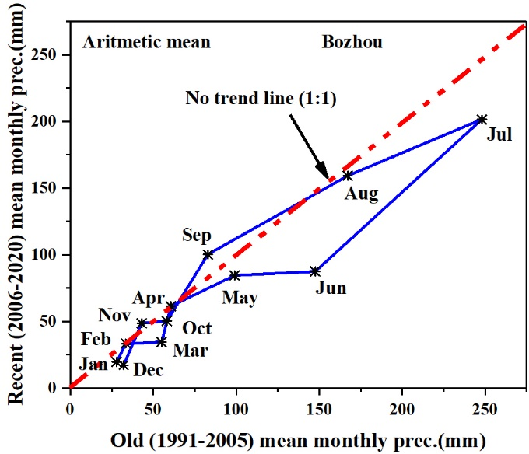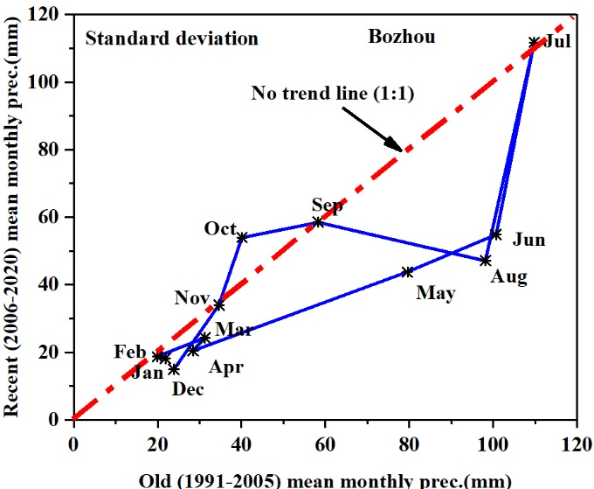

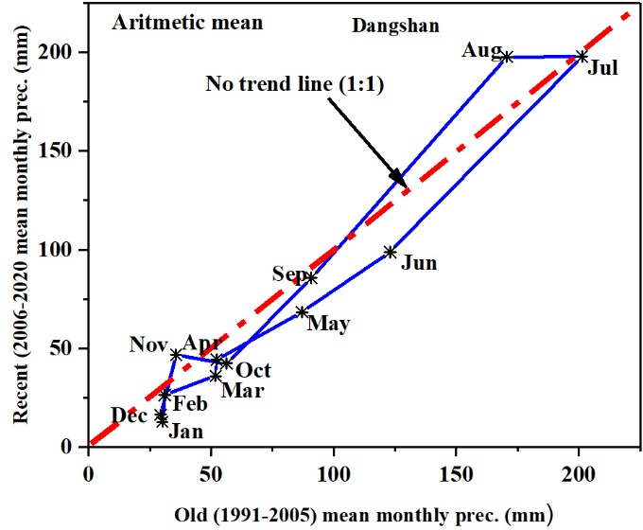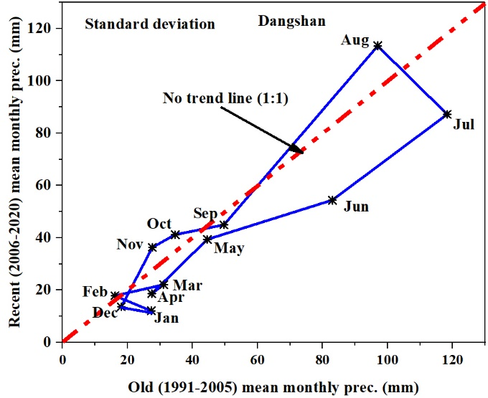

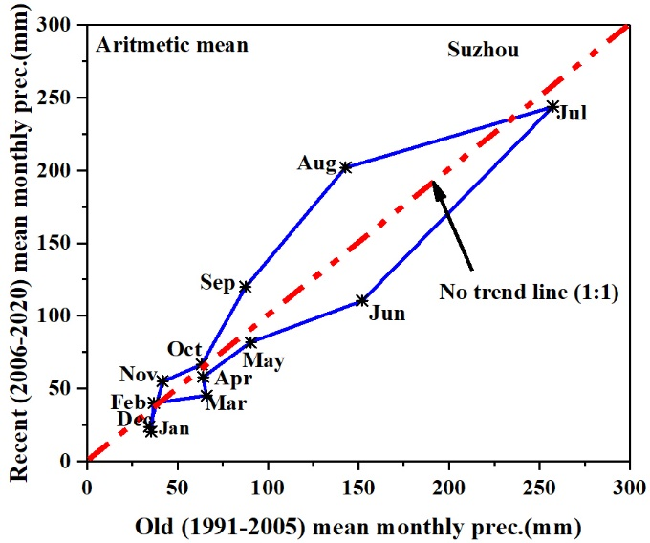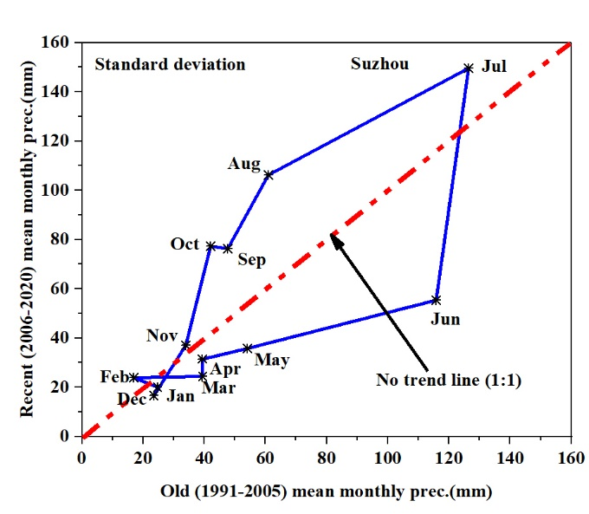
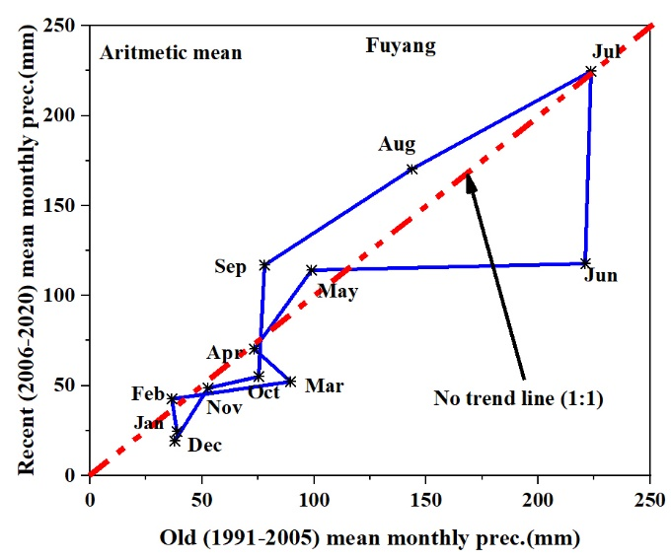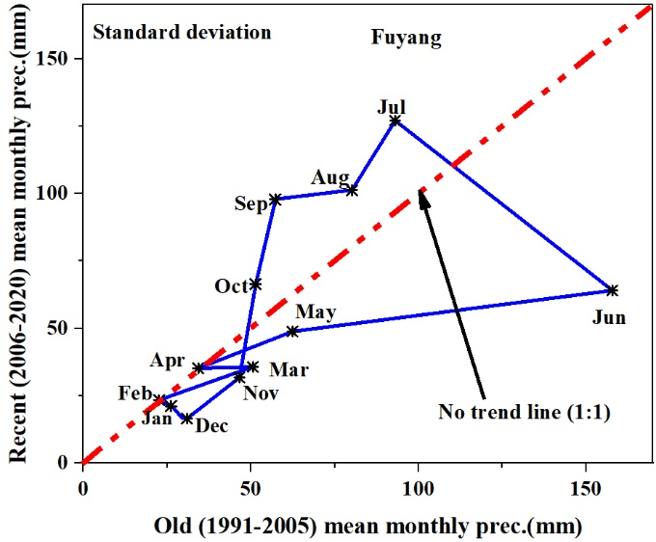
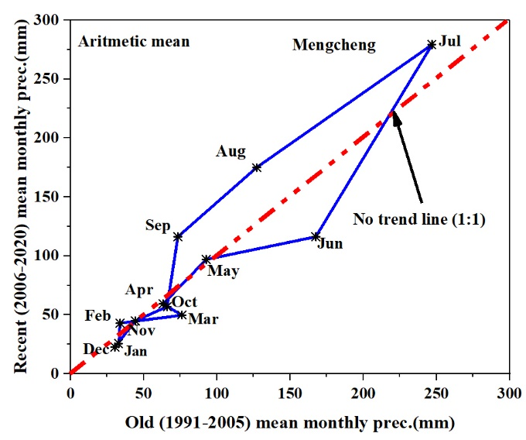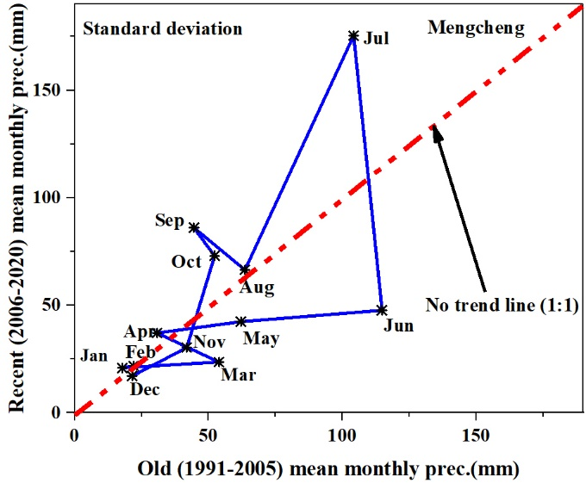
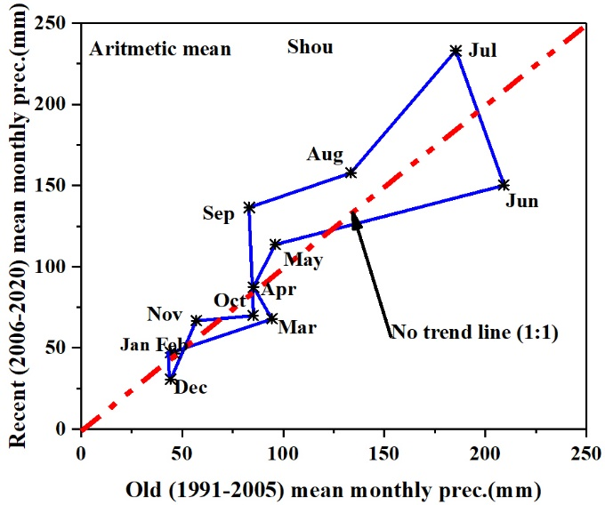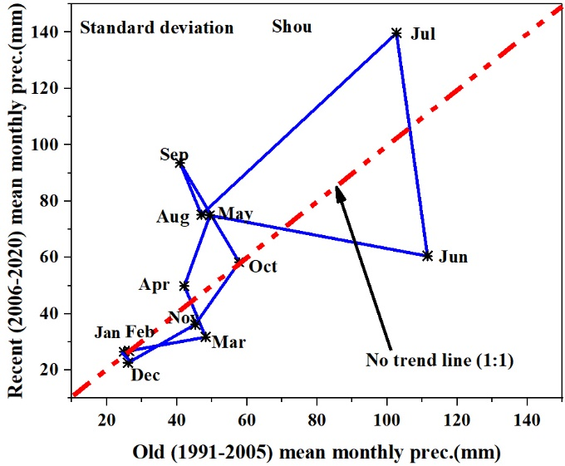

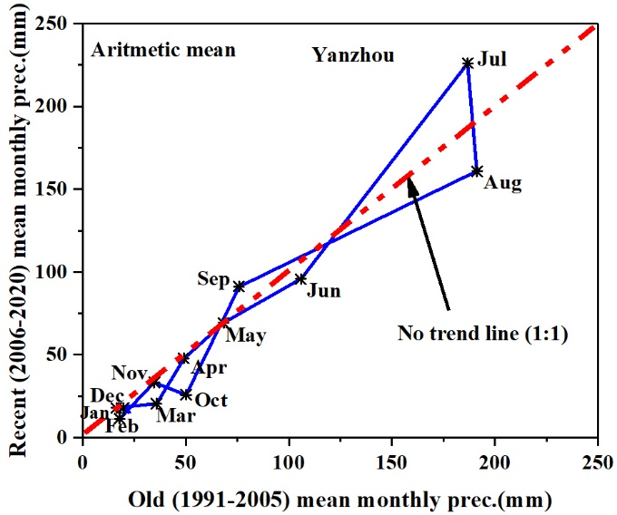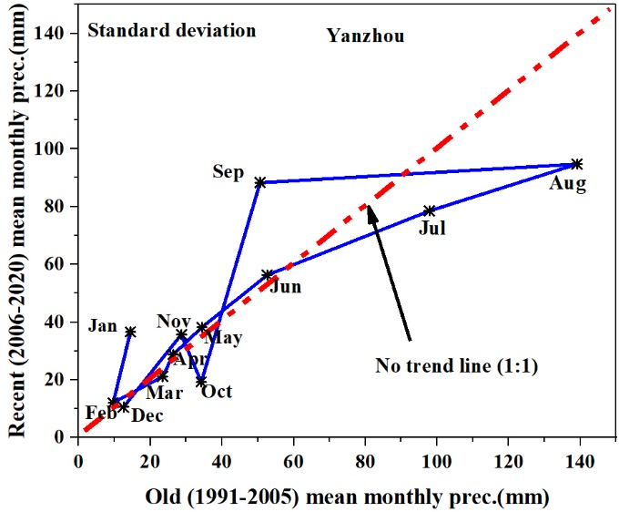
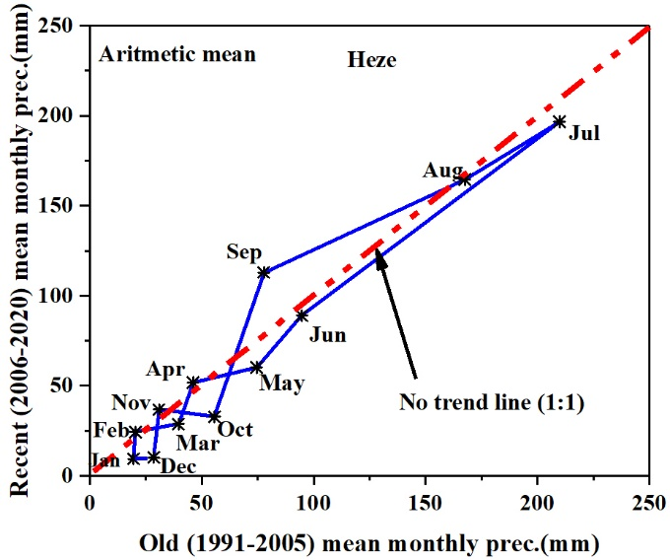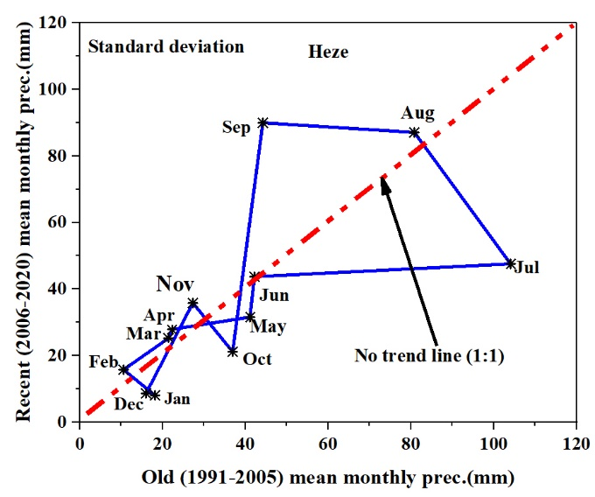
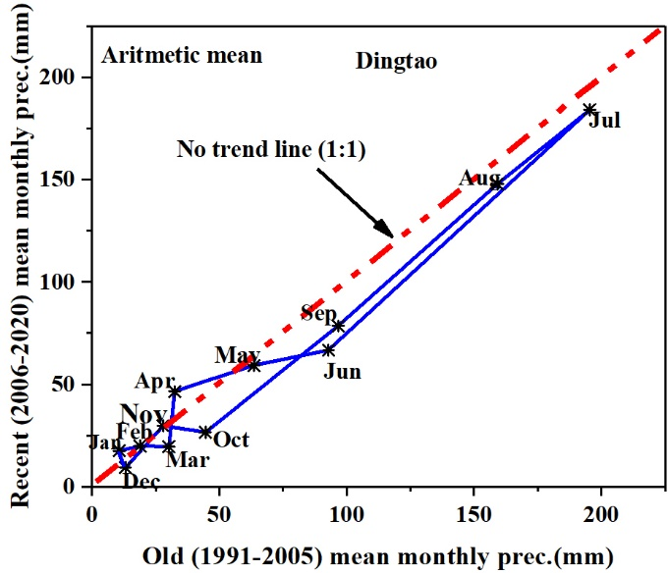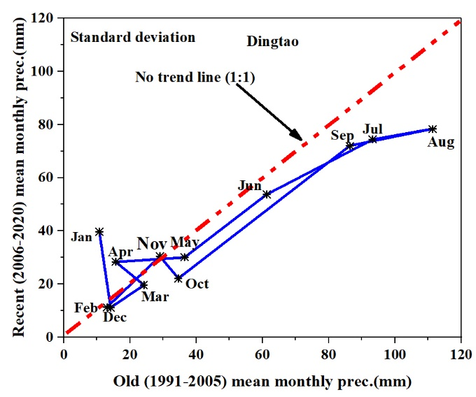

Figure 1. IPTA graph of the mean monthly precipitation and standard deviation of across all meteorological stations

Table 1. The arithmetic means and standard deviation of the IPTA graph in Figure 2 of the main document
Stations |  |  | Months
 |  |  | J | F | M | A | M | J | J | A | S | O | N | D
Bengbu | Arithmetic | Old (mm) | 47 | 42 | 87 | 76 | 97 | 190 | 225 | 142 | 98 | 75 | 52 | 38
Bengbu | Arithmetic | Recent (mm) | 34 | 51 | 52 | 69 | 110 | 162 | 239 | 202 | 126 | 55 | 54 | 27
Bengbu | Standard deviation | Old (mm) | 31 | 24 | 50 | 36 | 61 | 98 | 88 | 54 | 54 | 44 | 46 | 30
Bengbu | Standard deviation | Recent (mm) | 23 | 31 | 29 | 47 | 80 | 83 | 139 | 74 | 67 | 57 | 34 | 23
Linyi | Arithmetic | Old (mm) | 26 | 29 | 44 | 63 | 123 | 121 | 291 | 249 | 85 | 58 | 45 | 28
Linyi | Arithmetic | Recent (mm) | 15 | 28 | 36 | 46 | 87 | 119 | 285 | 260 | 118 | 36 | 44 | 26
Linyi | Standard deviation | Old (mm) | 22 | 17 | 29 | 34 | 60 | 36 | 108 | 132 | 45 | 34 | 44 | 21
Linyi | Standard deviation | Recent (mm) | 13 | 12 | 24 | 25 | 45 | 65 | 121 | 107 | 67 | 38 | 46 | 20

Table 2. Trend length and slope of the IPTA graph between two consecutive months for mean monthly precipitation
Stations | Test (mm) | Months
Stations | Test (mm) | J-F | F-M | M-A | A-M | M-J | J-J | J-A | A-S | S-O | O-N | N-D | D-J
Suzhou | Slope | -0.20 | -6.93 | 0.30 | 1.40 | 4.77 | 0.33 | -4.35 | 0.55 | 0.10 | 4.06 | -0.81 | 1.41
Suzhou | length | 19.69 | 29.55 | 12.97 | 35.52 | 67.80 | 169.94 | 121.9 | 98.70 | 58.60 | 24.48 | 32.23 | 3.56
Fuyang | Slope | -0.43 | -6.11 | 0.08 | -5.42 | -6.72 | -0.01 | 21.98 | 1.47 | -0.51 | 0.20 | 4.52 | 0.77
Fuyang | length | 18.14 | 53.88 | 24.28 | 50.62 | 122.37 | 107.13 | 96.64 | 84.86 | 61.71 | 23.32 | 32.99 | 5.30
Dangshan | Slope | 0.27 | 3.39 | 0.49 | 2.42 | 1.29 | 0.14 | -8.07 | -0.19 | 2.66 | -0.81 | -1.16 | 1.34
Dangshan | length | 13.54 | 22.92 | 8.30 | 42.36 | 47.13 | 126.17 | 30.68 | 137.41 | 55.36 | 21.03 | 31.06 | 3.66
Bozhou | Slope | 0.02 | 114.5 | -0.04 | -17.37 | 4.16 | 0.78 | 0.17 | -2.16 | -0.45 | -0.74 | -2.61 | 0.55
Bozhou | length | 14.75 | 21.56 | 27.62 | 44.86 | 48.50 | 152.02 | 91.19 | 102.99 | 55.45 | 15.37 | 33.31 | 4.94
Mengcheng | Slope | -1.29 | -2.87 | 0.15 | -1.13 | -11.42 | -0.64 | 1.47 | 0.91 | -0.21 | -0.07 | -12.77 | 0.90
Mengcheng | length | 17.11 | 42.83 | 15.81 | 47.84 | 77.43 | 181.13 | 158.8 | 79.56 | 59.85 | 25.13 | 26.10 | 4.00
Shou | Slope | 54.74 | -9.58 | -0.08 | 8.54 | -3.36 | -0.80 | 0.51 | 2.20 | -0.29 | -0.63 | -1.42 | 0.00
Shou | length | 2.18 | 54.29 | 21.50 | 28.39 | 118.84 | 86.08 | 91.40 | 54.55 | 66.59 | 28.46 | 38.19 | 16.02
Yanzhou | Slope | -0.76 | -9.70 | 0.08 | -0.77 | -11.13 | -3.90 | -0.78 | -0.50 | -1.58 | 0.06 | 4.71 | 0.32
Yanzhou | length | 3.57 | 19.58 | 30.47 | 28.88 | 45.89 | 153.27 | 65.30 | 134.88 | 70.32 | 17.19 | 27.66 | 6.85
Heze | Slope | -0.37 | -2.86 | -0.51 | -2.56 | 0.40 | 2.28 | 0.22 | -11.86 | -0.65 | -0.25 | -3.18 | 0.56
Heze | length | 15.03 | 19.79 | 23.82 | 29.63 | 35.17 | 157.58 | 53.09 | 103.54 | 83.09 | 25.08 | 26.59 | 9.12
Dingtao | Slope | 0.16 | -9.43 | -1.32 | -0.31 | 6.03 | 0.43 | 1.00 | 1.62 | 0.98 | -0.10 | -2.07 | -1.93
Dingtao | length | 8.46 | 11.33 | 27.10 | 33.55 | 30.26 | 155.87 | 51.12 | 93.37 | 73.52 | 16.80 | 25.07 | 8.45

