Purification and biochemical characterization of beta-hexosaminidase from freshwater cnidarian Hydra vulgaris Ind-Pune
Kowshik Kukkemane^{1,2}*, Lakshmi Surekha Krishnapati^{1a}, Ratna Mahathi Vuruputuri^{1a}, Kavyashree Sakharayapatna Ranganatha¹, Nadimpalli Siva Kumar¹*
¹ Protein Biochemistry and Glycobiology Laboratory, Department of Biochemistry, School of Life Sciences, University of Hyderabad, Hyderabad-500046, Telangana, India
² Department of Life Sciences, School of Sciences, CHRIST (Deemed to be University), Bengaluru – 560029, Karnataka, India.

ª These authors contributed equally to this study.

*Corresponding author: Tel: +9140 23134569, Fax: +91-40-23010120
E-mail: nsksl@uohyd.ac.in,
*co-corresponding author: kowshik.k@christuniversity.in

Supplementary Information – Uncropped gels and blots

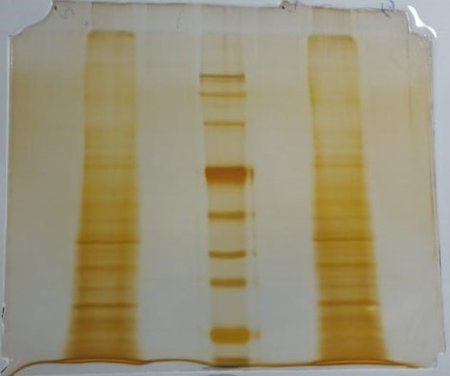
Fig S1 – 10% SDS-PAGE showing profiling of different proteins from Hydra crude soluble extract

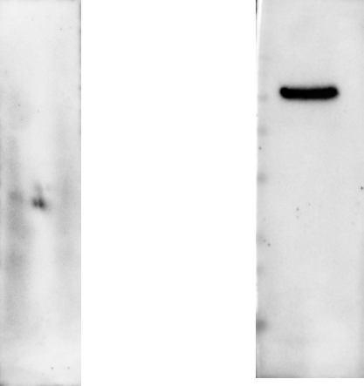

Fig S2 - Western blot analysis- Left Panel: Hydra crude soluble extract is not showing cross-reactivity with anti-HEXA antibody. Right Panel: Hydra crude soluble extract showing cross-reactivity with anti-HEXB antibody

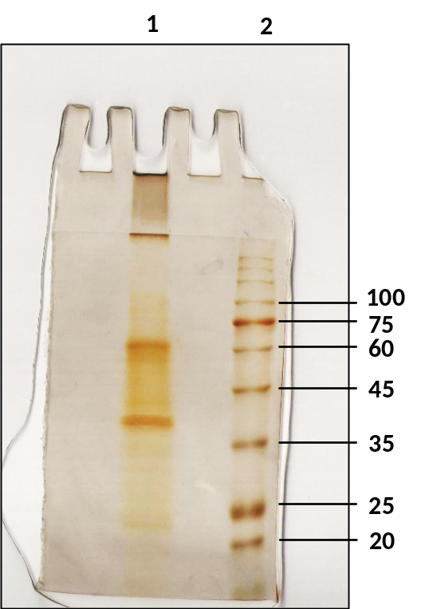
Fig S3 – 10% SDS-PAGE analysis of concentrated β-hexosaminidase active fractions eluted from phenyl-Sepharose gel

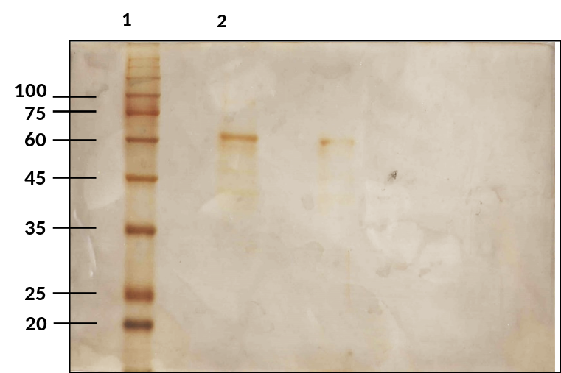

Fig. S4 - 10% SDS-PAGE analysis of purified Hydra β-Hexosaminidase after Sephacryl S-200 gel filtration chromatography: Lane 1- Molecular weight marker. Lane 2- Purified enzyme

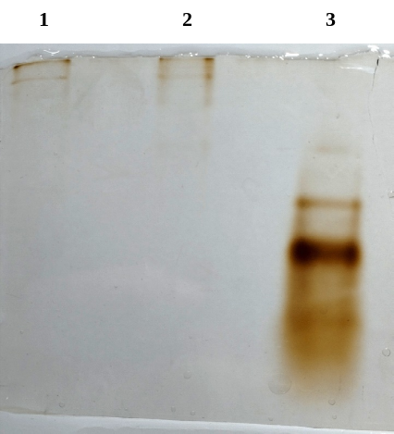
Fig. S5 - Native PAGE analysis of purified Hydra β-Hexosaminidase. Lane 1 and 2 – Purified Hydra β-Hexosaminidase. Lane 3 – protein marker

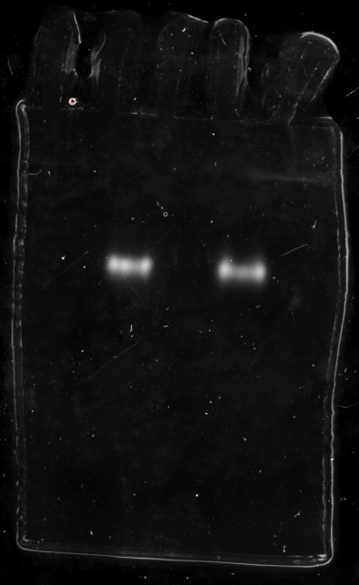
Fig. S6 - Zymogram analysis of purified Hydra β-Hexosaminidase

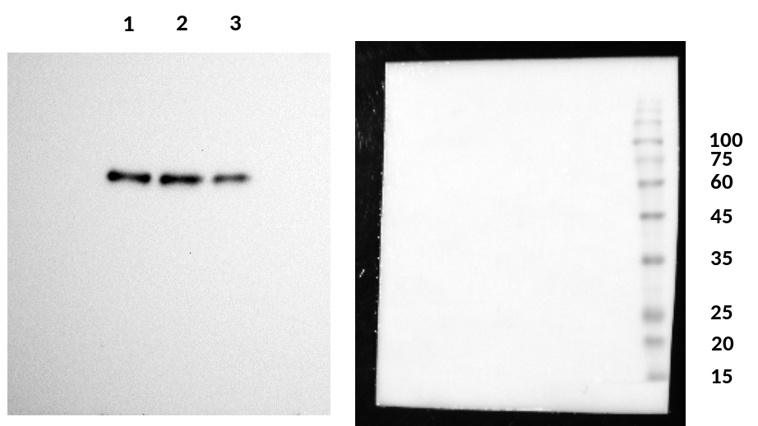

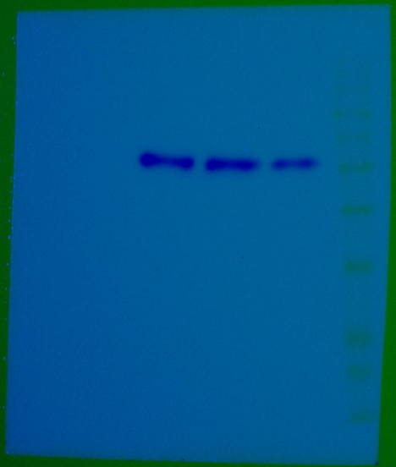

Fig. S7 - Immunoblotting analysis of purified Hydra β-Hexosaminidase probed with anti-HEXB antibody: Left panel - Lanes 1, 2, and 3- Purified Hydra β-Hexosaminidase. Right panel – corresponding PVDF membrane showing Molecular weight markers. Lower Panel -superimposed image.

