Clinical outcomes of aortic root repair using pericardial autograft for acute type A aortic dissection

Supplemental Figure Legends

Supplemental Figure 1
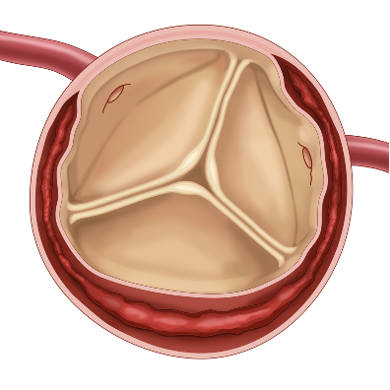
Figure S1. Aortic dissection with aortic root involvement can cause avulsion of aortic valve commissures and involvement of coronary ostia.

Supplemental Figure 2
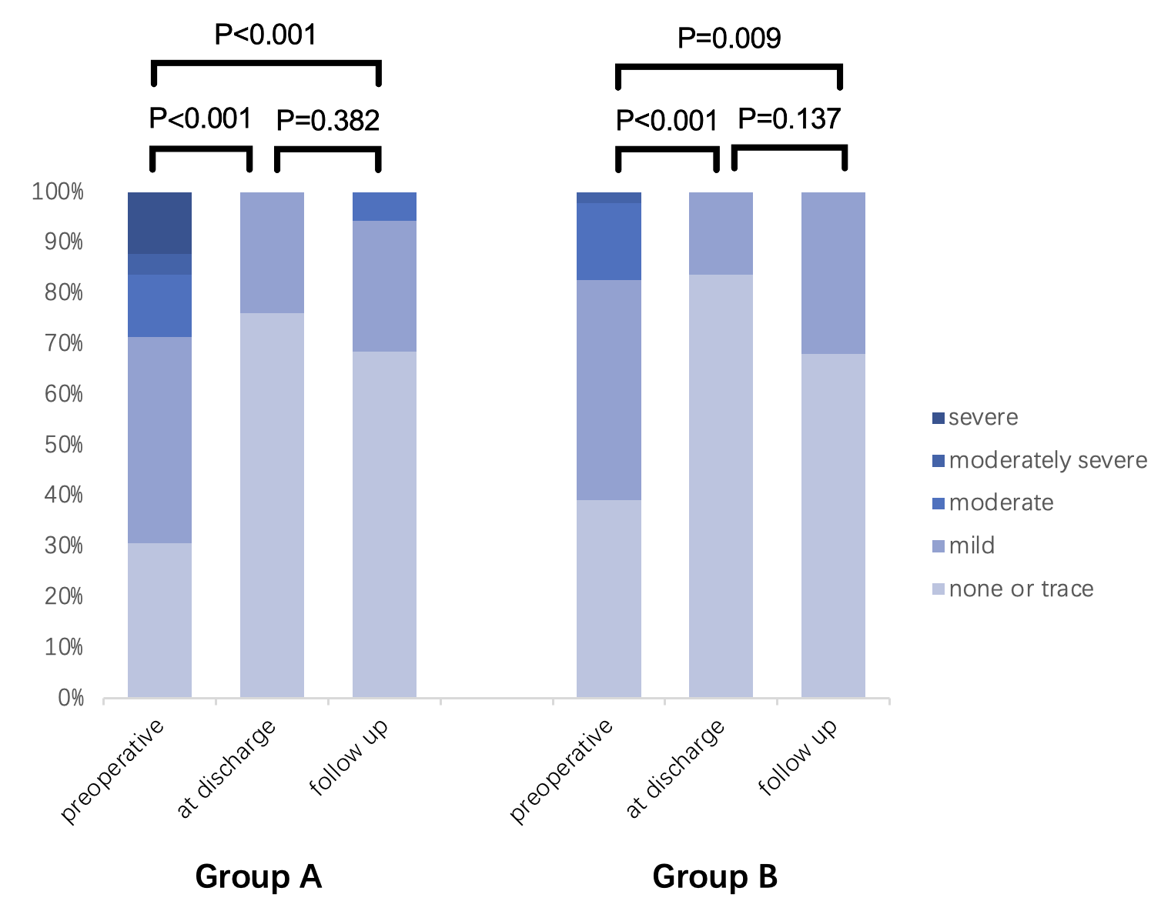
Figure S2. A comparison of aortic valve insufficiency before surgery, at discharge, and during follow-up between Group A and Group B.

Supplemental Figure 3
Figure S3. A comparison of aortic root diameter before surgery, at discharge, and during follow-up between Group A and Group B.

Supplemental Figure 4
Figure S4. Kaplan-Meier survival analysis curves for two groups of patients (units: months)

Supplemental Tables

Table S1. The grade of aortic valve insufficiency
 |  | Group A |  |  |  | Group B
Aortic valve  insufficiency | Preoperative  (n=49) | At discharge  (n=46) | Follow-up  (n=35) |  | Preoperative  (n=46) | At discharge  (n=43) | Follow-up  (n=25)
None or Trace | 15(31) | 35(76) | 24(69)  9(26) |  | 18(39) | 36(84) | 17(68)
Mild | 20(41) | 11(24) | 24(69)  9(26) |  | 20(43) | 7(16) | 8(32)
Moderate | 6(12) | 0(0) | 2(6) |  | 7(15) | 0(0) | 0(0)
Moderately severe | 2(4) | 0(0) | 0(0) |  | 1(2) | 0(0) | 0(0)
severe | 6(12) | 0(0) | 0(0) |  | 0(0) | 0(0) | 0(0)

Table S2. Aortic root diameter, median (first quartile, third quartile)
 |  | Group A |  |  |  | Group B
item | Preoperative  (n=49) | At discharge  (n=44) | Follow-up  (n=29) |  | Preoperative  (n=46) | At discharge  (n=39) | Follow-up  (n=24)
Aortic root  diameter (mm) | 38.5  (37-41.5) | 36.25  (34-38) | 38  (35-41) |  | 38.35  (36.25-41) | 36.38  (34.5-38) | 37  (32.75-39)

