Appendix
Figure A1. Experimental materials.
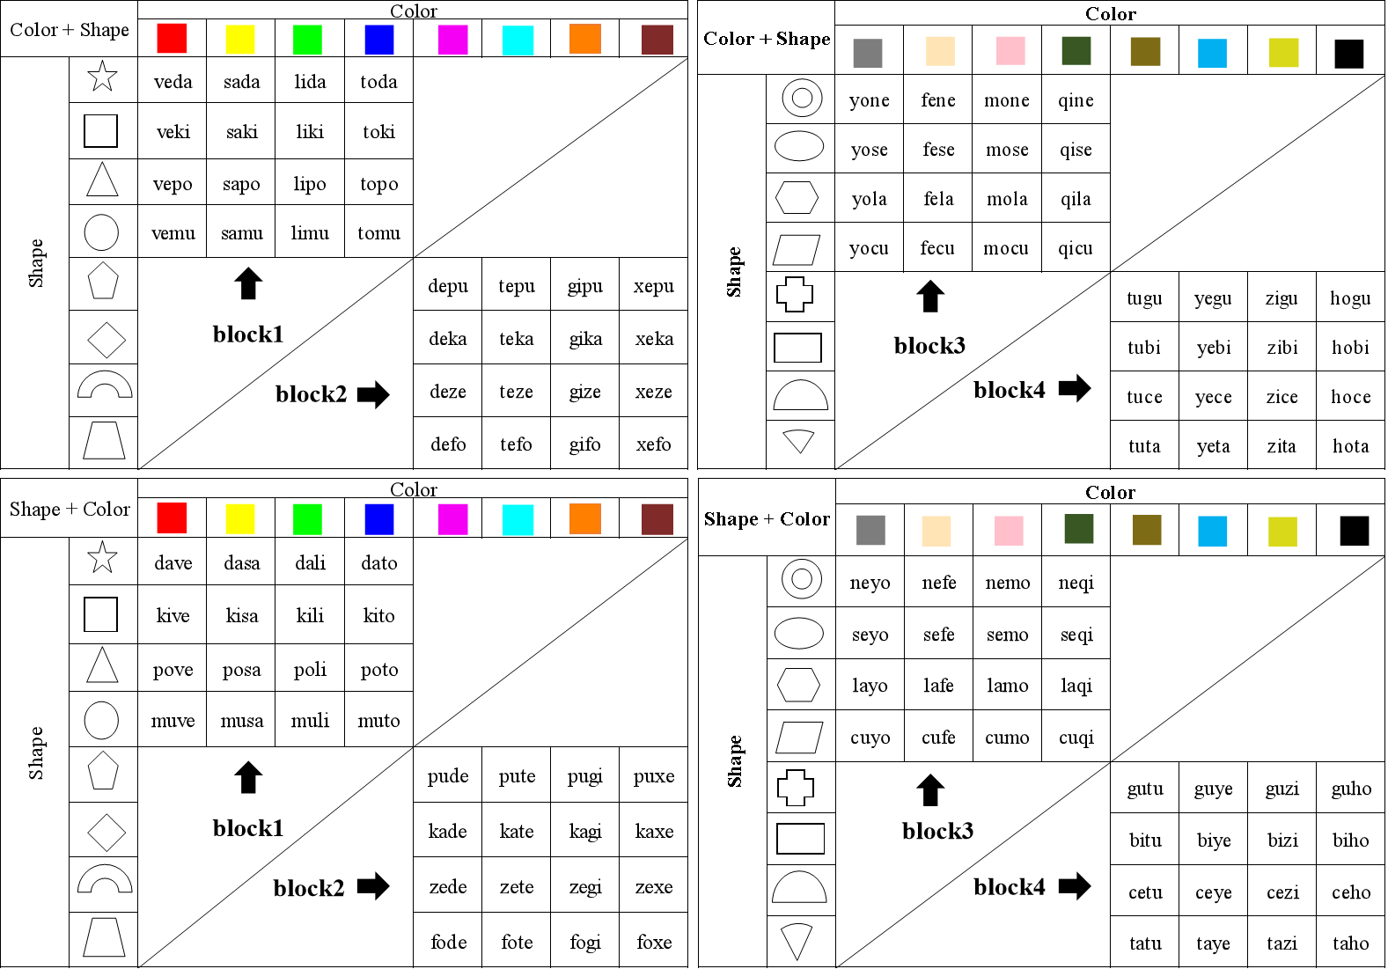
Notes: Four blocks were presented in the experiment. Blocks one and two were considered naïve learning, and blocks three and four were deemed as expert learning.

Figure A2. Original experimental flowchart in Chinese.
