Supporting information for
Inter-Brain Neural Correlates of Self–Other Integration in Joint Statistical Learning

Supplementary Discussion
Stimulus-locked P1
We first conducted a LMM analysis with trial type (i.e., self-relevant vs. self-irrelevant), context (i.e., joint vs. baseline), and their interaction as fixed effects. The results revealed a marginally significant main effect of trial type (β = 0.23, SE = 0.12, t₈₂ = 1.97, P = .051), with self-irrelevant trials exhibiting a significantly higher P1 amplitude than self-relevant trials. However, we did not find any significant main effects of context (β = -0.03, SE = 0.33, t₇₆ = -0.08, P = .936) nor of interactions between trial type and context (β = -0.02, SE = 0.14, t₈₂ = -0.12, P = .908, see Supplementary Figure 2C).
Regarding self-relevant trials (see Supplementary Figure 1C), analysis of the learning phase on P1 amplitude revealed neither a significant main effect of phase (β = 0.04, SE = 0.04, t₄₁₈ = 1.10, P = .274) nor of context (β = 0.28, SE = 0.39, t₁₀₀ = 0.72, P = .473). However, the two-way interaction effects of phase × context were significant (β = -0.10, SE = 0.05, t₄₁₈ = -2.06, P = .040). This was demonstrated by the slope of the P1 amplitude decrease, or the rate of the P1 amplitude increase, being steeper in the joint context compared to the baseline context (Supplementary Figure 1C). However, we did not observe any significant effects during the modulating phase on P1 amplitude (ts < 1.18, Ps > .240 for the linear model; ts < 0.87, Ps > .381 for the quadratic model).
For self-irrelevant trials, the results revealed neither a significant learning effect (ts < 1.90, Ps > .058) nor a significant modulating effect (ts < 0.18, Ps > .861 for the linear model; ts < 1.46, Ps > 0.147 for the quadratic model).
Stimulus-locked N1
A similar LMM analysis of trial type (i.e., self-relevant vs. self-irrelevant) or context (i.e., joint vs. baseline) on N1 revealed a significant main effect of trial type (β = 0.62, SE = 0.23, t₈₂ = 2.76, P = .007), with self-relevant trials exhibiting a significantly higher N1 amplitude than self-irrelevant trials. However, there were no significant main effects of context (β = 0.27, SE = 0.47, t₇₇= 0.57, P = .570) nor of interactions between trial type and context (β = -0.04, SE = 0.28, t₈₂ = -0.16, P = .875, see Supplementary Figure 2C).
Regarding self-relevant trials (see Supplementary Figure 1E), the analysis of learning phase on N1 amplitude revealed neither a significant main effect of phase (β = 0.04, SE = 0.04, t₄₁₈ = 0.73, P = .405) nor a significant main effect of context (β = 0.62, SE = 0.52, t₁₀₇ = 1.18, P = .242). However, the two-way interaction effects of phase × context were significant (β = -0.11, SE = 0.05, t418 = -2.09, P = .038). This interaction was indicated by the slope of N1 amplitude decrease, or the rate of N1 amplitude increase, were steeper in the joint context compared to the baseline context. However, we did not observe any significant effects during the modulating phase on N1 amplitude (ts < 1.83, Ps > .069 for the linear model; ts < 1.50, Ps > 0.135 for the quadratic model).
For self-irrelevant trials, the results revealed neither a significant learning effect (ts < 0.61, Ps > .546) nor a significant modulating effect (ts < 0.66, Ps > .512 for the linear model; ts < 0.82, Ps > 0.411 for the quadratic model).
The observed decreases in the amplitudes of the stimulus-locked P1 and N1 components reflected a learning-related downward trend due to the diminished allocation of visual attentional resources.
Fixation-locked P2
Our study also aimed to provide neural evidence to support the occurrence of predictive processing during SRT tasks. To test this, we analyzed the ERP data time-locked to the stimulus offset, with a focus on the mean amplitude measures of the P2 (see Supplementary Figure 2A & B).
The results of the trial type similarity analysis on the P2 revealed a significant main effect of phase (β = 0.50, SE = 0.19, t₈₁ = 2.41, P = .018). However, there were no significant main effects of trial type (β = -0.08, SE = 0.08, t82 = -0.84, P = .402) or of the interactions between trial type and context (β = -0.03, SE = 0.10, t₈₂ = -0.05, P = .806). These findings suggest that participants had similar predictive neural activity before the stimulus onset under both self-relevant and self-irrelevant trial conditions (see Supplementary Figure 2F). Thus, subsequent analyses were conducted by averaging data across the two trial type conditions.
Further LMM analysis revealed a significant main effect of context (β = 0.74, SE = 0.23, t₁₂₈ = 3.03, P = .001). However, the main effect of phase was not significant (β = -0.05, SE = 0.03, t₄₁₈ = -1.80, P = .073). Furthermore, the two-way interaction effects of phase × context were significant (β = -0.11, SE = 0.05, t₄₁₈ = -2.09, P = .038). This interaction was indicated by the slope of the P2 amplitude decrease, or of the P2 amplitude learning rate, being steeper in the joint context compared to the baseline context (see Supplementary Figure 1D). No significant effects were observed during the modulating phase (ts < 1.37, Ps > .173 for the linear model; ts < 0.87, P > .384 for the quadratic model).
Intra-brain Functional Connectivity (FC)
For the alpha band, the results of the trial type similarity analysis revealed a significant main effect of trial type (β = 7.29×10⁻³, SE = 2.77×10⁻³, t₈₂ = 2.63, P = .010), with self-relevant trials exhibiting a significantly higher connectivity in the alpha band than self-irrelevant trials (see Supplementary Figure 2D). However, there were no significant main effects of context (β = 0.55×10⁻³, SE = 8.43×10⁻³, t₆₉= 0.07, p = .948), nor of the interactions between trial type and context (β = 5.27×10⁻³, SE = 3.39×10⁻³, t₈₂ = -1.56, P = .124). Given the significant differences between different trial types, we conducted follow-up analyses for each trial type. Regarding self-relevant trials, analysis results revealed significant main effects of only phase (20 channel combinations, all P_{FDR} < .05), indicating that the intra-brain PLV exhibited a negative slope during the learning phase. No other significant effects were observed for the self-irrelevant trials after multiple comparison corrections.
As a control, we conducted parallel analyses of the beta band, but no significant results were detected after multiple comparison corrections. Therefore, for the remainder of this paper, we focus our analyses on the theta and alpha bands.
Brain-to-Brain Coupling Analysis
A total of 2,892 channel combinations were identified where the PLV significantly exceeded the averaged surrogate PLVs in alpha bands (all P_{FDR} < .05).
For the alpha band and beta band, no significant results were detected after multiple comparison corrections.

Supplementary Figure
Supplementary Figure 1. The intra-brain neural responses evoked by stimulus onset and offset. (A) Grand-averaged ERP waveforms at the parietal region showing peak amplitudes for the P1 and N1 components for self-relevant trials. Scalp topographic voltage maps for the P1 and N1 components. (B) Grand-averaged ERP waveforms at the frontal region showing peak amplitudes for the P2 components for the averaged trials. Scalp topographic voltage maps for the P2 components. (C & E) Intra-brain neural response reported by block for the P1 and N1 components for self-relevant trials. The light grey shading represents the learning phase, while the dark grey sharding represents the modulating phase. The colored line represents the fitted model for the learning and modulating phase respectively. (D) Intra-brain neural response reported by block for the P2 components for the averaged trials. The error bar represents the Standard Error of the Mean (SEM).

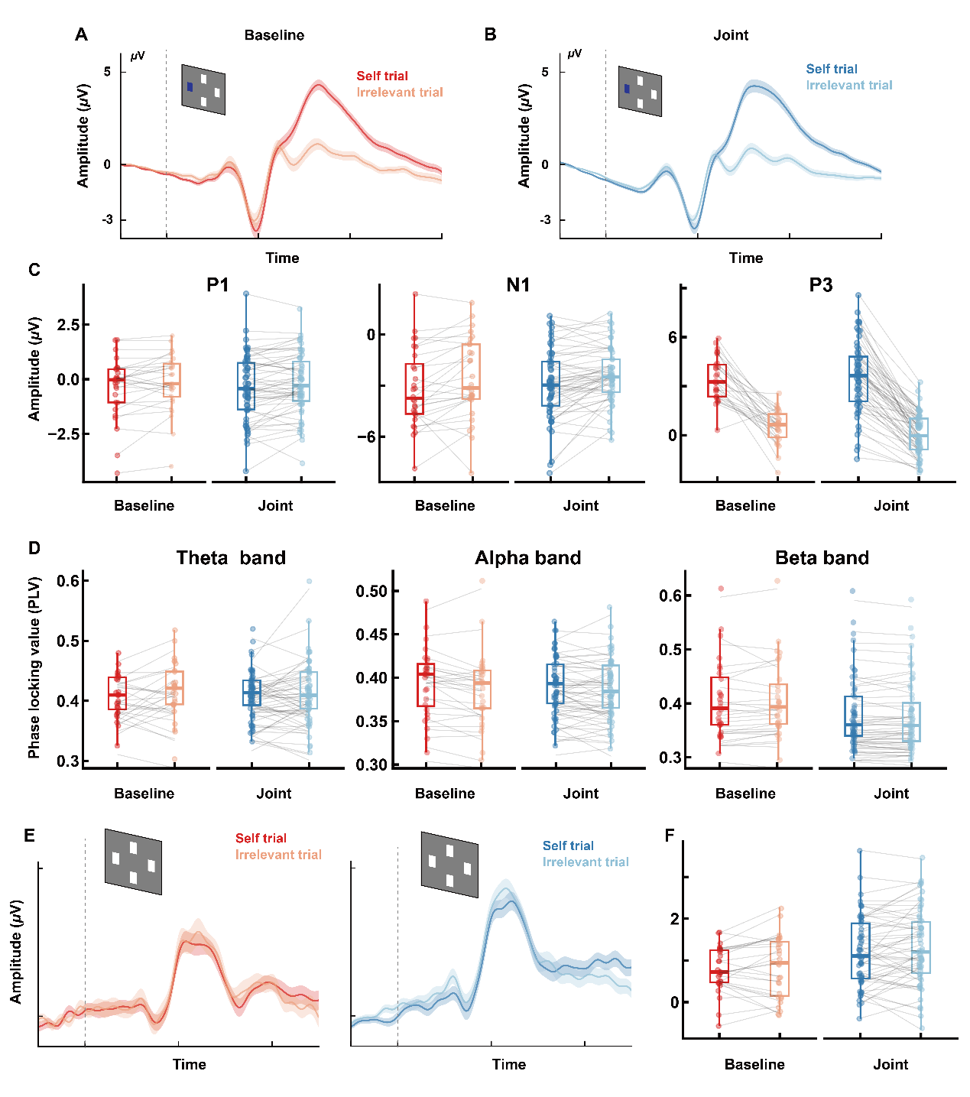
Supplementary Figure 2. The neural responses for the self-relevant and self-irrelevant trials. (A) The wave plot evoked by stimulus onset in the joint context for the self-relevant (red) and self-irrelevant (orange) trials. (B) The wave plot in the baseline context for the self-relevant (dark blue) and self-irrelevant (light blue) trials. (C) The ERP amplitudes of the joint context and base context split by self-relevant and self-irrelevant trials for the P1, N1, and P3 components. The bottom of the box represents the first quartile of the data, the line in the middle of the box represents the median of data and the box’s upper side represents the third quartile. The dot represents the original data. (D) The functional connectivity amplitudes of the joint context and base context split by self-relevant and self-irrelevant trials for the theta, alpha and beta band. (E) The wave plot evoked by fixation onset in the joint context for the self-relevant (red) and self-irrelevant (orange) trials. (F) The ERP amplitudes of the joint context and base context split by self-relevant and self-irrelevant trials for the P2 component. The error bar represents the Standard Error of the Mean (SEM).

