Economic Evaluation of PV Water Pumping Systems
in Agriculture Sector in the Middle East
Kamil A. Khalafª, Ahmed Abdel Salam^{b}, Bashar Attiya^{c}
ª Department of Biosystems Engineering, University of Arizona, Tucson, AZ 85721, USA.
^{b} Department of Materials Science, Institute of Graduate Studies and Research, Alexandria ‎University, P.O. Box 832, Egypt.‎
^{c} Department of Cooling and Air Conditioning Engineering, Imam Ja’afar Al-Sadiq University, Kirkuk, Iraq.

3. Results and Discussion
3.1 Solar Availability in the Middle East
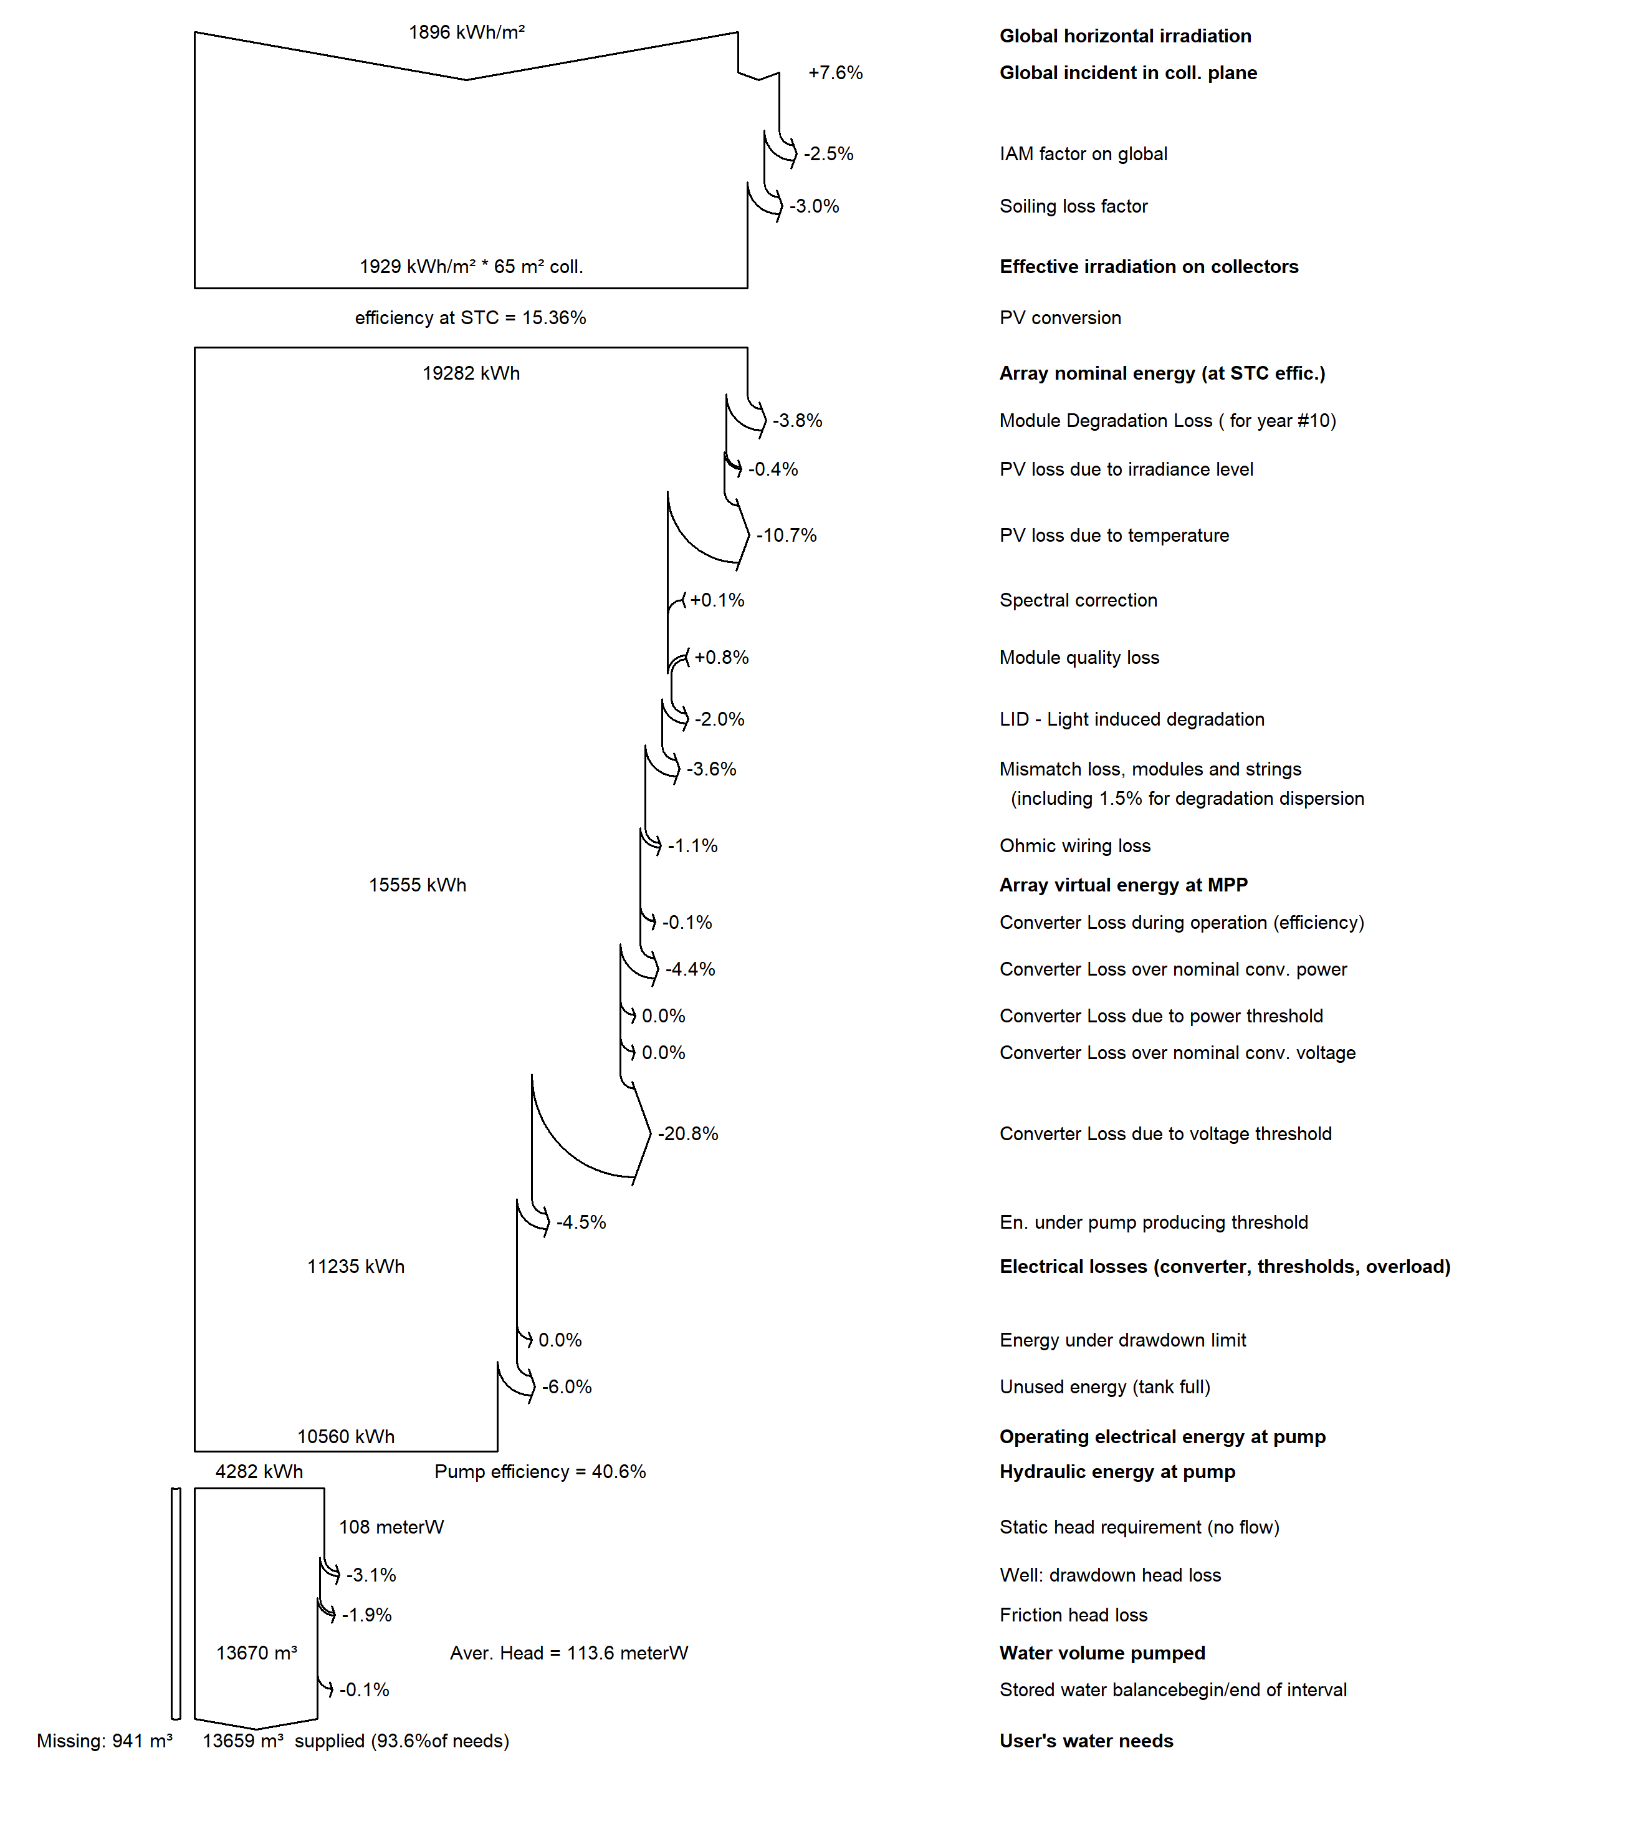
Figure 1S. illustrates the loss diagram of solar water pumping project using PVSYST in Bahtim, Egypt.

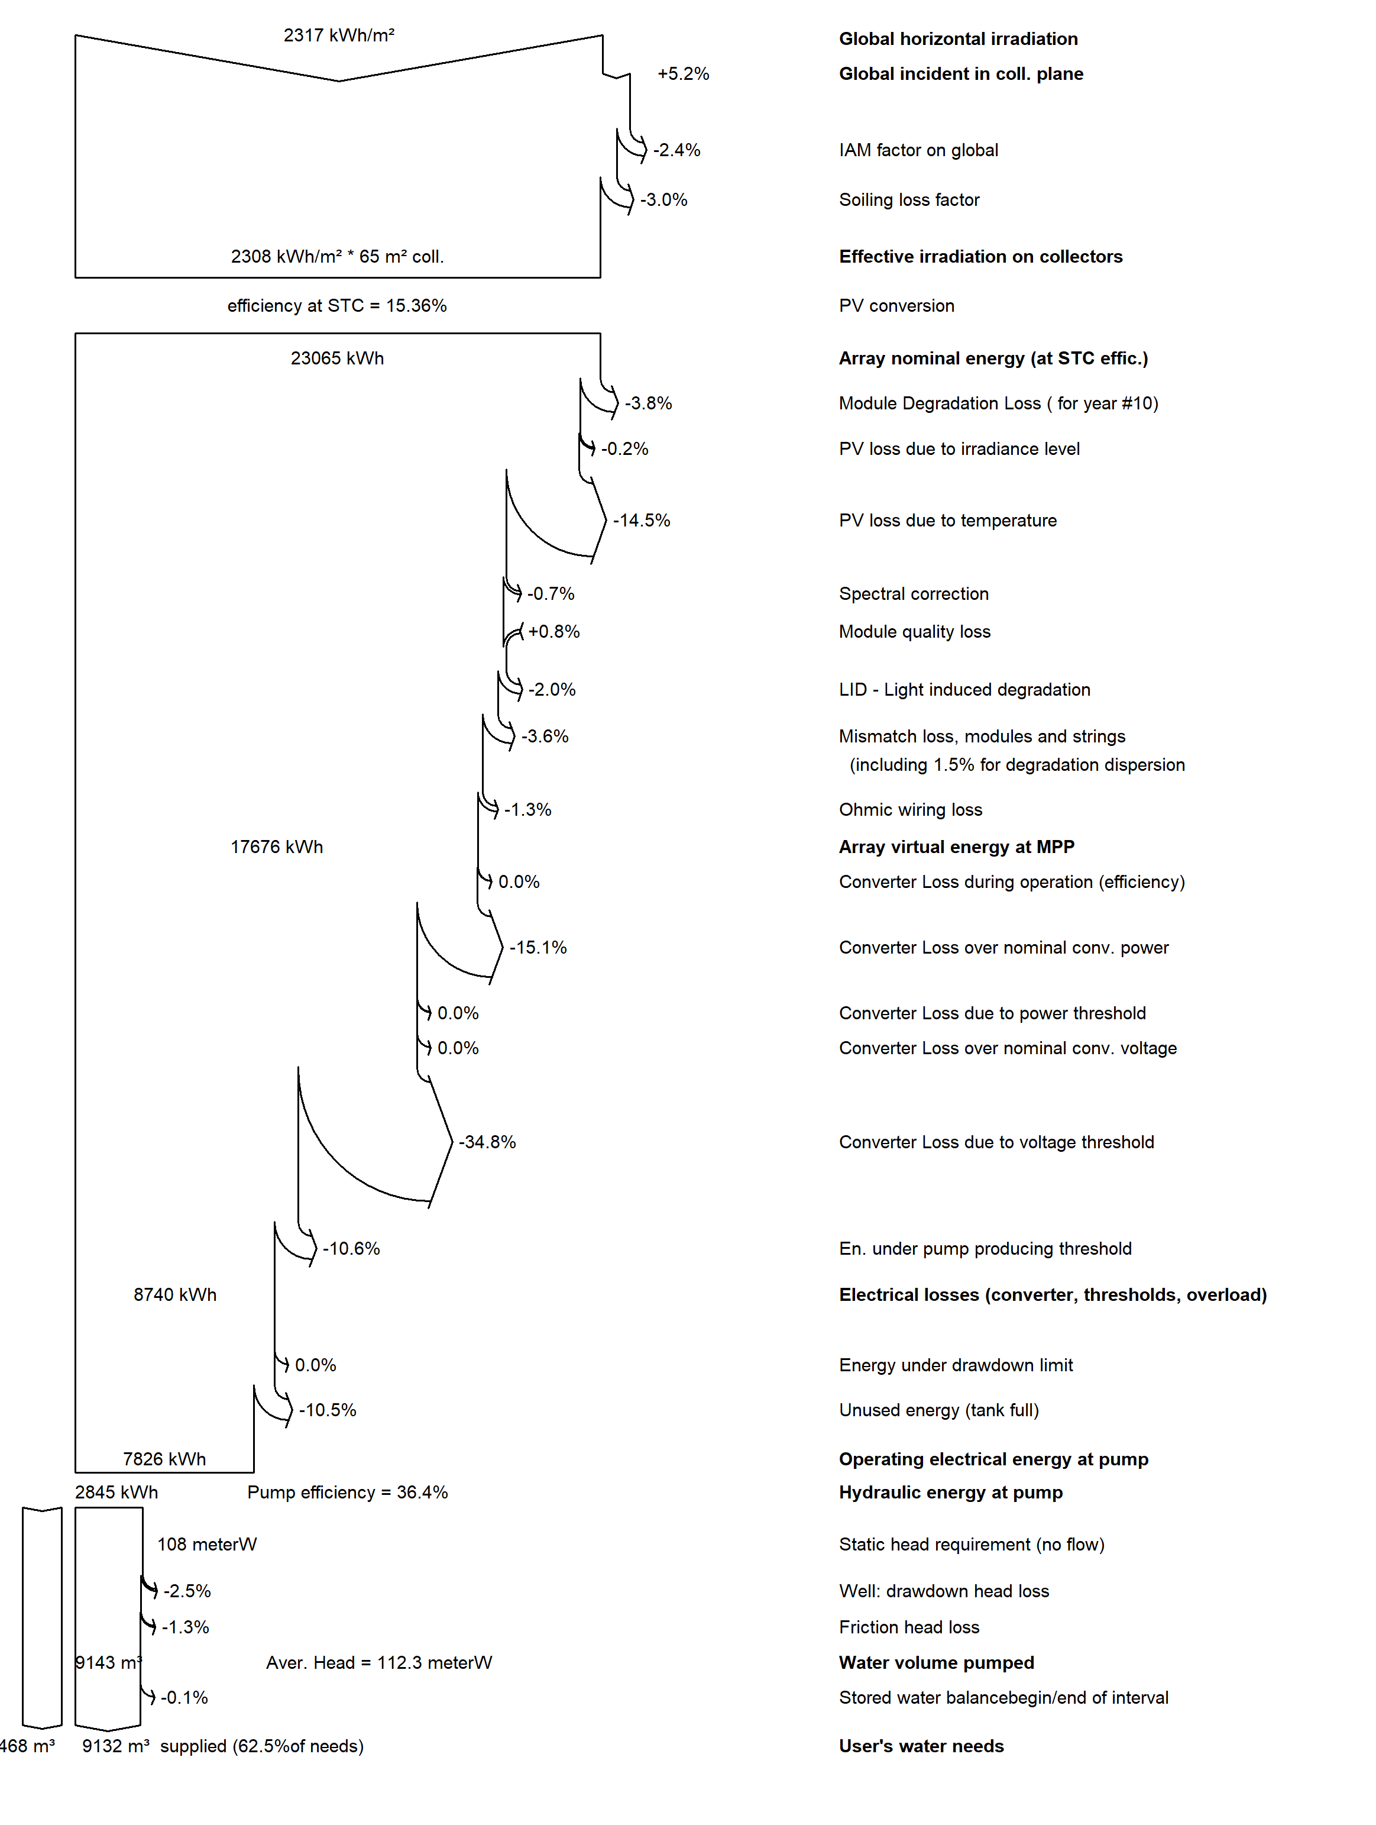
‎ Figure 2S. illustrates the loss diagram of solar water pumping project using PVSYST in Wadi Al ‎Dawaserm, ‎Saudi Arabia. ‎

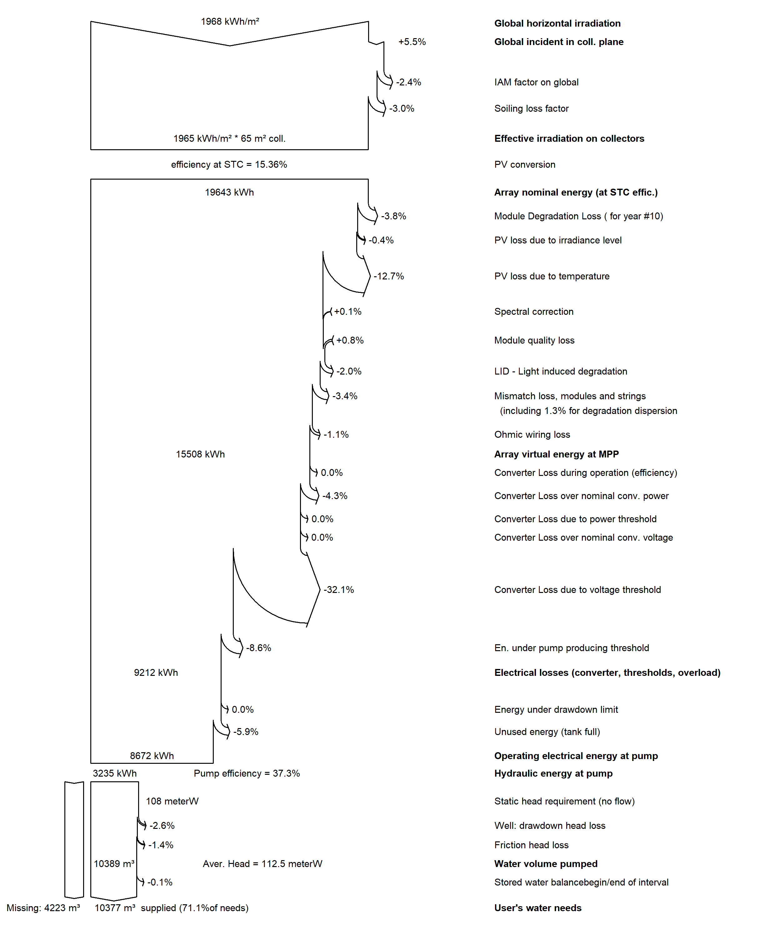
‎ Figure 3S. illustrates the loss diagram of solar water pumping project using PVSYST in ‎ Ash Shibaniyah, ‎Qatar. ‎

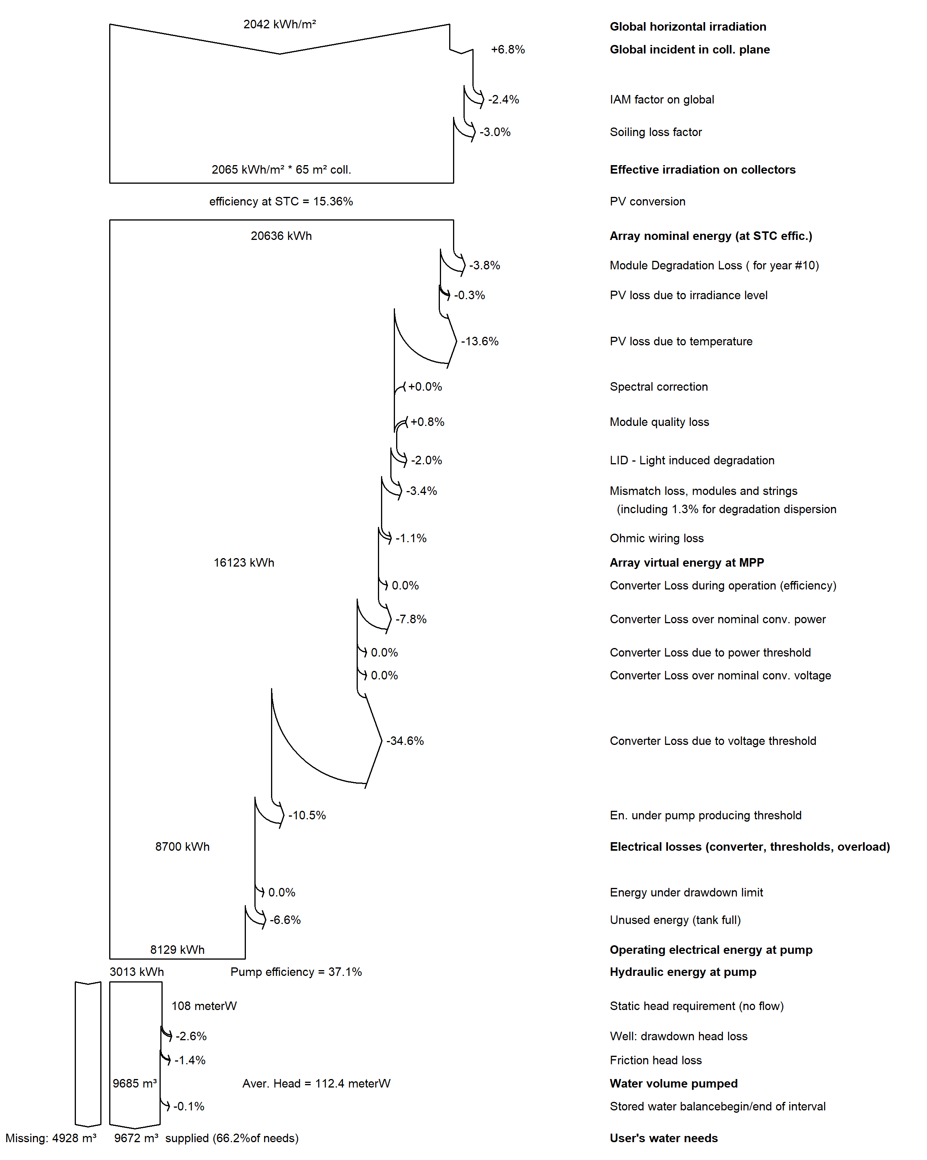
‎ Figure 4S. illustrates the loss diagram of solar water pumping project using PVSYST in ‎ ‎ Suwyban, ‎UAE. ‎

